Challenge – 10
Write a code using Terraform that deploys and achieves the following:-
- Create an EC2 Instance on AWS Cloud using the below-mentioned ubuntu AMI and instance_type. Or, (You can use of your choice as well) ami = "ami-0461b1436c9b3c1a3" instance_type = "t2.micro"
Steps:
- First configured aws configure & created a aws_instance f=directory created the below files in aws_instance directory
- Created a main.tf file with the below code & save:
resource "aws_instance" "webserver" {
ami = var.ami
key_name = "linux_testing"
instance_type = "t2.micro"
subnet_id = var.subnet_id
tags = {
Name = "Web-server-01"
}
}
- Created a variables.tf file with the below code in VS code & save:
variable "ami" {
default = "ami-08f44e8eca9095668"
}
variable "subnet_id" {
default = "subnet-0d1454707d798a065"
}
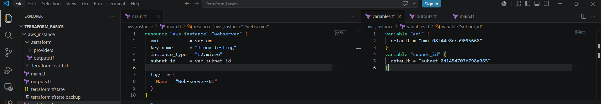
- Now create a outputs.tf file & save with the below code:
output "public_ip" {
value = aws_instance.webserver.public_ip
}
output "public_dns" {
value = aws_instance.webserver.public_dns
}
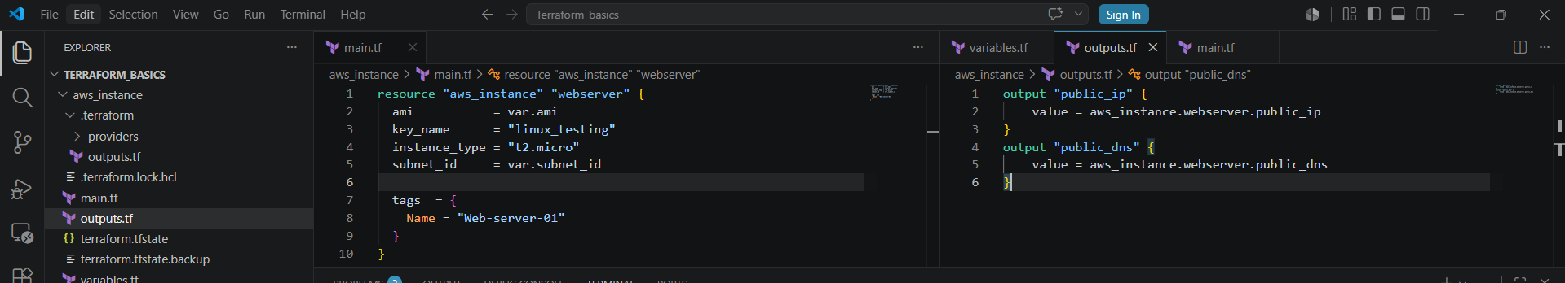
- In the terminal execute terraform init, terraform fmt, terraform validate & terraform apply & we can see the ec2 instance got created
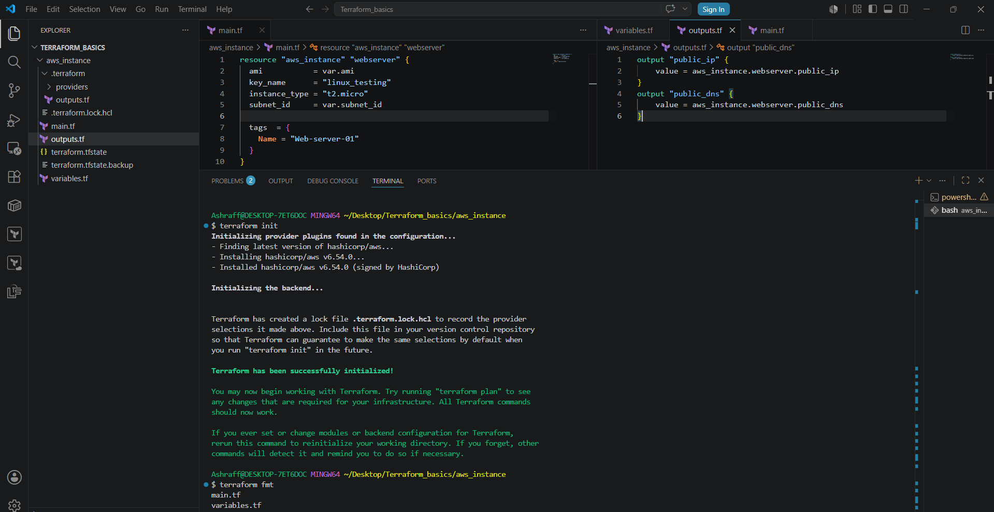
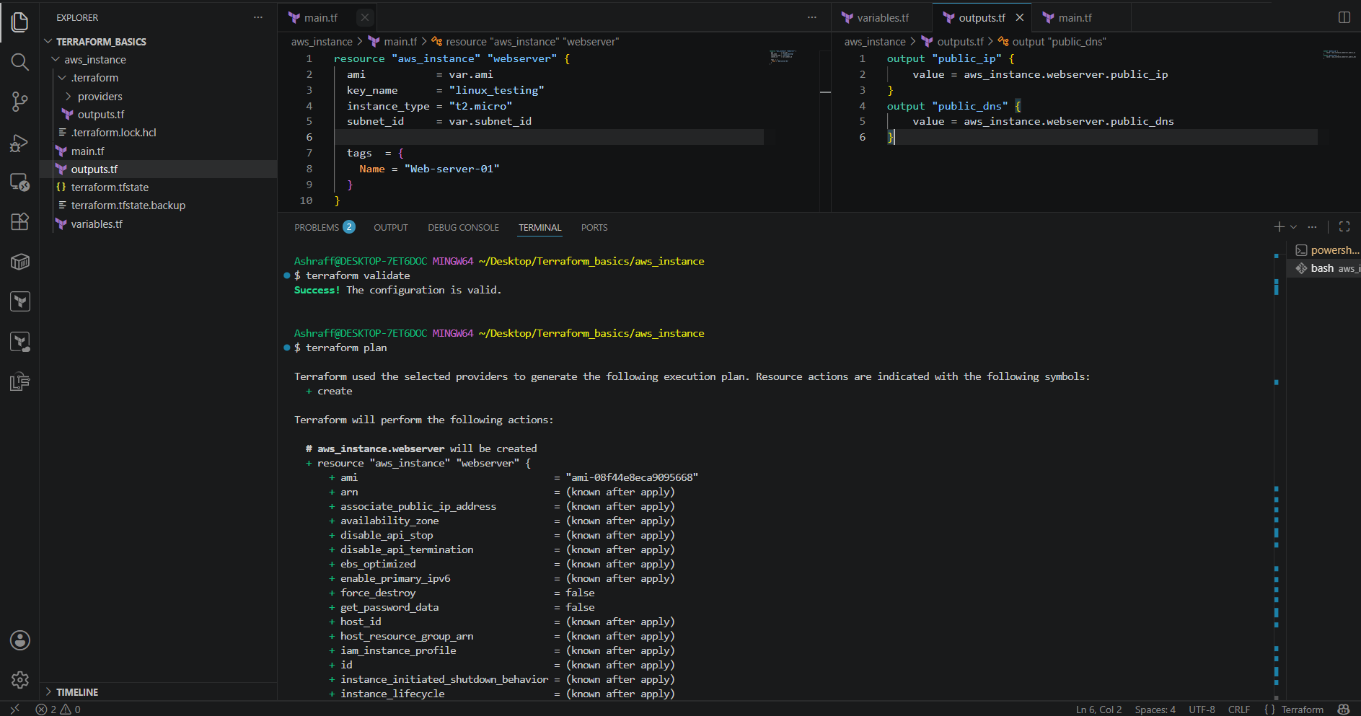
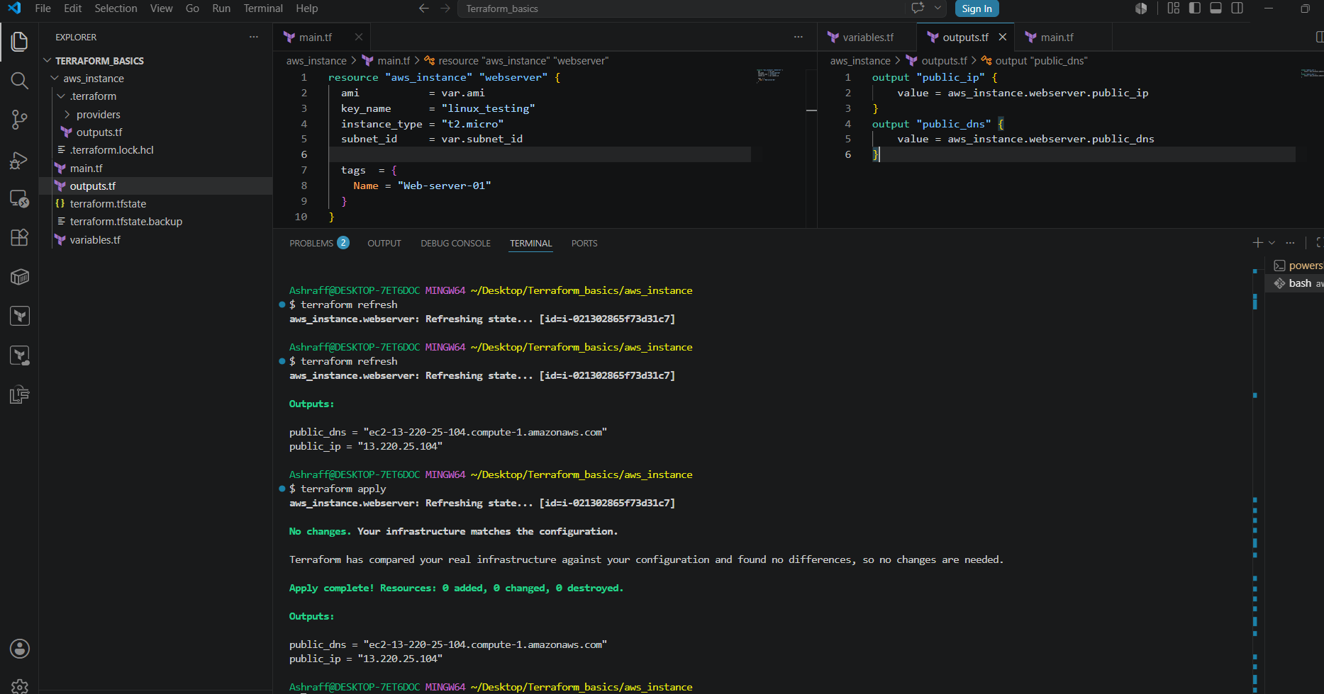
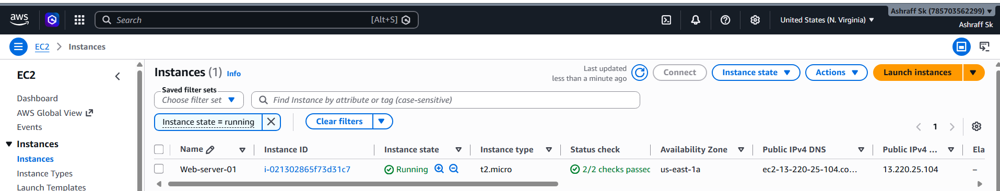
- Install a web server on the same EC2 Instance. The web server should listen on port 8080.
Steps:
- Before starting this task execute terraform destroy & delete all the files.
- First configured aws configure & created a aws_instance f=directory created the below files in aws_instance directory
- Created a main.tf file with the below code & save:
- resource "aws_instance" "webserver" {
- ami = var.ami
- subnet_id = var.subnet_id
- instance_type = "t2.micro"
- user_data = <<-EOF
- #!/bin/bash
- sudo yum update -y
- sudo yum install httpd -y
- sed -i 's/^Listen 80/Listen 8080/' /etc/httpd/conf/httpd.conf
- sudo systemctl enable httpd
- sudo systemctl start httpd
- echo "Apache running on port 8080" > /var/www/html/index.html
- EOF
- tags = {
- Name = "Terraform-webserver"
- }
- }

- Created a variables.tf file with the below code in VS code & save:

variable "ami" {
default = "ami-08f44e8eca9095668"
}
variable "subnet_id" {
default = "subnet-0d1454707d798a065"
}

- Created a outputs.tf file with the below code in VS code & save:
- output "public_ip" {
- value = aws_instance.webserver.public_ip
- }
- output "public_dns" {
- value = aws_instance.webserver.public_dns
- }

- In the terminal execute terraform init, terraform fmt, terraform validate & terraform apply & we can see the ec2 instance got created & checked whether the httpd is installed in ec2 instance by connecting to the instance & browser as well
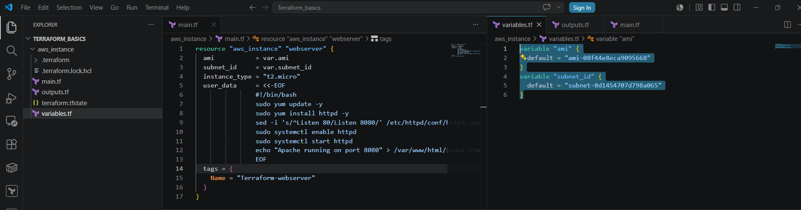
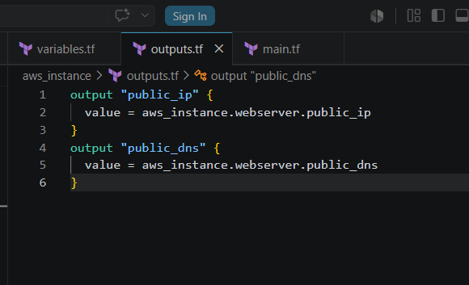
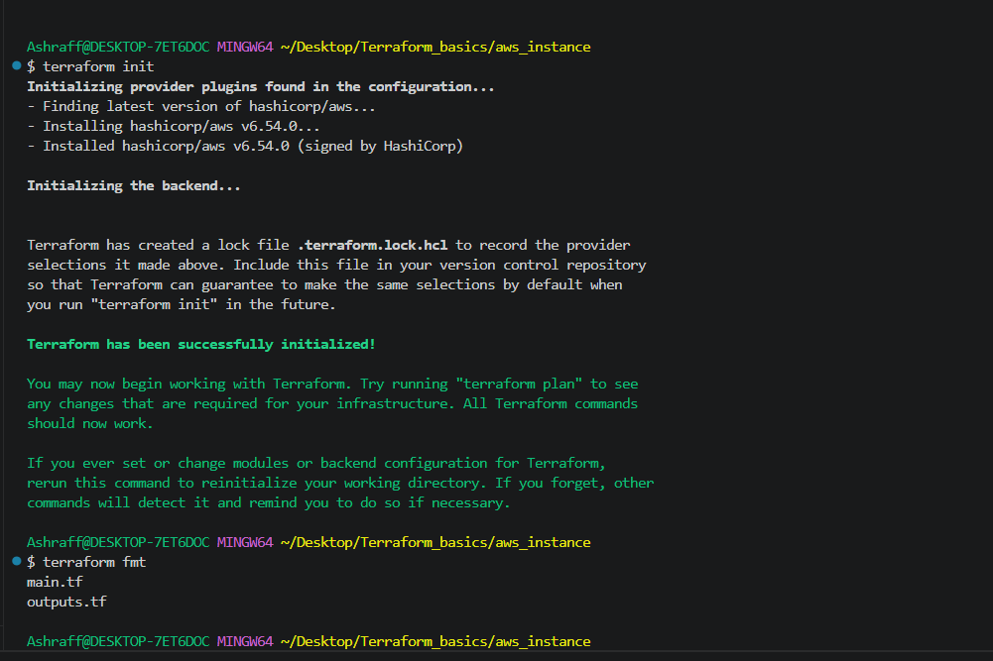
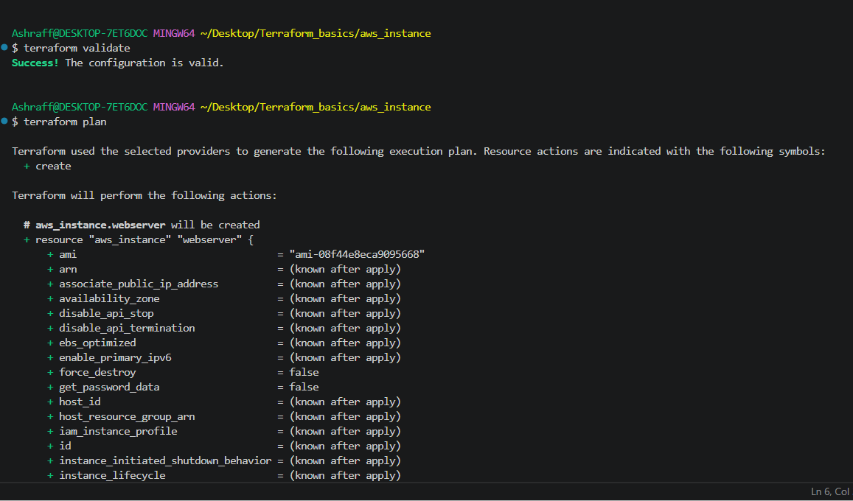
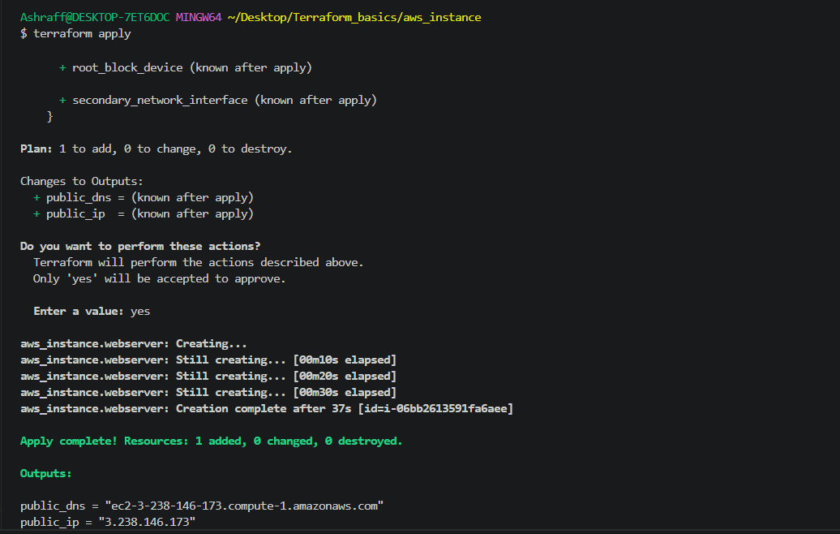
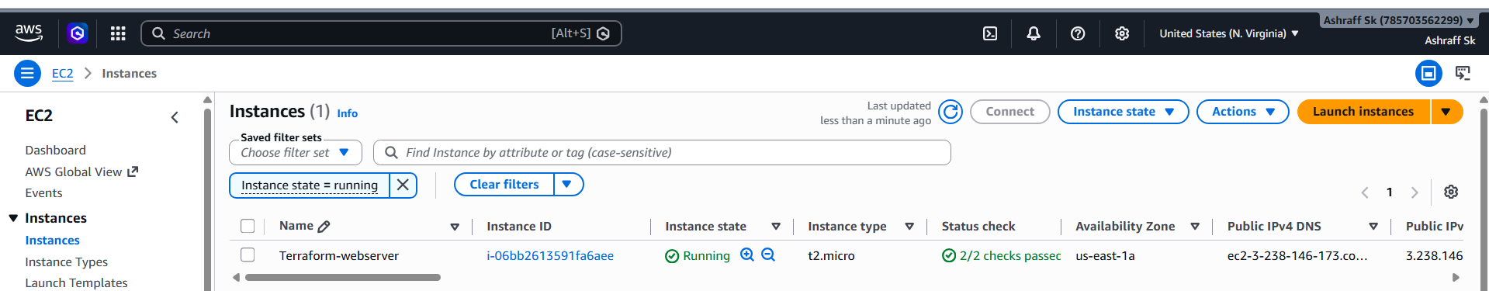

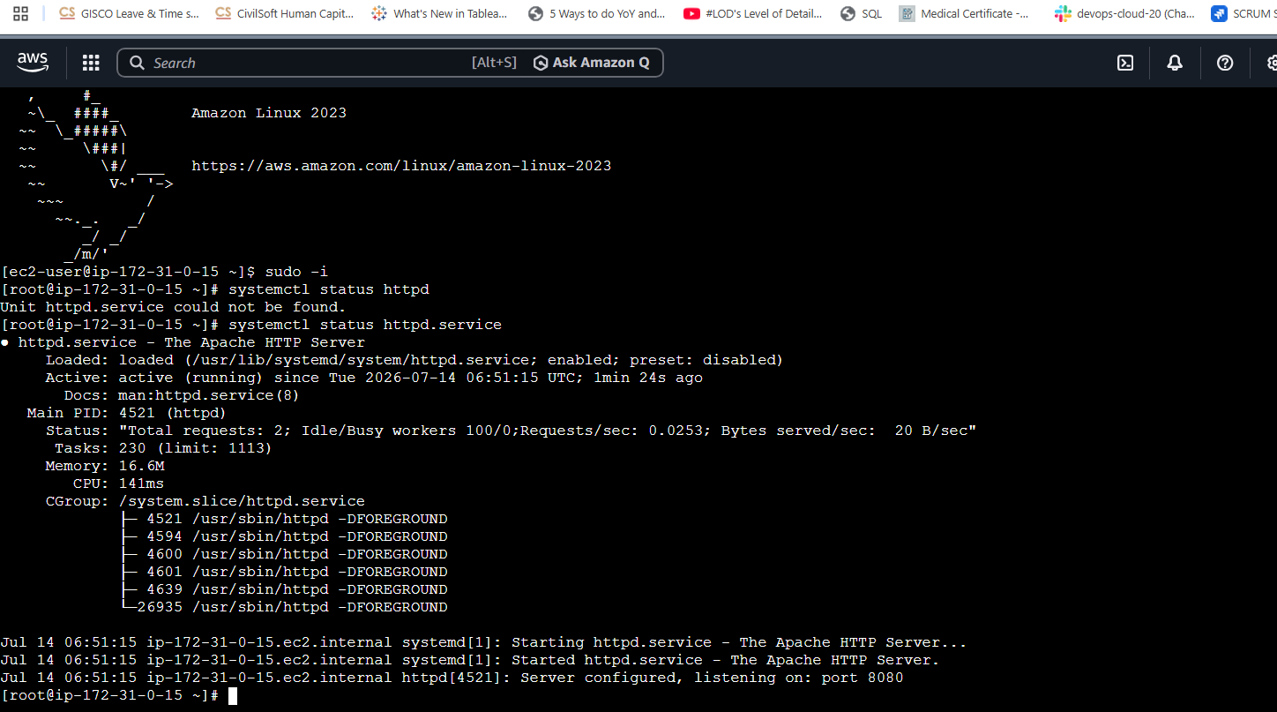
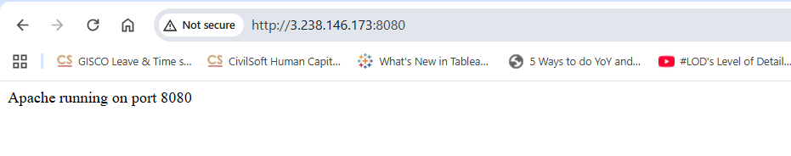

- Create a Docker-compose file for the project:https://github.com/betawins/cricbuzz-docker-hello-world.gitand point it to port 8000.
Steps:
- Created a docker_compse directory under TERRAFORM_BASICS
- Now make sure that aws configure is done & created a main.tf as per the below snapshot & save

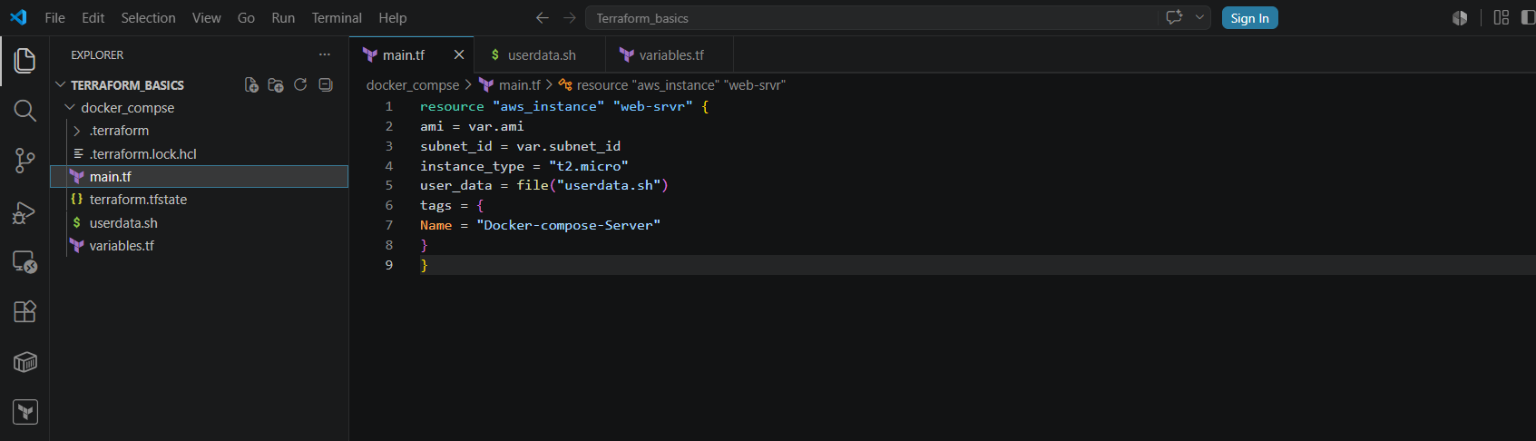
- Now created a userdata.sh file under docker_compse directory as per the below snapshot & save

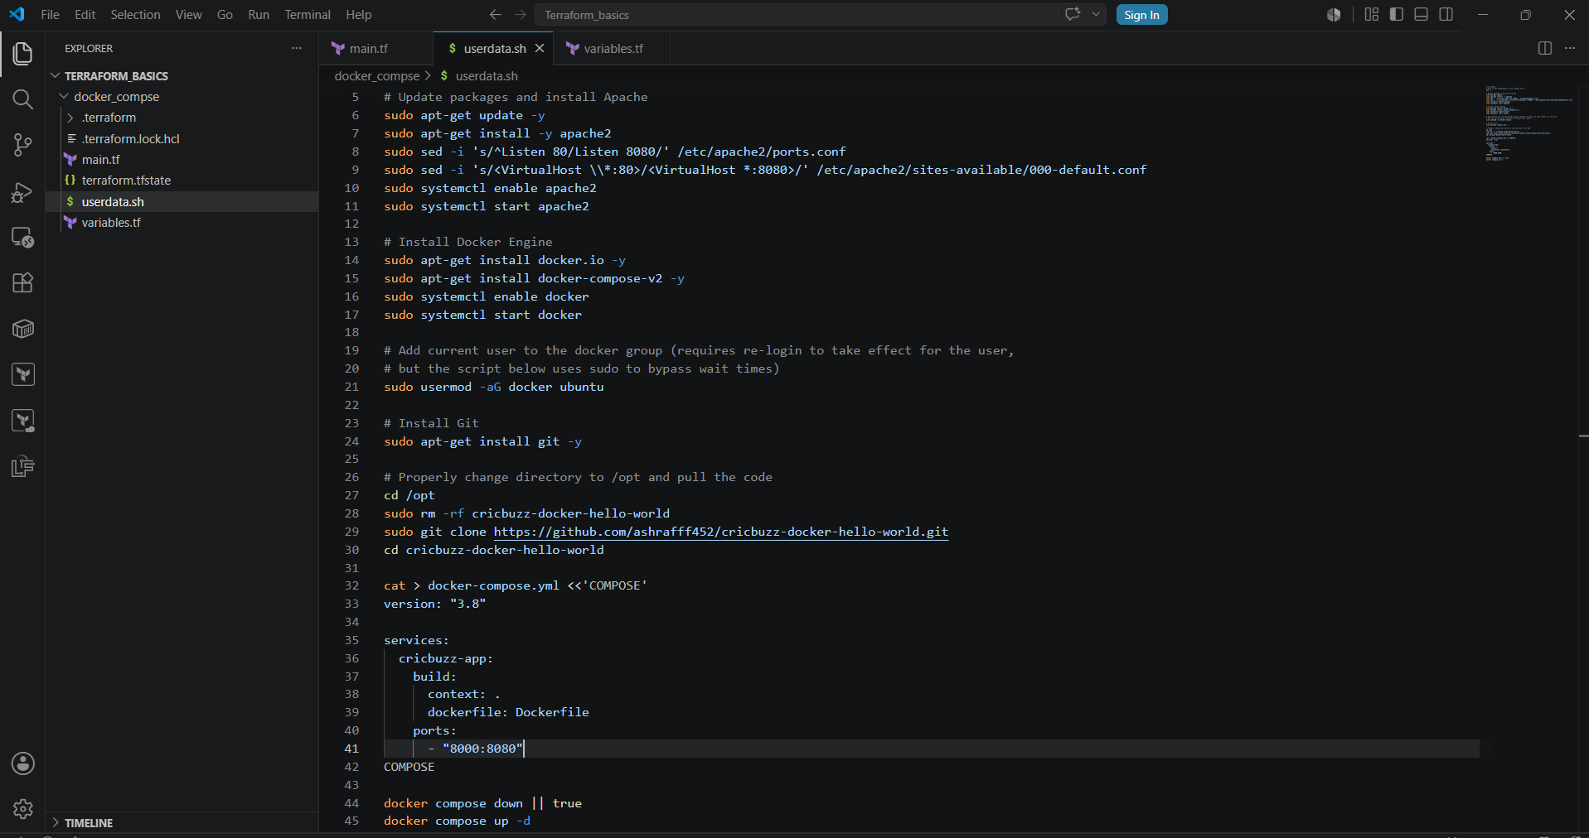
- Now created the variables.tf file & declared the ami & subnet id as per the below snapshot & save.
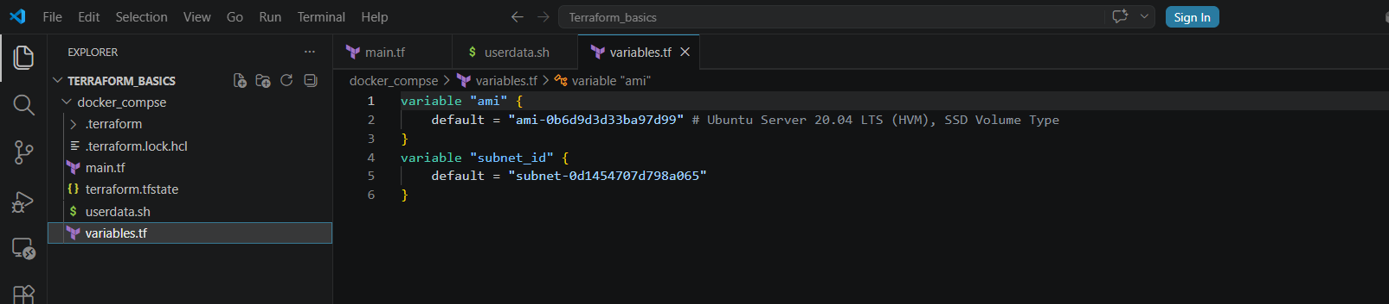
- In the output terminal go to docker_compse location by cd /docker_compse & execute terraform init & terraform apply & click yes to proceed
- We can see in ec2 an instance got created & after ec2 instance connect can see the docker installed, docker compose running in the container on port 8000 & httpd running on port 80
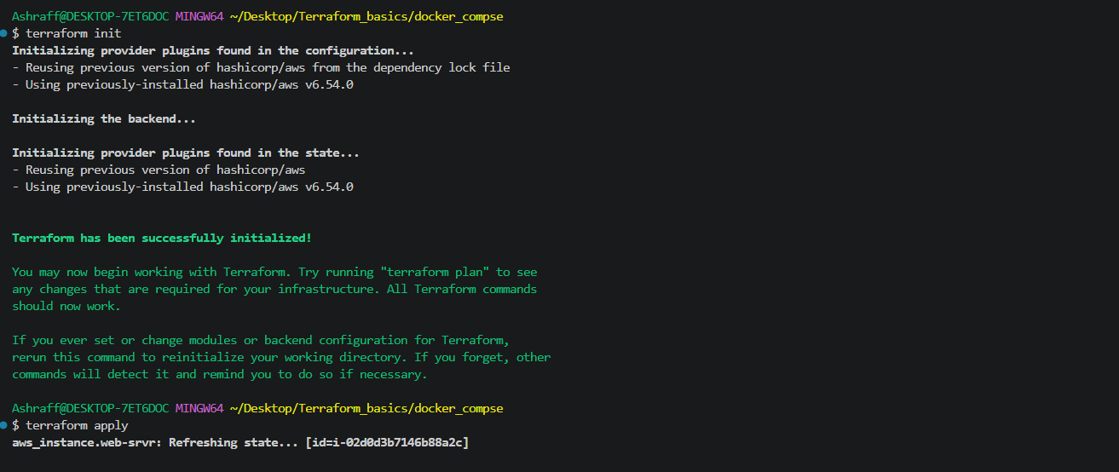
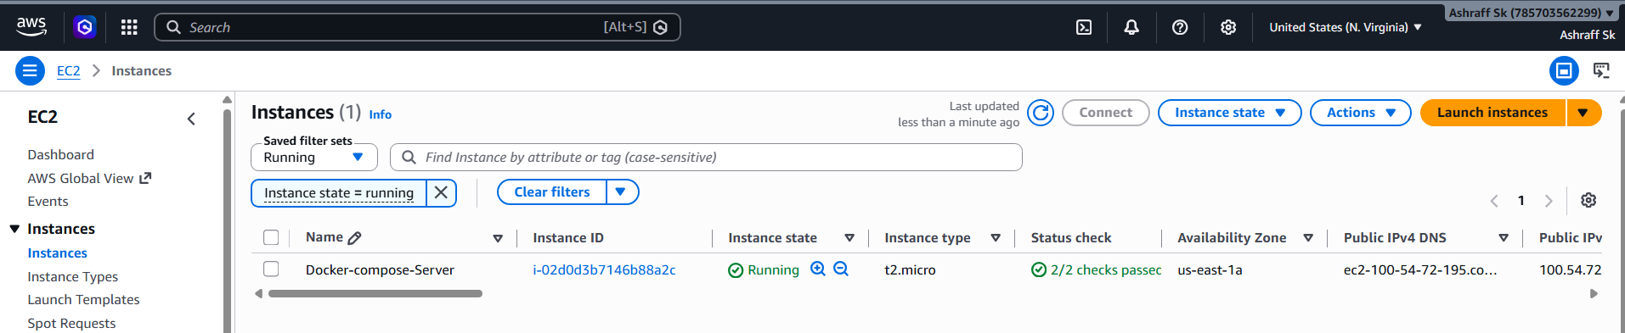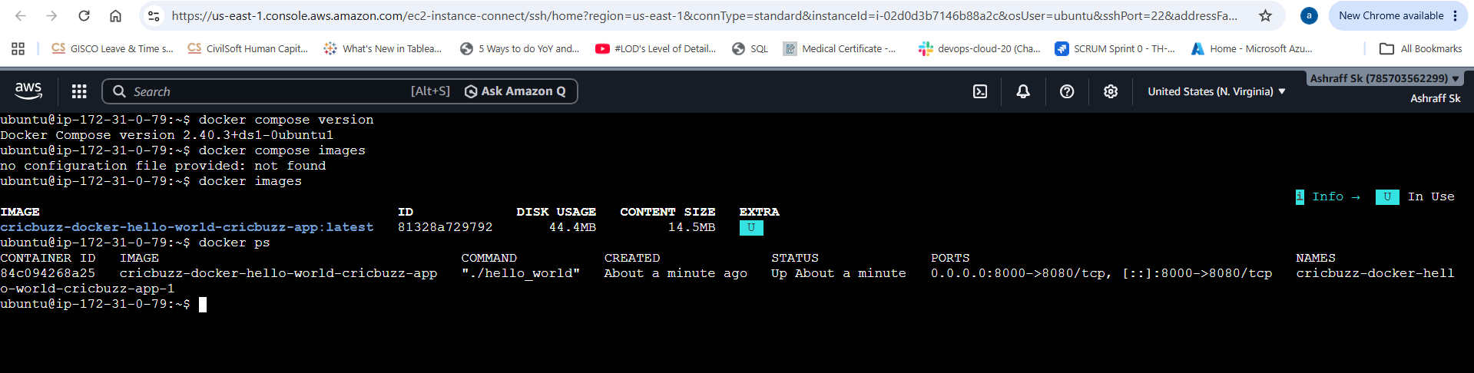

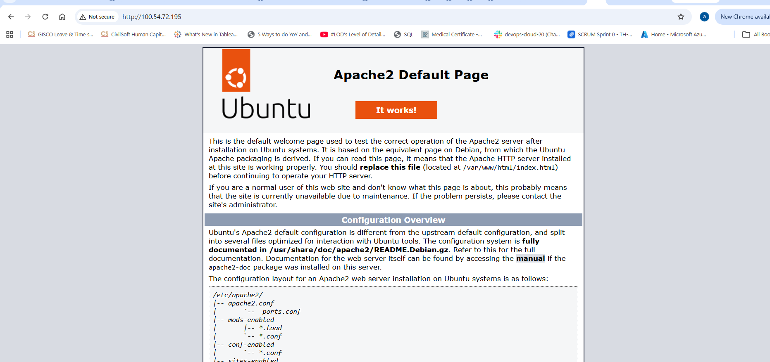

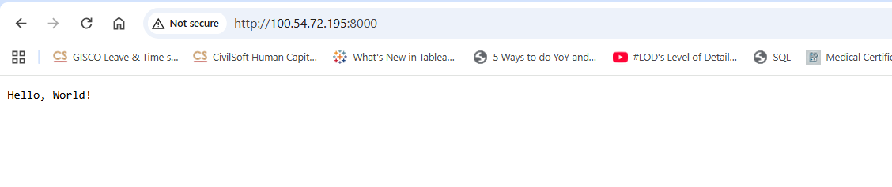
- Make the web server point to the above service so that 8080 returns the response from the Docker service.
Steps:
- Created a docker_compse directory under TERRAFORM_BASICS
- Now make sure that aws configure is done & created a main.tf as per the below snapshot & save
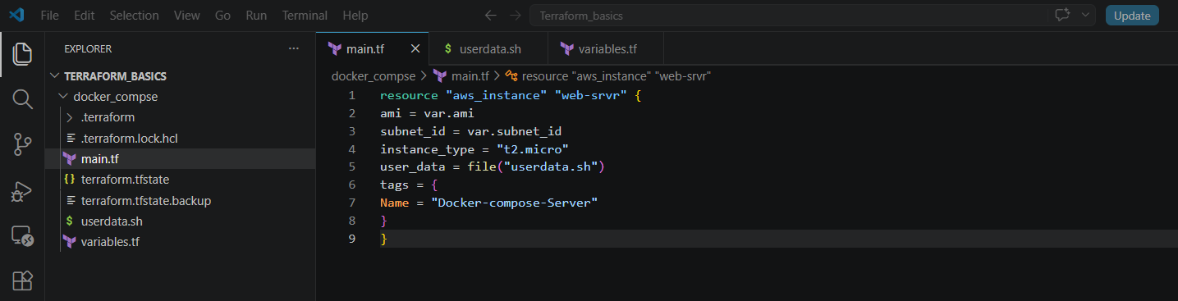
- Now created the userdata.sh file with the below code & save
user_data = <<-EOF
#!/bin/bash
apt-get update -y
apt-get install -y apache2 docker.io git

systemctl enable apache2
systemctl enable docker

systemctl start apache2
systemctl start docker

a2enmod proxy
a2enmod proxy_http

sed -i 's/^Listen 80/Listen 8080/' /etc/apache2/ports.conf

cat > /etc/apache2/sites-available/000-default.conf <<EOL
<VirtualHost *:8080>

ProxyPreserveHost On
ProxyPass / http://localhost:8000/
ProxyPassReverse / http://localhost:8000/

</VirtualHost>
EOL

systemctl restart apache2

cd /opt
git clone https://github.com/ashrafff452/cricbuzz-docker-hello-world.git
cd cricbuzz-docker-hello-world

cat > docker-compose.yml <<EOL
version: "3.8"

services:
cricbuzz-app:
build: .
ports:
- "8000:8080"
EOL

docker compose up --build -d
EOF
}

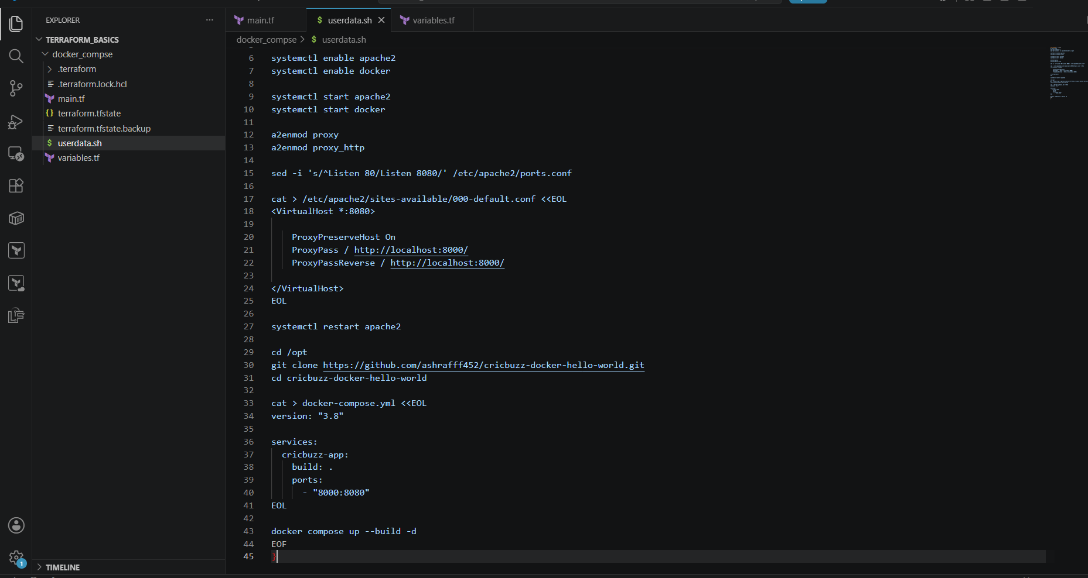

- Now created the variables.tf file with below code & save
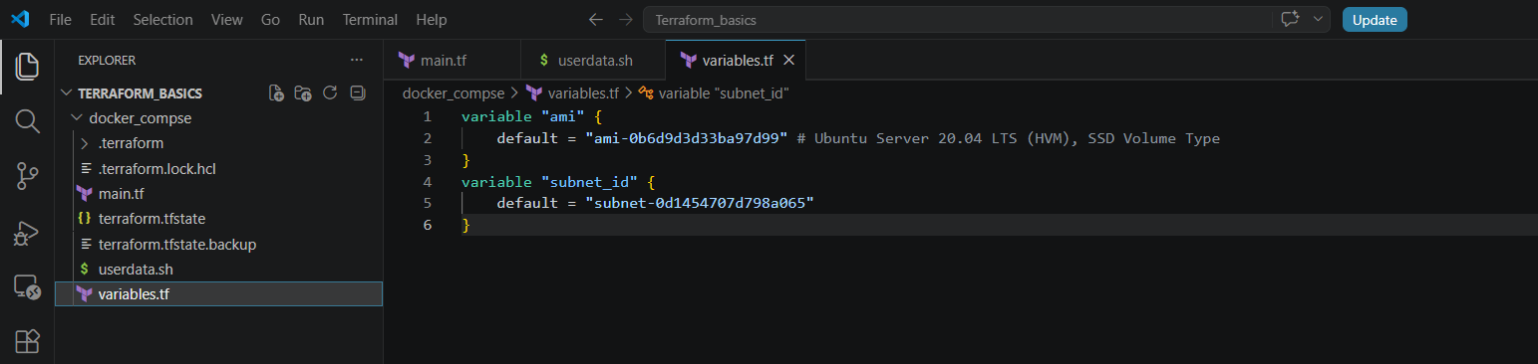
- In the output terminal go to docker_compse location by cd /docker_compse & execute terraform init & terraform apply & click yes to proceed
- We can see in ec2 an instance got created & after ec2 instance connect can see the docker installed, docker compose running in the container on port 8080

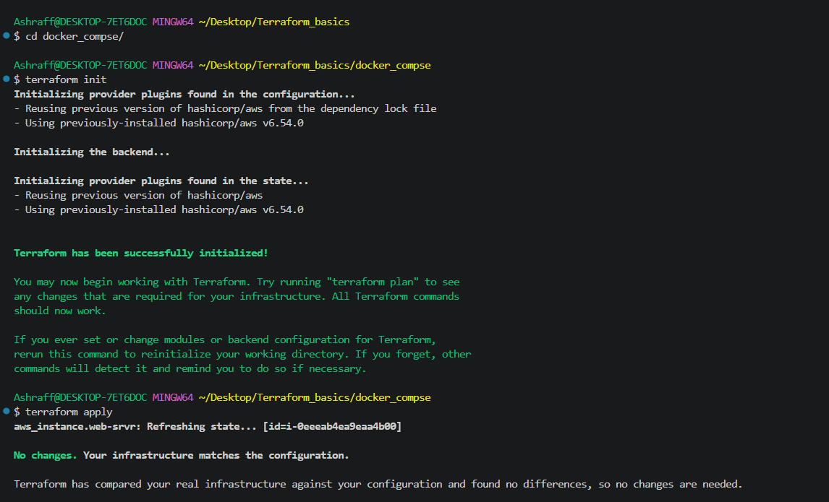
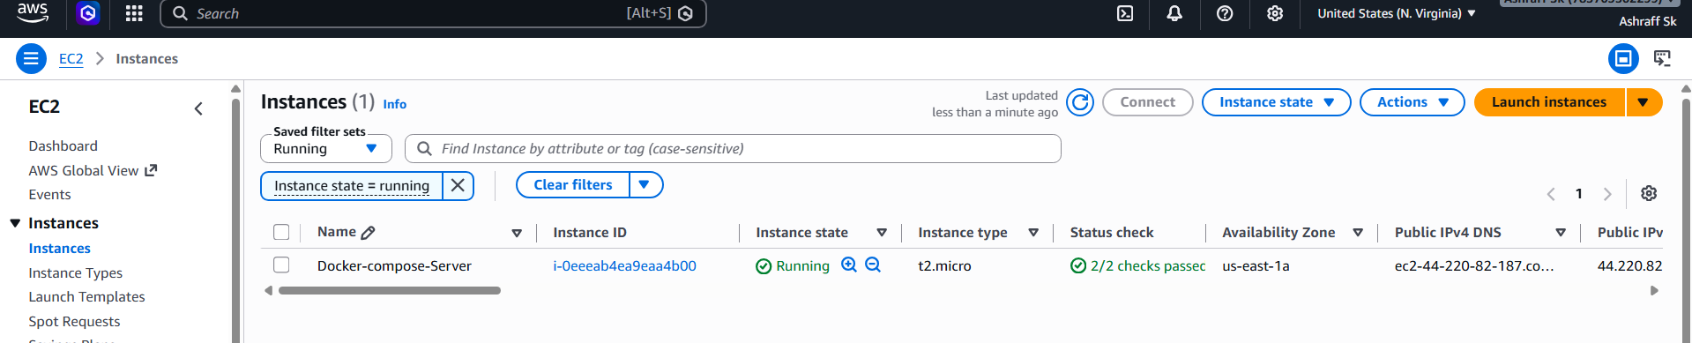
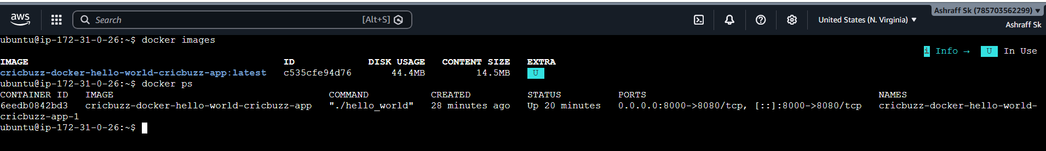
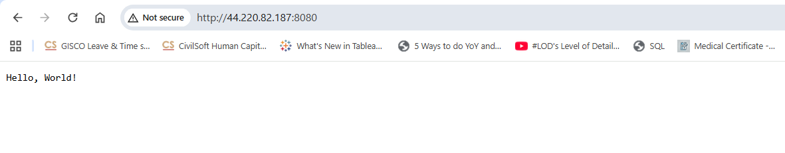
Conclusion:
Using Terraform, the EC2 instance was provisioned and configured with Apache and Docker. Apache was set up as a reverse proxy to forward requests from port 8080 to the Dockerized application. As a result, users can access the application through the web server at http://<EC2-Public-IP>:8080, while the Docker container remains behind the web server. This approach improves security, simplifies access to the application, and provides a repeatable, automated deployment process through Infrastructure as Code.

- Configure to Save the Logs in the location /var/log/cb.log
Steps:
- Created a userdata.sh file with the below code & save:
#!/bin/bash
set -e

# Update packages
apt-get update -y

# Install Apache
apt-get install -y apache2

# Enable proxy modules
a2enmod proxy
a2enmod proxy_http

# Create log files with correct permissions (www-data can write)
touch /var/log/cb.log
chown www-data:adm /var/log/cb.log
chmod 640 /var/log/cb.log

# Change Apache to listen on 8080
sed -i 's/^Listen 80/Listen 8080/' /etc/apache2/ports.conf

# Configure Apache as reverse proxy + custom logs
tee /etc/apache2/sites-available/000-default.conf > /dev/null <<EOF
<VirtualHost *:8080>
ServerName localhost

ProxyPreserveHost On

ProxyPass / http://localhost:8000/
ProxyPassReverse / http://localhost:8000/

CustomLog /var/log/cb.log combined

</VirtualHost>
EOF

systemctl enable apache2
systemctl restart apache2

# Install Docker
apt-get install -y docker.io docker-compose-v2
systemctl enable docker
systemctl start docker

# Add ubuntu user to docker group
usermod -aG docker ubuntu

# Install Git
apt-get install -y git

# Clone repository
cd /opt
rm -rf cricbuzz-docker-hello-world
git clone https://github.com/ashrafff452/cricbuzz-docker-hello-world.git
cd cricbuzz-docker-hello-world

# Create docker-compose.yml
cat > docker-compose.yml <<EOF
version: "3.8"

services:
cricbuzz-app:
build:
context: .
dockerfile: Dockerfile
ports:
- "8000:8080"
restart: unless-stopped
EOF

# Start application
docker compose down || true
docker compose up -d

echo " userdata script completed successfully"

- Now create variables.tf file with below code & save:
- variable "ami" {
- default = "ami-0b6d9d3d33ba97d99" # Ubuntu Server 20.04 LTS (HVM), SSD Volume Type
- }
- variable "subnet_id" {
- default = "subnet-0d1454707d798a065"
- }
- Now create main.tf file with below code & save:
- resource "aws_instance" "web-srvr" {
- ami = var.ami
- subnet_id = var.subnet_id
- instance_type = "t2.micro"
- user_data = file("userdata.sh")
- tags = {
- Name = "Docker-compose-Server"
- }
- }

- Now in terminal execute terraform init, terraform apply & we can see an ec2 instance got created

- Connected to the ec2 instance & checked the cb.log & the container running with the created image.

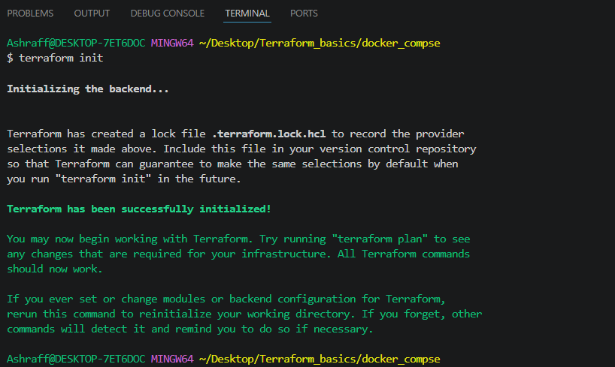

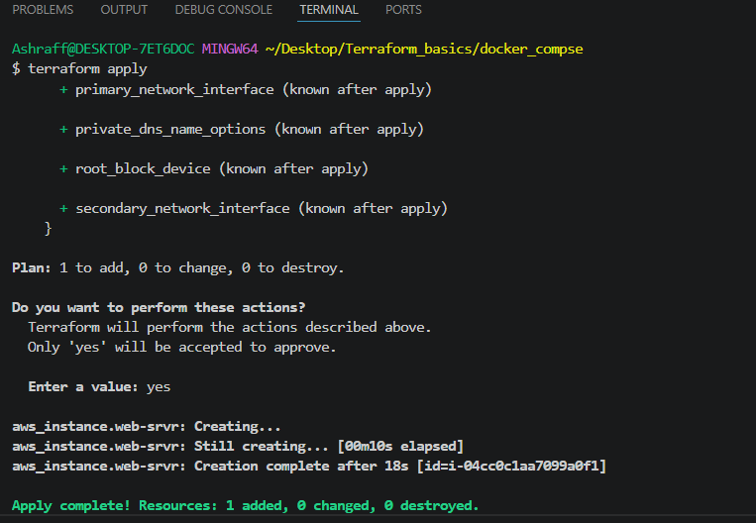
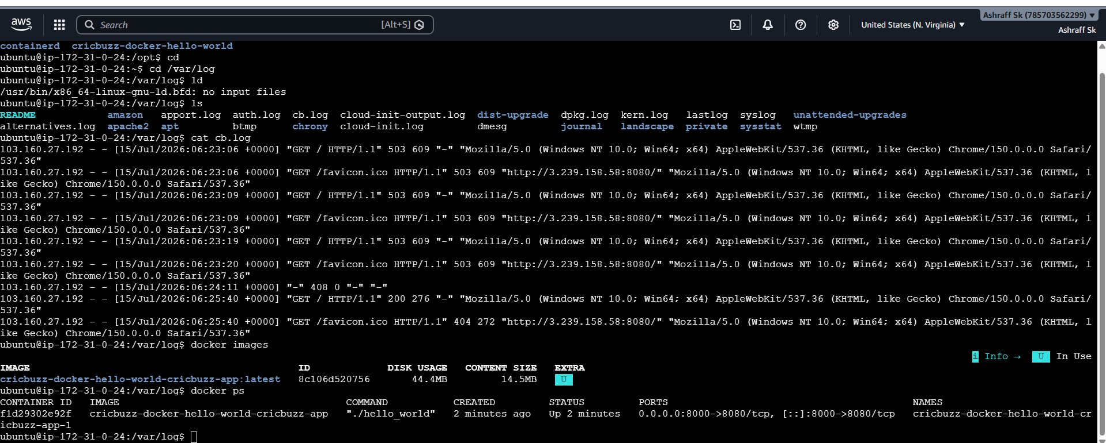
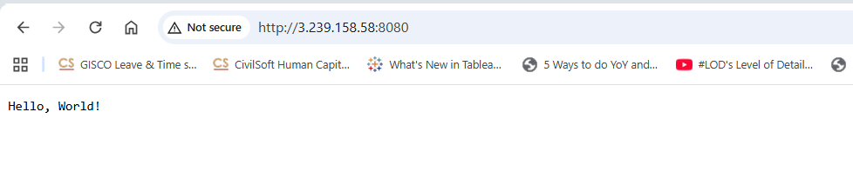
- Write the Log rotate configuration for the above file
Steps:
- Created a userdata.sh file with the below code & save:
- #!/bin/bash
- set -e

- # Update packages
- apt-get update -y

- # Install Apache
- apt-get install -y apache2

- # Enable proxy modules
- a2enmod proxy
- a2enmod proxy_http

- # Create log files with correct permissions (www-data can write)
- touch /var/log/cb.log
- chown www-data:adm /var/log/cb.log
- chmod 640 /var/log/cb.log

- # Change Apache to listen on 8080
- sed -i 's/^Listen 80/Listen 8080/' /etc/apache2/ports.conf

- # Configure Apache as reverse proxy + custom logs
- tee /etc/apache2/sites-available/000-default.conf > /dev/null <<EOF
- <VirtualHost *:8080>
- ServerName localhost

- ProxyPreserveHost On

- ProxyPass / http://localhost:8000/
- ProxyPassReverse / http://localhost:8000/

- ErrorLog /var/log/cb_error.log
- CustomLog /var/log/cb.log combined

- </VirtualHost>
- EOF

- systemctl enable apache2
- systemctl restart apache2

- # Install Docker
- apt-get install -y docker.io docker-compose-v2
- systemctl enable docker
- systemctl start docker

- # Add ubuntu user to docker group
- usermod -aG docker ubuntu

- # Install Git
- apt-get install -y git

- # Clone repository
- cd /opt
- rm -rf cricbuzz-docker-hello-world
- git clone https://github.com/ashrafff452/cricbuzz-docker-hello-world.git
- cd cricbuzz-docker-hello-world

- # Create docker-compose.yml
- cat > docker-compose.yml <<EOF
- version: "3.8"

- services:
- cricbuzz-app:
- build:
- context: .
- dockerfile: Dockerfile
- ports:
- - "8000:8080"
- restart: unless-stopped
- EOF

- # Start application
- docker compose down || true
- docker compose up -d

- # Configure logrotate for cb.log and cb_error.log
- cat > /etc/logrotate.d/cb << 'EOF'
- /var/log/cb.log /var/log/cb_error.log {
- daily
- rotate 14
- compress
- delaycompress
- missingok
- notifempty
- create 640 www-data adm
- su www-data adm
- sharedscripts
- postrotate
- systemctl reload apache2 > /dev/null 2>&1 || true
- endscript
- }
- EOF

- logrotate -d /etc/logrotate.d/cb

- echo "Logrotate configured for /var/log/cb.log"

- echo " userdata script completed successfully"

- Now create variables.tf file with below code & save:
- variable "ami" {
- default = "ami-0b6d9d3d33ba97d99" # Ubuntu Server 20.04 LTS (HVM), SSD Volume Type
- }
- variable "subnet_id" {
- default = "subnet-0d1454707d798a065"
- }
- Now create main.tf file with below code & save:
- resource "aws_instance" "web-srvr" {
- ami = var.ami
- subnet_id = var.subnet_id
- instance_type = "t2.micro"
- user_data = file("userdata.sh")
- tags = {
- Name = "Docker-compose-Server"
- }
- }

- Now in terminal execute terraform init, terraform apply & we can see an ec2 instance got created

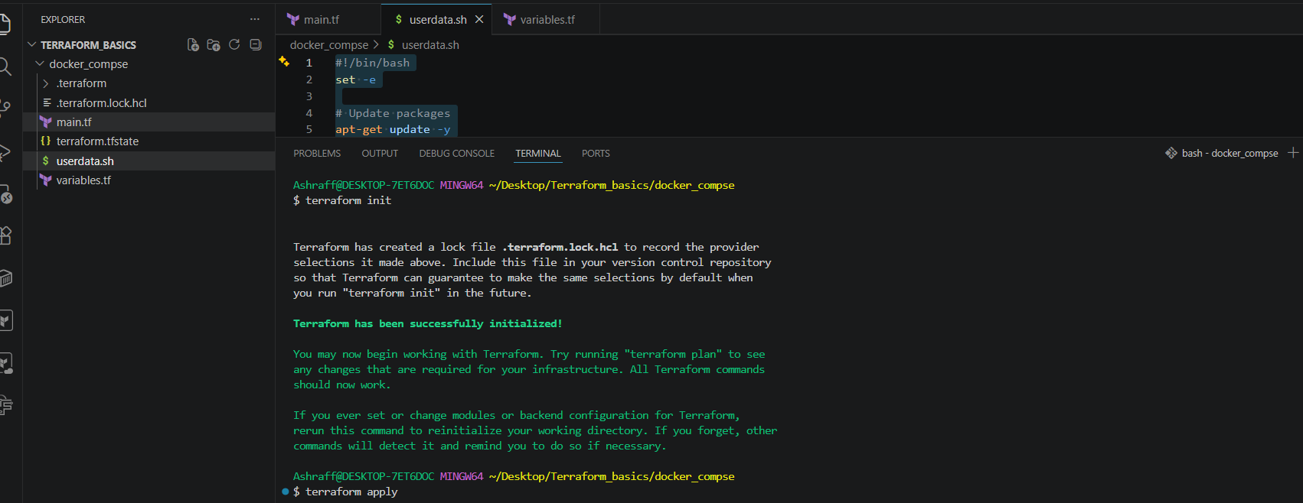
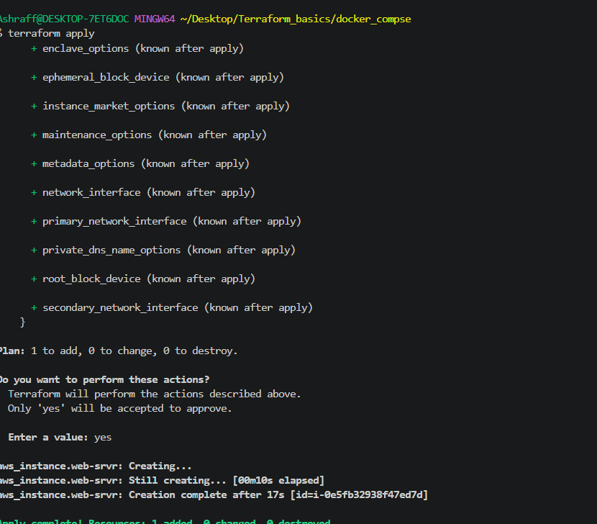
- Connected to the ec2 instance & checked the cb.log & the container running with the created image.
- Verify the configuration
Check the configuration:cat /etc/logrotate.d/cb
- Verify the rotated files:ls -lh /var/log/cb*

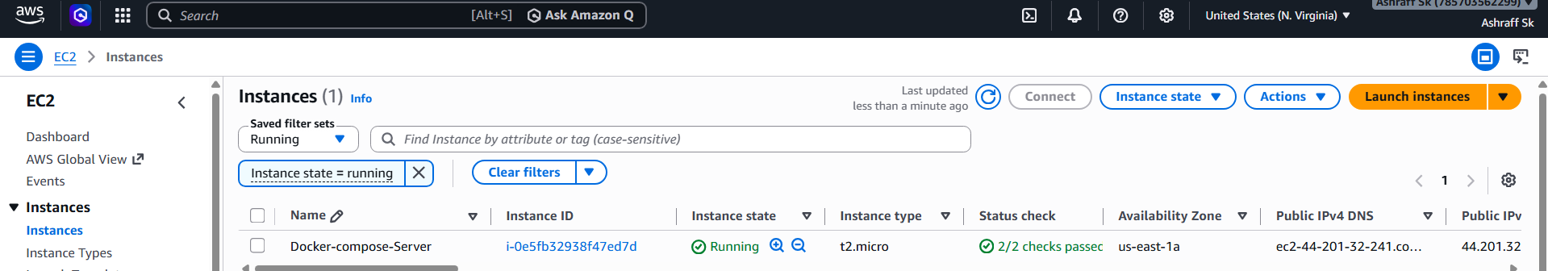
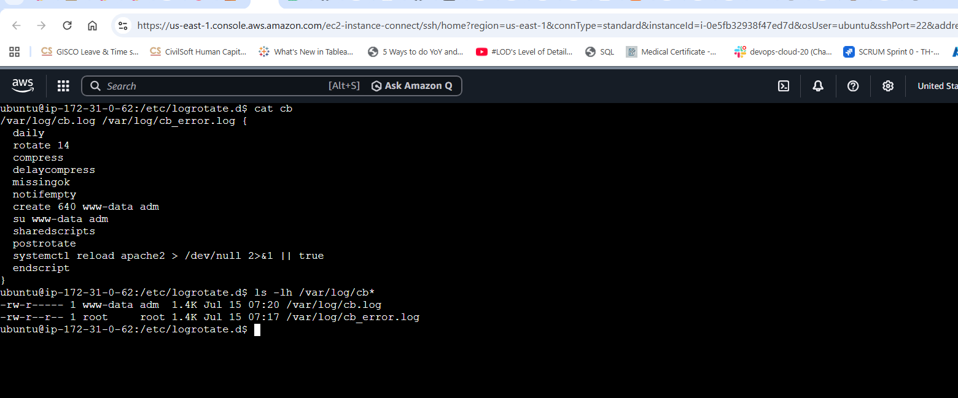

Conclusion:
By provisioning a Logrotate configuration through Terraform, the EC2 instance automatically rotates /var/log/cb.log on a scheduled basis, retains the required number of historical log files, compresses older logs to reduce storage usage, and keeps the logging process transparent to the running application. This provides a reliable and maintainable logging solution as part of the infrastructure deployment.

