TERRAFORM FINAL TASK
- Create VPC
- Created a Ec2_ubuntu directory under TERRAFORM_BASICS directory
- Now created a main.tf file under Ec2_ubuntu directory
- To create a VPC written the below code in main.tf & save
resource "aws_vpc" "VPC-01" {
cidr_block = "172.0.0.0/16"
tags = {
Name = "Terraform-VPC"
}
}
- Now execute terraform init & terraform apply & click yes
- Once success we can see a VPC got created in AWS account
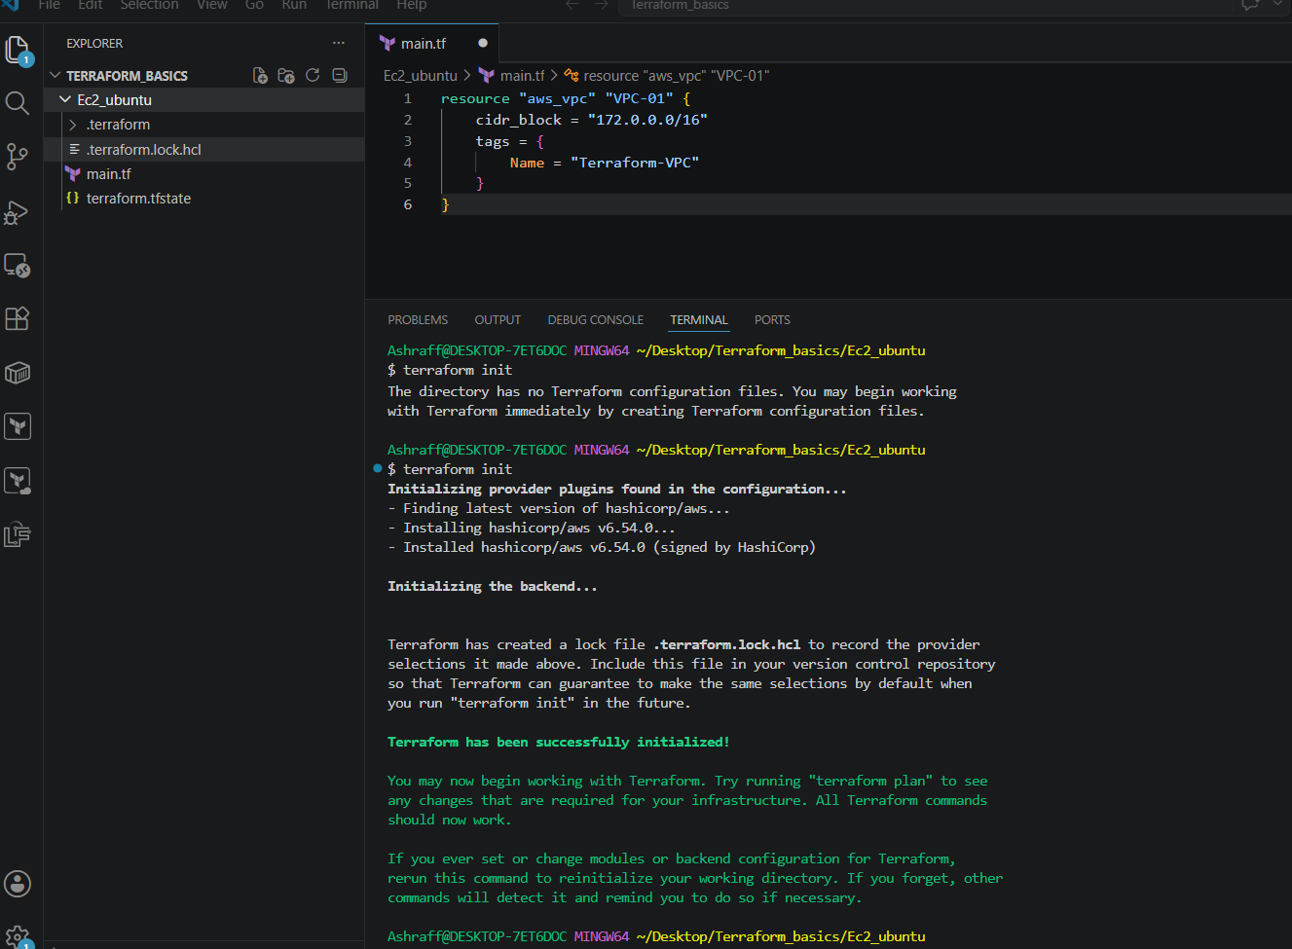
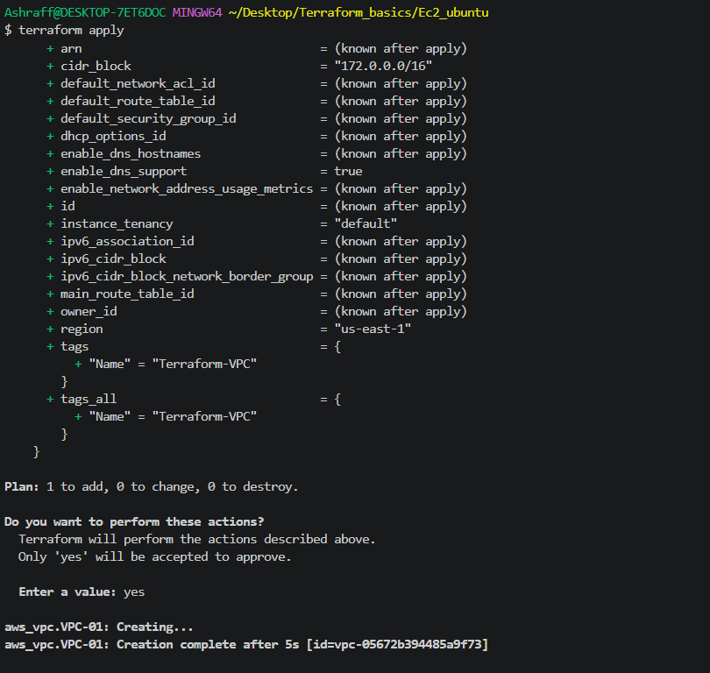

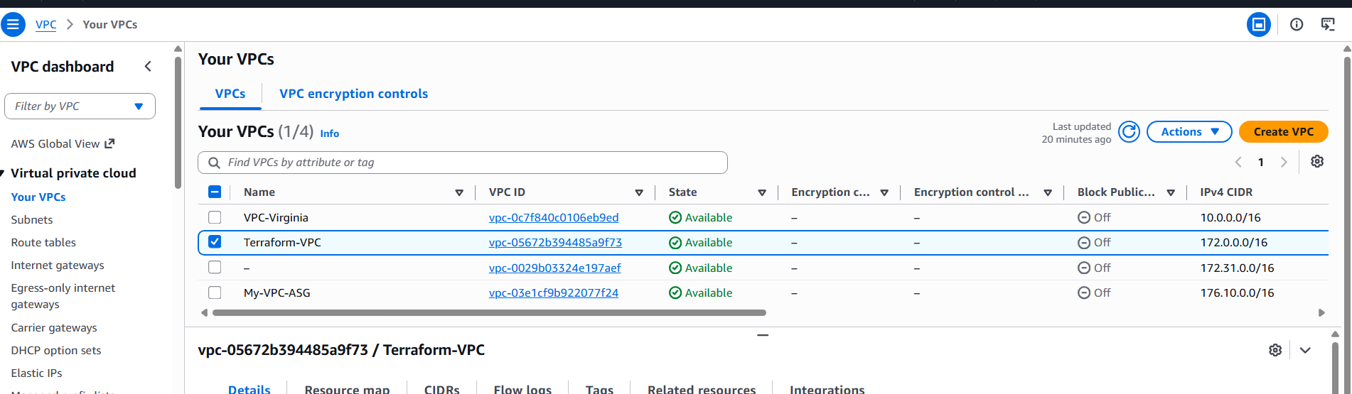

- Create Internet gateway
- To the main.tf file created in Task-01 I have updated with the aws_internet_gateway resource block as below & save:
resource "aws_internet_gateway" "igw" {
vpc_id = aws_vpc.VPC-01.id
tags = {
Name = "Terraform-IGW"
}
}
- Now in the terminal make sure to be in Ec2_ubuntu directory & execute terraform apply commands & click yes
- We can see an internet gateway is created in AWS attaching to the VPC ID created earlier
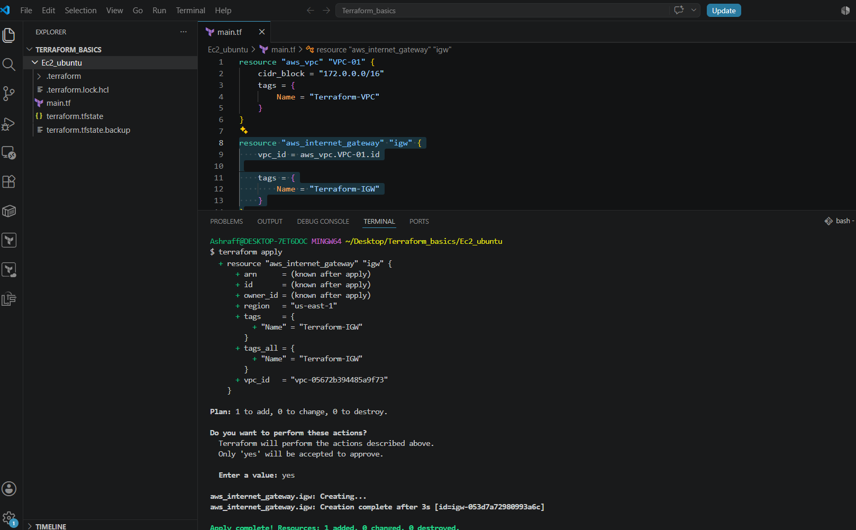

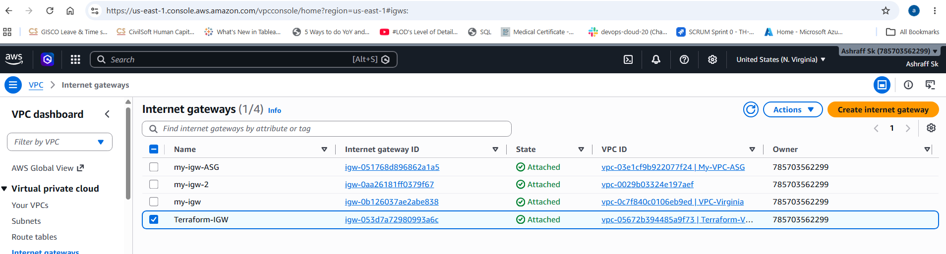

- Create Custom Route Table
- For the Task-01 we need to create a custom Route table using the created vpc
- From the task-02 update the main.tf file with the below code & save
- resource "aws_subnet" "public-1" {
- vpc_id = aws_vpc.VPC-01.id
- cidr_block = "172.0.1.0/24"
- availability_zone = "us-east-1a"
- map_public_ip_on_launch = true

- tags = {
- Name = "Public-subnet-1"
- }
- }

- Now after changing to Ec2_ubuntu in the output execute terraform fmt, terraform validate & terraform apply to create a customized route table
- We can see the route table named, Terraform-RT got created for the vpc created in task-01.
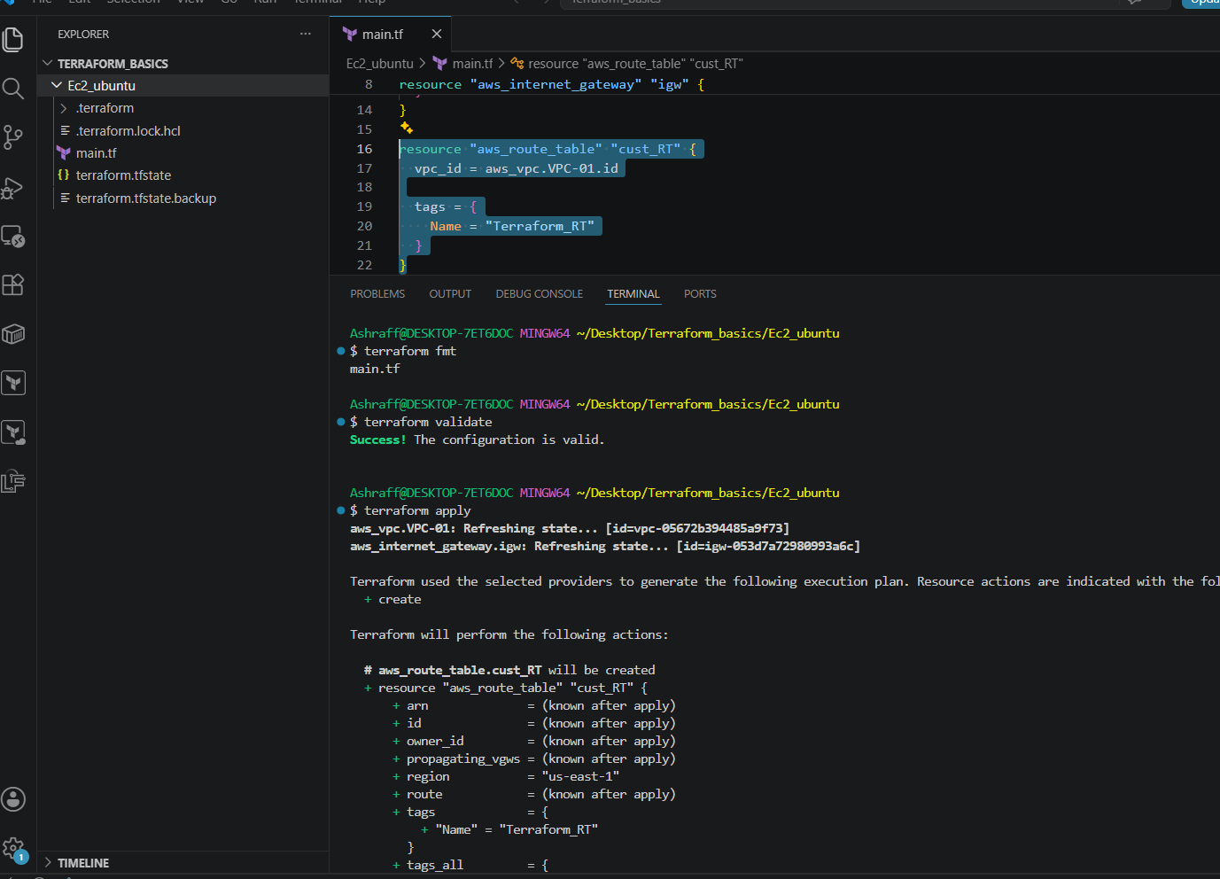
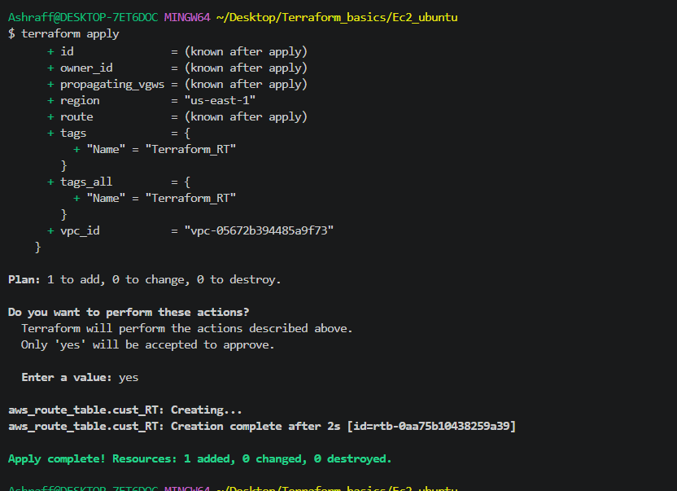
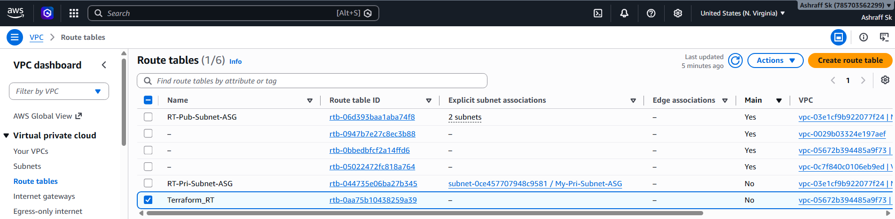

- Create Subnet
- From the task-01 we need to create a subnet using the aws_subnet resource block
- From task-03 we will update the main.tf file & save with the below code:
resource "aws_subnet" "public-1" {
vpc_id = aws_vpc.VPC-01.id
cidr_block = "172.0.1.0/24"
availability_zone = "us-east-1a"
map_public_ip_on_launch = true

tags = {
Name = "Public-subnet-1"
}
}

- Now execute the commands, terraform fmt, terraform validate & terraform apply & click yes
- Once successful we can see Public-subnet-1 got created & can see in AWS account as well
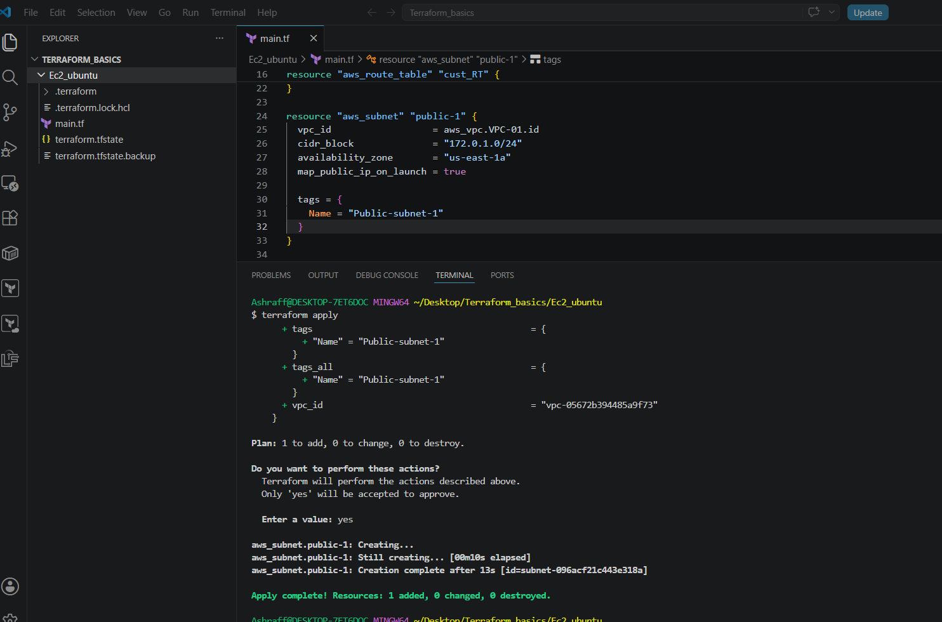

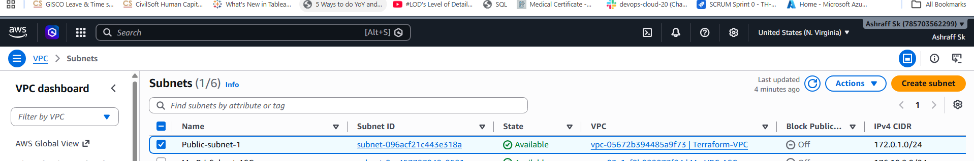

- Associate subnet with Route Table
- From the task-04 updated the main.tf file with the below code & save
- resource "aws_route_table_association" "public1" {
- subnet_id = aws_subnet.public-1.id
- route_table_id = aws_route_table.cust_RT.id
- }

- Now execute terraform apply & we can see the route table associated to the created subnet
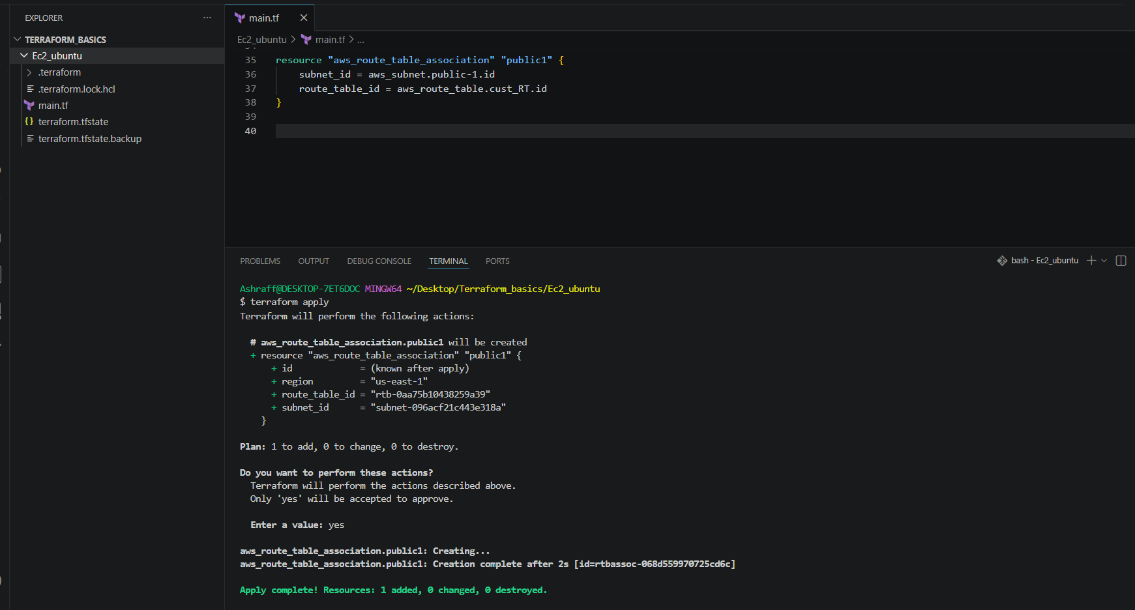
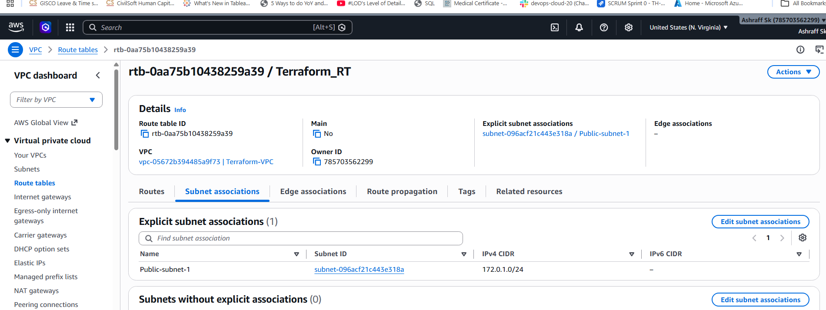

- Create Security Group to allow port 22.80,443
- Updated the main.tf file with the below code & save:
resource "aws_security_group" "tf_sg" {
name = "Web-security-group"
description = "Allow SSH, HTTP & HTTPS"
vpc_id = aws_vpc.VPC-01.id

ingress {
description = "SSH Access"
from_port = 22
to_port = 22
protocol = "tcp"
cidr_blocks = ["0.0.0.0/0"]
}
ingress {
description = "HTTP Access"
from_port = 80
to_port = 80
protocol = "tcp"
cidr_blocks = ["0.0.0.0/0"]
}
ingress {
description = "HTTPS Acces"
from_port = 443
to_port = 443
protocol = "tcp"
cidr_blocks = ["0.0.0.0/0"]
}

egress {
description = "Allow all outbound traffic"
from_port = 0
to_port = 0
protocol = "-1"
cidr_blocks = ["0.0.0.0/0"]
}

tags = {
Name = "Web-Security-Group"
}
}

- Now execute terraform apply in the output terminal & we can see the security group has been created & verified in AWS account.
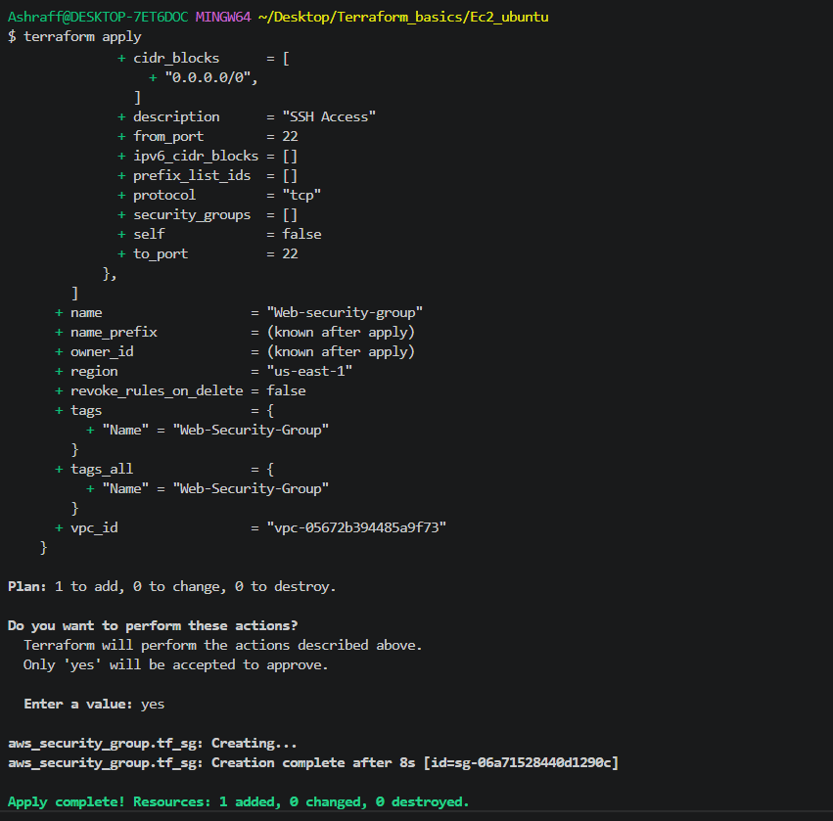
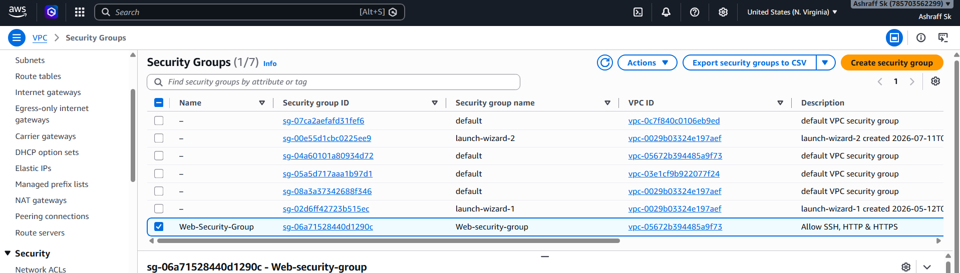

- Create a network interface with an ip in the subnet that was created in step 4
- We have updated the main.tf file from task -6 as below & save
resource "aws_network_interface" "web_eni" {
subnet_id = aws_subnet.public-1.id
private_ips = ["172.0.1.10"]
security_groups = [aws_security_group.tf_sg.id]

tags = {
Name = "Web-Network-Interface"
}

}

- Now execute terraform apply and we can see the created network interface in AWS
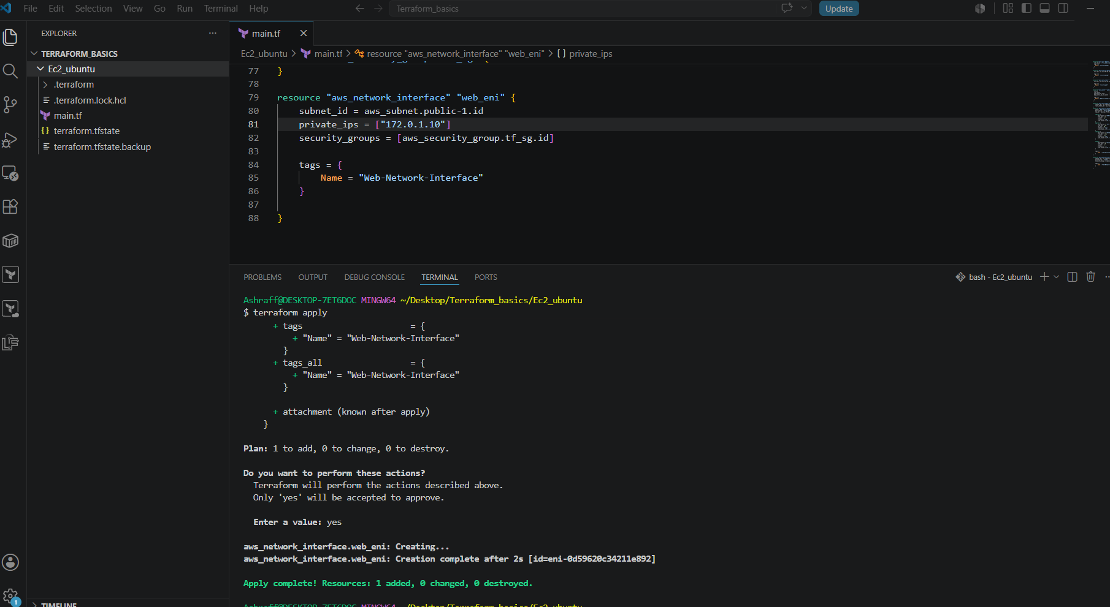

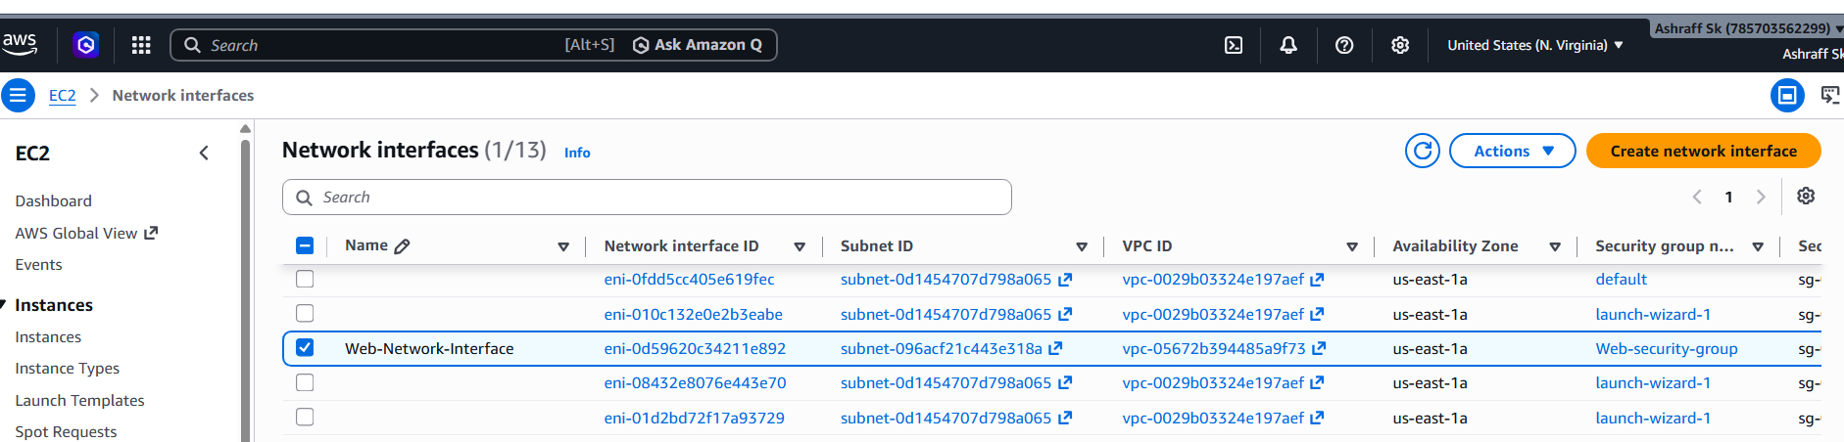

- Assign an elastic IP to the network interface created in step 7
- Updated the main.tf file from task-07 with below code & save
- resource "aws_eip" "web_ip" {
- domain = "vpc"
- network_interface = aws_network_interface.web_eni.id
- tags = {
- Name = "Web-Elastic-IP"
- }
- }

- Now execute terraform apply and we can see the Elastic Ip got created & verified in the AWS as well

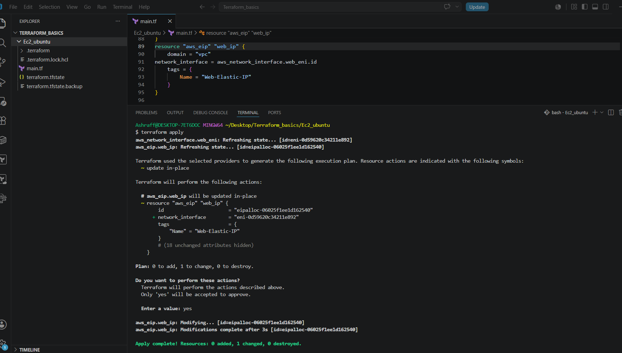
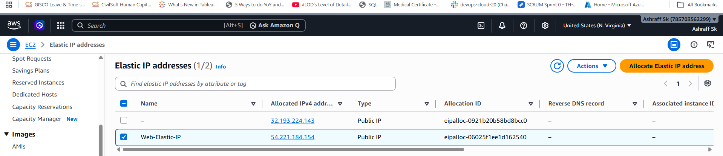

- Create Ubuntu server and install/enable apache2
Steps:
- For this task I have deleted the existing main.tf file
- Under Ec2_Ubuntu created main.tf & userdata.sh files
- The main.tf file is with the below code & saved as well
resource "aws_vpc" "VPC-01" {
cidr_block = "172.0.0.0/16"
tags = {
Name = "Terraform-VPC"
}
}
resource "aws_internet_gateway" "igw" {
vpc_id = aws_vpc.VPC-01.id
tags = {
Name = "Terraform-IGW"
}
}
resource "aws_route_table" "cust_RT" {
vpc_id = aws_vpc.VPC-01.id
route {
cidr_block = "0.0.0.0/0"
gateway_id = aws_internet_gateway.igw.id
}
tags = {
Name = "Terraform_RT"
}
}
resource "aws_subnet" "public-1" {
vpc_id = aws_vpc.VPC-01.id
cidr_block = "172.0.1.0/24"
availability_zone = "us-east-1a"
map_public_ip_on_launch = true
tags = {
Name = "Public-subnet-1"
}
}
resource "aws_route_table_association" "public1" {
subnet_id = aws_subnet.public-1.id
route_table_id = aws_route_table.cust_RT.id
}
resource "aws_security_group" "tf_sg" {
name = "Web-security-group"
description = "Allow SSH, HTTP & HTTPS"
vpc_id = aws_vpc.VPC-01.id
ingress {
description = "SSH Access"
from_port = 22
to_port = 22
protocol = "tcp"
cidr_blocks = ["0.0.0.0/0"]
}
ingress {
description = "HTTP Access"
from_port = 80
to_port = 80
protocol = "tcp"
cidr_blocks = ["0.0.0.0/0"]
}
ingress {
description = "HTTPS Acces"
from_port = 443
to_port = 443
protocol = "tcp"
cidr_blocks = ["0.0.0.0/0"]
}

egress {
description = "Allow all outbound traffic"
from_port = 0
to_port = 0
protocol = "-1"
cidr_blocks = ["0.0.0.0/0"]
}
tags = {
Name = "Web-Security-Group"
}
}
resource "aws_network_interface" "web_eni" {
subnet_id = aws_subnet.public-1.id
private_ips = ["172.0.1.10"]
security_groups = [aws_security_group.tf_sg.id]
tags = {
Name = "Web-Network-Interface"
}
}
resource "aws_eip" "web_ip" {
domain = "vpc"
network_interface = aws_network_interface.web_eni.id
tags = {
Name = "Web-Elastic-IP"
}
}
resource "aws_instance" "ubuntu" {
ami = "ami-0b6d9d3d33ba97d99"
instance_type = "t3.micro"
key_name = "linux_testing"

network_interface {
network_interface_id = aws_network_interface.web_eni.id
device_index = 0
delete_on_termination = false
}
user_data = file("userdata.sh")
tags = {
Name = "Ubuntu-Apache-server"
}
depends_on = [aws_eip.web_ip]
}
- Now created the userdata.sh file with the below code & save
#!/bin/bash
apt-get update -y
apt-get install -y apache2
systemctl enable apache2
systemctl start apache2
echo "Apache Installed using Terraform infrastructure" > /var/www/html/index.html
- Now executed the terraform init & terraform apply & click yes
- Once successful we can see the creation of VPC, subnet, Internet gate way, Route table, security groups, route table association, network interface, elatic Ip & an ec2 instance with ubuntu installed in it
- Verified the same in AWS as well
