TERRAFORM CHALLENGE
Goal of the Exercise
The goal of this exercise is to test your understanding of a Cloud Compute deployment with Terraform.
You are tasked with creating a codebase for a microservice deployment on a cloud environment, using Terraform. Since our focus is not the application itself, the service will be a simple web server that returns a static page.
Requirements
Service Details
- The service will be a simple web server that returns a static page.
- You can use apache2 or nginx to serve a simple HTML file.
- The service should be containerized and stored in a Docker registry.
- The service should be deployed on a single VM instance as a docker container.
- The image should be pulled from the registry specified earlier.
- The service should not be accessible from the internet but only through a Load Balancer, except for SSH access from specific IP addresses.
Deliverables
You are to provide the following as part of your solution:
- Dockerfileto build the image.
- Terraform codebaseto deploy the following:
  - Docker registry
  - VPC and all required networking resources
  - EC2 instance
  - Load Balancer
Notes
- Since a CI/CD pipeline is not part of this exercise, we will work around that with the help of Terraform.
- To push the image to the Docker registry, build the image locallybefore running the Terraform code.
- Once the image registry is created, use Terraform to push the local image to the registry.
- Similarly, use Terraform to pull the image from the registry and run it on the VM instance once it is created.
- For SSH access:
  - Use a locally created key.
  - Add it to the cloud provider key storage.
  - Attach it to the instance.
- Use Terraform best practices for file structure and code organization.
  - Use variables, locals, modules, etc. when appropriate.
- Include all tfvars, scripts, and other helper files used to deploy the application.
- You may use any cloud provider of your choosing, although AWS is preferred.
- Use afree tier account or atrial account to deploy the resources.

Task objective:
The goal of this task was to deploy a simple web application on AWS
using Terraform.
The application had to meet these requirements:
- Serve a static webpage.
- Use Nginx as the web server.
- Run inside a Docker container.
- Store the Docker image in a Docker registry.
- Deploy the container on an EC2 instance.
- Place the application EC2 instance inside a private subnet.
- Make the application accessible only through an Application LoadBalancer.
- Prevent direct internet access to the application EC2 instance.
- Allow SSH access only from a specific public IP address.
- Use a locally generated SSH key.
- Create the AWS infrastructure using Terraform
Terraform:

Terraform was used to create and manage all AWS infrastructure.
Terraform created:
  - VPC
  - Public subnets
  - Private subnet
  - Internet Gateway
  - NAT Gateway
  - Elastic IP
  - Public route table
  - Private route table
  - Security groups
  - AWS key pair
  - Bastion EC2 instance
  - Private application EC2 instance
  - Application Load Balancer
  - Target group
  - Target group attachment
  - HTTP listener

Steps:
- First created a index.html in my Desktop, local machine with the content as “This is Nginx”
- Created a Dockerfile in local machine as below & saved
FROM nginx:latest
LABEL maintainer=Ashraff
COPY index.html /usr/share/nginx/html/index.html
EXPOSE 80
CMD ["nginx", "-g", "daemon off;"]
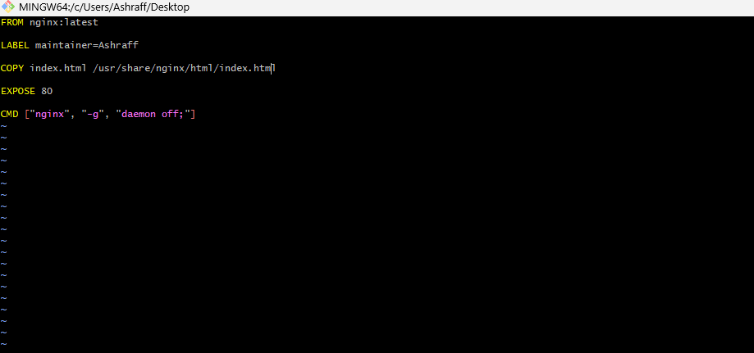
- Now from git bash build the image using the command, docker build -t my_nginx:v1 .
- We can see the build images by docker images
- Now created a repository in docker hub as my_nginx
- From terraform created a directory Terraform_project under Terraform_basics directory
- Under Terraform_project directory created a docker_push_image.tf with the below code & save
resource "null_resource" "docker_push" {
provisioner "local-exec" {
command = "docker push ashraff452/my_nginx"
}
}
- Now we can see the docker image is pushed to the docker hub registry
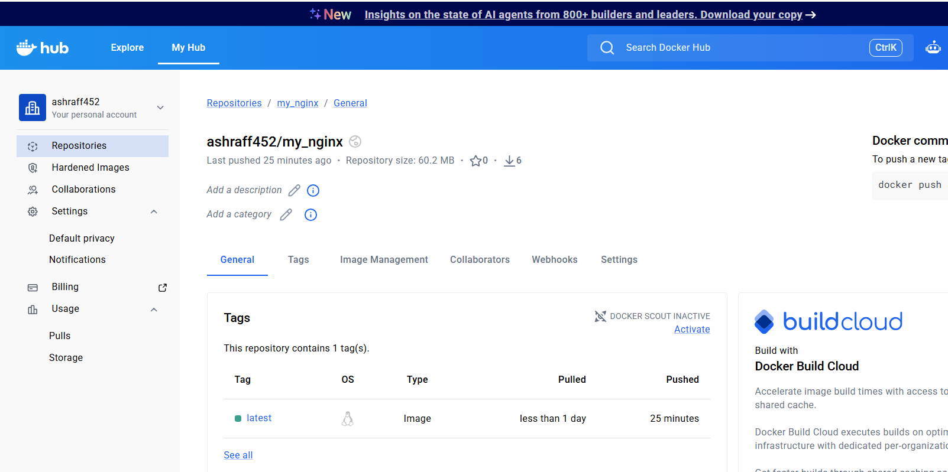
- Now created a vpc.tf file with the below code & save

- resource "aws_vpc" "VPC-01" {
- cidr_block = "20.0.0.0/16"
- tags = {
- Name = "Terraform-VPC"
- }
- }
- resource "aws_internet_gateway" "igw" {
- vpc_id = aws_vpc.VPC-01.id

- tags = {
- Name = "Terraform-IGW"
- }
- }
- resource "aws_route_table" "RT" {
- vpc_id = aws_vpc.VPC-01.id
- route {
- cidr_block = "0.0.0.0/0"

- gateway_id = aws_internet_gateway.igw.id
- }
- tags = {
- Name = "Terraform-RT"
- }
- }
- resource "aws_route_table" "RT2" {
- vpc_id = aws_vpc.VPC-01.id
- route {
- cidr_block = "0.0.0.0/0"
- nat_gateway_id = aws_nat_gateway.nat.id
- }
- tags = {
- Name = "Terraform-RT2"
- }
- }

- resource "aws_subnet" "Pub-subnet-1" {
- vpc_id = aws_vpc.VPC-01.id
- cidr_block = "20.0.1.0/24"
- availability_zone = "us-east-1a"
- map_public_ip_on_launch = true

- tags = {
- Name ="Tf-Pub-subnet"
- }

- }

- resource "aws_subnet" "Pub-subnet-2" {
- vpc_id = aws_vpc.VPC-01.id
- cidr_block = "20.0.2.0/24"
- availability_zone = "us-east-1b"
- map_public_ip_on_launch = true

- tags = {
- Name ="Tf-Pub-subnet-2"
- }

- }
- resource "aws_subnet" "Pri-subnet" {
- vpc_id = aws_vpc.VPC-01.id
- cidr_block = "20.0.3.0/24"
- availability_zone = "us-east-1a"

- tags = {
- Name = "Tf-Pri-subnet"
- }
- }
- resource "aws_route_table_association" "public1" {
- subnet_id = aws_subnet.Pub-subnet-1.id
- route_table_id = aws_route_table.RT.id
- }
- resource "aws_route_table_association" "public2" {
- subnet_id = aws_subnet.Pub-subnet-2.id
- route_table_id = aws_route_table.RT.id
- }
- resource "aws_route_table_association" "private" {
- subnet_id = aws_subnet.Pri-subnet.id
- route_table_id = aws_route_table.RT2.id
- }
- resource "aws_eip" "nat_eip" {
- domain = "vpc"

- tags = {
- Name = "NAT-EIP"
- }
- }
- resource "aws_nat_gateway" "nat" {
- allocation_id = aws_eip.nat_eip.id
- subnet_id = aws_subnet.Pub-subnet-1.id

- tags = {
- Name = "Terraform-NAT-Gateway"
- }
- depends_on =[aws_internet_gateway.igw]
- }

- Now created a variables.tf file & saved with the below code:

variable "ami" {
type = string
default = "ami-0521cb2d60cfbb1a6"
}
variable "instance_type" {
type = string
default = "t3.micro"
}
- Created a sg.tf file and saved with the below code:
- resource "aws_security_group" "alb_sg" {
- name = "alb-sg"
- description = "Allow HTTP from Internet"
- vpc_id = aws_vpc.VPC-01.id

- ingress {
- description = "HTTP"
- from_port = 80
- to_port = 80
- protocol = "tcp"
- cidr_blocks = ["0.0.0.0/0"]
- }
- egress {
- description = "Allow all outbound"
- from_port = 0
- to_port = 0
- protocol = "-1"
- cidr_blocks = ["0.0.0.0/0"]
- }
- tags = {
- Name = "ALB-SG"
- }
- }

- resource "aws_security_group" "ec2_sg" {
- name = "ec2-sg"
- description = "Allow HTTP only from ALB and SSH"
- vpc_id = aws_vpc.VPC-01.id

- ingress {
- description = "HTTP from ALB"
- from_port = 80
- to_port = 80
- protocol = "tcp"
- security_groups = [aws_security_group.alb_sg.id]
- }
- ingress {
- description = "SSH"
- from_port = 22
- to_port = 22
- protocol = "tcp"
- cidr_blocks = ["192.168.1.16/32"]
- }
- egress {
- description = "All all outbound"
- from_port = 0
- to_port = 0
- protocol = "-1"
- cidr_blocks = ["0.0.0.0/0"]
- }

- tags = {
- Name = "EC2-SG"
- }
- }

- Now created a alb.tf file with below code & save
- resource "aws_lb_target_group" "tg" {
- port = 80
- protocol = "HTTP"
- vpc_id = aws_vpc.VPC-01.id

- health_check {
- path = "/"
- protocol = "HTTP"
- matcher = "200"
- interval = 30
- timeout = 5
- healthy_threshold = 2
- unhealthy_threshold = 2
- }
- }

- resource "aws_lb" "alb" {
- name = "terraform-alb"
- internal = false
- load_balancer_type = "application"
- subnets = [
- aws_subnet.Pub-subnet-1.id,
- aws_subnet.Pub-subnet-2.id
- ]

- security_groups = [aws_security_group.alb_sg.id]

- tags = {
- Name = "Terraform-ALB"
- }
- }

- resource "aws_lb_listener" "http" {
- load_balancer_arn = aws_lb.alb.arn
- port = 80
- protocol = "HTTP"
- default_action {
- type = "forward"
- target_group_arn = aws_lb_target_group.tg.arn
- }
- }

- resource "aws_lb_target_group_attachment" "web" {
- target_group_arn = aws_lb_target_group.tg.arn
- target_id = aws_instance.webserver.id
- port = 80
- }

- Created a key.tf file with below code & save
- resource "aws_key_pair" "tf-key" {
- key_name = "tf-key"
- public_key = file("C:/Users/Ashraff/.ssh/id_rsa.pub")

- tags = {
- Name = "Terraform-key"
- }
- }

- Finally created a userdata.sh file with the below code & save

#!/bin/bash
yum update -y
yum install docker -y
systemctl enable docker
systemctl start docker
docker login
docker pull ashraff452/my_nginx:latest
docker run -itd --name nginx_container -p 80:80 ashraff452/my_nginx:latest

echo "Docker container started successfully"

- Now in the output terminal, change to Terraform_project directory & execute terraform init & terraform apply & click yes
- We can see the vpc , internet gateway, security groups, Public subnets, private subnets, route tables, nat gateway security groups got created & verified the same in AWS account.
- An ec2 instance got created with Private subnet, checked the health check status of target group & load balancer
- By using the load balancer DNS we can see the deployed index.html using docker container
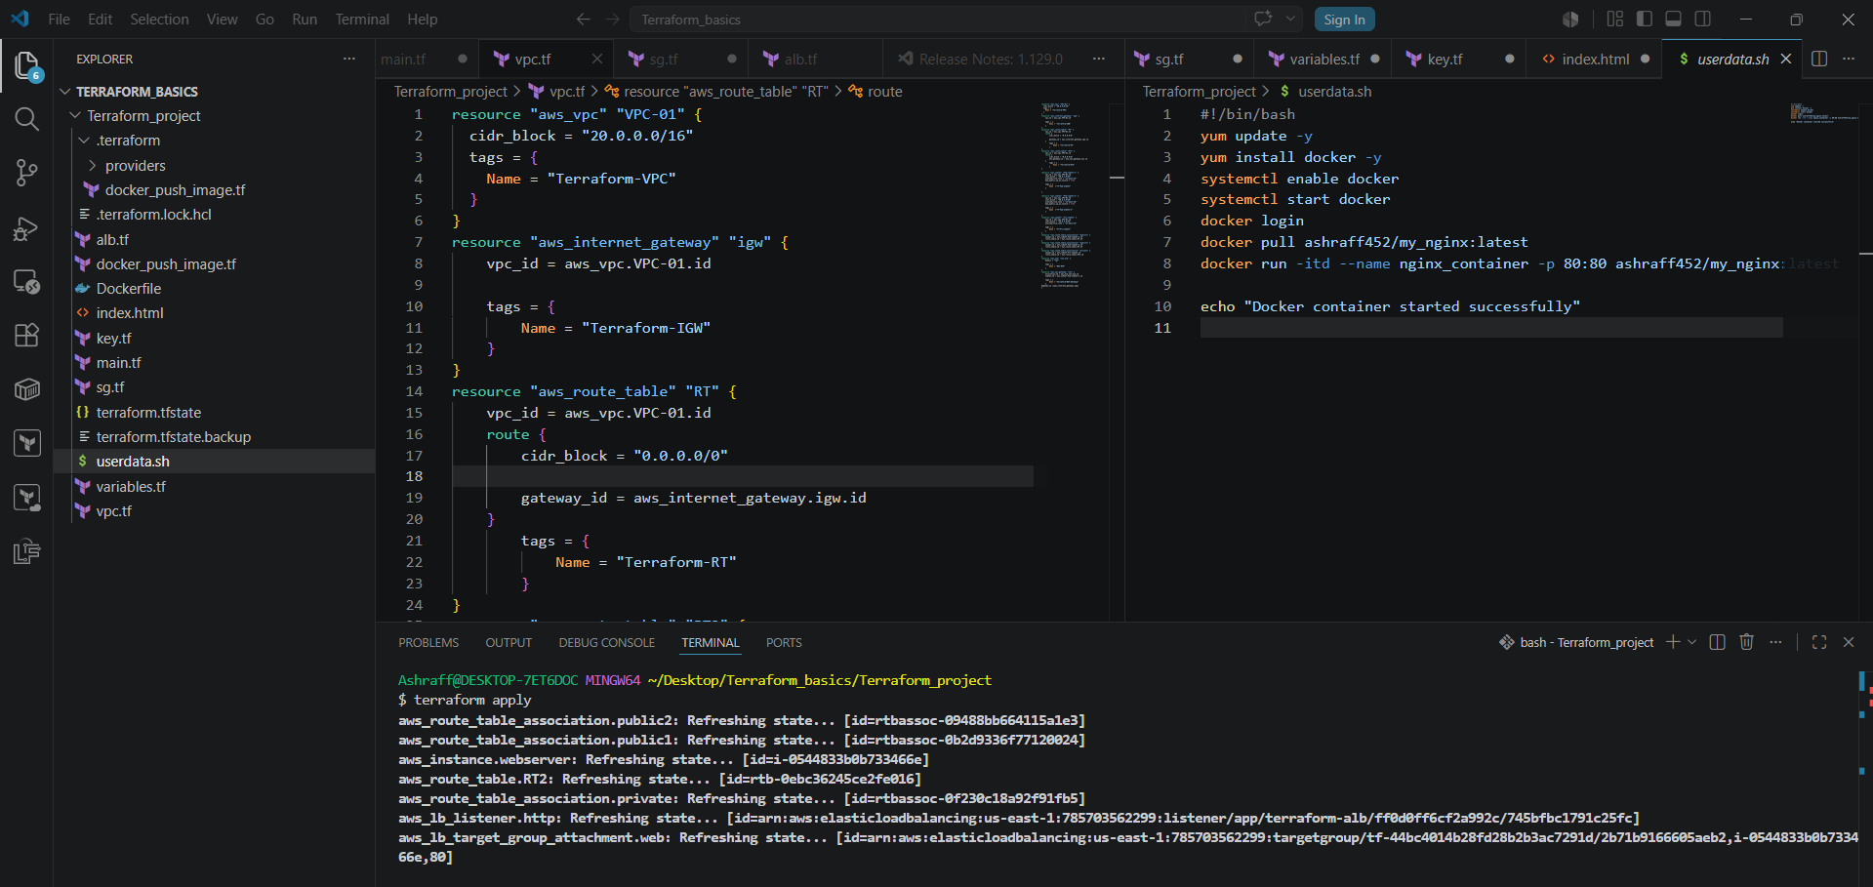

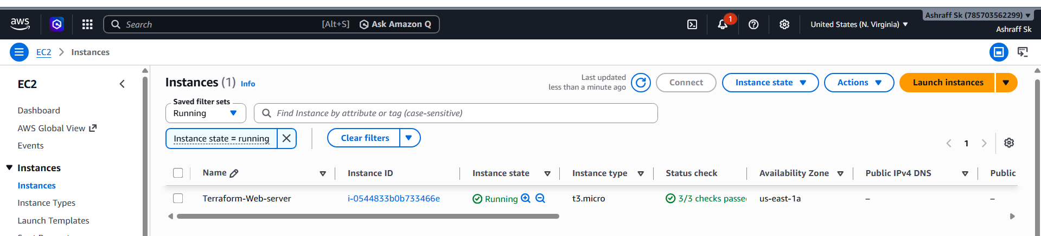

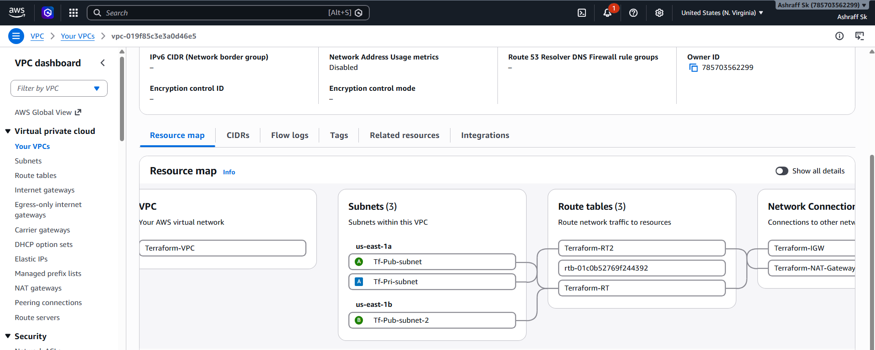

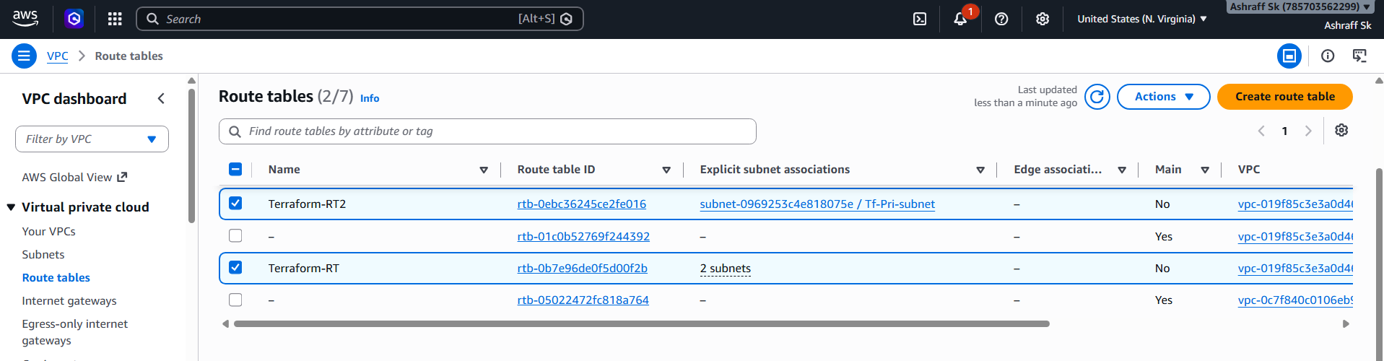

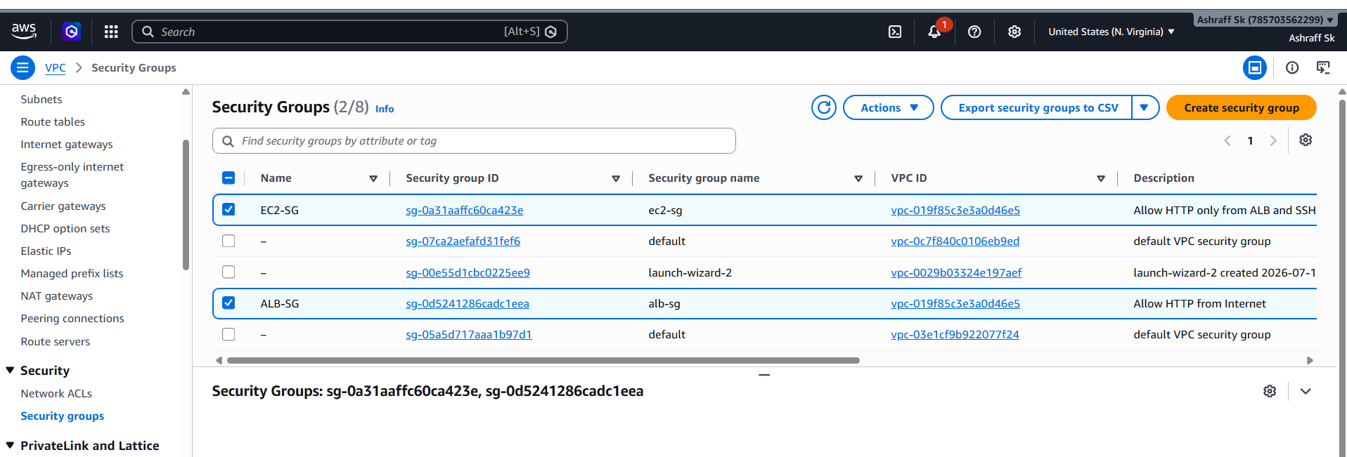

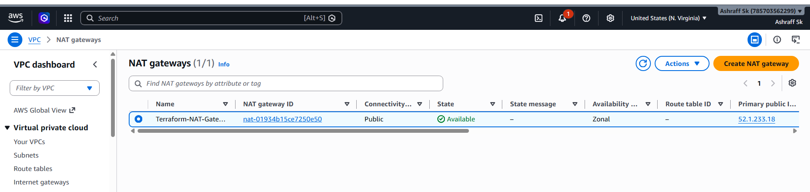

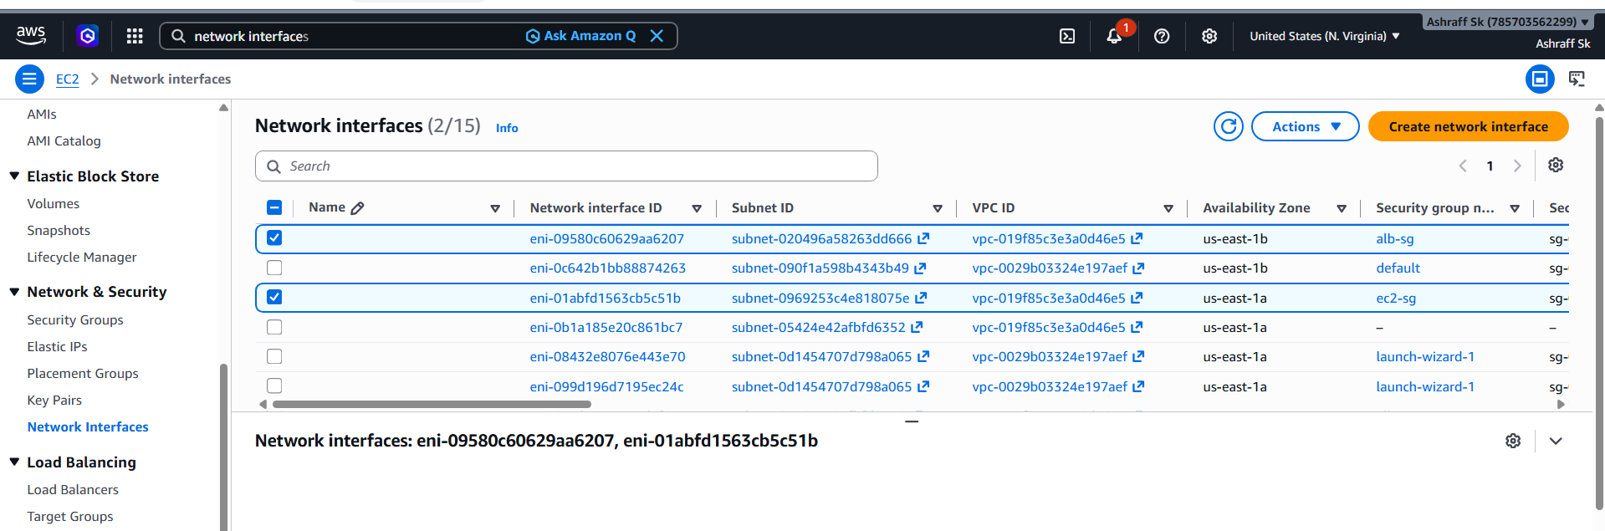

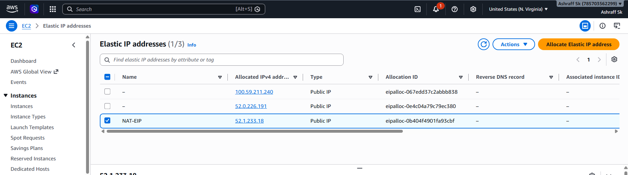
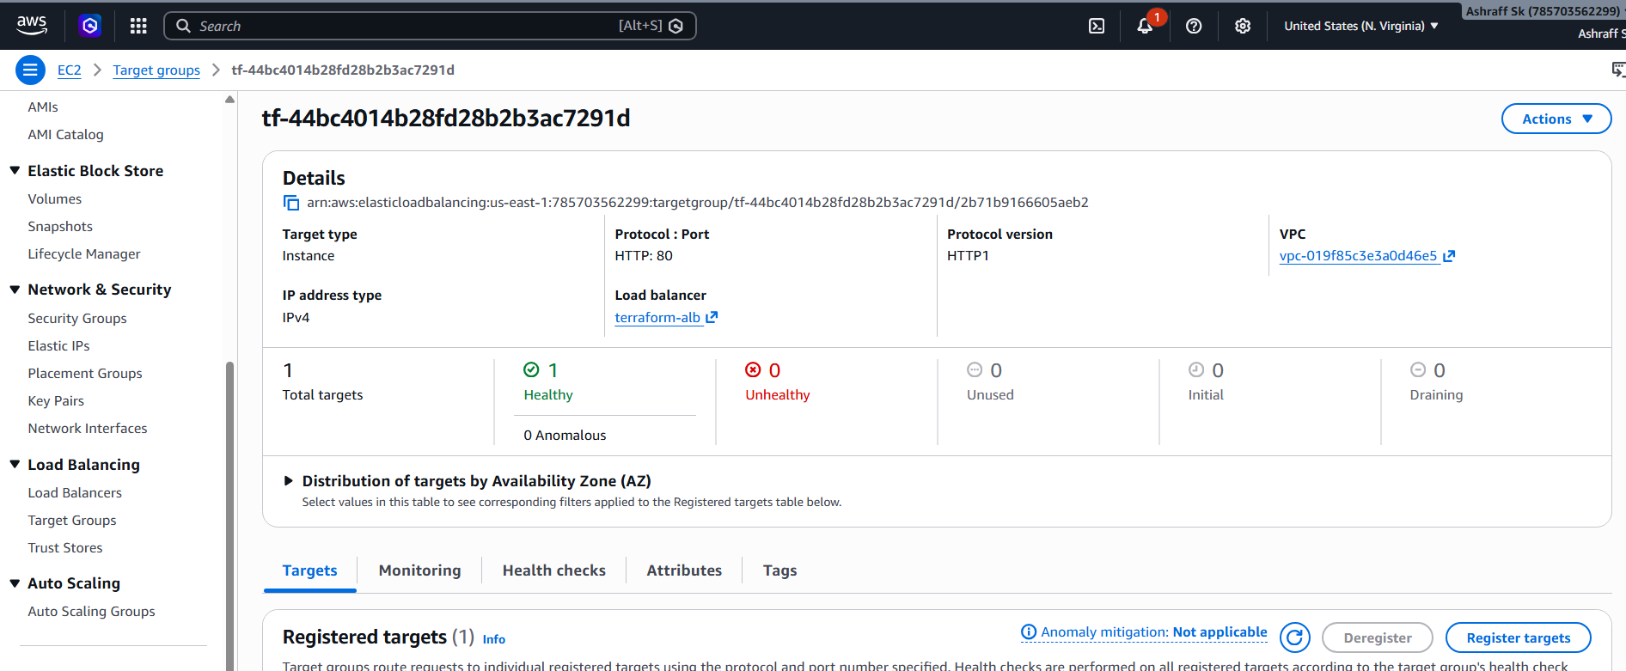

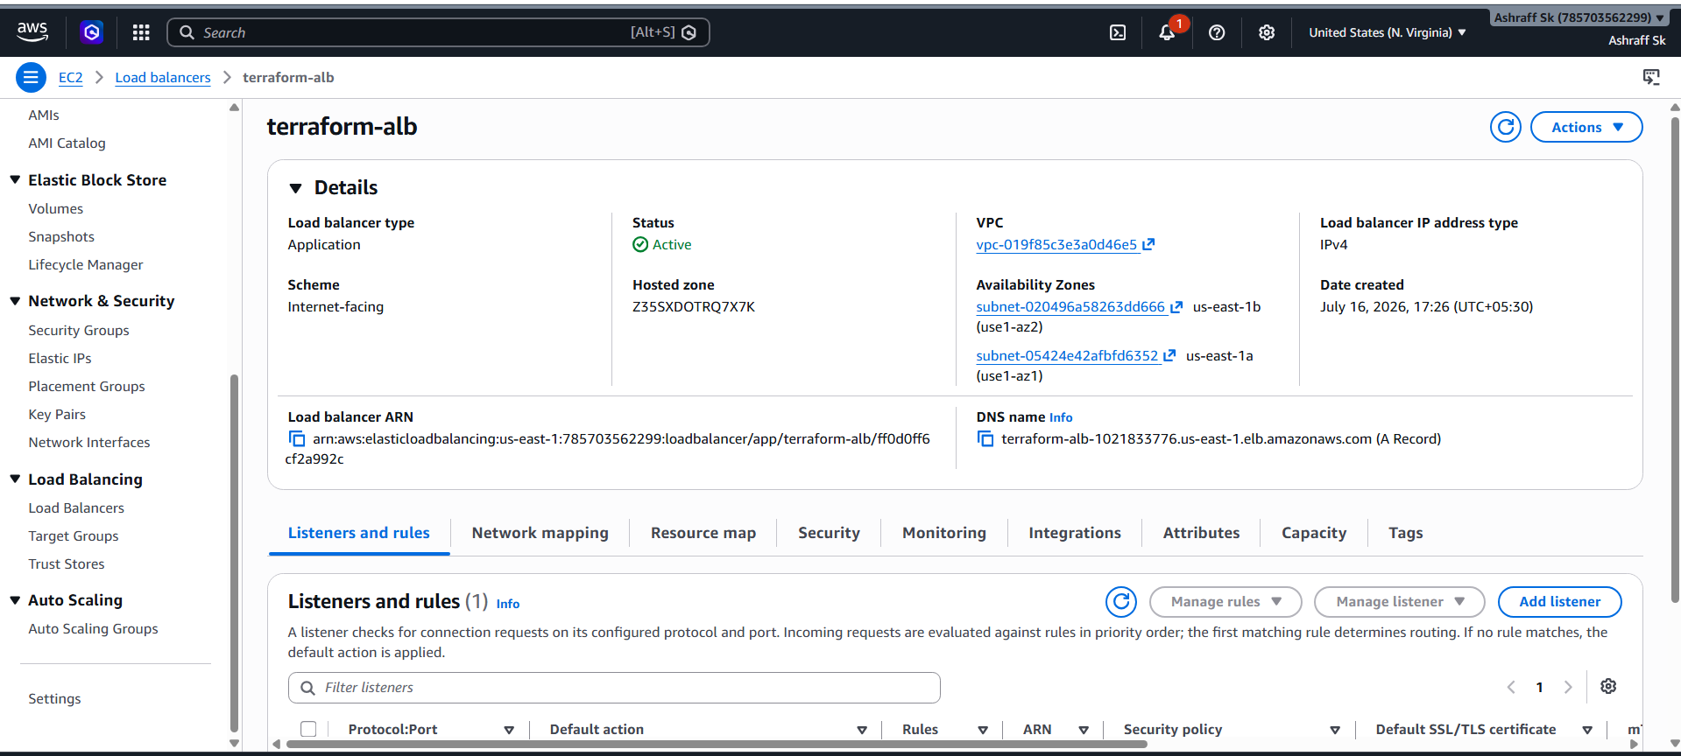

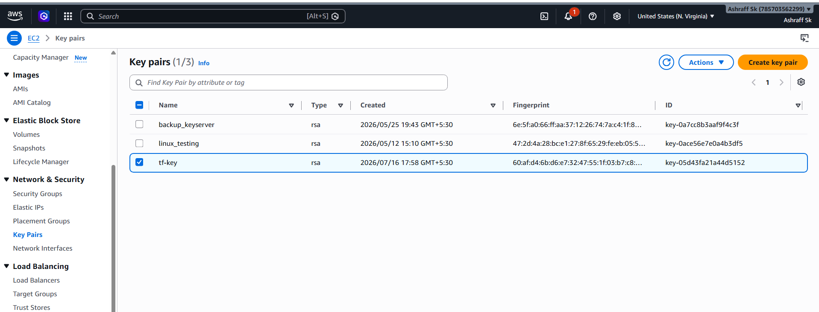

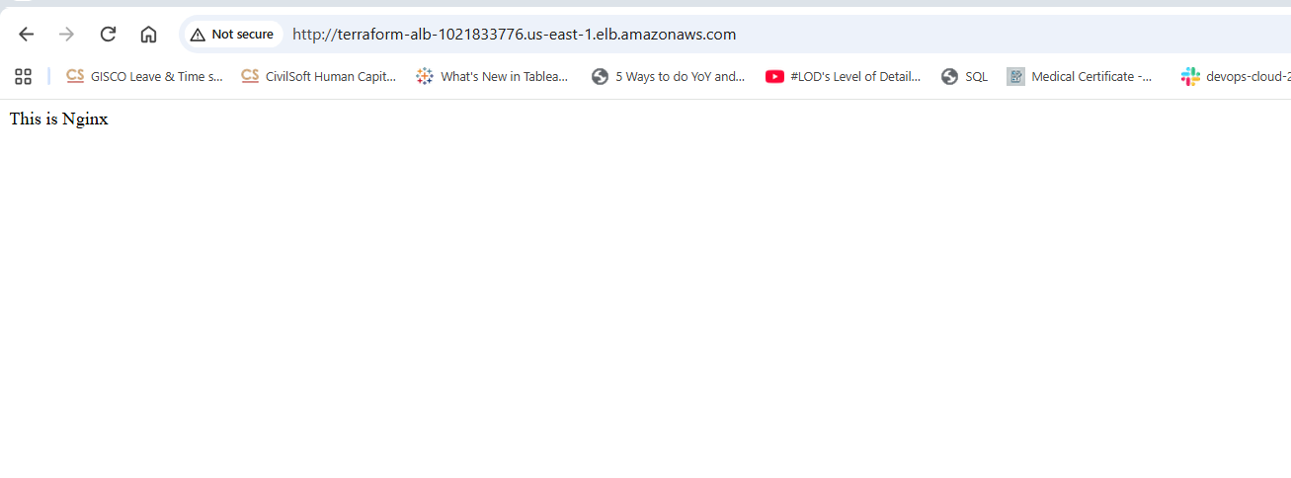
Conclusion:
- Successfully deployed a containerized microservice on AWS using Terraform.
- Provisioned infrastructure including VPC, Public Subnets, Internet Gateway, Route Table, Security Groups, IAM Role, EC2, Application Load Balancer, and Docker hub.
- Built and pushed a Docker image to Amazon ECR.
- Automatically deployed the Docker container on an EC2 instance using User Data.
- Configured the Application Load Balancer to route traffic to the EC2 instance through a Target Group.
- Implemented Infrastructure as Code (IaC) using Terraform following the best practice

