Challenge on VPC Transit Gateway & VPC Endpoint

Use Case: Setting up Transit Gateway and VPC Endpoints for a
Multi-VPC Architecture

Scenario:
- A large organization is migrating its on-premises
infrastructure to the AWS cloud.
- The organization's architecture involves multiple VPCs
for different departments and applications, each
requiring secure communication with centralized
services and external resources.
- The IT team needs to design and implement a scalable
and efficient network architecture to accommodate the
organization's growth and ensure robust connectivity
between VPCs and external services.

1.Design and deploy a scalable network architecture using
AWS Transit Gateway to simplify network connectivity
between multiple VPCs.
Purpose: The purpose of using an AWS Transit Gateway is
to connect and communicate between multiple VPCs and on-premises networks without creating individual peering connections.

Steps:
- Created 3 VPCs
- Created 3 subnets (1 public and 2 private) and configured with 3 VPCs
- Created an internet gateway for the public subnet and attached to that VPC
- Created a transit gateway.
- Added the transit gateway attachments for 3 VPCs
- Route tables for each VPC has been created.
- Created 3 ec2 instances of AMI as Amazon Linux 2023 by using the VPC and subnets.
- In security groups the inbound rule to allow all traffic is set.
- Connected to the public ip (on-premises instance) using ssh -i <key_pair> user@<public IP>
- Now connected with all private IPs of pub-ec2, pri-01-ec2 & pri-02-ec2 instances using on-premises instance ssh connection as jump server

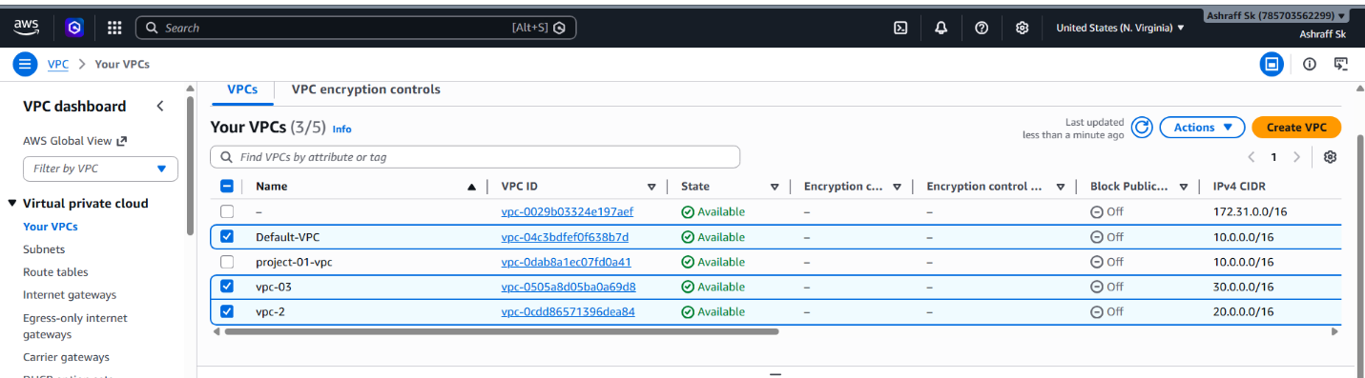

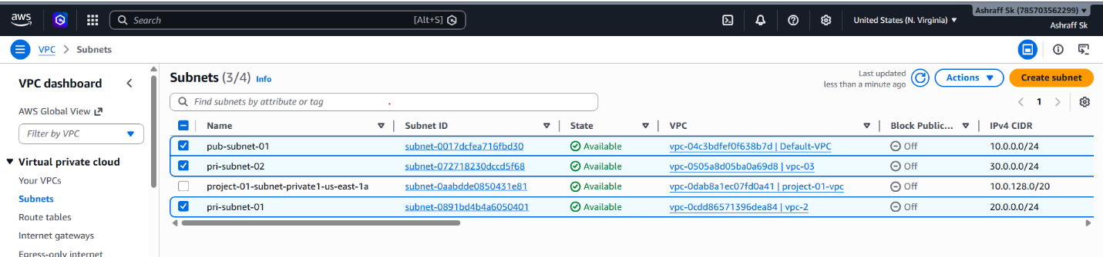

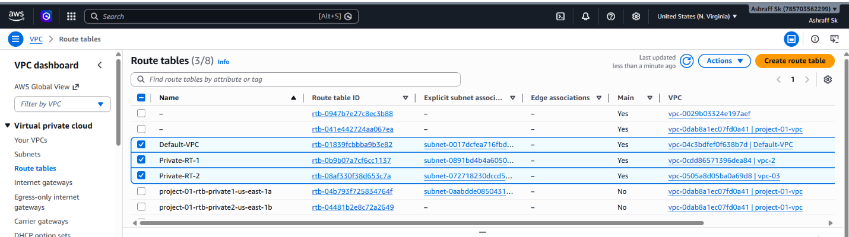

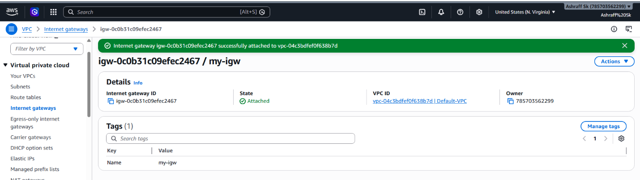
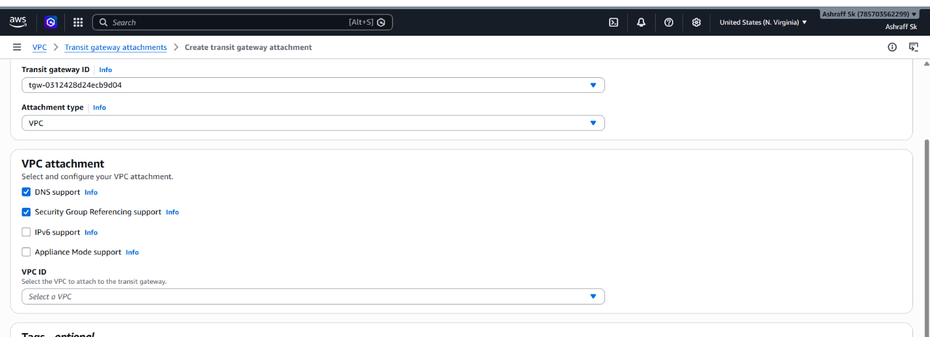
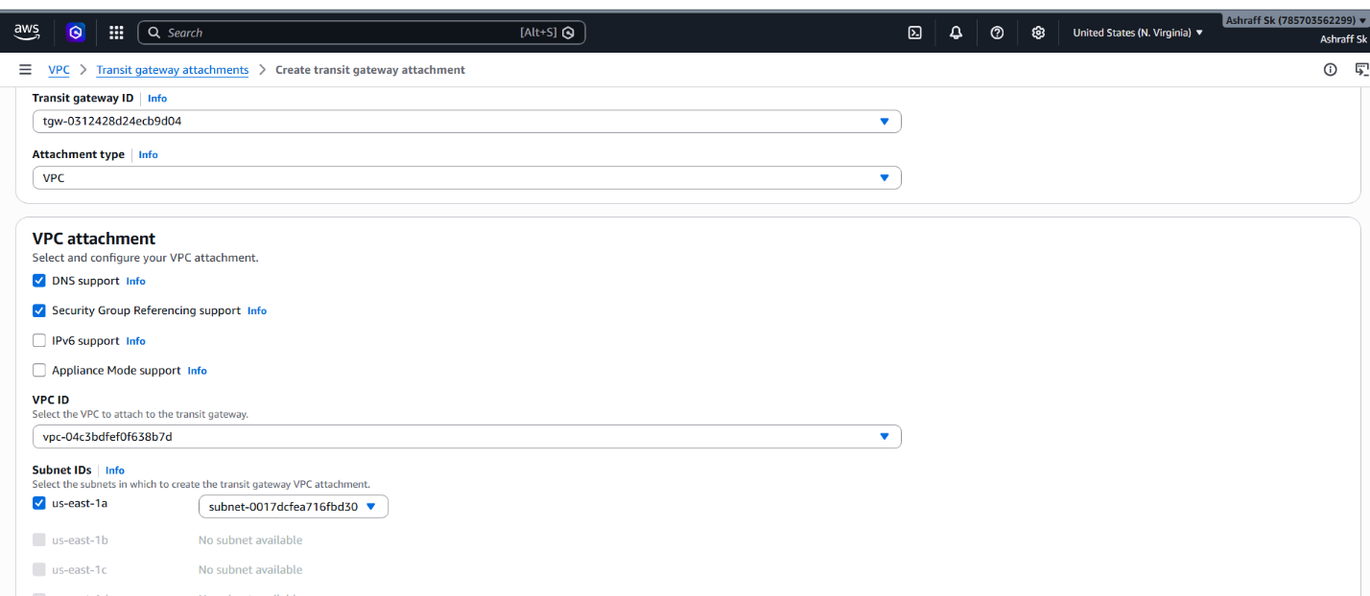
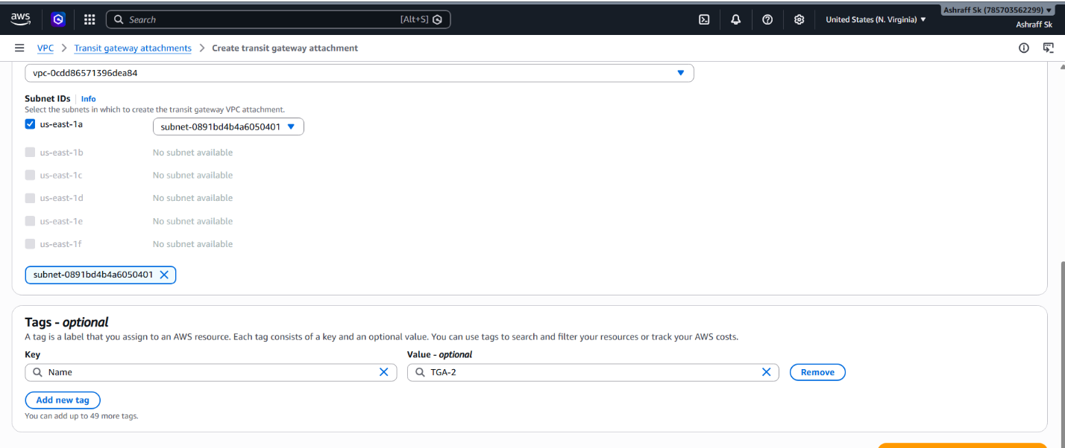
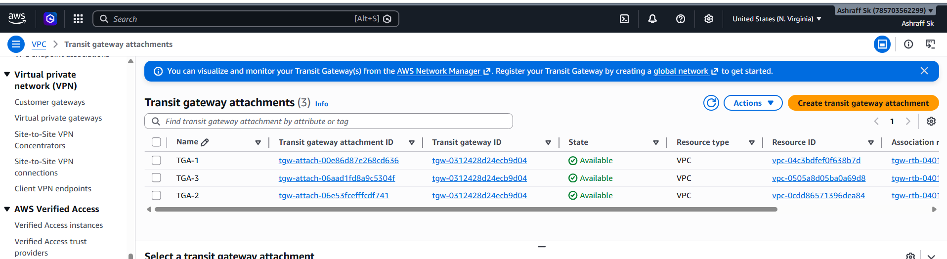


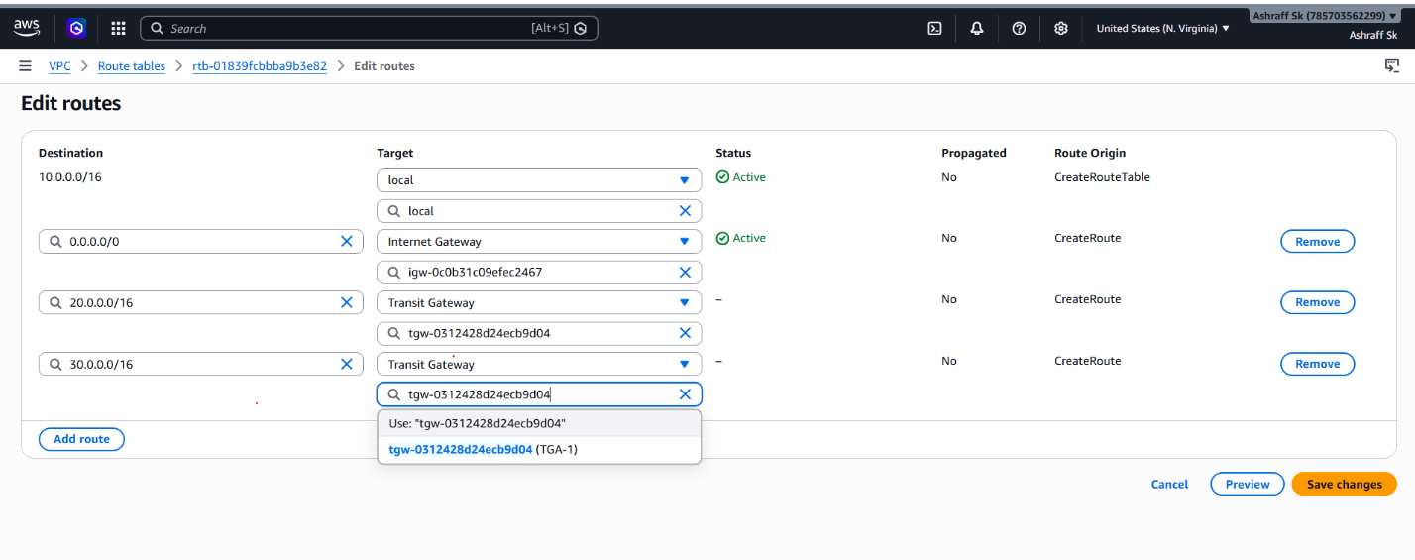
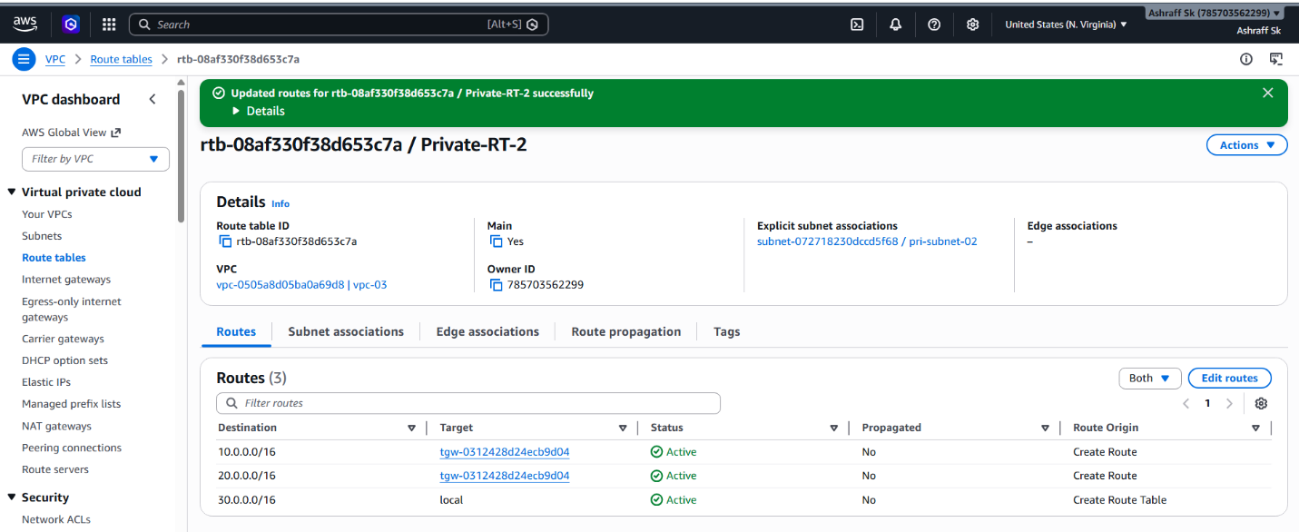

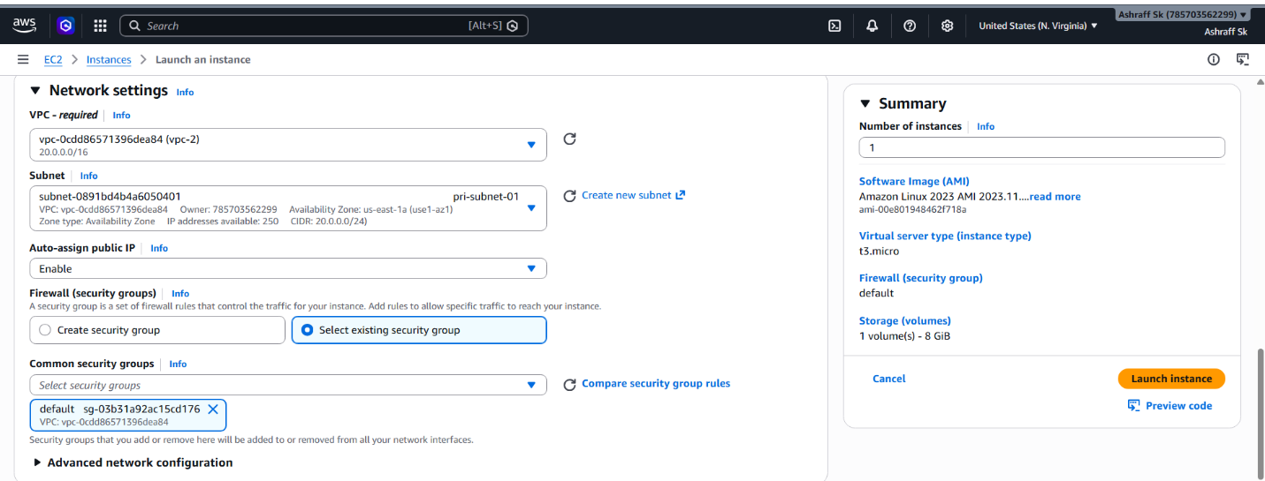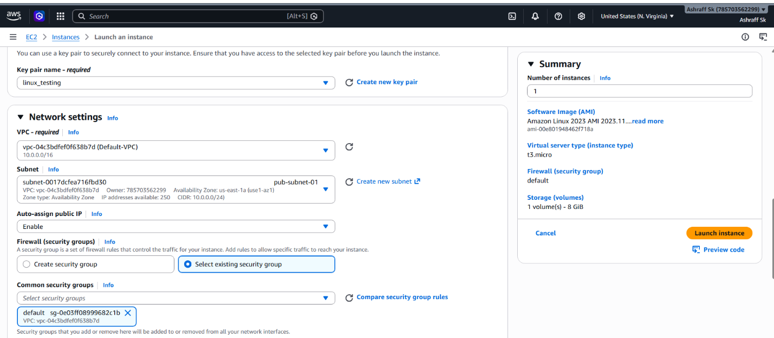
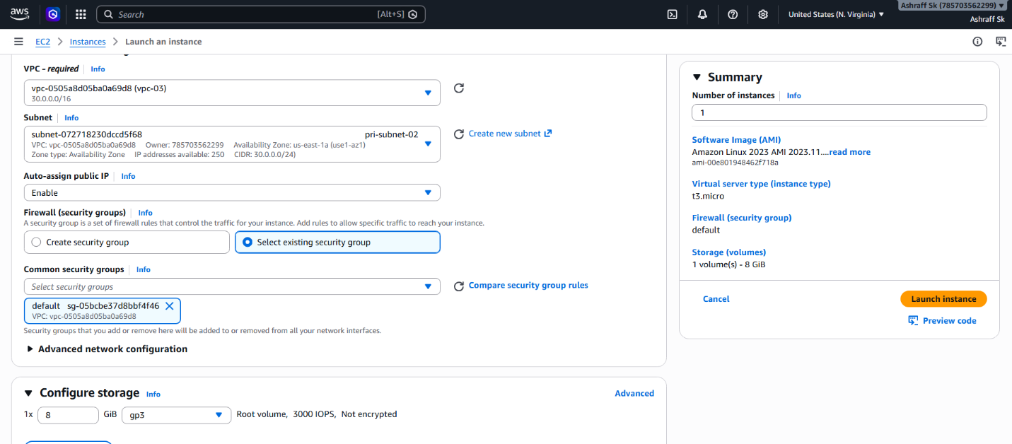
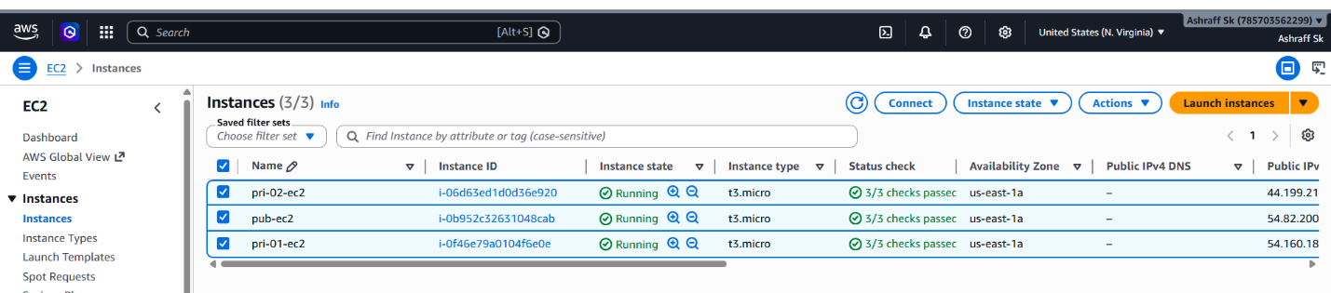

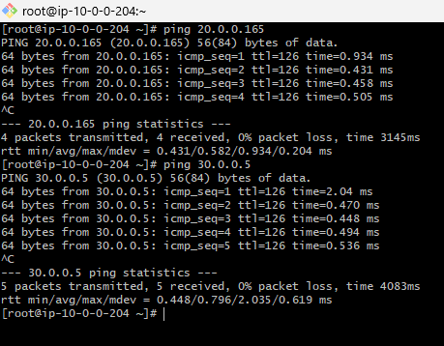
2. Configure VPC endpoints to securely access AWS services without internet gateways or NAT gateways, ensuring data privacy and minimizing exposure to external threats
Objective:
To configure a VPC Endpoint that allows
resources within a VPC to securely access AWS services using the AWS private network.

Pre-requisites:
Public Subnet-01
Private Subnet-01
VPC-01
Amazon S3 bucket
Steps:
- Create a VPC, my-vpc-endpoint with CIDR as 176.10.0.0/16 & availability zone as us-east-1a.
- Created a public subnet, my-pub-subnet-endpoint with CIDR as 176.10.1.0/24 & availability zone as us-east-1a.
- Created a internet gateway, my-igw & attached to the VPC, my-vpc-endpoint.
- Created a public subnet, my-pri-subnet-endpoint with CIDR as 176.10.1.0/26 & availability zone as us-east-1a.
- Go to VPC Route Tables
- Create a public & private route table, public-RT for the
my-vpc-endpoint.
- In public-RT edit route & add 0.0.0.0/0 as internet gateway & select the igw ID & save
- Select public-RT Subnet associations Edit subnet associations select my-pub-subnet-endpoint & save associations.
- Select private-RT Subnet associations Edit subnet associations select my-pri-subnet-endpoint & save associations.
- Created an ec2 instance named as my-ec2-pub-endpoint with AMI as Linux 2023, t3.micro, VPC as my-vpc-endpoint, subnet, my-pub-subnet-endpoint.
- Created an ec2 instance named as my-ec2-pri-endpoint with AMI as Linux 2023, t3.micro, VPC as my-vpc-endpoint, subnet, my-pri-subnet-endpoint.
- Created a s3 bucket named myvpc-flowlog-0452.
- Connected to an ec2 instance, my-ec2-pub-endpoint with command, ssh -I <key_pair> user@<public-IPV4>
- Now change to root user, sudo su –.
- ping <private-IPV4 of my-ec2-pri-endpoint> & communication is established.
- Create an Endpoint, VPC Endpoints Create endpoint
- Named as my-endpoint
- In Services, select com.amazonaws.us-east-1.s3
- In Network settings, select my-vpc-endpoint
- In Route tables, select private-RT & create endpoint.
- Connect to the public instance & check the aws version, aws –version.
- aws configure & enter the access key ID & secret Key, region as us-east-1 & output format as json
- Now run the command, aws s3 ls & myvpc-flowlog-0452 is displayed
