AWS SQS, MQ & Secrets Manager

AWS SQS (Simple Queue Service)
What is AWS SQS?
Amazon SQS is a fully managed message queuing service that enables decoupling of microservices, distributed systems, and serverless applications.
Instead of applications communicating directly, they send messages to a queue. Consumers process messages asynchronously from the queue.

Architecture
Producer Application
|
v
Amazon SQS Queue
|
v
Consumer Application

Types of SQS Queues
1. Standard Queue
Features:
- Unlimited throughput
- At-least-once message delivery
- Best-effort ordering
Use Cases:
- Log processing
- Data processing
- Background tasks

2. FIFO Queue (First In First Out)
Features:
- Exactly-once processing
- Strict message ordering
Use Cases:
- Financial transactions
- Order processing
- Payment systems
Important Concepts
1. Visibility Timeout
After a consumer receives a message:
Message becomes invisible to other consumers.
Consumer processes the message.
Consumer deletes the message after successful processing.

Example:
Visibility Timeout = 30 seconds
If processing fails, the message becomes visible again.

2. Message Retention Period
How long SQS stores messages.
Range:
1 minute to 14 days
Default:
4 days

3. Dead Letter Queue (DLQ)
Failed messages are moved to a DLQ after a specified number of retries.
Application
|
v
SQS Queue
|
v
Failed Messages
|
v
Dead Letter Queue
Benefits:
- Troubleshooting
- Error analysis
- Prevents infinite retries

SQS with Lambda
Architecture:
API Gateway
|
v
Lambda
|
v
SQS Queue
|
v
Lambda Consumer
Benefits:
- Event-driven architecture
- Automatic scaling
- Cost-effective

AWS SQS Setup (Step-by-Step)

Step 1: Create Queue
- Open AWS Console.
- Navigate to Amazon SQS Console
- Click Create Queue.
- Select:
  - Standard Queue or FIFO Queue.
- Enter queue name.
- Click Create Queue.
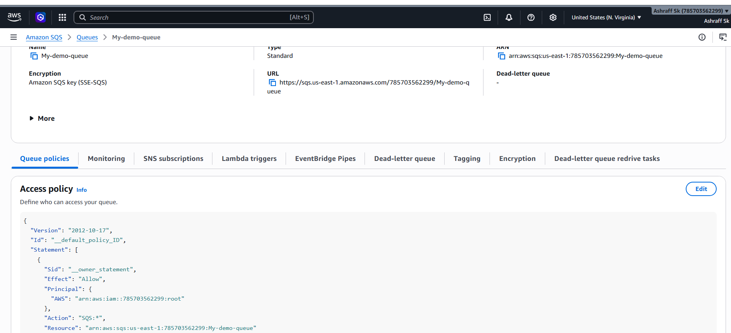

Step 2: Send Message
- Open queue.
- Click Send and Receive Messages.
- Enter message:
{
"orderId": 101,
"customer": "John"
}
- Click Send Message. 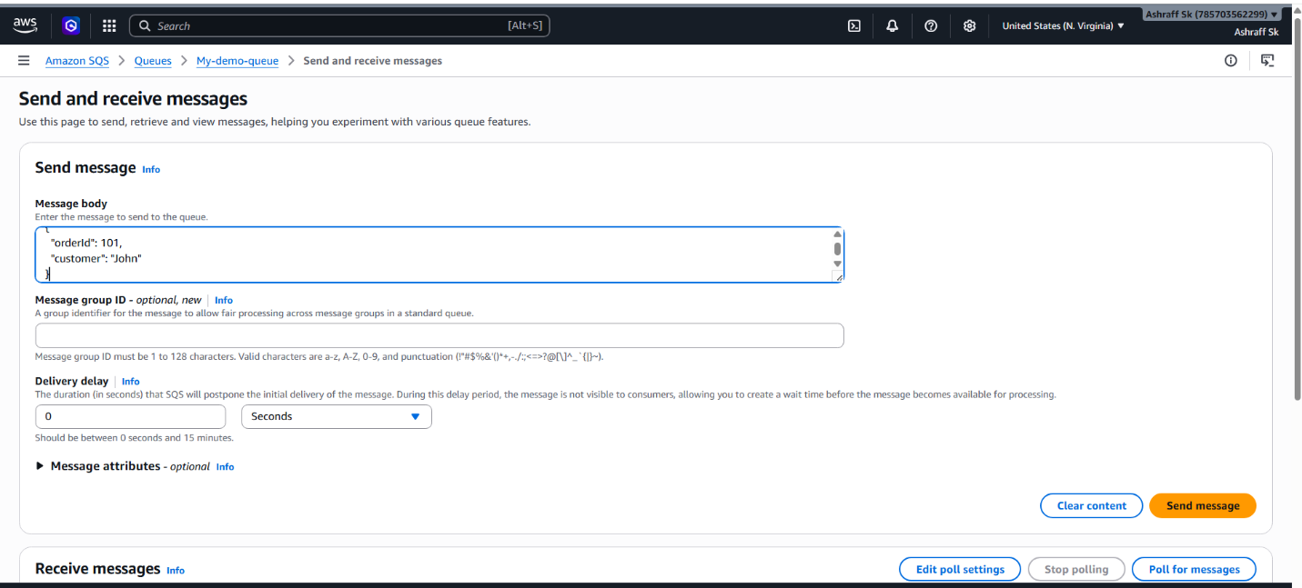

Step 3: Receive Message
- Click Poll for Messages.
- View message.
- Delete after processing

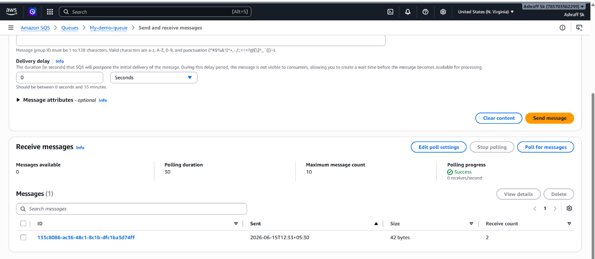
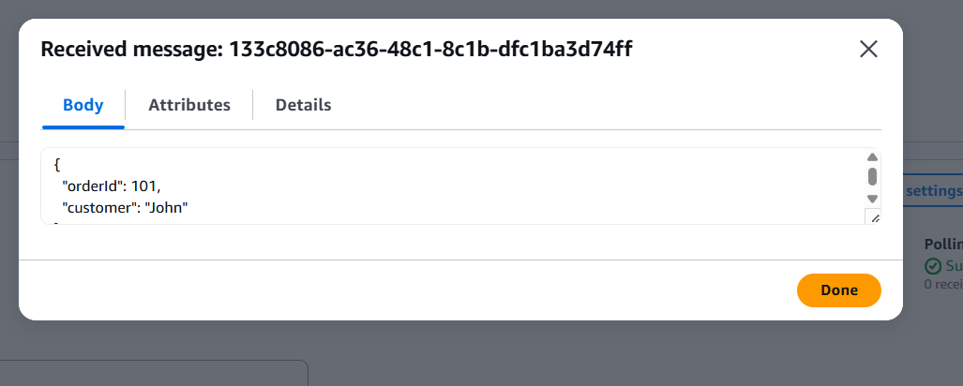

Trigger AWS Lambda Using SQS – Step by Step
Step 1: Create an SQS Queue
Open AWS Console → SQS → Create Queue
Select:
Standard Queue
Example Queue Name:
My-queue_01

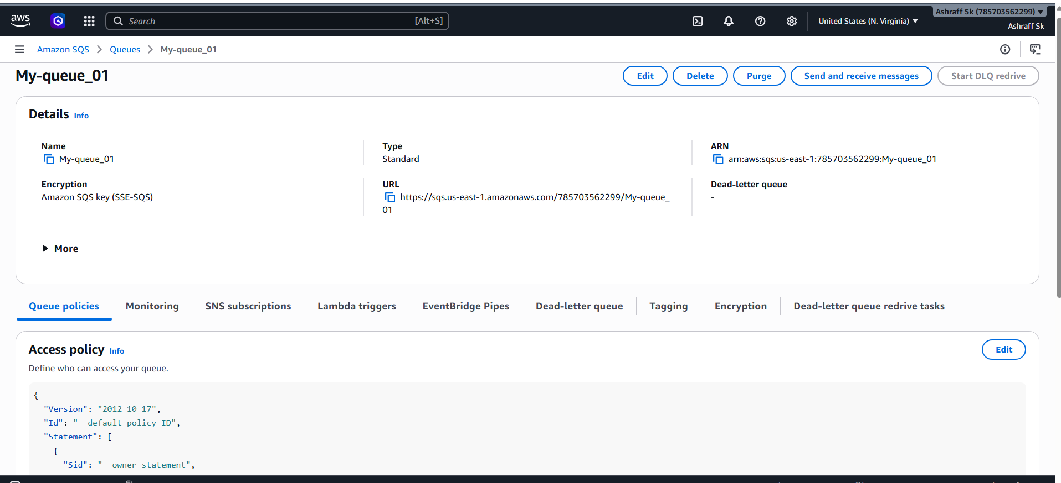

Step 2: Create a Lambda Function
Open AWS Console → Lambda
Click:
Create Function
Configuration:
Function Name: My-SQS-fn
Runtime: Python 3.x
Click Create Function.
Step 3: Add Lambda Code
Print(event)
Click Deploy
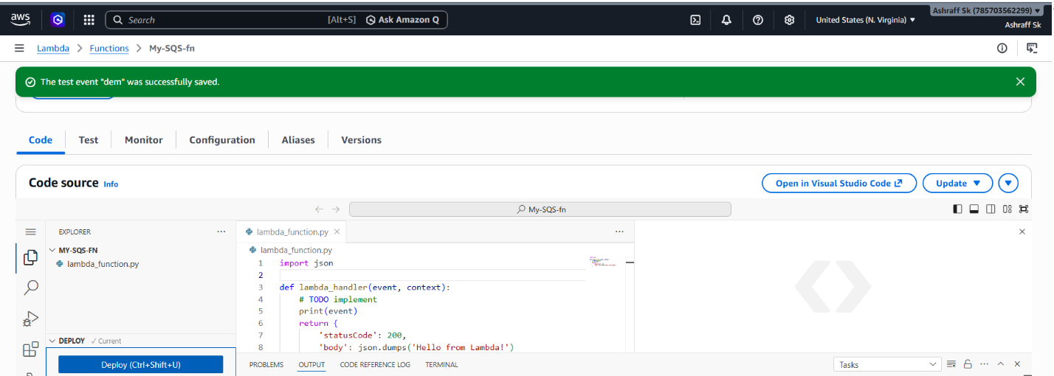
Step 4: Grant Permissions
Lambda requires permission to read messages from SQS.
Go to:
Lambda
→ Configuration
→ Permissions
Attach IAM Policy:
AWSLambdaSQSQueueExecutionRole
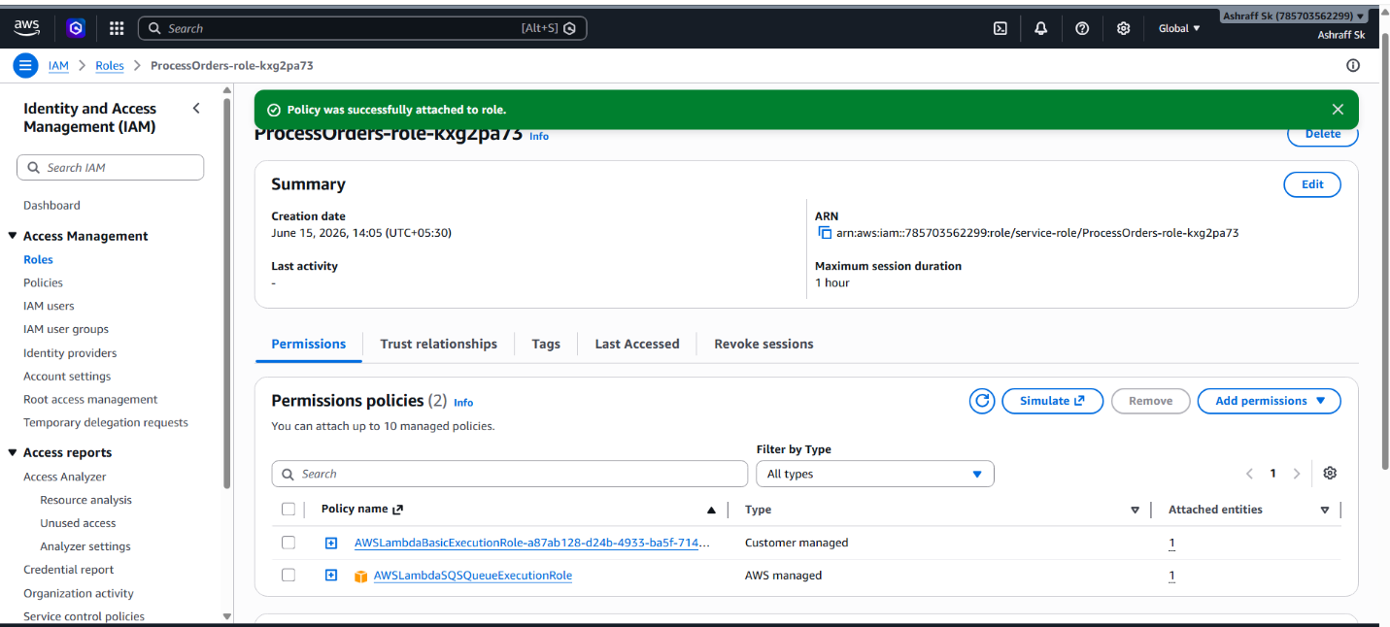
Step 5: Add SQS Trigger
Inside Lambda:
Add Trigger
Select:
SQS
Choose:
My-queue_01
Configure:
Batch Size: 10
Enabled: Yes
Click:
Add

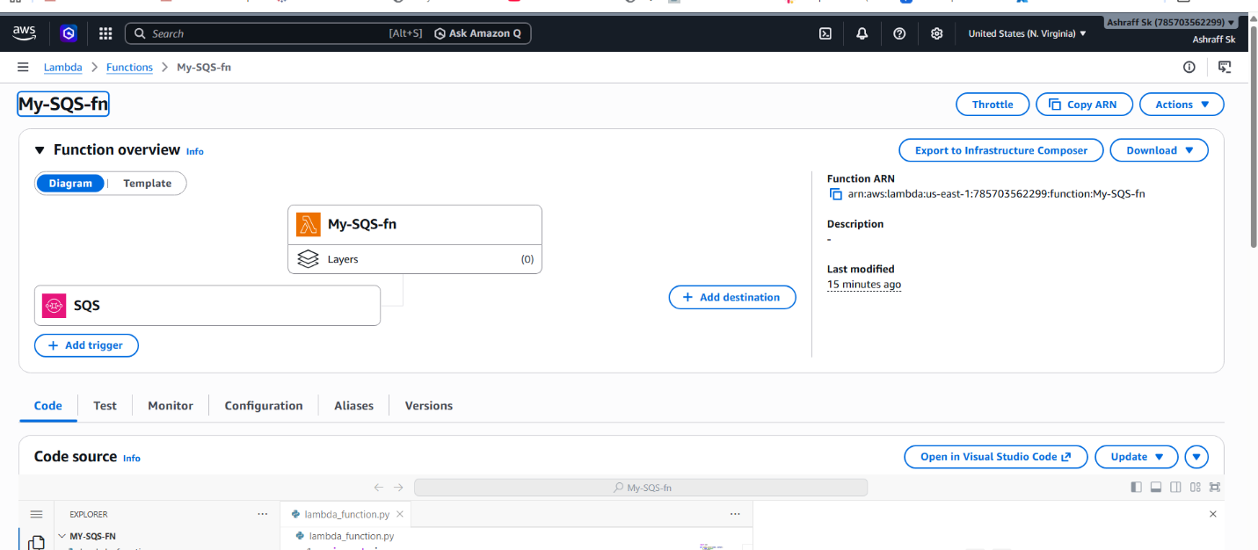

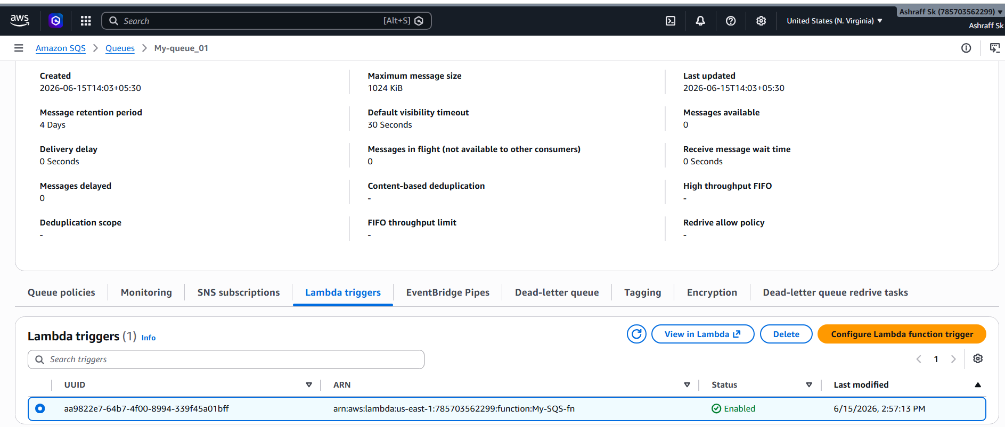

Step 6: Send a Test Message
Open SQS Queue.
Click:
Send and Receive Messages
Enter Message as hello this is my first sqs message!
Click:
Send Message

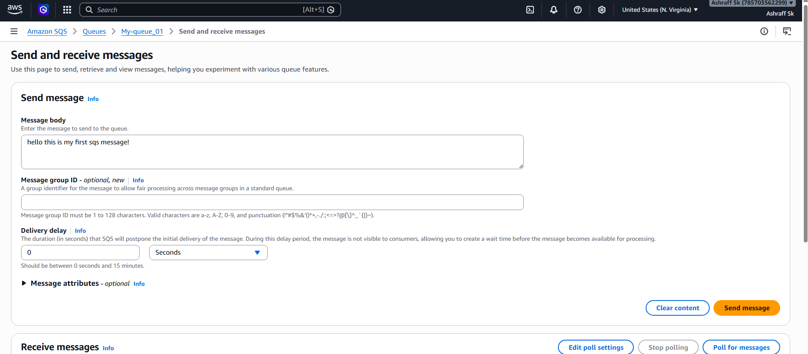
Step 7: Verify Lambda Execution
Open:
Lambda
→ Monitor
→ View CloudWatch Logs

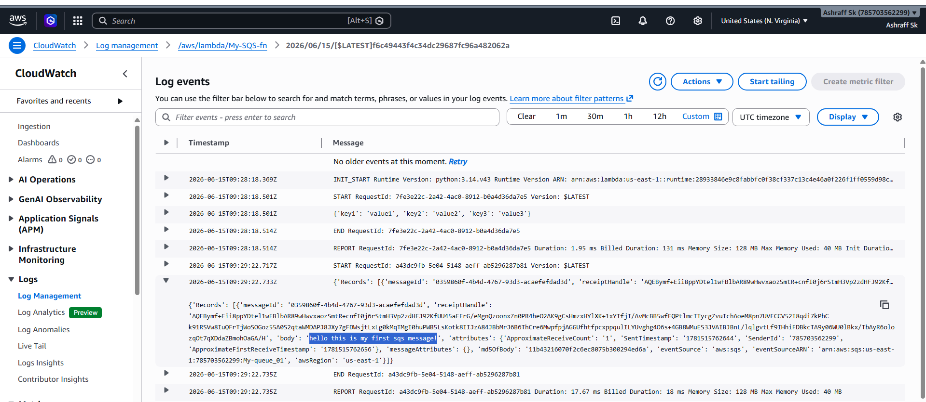

Amazon MQ
What is Amazon MQ?
Amazon MQ is a fully managed message broker service provided by AWS that makes it easy to set up and operate message brokers in the cloud.
It supports popular messaging protocols and brokers such as:
- Apache ActiveMQ
- RabbitMQ
Amazon MQ is useful when migrating existing applications that already use traditional message brokers without changing application code.

Why Use Amazon MQ?
Applications often need reliable communication between components.
Without a message broker:
Application A
|
v
Application B
If Application B is unavailable, messages may be lost.
With Amazon MQ:
Application A
|
v
Amazon MQ
|
v
Application B
Messages are stored safely until consumers process them.

Amazon MQ vs SQS
Feature | Amazon MQ | Amazon SQS
Managed Broker | Yes | No
Protocol Support | JMS, AMQP, MQTT, STOMP, OpenWire | AWS API only
Message Ordering | Supported | FIFO Queue
Existing App Migration | Excellent | Requires code changes
Broker Management | Required | Fully serverless
Use Case | Enterprise Messaging | Cloud-Native Messaging

Supported Engines
Apache ActiveMQ
Supports:
- JMS
- AMQP
- MQTT
- STOMP
- OpenWire
Ideal for:
- Java applications
- Enterprise systems
RabbitMQ
Supports:
- AMQP
- MQTT
- STOMP
Ideal for:
- Microservices
- Event-driven applications

Creating an Amazon MQ Broker
Step 1: Open Amazon MQ
AWS Console → Amazon MQ
Click:
Create Broker
Step 2: Select Broker Engine
Choose:
ActiveMQ

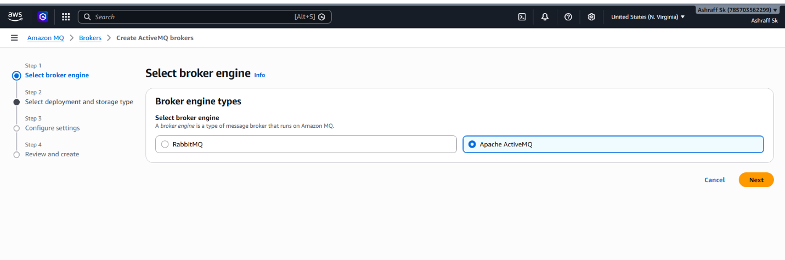
Step 3: Configure Broker
Broker Name:
order-broker
Step 4: Configure Authentication
Username:
admin
Password:
Admin1234567890
Store credentials securely.
Step 5: Network Configuration
Select:
VPC
Subnet
Security Group
In security group of the used VPC added port 8162 in inbound rules
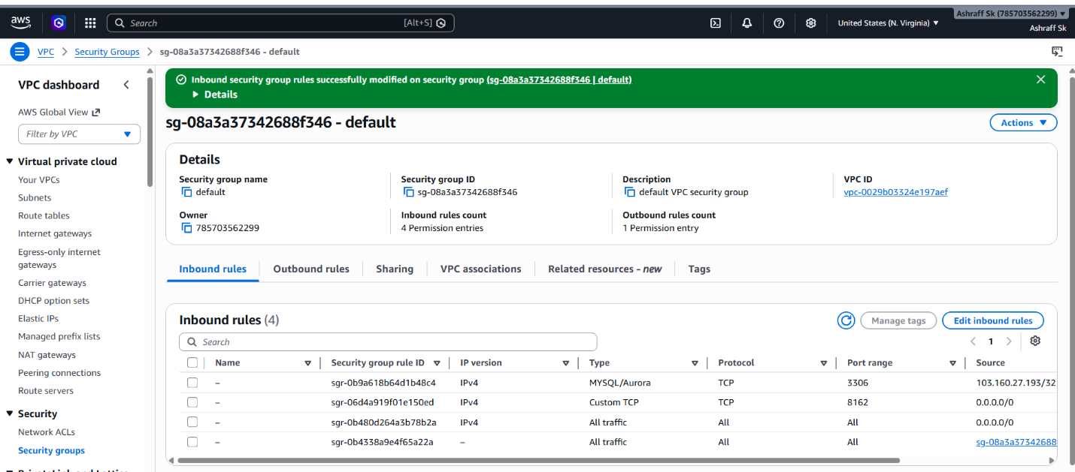
Step 6: Create Broker
Click:
Create Broker
Provisioning takes approximately:
15–20 minutes

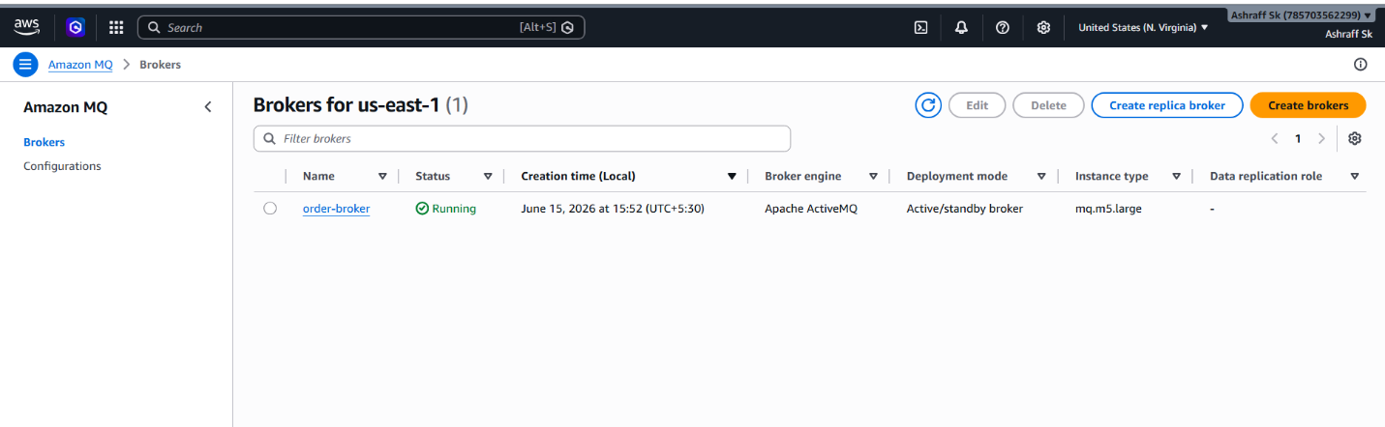
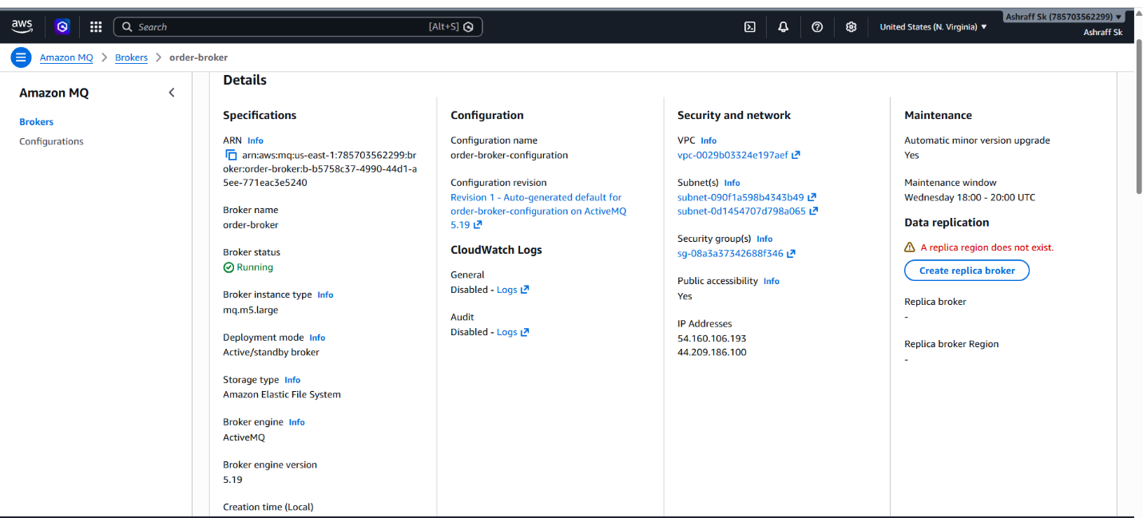
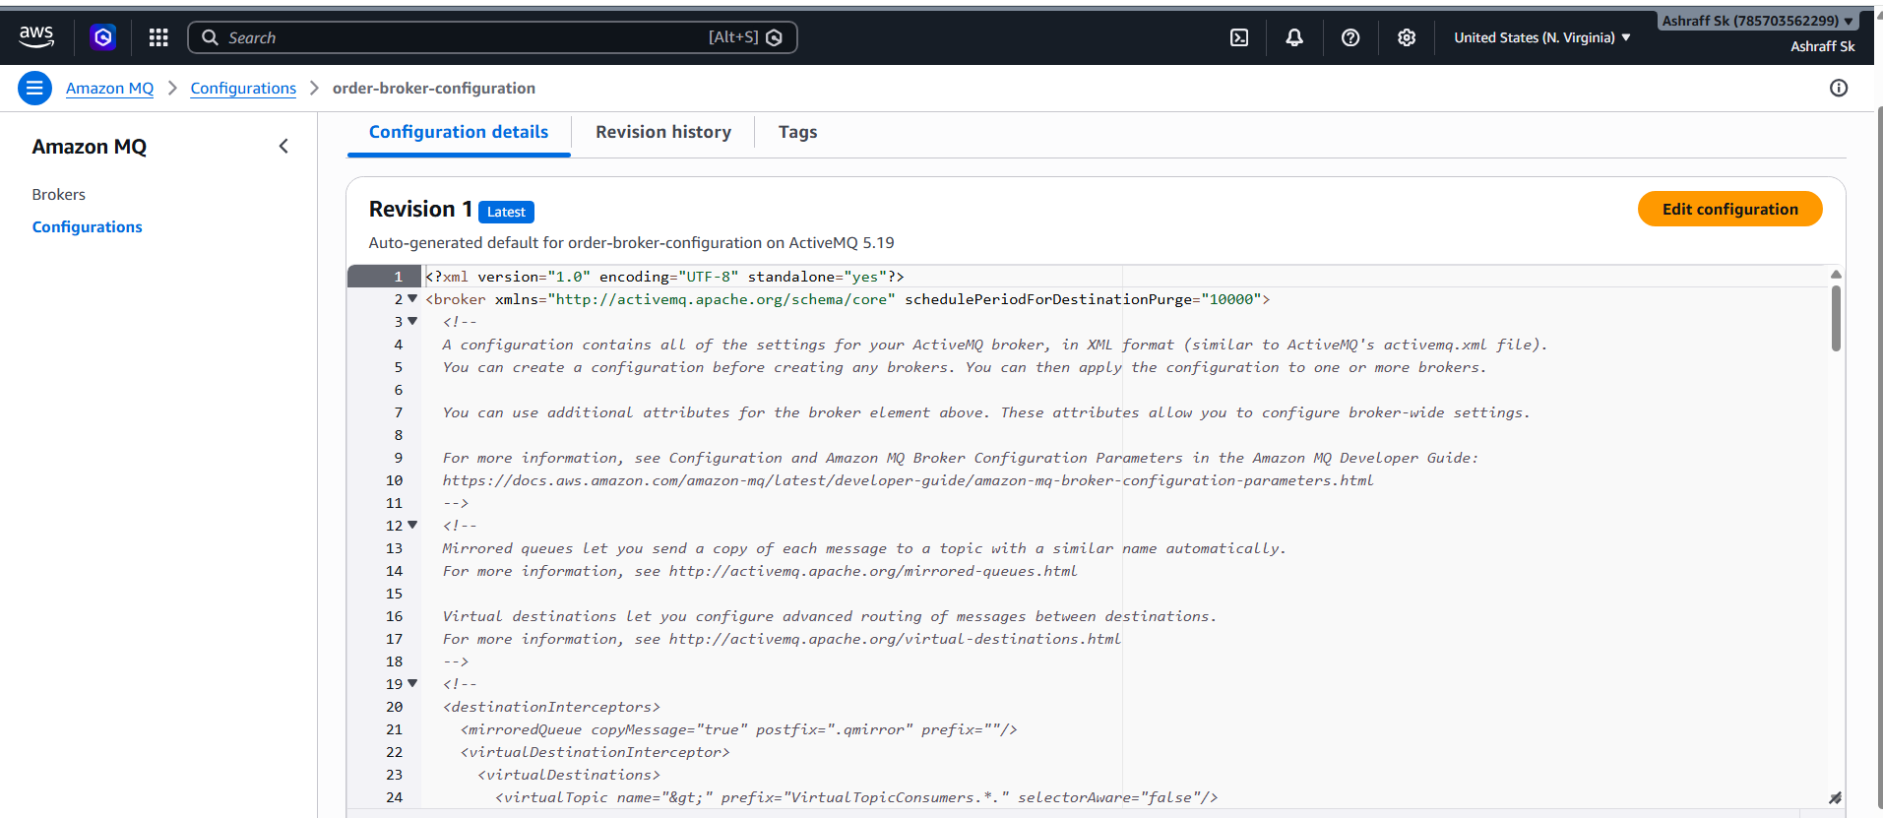
Open ActiveMQ Web Console
https://b-b5758c37-4990-44d1-a5ee-771eac3e5240-1.mq.us-east-1.amazonaws.com:8162
Login with
Username: admin
Password: admin1234567890
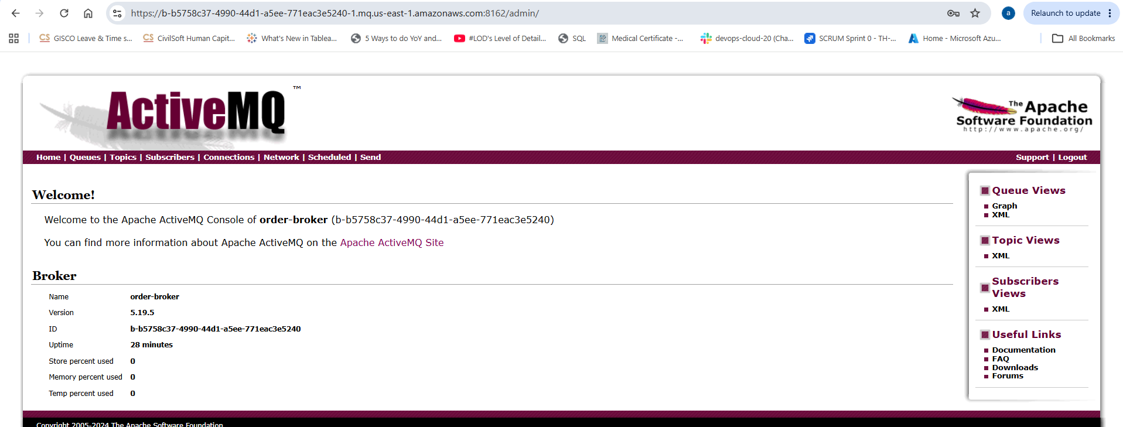

Create a Queue
- Click Queues tab.
- Under Send To, enter queue name:
OrderQueue
- Enter a test message:
Order ID: 1001
- Click Send.
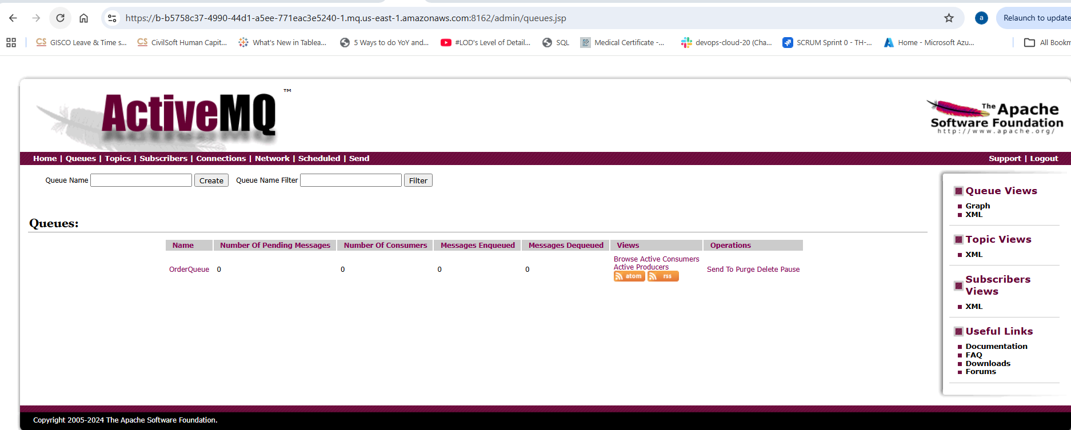
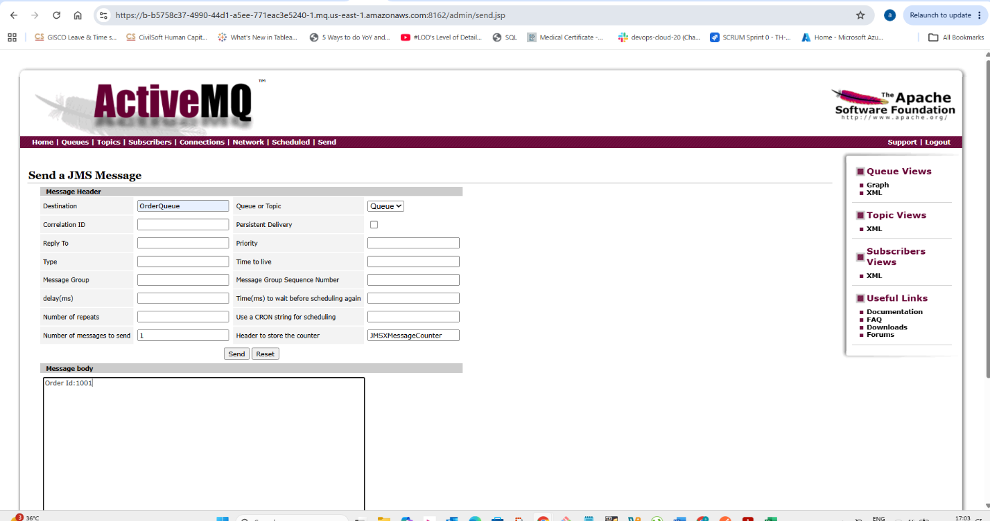

Verify Queue Creation
Go to:
Queues
You should see:
OrderQueue

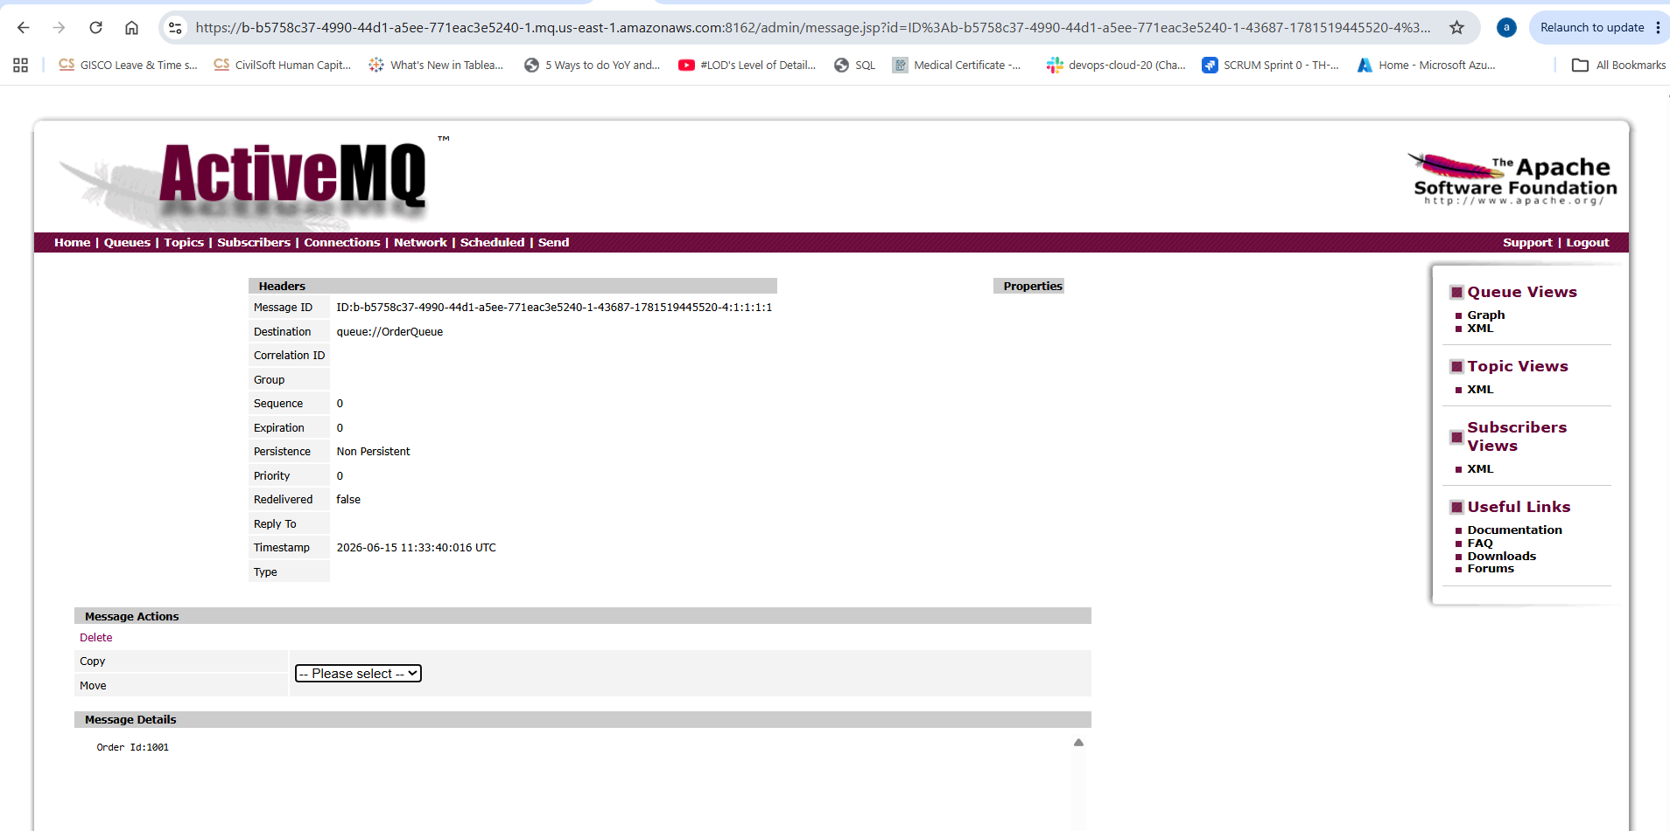

AWS Secrets Manager
What is AWS Secrets Manager?
AWS Secrets Manager is a fully managed AWS service used to securely store, retrieve, and manage sensitive information such as:
- Database passwords
- API keys
- OAuth tokens
- SSH keys
- Application credentials
- Third-party service credentials
Instead of hardcoding passwords in applications, you store them securely in Secrets Manager and retrieve them when needed.
Using Secrets Manager
Benefits:
- Encrypted storage
- Automatic rotation
- Centralized management
- Audit logging
Step 1: Create a Secret
Open AWS Console.
Navigate to Secrets Manager.
Click Store a new secret.

Select:
Other type of secret
Enter:
"username": "admin",
"password": "admin1234567890"

Secret Name:
prod/mysql-credentials

Click Store.
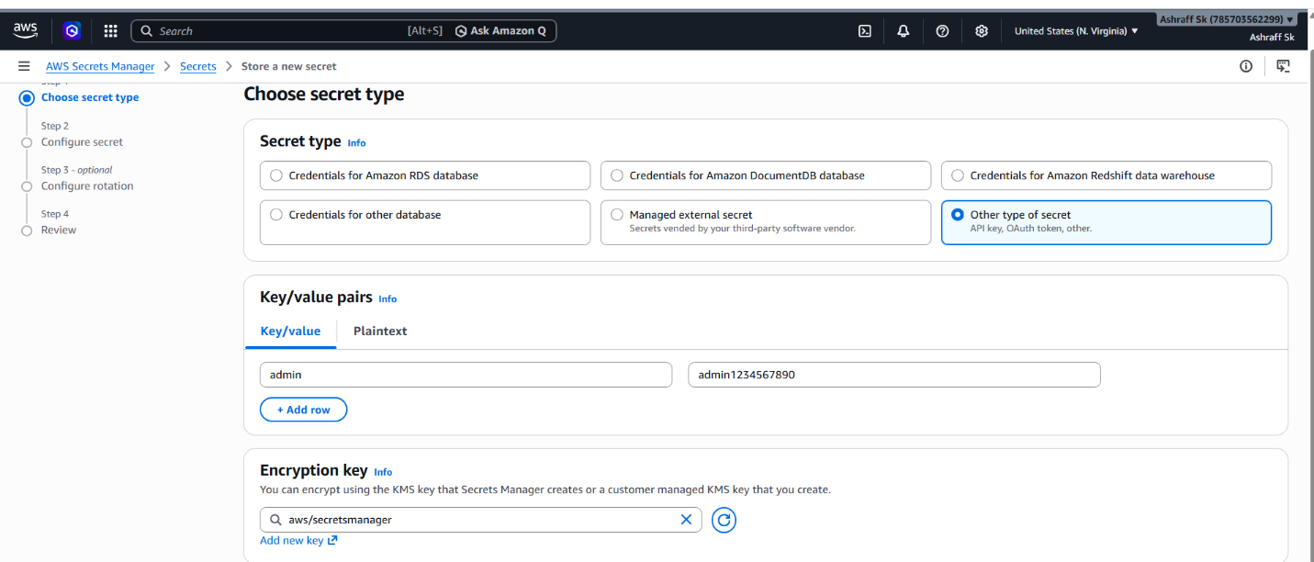
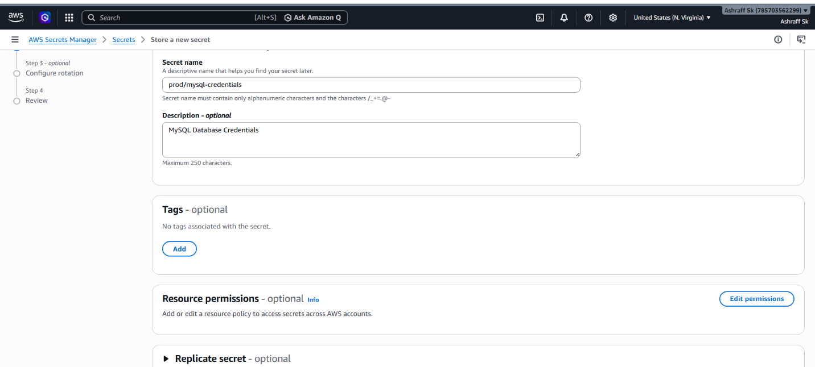
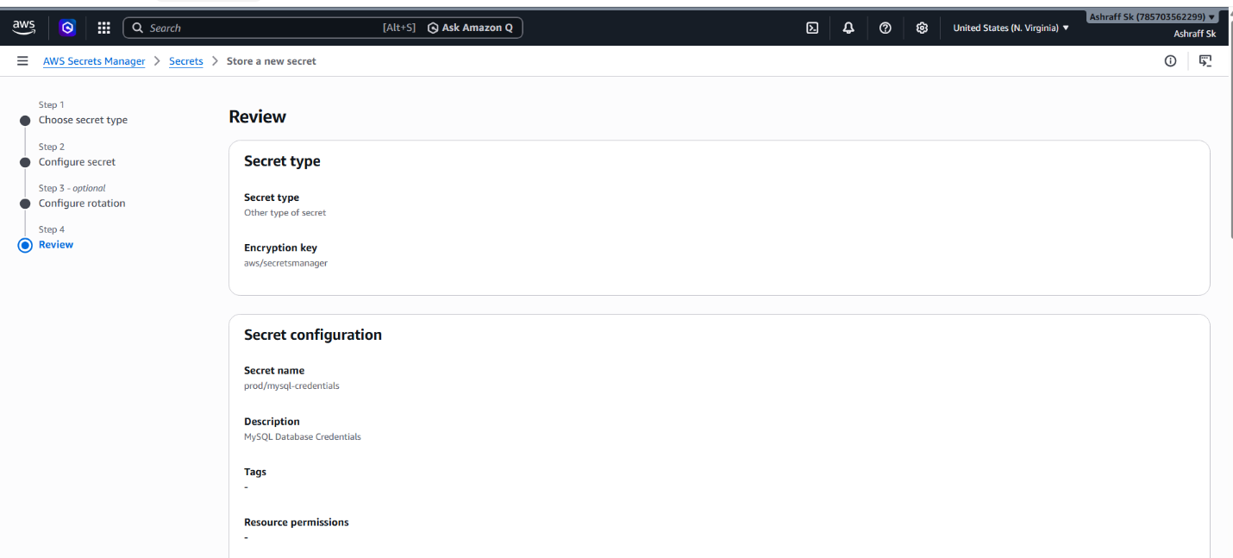
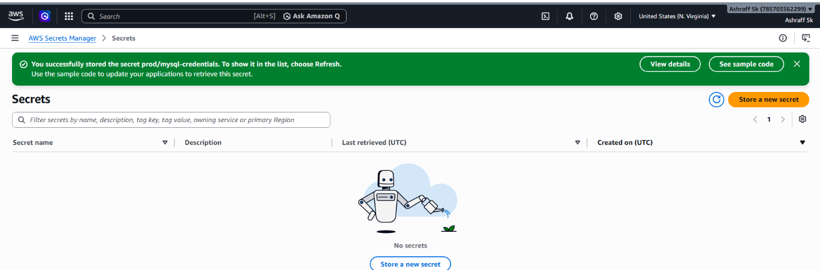
Step 2: Launch an EC2 Instance
Launch an Amazon Linux EC2 instance.
Example:
Name: My-ec2-secretmgr
AMI: Amazon Linux 2023
Instance Type: t3.micro
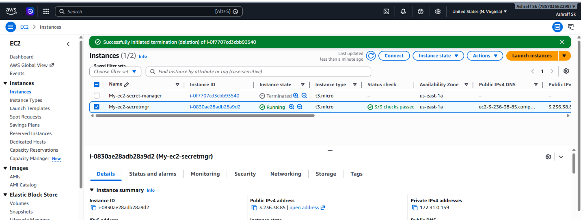

Step 3: Create an IAM Role
Open IAM → Roles → Create Role
Trusted Entity:
AWS Service
Use Case:
EC2
Click Next.
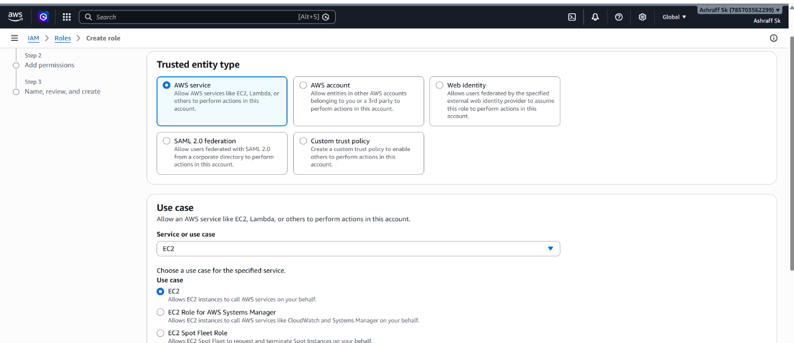

4.We have to create a policy to give permissions from EC2 to Secret MANAGER and this created policy we have to add to the role.
5.After creating role, we have attach this role to the
instance.
6.After logging into that instance, we have download the
aws cli in our instance.Command -> yum install awscli -y
7.aws configure with the credentials
8.After downloading that we have to get the secret
manager credentials.
9. Command -> aws secretsmanager get-secret-value \
--secret-id prod/mysql-credentials \

