Docker-01
- Setup a virtual machine using Ubuntu image.
Objective:
To create and configure an Ubuntu Virtual Machine for learning, development, and testing purposes.
Purpose
Create a virtual Linux environment without affecting the host operating system.
Learn Linux administration.
Practice DevOps, Docker, Kubernetes, and AWS CLI.
Test applications safely.
Prerequisites
Windows/Linux/macOS system
Minimum 8 GB RAM (16 GB recommended)
30 GB free disk space
Internet connection
VirtualBox installed
Ubuntu ISO image downloaded

Steps:
Step 1: Download Ubuntu 26.04 LTS ISO
Download the Ubuntu 26.04 LTS Desktop ISO from the official Ubuntu website.
Step 2: Install and Open Oracle VirtualBox
Install Oracle VirtualBox.
Launch VirtualBox Manager.
Click New to create a new virtual machine.
Click Create.
Step 3: Create a New Virtual Machine
Enter the following details:
Setting Value
Name Ubuntu26VM
Type Linux
Version Ubuntu (64-bit)
ISO Image Ubuntu-26.04-LTS.iso
Click Next.
Step 4: Configure Hardware
Allocate system resources.
Resource Recommended
RAM 8192 MB
CPU 2–4 Cores
Click Next.
Step 5: Create a Virtual Hard Disk
Configure storage as follows:
Create a Virtual Hard Disk Now
Disk Type: VDI (VirtualBox Disk Image)
Storage: Dynamically Allocated
Size: 40 GB
Click Finish.
Step 6: Start the Virtual Machine
Select the VM and click Start.
The Ubuntu installer will boot automatically.
Step 7: Begin Ubuntu Installation
Choose:
Install Ubuntu
English Language
Keyboard Layout (English US)
Click Continue.
Step 8: Installation Options
Select:
Normal Installation
Download updates while installing
Install third-party software (optional)
Click Continue.
Step 9: Installation Type
Select:
Erase Disk and Install Ubuntu
Note: This only formats the virtual hard disk created inside VirtualBox. Your host computer's hard drive is not affected.
Click Install Now.
Step 10: Select Time Zone
Choose your location.
Example:
Region: Asia
City: Kolkata
Click Continue
Step 11: Create a User Account
Enter the following details:
Field Example
Your Name Ashraff Sk
Computer Name ubuntu26
Username Ashraff sk
Password India@5868
Click Continue.
Step 12: Wait for Installation
Ubuntu copies files and installs the operating system.
Approximate installation time:
10–20 minutes
Step 13: Restart the Virtual Machine
Click Restart Now.
Remove the ISO if prompted and press Enter.
Step 14: Login
Enter your username and password.
The Ubuntu desktop will appear.
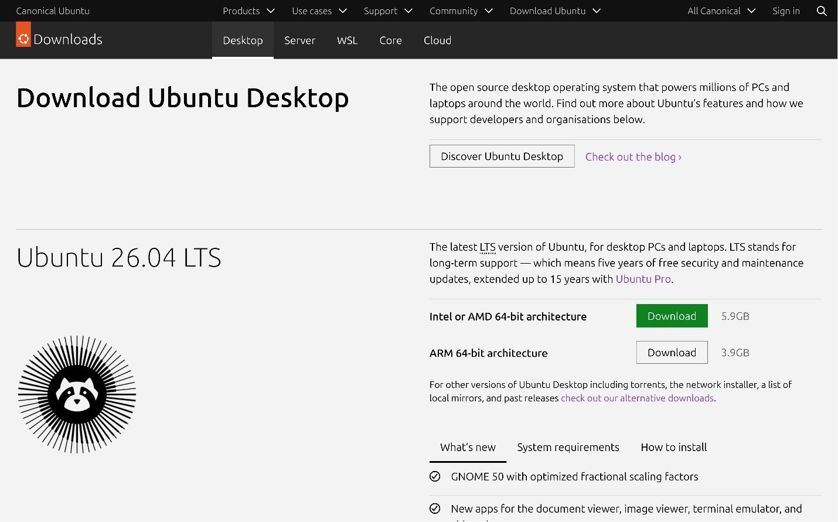

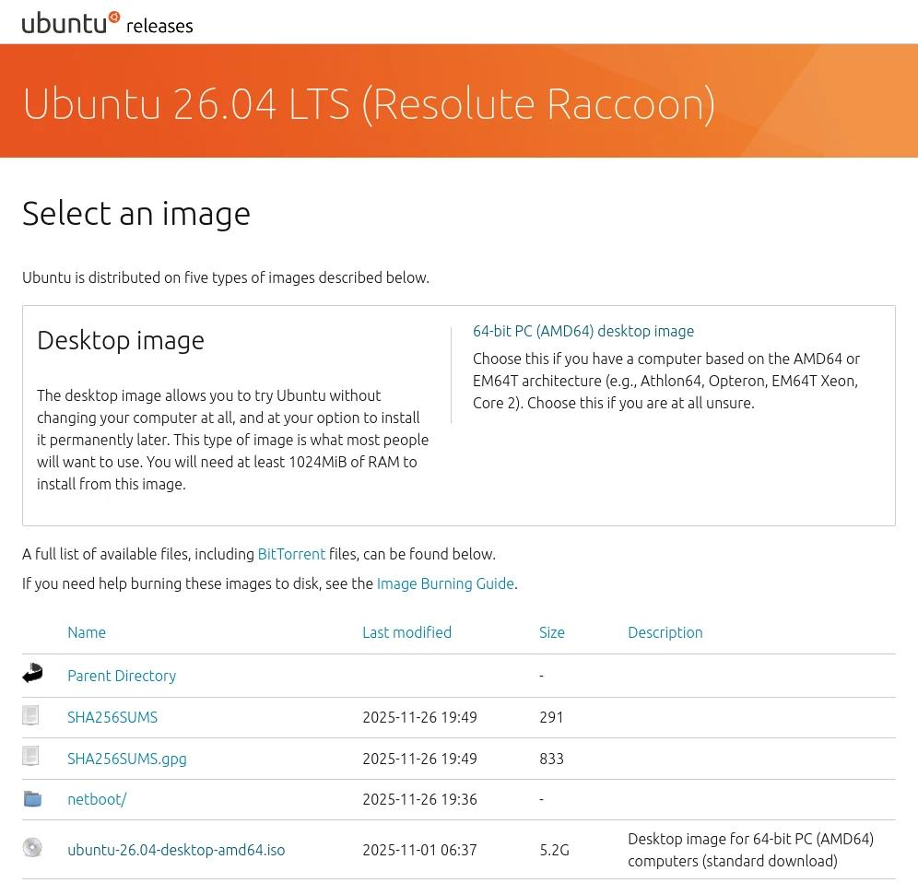
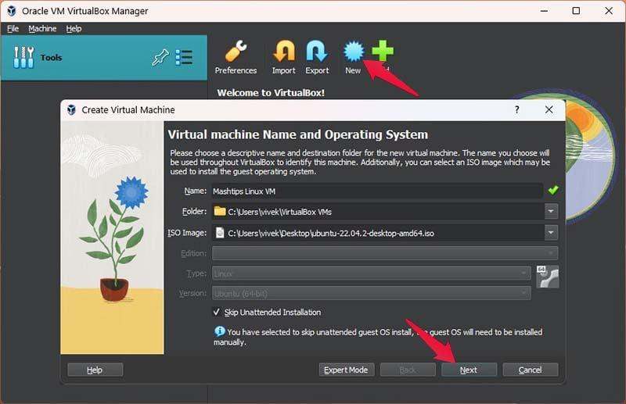
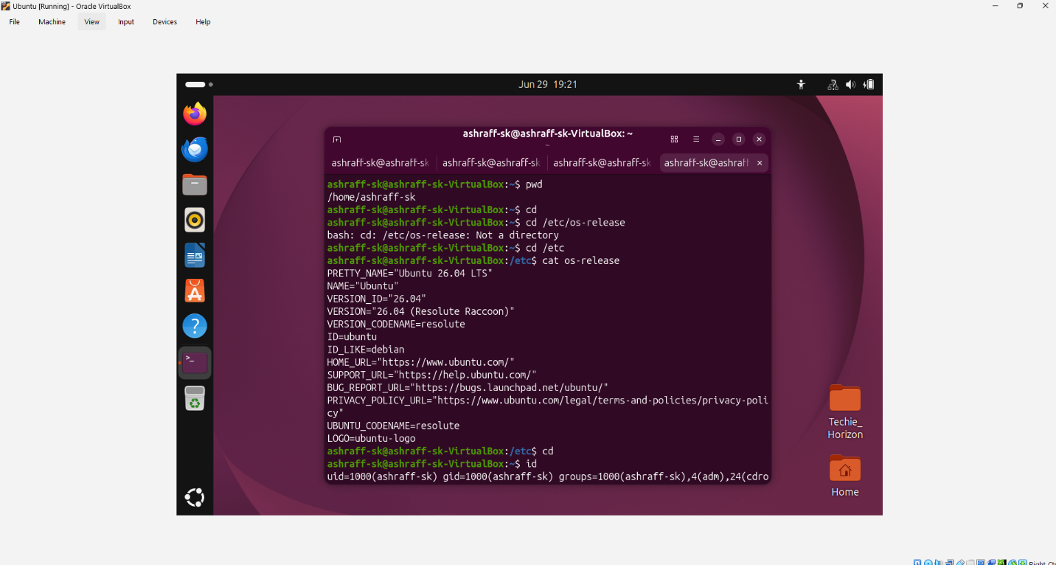
Conclusion:
I have successfully created a virtual machine using the Ubuntu 26.04 LTS image in Oracle VirtualBox. The virtual machine is now ready for Linux administration, DevOps practice, software development, and cloud computing exercises. The screenshots above illustrate the key stages of the installation process and may vary slightly depending on your VirtualBox and Ubuntu build versions.

- Install docker on ec2.
Objective
To install Docker on an Amazon EC2 instance so that you can build, run, and manage containerized applications.
Prerequisites:
AWS Account
EC2 Instance (Amazon Linux 2023)
Security Group allowing SSH (Port 22)
SSH Key Pair (.pem file)
Steps:
Step 1: Launch an EC2 Instance
Login to AWS Console.
Go to EC2.
Click Launch Instance.
Select Amazon Linux 2023 AMI.
Choose t3.large.
Create/select a key pair.
Allow SSH (Port 22).
Launch the instance.
Step 2: Connect to the EC2 Instance
ssh -i <key_pair> ec2-user@<Public-IP>
Step 3: Update the System using sudo yum update -y
Step 4: Install Docker, sudo yum install docker -y
Step 5: Start Docker Service, sudo systemctl start
docker
Step 6: Verify Docker Service
sudo systemctl status docker
Step 7: Add ec2-user to Docker Group
sudo usermod -aG docker ec2-user
Step 8: Refresh Group Membership
newgrp docker
Step 9: Now make the instance stop & start
Step 10: Verify Docker Works Without sudo
Login with ssh & run docker ps without sudo
Step 11: Run a Test Container
docker run hello-world
Expected: Hello from Docker!
This message shows that your installation appears to be working correctly.
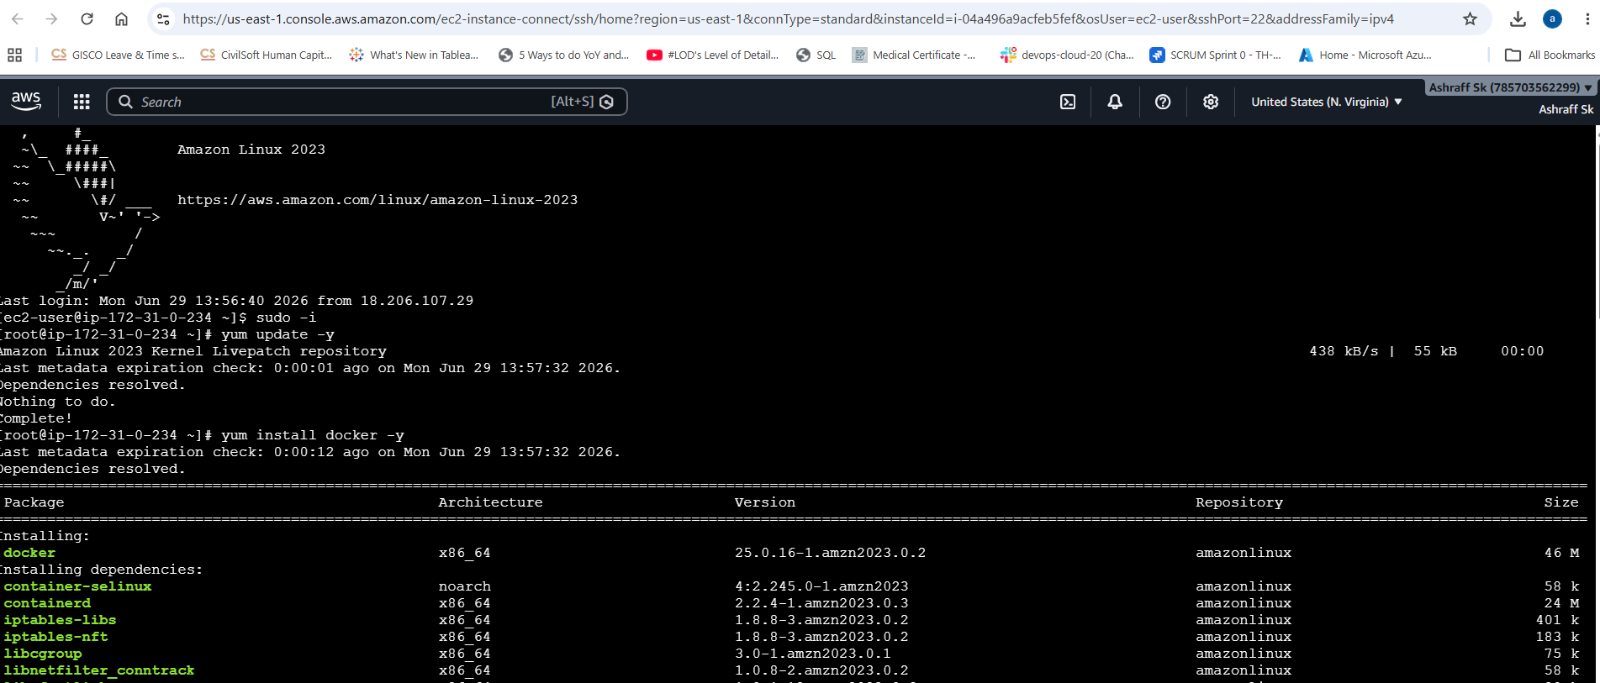
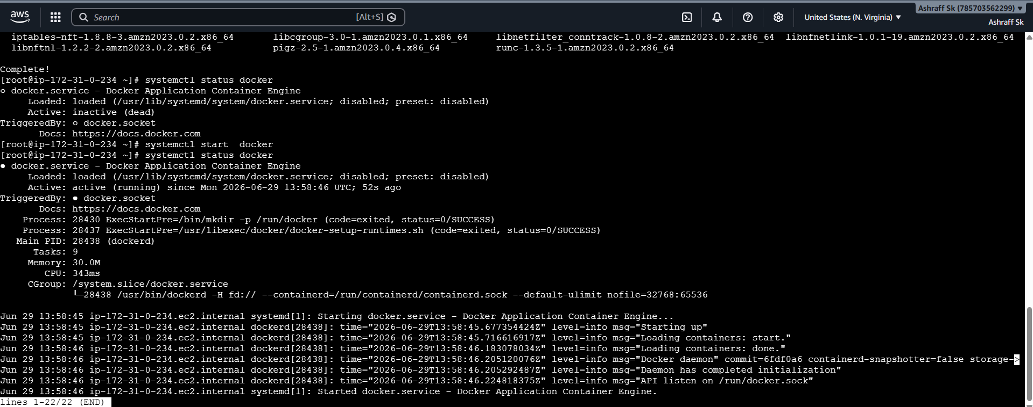
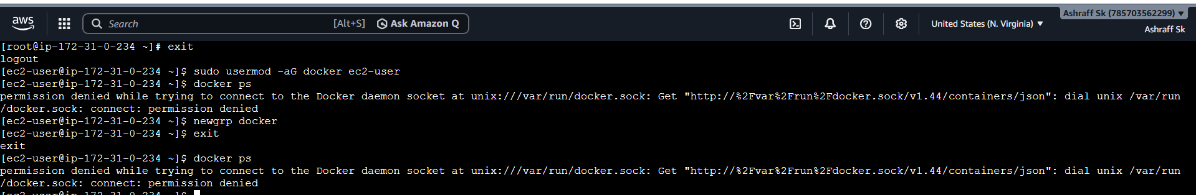
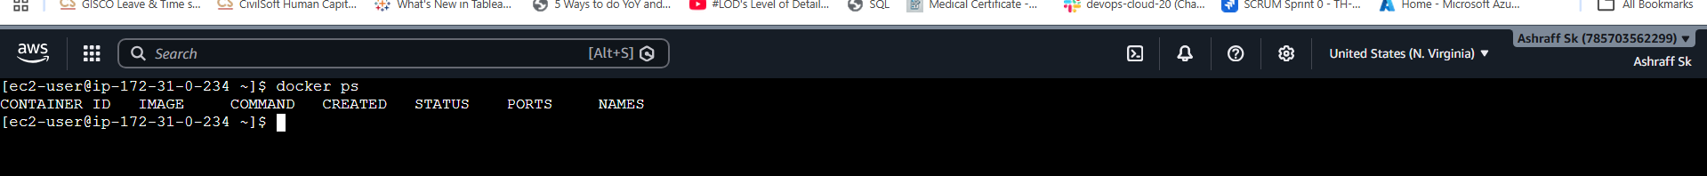
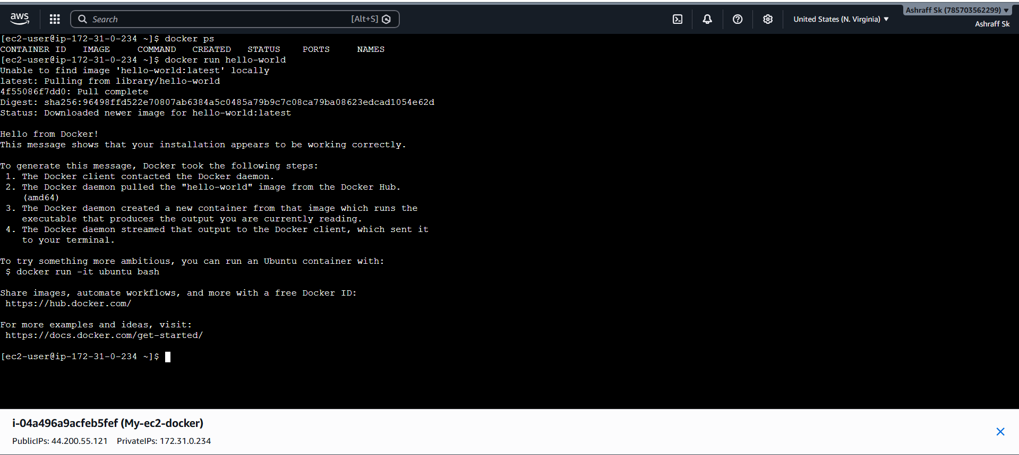

- Pull 5 docker images. (nginx, Apache tomcat, ubuntu, Jenkins, SonarQube)
Objective:
To download five commonly used Docker images from Docker Hub into an EC2 instance for deploying web servers, CI/CD tools, and application containers.
Prerequisites
AWS EC2 Instance (Amazon Linux 2023/Ubuntu)
Docker installed and running
Internet connectivity
Logged in as ec2-user (or another user with Docker permissions)
Steps:
    - Created an ec2 instance, My-ec2-docker with t3.large instance, default security group, existing key-pair & EBS volume as 20 GB.
    - Installed docker in task-01
    - Run the commands to pull the 5 docker images,
docker pull nginx:latest && \
docker pull tomcat:10 && \
docker pull ubuntu:24.04 && \
docker pull jenkins/jenkins:lts && \
docker pull sonarqube:community
- Used docker images command to see the pulled images

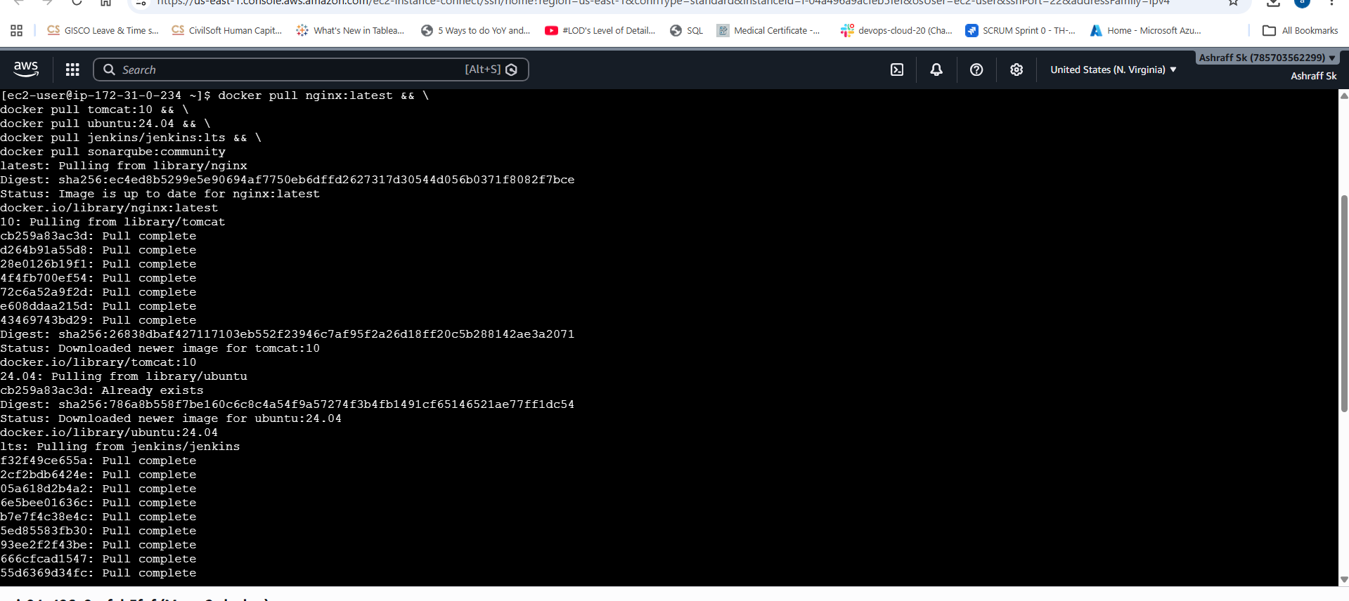
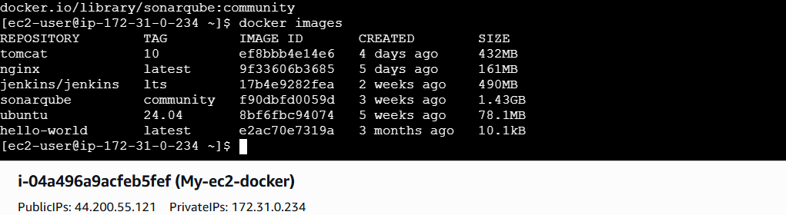
- Run nginx container and expose on port 81.

Steps:
  - Created a My-ec2-docker instance & installed docker
  - By using docker pull nginx image has been pulled from the registry
  - To run the nginx used below command:
docker run -d \
--name nginx-server \
-p 81:80 \
nginx:latest

Flag, Meaning
-d, Run in detached mode (background)
--name nginx-server, Give the container a readable name
-p 81:80, Map host port 81 → container port 80
nginx:latest, Image to use

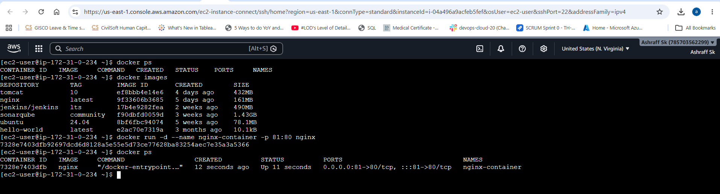
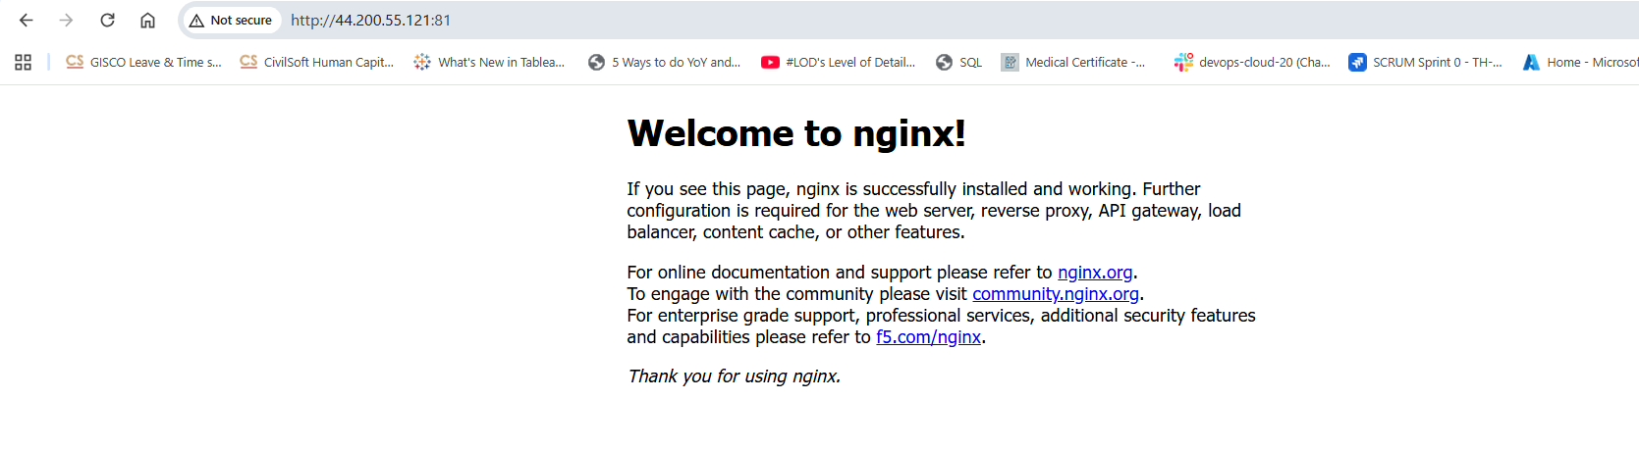

- Delete the Apache tomcat image from local.

List all images
docker images
Then remove using the IMAGE ID
docker rmi <image ID>

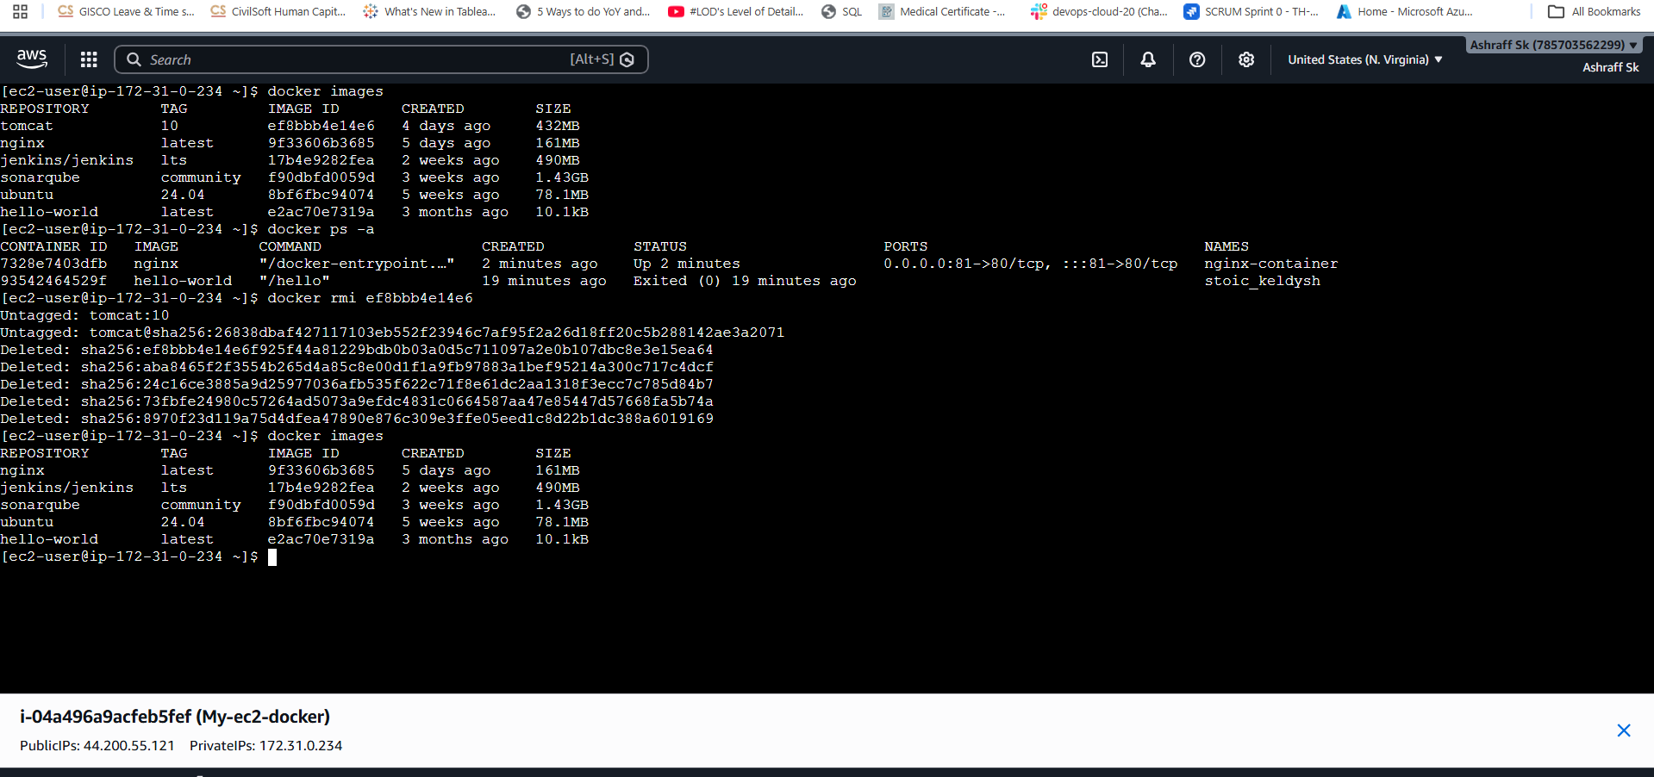

- Inspect the Jenkins image, SonarQube image.
Objective:
To inspect the Jenkins and SonarQube Docker images and view their metadata such as image ID, layers, environment variables, exposed ports, entry point, labels, and size.
Purpose
Understand Docker image metadata.
Verify image details before creating containers.
Identify exposed ports, environment variables, and startup commands.
Learn how Docker stores image configuration.
Prerequisites:
Docker installed
Jenkins image downloaded
SonarQube image downloaded
Verify available images: docker images
Steps:
Step 1: Run docker images command
From this use the repository & tag to inspect the images
Step 2: Inspect the Jenkins Image
Run
docker image inspect jenkins/jenkins:lts
Step 3: Inspect the Sonarqube Image
Run
docker image inspect
sonarqube:community
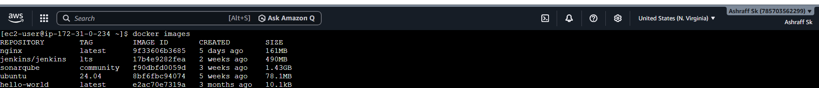
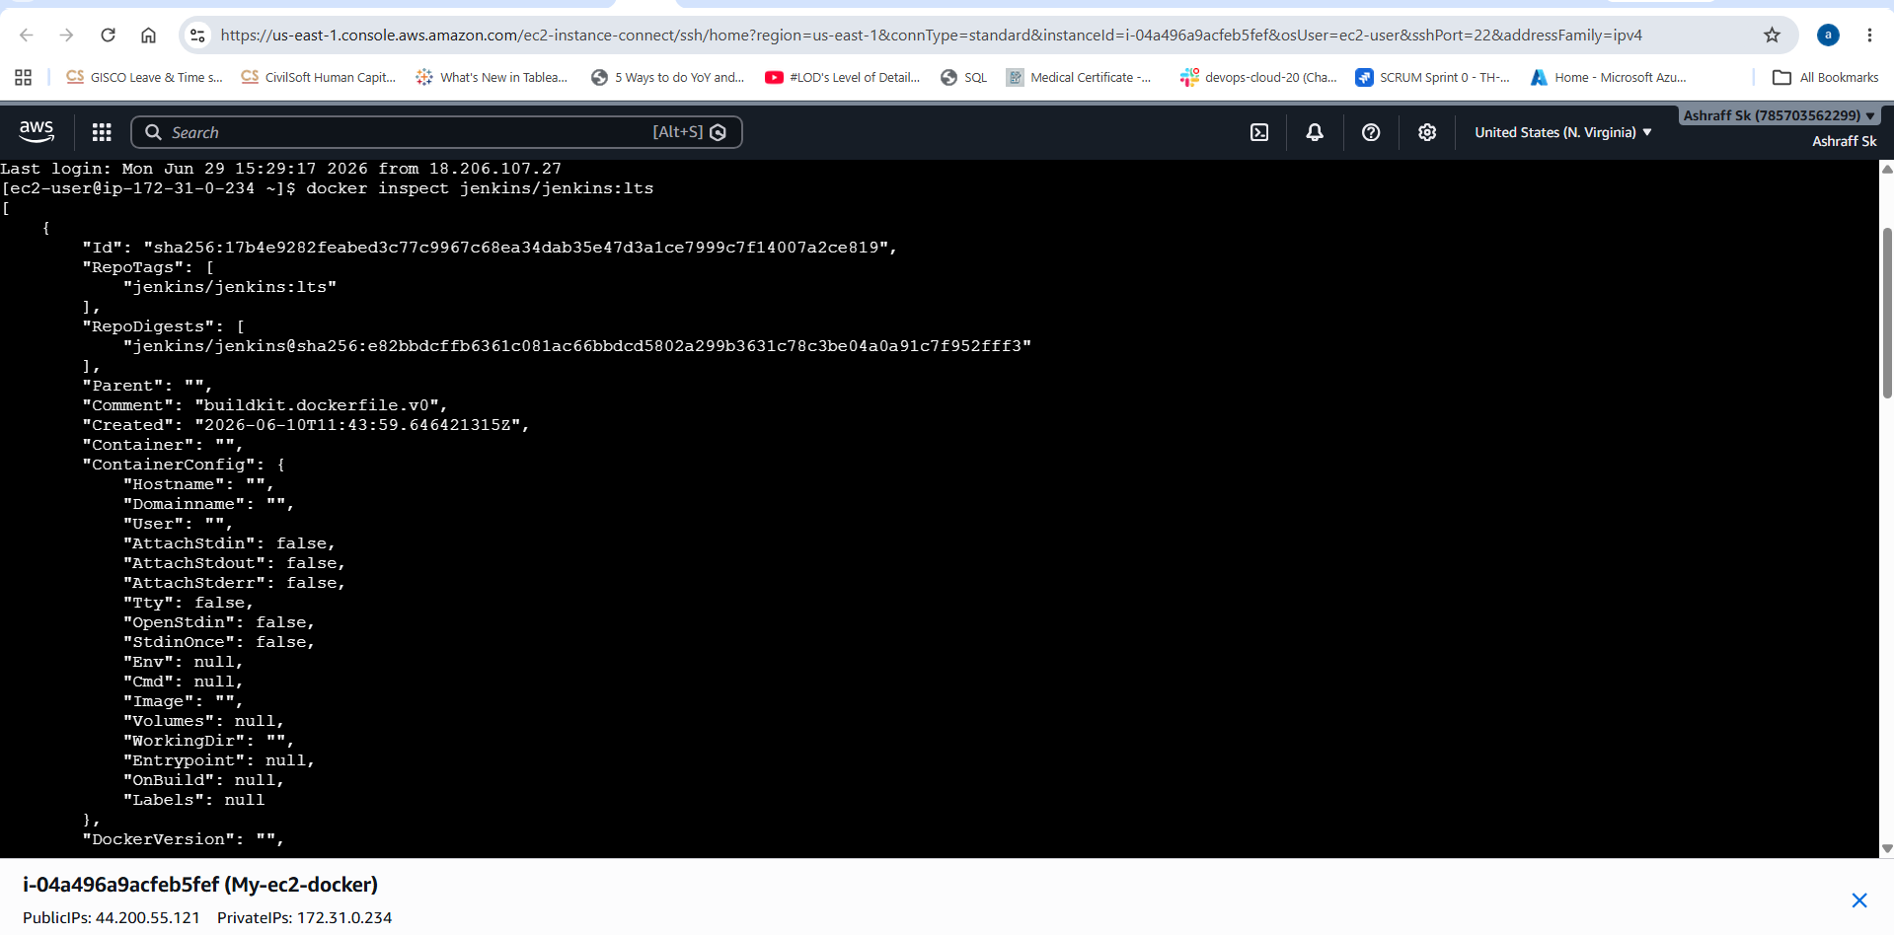
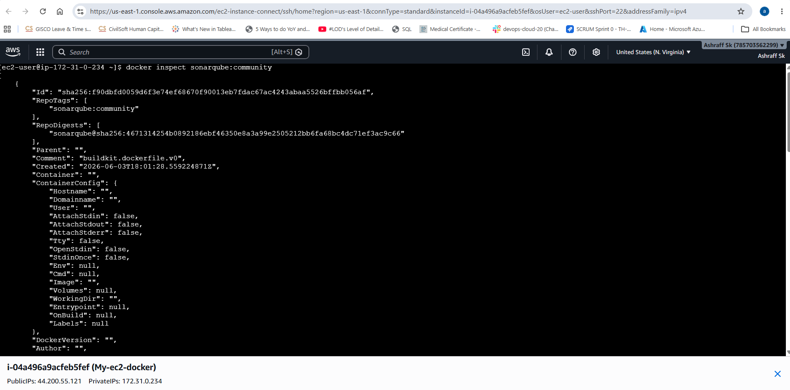
Conclusion:

Using the docker image inspect (or docker inspect) command, you can retrieve detailed metadata about Docker images without running containers. Inspecting the Jenkins and SonarQube images helps verify configuration details such as exposed ports, entry points, environment variables, and image size, making it easier to validate images before deploying them in development or production environments.
- Run Jenkins container and run one sample job.

Steps:
  - Created a My-ec2-docker instance with t3.large & EBS volume as 20 GB
  - Installed docker & pulled the Jenkins lts image
  - Run the Jenkins using below command,
docker run -d \
--name jenkins \
-p 8080:8080 \
-p 50000:50000 \
-v jenkins_home:/var/jenkins_home \jenkins/jenkins:lts

Explanation
-d → Run in detached mode
--name jenkins → Container name
8080:8080 → Jenkins Web UI
50000:50000 → Jenkins Agent port
jenkins_home → Persistent storage
  - Verified the container, docker ps
  - Access the Jenkins using, http://<EC2-Public-IP>:8080
  - Get initial password, docker exec -it jenkins cat /var/jenkins_home/secrets/initialAdminPassword
  - Unlock Jenkins by Paste the password & click continue
  - Installed Suggested Plugins & wait for installation complete
  - Created an Admin User by providing the userb=name as admin, password as India@5868, Full Name as admin & Email:ashraff452@gmail.com
  - Now click save & continue.
  - Created a Sample Freestyle Job, Sample_job
  - Configured Build Step, Add Build Step Execute Shell
Enter echo "Hello Jenkins"
echo "Docker Jenkins Container"
hostname
pwd
date
whoami
  - Now save & select Build Now
  - A build appers under build history & view console output
Expected output:
Started by user admin
Hello Jenkins
Docker Jenkins Container
ip-172-31-xx-xx
/var/jenkins_home/workspace/Sample-Job
Fri Jun 29 16:05:13 UTC 2026
jenkins
Finished: SUCCESS
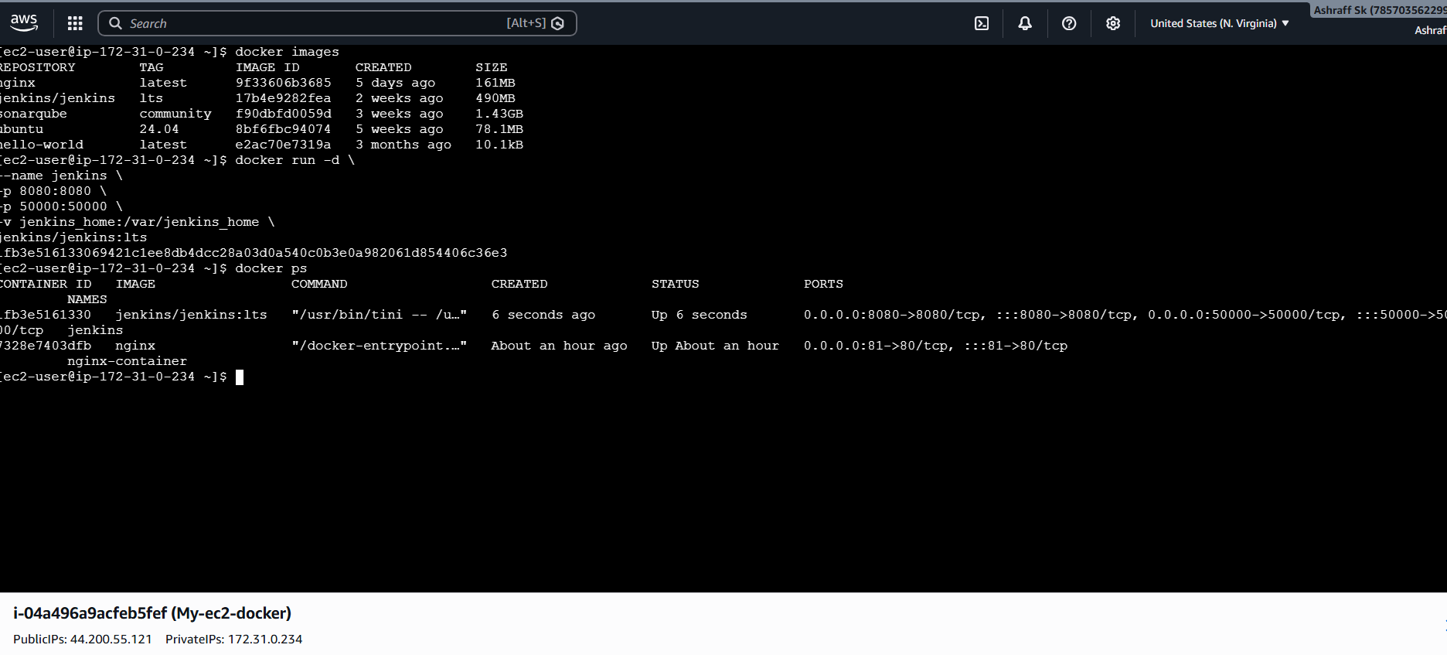
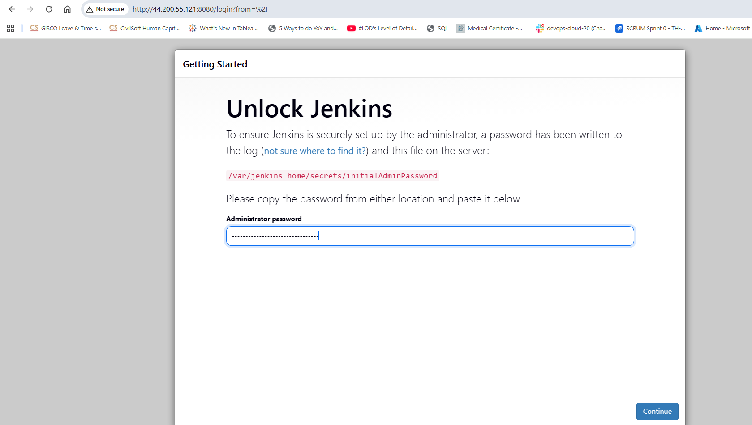
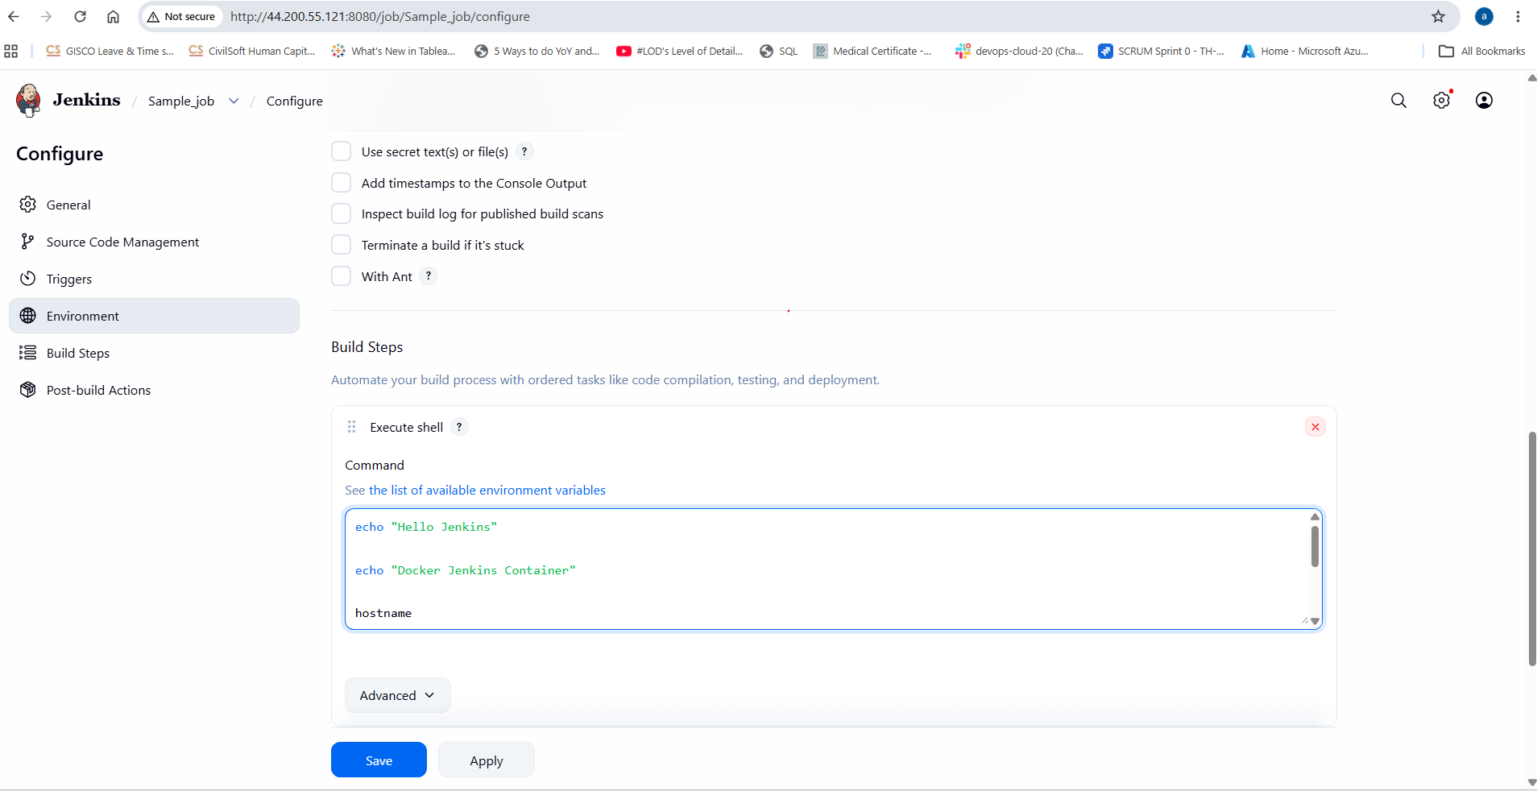
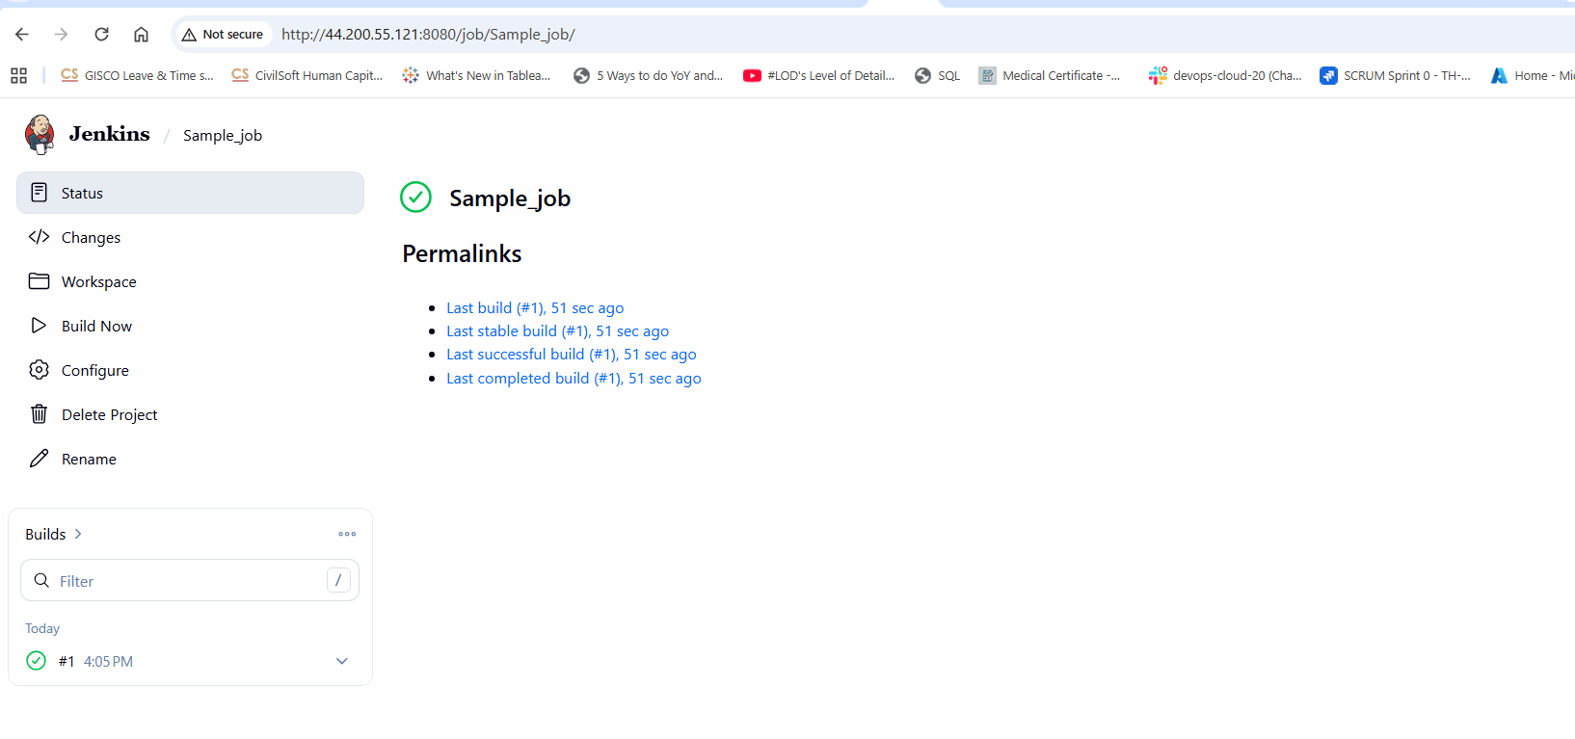
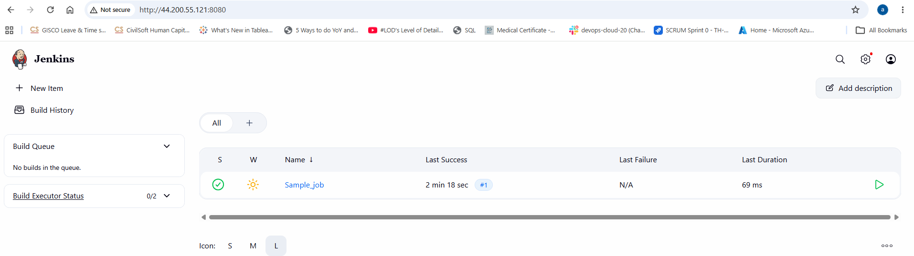
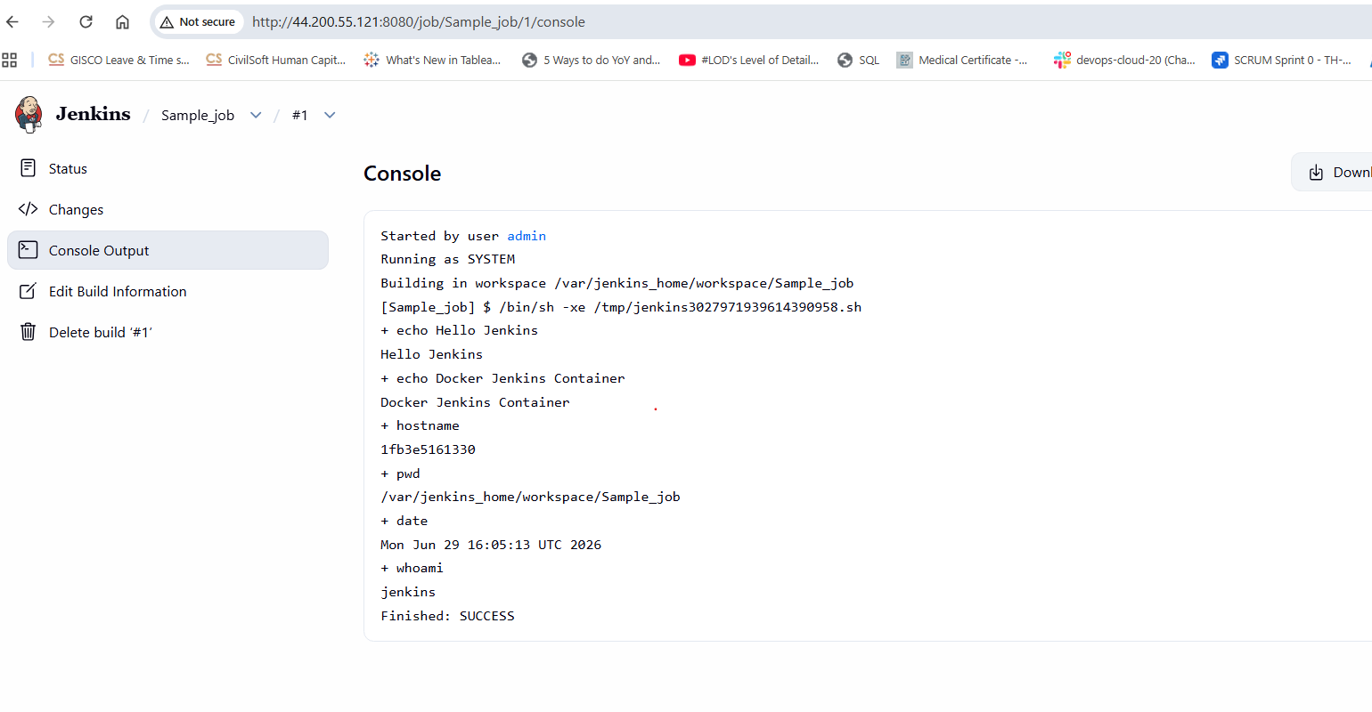
Conclusion:

We have successfully deployed Jenkins as a Docker container on an EC2 instance, configured the initial setup, created a sample Freestyle job, and verified the installation by running a successful build. This Jenkins instance is now ready for creating more advanced CI/CD pipelines.

