DOCKER – 02
- Create a tomcat container on 8080 and deploy sample application in tomcat.

Objective:

To create an Apache Tomcat Docker container on port 8080, deploy a sample Java web application (WAR file), and verify that the application is accessible through a web browser.

Purpose:
Learn how to run Apache Tomcat in Docker.
Deploy a Java web application (WAR file).
Understand Tomcat web application deployment.
Verify application deployment using a browser.

Prerequisites:
Docker installed and running
Internet connectivity (to pull the Tomcat image)
A sample WAR file (e.g., sample.war)

Steps:
- Created an ec2-instance, My-ec2-docker with t3.large instance, default security group, existing key-pair & EBS as 20 GB volume
- Connect to the instance from Ec2 instance connect in AWS & install docker using, yum install docker -y
- Docker pull tomcat:9.0
- Run the tomcat container using command,
docker run -d \
--name tomcat-server \
-p 8080:8080 \
tomcat:9.0
- Verify the container, docker ps
- Verify the tomcat is running, http://localhost:8080
- Run the command docker exec -it <tomcat_container_id> /bin/bash to connect the tomcat
- Go to webapps, cd /usr/local/tomcat/webapps
- Since there is no application deployed we get 404 error in browser
- In /usr/local/tomcat/webapps wget <sample.war_url> to download
- Run the command to get wget installed & vi editor in tomcat container
apt-get update && apt-get install -y wget
apt-get update && apt-get install -y vim
- Now in the browser we can see the deployed sample file.
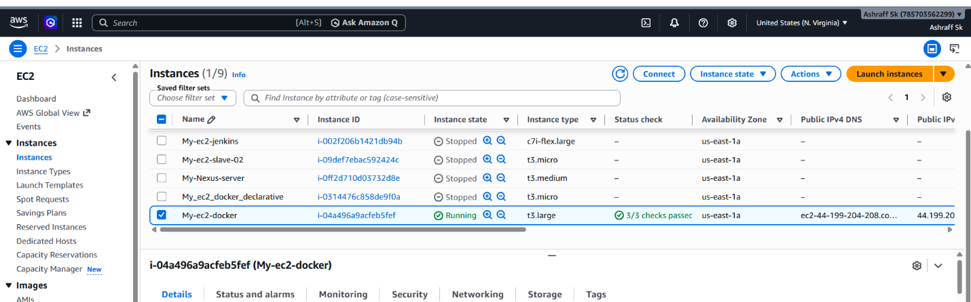

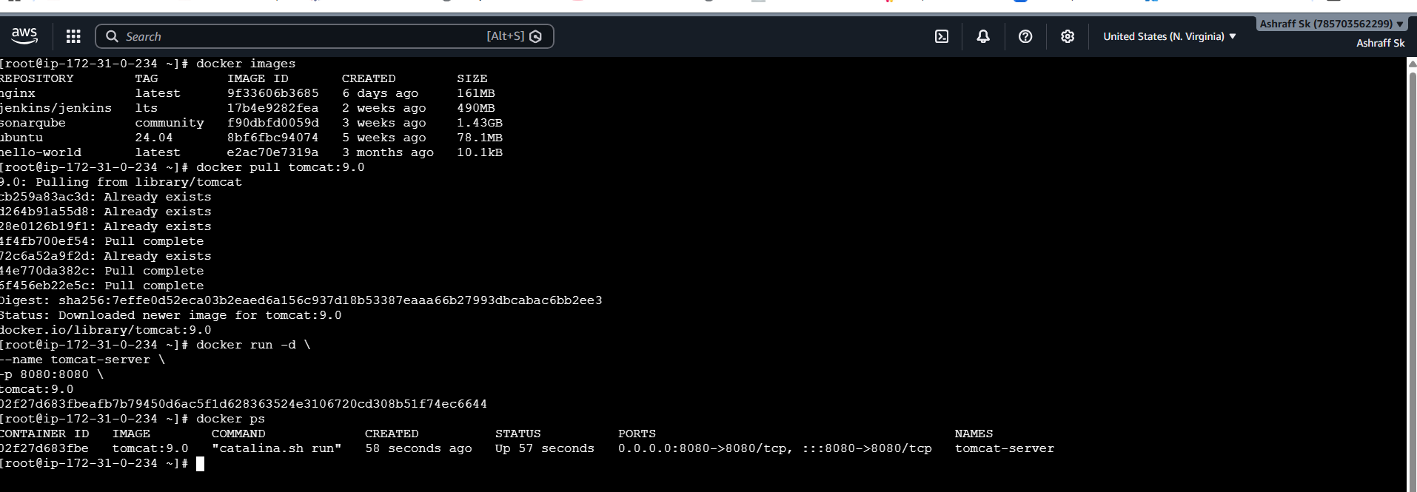

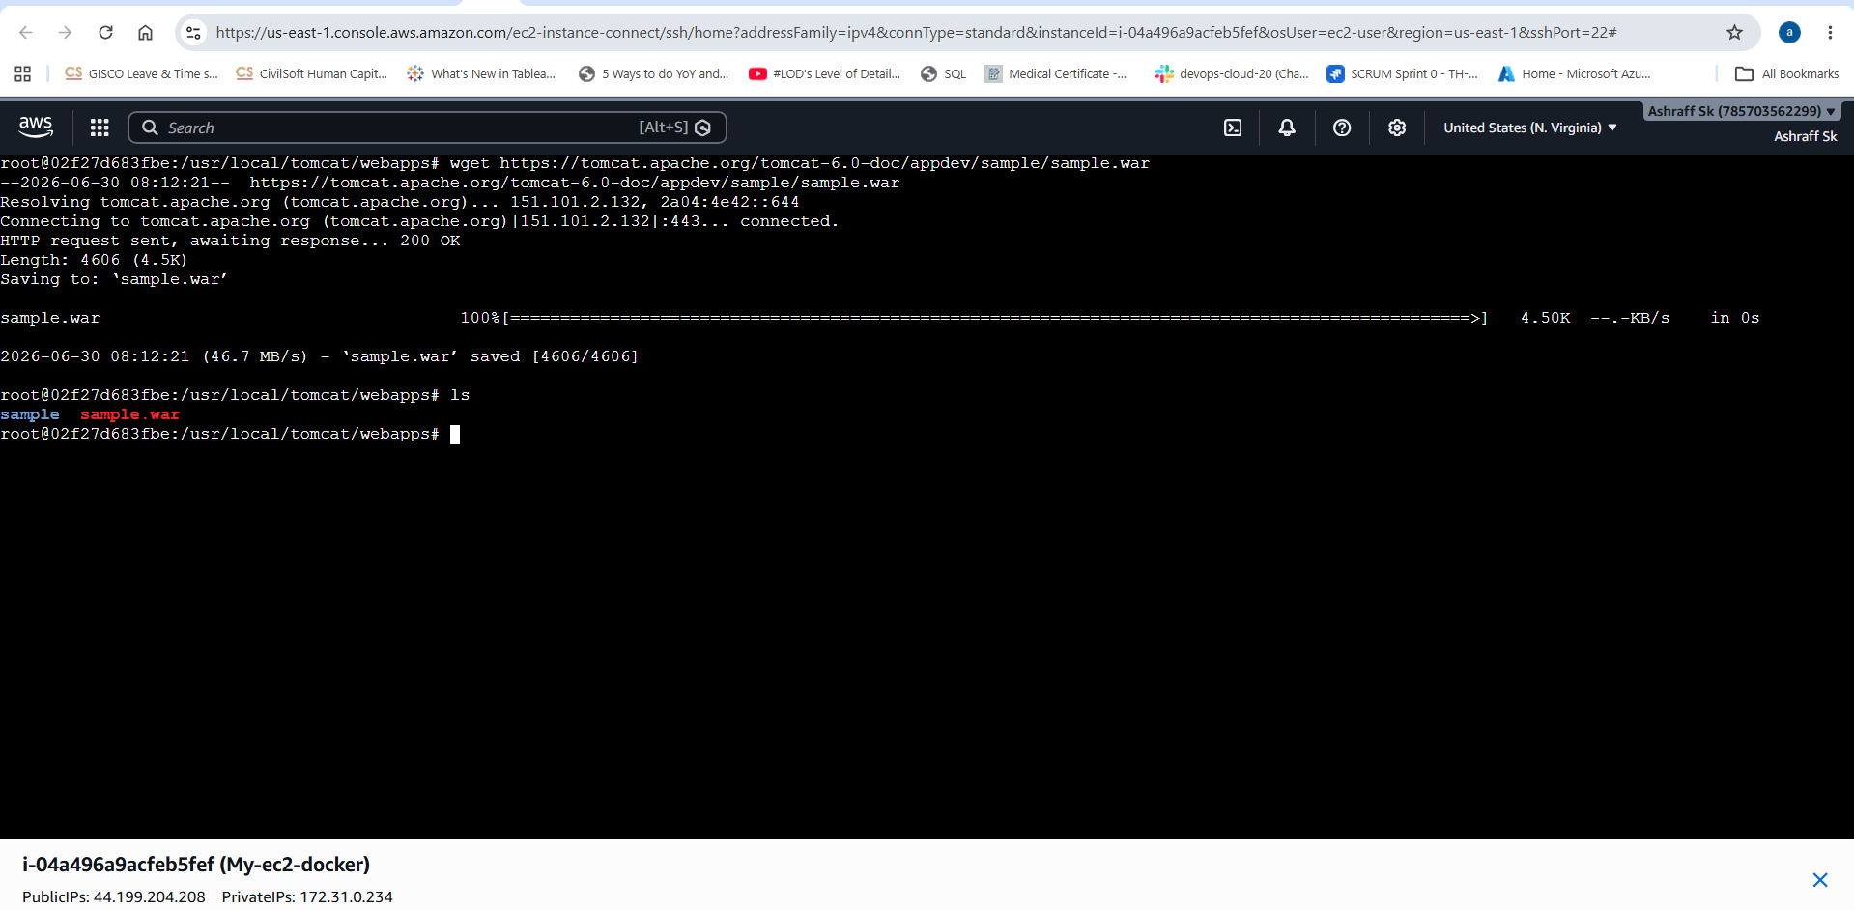

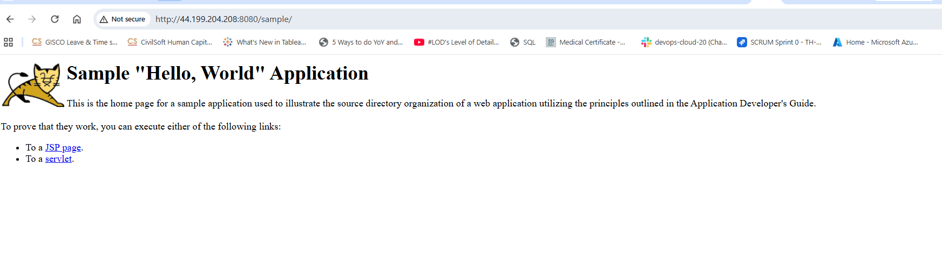
- Create volume and deploy tomcat container on port 8081.

Objective:

To create a Docker volume for persistent storage and deploy an Apache Tomcat container using that volume, exposing the application on port 8081.

Purpose:
Understand Docker volumes for persistent data storage.
Deploy an Apache Tomcat container using a named volume.
Access Tomcat through port 8081.
Ensure application data persists even if the container is removed.

Prerequisites:
Docker installed and running
Internet connection
User with Docker privileges
Steps:
- Verified the docker installation, docker –version
- Pull the tomcat image, docker images
- Created a docker volume, docker volume create tomcat_deployment
- Verify the volume, docker volume ls
- Inspect the docker volume, docker volume inspect tomcat_deployment
- Run the tomcat container on port 8081, docker run -itd -p 8081:8080 -v /var/lib/docker/volumes/tomcat_deployment/_data:/usr/local/tomcat/webapps tomcat:9.0
- Verified the running container, docker ps
- Verified the tomcat using url, http://localhost:8081
- Verified the mounted volume & webapps of new tomcat container.


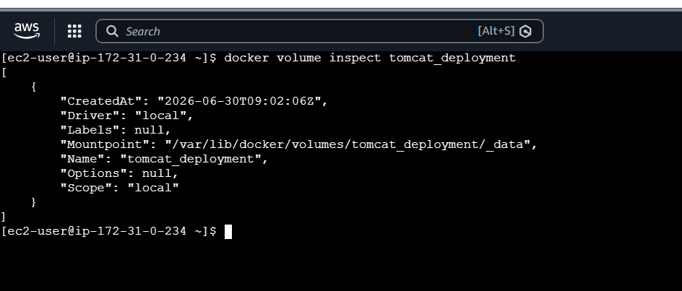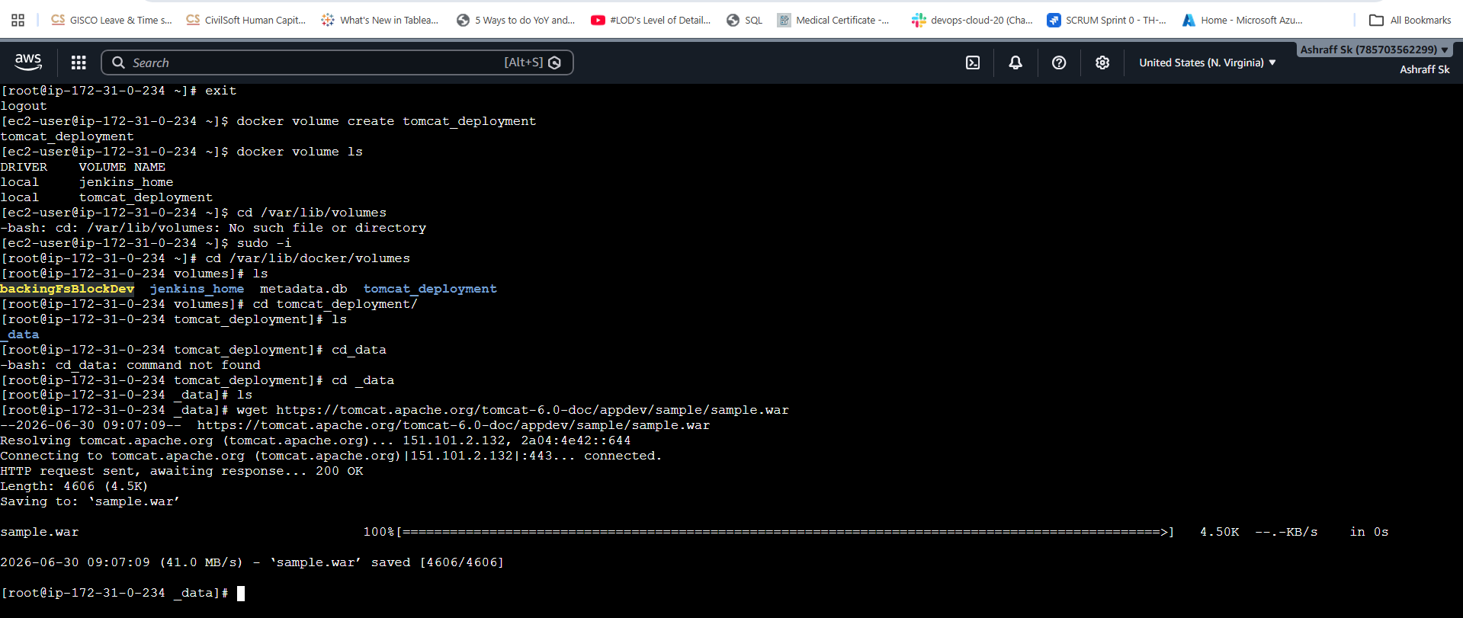
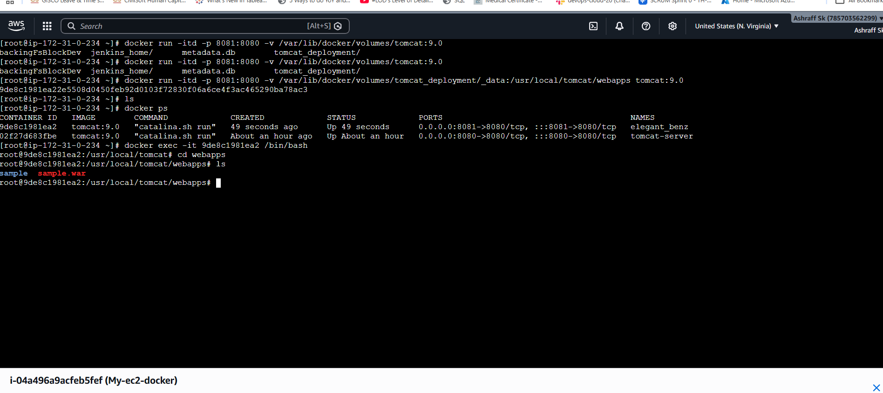
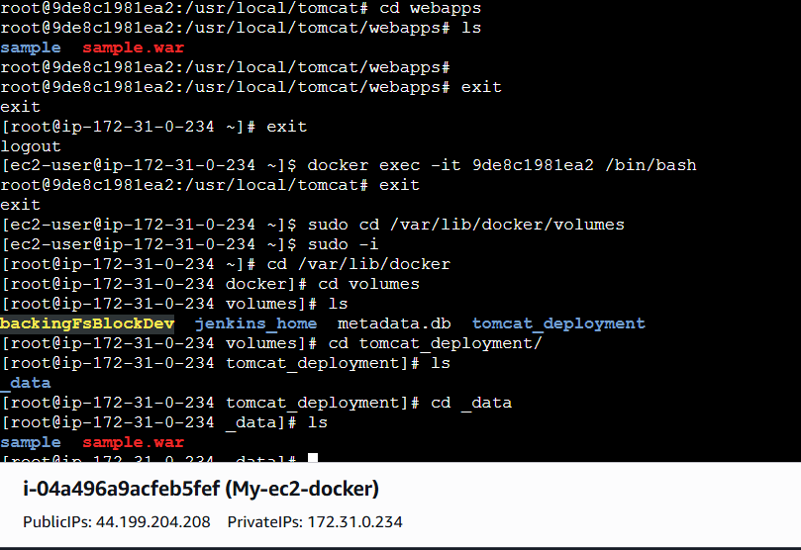
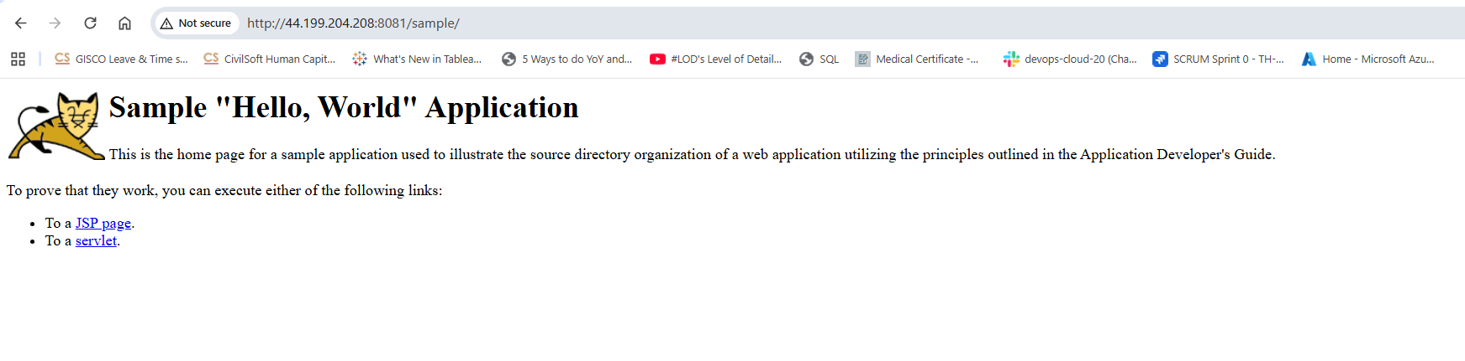
Expected Outcome:
Docker volume tomcat-data is created.
Apache Tomcat container starts successfully.
Tomcat is accessible on http://localhost:8081 (or http://<EC2-Public-IP>:8081).
The Docker volume stores web application data persistently.
Data remains available even after the container is removed and recreated with the same volume.

Conclusion:

You have successfully created a Docker volume and deployed an Apache Tomcat container on port 8081 using that volume. The volume provides persistent storage for Tomcat's web applications, ensuring that deployed content is retained across container restarts or recreations, which is a common practice in production container environments.

- Limit the nginx container to 500 MB.

Objective:

To run an Nginx Docker container with a maximum memory limit of 500 MB.

Purpose:
Learn how to restrict container memory usage.
Prevent a container from consuming excessive host memory.
Understand Docker resource management using memory limits.

Prerequisites:
Docker installed and running
Internet connection (to pull the Nginx image)

Steps:

    - First pull the nginx image 7 if available, docker images
    - Run the Nginx Container with a 500 MB Memory Limit, docker container run -itd -p 8082:80 –memory=500m nginx:latest
    - Verify the stats, docker stats
    - Verify the nginx running on port 8082 in browse, htttp://public ipv4:8082
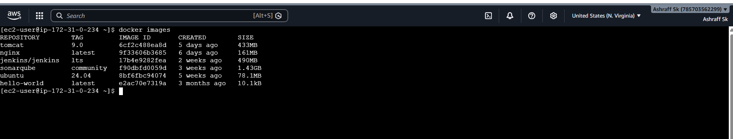

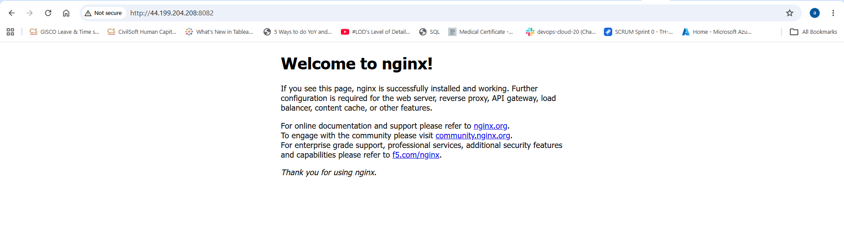
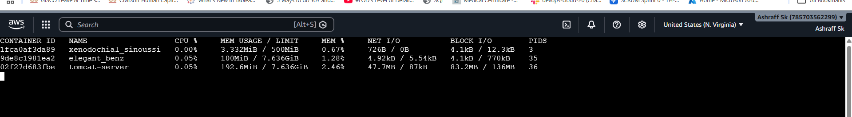

Expected Outcome:
Nginx container starts successfully.
The container's memory usage is limited to 500 MB.
The Nginx web page is accessible on port 8082.
Memory limits can be verified using docker inspect and docker stats.
Conclusion:

We have successfully deployed an Nginx container with a 500 MB memory limit using Docker's --memory option. Resource limits help improve system stability, prevent containers from consuming excessive memory, and are an important best practice for running applications in production environments.
- Create a sample docker file using below instructions.
  - Base module as amazonlinux:latest
  - Maintainer you name
  - Install nginx
  - COPY one index.html file to image
  - Expose on port 80
  - Command to start the nginx container
Objective:

To create a Docker image using amazonlinux:latest as the base image, install Nginx, copy a custom index.html file into the image, expose port 80, and run the Nginx web server.
Purpose:
Learn how to create a custom Docker image.
Understand Dockerfile instructions.
Install software inside a Docker image.
Deploy a custom web page using Nginx.
Prerequisites:
Docker installed and running
Internet connection
Linux terminal or command prompt
Steps:
Step 1: Create a Project Directory
Create a directory for the Docker project.
mkdir nginx-docker
cd nginx-docker
Step 2: Create an index.html File
Create a file named index.html.
vi index.html
Step 3: Create the Dockerfile
Create a file named Dockerfile.
vi Dockerfile
# Base Image
FROM amazonlinux:latest
# Maintainer
LABEL maintainer="Shaik"
# Install Nginx
RUN yum update -y && \
yum install -y nginx && \
yum clean all
# Copy Custom Web Page
COPY index.html /usr/share/nginx/html/index.html
# Expose Port
EXPOSE 80
# Start Nginx
CMD ["nginx", "-g", "daemon off;"]

Save the file.
FROM amazonlinux:latest Uses Amazon Linux as the base image
LABEL maintainer="Shaik" Adds maintainer information
RUN yum install -y nginx Installs the Nginx web server
COPY index.html ... Copies the HTML page into the image
EXPOSE 80 Documents that the container listens on port 80
CMD ["nginx","-g","daemon off;"] Starts Nginx in the foreground
Step 4: Build the Docker Image
Run the following command:
docker build -t my-nginx:v1
Step 5: Verify the Image
docker images
Step 6: Run the Container
Run the image and map port 8080 on the host to 80 in the container.
docker run -d \
--name my-nginx-container \
-p 8080:80 \
my-nginx:v1
Step 7: Verify the Running Container
docker ps
Step 8: Test the Application
Open a web browser.
For a local machine:
http://localhost:8080
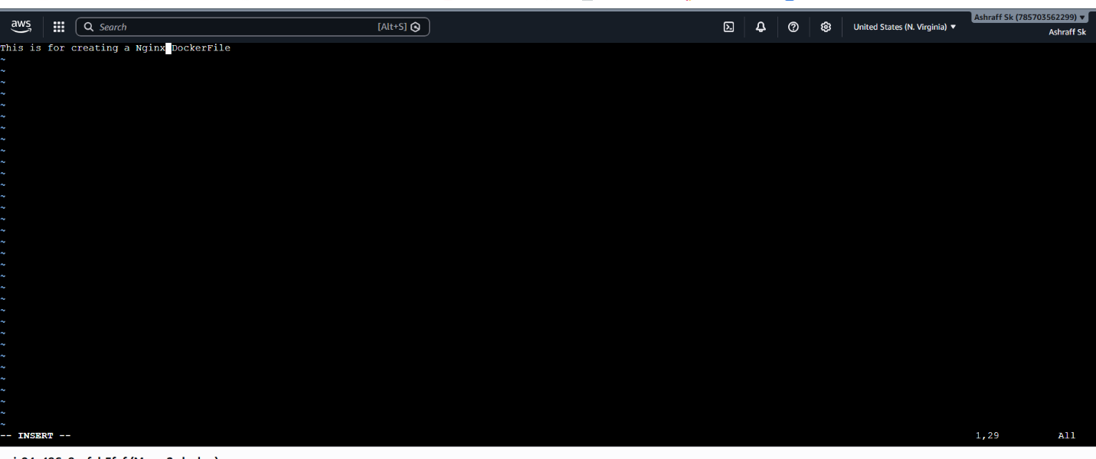
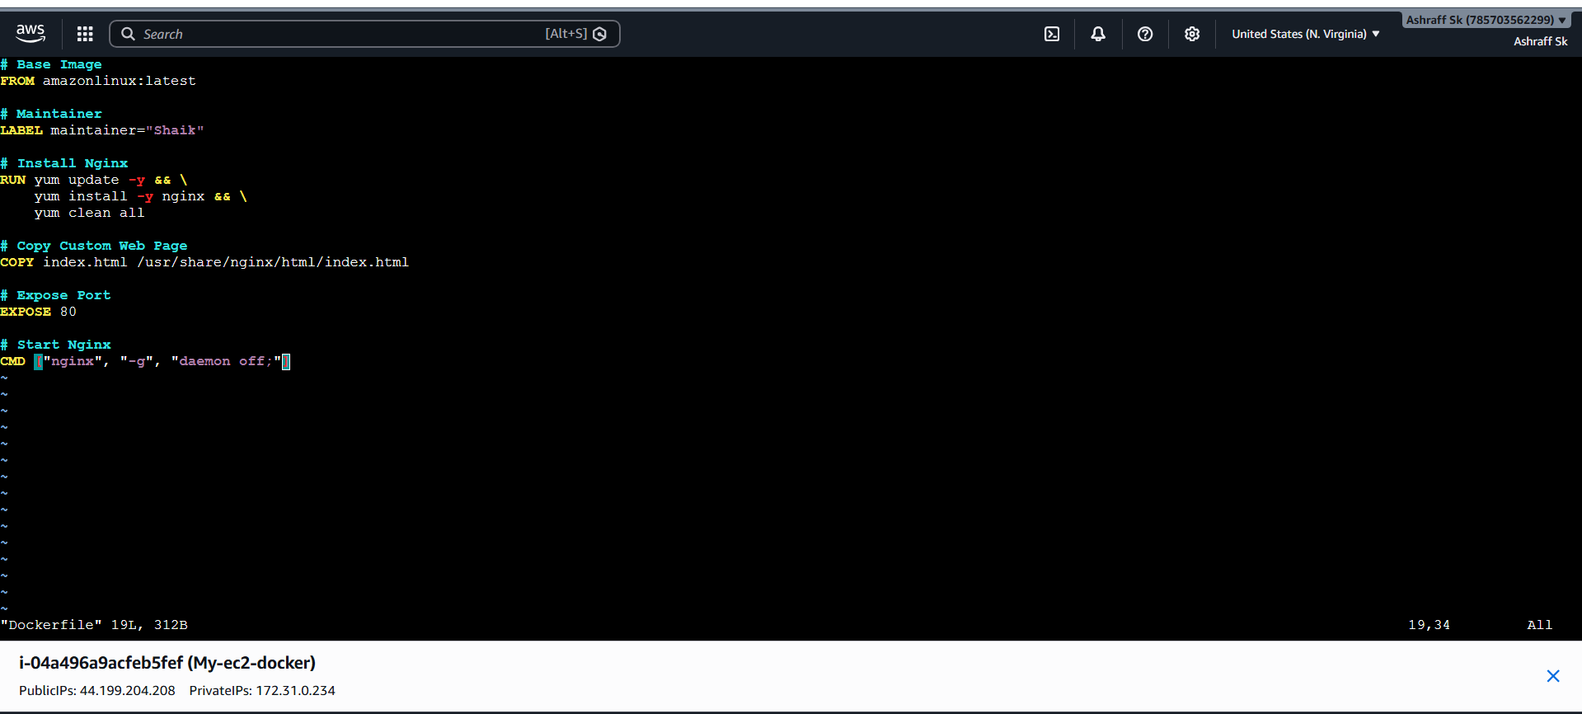
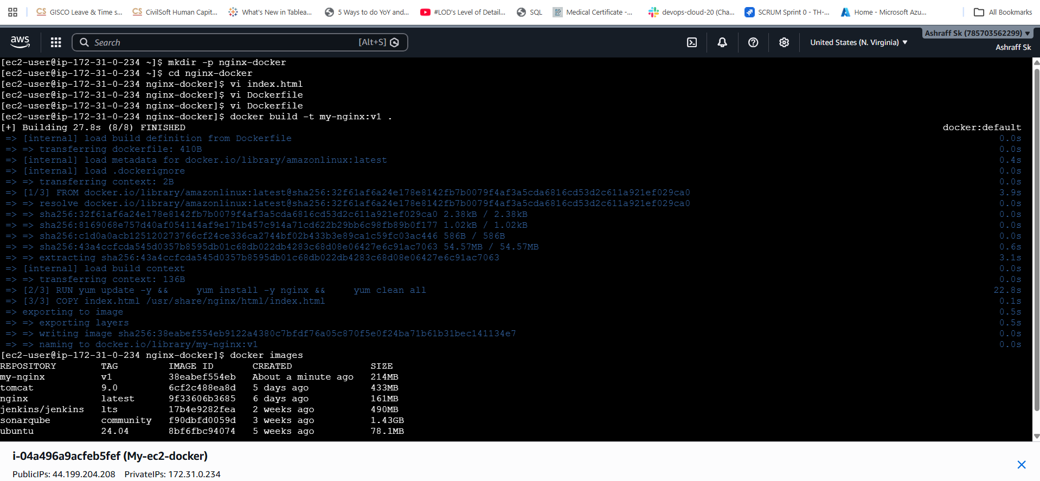
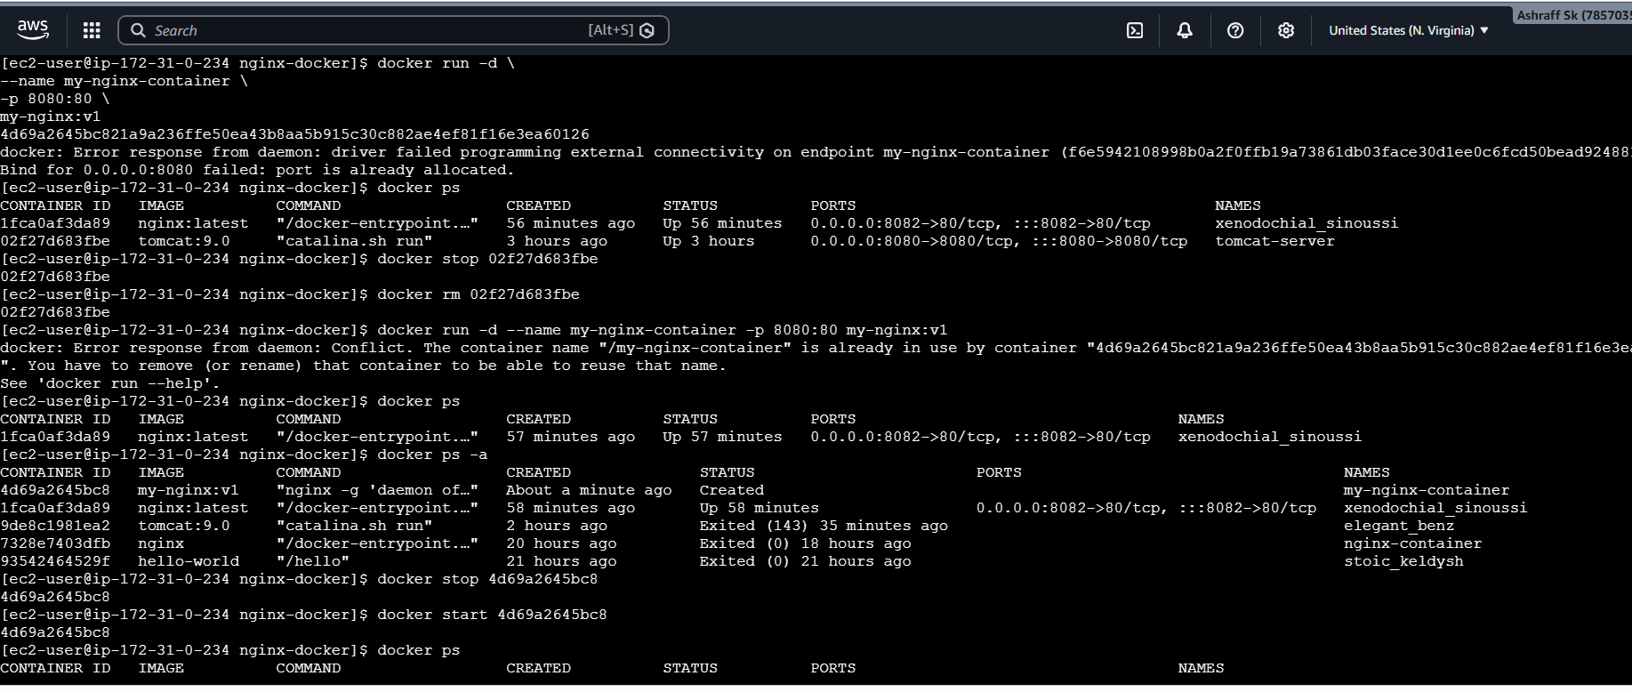
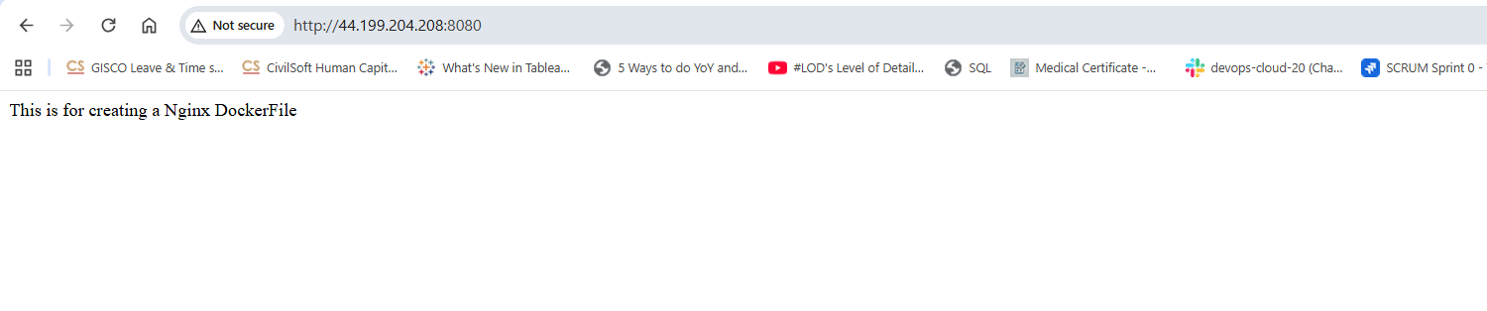
Expected Outcome:
Docker image is successfully built using amazonlinux:latest.
Nginx is installed in the image.
The custom index.html file is copied into the Nginx web root.
The image exposes port 80.
The container starts successfully and serves the custom web page.
Conclusion:

We have successfully created a custom Docker image using Amazon Linux as the base image. The Dockerfile installs Nginx, copies a custom index.html page, exposes port 80, and starts the Nginx server. This demonstrates the fundamental Dockerfile instructions (FROM, LABEL, RUN, COPY, EXPOSE, and CMD) used to build and run custom container images.

- Push image to Docker hub

Objective:

To tag a locally built Docker image and push it to a Docker Hub repository.

Purpose:
Learn how to publish Docker images.
Store custom images in Docker Hub.
Share images across systems.
Use images for deployment in CI/CD pipelines.
Prerequisites:
Docker installed and running
A Docker Hub account
A Docker image available locally (e.g., my-nginx:v1)
Internet connection
Steps:
Step 1: Verify the Local Docker Image
List all Docker images:
docker images
Step 2: Create a Repository in Docker Hub
ashraff-0452 & make it as public and click create
Step 3: Log in to Docker Hub from the Terminal
Run:docker login
Enter credentials
Username & Password
Now it shows as Login Succeeded
Step 4: Tag the Docker Image

Tag the image using your Docker Hub username.
docker tag my-nginx:v1 ashraff452/ashraff-0452:v1
Step 5: push the image
Docker push ashraff452/ashraff-0452:v1
Step 6: Verify the Image on Docker Hub
Open https://hub.docker.com.
Go to Repositories.
Open ashraff-0452.
Verify that the v1 tag is listed
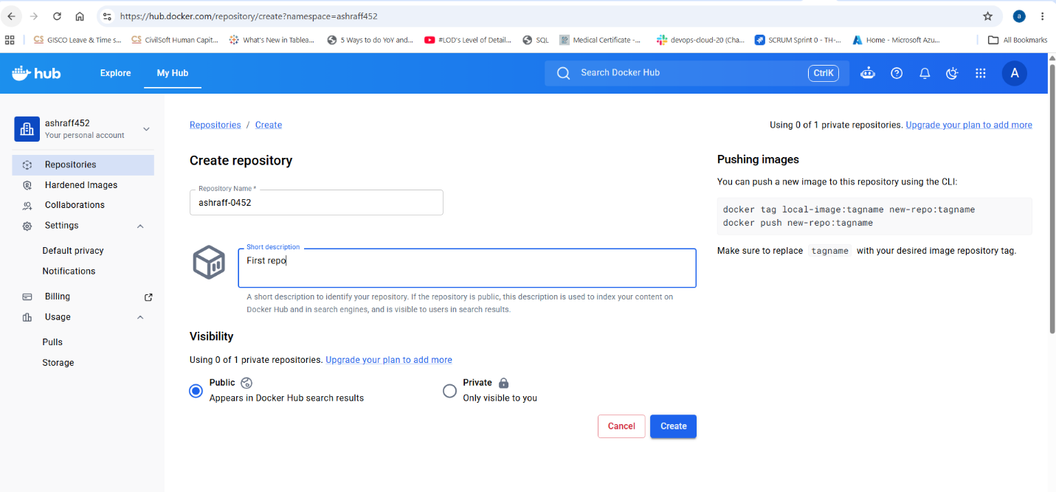
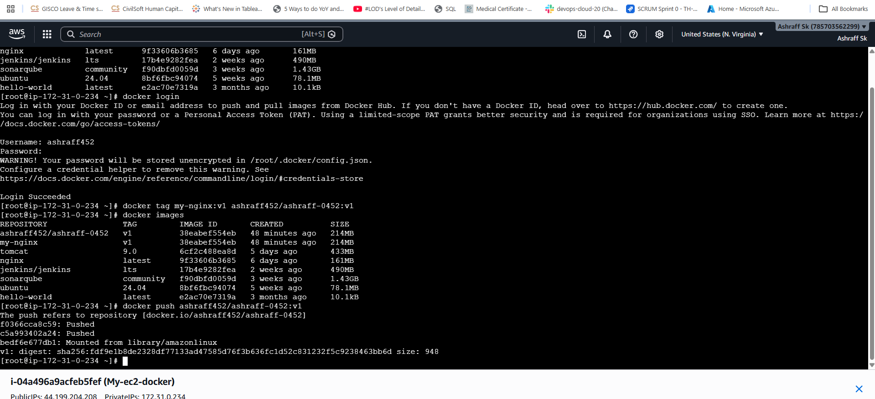
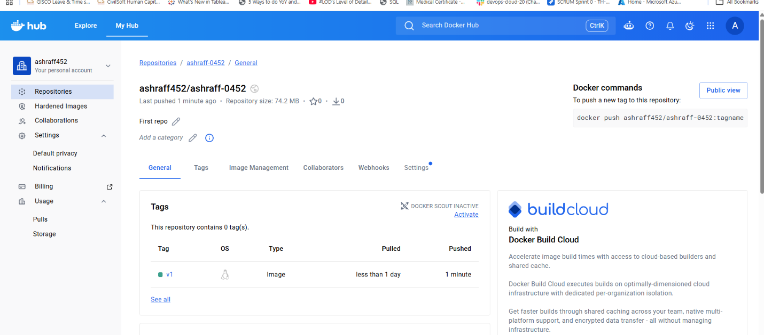

- push image to AWS ECR

Objective:

To create an Amazon ECR repository, authenticate Docker with AWS, tag a local Docker image, and push it to AWS Elastic Container Registry (ECR).
Purpose:
Learn how to use Amazon ECR.
Store Docker images securely in AWS.
Prepare images for deployment to ECS, EKS, or EC2.
Understand the Docker image push workflow in AWS.
Prerequisites:
AWS Account
IAM user with AmazonEC2ContainerRegistryFullAccess (or equivalent permissions)
AWS CLI installed and configured
Docker installed and running
A local Docker image (e.g., my-nginx:v1)
Verify AWS CLI:
Steps:
Step 1: Configure AWS CLI
Configure your AWS credentials:
aws configure & enter AWS Access Key ID,
AWS Secret Access Key,
Default region name &
Default output format
Verify:
aws sts get-caller-identity
Step 2: Create an ECR Repository
Run the following command:
aws ecr create-repository --repository-name my-nginx
Step 3: Verify the Repository
aws ecr describe-repositories
Step 4: Authenticate Docker to Amazon ECR
Run:
aws ecr get-login-password --region us-east-1 | docker login --username AWS --password-stdin <account_id>.dkr.ecr.us-east-1.amazonaws.com
Step 5: Tag the Docker Image
Syntax:

docker tag <local-image>:<tag> <account-id>.dkr.ecr.<region>.amazonaws.com/<repository>:<tag>
Step 6: Push the Imag<account_id> to ECR
docker push .dkr.ecr.us-east-1.amazonaws.com/my-nginx:v1
Step 8: Verify the Image in ECR
List images:
aws ecr list-images --repository-name my-nginx
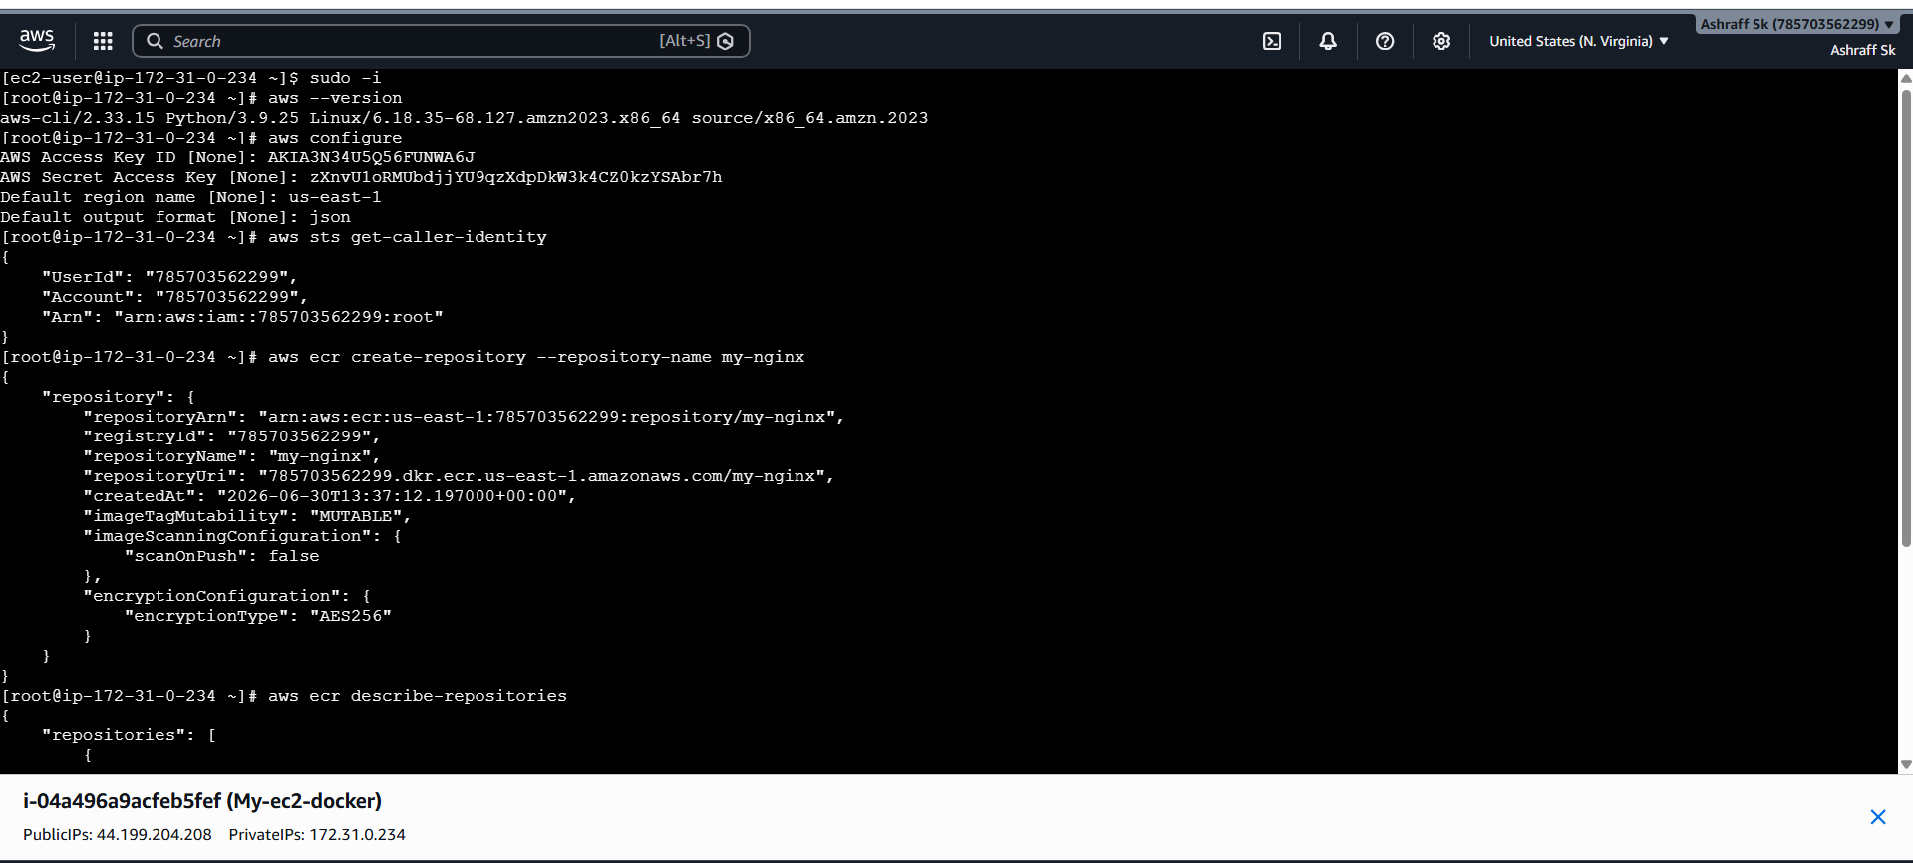
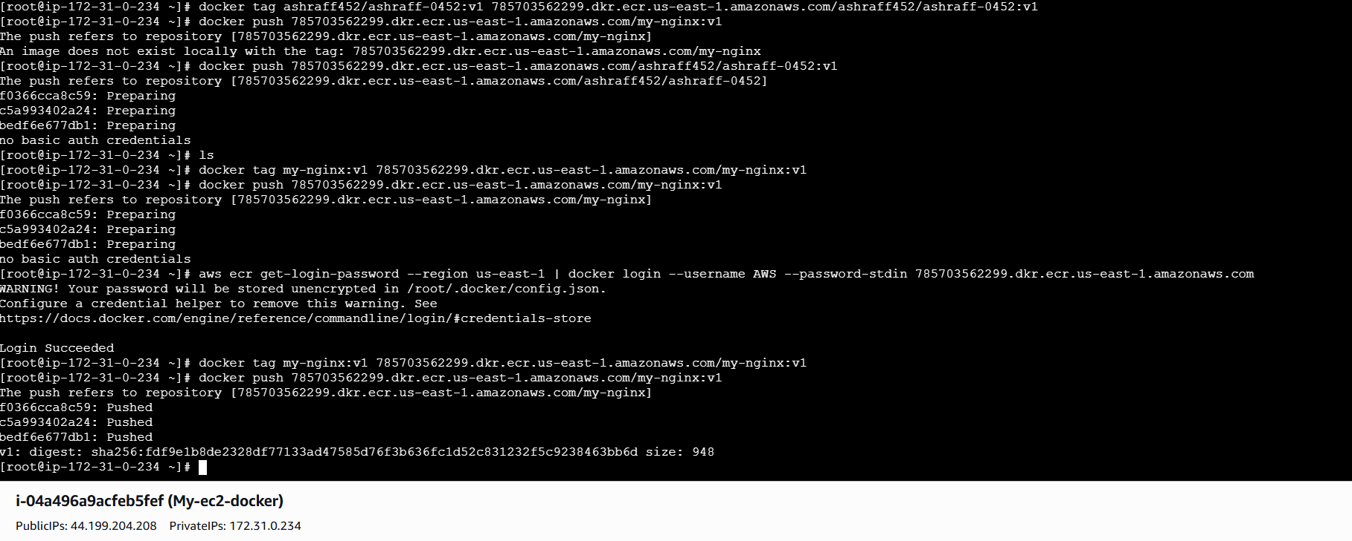
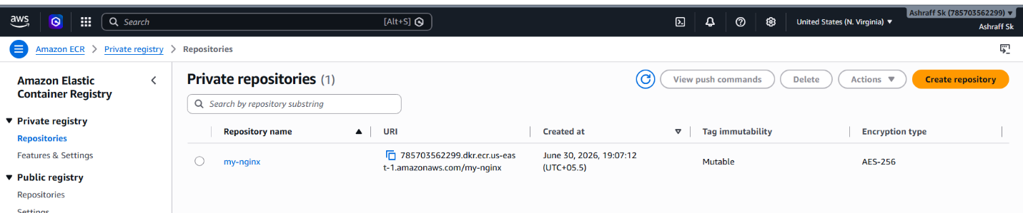
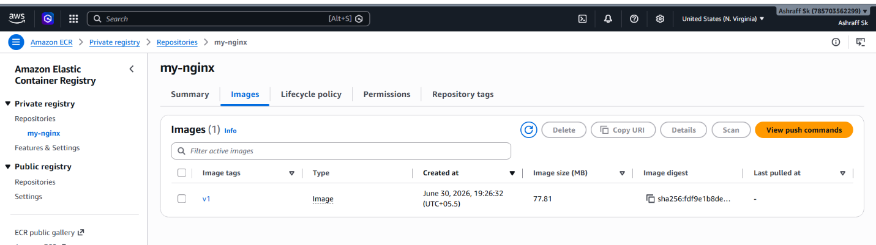
Conclusion:

We have successfully pushed a Docker image to Amazon Elastic Container Registry (ECR). By creating an ECR repository, authenticating Docker with AWS, tagging the image using the ECR repository URI, and executing docker push, the image is securely stored in AWS and is ready for deployment to services such as Amazon ECS, Amazon EKS, or EC2.

