Challenge -JENKINS
Use the below code and implement our CICD stages.

- Source Code:https://github.com/betawins/hiring-app.git
  - Repository contains the application code for the hiring app.

- Create one Declarative pipeline job
Steps:
- Created an ec2-instance, My-ec2-jenkins with instance type, c7i.flex.large, default security group.
- Installed java-21 in this instance as it is a prerequisite for Jenkins
- Installed Jenkins & connected with ipv4 & port 8081
- Installed plugins & changed the admin password
- Created an ec2 instance, My-ec2-docker_sonarqube with docker installed, sonarqube & tomcat installed
- Installed the sonarqube_scanner, maven, nexus artifactory uploader & Deploy to container plugins & done the configuration in settings, Tools with the valid credentials in Jenkins GUI.
- Now in GUI create a new job, hiring_app_pipeline selecting job as pipeline & create
- In configure, pipeline write the below declarative pipeline code to integrate & deploy to tomcat application.

pipeline {
agent any
tools {
maven 'MVN_HOME'
}
stages {
stage('Git Clone') {
steps {
git branch: 'main',
url: 'https://github.com/betawins/hiring-app.git'
}
}
stage('SonarQube Integration') {
steps {
withSonarQubeEnv('sonarqube-srvr') {
sh '''
mvn sonar:sonar\
-Dsonar.projectKey=Ashraff-app\
-Dsonar.projectName=Ashraff-app
'''
}
}
}

stage('Maven Build') {
steps {
sh 'mvn clean package -DskipTests'
}
}
stage('Publish to Nexus') {
steps {
// This step is provided by the Nexus Artifact Uploader plugin
nexusArtifactUploader(
nexusVersion: 'nexus3',
protocol: 'http',
nexusUrl: '100.53.70.44:8081',
groupId: 'in.javahome',
version: '0.1',
repository: 'Hiring_app',
credentialsId: 'Nexus_server', // Jenkins Credential ID
artifacts: [
[artifactId: 'hiring', classifier: '', file: "target/hiring.war", type: 'war']
]
)
}
}

stage('Deploy to Tomcat') {
steps {
deploy adapters: [
tomcat9(
credentialsId: 'tomcat_deploy',
url: 'http://98.92.201.18:8080/'
)
],
contextPath: '',
war: '**/*.war'
}
}
}

post {
success {
slackSend(
channel: "#all-ashraff",
color: 'good',
message: "SUCCESS: ${JOB_NAME} #${BUILD_NUMBER} deployed successfully"
)
}
failure {
slackSend(
channel: "#all-ashraff",
color: 'danger',
message: "FAILED: ${JOB_NAME} #${BUILD_NUMBER}"
)
}
}
}
- Now click build now
- Capture the console output once the job is success
- The job has passed the checks, compiled by maven & war file is stored in nexus repository & deployed to tomcat & slack notification received for job success/failure.
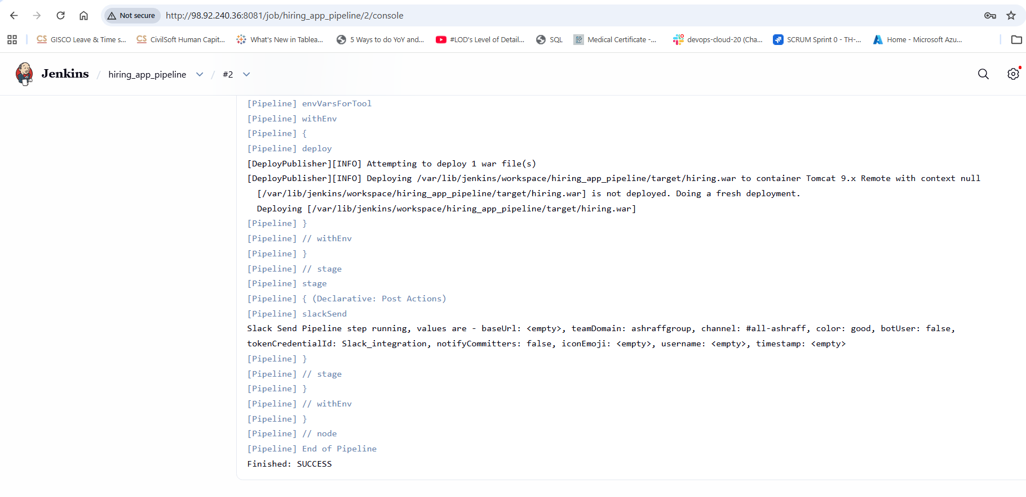
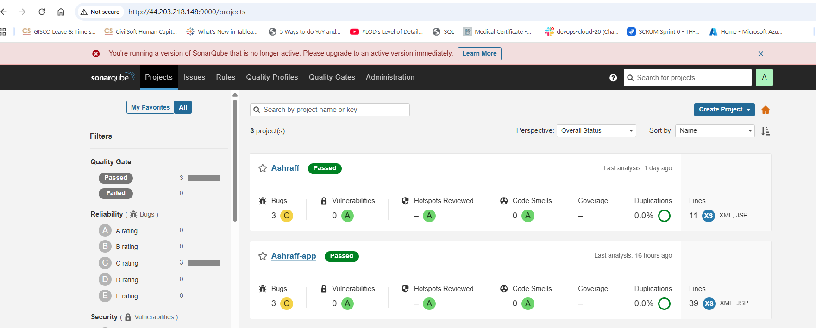
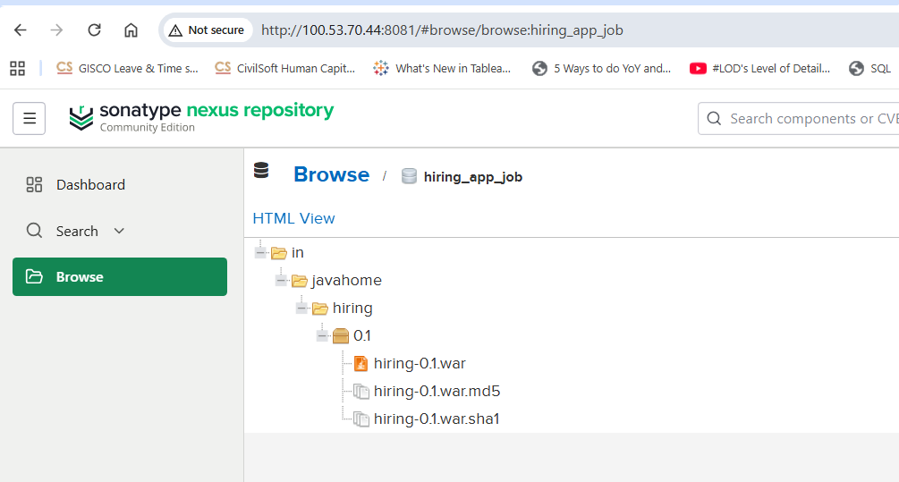
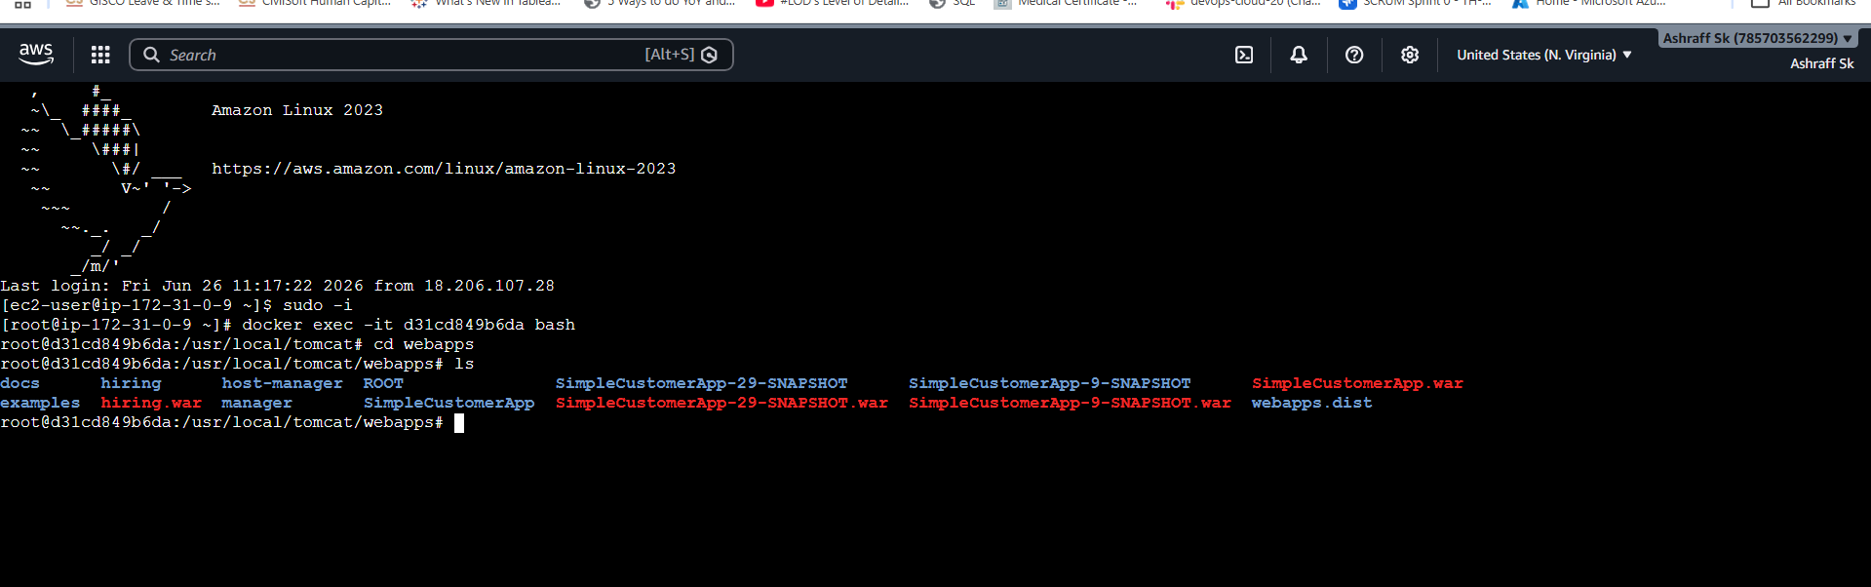
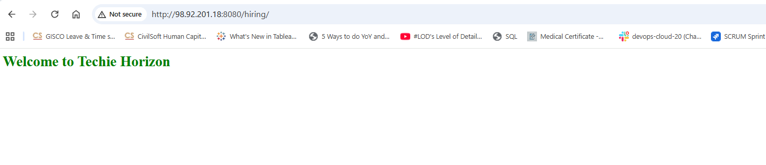
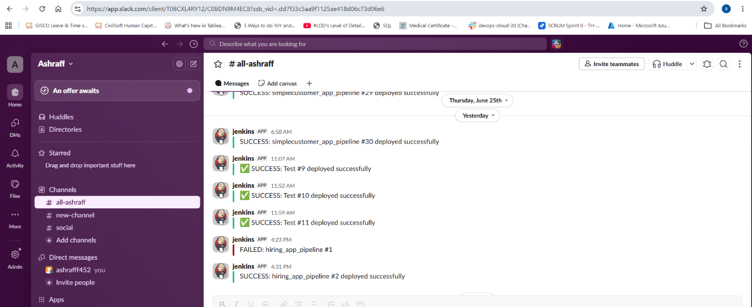
- Create one Scripted pipeline job
Steps:
- Created an ec2-instance, My-ec2-jenkins with instance type, c7i.flex.large, default security group.
- Installed java-21 in this instance as it is a prerequisite for Jenkins
- Installed Jenkins & connected with ipv4 & port 8081
- Installed plugins & changed the admin password
- Created an ec2 instance, My-ec2-docker_sonarqube with docker installed, sonarqube & tomcat installed
- Installed the sonarqube_scanner, maven, nexus artifactory uploader & Deploy to container plugins & done the configuration in settings, Tools with the valid credentials in Jenkins GUI.
- Now in GUI create a new job, hiring_app_scripted selecting job as pipeline & create
- In configure, pipeline write the below declarative pipeline code to integrate & deploy to tomcat application.
- Now click build now
- Capture the console output once the job is success
- The job has passed the checks, compiled by maven & war file is stored in nexus repository & deployed to tomcat & slack notification received for job success/failure.
node {
try {
// Define Maven tool (since 'tools' block doesn't work the same in scripted)
def mavenHome = tool name: 'MVN_HOME', type: 'maven'
env.PATH = "${mavenHome}/bin:${env.PATH}"

stage('Git Clone') {
git branch: 'main',
url: 'https://github.com/betawins/hiring-app.git'
}

stage('SonarQube Integration') {
withSonarQubeEnv('sonarqube-srvr') {
sh '''
mvn clean verify sonar:sonar \
-Dsonar.projectKey=Ashraff1-app \
-Dsonar.projectName=Ashraff1-app
'''
}
}

stage('Maven Build') {
sh 'mvn clean package -DskipTests'
}

stage('Publish to Nexus') {
nexusArtifactUploader(
nexusVersion: 'nexus3',
protocol: 'http',
nexusUrl: '100.53.70.44:8081',
groupId: 'in.javahome',
version: "0.1",
repository: 'hiring_app_scripted',
credentialsId: 'Nexus_server_2',
artifacts: [
[
artifactId: 'hiring',
classifier: '',
file: "target/hiring.war",
type: 'war'
]
]
)
}

stage('Deploy to Tomcat') {
deploy adapters: [
tomcat9(
credentialsId: 'tomcat_declarative',
url: 'http://3.236.153.147:8080/'
)
],
contextPath: '',
war: 'target/*.war'
}

currentBuild.result = 'SUCCESS'
slackSend(
channel: "#all-ashraff",
color: 'good',
message: "✅ SUCCESS: ${JOB_NAME} #${BUILD_NUMBER} deployed successfully"
)

} catch (Exception e) {
currentBuild.result = 'FAILURE'
slackSend(
channel: "#all-ashraff",
color: 'danger',
message: "❌ FAILED: ${JOB_NAME} #${BUILD_NUMBER}"
)
throw e
} finally {
cleanWs()
}
}
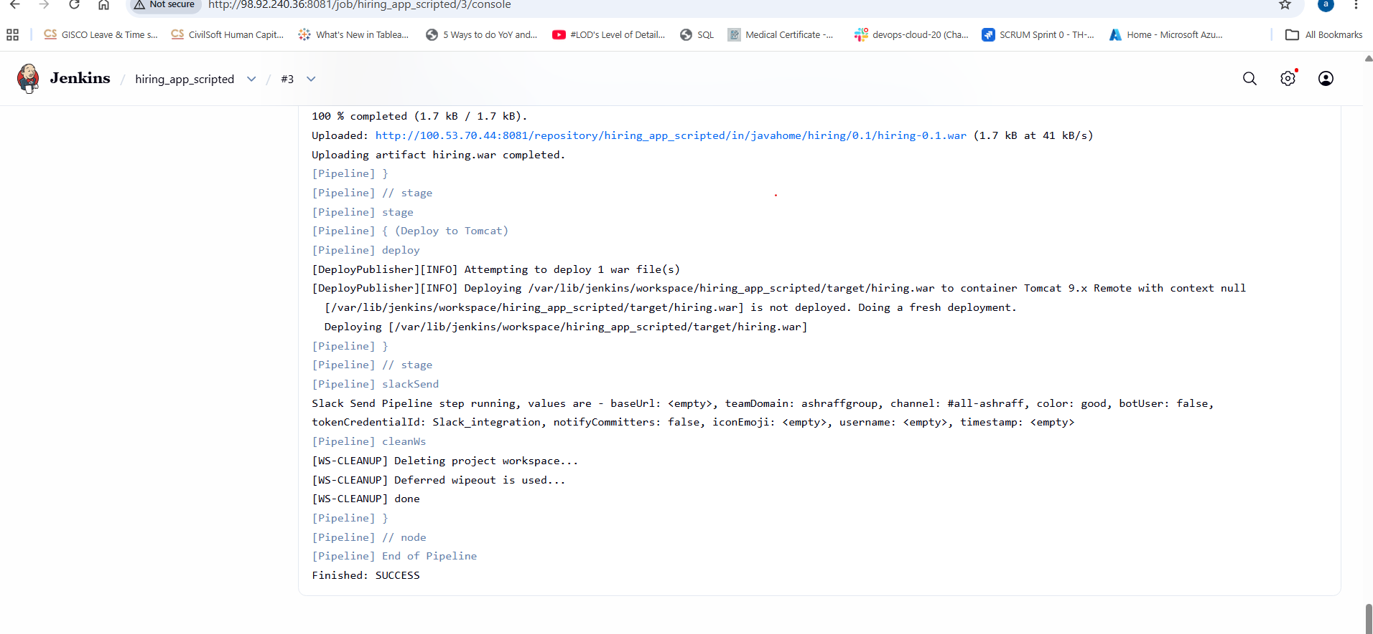
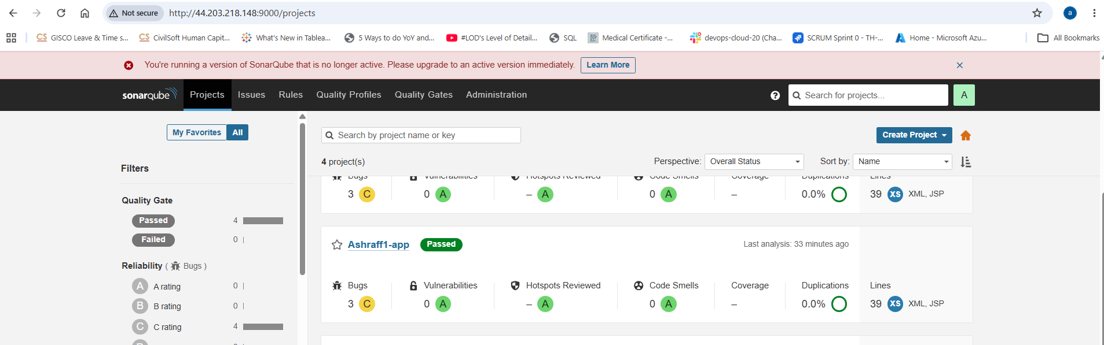
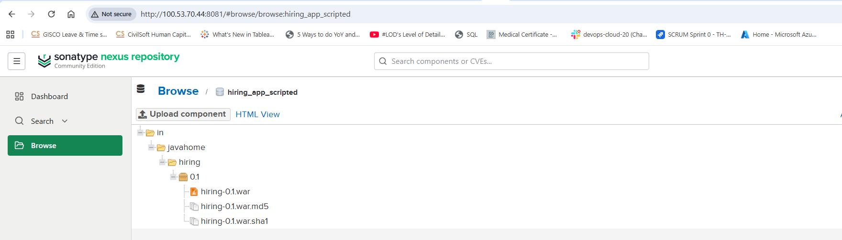
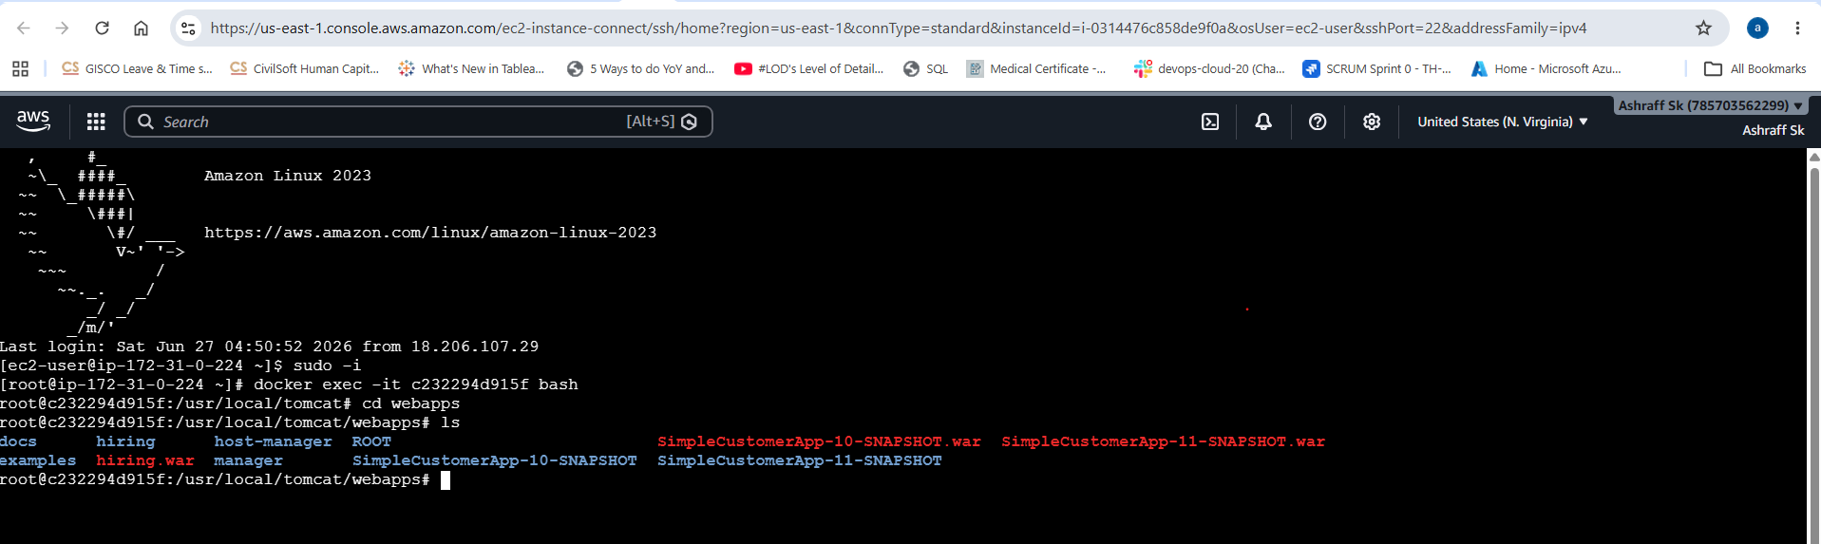
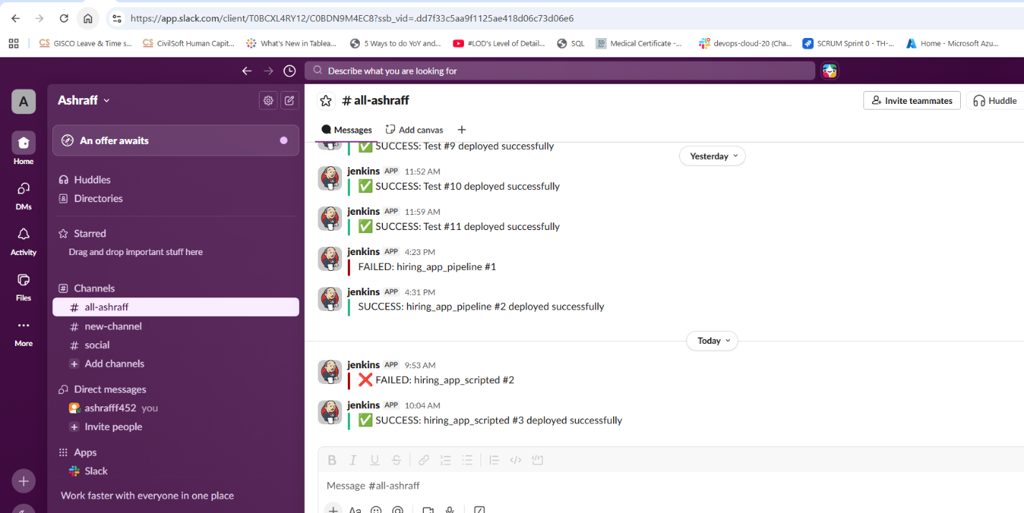
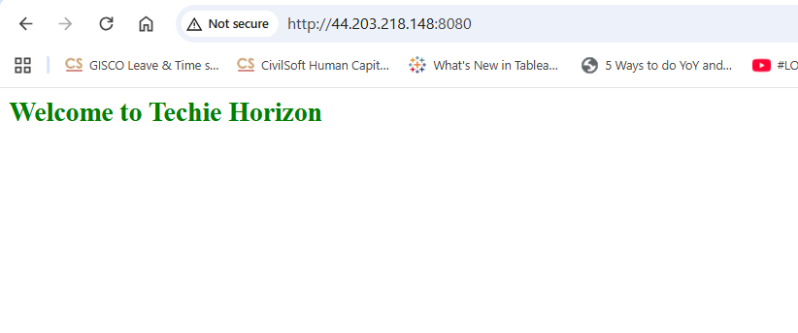
- Create one multi stage pipeline job
Steps:
•Created an ec2-instance, My-ec2-jenkins with instance type, c7i.flex.large, default security group.
• Installed java-21 in this instance as it is a prerequisite for Jenkins
• Installed Jenkins & connected with ipv4 & port 8081
• Installed plugins & changed the admin password
• Created an ec2 instance, My-ec2-docker_sonarqube with docker installed, sonarqube & tomcat installed
• Installed the sonarqube_scanner, maven, nexus artifactory uploader & Deploy to container plugins & done the configuration in settings, Tools with the valid credentials in Jenkins GUI.
• Now in GUI create a new job, Multi_stage_pipeline selecting job as pipeline & create
• In configure, pipeline write the below declarative pipeline code to integrate & deploy to tomcat application.
• Now click build now
• Capture the console output once the job is success
• The job has passed the checks, compiled by maven & war file is stored in nexus repository & deployed to tomcat & slack notification received for job success/failure.
// 1. Pipeline Declaration
pipeline {

// 2. Agent Definition
agent any

// 3. Tools Configuration
tools {
maven 'MVN_HOME'
}

// 4. Environment Variables
environment {
NEXUS_URL = '100.53.70.44:8081'
NEXUS_REPO = 'hiring_app_challenge'
TOMCAT_URL = 'http://98.92.201.18:8080/'
PROJECT_KEY = 'Asharaff'
}

// 5. Stages Section
stages {

// Stage 1
stage('Git Clone') {
steps {
git branch: 'main',
url: 'https://github.com/betawins/hiring-app.git'
}
}

// Stage 2
stage('SonarQube Analysis') {
steps {
withSonarQubeEnv('sonarqube-srvr') {
sh '''
mvn clean verify sonar:sonar \
-Dsonar.projectKey=${PROJECT_KEY} \
-Dsonar.projectName=${PROJECT_KEY}
'''
}
}
}

// Stage 3
stage('Maven Build') {
steps {
sh 'mvn clean package -DskipTests'
}
}

// Stage 4
stage('Publish to Nexus') {
steps {
script {
nexusArtifactUploader(
nexusVersion: 'nexus3',
protocol: 'http',
nexusUrl: "${NEXUS_URL}",
groupId: 'in.javahome',
version: "0.1",
repository: "${NEXUS_REPO}",
credentialsId: 'Nexus_server',
artifacts: [
[artifactId: 'hiring', classifier: '', file: "target/hiring.war", type: 'war']
]
)
}
}
}

// Stage 5
stage('Deploy to Tomcat') {
steps {
deploy adapters: [
tomcat9(
credentialsId: 'tomcat_deploy',
url: "${TOMCAT_URL}"
)
],
contextPath: '',
war: 'target/*.war'
}
}
}

// 6. Post Build Actions
post {
success {
slackSend(
channel: "#all-ashraff",
color: 'good',
message: "✅ SUCCESS: ${JOB_NAME} #${BUILD_NUMBER} deployed successfully"
)
}
failure {
slackSend(
channel: "#all-ashraff",
color: 'danger',
message: "❌ FAILED: ${JOB_NAME} #${BUILD_NUMBER}"
)
}
always {
cleanWs()
}
}
}

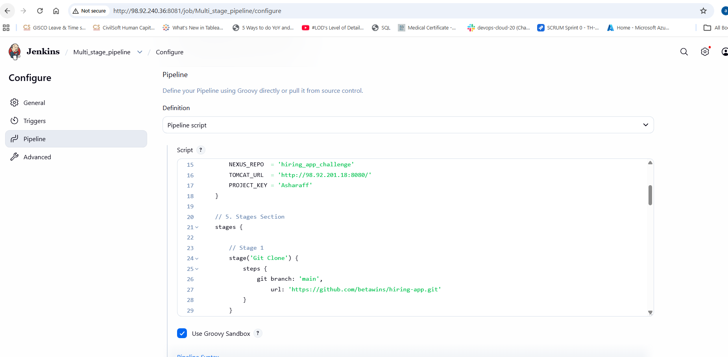
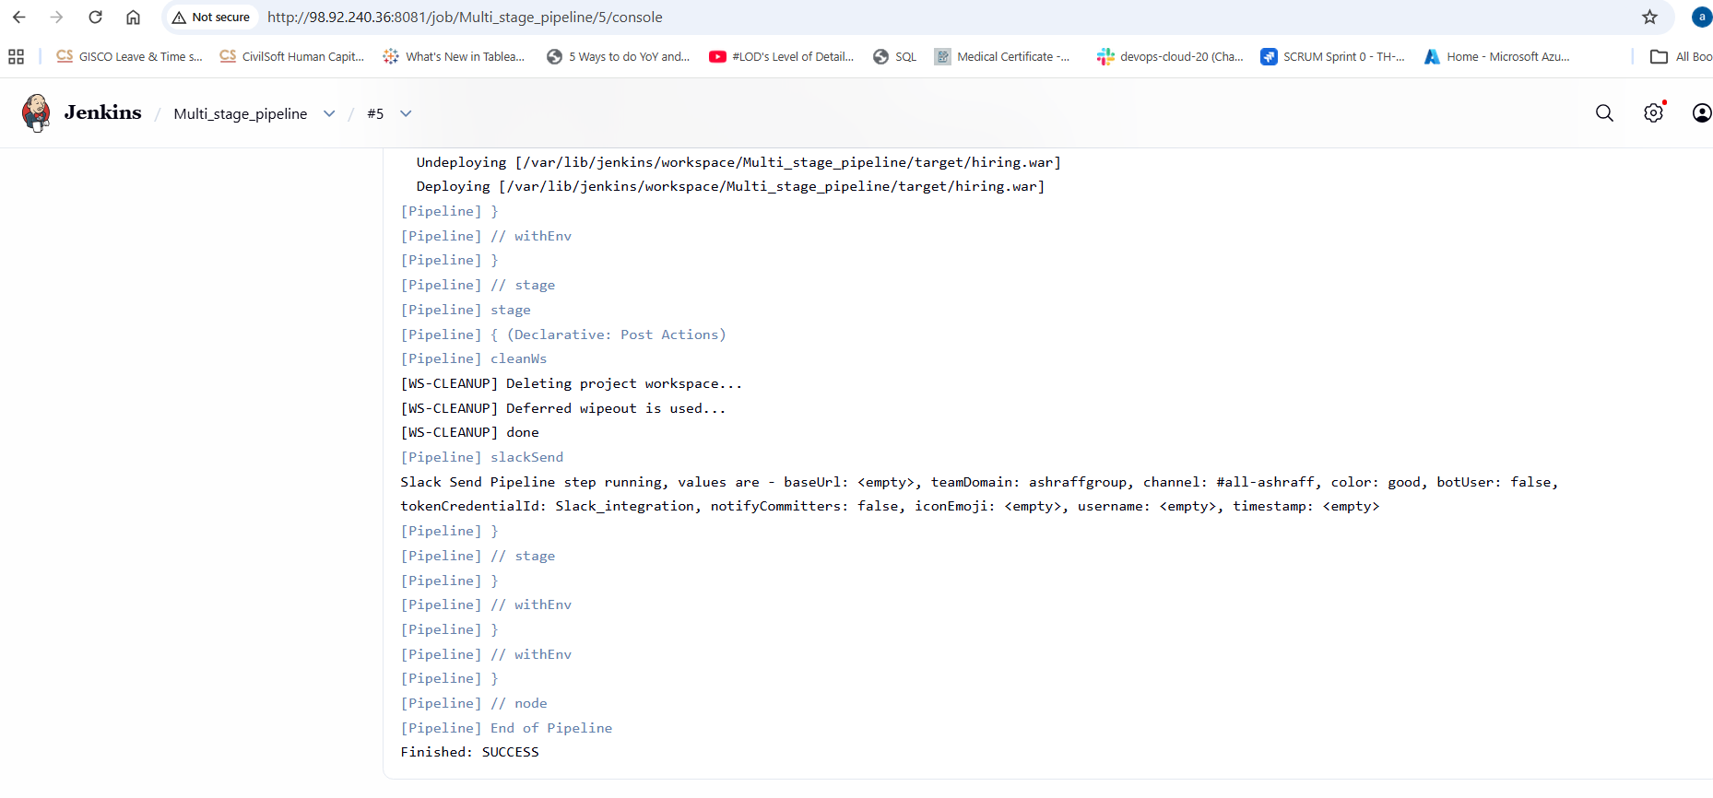
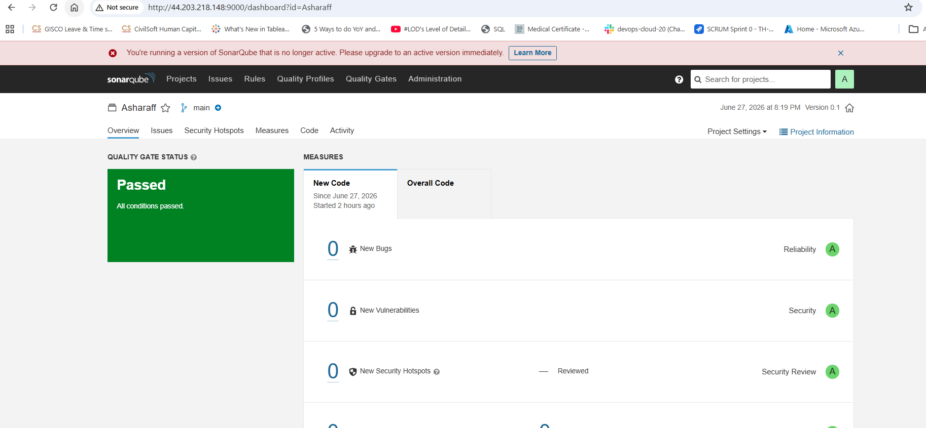
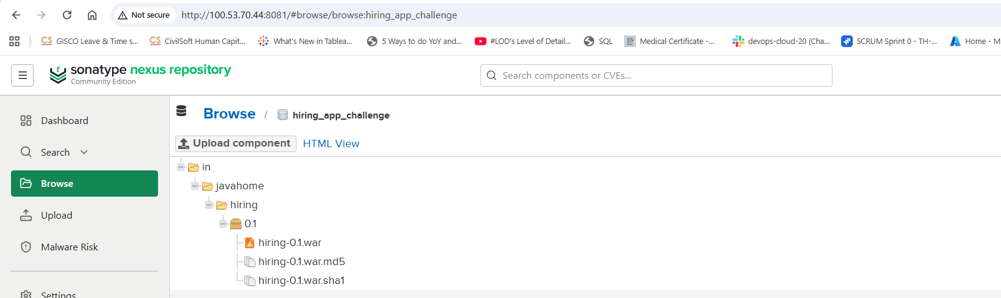
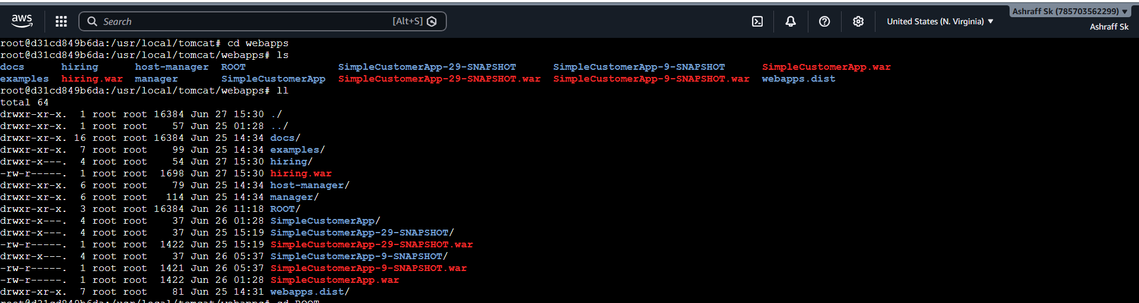
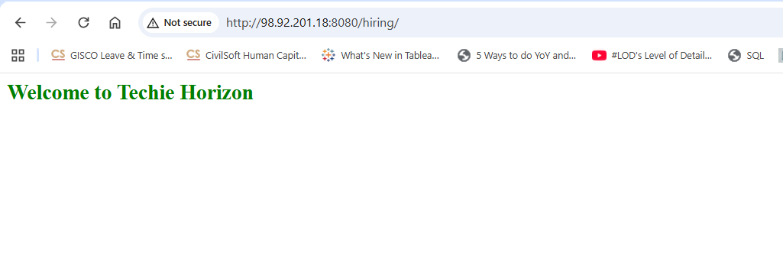
- Create one parallel stage pipeline job
Steps:
- Created an ec2-instance, My-ec2-jenkins with instance type, c7i.flex.large, default security group.
- Installed java-21 in this instance as it is a prerequisite for Jenkins
- Installed Jenkins & connected with ipv4 & port 8081
- Installed plugins & changed the admin password
- Created an ec2 instance, My-ec2-docker_sonarqube with docker installed, sonarqube & tomcat installed in My-ec2-docker_tomcat
- Installed the sonarqube_scanner, maven, nexus artifactory uploader & Deploy to container plugins & done the configuration in settings, Tools with the valid credentials in Jenkins GUI.
- Now in GUI create a new job, Parallel_stage_pipeline selecting job as pipeline & create
- In configure, pipeline write the below declarative pipeline code to integrate & deploy to tomcat application.
- Now click build now
- Capture the console output once the job is success
- The job has passed the checks, compiled by maven & war file is stored in nexus repository & deployed to tomcat & slack notification received for job success/failure.
pipeline {
agent any

tools {
maven 'MVN_HOME'
}

environment {
NEXUS_URL = '100.53.70.44:8081'
NEXUS_REPO = 'hiring_app_parallel'
TOMCAT_URL = 'http://98.92.201.18:8080/'
PROJECT_KEY = 'Asharaff_1'
}

stages {
stage('Git Clone') {
steps {
git branch: 'main',
url: 'https://github.com/betawins/hiring-app.git'
}
}

// Parallel Stage Block
stage('Parallel Execution') {
parallel {

stage('SonarQube Analysis') {
steps {
withSonarQubeEnv('sonarqube-srvr') {
sh '''
mvn clean verify sonar:sonar \
-Dsonar.projectKey=${PROJECT_KEY} \
-Dsonar.projectName=${PROJECT_KEY}
'''
}
}
}

stage('Maven Build') {
steps {
sh 'mvn clean package -DskipTests'
}
}
}
}

stage('Publish to Nexus') {
steps {
script {
nexusArtifactUploader(
nexusVersion: 'nexus3',
protocol: 'http',
nexusUrl: "${NEXUS_URL}",
groupId: 'in.javahome',
version: "0.1",
repository: "${NEXUS_REPO}",
credentialsId: 'Nexus_server',
artifacts: [
[artifactId: 'hiring', classifier: '', file: "target/hiring.war", type: 'war']
]
)
}
}
}

stage('Deploy to Tomcat') {
steps {
deploy adapters: [
tomcat9(
credentialsId: 'tomcat_deploy',
url: "${TOMCAT_URL}"
)
],
contextPath: '',
war: 'target/*.war'
}
}
}

post {
success {
slackSend(
channel: "#all-ashraff",
color: 'good',
message: "✅ SUCCESS: ${JOB_NAME} #${BUILD_NUMBER} deployed successfully"
)
}
failure {
slackSend(
channel: "#all-ashraff",
color: 'danger',
message: "❌ FAILED: ${JOB_NAME} #${BUILD_NUMBER}"
)
}
always {
cleanWs()
}
}
}
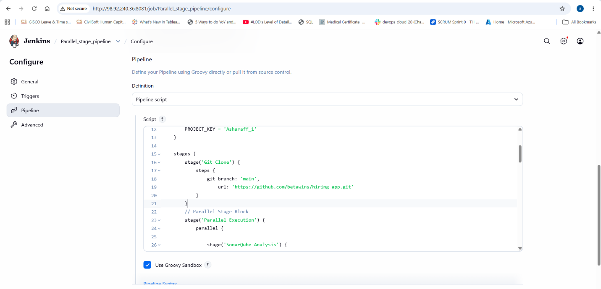
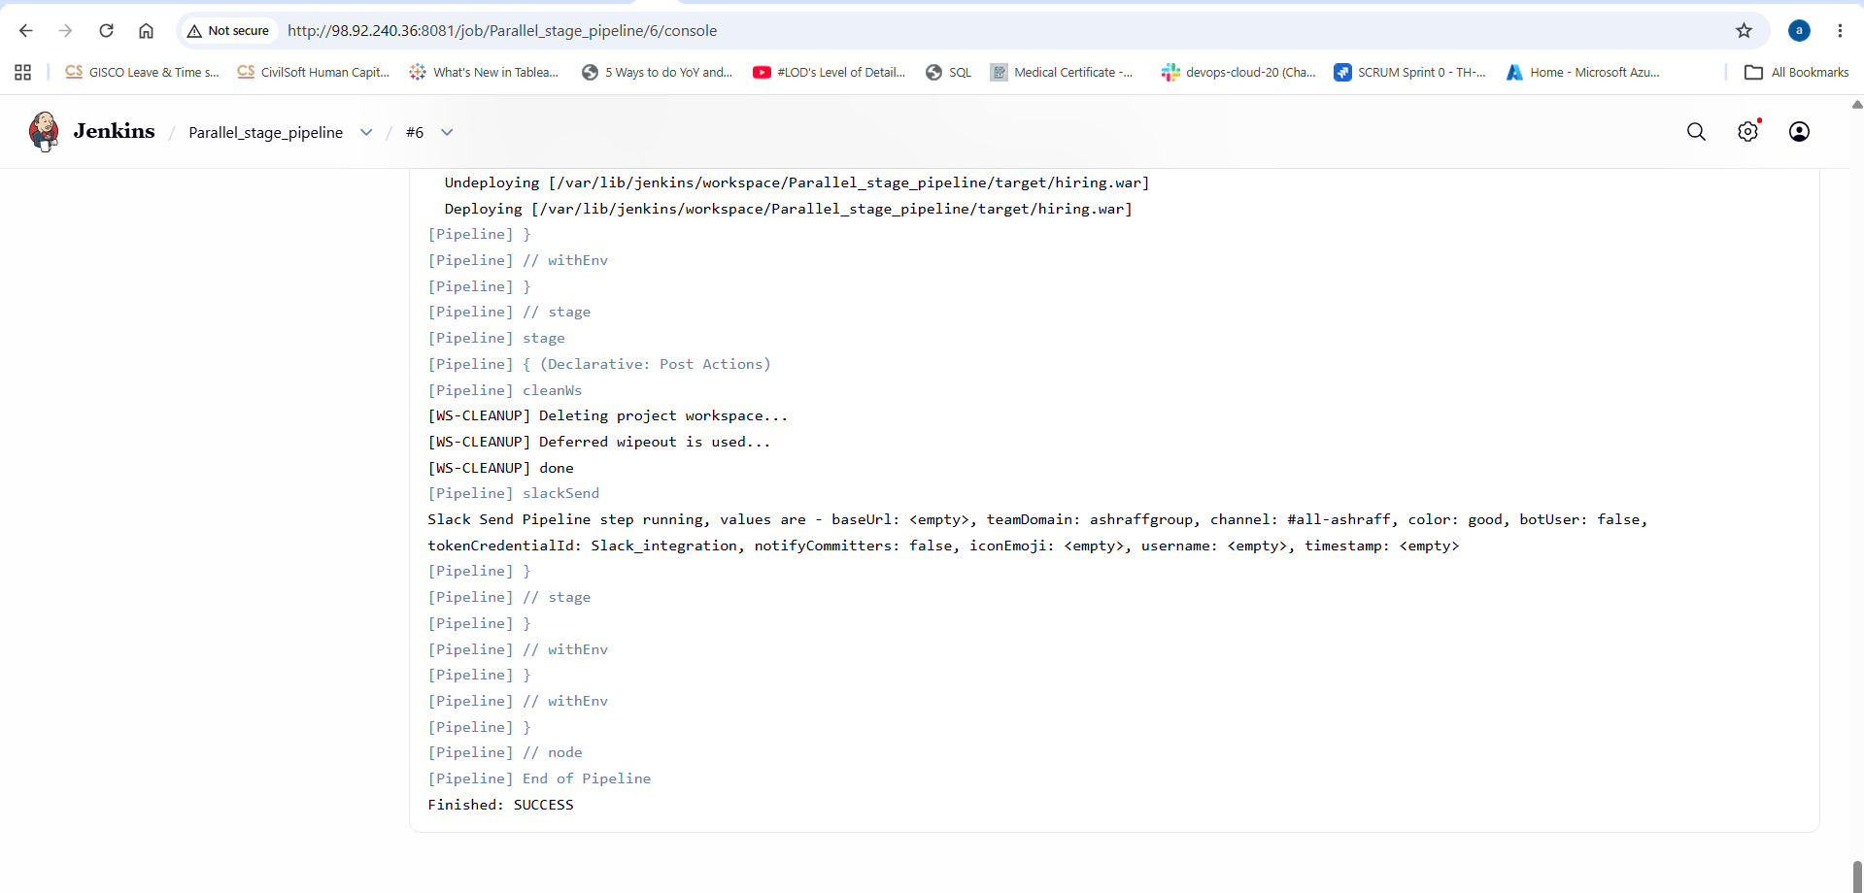
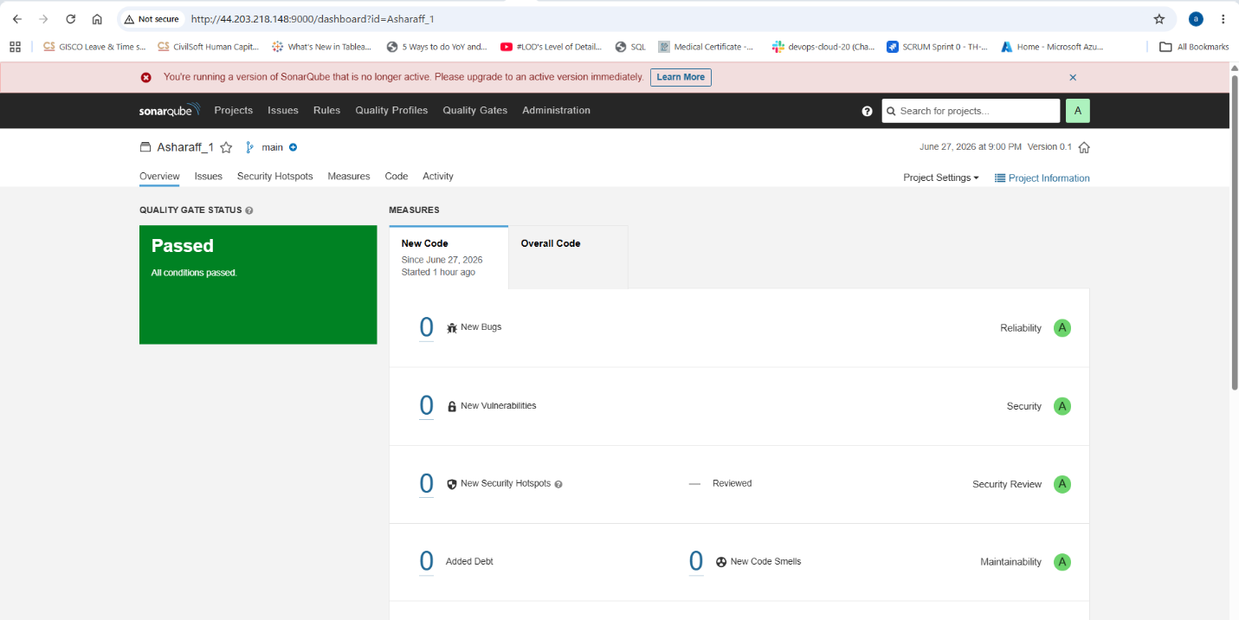
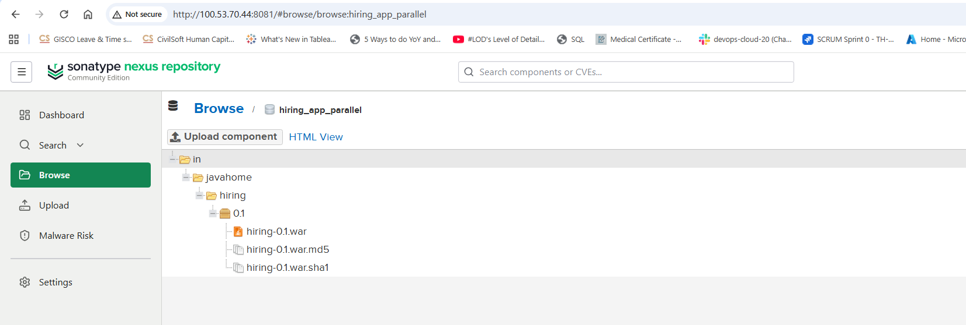

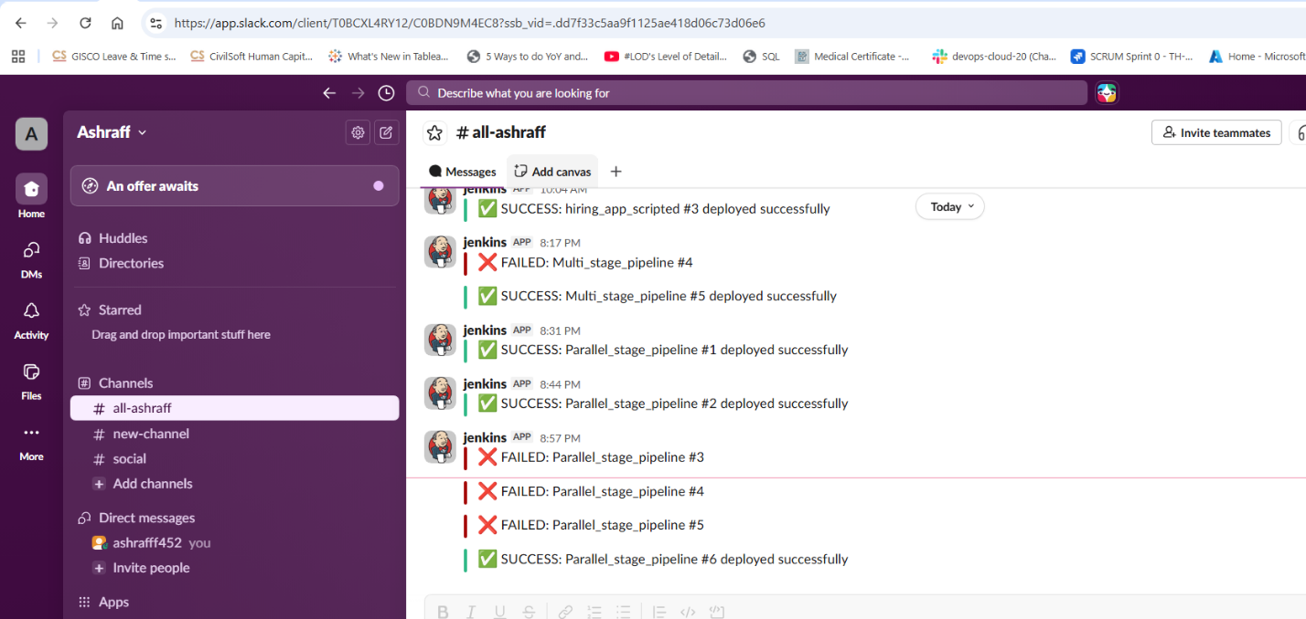

Conclusion:
The stages, sonarqube integration & building the code with maven are executed as parallel.

