TERRAFORM task – 06
2). Execute the script shown in the video.
Terraform Modules:
- Under TERRAFORM_BASICS we create two directories, aws_instance & development
- In aws_instance directory we create main.tf with the below code.
resource "aws_instance" "webserver" {
ami = var.ami
subnet_id = var.subnet_id
instance_type = "t3.micro"
}
- we create variables.tf file with the below code.
variable "ami" {
}
variable "subnet_id" {
}
- In development directory created a main.tf file with the below code:
module "dev-webserver" {
source = "../aws_instance"
ami = "ami-0521cb2d60cfbb1a6"
subnet_id = "subnet-0d1454707d798a065"
}

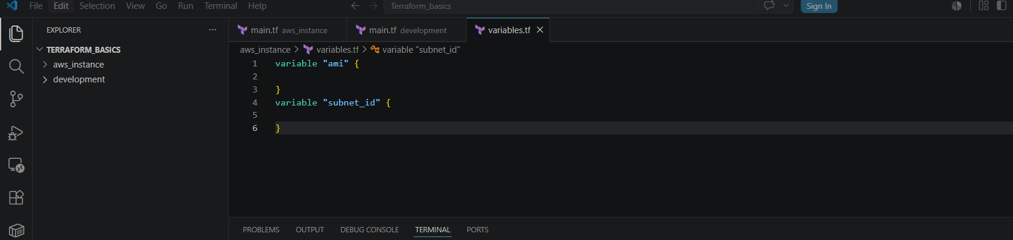
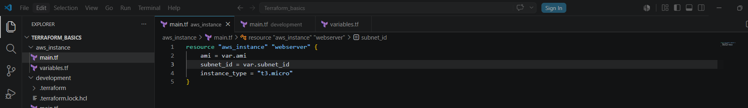
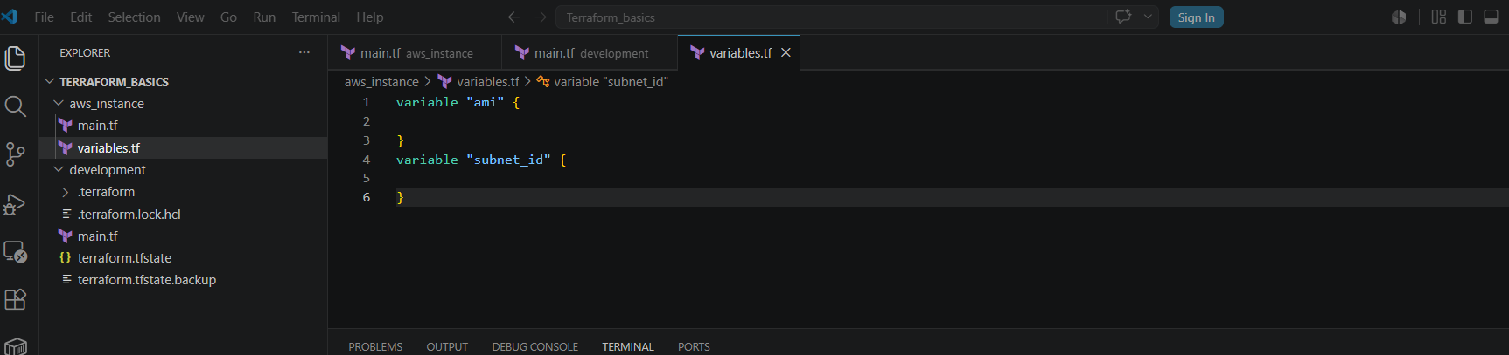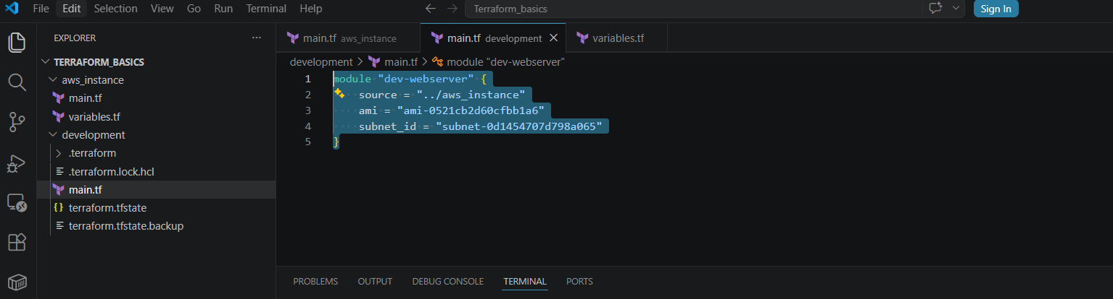
- Now go to development directory & execute terraform init command
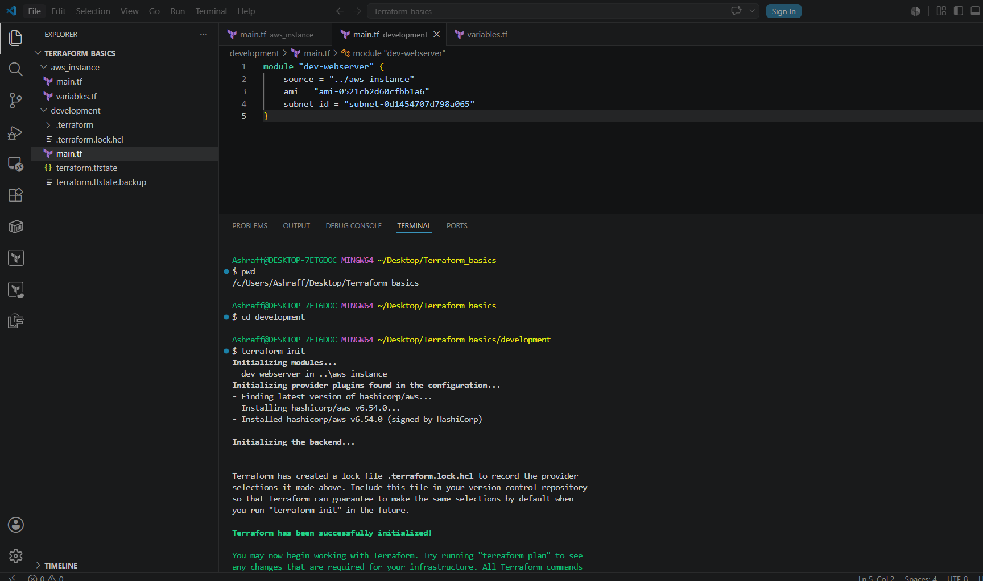
- Now execute the command terraform apply & click yes to continue
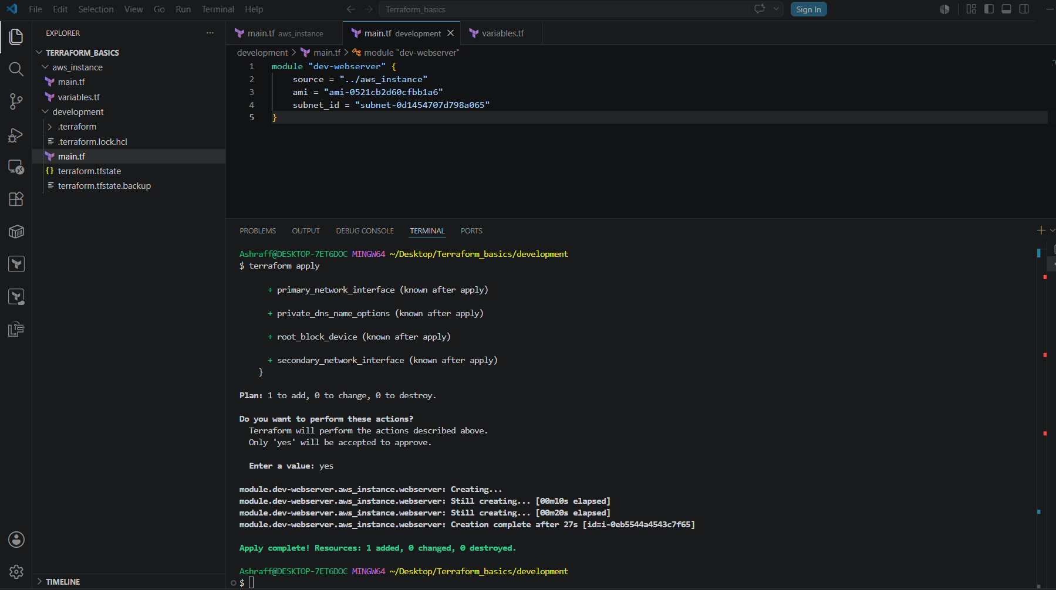
- We can see one ec2 instance got created and running
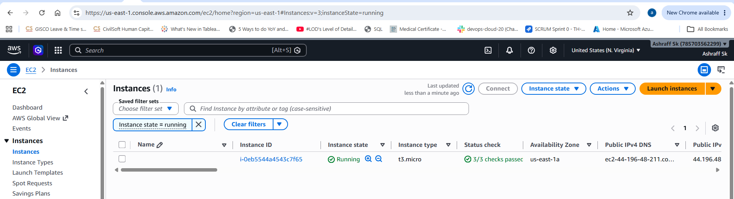

Terraform Workspace:
- First we created a directory, aws_instance in TERRAFORM_BASICS
- Now created two workspaces using the command terraform workspace new projectA & terraform workspace new projectB.
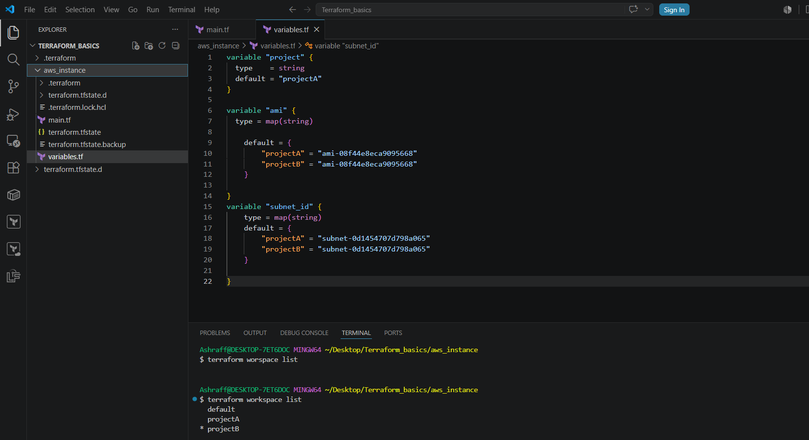
- Created a main.tf file as below & save
resource "aws_instance" "webserver" {
ami = var.ami[var.project]
subnet_id = var.subnet_id[var.project]
instance_type = "t3.micro"
}
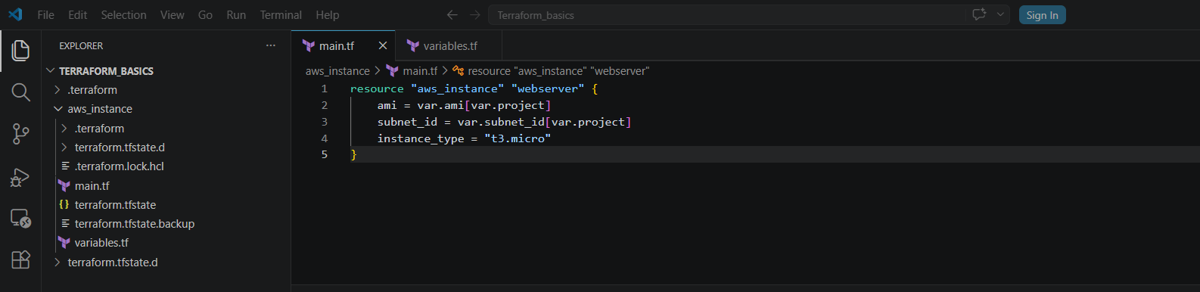
- Now created a variables.tf file in the aws_instance directory & saved with the below code:
variable "project" {
type = string
default = "projectA"
}

variable "ami" {
type = map(string)

default = {
"projectA" = "ami-08f44e8eca9095668"
"projectB" = "ami-08f44e8eca9095668"
}

}
variable "subnet_id" {
type = map(string)
default = {
"projectA" = "subnet-0d1454707d798a065"
"projectB" = "subnet-0d1454707d798a065"
}

}
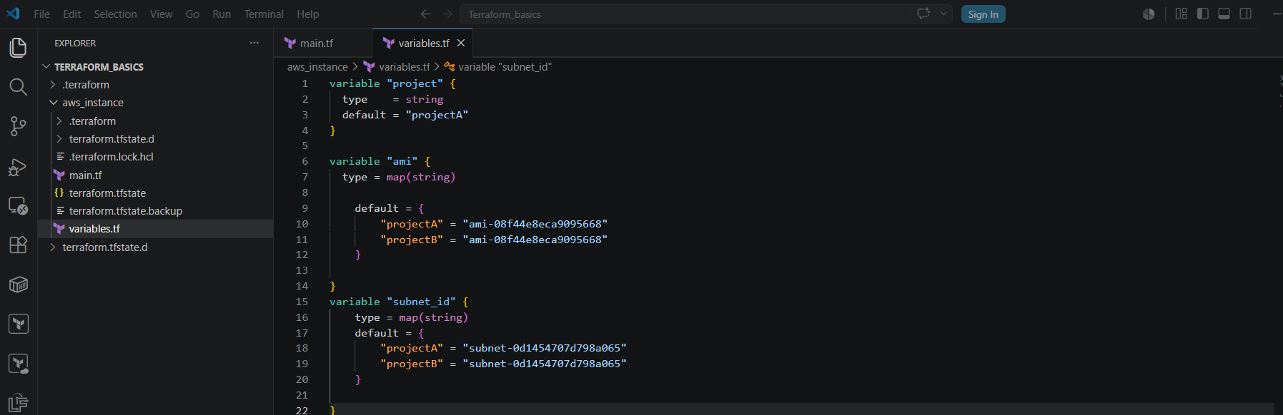
- Now changed to workspace projectA using terraform workspace select projectA
- Now execute the terraform init & terraform apply
- We can see the new ec2 instance has been created in AWS
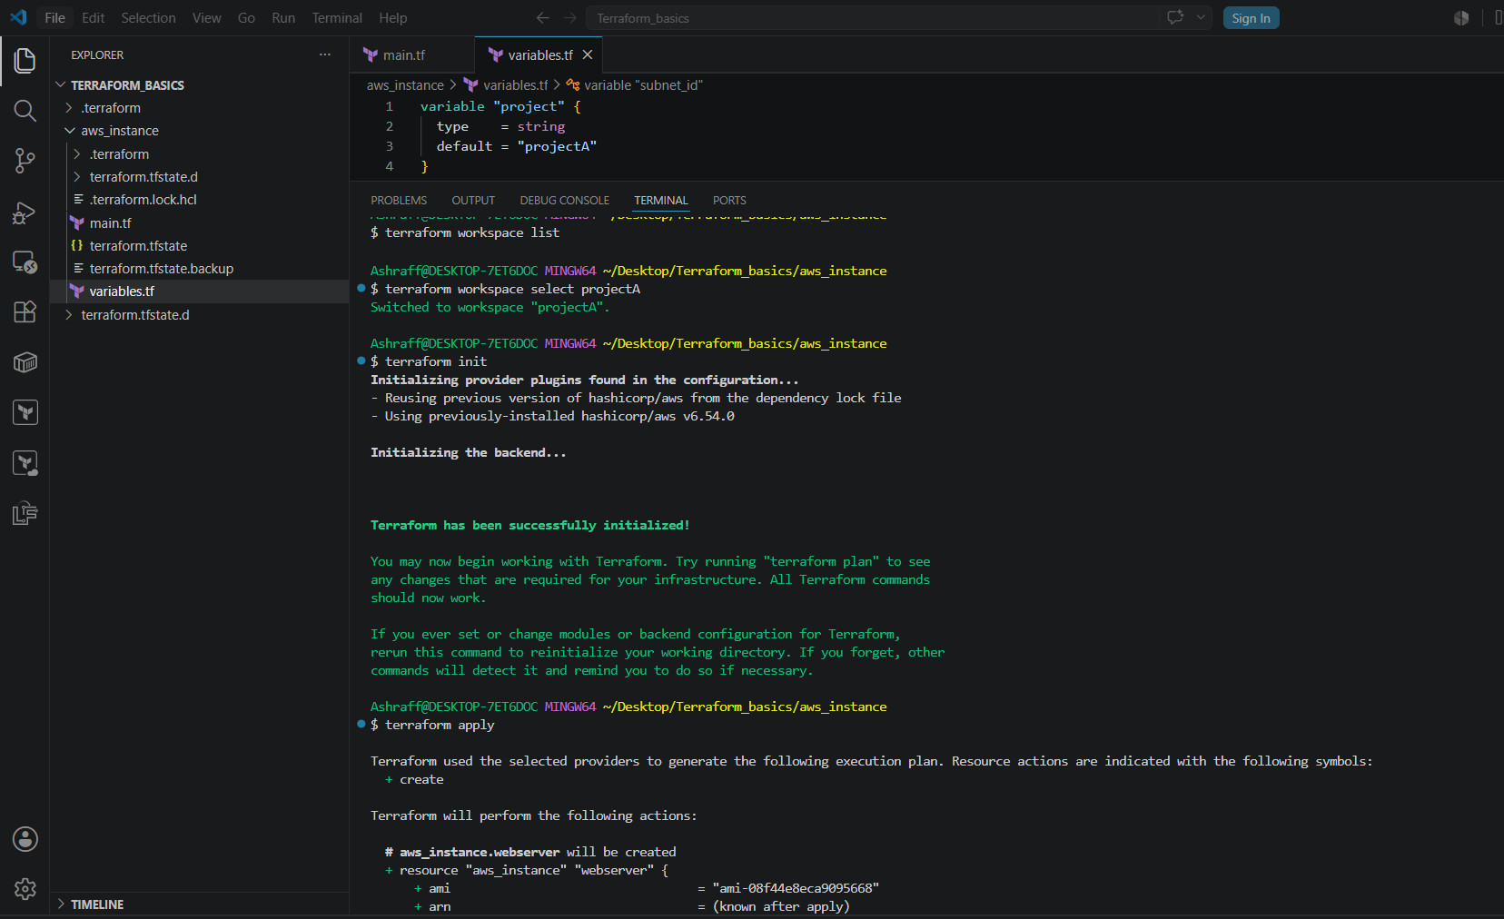

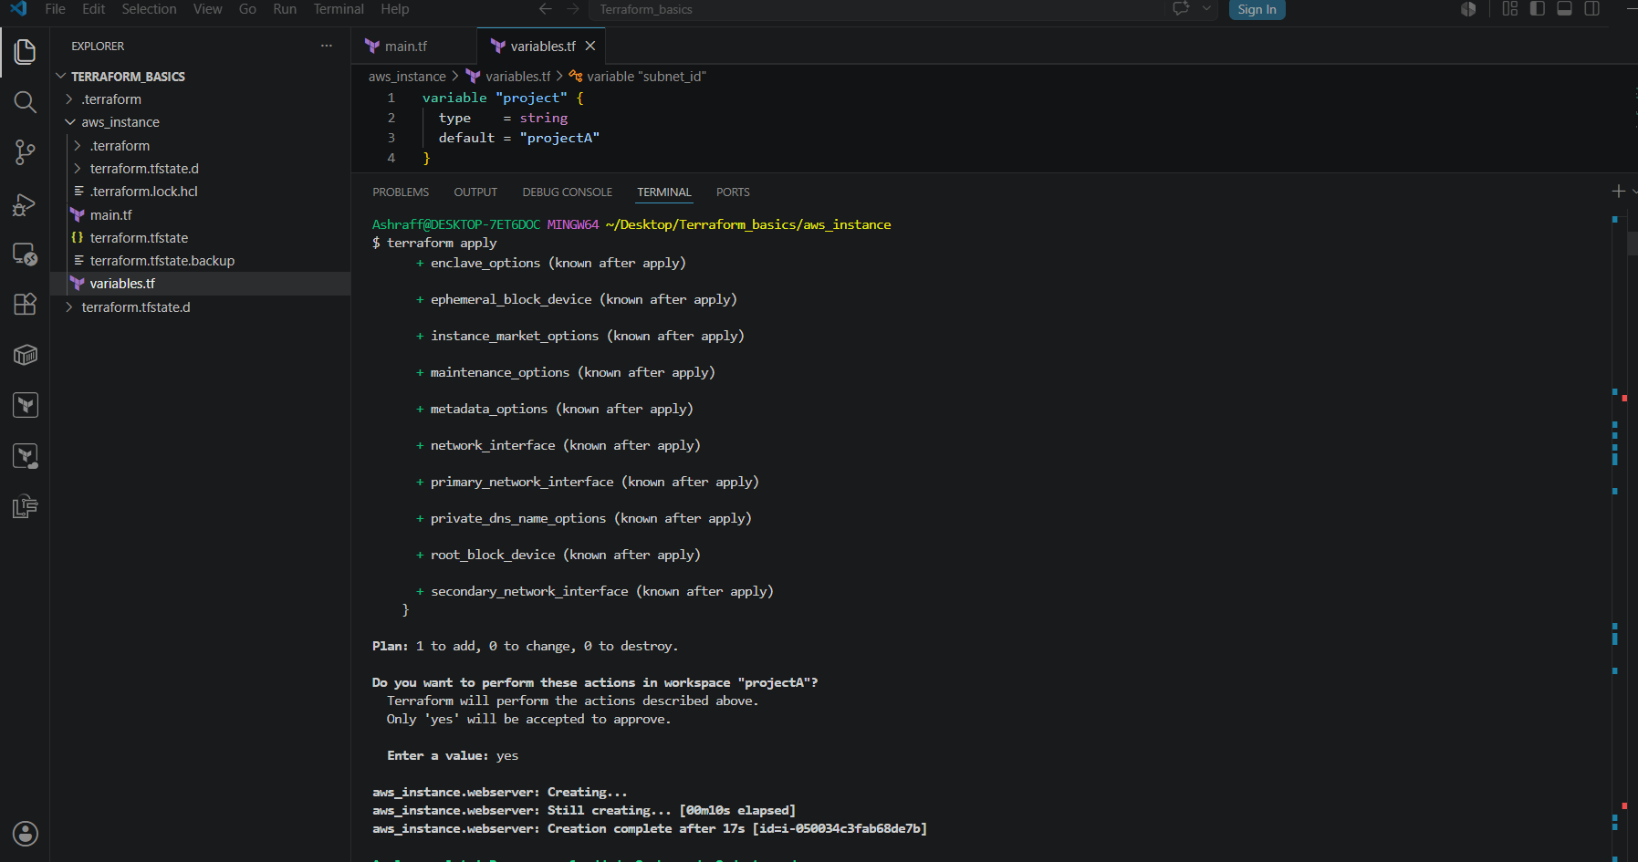
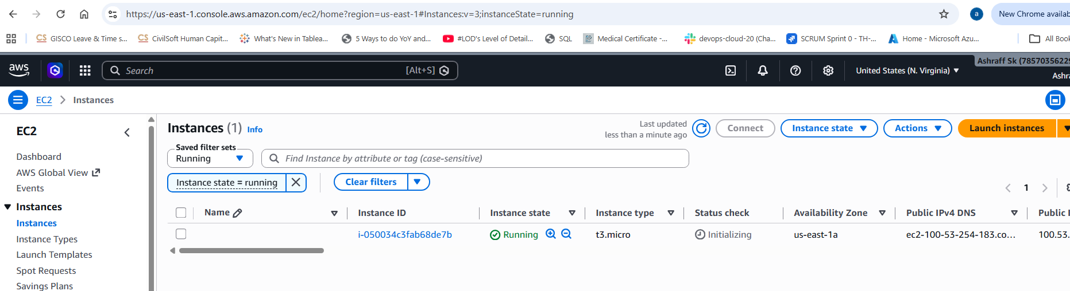
- Now changed to workspace projectB using terraform workspace select projectB
- Now execute the terraform init & terraform apply
- We can see the new ec2 instance has been created in AWS
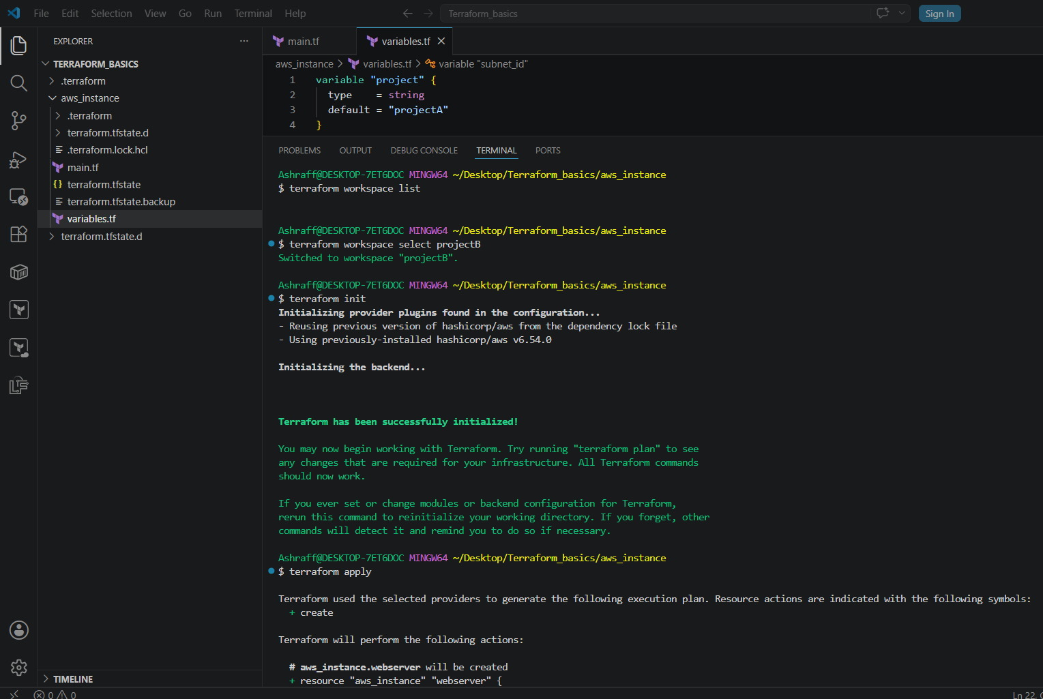
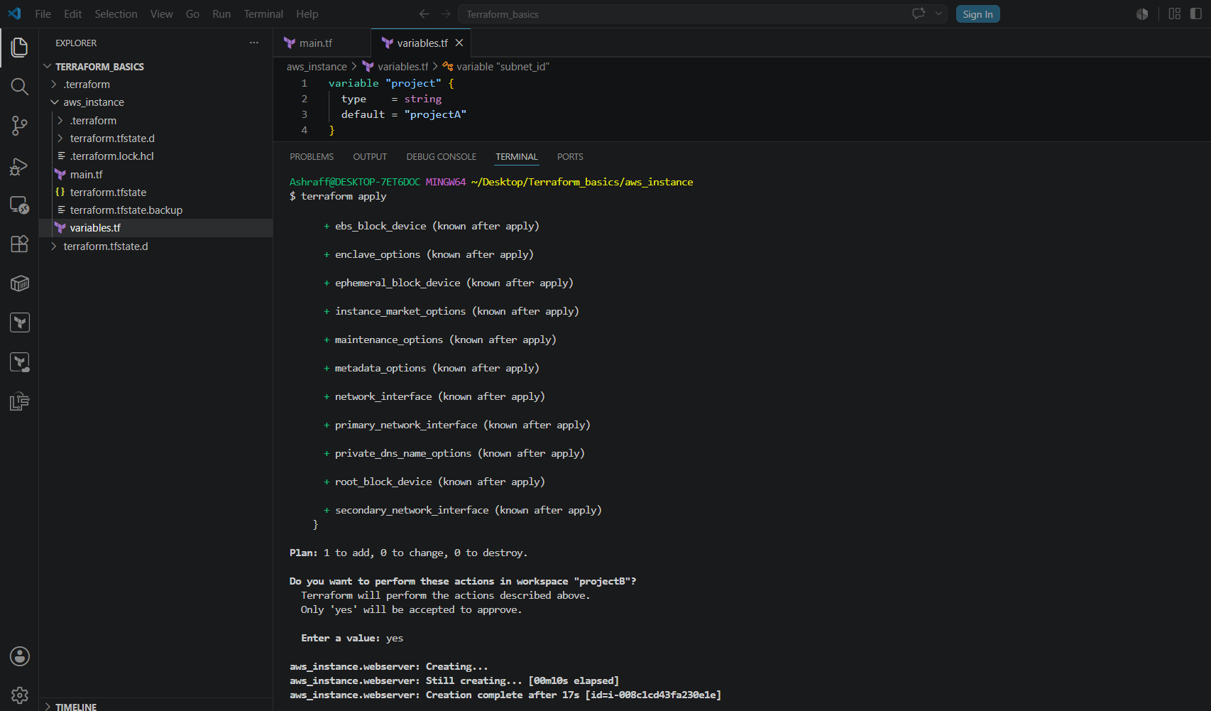
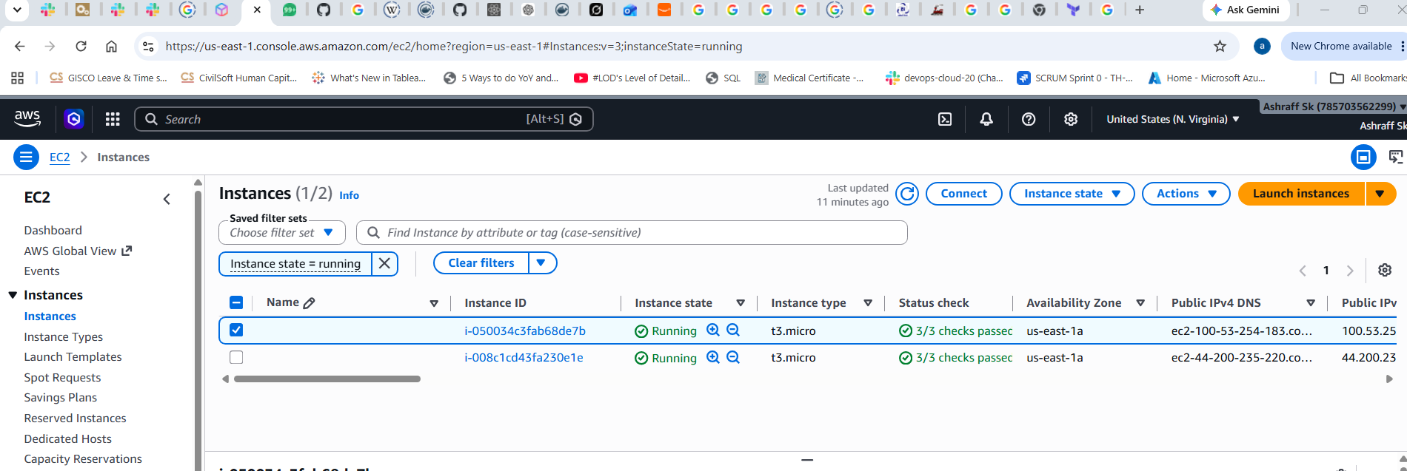

3). Provision EC2, S3, and VPC using Terraform modules.
Objective:
Provision AWS infrastructure using reusable Terraform modules for:
- VPC
- EC2 Instance
- S3 Bucket
Purpose:
Reuse infrastructure code
Improve maintainability
Follow Terraform best practices
Separate infrastructure into independent modules

Steps:
- First create a modules directory & a root directory under the TERRAFORM_BASICS directory
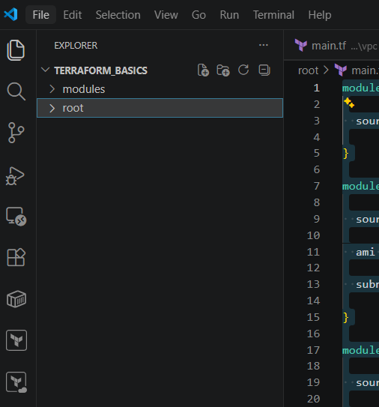
- Under modules create a VPC directory with main.tf as below & save the file:
resource "aws_vpc" "main" {
cidr_block = "10.0.0.0/16"
tags = {
Name = "Terraform-VPC"
}
}
resource "aws_subnet" "public" {
vpc_id = aws_vpc.main.id
cidr_block = "10.0.1.0/24"
map_public_ip_on_launch = true
tags = {
Name = "Public-Subnet"
}
}
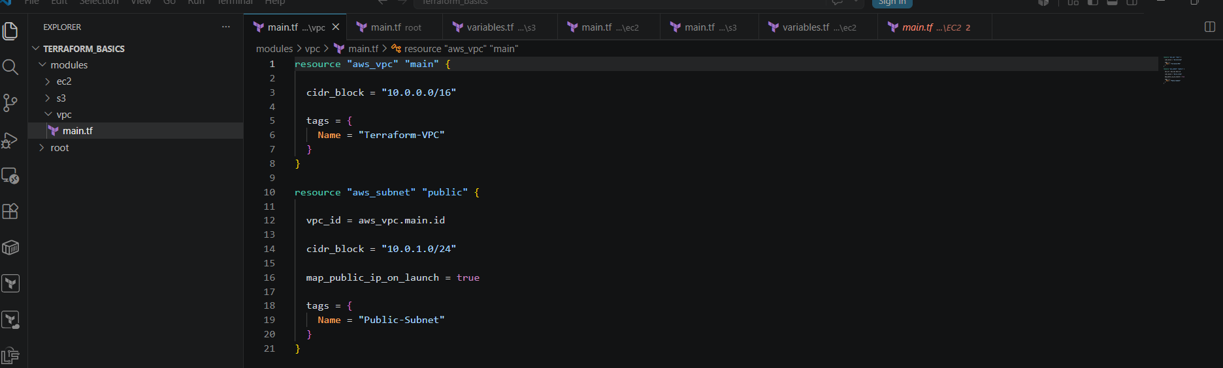
- Now create the ec2 directory & main.tf file & save with below code:
resource "aws_instance" "webserver" {
ami = var.ami
instance_type = "t3.micro"
subnet_id = var.subnet_id
user_data = <<EOF
#!/bin/bash
yum update -y
yum install httpd -y
systemctl enable httpd
systemctl start httpd

echo "<h1>Apache Installed Using Terraform Modules</h1>" > /var/www/html/index.html

EOF
tags = {
Name = "Terraform-Webserver"
}
}
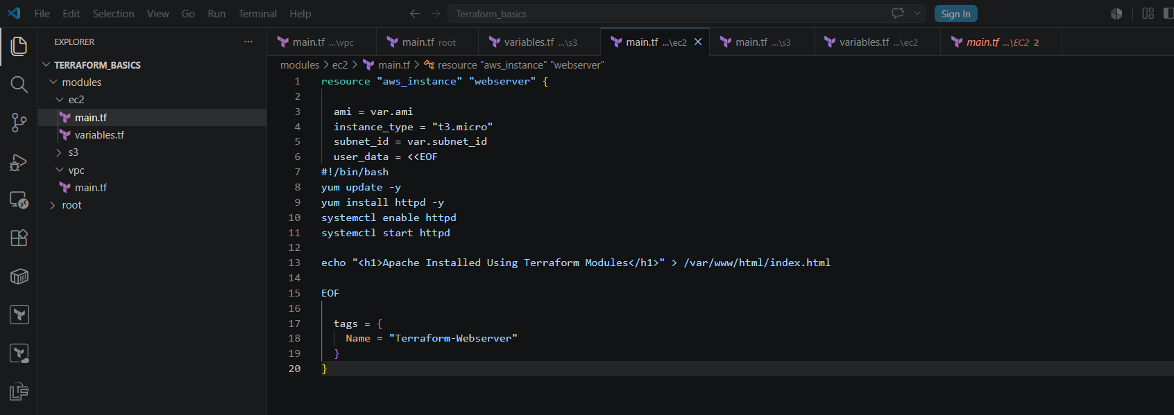
- Create a variables.tf with below code & save
variable "ami" {
type = string
}
variable "subnet_id" {
type = string
}
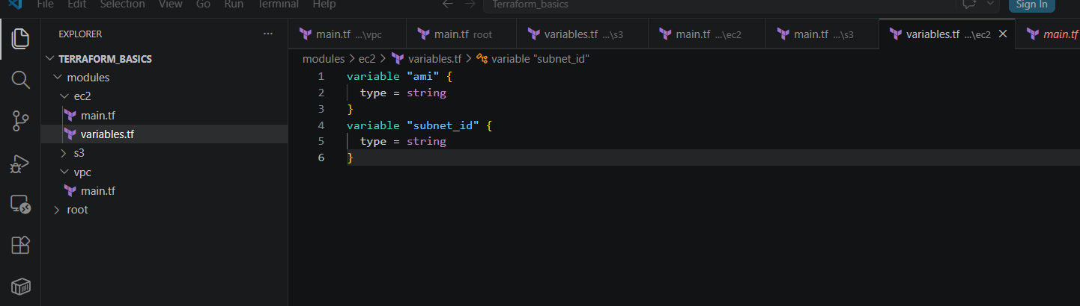
- Now create a s3 directory under modules directory & create a main.tf & save as below:
resource "aws_s3_bucket" "bucket" {
bucket = var.bucket_name
tags = {
Name = "Terraform-S3"
}
}
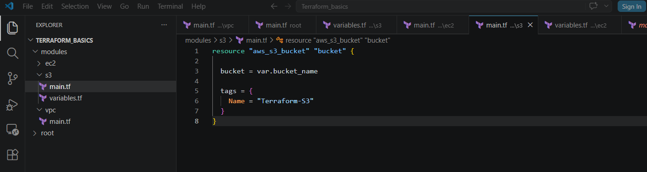
- Create and save variables.tf as below:
variable "bucket_name" {
type = string
}
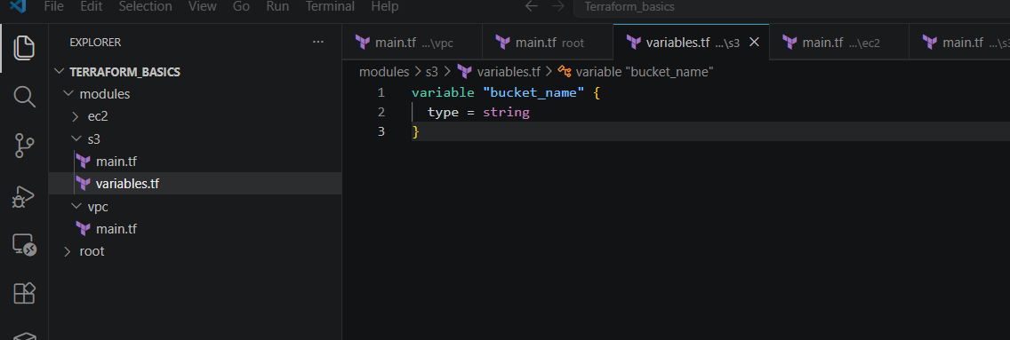
- Under root directory create a main.tf file & save as below:
module "vpc" {
source = "../modules/vpc"
}
module "ec2"
source = "../modules/ec2"
ami = "ami-08f44e8eca9095668"
subnet_id = "subnet-0d1454707d798a065"
}
module "s3" {
source = "../modules/s3"
bucket_name = "ashraff452-terraform-module-demo-2026"
}
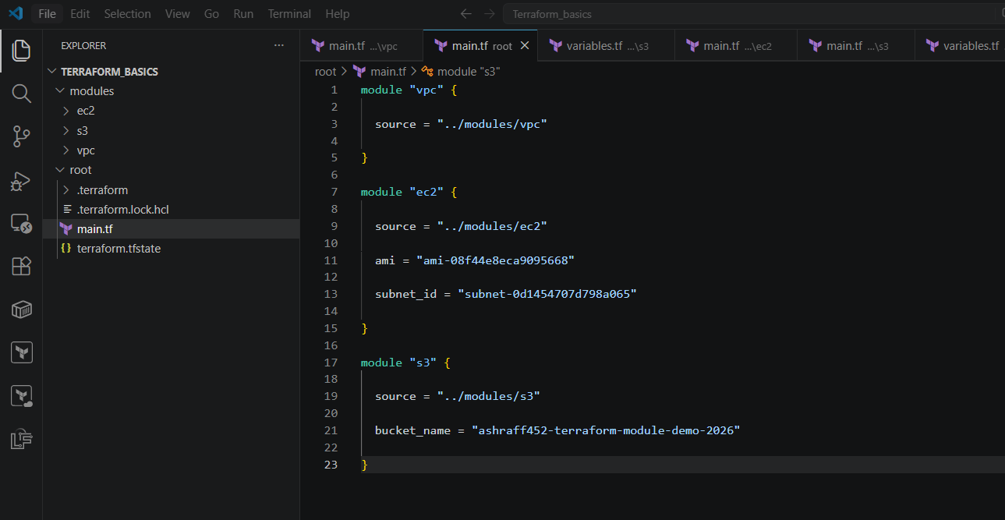
- Now under root directory execute terraform init
- Once success execute terraform apply & we can see that an VPC, Terraform-VPC got created, ec2, Terraform-webserver got created & s3, ashraff452-terraform-module-demo-2026 got created as well.
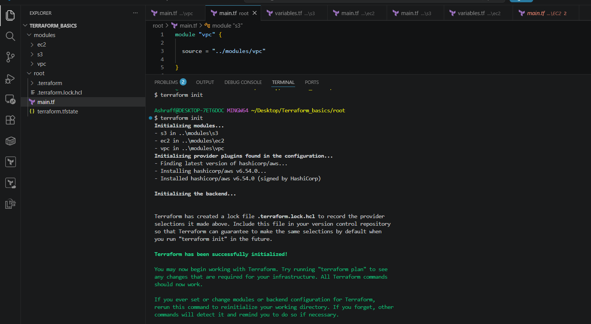
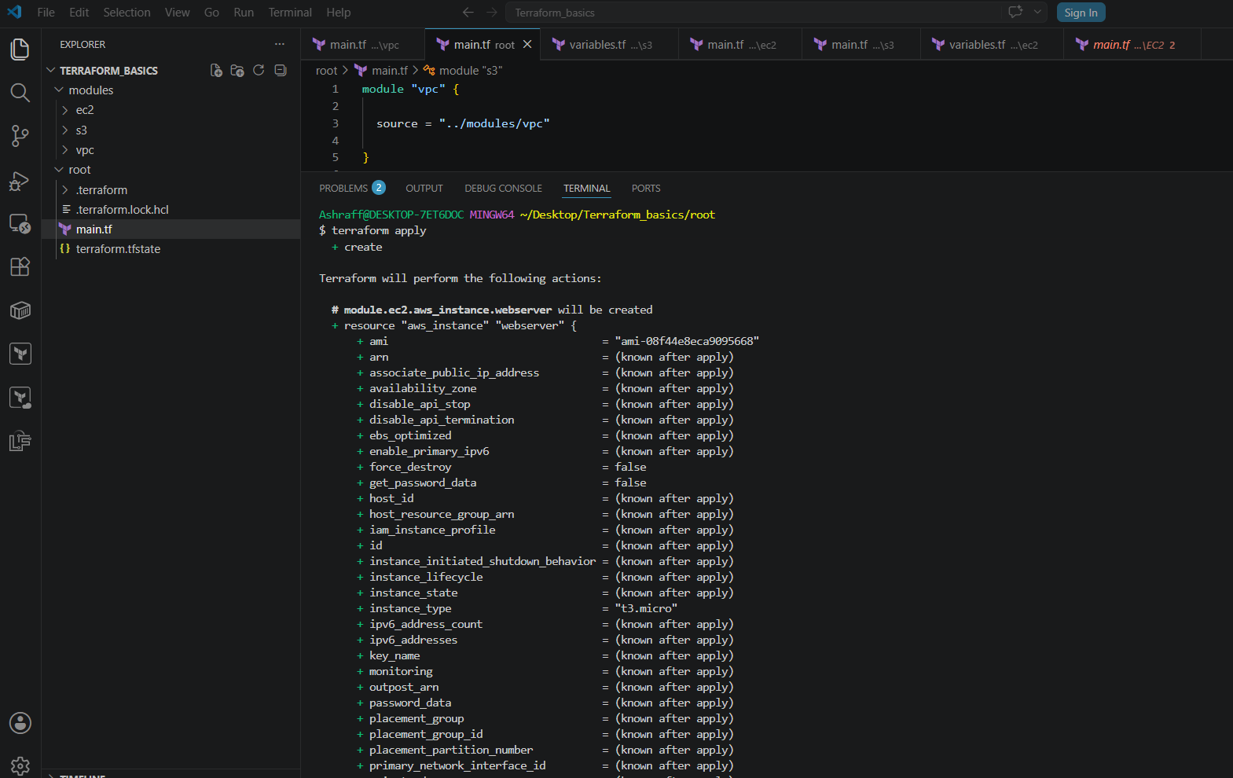
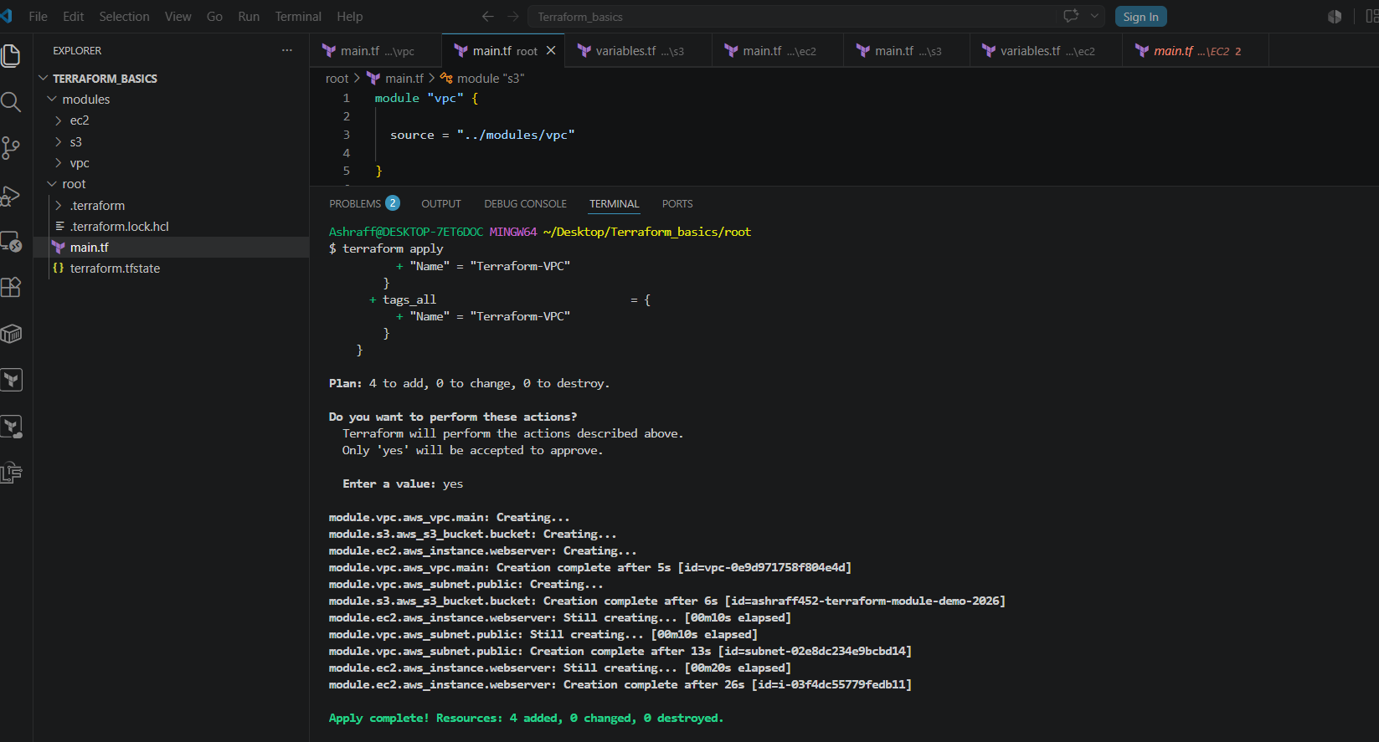
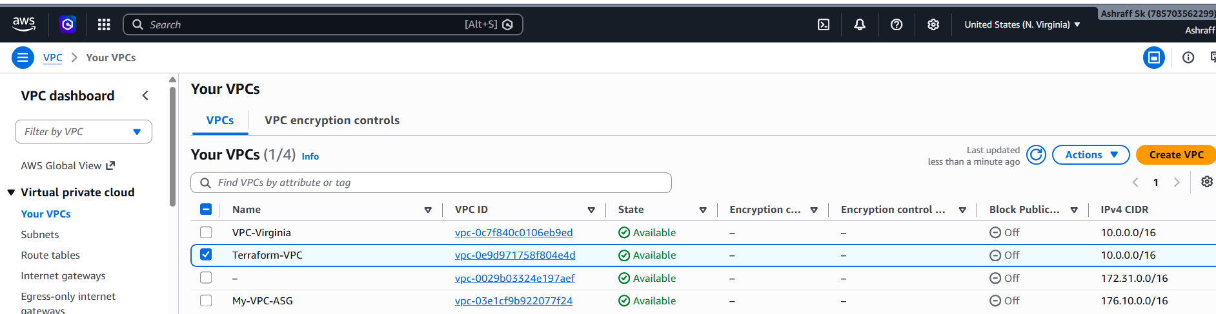
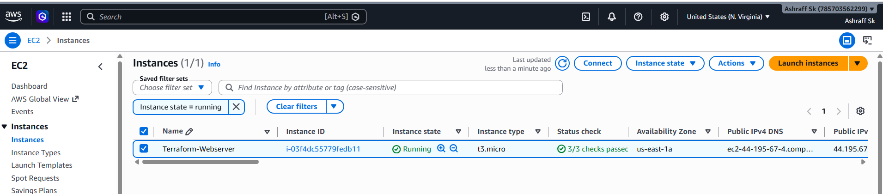

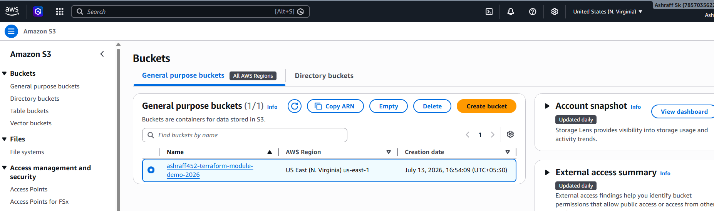
Conclusion:
We successfully:
- Created reusable Terraform modules.
- Provisioned a VPC and public subnet.
- Launched an EC2 instance with Apache installed using user_data.
- Created an S3 bucket.
- Used outputs to retrieve the EC2 public IP, VPC ID, and S3 bucket name.
- Managed the complete lifecycle of the infrastructure using terraform init, plan, apply, and destroy.

4). Provision EC2 for 3 different environments (Dev, Staging, and Prod) using Terraform workspaces.
Objective:
Provision separate EC2 instances for Development, Staging, and Production environments using Terraform Workspaces while maintaining a single Terraform configuration.
Purpose:
- Learn Terraform Workspaces.
- Deploy multiple environments from the same code.
- Reduce code duplication.
- Manage infrastructure efficiently.
Prerequisites:
AWS Account
Terraform Installed
AWS CLI Configured
IAM User with EC2 permissions

Steps:
- Create a aws_instance directory under TERRAFORM_BASICS directory
- Under aws_instance directory created a main.tf & saved as below:
resource "aws_instance" "webserver" {
ami = var.ami
subnet_id = var.subnet_id
instance_type = "t3.micro"
key_name = "linux_testing"
tags = {
Name = "${terraform.workspace}-Server"
Environment = terraform.workspace
}
}
- Create a variables.tf file & save with below code:
variable "ami" {
default = "ami-0521cb2d60cfbb1a6"
}
variable "subnet_id" {
default = "subnet-0d1454707d798a065"
}
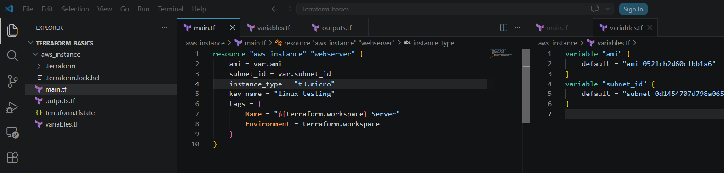
- Now created a outputs.tf file & saved with below code:
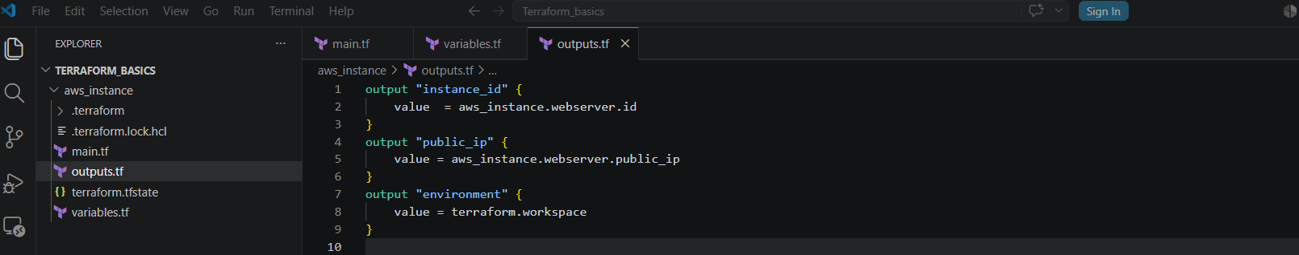
- In the terminal change to aws_instance directory by cd aws_instance
- Now execute terraform init
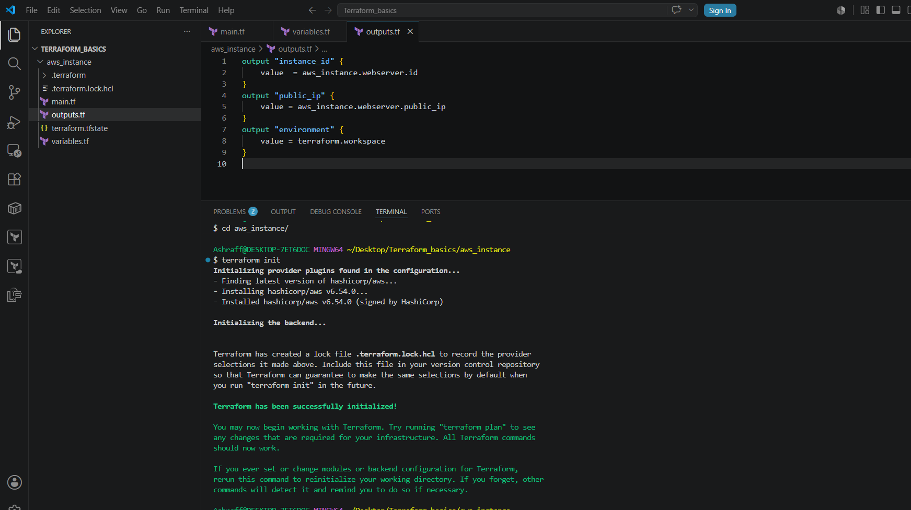
- Now execute terraform apply
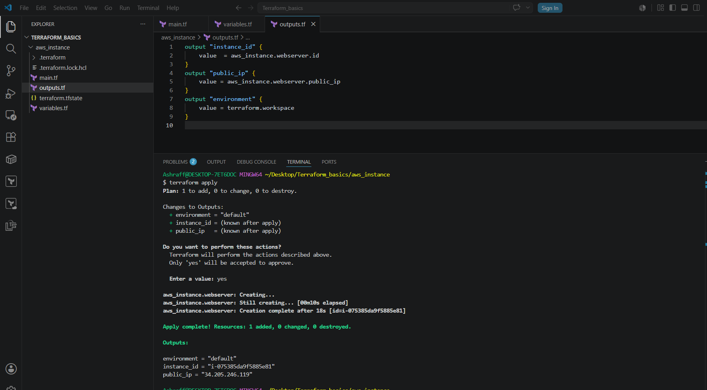
- To see the available workspaces, execute terraform workspace list
- We can see only default is available
- Created Development, Staging & Production workspaces using the below command:
terraform workspace new Development
terraform workspace new Staging
terraform workspace new Production
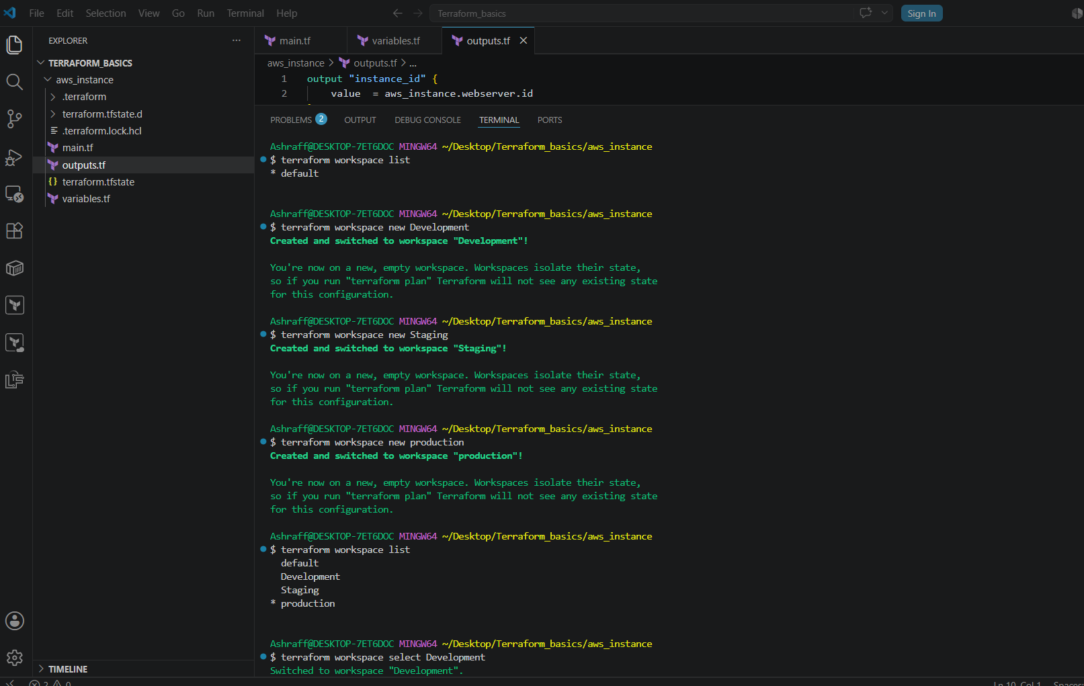
- Now select the Development workspace,
Terraform workspace select Development
- Now execute terraform init & once successful execute terraform apply & the success status with creating an ec2 instance
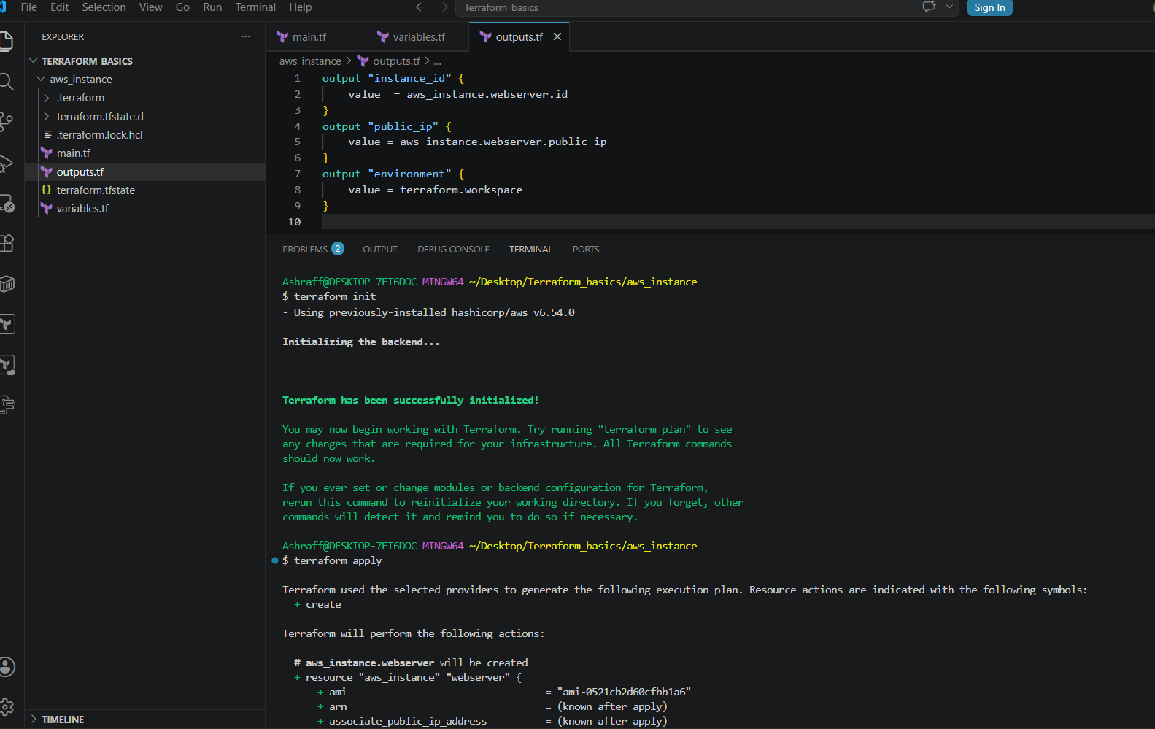
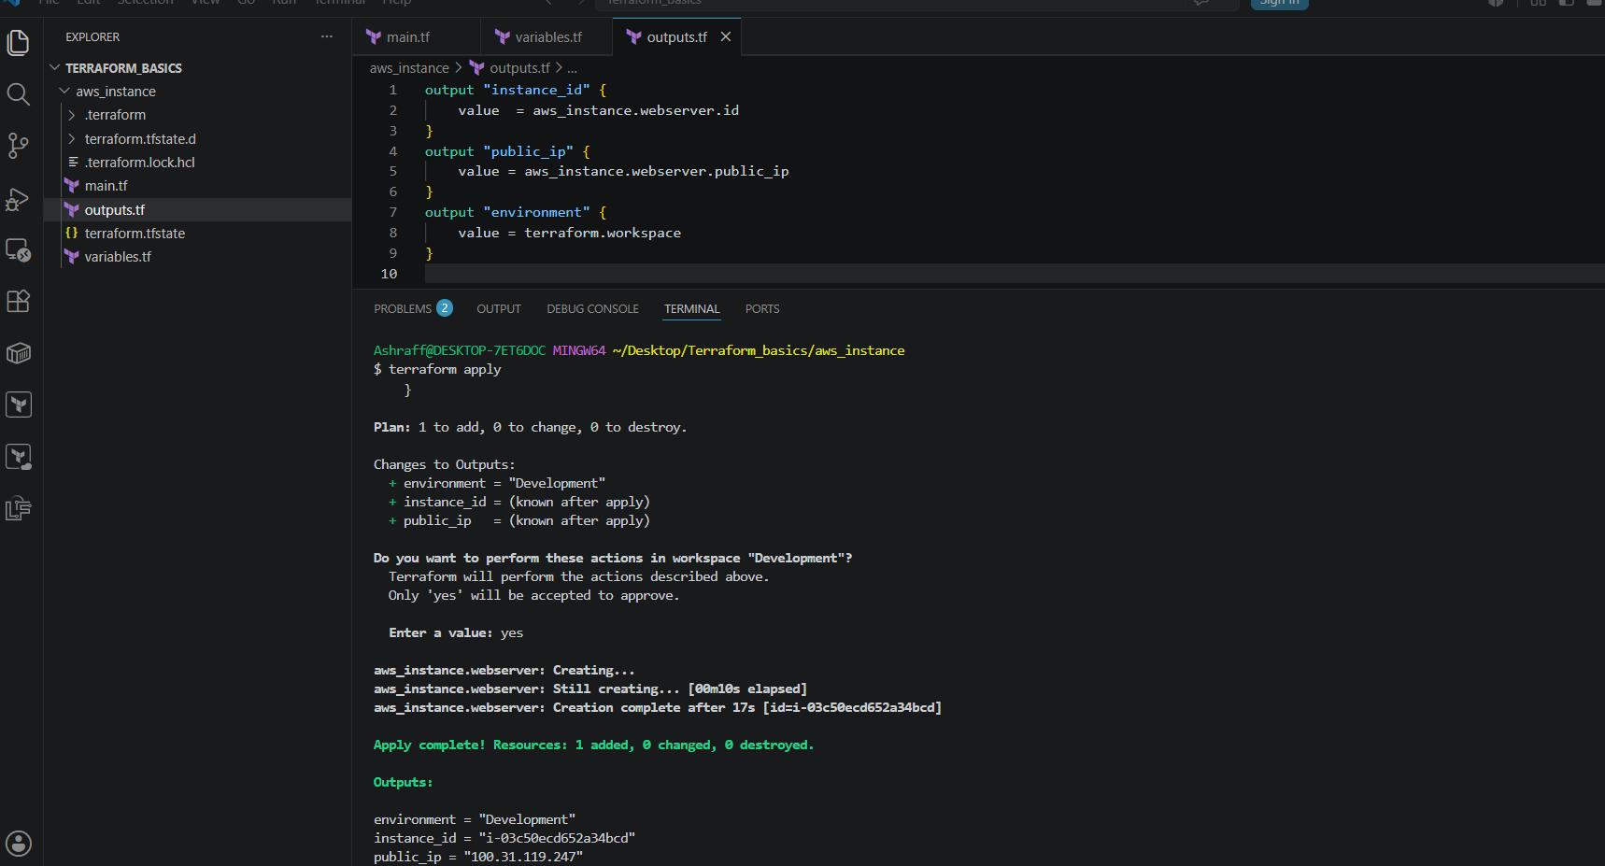

- Now select the Staging workspace,
Terraform workspace select Staging
- Now execute terraform init & once successful execute terraform apply & the success status with creating an ec2 instance
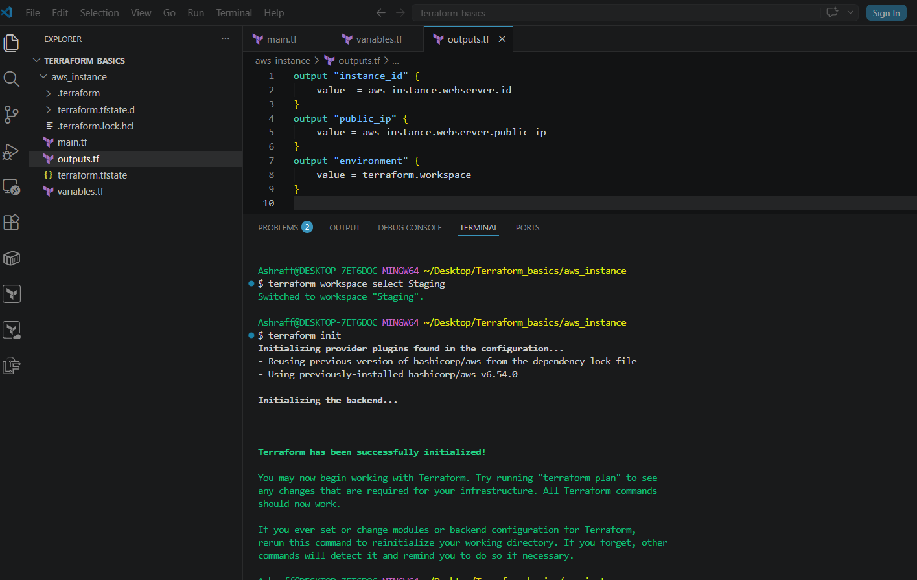
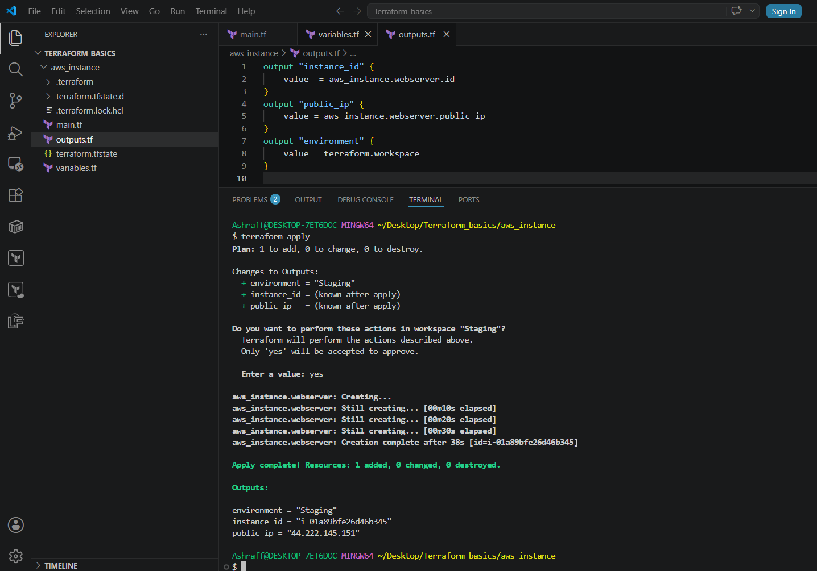
- Now select the production workspace,
Terraform workspace select production
- Now execute terraform init & once successful execute terraform apply & the success status with creating an ec2 instance
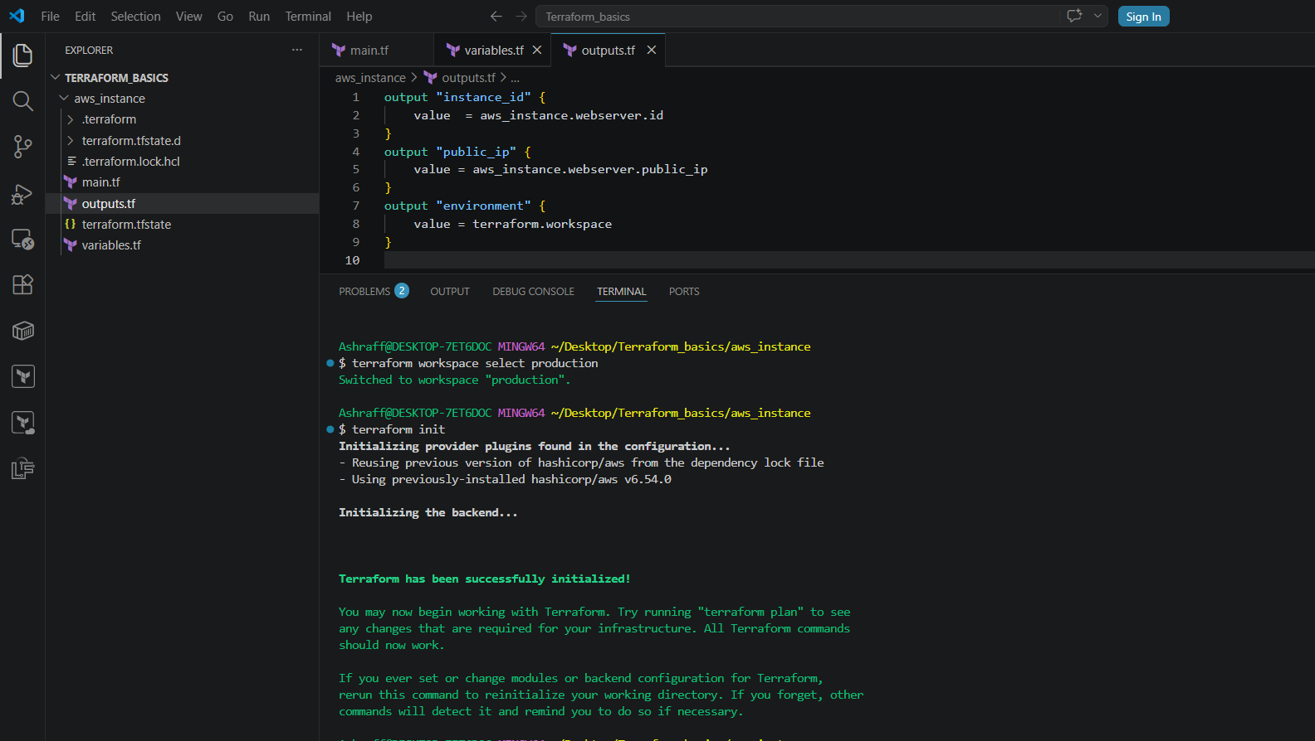
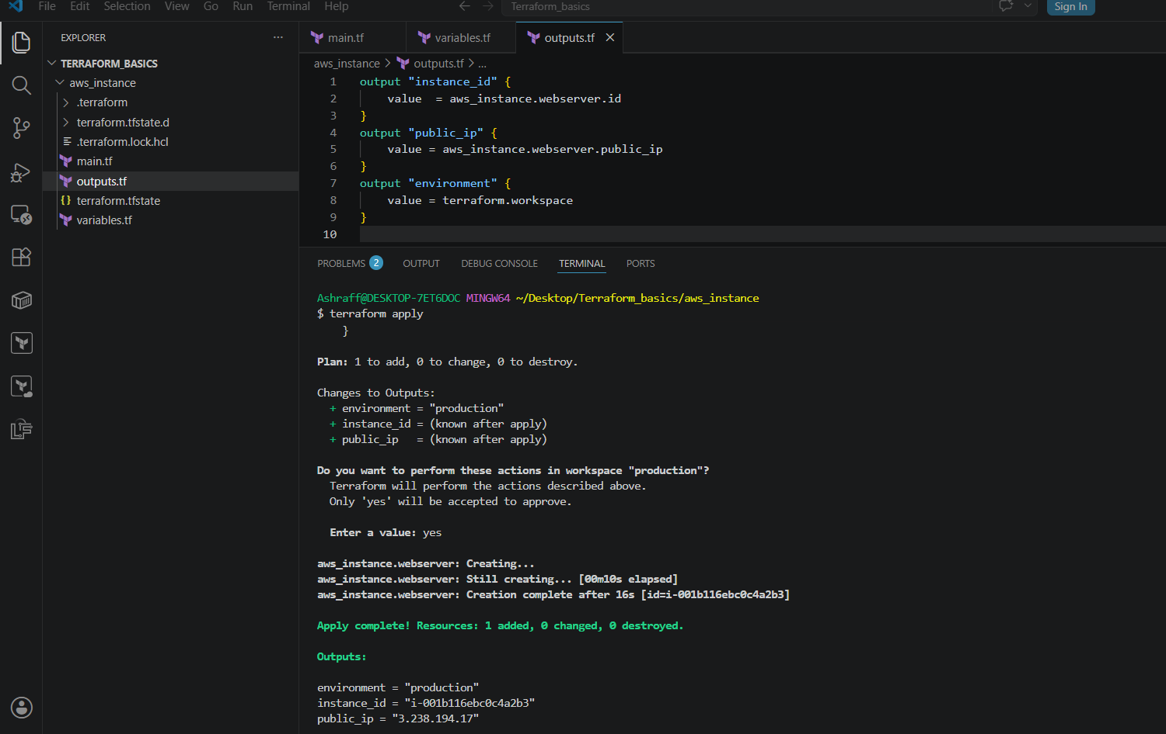
- Now we can check the ec2 instances created in each environment
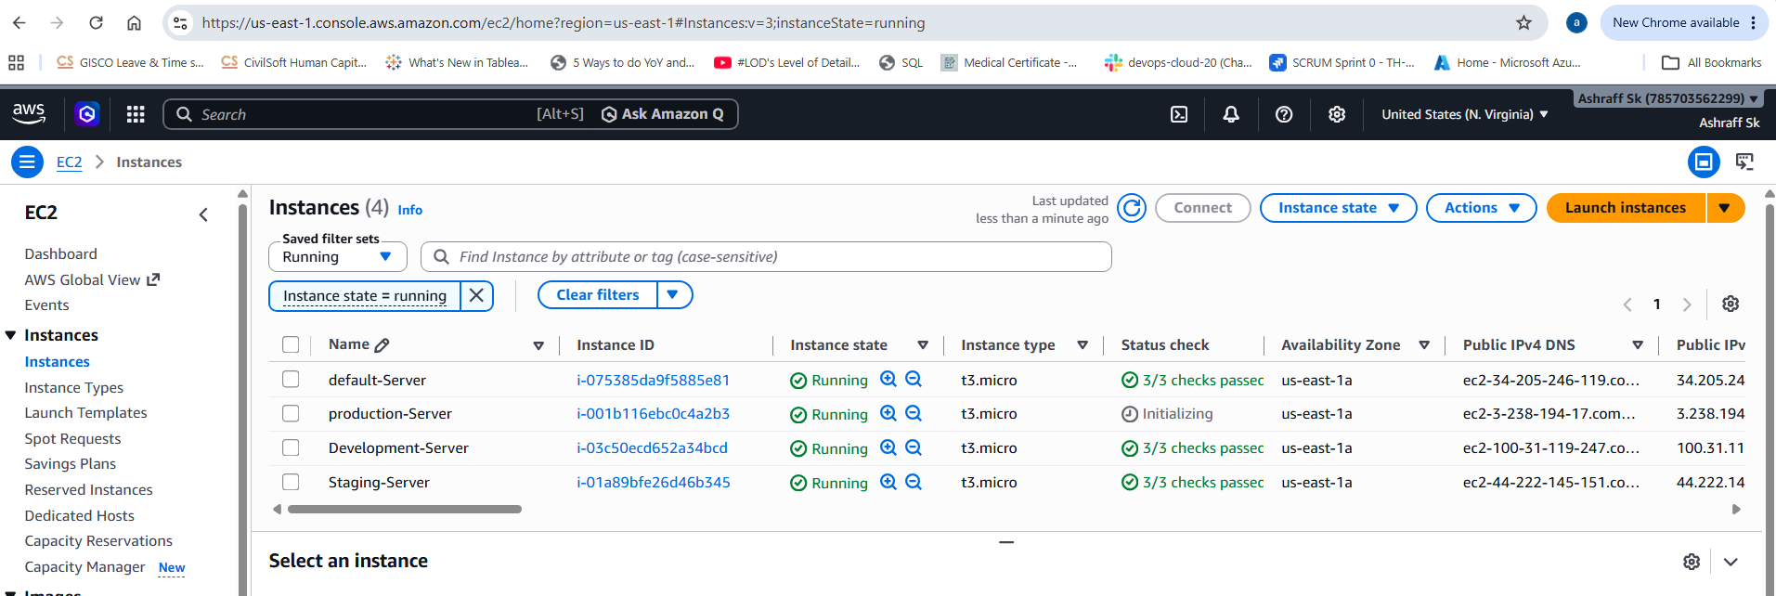

Advantages of Terraform Workspaces
- Single Terraform configuration for multiple environments.
- Isolated state files for each workspace.
- Easy switching between environments.
- Simplified infrastructure management.
- Reduces code duplication.

Conclusion:
In this lab, you successfully:
- Created Dev, Staging, and Prod workspaces.
- Used a single Terraform configuration to deploy three separate EC2 instances.
- Assigned different instance types using the active workspace.
- Switched between environments with terraform workspace select.
- Verified each deployment independently while keeping separate Terraform state for each environment.

