Terraform task – 04

1). Execute the script shown in the video.

Version provider:
- Open the project folder, Terraform basics in VS code
- Create a main.tf configuration file as mentioned below & save the file
terraform {
required_providers {
local = {
source = "hashicorp/local"
version = "2.7.0"
}
}
}
resource "local_file" "my_pet" {
filename = "pets.txt"
content = "I love Ducks"
}

- In the above code instead of downloading the latest plugin of the provider, local as 2.9.0 from hashicorp, I’m restricting to download the version as 2.7.0 instead of 2.9.0
- When executed terraform init, you can see that provider plugin of version 2.7.0 is downloaded
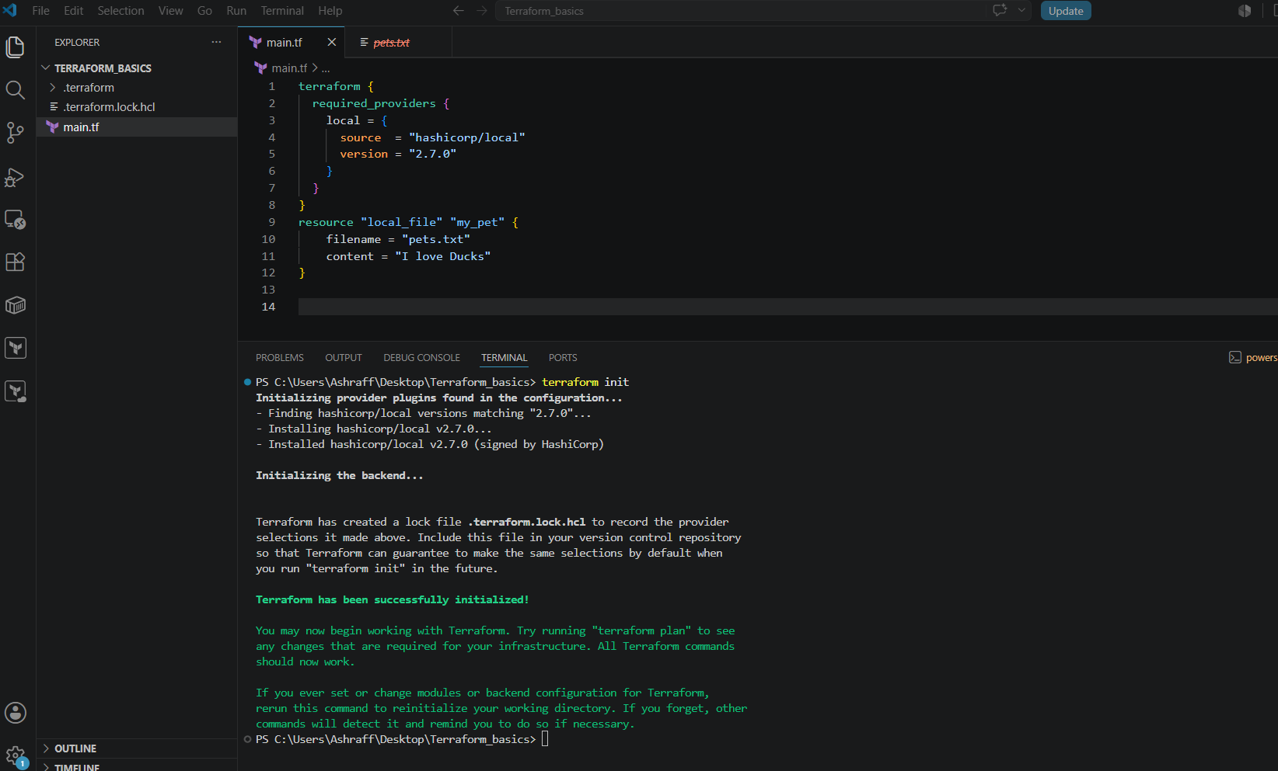
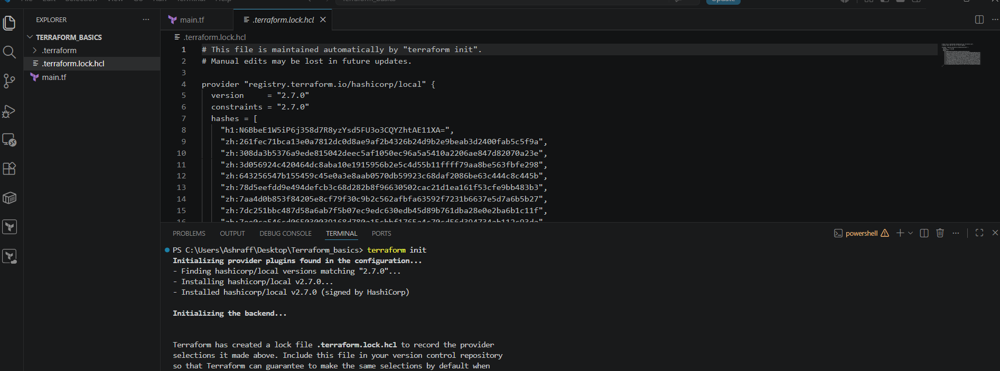
Version = “!=2.7.0”:

- Create a main.tf configuration file as mentioned below & save the file
- terraform {
- required_providers {
- local = {
- source = "hashicorp/local"
- version = "!=2.7.0"
- }
- }
- }
- resource "local_file" "my_pet" {
- filename = "pets.txt"
- content = "I love Ducks"
- }

- In the above code instead of downloading the latest plugin of the provider, local as other than 2.7.0 from hashicorp, I’m downloaded the version as 2.9.0

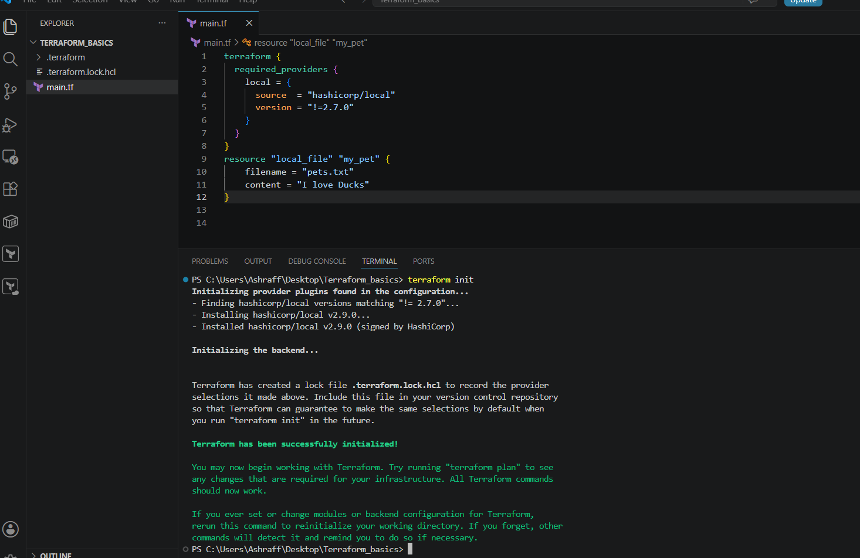
Version = “<2.7.0”:
- To check this option first I’ll delete the .terraform & .terraform.lock.hcl files
- Create a main.tf configuration file as mentioned below & save the file
- terraform {
- required_providers {
- local = {
- source = "hashicorp/local"
- version = "<2.7.0"
- }
- }
- }
- resource "local_file" "my_pet" {
- filename = "pets.txt"
- content = "I love Ducks"
- }

- In the above code instead of downloading the latest plugin of the provider, local as less than 2.7.0 from hashicorp, the terraform downloaded the version as 2.6.2

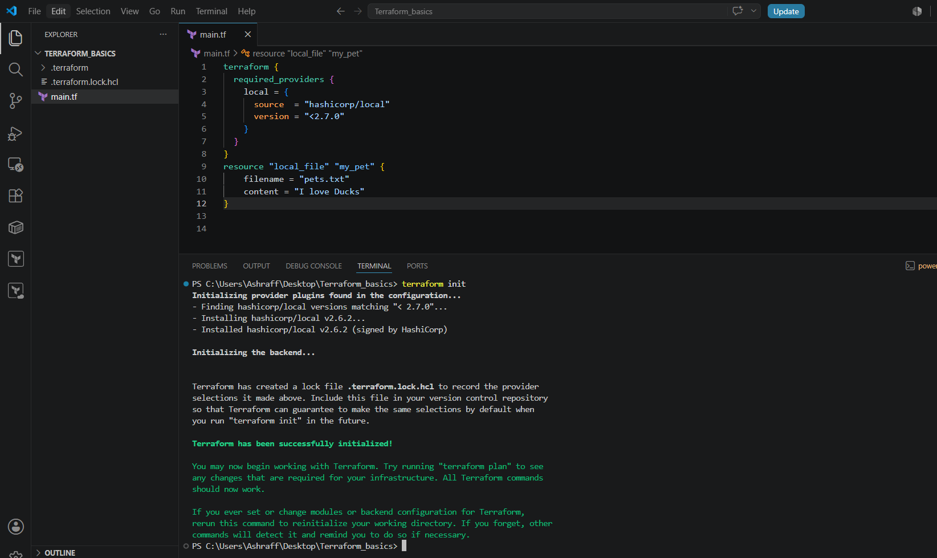

Version = “>2.7.0”:
- To check this option first I’ll delete the .terraform & .terraform.lock.hcl files
- Create a main.tf configuration file as mentioned below & save the file
- terraform {
- required_providers {
- local = {
- source = "hashicorp/local"
- version = ">2.7.0"
- }
- }
- }
- resource "local_file" "my_pet" {
- filename = "pets.txt"
- content = "I love Ducks"
- }

- In the above code instead of downloading the latest plugin of the provider, local as greater than 2.7.0 from hashicorp, terraform downloaded the version as 2.9.0

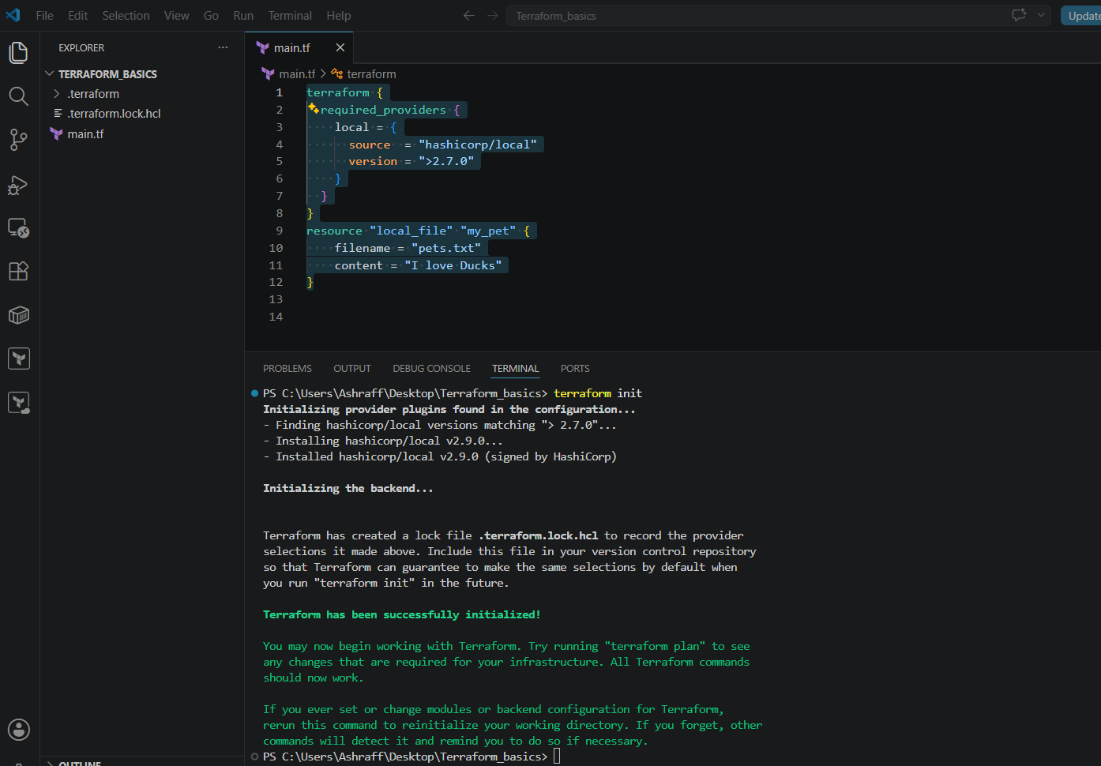

Version = “!=2.6.0,<2.3.0”:
- To check this option first I’ll delete the .terraform & .terraform.lock.hcl files
- Create a main.tf configuration file as mentioned below & save the file
- In the above code instead of downloading the latest plugin of the provider, local as not equal to 2.6.0 & less than 2.3.0 from hashicorp, terraform downloaded the version as 2.2.3

terraform {
required_providers {
local = {
source = "hashicorp/local"
version = "!=2.6.0,<2.3.0"
}
}
}
resource "local_file" "my_pet" {
filename = "pets.txt"
content = "I love Ducks"
}

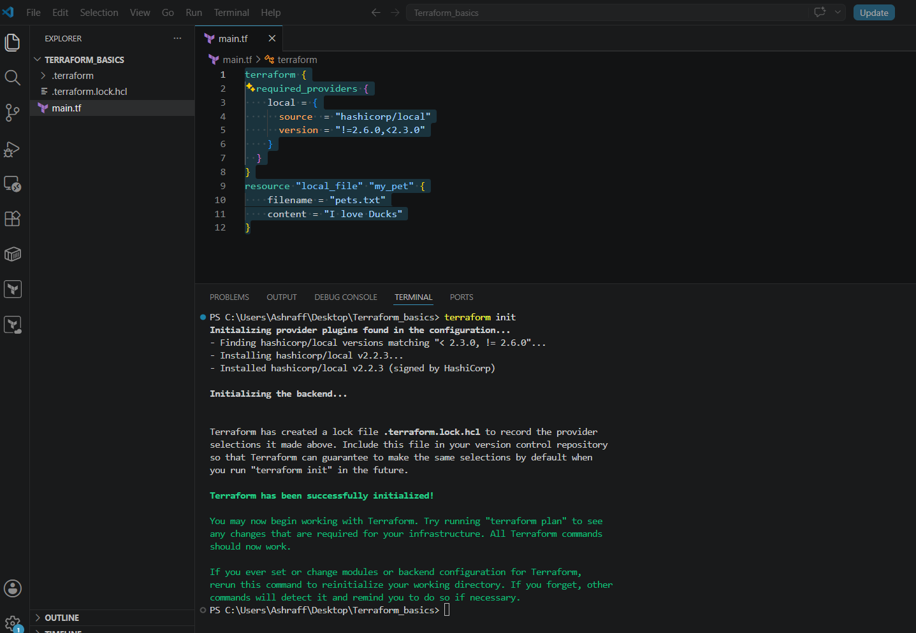

Data block:
- Create a main.tf configuration file as mentioned below & save the file
- resource "local_file" "my-pet" {
- filename = "pets.txt"
- content = "I love cats"
- }
- In the terminal executed, terraform init & terraform apply
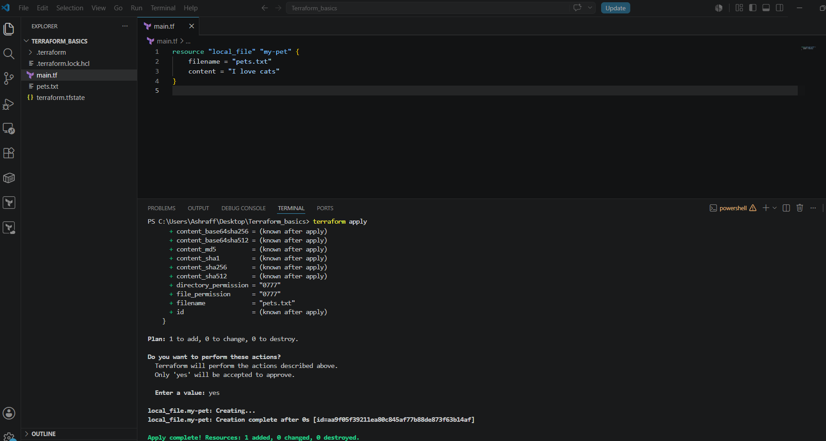
- Now created a dogs.txt file externally with the content as I love Dogs!
- Now created a data block as mentioned below:

data "local_file" "dog" {
filename = "dogs.txt"
}

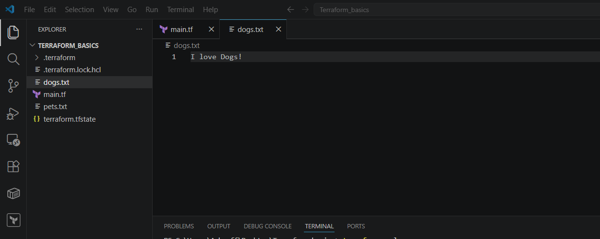

- Now done the changes to the main.tf file & saved as mentioned below:
resource "local_file" "my-pet" {
filename = "pets.txt"
content = data.local_file.dog.content
}
data "local_file" "dog" {
filename = "dogs.txt"
}

- Now we can see that data local_file content is been captured in the pets.txt content as I love Dogs!
- The data sources are used to read the content of the infrastructure.

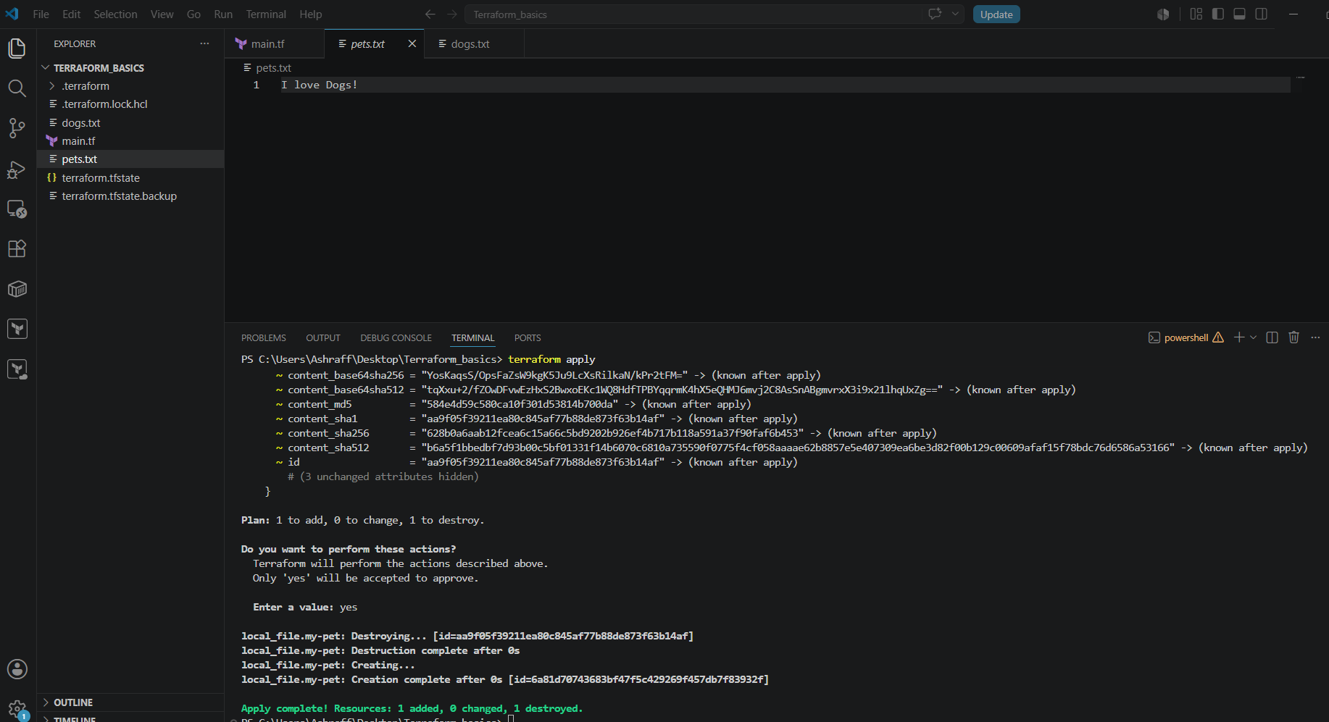

Meta-arguments:
Meta arguments are used to if we want to create multiple resources
• Metadata arguments (also called meta-arguments) are special arguments in Terraform that control how resources are created, managed, or depend on each other. They are supported by many resource types and are not specific to any one provider.
• Unlike normal arguments (such as ami or instance_type), meta-arguments affect Terraform's behavior, not the configuration of the resource itself.

Why Use Meta-Arguments?
Meta-arguments help you:
• Create multiple resources
• Create resources conditionally
• Control resource dependencies
• Customize resource lifecycle
• Select different providers
• Manage modules efficiently
- Depends_on
- Lifecycle rules
- Lifecycle:
- Create_before_destroy:

- Now in pets.txt I will change the content as My pet name is Zebra & lifecycle as create_before_destroy = true & save the file
Now terraform apply & we can see that the change is replaced by My pet name is Zebra & creating first and destroy next instead of destroy as first.
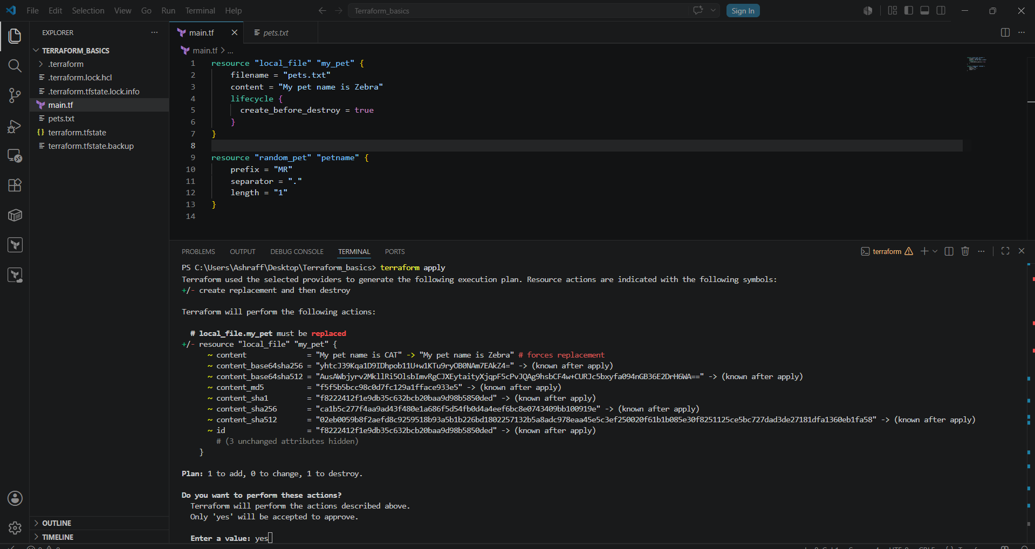
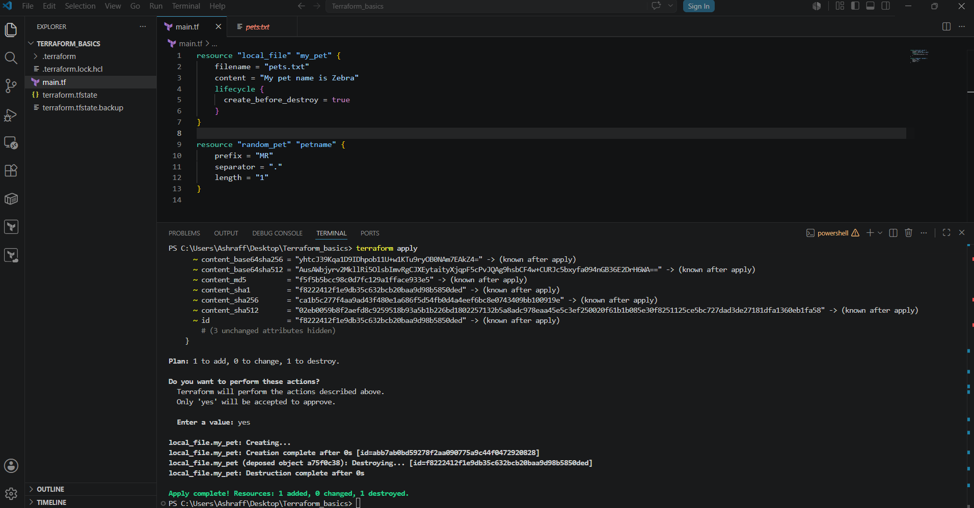
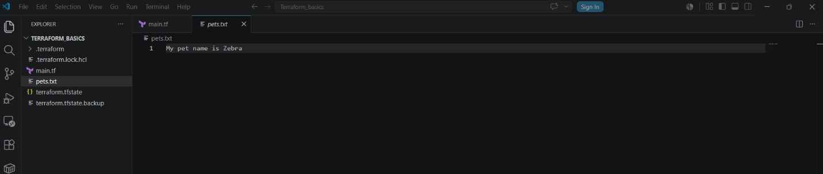

Prevent_destroy:
- Now when I have done the content change as My pet name is Elephant & using lifecycle prevent_destroy = true & save the file
- When execute terraform apply unable to destroy the old file because of the lifecycle, prevent_destroy

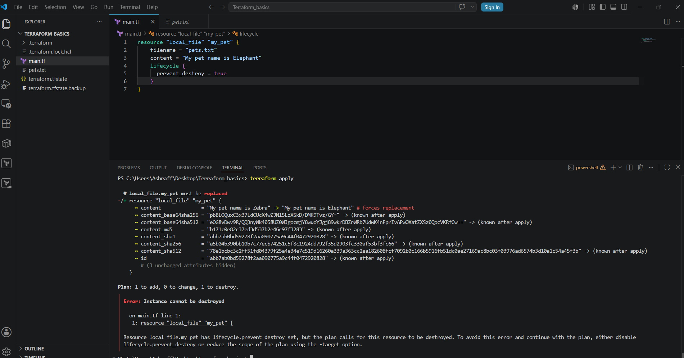

- Now even I changed the pets.txt content to My pet name is Giraffe with lifecycle as prevent_destroy = true & save
- Now when I execute the command, terraform destroy unable to destroy as well.
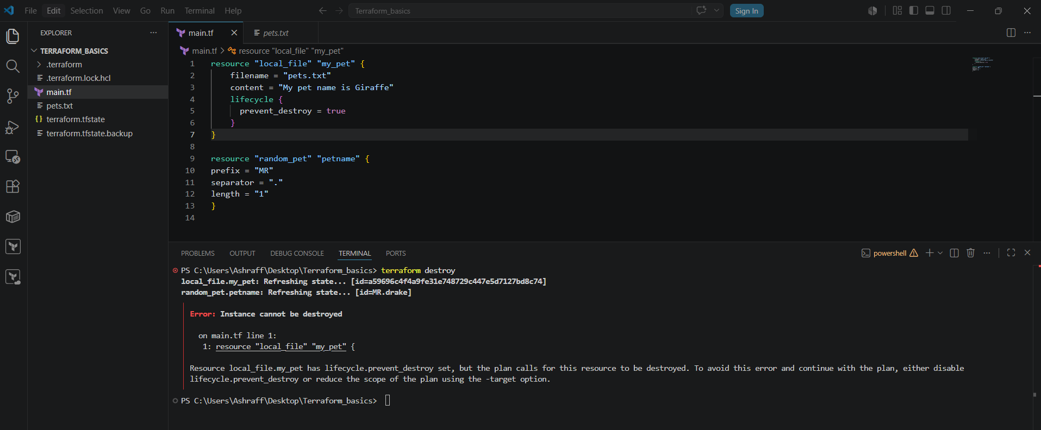

- Ignore_changes:

- Now even I changed the pets.txt content to My pet name is Giraffe with lifecycle as ignore_changes = [ content ] & save
- When executed the terraform apply command we see that no changes ignoring the changes because of the lifecycle ignore_changes.

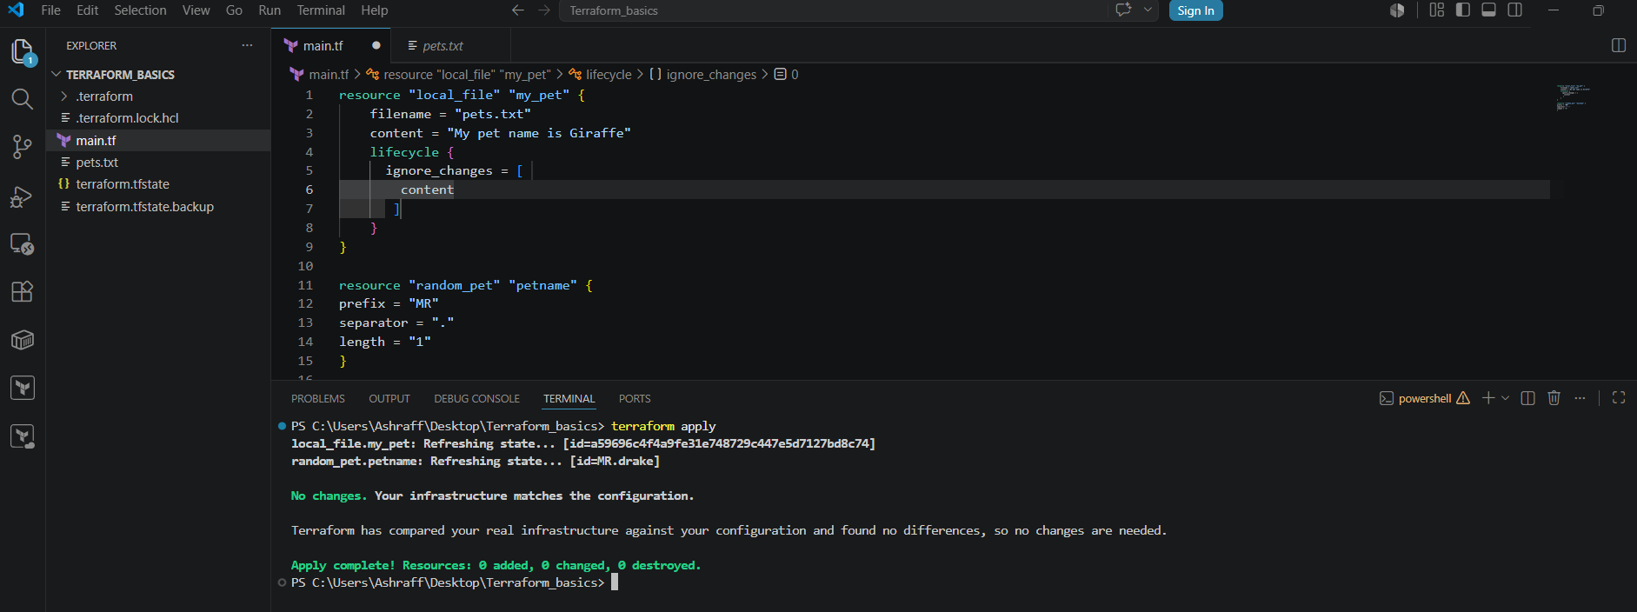

- Count

- Created main.tf file as mentioned below using count meta argument & save the file:
resource "local_file" "my-pet" {
filename = var.filename[count.index]
content = "I love Dogs!"
count = length(var.filename)
}
- Created the variables.tf file as mentioned below & save the file.
variable "filename" {
default =
[ "cats.txt", "pets.txt" ] }
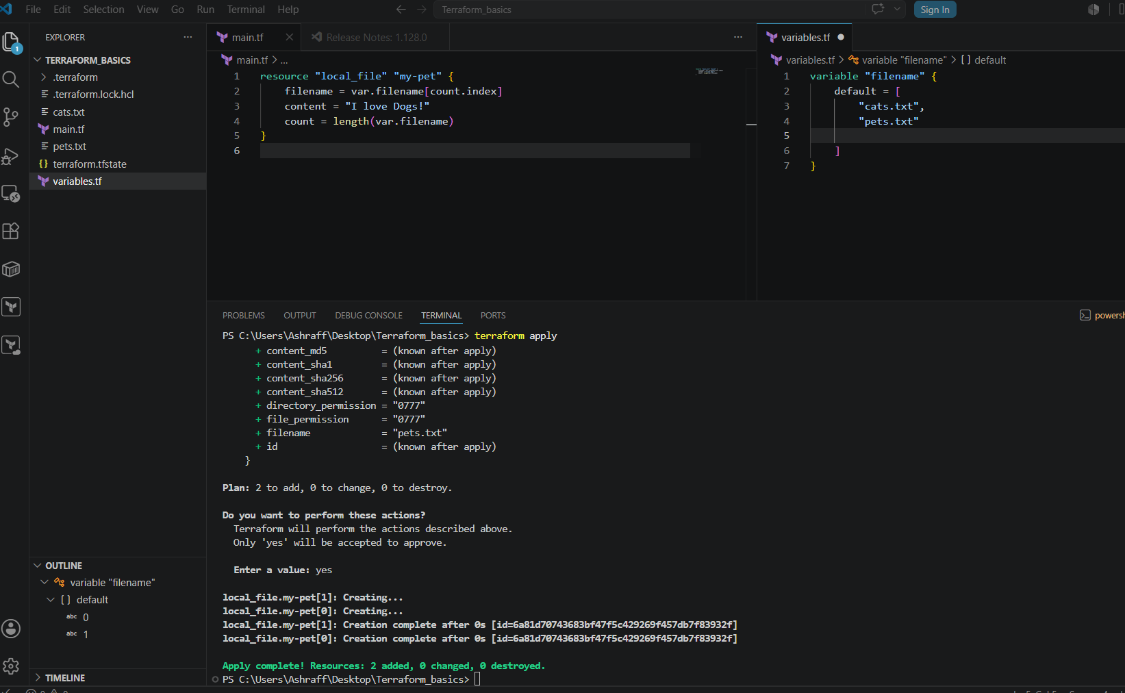

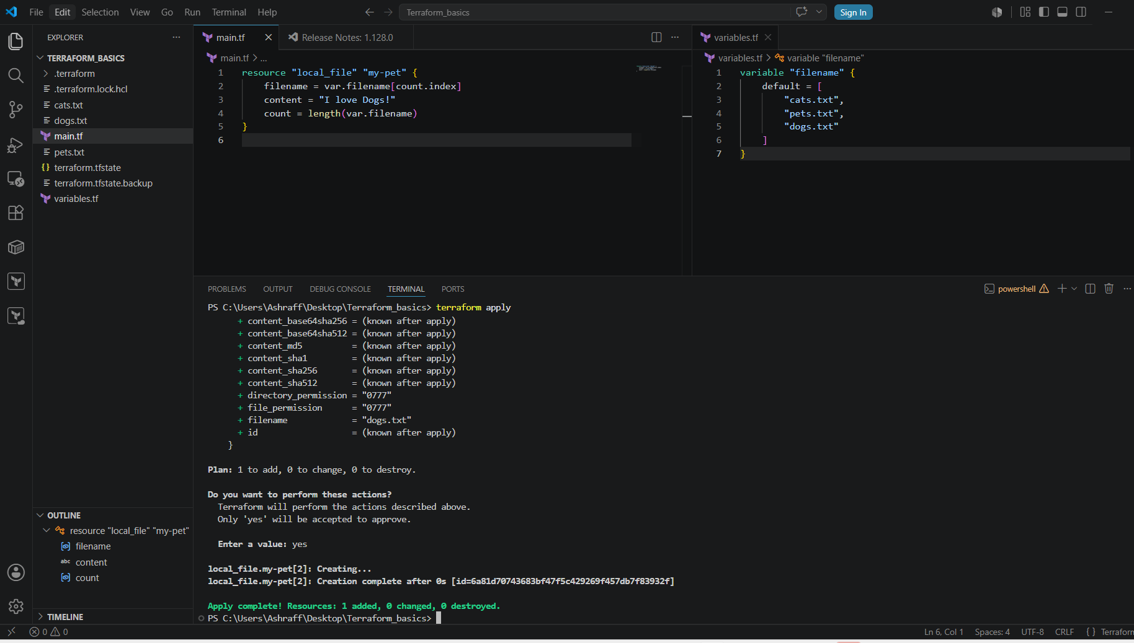

- For_each

Created a main.tf file with below code:
resource "local_file" "my-pet" {
filename = each.value
content = "I love cats"
for_each = toset(var.filename)
}
Created a variables.tf file as mentioned below:
variable "filename" {
default = [
"cats.txt",
"pets.txt",
"dogs.txt"
]
}
By using the in-built function toset we can create three files.
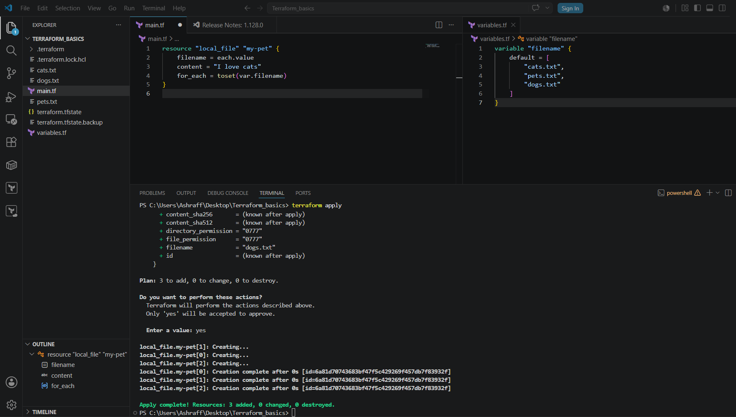
Now instead of using the toset inbuilt function we can do the below changes to main.tf & variables.tf files & can create multiple files.
resource "local_file" "my-pet" {
filename = each.value
content = "I love cats"
for_each = var.filename
}

variable "filename" {
type = set(string)
default = [
"cats.txt",
"pets.txt",
"dogs.txt"
]
}
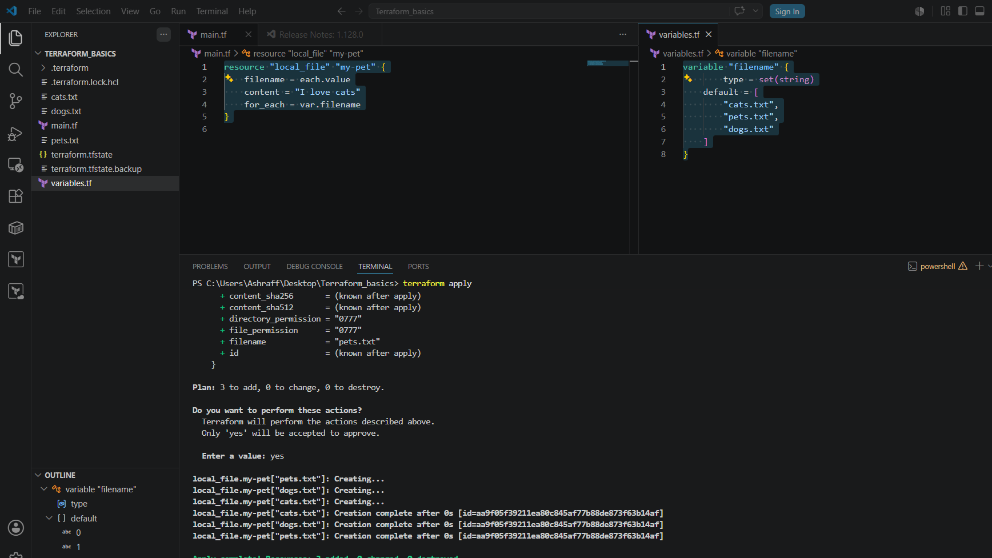

AWS:
IAM user creation:
- First login to AWS console as a root user
- Now create a main.tf file in VS code as mentioned below:
resource "aws_iam_user" "Admin-user" {
name = "hamna"
tags = {
"description" = "Technical Team Lead"
}
}
- Now executing terraform init installing the aws dependencies
- We need to configure aws by running aws configure in VS code
- Now execute terraform apply & we can see that one user named hamna is created in my aws account
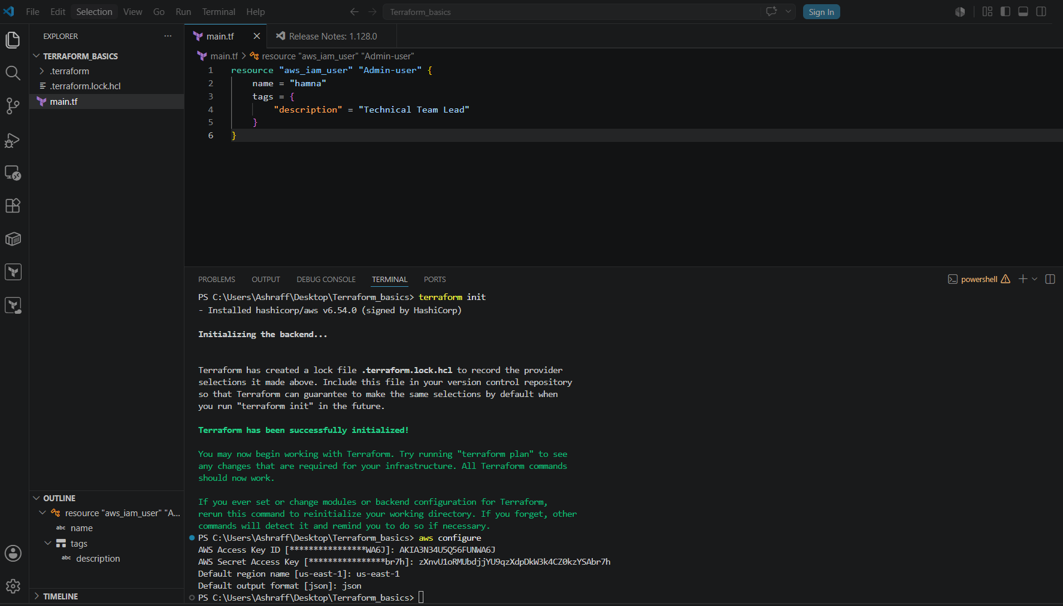
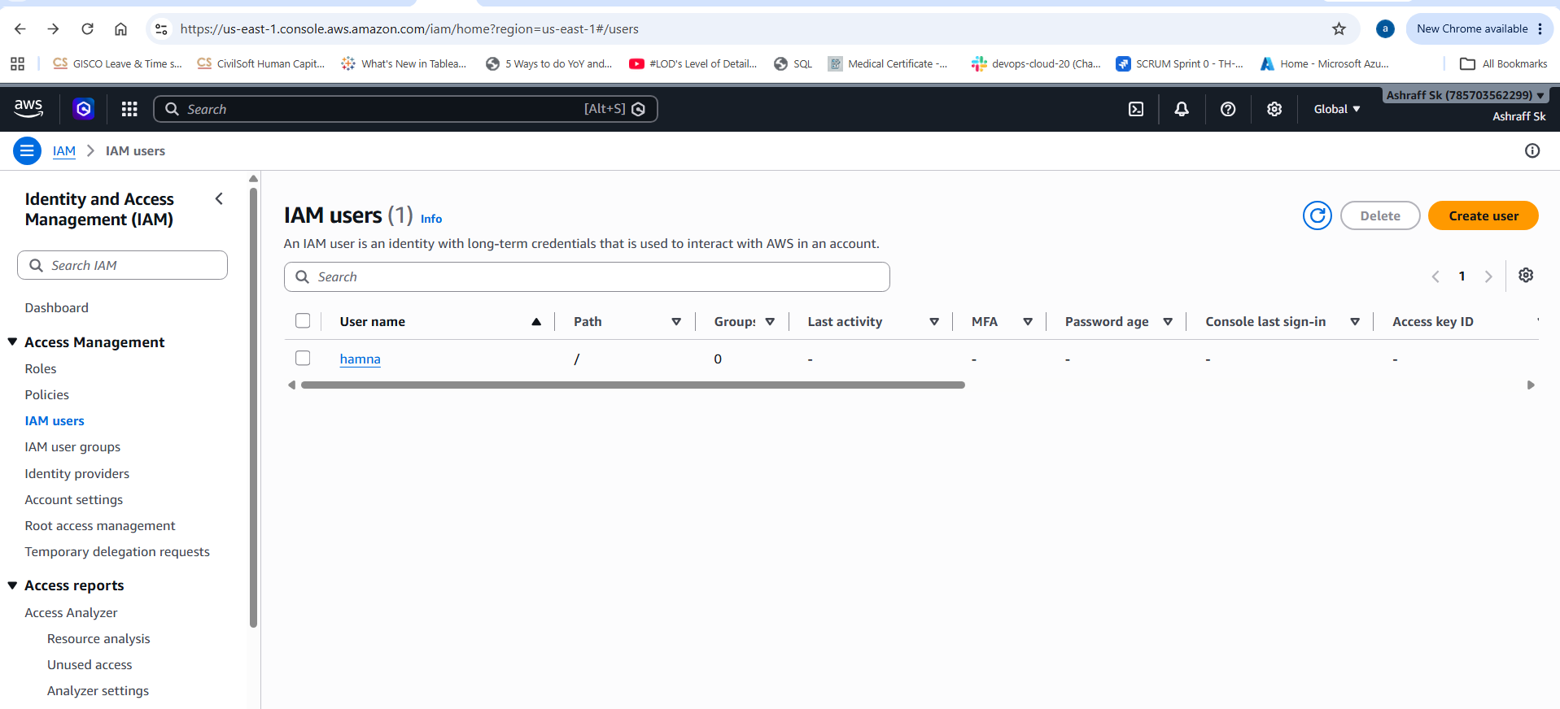

- Now executed terraform destroy & created the main.tf file as mentioned below:
resource "aws_iam_user" "admin_user" {
name = "lucy"
tags = {
"description" = "Technical Team Lead"
}
}
resource "aws_iam_policy" "adminuser" {
name = "AdminUsers"
policy = <<EOF
{
"Version" : "2012-10-17",
"Statement" : [
{
"Sid": "123456",
"Effect" : "Allow",
"Action" : "*",
"Resource" : "*"
}
]
}
EOF
}
resource "aws_iam_user_policy_attachment" "lucy_admin_access" {
user = aws_iam_user.admin_user.name
policy_arn = aws_iam_policy.adminuser.arn
}

- Now executed the terraform plan & apply where in aws account one user named lucy got created & got policy attached.

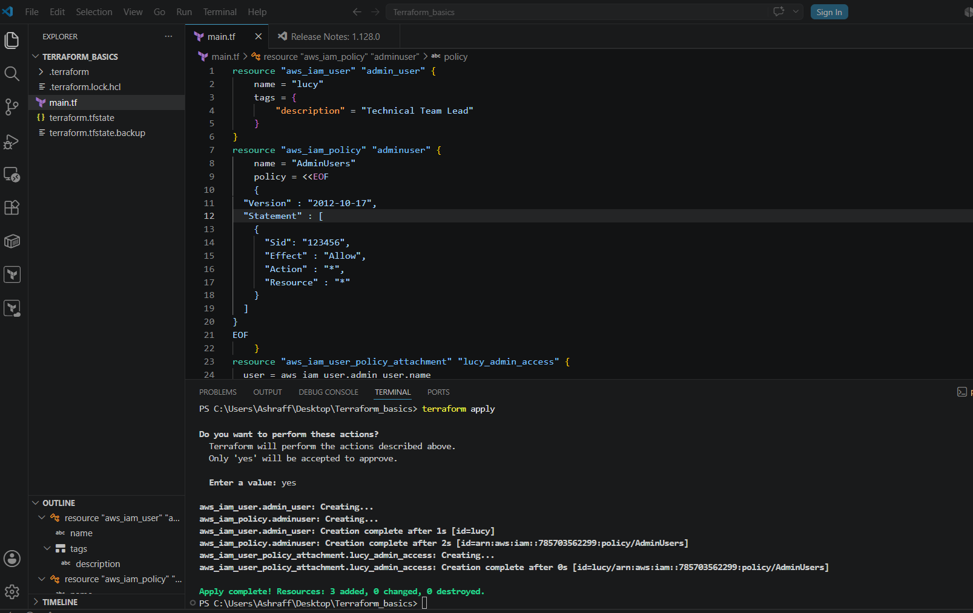

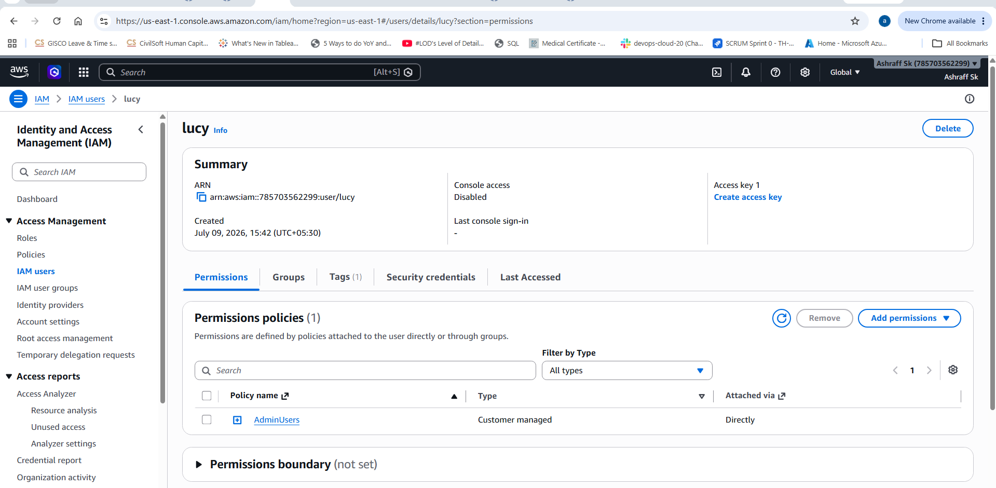
2). Integrate Terraform in Jenkins using the Terraform plugin.
Steps:
Created a Jenkins pipeline as mentioned below:
pipeline {
agent any

tools {
terraform 'terraform'
}

environment {
AWS_DEFAULT_REGION = 'us-east-1'
}

stages {

stage('Git Clone') {
steps {
git branch: 'main',
url: 'https://github.com/ashrafff452/aws-terraform.git'
}
}

stage('Terraform Init') {
steps {
withCredentials([[
$class: 'AmazonWebServicesCredentialsBinding',
credentialsId: 'aws_credentials'
]]) {
sh 'terraform init'
}
}
}

stage('Terraform Plan') {
steps {
withCredentials([[
$class: 'AmazonWebServicesCredentialsBinding',
credentialsId: 'aws_credentials'
]]) {
sh 'terraform plan'
}
}
}

stage('Terraform Apply') {
steps {
withCredentials([[
$class: 'AmazonWebServicesCredentialsBinding',
credentialsId: 'aws_credentials'
]]) {
sh 'terraform apply -auto-approve'
}
}
}
}

post {
success {
echo 'Terraform deployment successful'
}

failure {
echo 'Terraform deployment failed'
}

always {
cleanWs()
}
}
}
- Installed the plugin AWS credentials
- In credentials of Jenkins GUi updated the aws access key & secret key
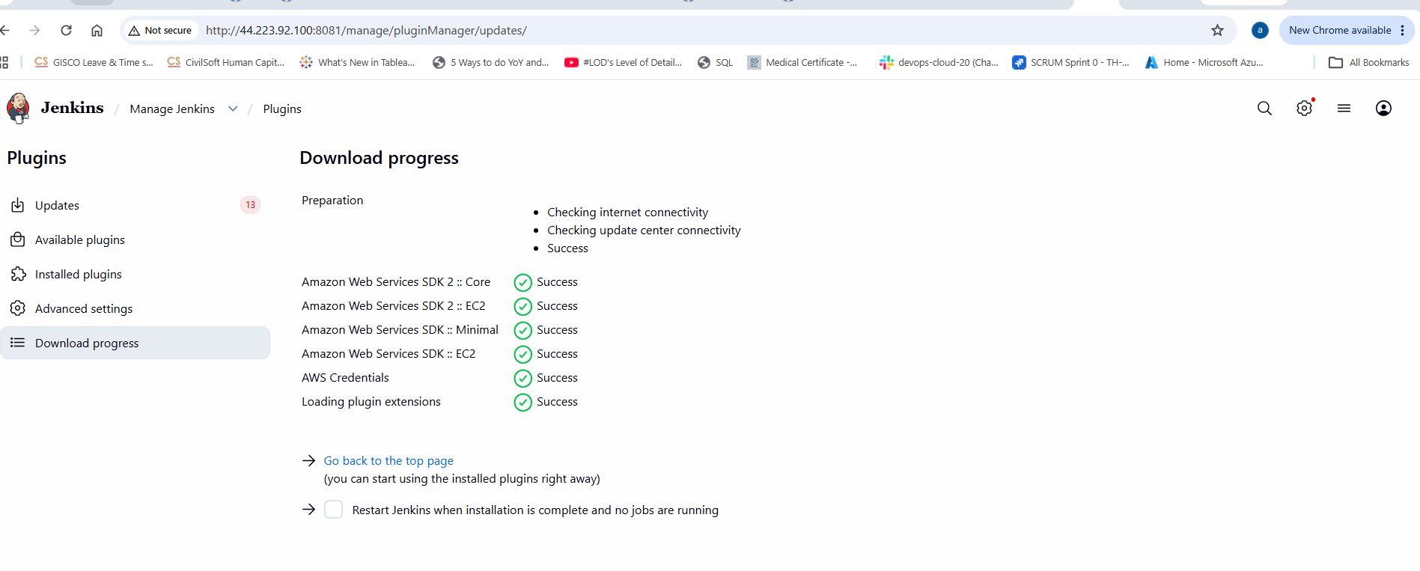
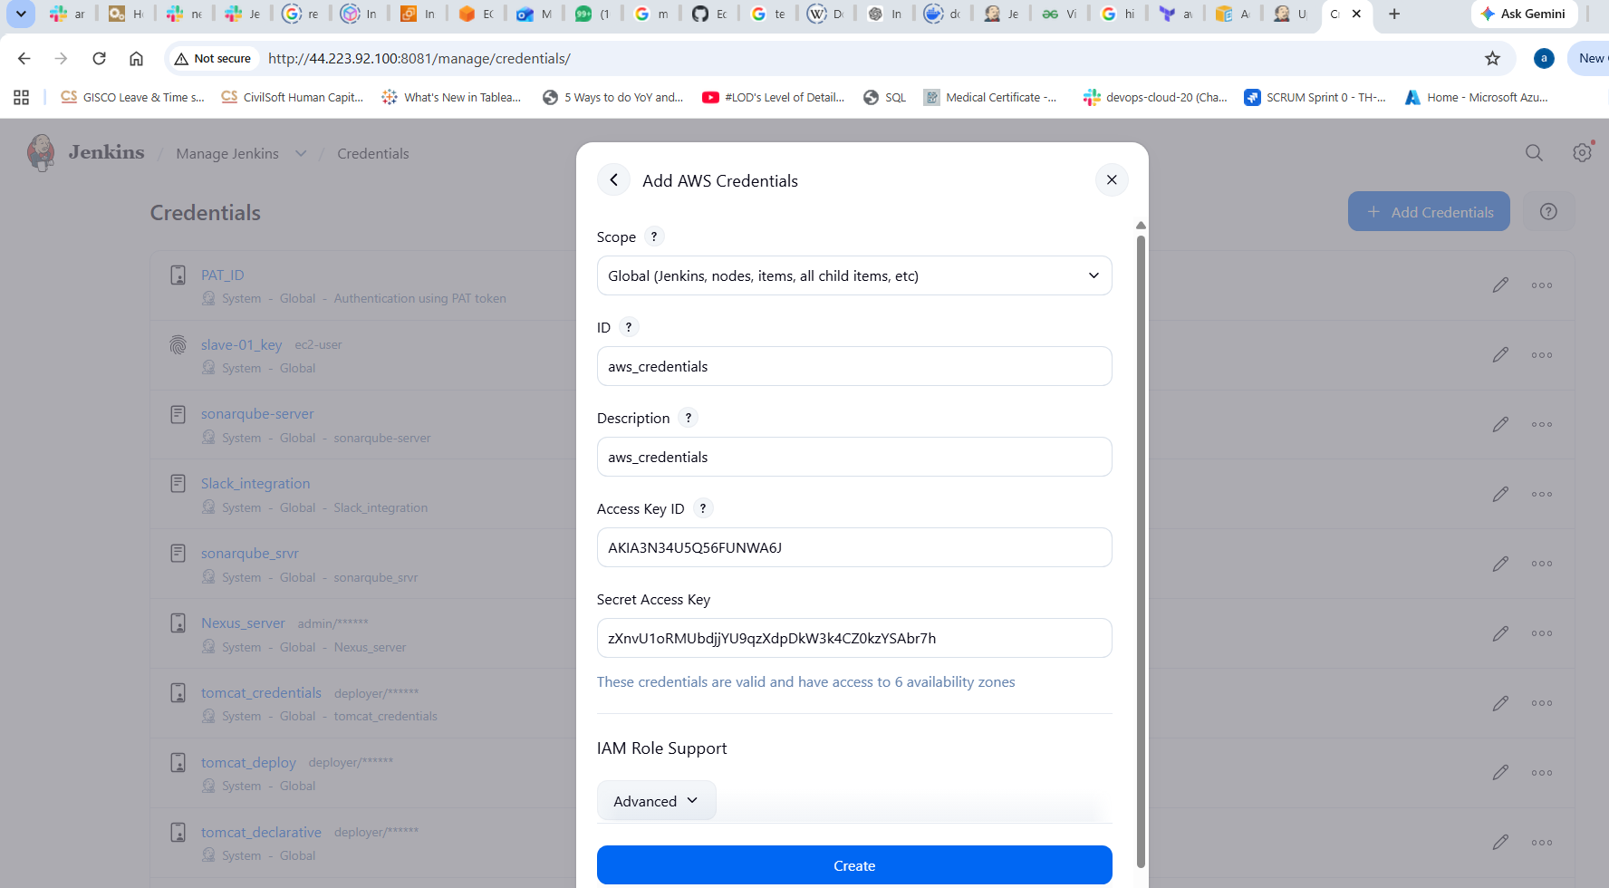
- Now created the main.tf & Jenkinsfile in the Github repo& used the url in Jenkinsfile
- Created a job aws_IAM_job & executed & captured the output from aws account.

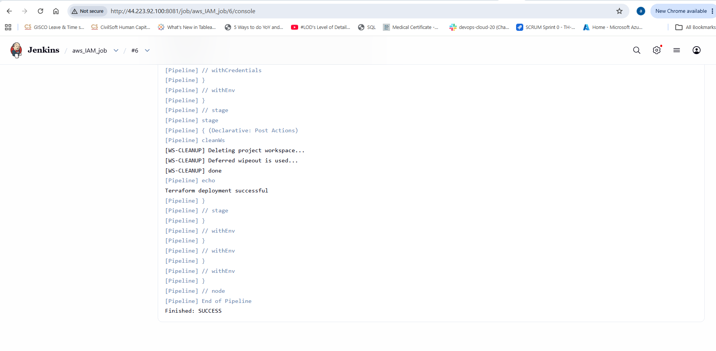
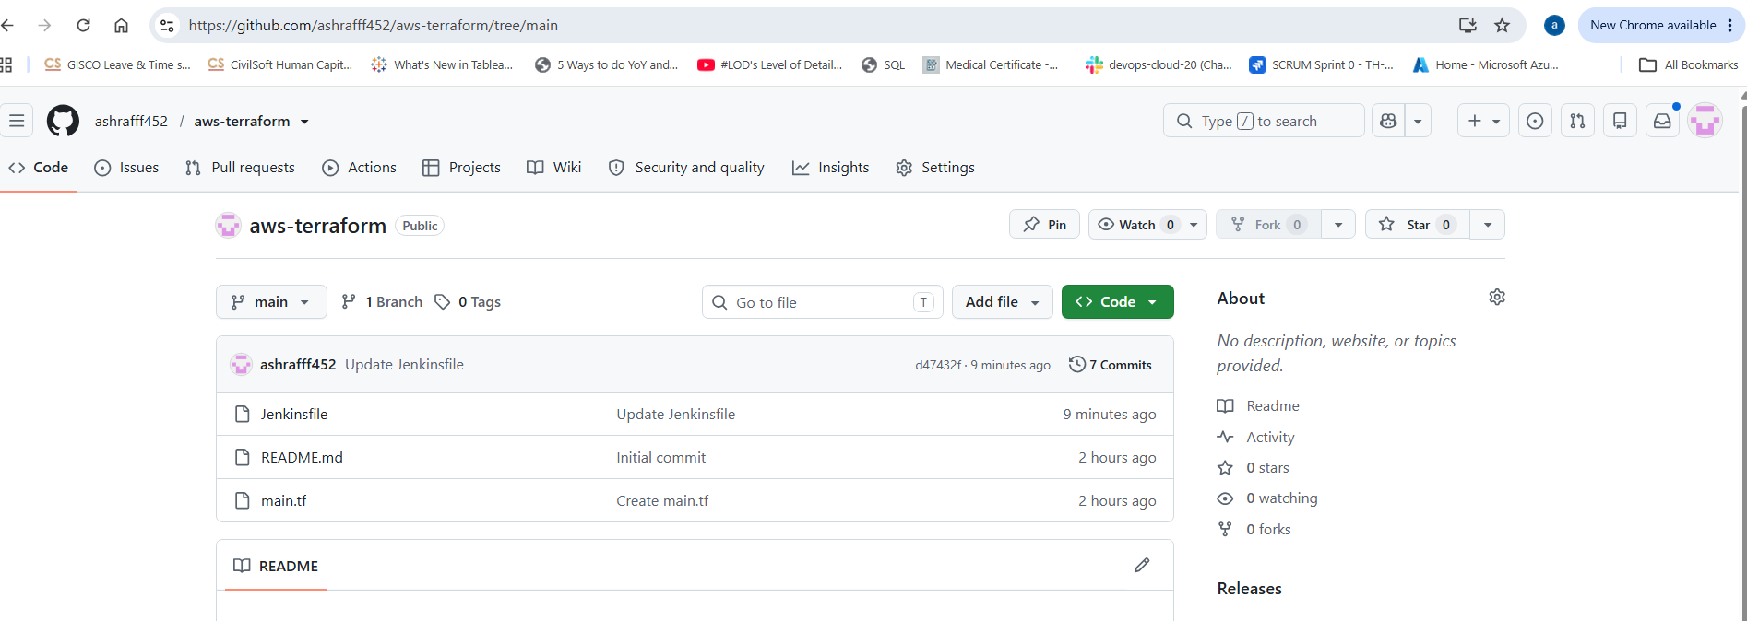
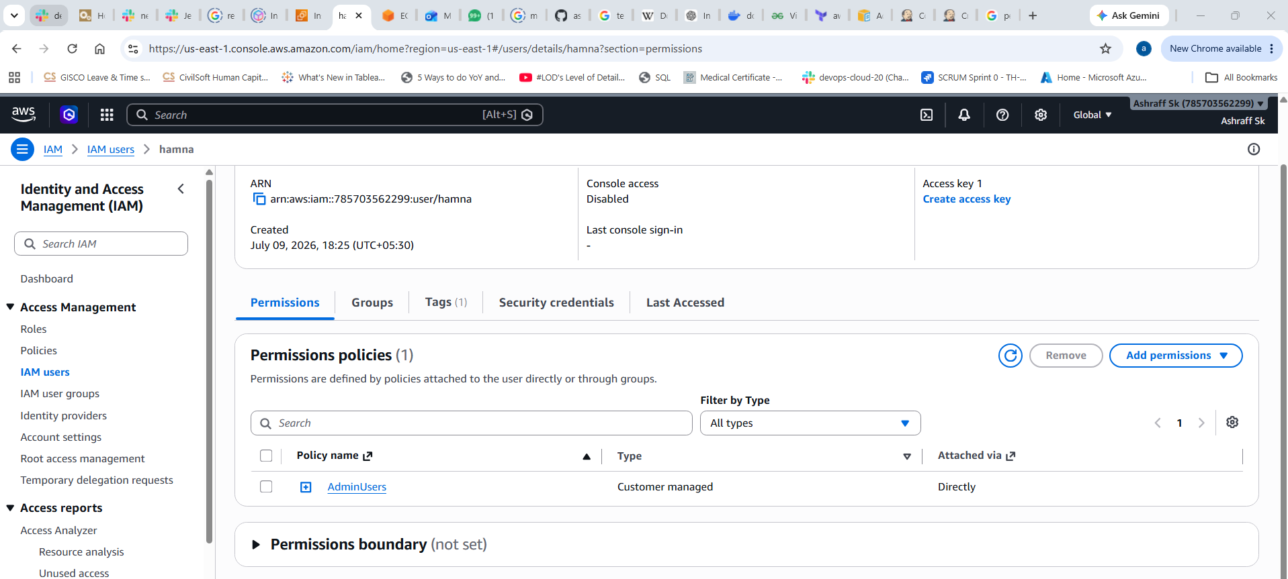
3). Create a CI/CD pipeline for a Nodejs Application: https://github.com/betawins/Trading-UI.git
Steps:
- First connect to My-ec2-jenkins instance
- Login to jenking GUI, download the nodejs plugin
- Fork the repo into my Git hub account & create a Dockerfile
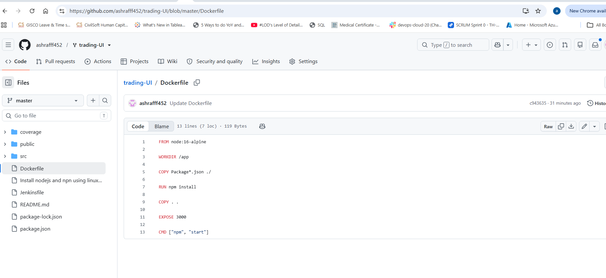
- Now integrate the installed nodejs path in Tools section of Manage Jenkins, Jenkins GUI
- Now created a Node-js_job pipeline
pipeline {
agent any

tools {
nodejs 'nodejs'
}

environment {
IMAGE_NAME = "ashraff452/trading-ui"
TAG = "v1"
}

stages {

stage('Git Clone') {
steps {
git branch: 'master',
url: 'https://github.com/ashrafff452/trading-UI.git'
}
}

stage('Build Docker Image') {
steps {
sh 'docker build -t $IMAGE_NAME:$TAG .'
}
}

stage('Push Docker Image') {
steps {
withDockerRegistry([credentialsId: 'Docker_credentials', url: '']) {
sh 'docker push $IMAGE_NAME:$TAG'
}
}
}

stage('Deploy') {
steps {
sh '''
docker stop trading-ui || true
docker rm trading-ui || true

docker run -d \
--name trading-ui \
-p 3000:3000 \
$IMAGE_NAME:$TAG
'''
}
}
}
}
- Captured the console output once the job is success
- IPv4:3000 in the browser shows the deployed app & check in Jenkins workspace

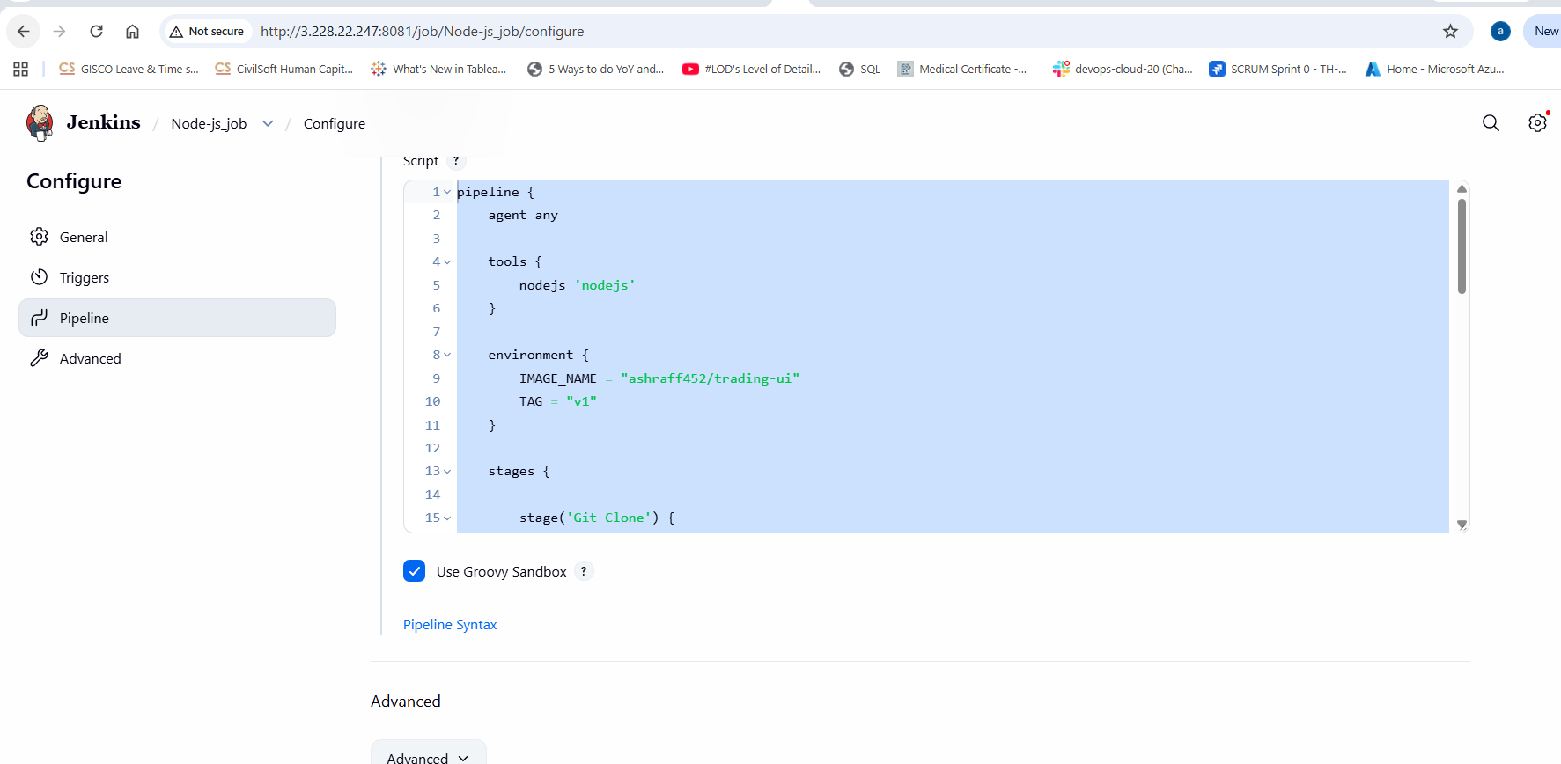

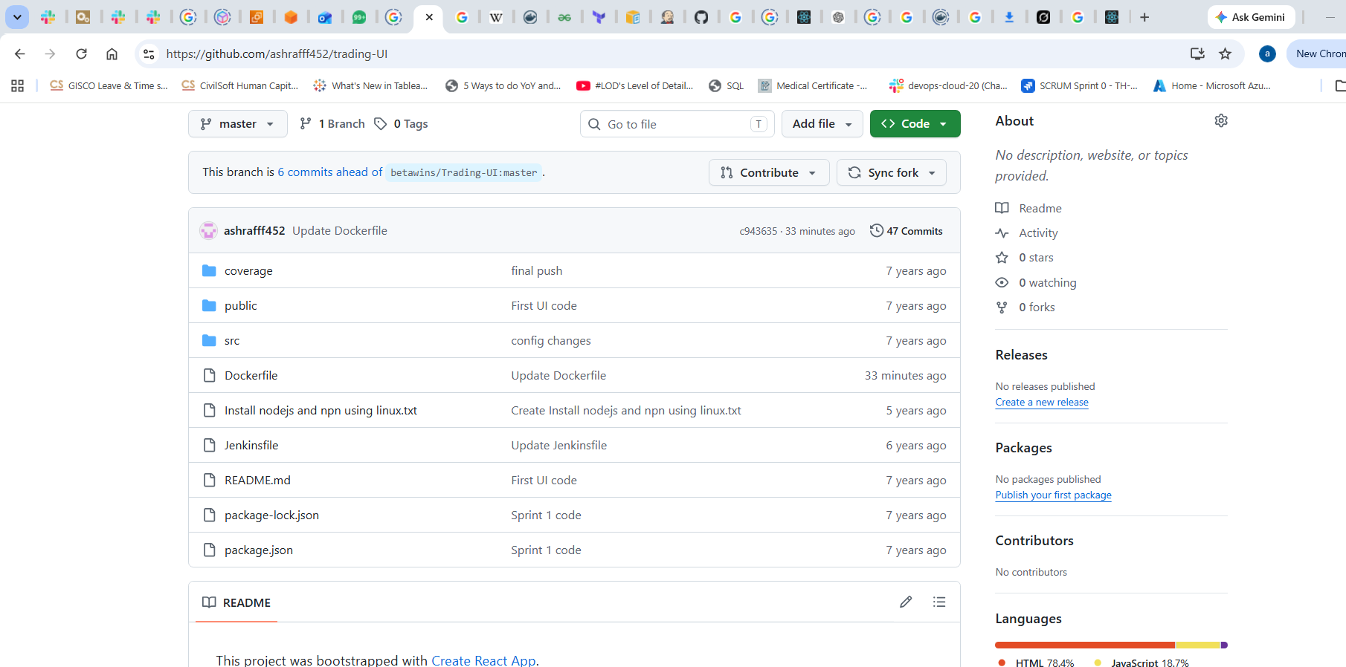
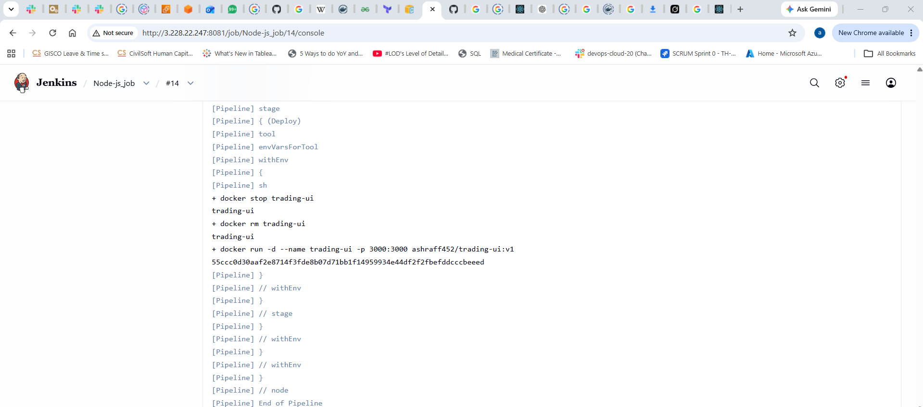

Created a trading-ui repo in the docker hub registry

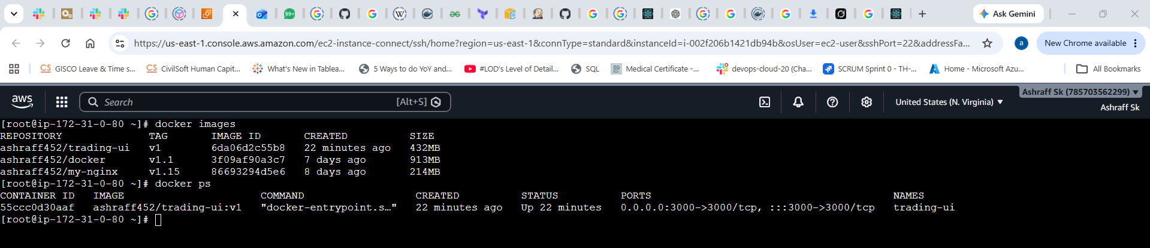

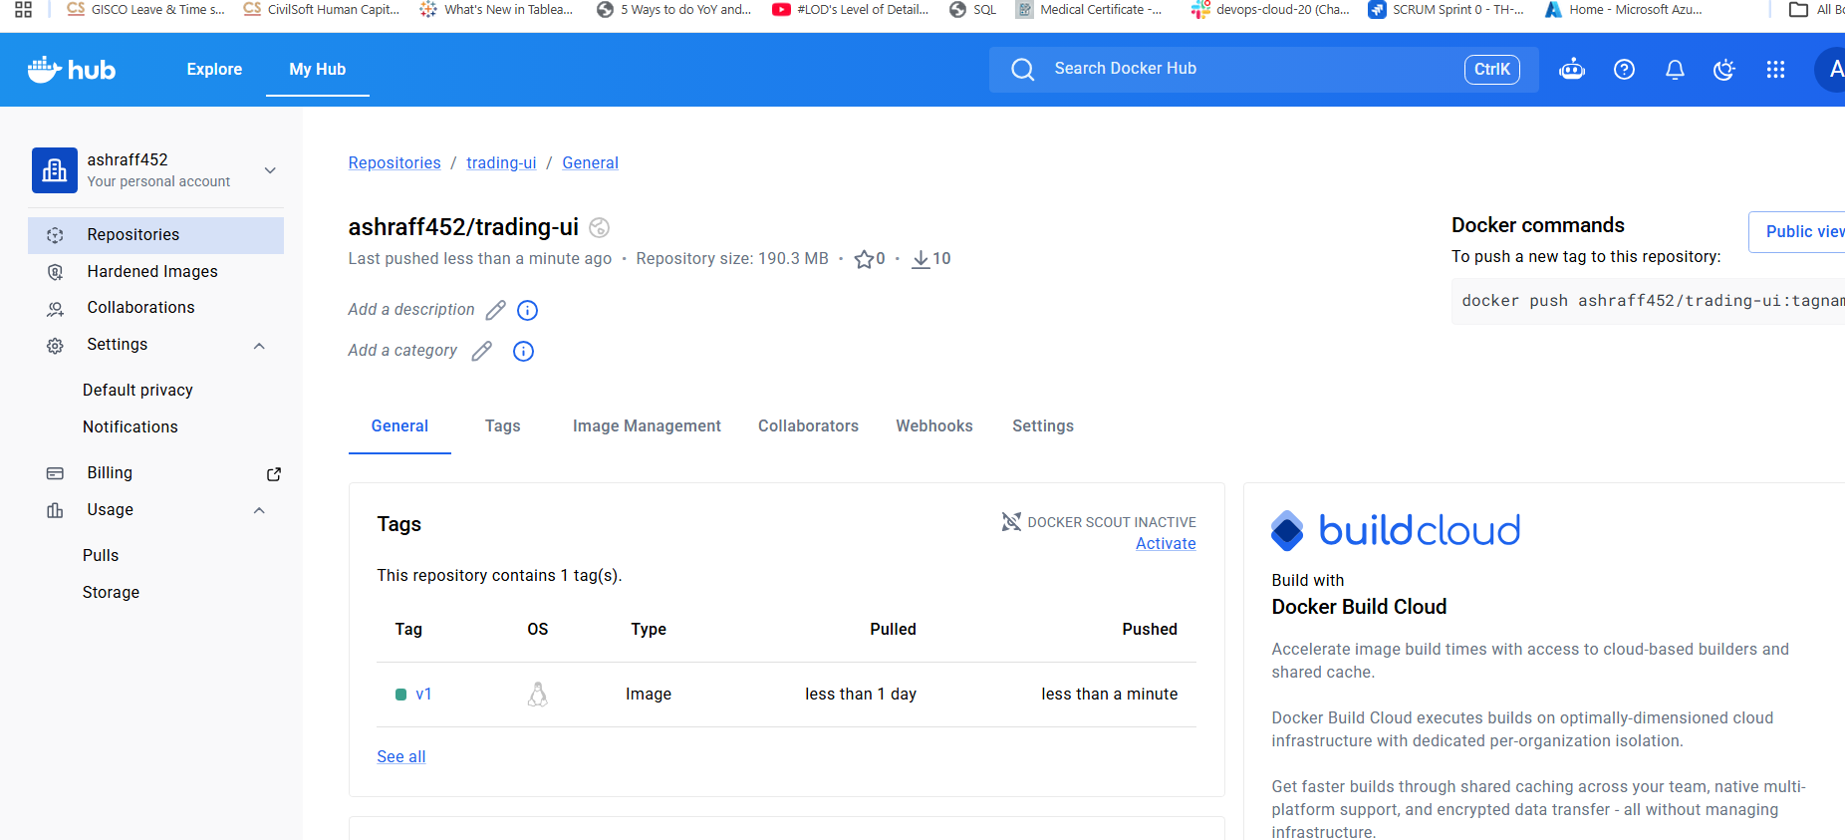
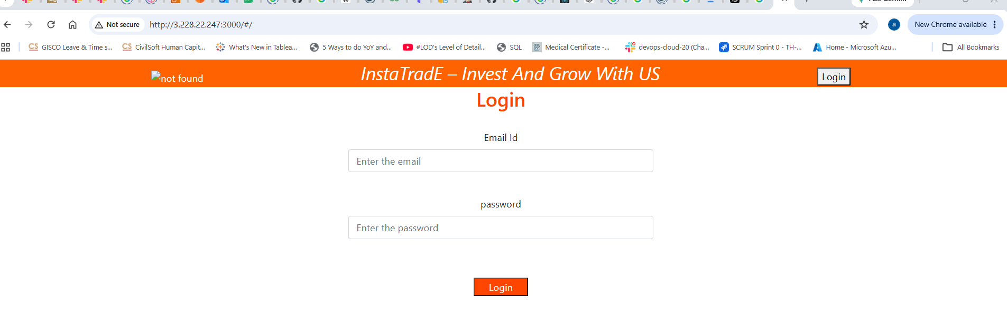
4). Explain 10 Maven commands.

Command | Syntax | Purpose | Example Use Case
1. Check Maven Version | mvn -version | Displays the installed Maven version, Java version, and OS details. | Verify Maven installation before building a project.
2. Compile Project | mvn compile | Compiles the project's source code (src/main/java). | Check for compilation errors without creating a package.
3. Run Unit Tests | mvn test | Executes unit tests in src/test/java. | Ensure all JUnit/TestNG tests pass before deployment.
4. Package Application | mvn package | Compiles, tests, and packages the application into a JAR or WAR file. | Generate a deployable artifact.
5. Install Artifact | mvn install | Installs the built artifact into the local Maven repository (~/.m2/repository). | Make the artifact available to other local Maven projects.
6. Clean Project | mvn clean | Deletes the target/ directory and previous build files. | Remove old compiled files before a fresh build.
7. Clean and Install | mvn clean install | Cleans the project, compiles, tests, packages, and installs the artifact. | Most commonly used command in Jenkins CI pipelines.
8. Verify Project | mvn verify | Runs additional verification checks after tests. | Validate the project before deployment.
9. Deploy Artifact | mvn deploy | Uploads the artifact to a remote repository such as Nexus or Artifactory. | Publish artifacts for other teams or environments.
10. Generate Site | mvn site | Generates project documentation, reports, and test results. | Create project documentation and code quality reports.

