TERRAFORM TASK-01
1). Install Terraform on your PC

Objective:
Install Terraform on a Windows PC and verify that it is working correctly.
Prerequisites:
Windows 10 or Windows 11
Administrator privileges
Internet connection
Steps:
Step 1: Download Terraform
Open your web browser.
Visit the official Terraform download page:
https://developer.hashicorp.com/terraform/downloads
Select:
Windows
AMD64 (64-bit)
Download the ZIP file.
Step 2: Extract the ZIP File
Navigate to the Downloads folder.
Right-click the ZIP file.
Click Extract All.
Extract it to: C:\Terraform
Step 3: Add Terraform to the System PATH
Press Windows + R.
Type: sysdm.cpl
Press Enter.
Click the Advanced tab.
Click Environment Variables.
Under System Variables, select Path.
Click Edit.
Click New.
Add: C:\Terraform
Click OK to save all changes
Step 4: Open Command Prompt/ Git bash
Run terraform -version
Expected output:

Terraform v1.x.x
on windows_amd64
Step 6: Check Terraform Help
Run: terraform
We cansee available Terraform commands such as:
Usage: terraform [global options] <subcommand>
Main commands:
init
plan
apply
destroy
validate
fmt
output
state
version

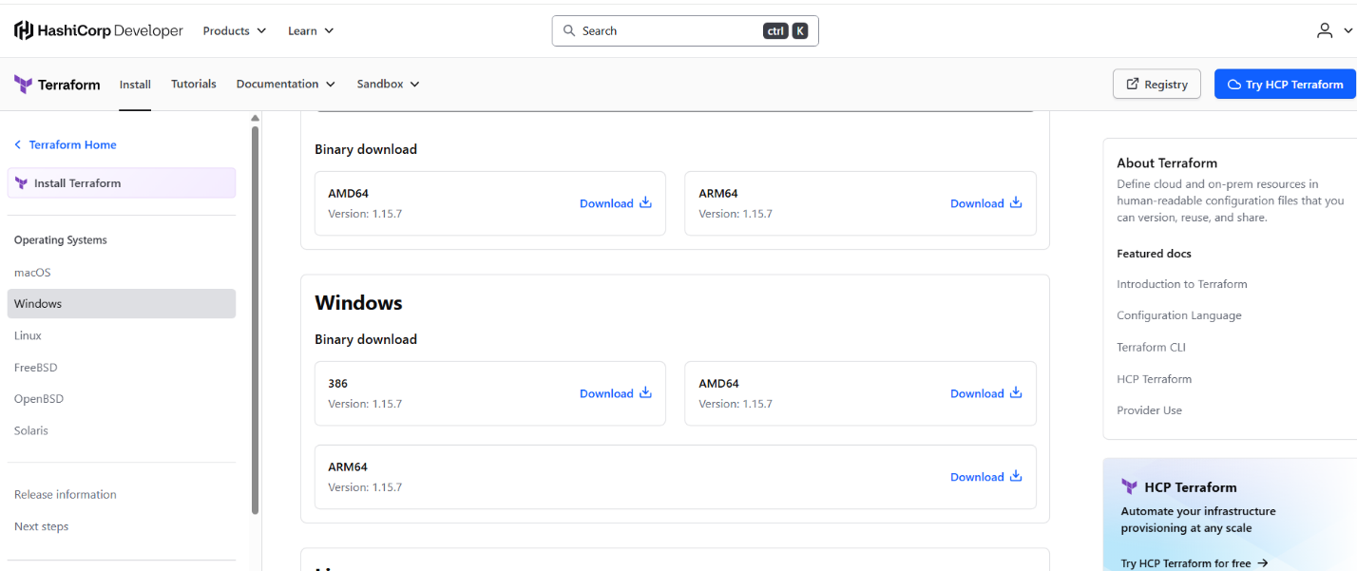
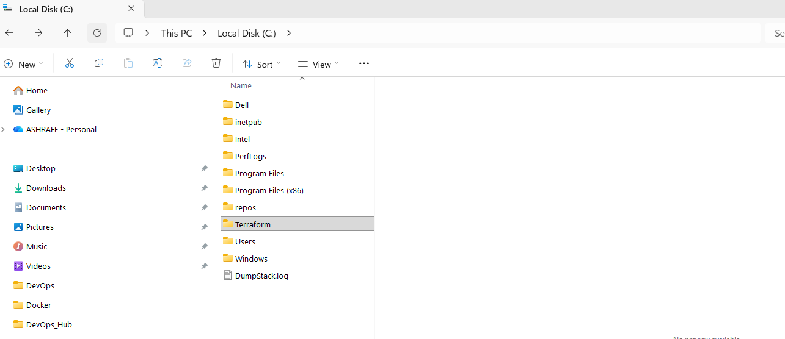
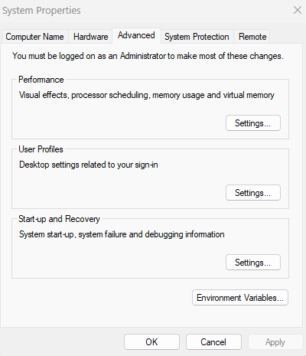
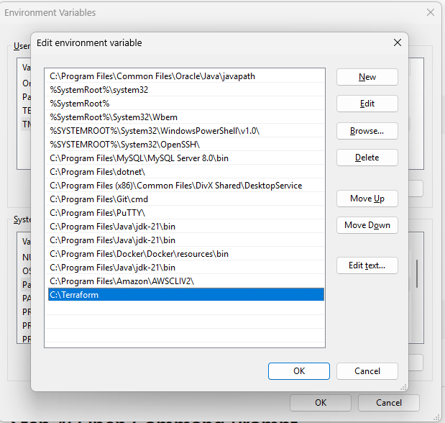
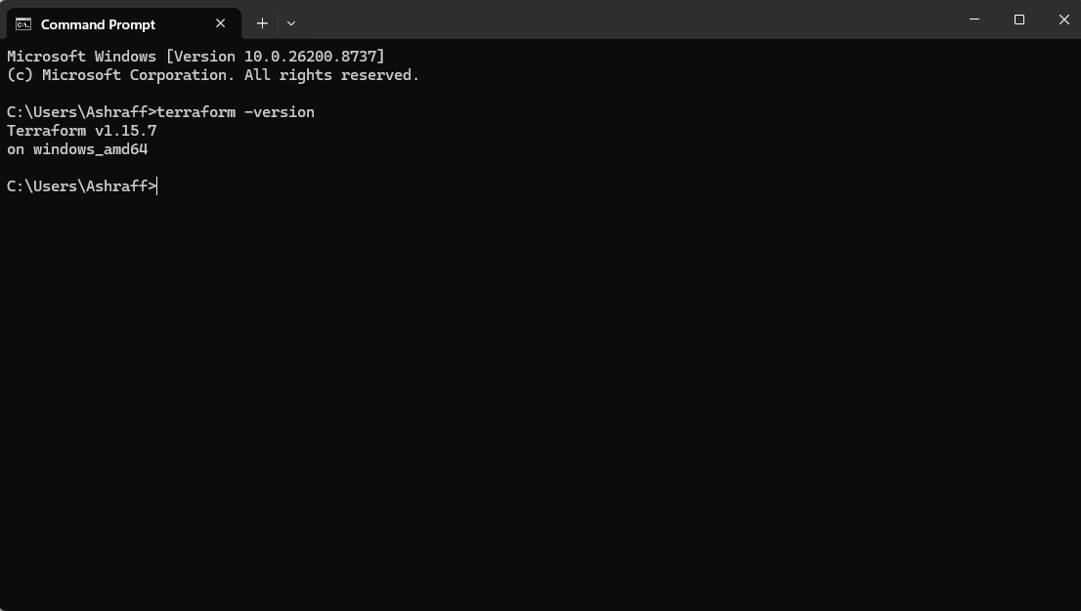

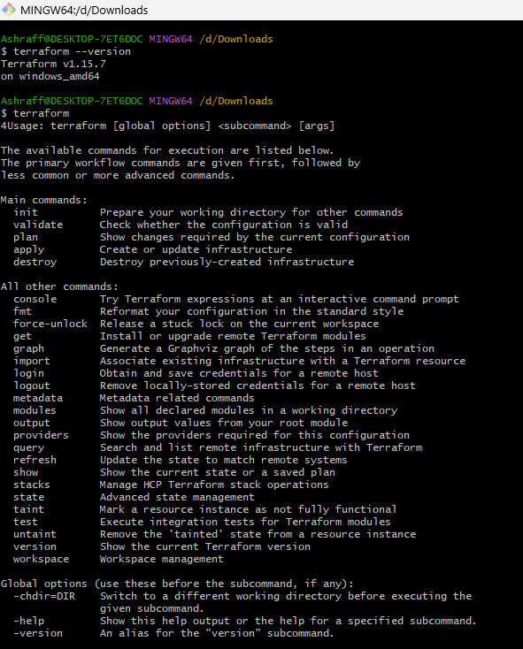

2). Execute all the templates shown in video.
3). Note down below points, Terraform Init Terraform Plan Terraform Apply Terraform Provider.
Steps:
- First after installing terraform in local machine
- In Visual studio in extensions install hashicorp for terraform extension.
- Go to Visual studio & in desktop create a directory, Terraform_basics
- From Visual studio go to the location C:\Users\ Ashraff\ Desktop\Terraform_basics & create a file named, main.tf
- Then wite the code as below:
resource "local_file" "my_pet" {
filename = "pets.txt"
content = "I love pets!"
}
Where resource -> block
    - local -> provider
    - File -> type
    - my_pet -> logical name
- We need to initiate using terraform init command
- Then terraform plan to see the changes happen before terraform apply command
- Terraform apply to execute & need to enter yes for execution
- Now we see that pets.txt file got created with the text I love pets!
- Once doing the content change to I love dogs & saving the file.
- Now terraform plan shows the changes done & terraform apply will destroy the old file & create a new file with the modified changes
- Now we take random_pet provider & write the below code:
resource "random_pet" "my-pet" {
prefix = "MR"
separator = "."
length = "1"
}
- We need to initiate using terraform init command
- Then terraform plan to see the changes happen before terraform apply command
- Terraform apply to execute & need to enter yes for execution
- Now we see that MR. with random name got generated.
- Once doing the prefix change to Miss & saving the file.
- Now terraform plan shows the changes done & terraform apply will destroy the old file & create a new file with the modified changes.
- We used terraform fmt command to organize syntax automatically.
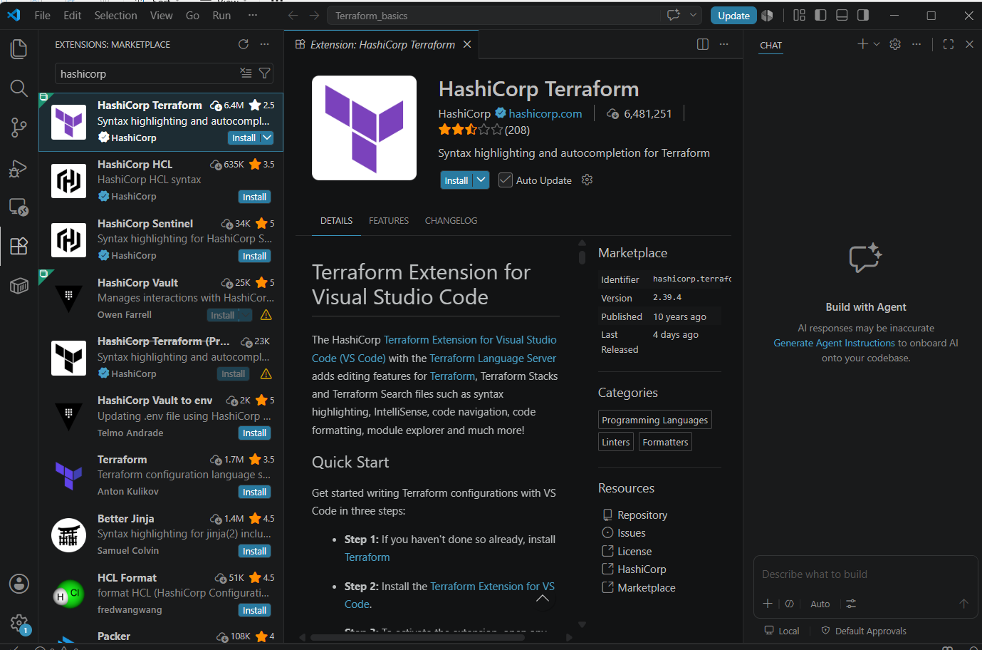
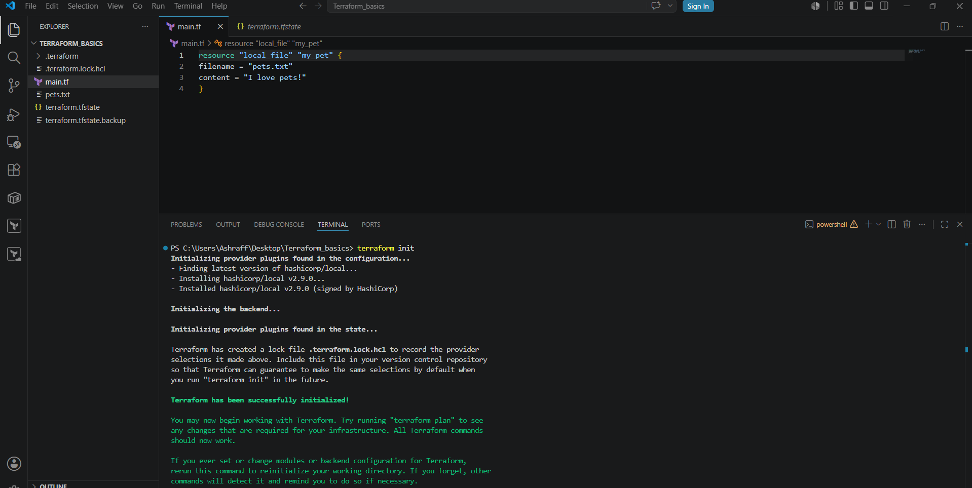
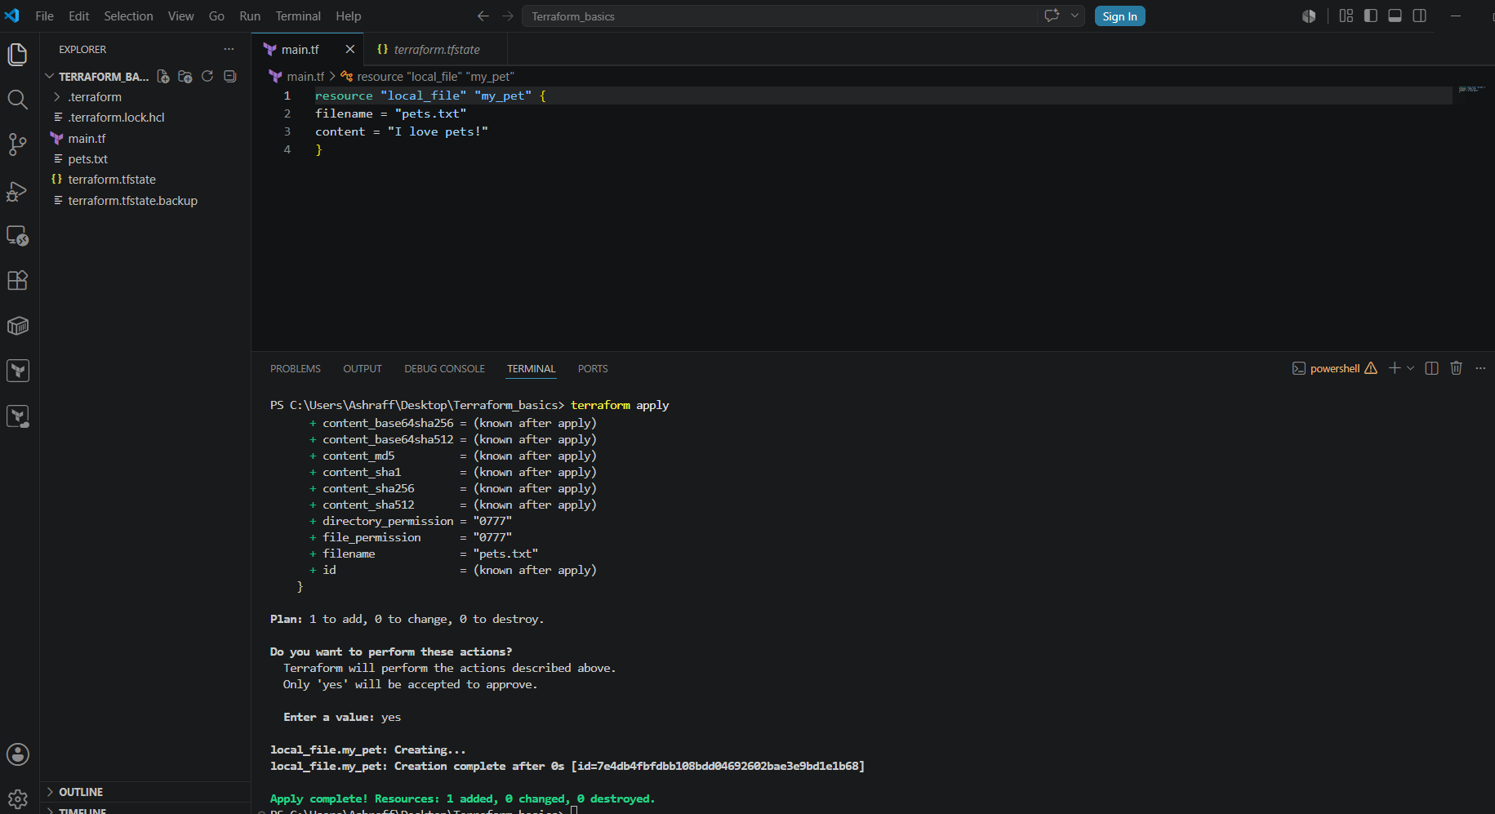
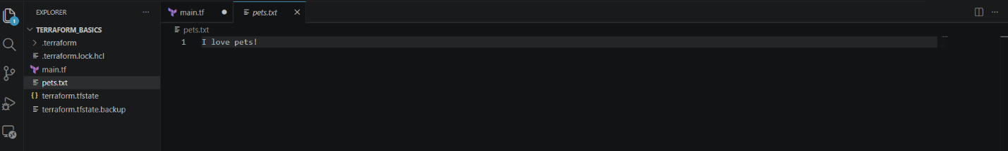
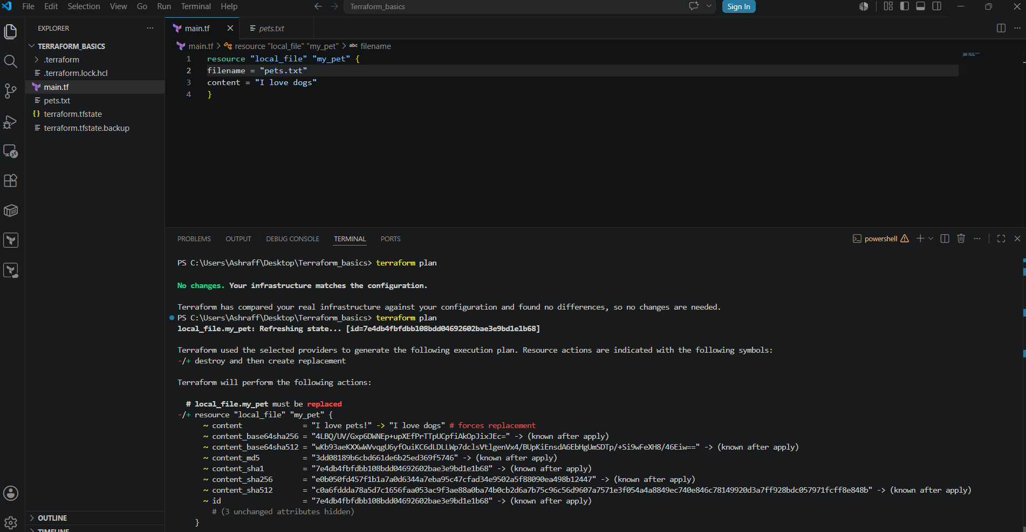
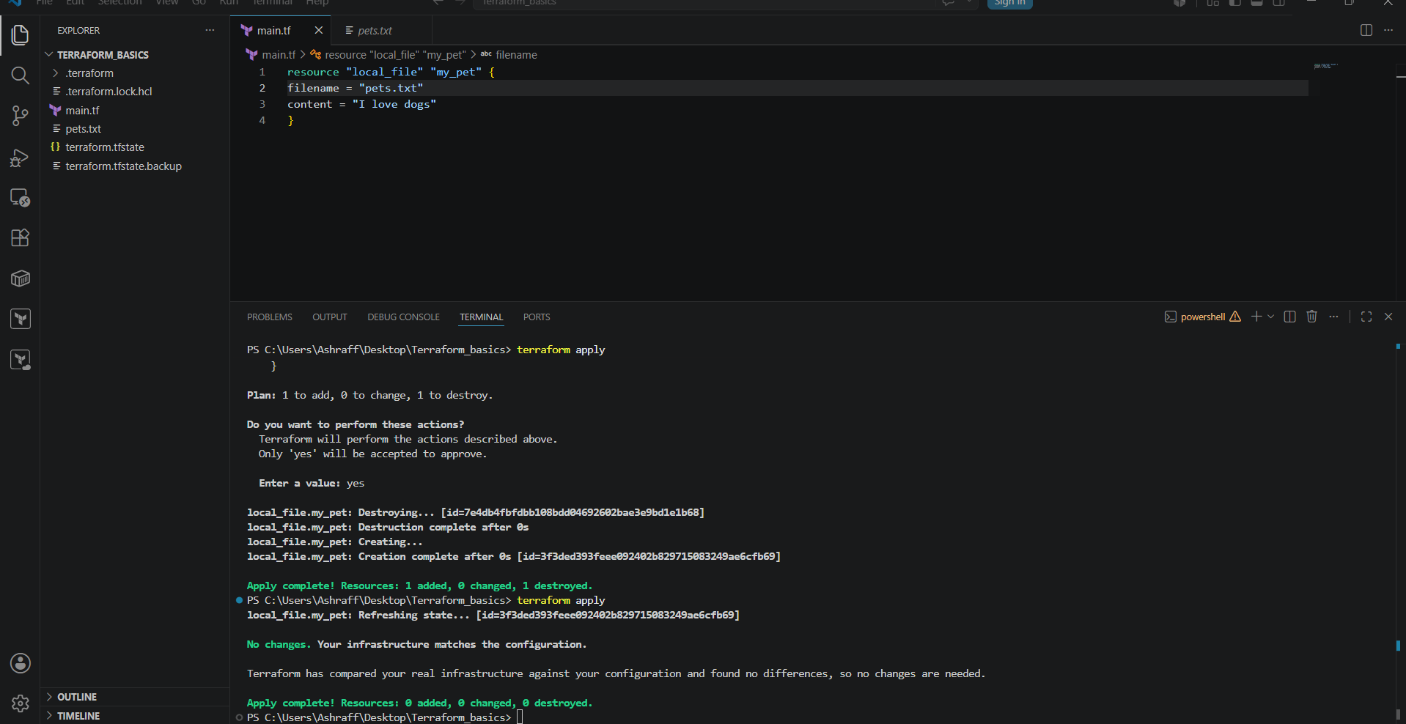
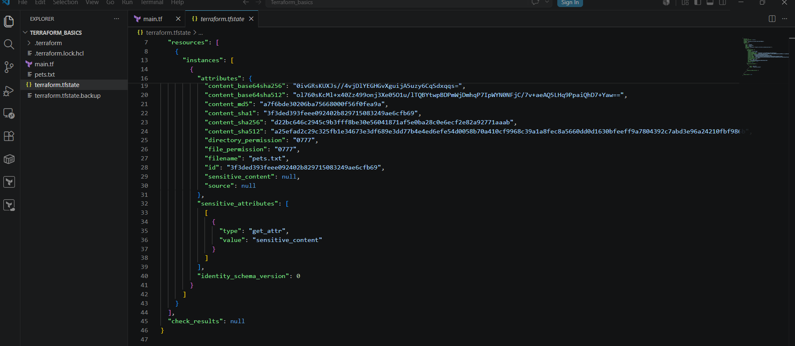
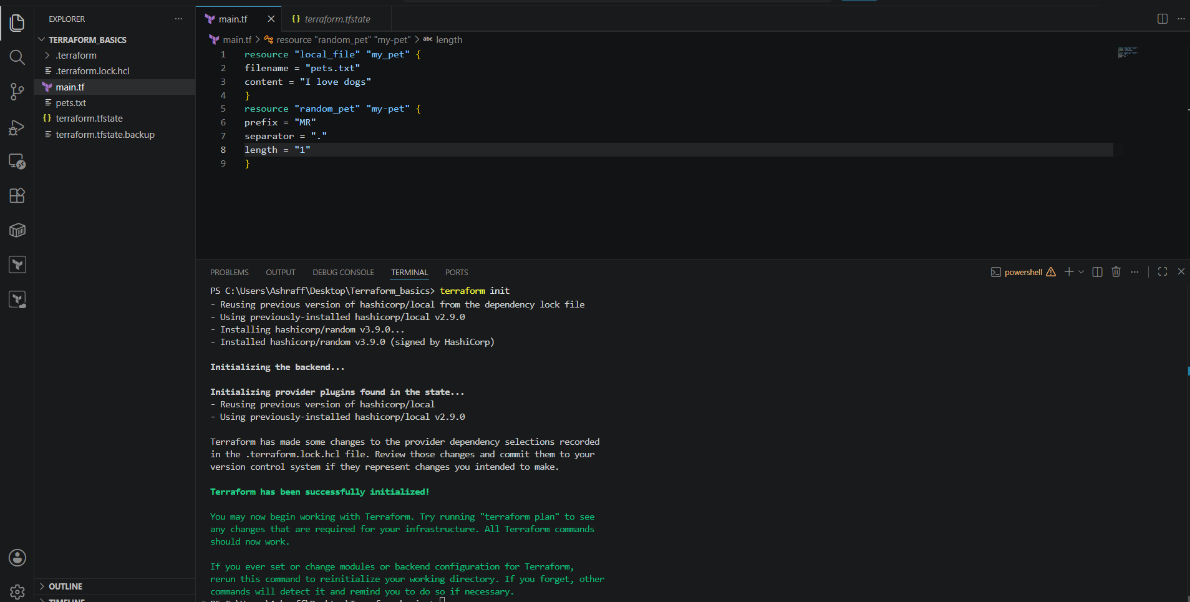
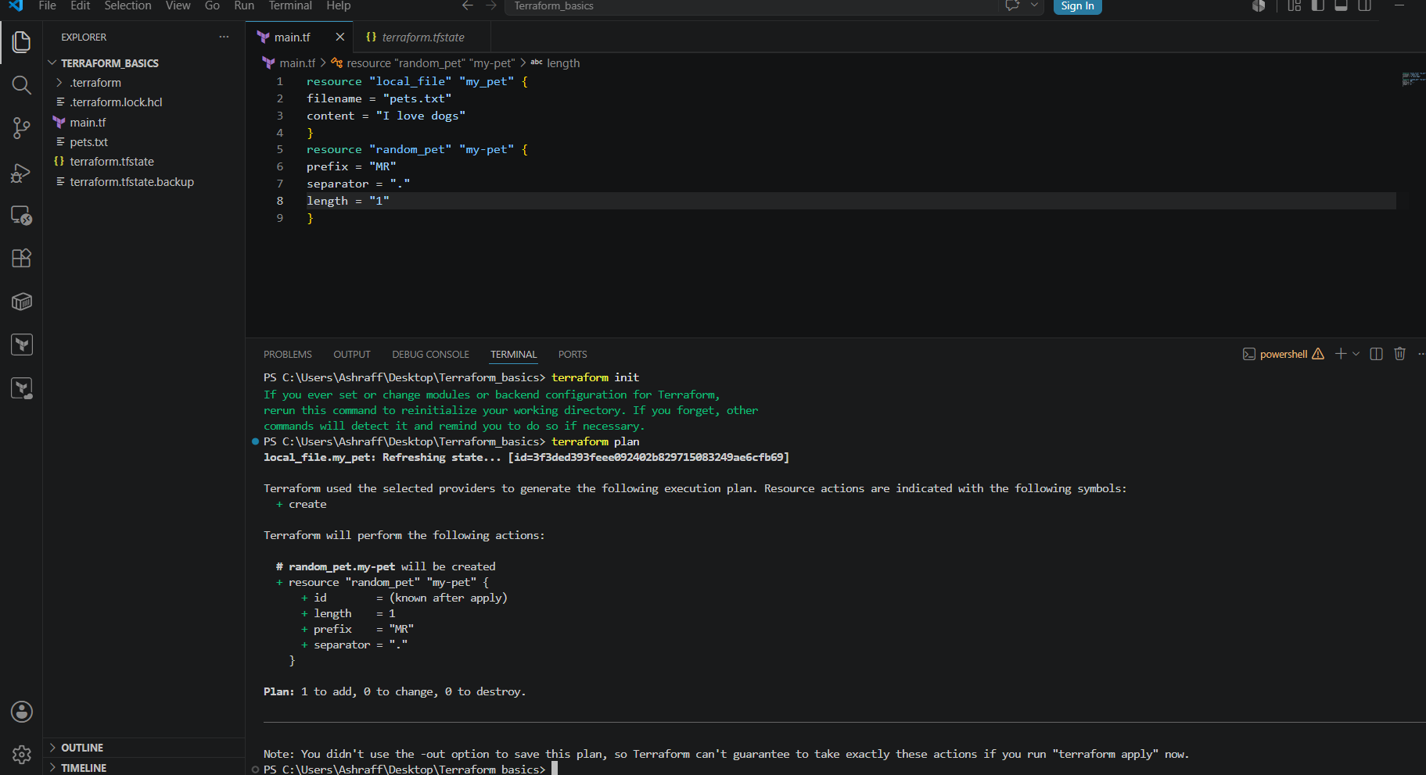
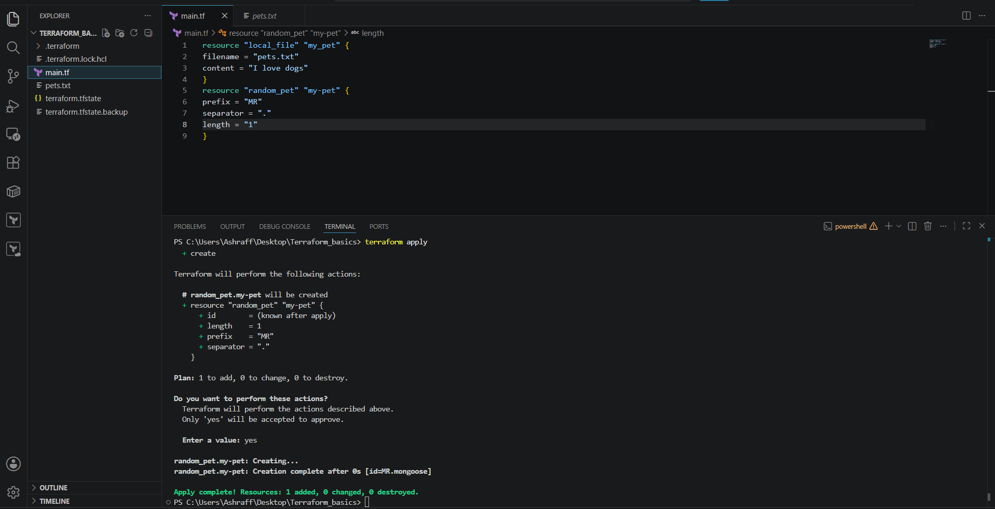
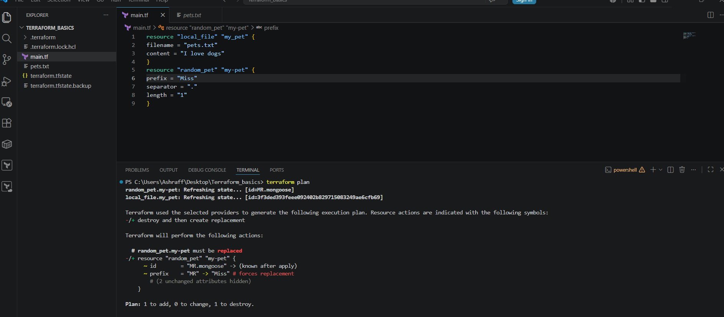
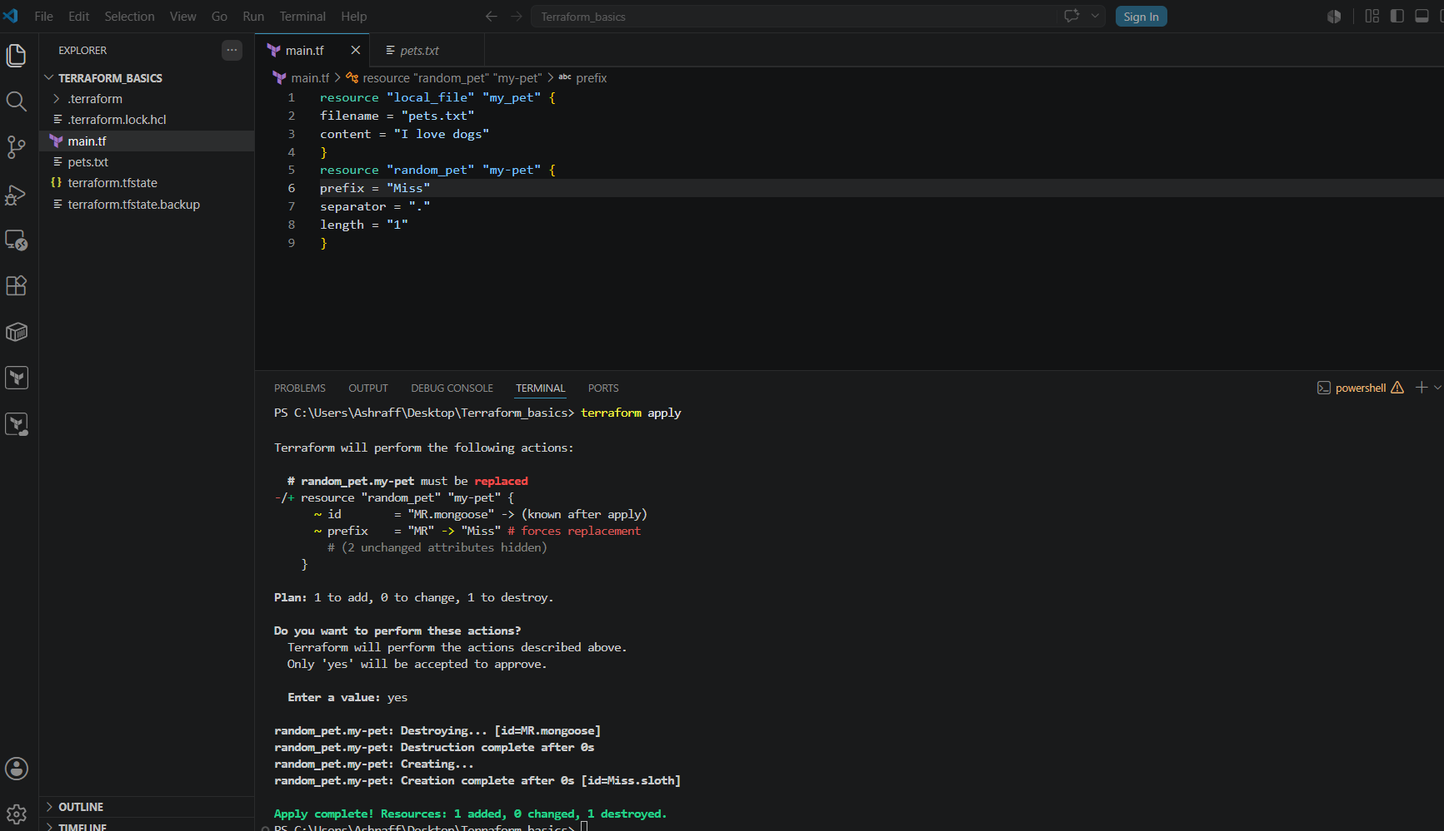
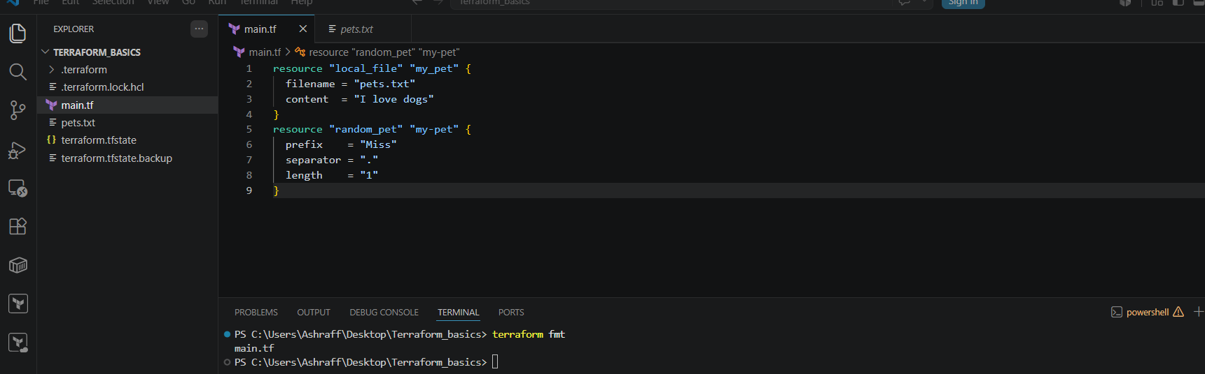

4). Integrate a sample Terraform template in Jenkins.

Steps:
- Created an ec2 instance, My-ec2-jenkins with c7i-flex.large instance type & default key-pair, security group
- Installed Jenkins using yum install Jenkins -y
- Installed terraform using below commands
sudo dnf install -y yum-utils shadow-utils
sudo yum-config-manager --add-repo https://rpm.releases.hashicorp.com/AmazonLinux/hashicorp.repo
sudo yum -y install terraform
terraform -version
- Created a main.tf file with the below code
resource "local_file" "my_pet" {
filename = "pets.txt"
content = "I love pets!"
}
- Save the file & created a repo in Git hub, terraform-jenkins & the url is https://github.com/ashrafff452/terraform-jenkins.git
- Now connect to the Jenkins UI with the login credentials
- Create a job, Terraform-jenkins with the below pipeline
pipeline {
agent any
stages {
stage ('Git clone') {
steps {
git branch: 'main',
url: 'https://github.com/ashrafff452/terraform-jenkins.git'
}
}
stage ('init') {
steps {
sh 'terraform init'
}
}
stage ('plan') {
steps {
sh 'terraform plan'
}
}
stage ('apply') {
steps {
sh 'terraform apply -auto-approve'
}
}
}
}
- Now build now & capture the console output once the job is success
- Check the workspace of Jenkins ec2 instance & GUI
Where the pets.txt file got created.
