KUBERNETES-01
- Setup Minikube in your local machine.
Steps:
- First install the docker desktop in my local machine
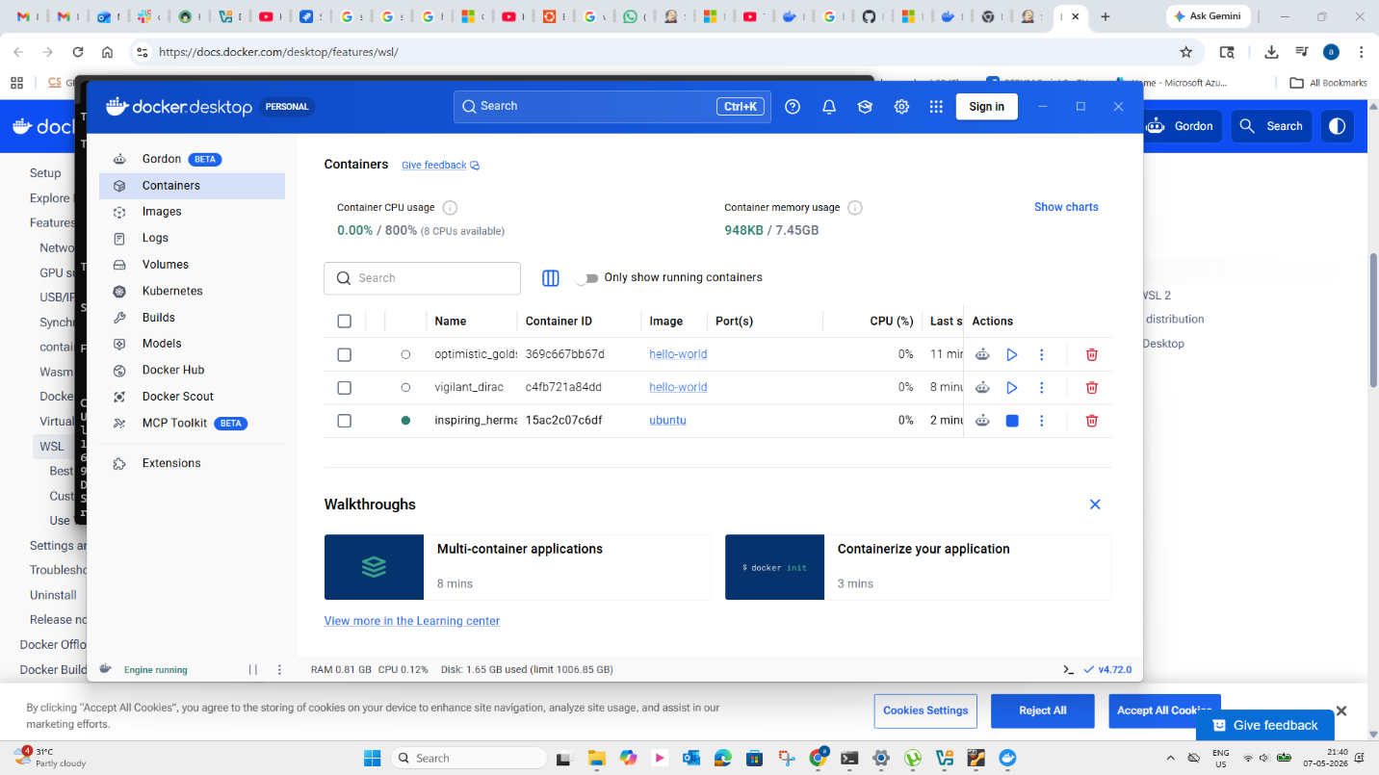
- Install the Oracle box on windows
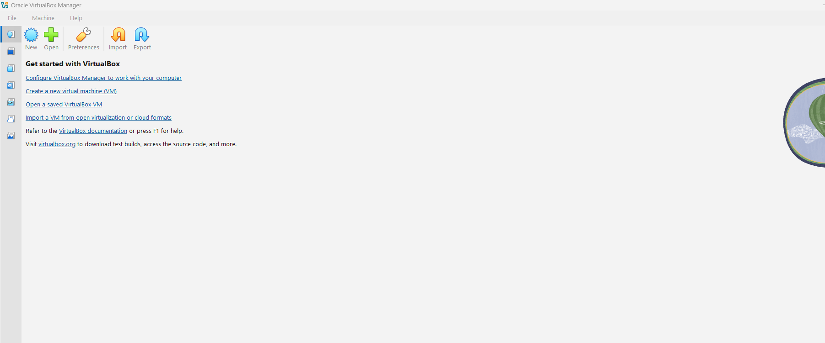
- Open CMD prompt & run systeminfo command

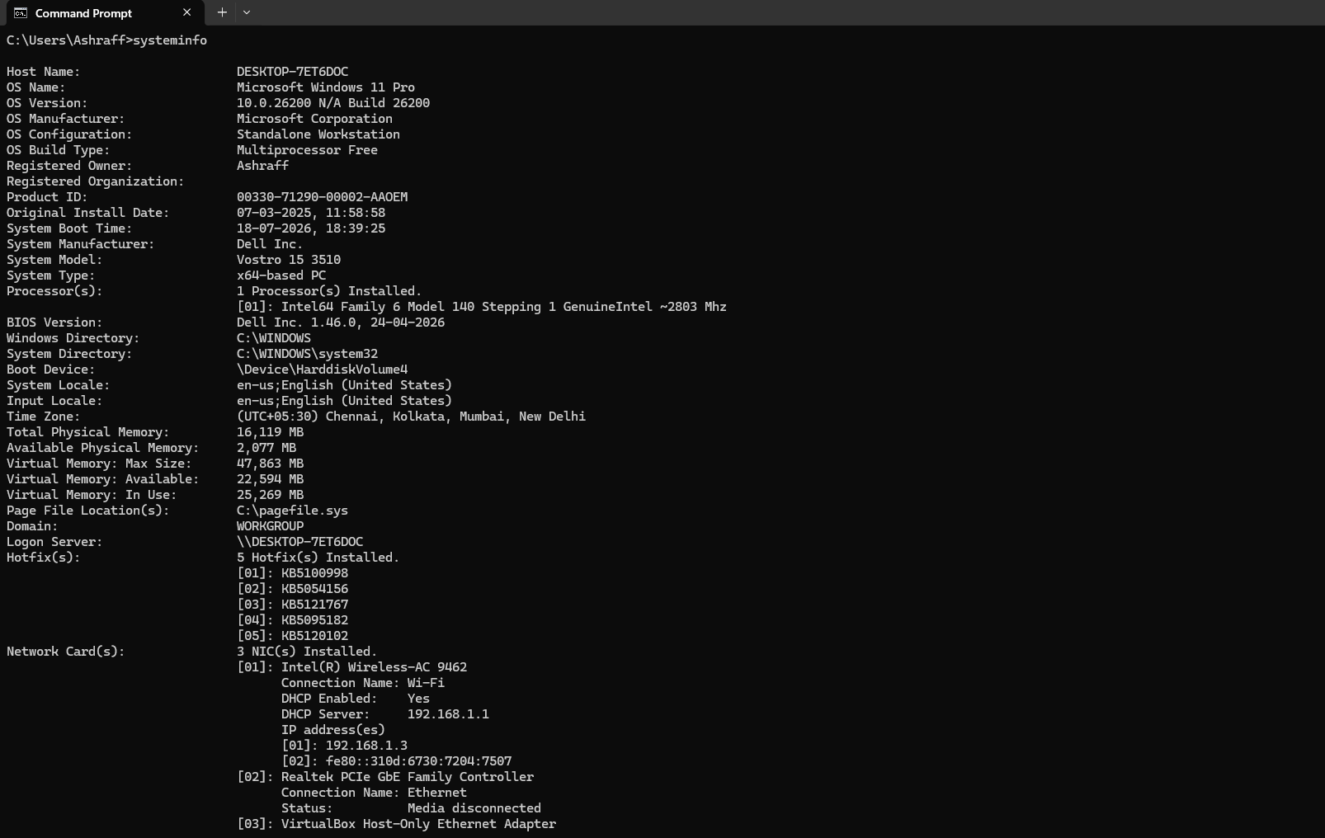
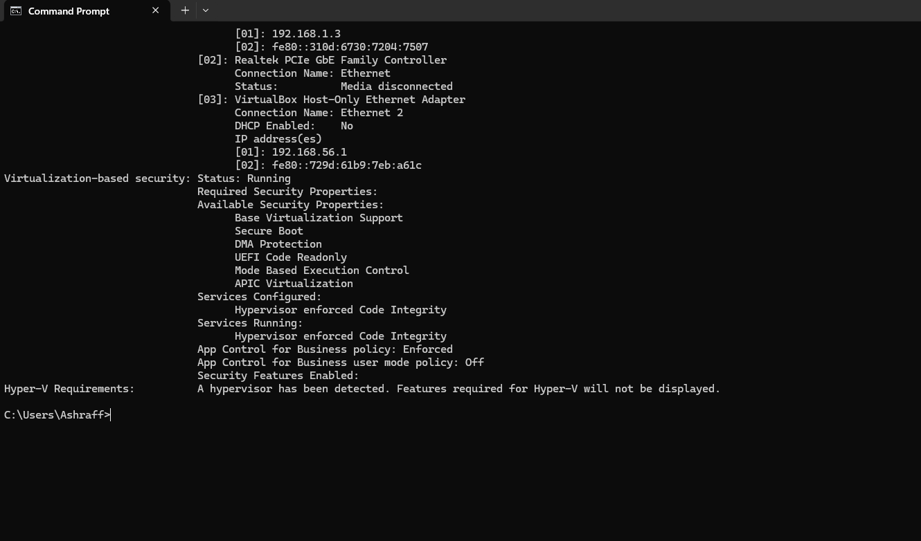

- Now open powershell & to install minikube run the command
New-Item -Path 'c:\' -Name 'minikube' -ItemType Directory -Force
$ProgressPreference = 'SilentlyContinue'; Invoke-WebRequest -OutFile 'c:\minikube\minikube.exe' -Uri 'https://github.com/kubernetes/minikube/releases/latest/download/minikube-windows-amd64.exe' -UseBasicParsing
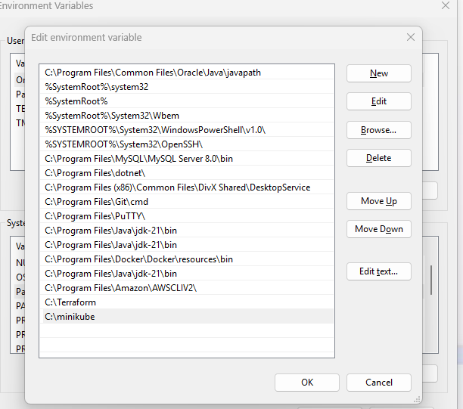
- Now Go to environment variables 7 select the path & click edit & click New & paste the path of minikube downloaded, C:/minikube & click save & ok
- Now restart the windows power shell & run the command minikube start
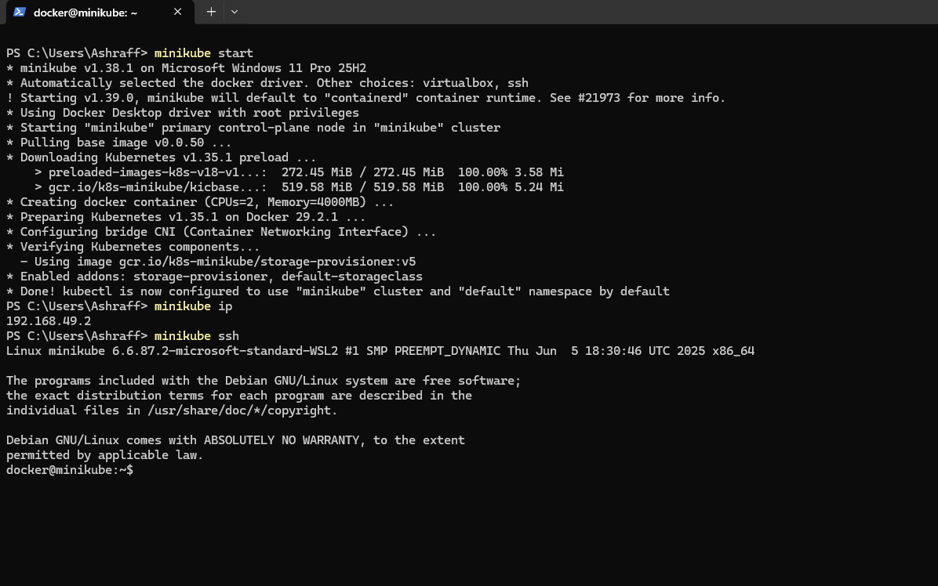
- It will download the images & run minikube ip to check the assigned ip & to connect to the container run minikube ssh
- We can run the command docker ps to see the running container
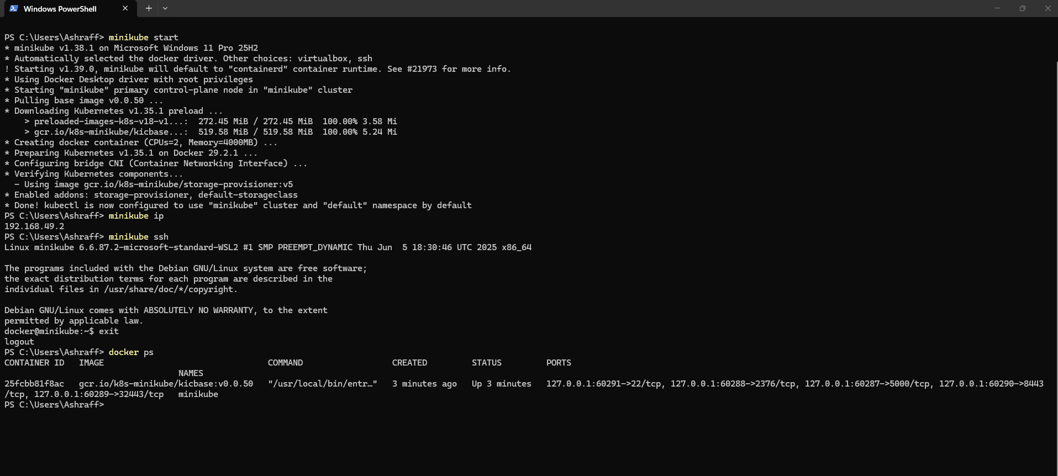

- Setup k8s master and two worker nodes on ubuntu.
Steps:
- First created three ec2 instances with existing key-pair, instance type as t2.medium , default security groups & EBS volume as 20 GiB
- Now named instances as k8s – Master, Worker – 01 & Worker - 02
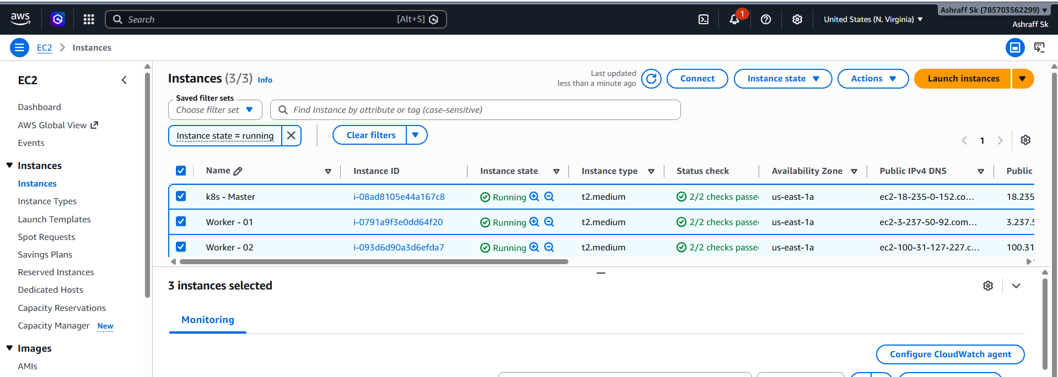
- Connect to the k8s – Master ec2 from ec2 instance connect & change the hostname to master by using the command, vi /etc/hostname from root user
- Run the commands, hostname master & echo $hostname & refresh the instance & we can see the hostname changed to master
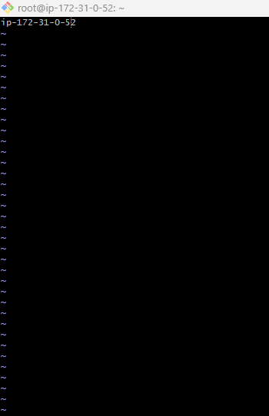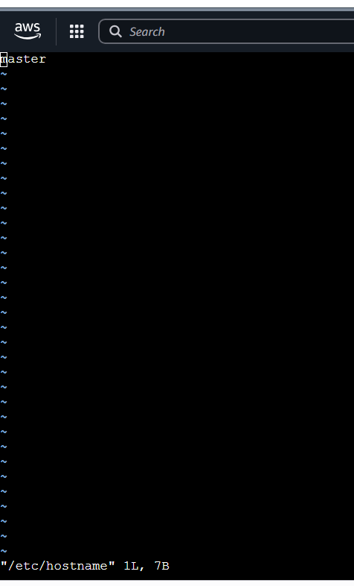
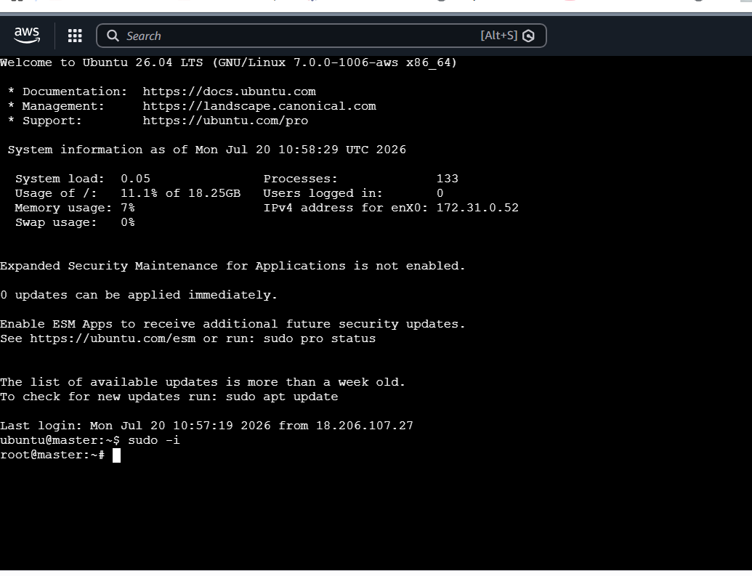
- Connect to the Worker - 01 ec2 from git bash & change the hostname to Worker-01 by using the command, vi /etc/hostname from root user
- Run the commands, systemctl restart sshd, hostname Worker-01& echo $hostname & exit and reconnect to the instance & we can see the hostname changed to Worker-01
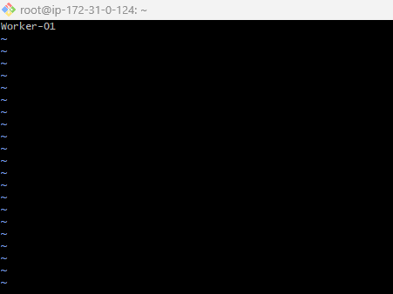

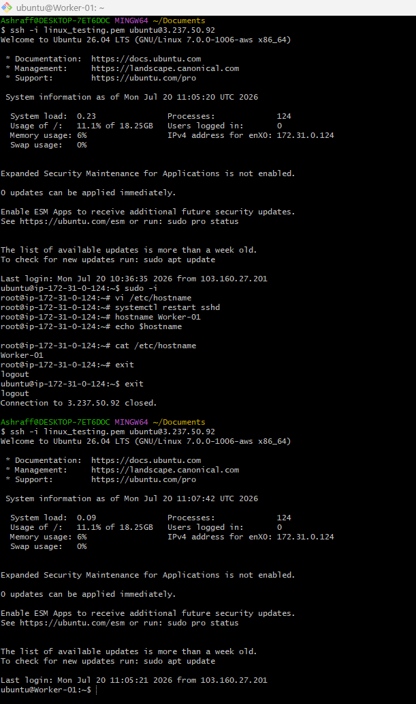
- Connect to the Worker - 02 ec2 from git bash & change the hostname to Worker-01 by using the command, vi /etc/hostname from root user
- Run the commands, systemctl restart sshd, hostname Worker-02 & echo $hostname & exit and reconnect to the instance & we can see the hostname changed to Worker-02
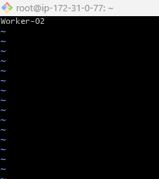

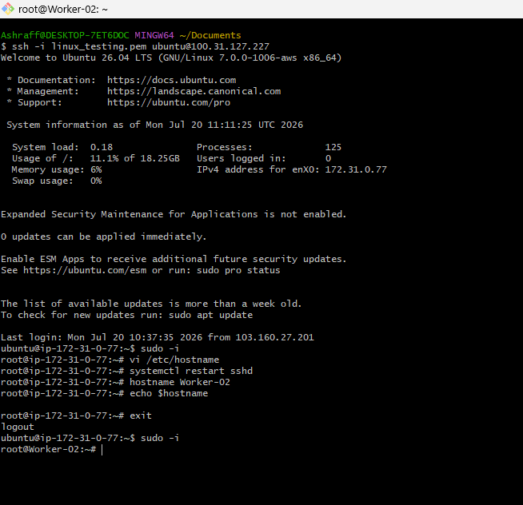

- Now install the docker in k8s – Master ec2 instance using the commands
Sudo apt-get update -y
Sudo apt-get upgrade -y
Sudo apt-get install docker.io -y
- Systemctl enable docker
Systemctl start docker
Systemctl status docker
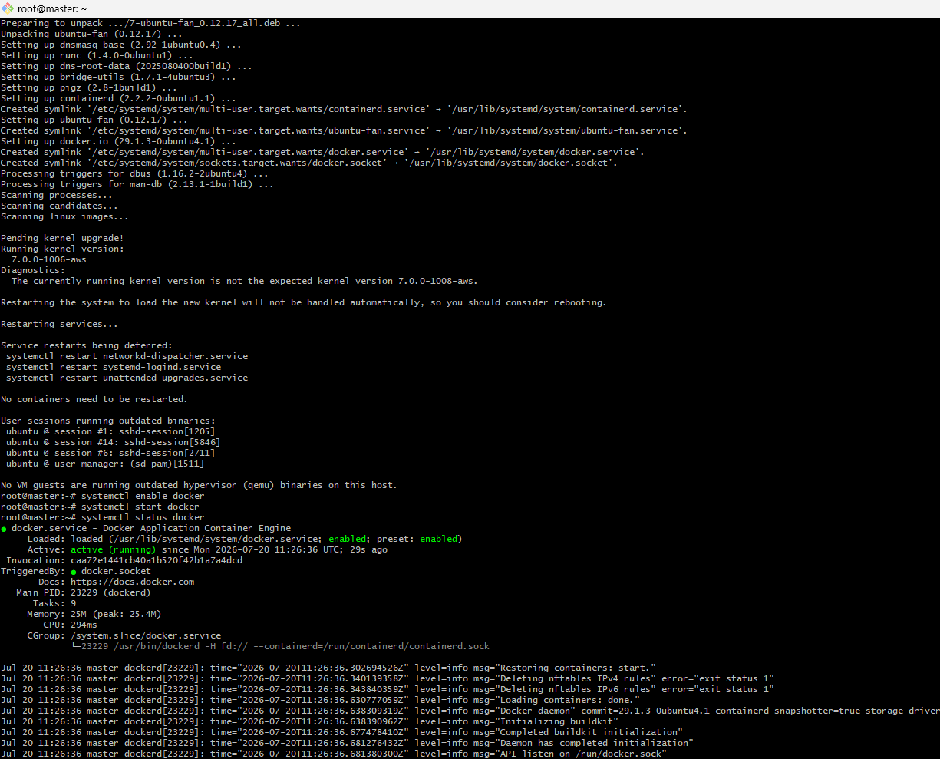
- Now install the docker in Worker - 01 ec2 instance using the commands
Sudo apt-get update -y
Sudo apt-get upgrade -y
Sudo apt-get install docker.io -y
- Systemctl enable docker
Systemctl start docker
Systemctl status docker
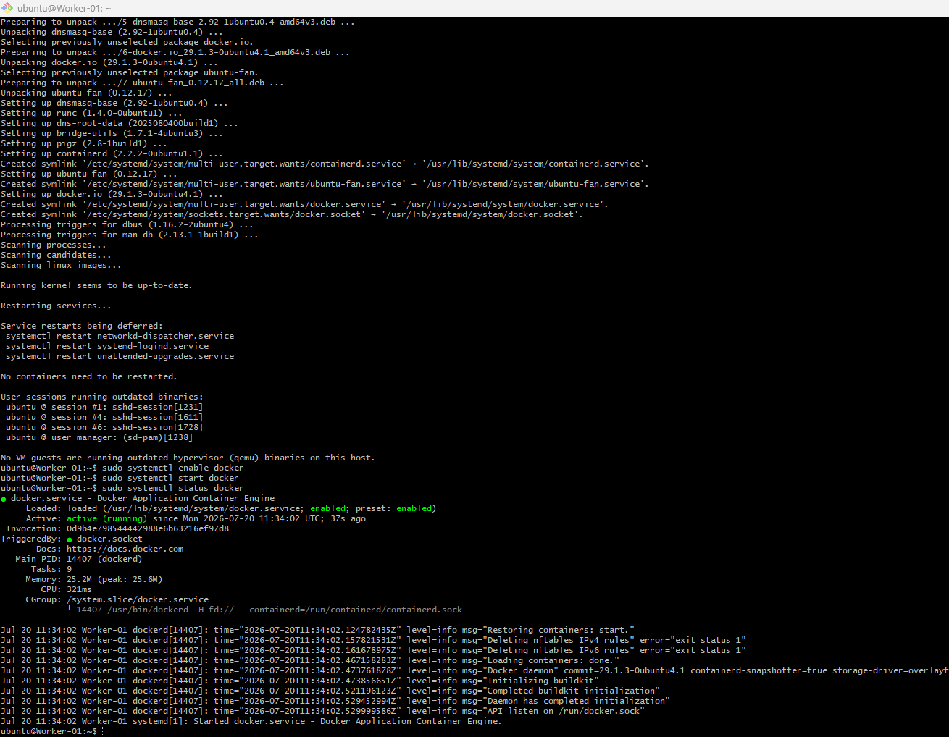
- Now install the docker in Worker - 02 ec2 instance using the commands
Sudo apt-get update -y
Sudo apt-get upgrade -y
Sudo apt-get install docker.io -y
- Systemctl enable docker
Systemctl start docker
Systemctl status docker
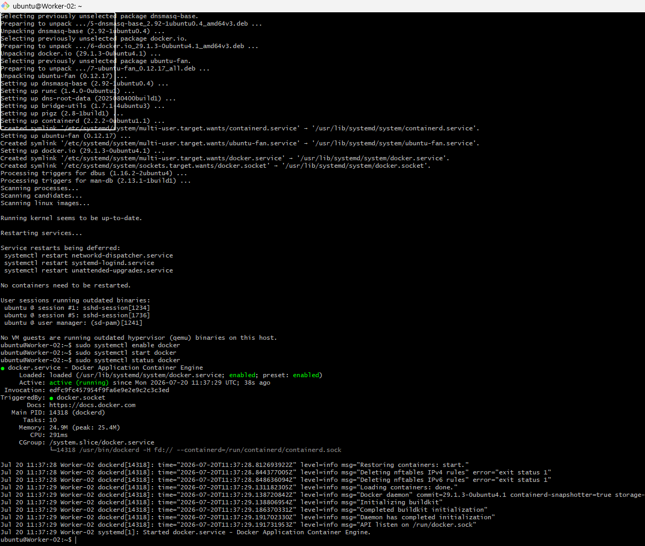
- To set up k8s cluster we use tool, kubeadm from the below link & ran the commands in k8s – Master, Worker – 01 & Worker -02 instances
- https://kubernetes.io/docs/setup/production-environment/tools/kubeadm/install-kubeadm/
sudo apt-get install -y apt-transport-https ca-certificates curl gpg

curl -fsSL https://pkgs.k8s.io/core:/stable:/v1.36/deb/Release.key | sudo gpg --dearmor -o /etc/apt/keyrings/kubernetes-apt-keyring.gpg

echo 'deb [signed-by=/etc/apt/keyrings/kubernetes-apt-keyring.gpg] https://pkgs.k8s.io/core:/stable:/v1.36/deb/ /' | sudo tee /etc/apt/sources.list.d/kubernetes.list
sudo apt-get update
sudo apt-get install -y kubelet kubeadm kubectl
sudo apt-mark hold kubelet kubeadm kubectl
sudo systemctl enable --now kubelet
kubectl version
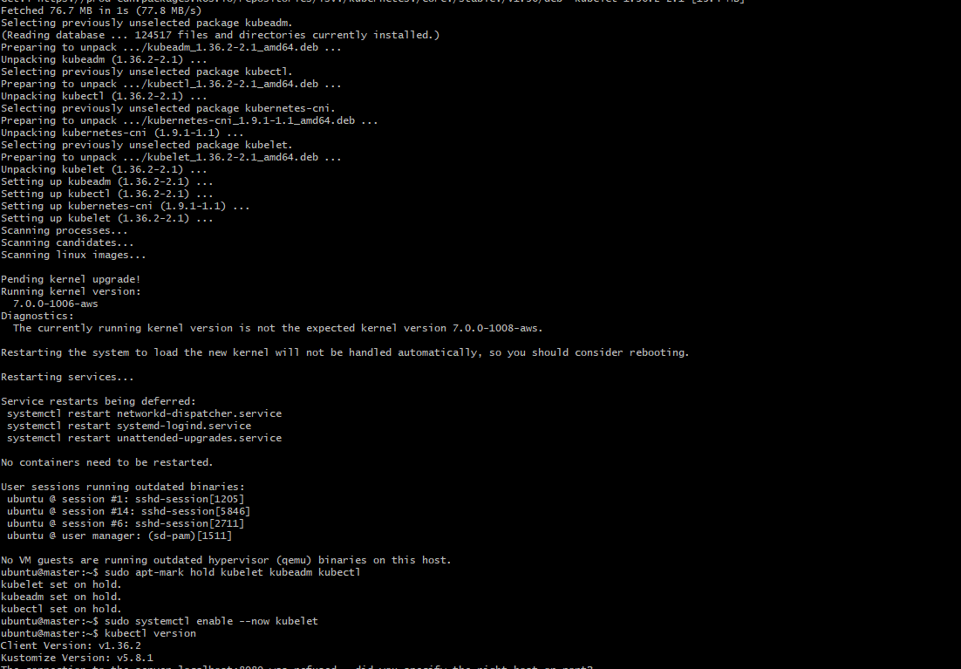

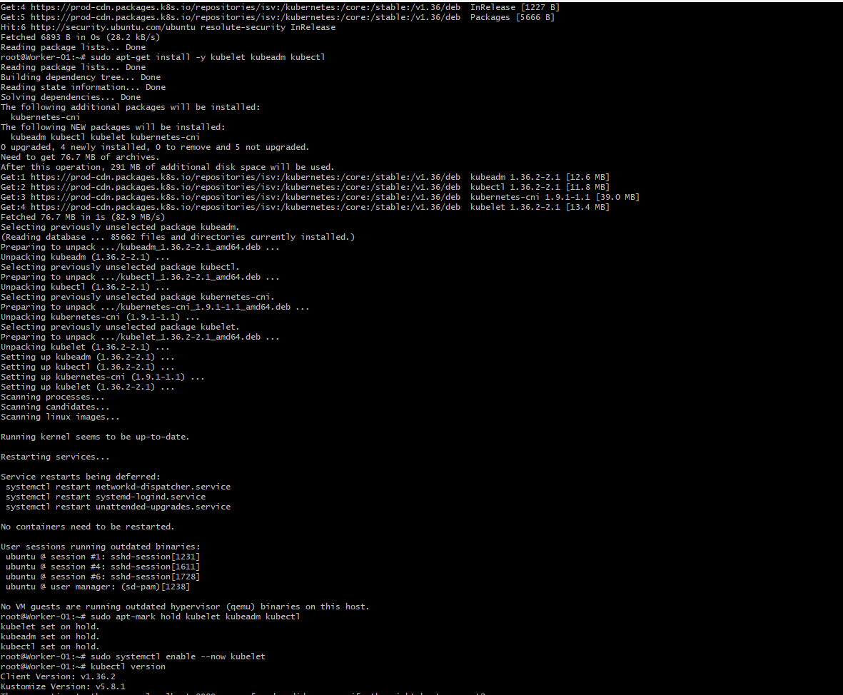

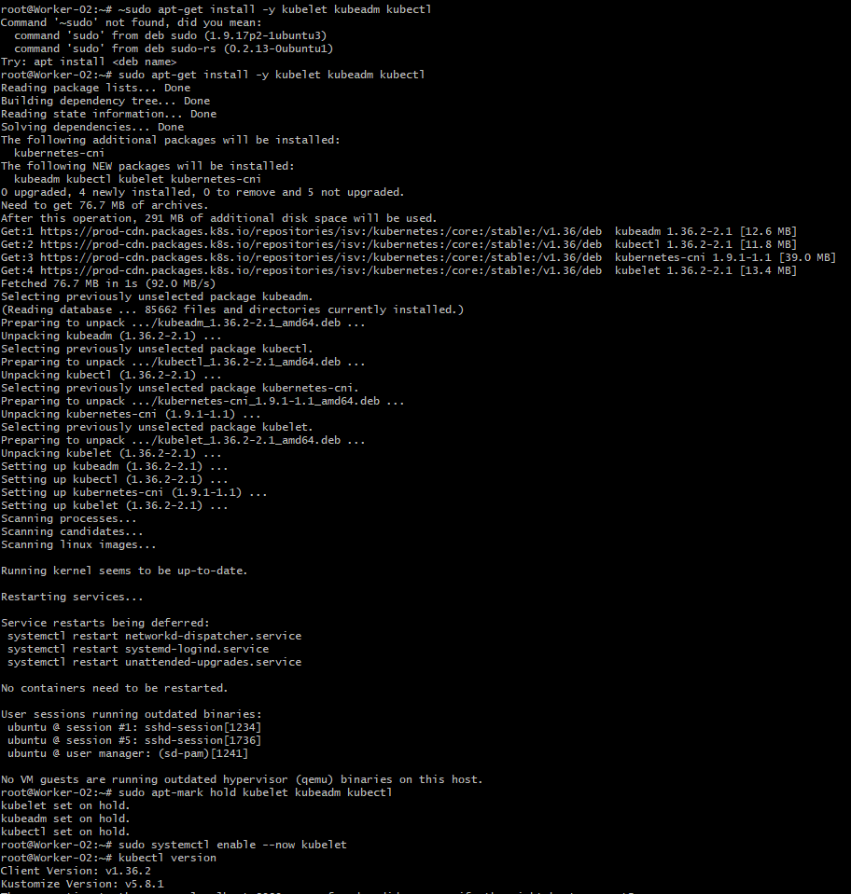
- To configure Master we need to execute the below command in k8s – Master instance
kubeadm init --pod-network-cidr=10.244.0.0/16

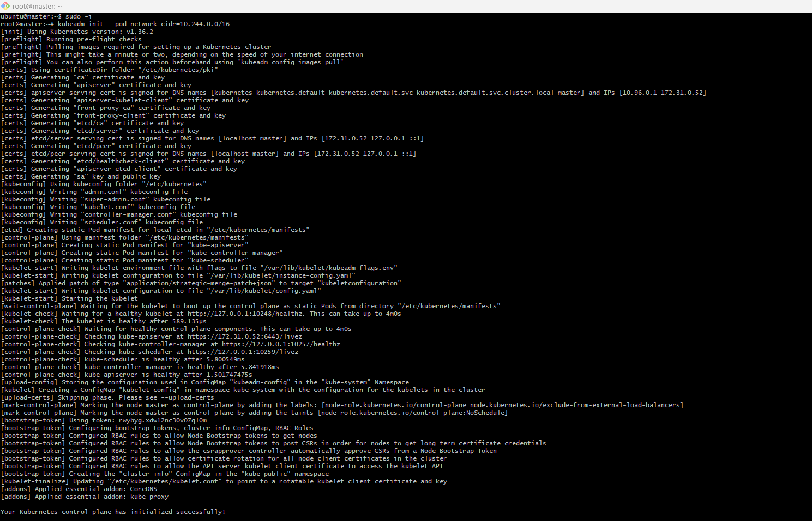
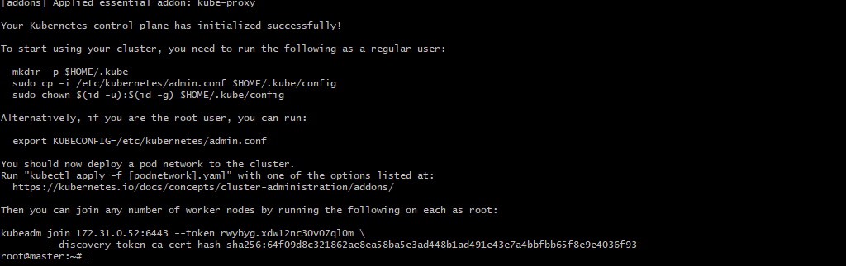

- Now run the below commands in master instance
mkdir -p $HOME/.kube
sudo cp -i /etc/kubernetes/admin.conf $HOME/.kube/config
sudo chown $(id -u):$(id -g) $HOME/.kube/config
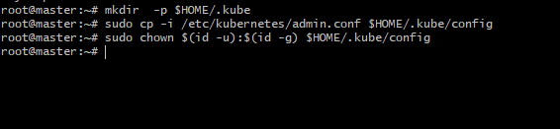
- Now run the below command in Worker – 01 & Worker – 02 instances
kubeadm join 172.31.0.52:6443 --token rwybyg.xdw12nc30v07ql0m \
--discovery-token-ca-cert-hash sha256:64f09d8c321862ae8ea58ba5e3ad448b1ad491e43e7a4bbfbb65f8e9e4036f93
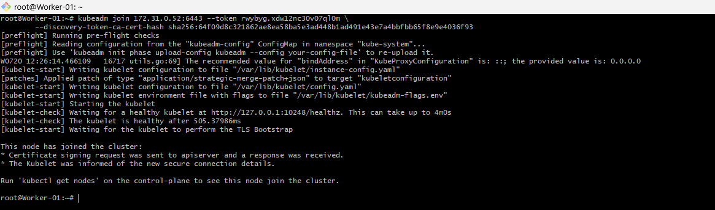
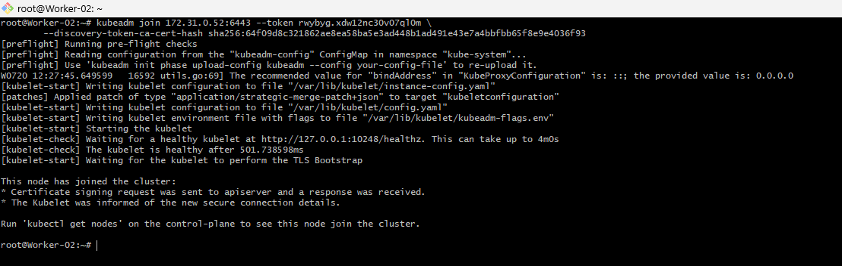
- Now in the k8s – Master instance run kubectl get nodes
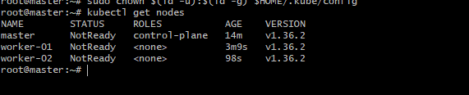
- Now run the command in k8s – Master instance to make the worker nodes ready

kubectl apply -f https://github.com/flannel-io/flannel/releases/latest/download/kube-flannel.yml
- Verified the cluster by the command, kubectl get nodes
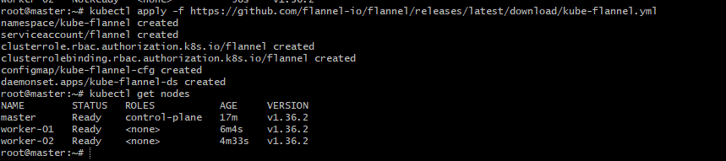

- Run one nginx pod.
Steps:
- In the k8s – Master instance run the below command:
kubectl get nodes
- Now run the below command
kubectl get nodes -o wide
- kubectl run nginx-pod --image=nginx:latest to create a pod named, nginx-pod
- Created a nodeport service using the below command:
kubectl expose pod nginx-pod \
--name=nginx-service \
--type=NodePort \
--port=80 \
--target-port=80
- Checked the nodeport service using
kubectl get service nginx-service
- Use the command kubectl get svc to see the exposed port & verified in the browser as well

