Kubernetes – Task -02

- Create a Simple Pod Using YAML Task: Write a YAML file to create a Pod named firstpod with an nginx container. Verify the Pod creation using kubectl get pods and check the logs of the container using kubectl logs firstpod.
Steps:
- Create k8s-master, worker-01, worker-02 ec2 instances & done the setup of k8s cluster
- In VS code install the extension, YAML
- In VS code YAML settings, in Custom Tags, Edit in settings.json & replace with the below code & save
{
"yaml.schemas": {
"kubernetes": "*.yaml"
},
"yaml.customTags": [

],
"[python]": {
"editor.formatOnType": true
}
}
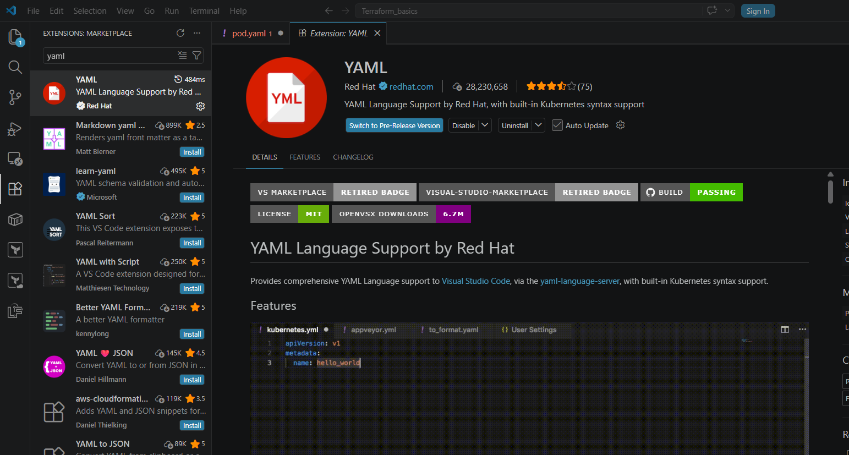
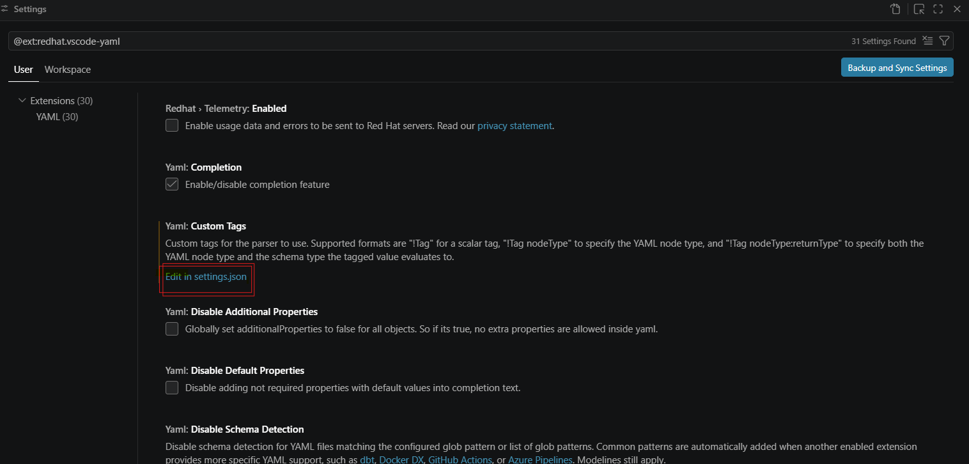
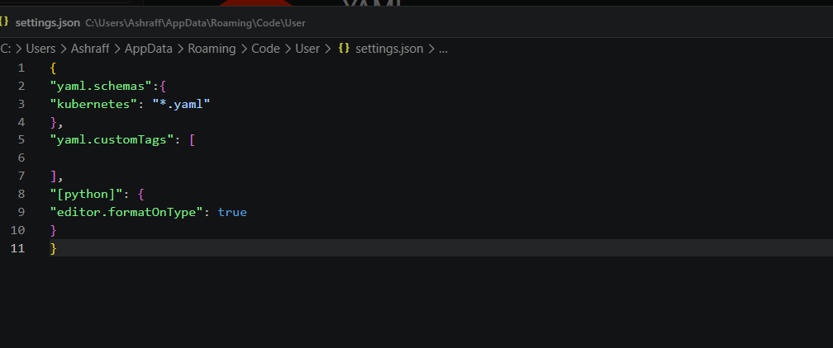
- Now created a first.yaml file with the below code
apiVersion: v1
kind: Pod
metadata:
name: firstpod
spec:
containers:
- name: nginx-container
image: nginx
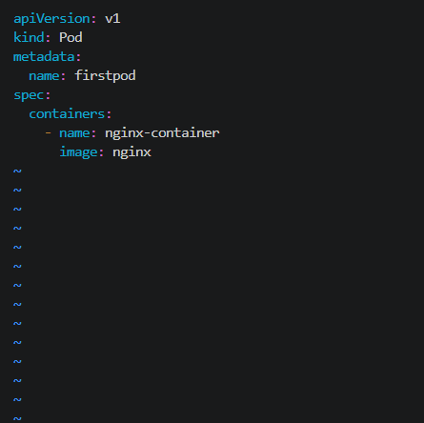
- Created a pod using the command kubectl create -f first.yaml
- We can see the created pod by using the command, kubectl get pods
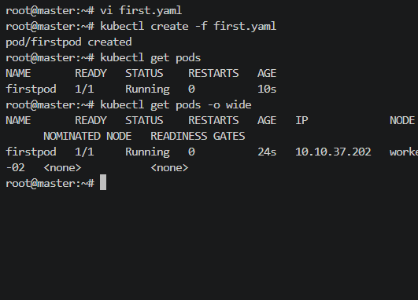

- Set Environment Variables in a Pod Task: Modify the YAML file to include environment variables myname: sabair and City: Hyderabad. Deploy the Pod and use kubectl exec <pod_name> -- env to check if the environment variables are set properly.
Steps:
- Before to the starting of the task delete the pod, firstpod by using the command kubectl delete pod firstpod
- Now added environment name to the already created a first.yaml file with the below code shown in the snapshot:

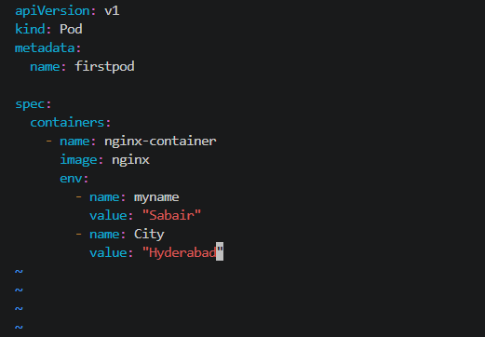
- Now created a pod using kubectl apply -f first.yaml
- Run the command to check the environment variables, kubectl exec firstpod -- env
- We can see the environment variables in the yaml file
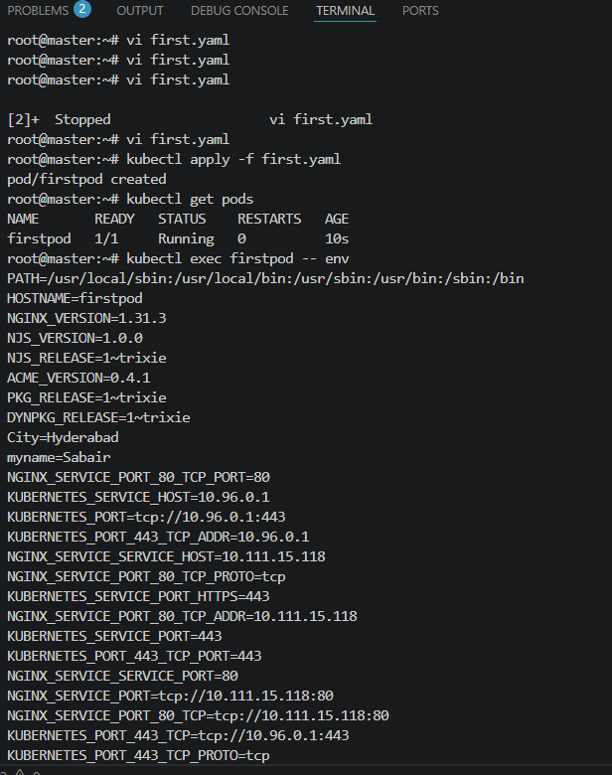

- Deploy a Pod with Commands (Args) in YAML Task: Modify the YAML file to add args that instruct the container to sleep for 50 seconds. Deploy the Pod and use kubectl describe pod to verify the args are correctly passed to the container.
Steps:
- To the first.yaml file add the arguments as shown below & save
apiVersion: v1
kind: Pod
metadata:
name: firstpod
spec:
containers:
- name: nginx-container
image: nginx
env:
- name: myname
value: "Sabair"
- name: City
value: "Hyderabad"
command: ["sleep"]
args: ["50"]

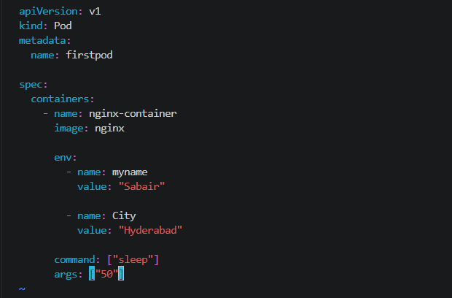
- Now delete the existing pod by using the command, kubectl delete pod firstpod
- Now create a pod using the command, kubectl apply -f first.yaml
- To check the pod created after the 50 seconds run the command, kubectl get pods -w
- After 50 sec we can see the pod created & running
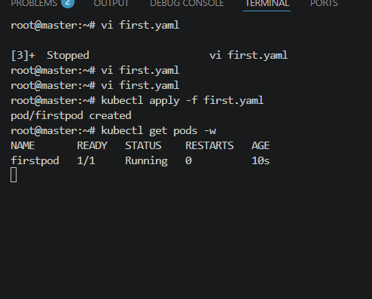
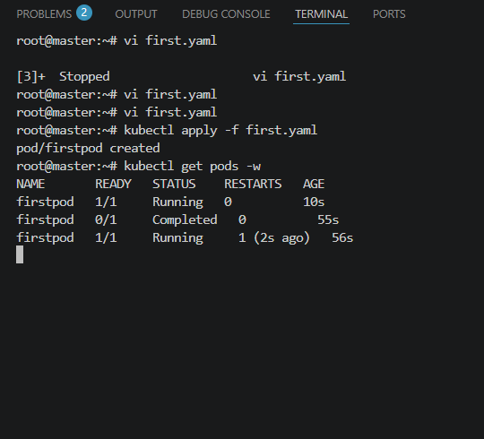
- Create a Pod with Two Containers Task: Create a YAML file to define a Pod with two nginx containers inside. Use kubectl exec to access both containers and verify that both containers can communicate through the same network (e.g., using telnet between them).
Steps:
- Edited the first.yaml file with the below code & save
apiVersion: v1
kind: Pod
metadata:
name: two-nginx-pod

spec:
containers:
- name: nginx-container-1
image: nginx

- name: nginx-container-2
image: nginx
command: ["/bin/sh", "-c"]
args:
- |
sed -i 's/listen 80;/listen 8080;/' /etc/nginx/conf.d/default.conf
nginx -g 'daemon off;'
- Created the pod using kubectl apply -f first.yaml
- Checked the pod is running or not by kubectl get pods
- Ran the command kubectl describe pod two-nginx-pod & verified two containers
- kubectl get pod two-nginx-pod -o wide & confirmed bot the pods running on same ip
- To access the nginx-conatiner-1, kubectl exec -it two-nginx-pod -c nginx-container-1 -- /bin/bash
& Checked the hostname, hostname -i
- To access the nginx-conatiner-2, kubectl exec -it two-nginx-pod -c nginx-container-2 -- /bin/bash
& Checked the hostname, hostname -i
- Connect to the container-1, kubectl exec -it two-nginx-pod -c nginx-container-1 -- /bin/bash & run curl localhost:8080
- We can see from container-1 can communicate with container-2

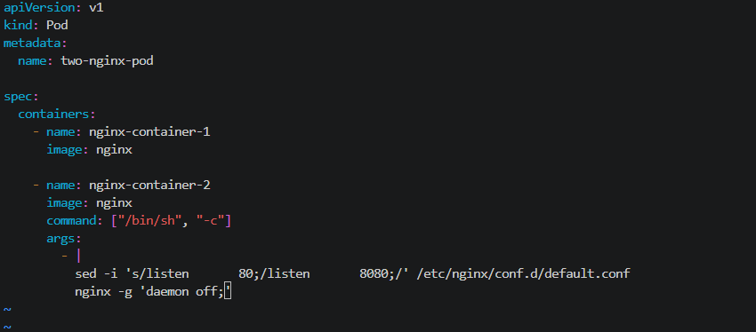

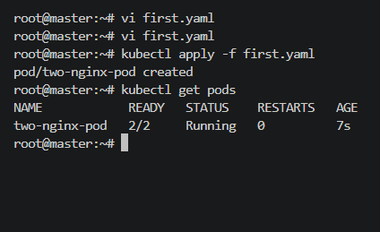

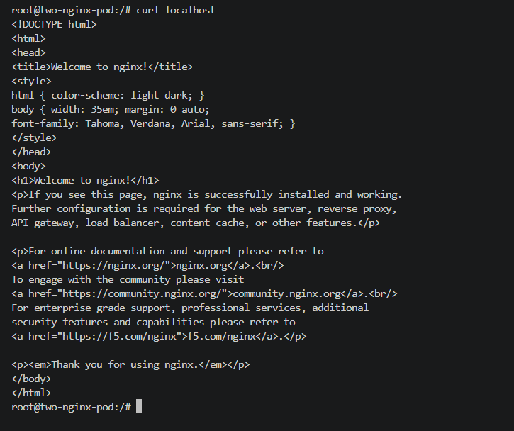
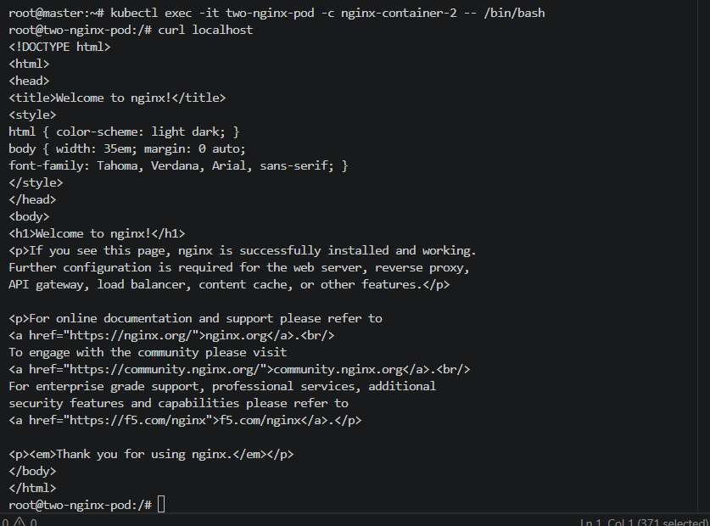

- Set Up an Init Container in a Pod Task: Modify the YAML to include an init container that sleeps for 30 seconds before the main containers start. Verify the init container's execution using kubectl describe pod and check the logs to confirm its completion.
Steps:
- Now to the existing first.yaml file added the init containers as shown below:
apiVersion: v1
kind: Pod
metadata:
name: two-nginx-pod

spec:
initContainers:
- name: initcontainer
image: busybox:latest
command: ["sh", "-c"]
args:
- echo "Init container started"
sleep 30
echo "Init container completed"

containers:
- name: nginx-container-1
image: nginx

- name: nginx-container-2
image: nginx
command: ["/bin/sh", "-c"]
args:
- |
sed -i 's/listen 80;/listen 8080;/' /etc/nginx/conf.d/default.conf
nginx -g 'daemon off;'
- Now run the command to create a pod, kubectl apply -f first.yaml
- Checked the pods got created using the command, kubectl get pods
- Run the command to see the init container is created first by using the command, kubectl get pods -w
- kubectl describe pod two-nginx-init-pod to check the init container created & started
- Checked the initcontainer logs by the command, kubectl logs two-nginx-init-pod -c init-container
- Verified the communication after init by running the command by, kubectl exec two-nginx-init-pod \
-c nginx-container-1 \
-- curl http://localhost:8080

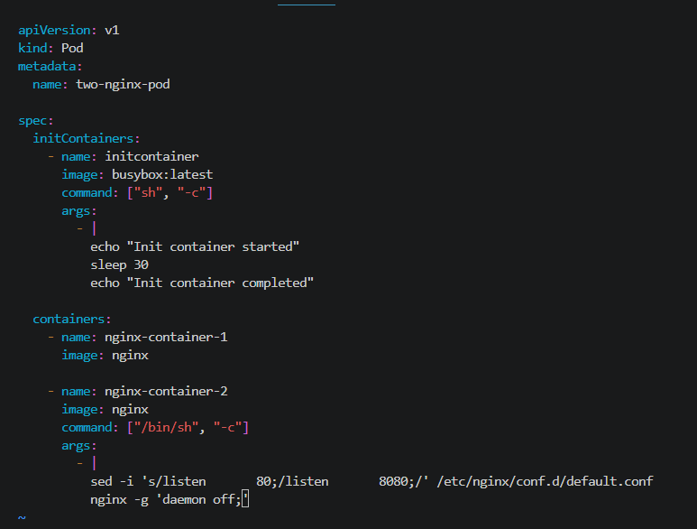
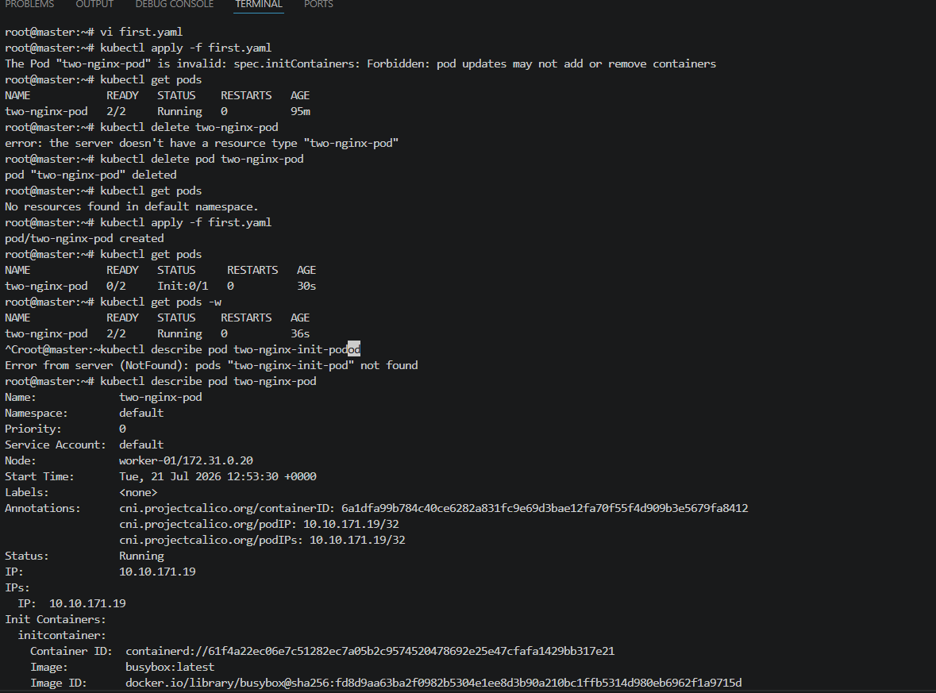
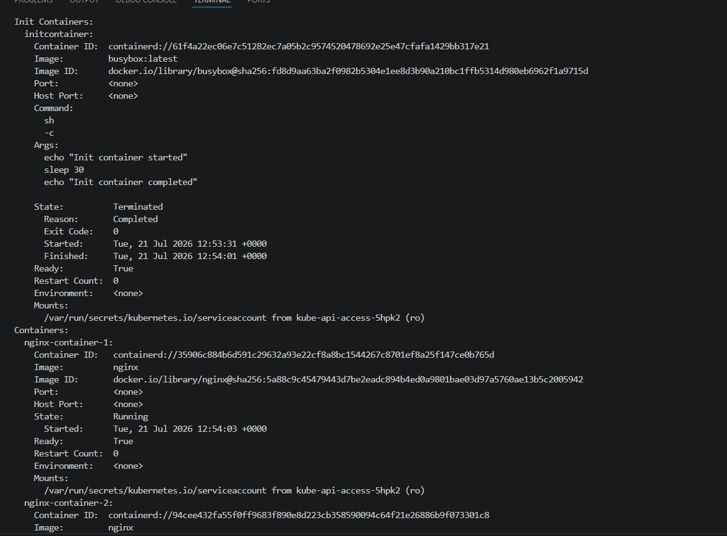
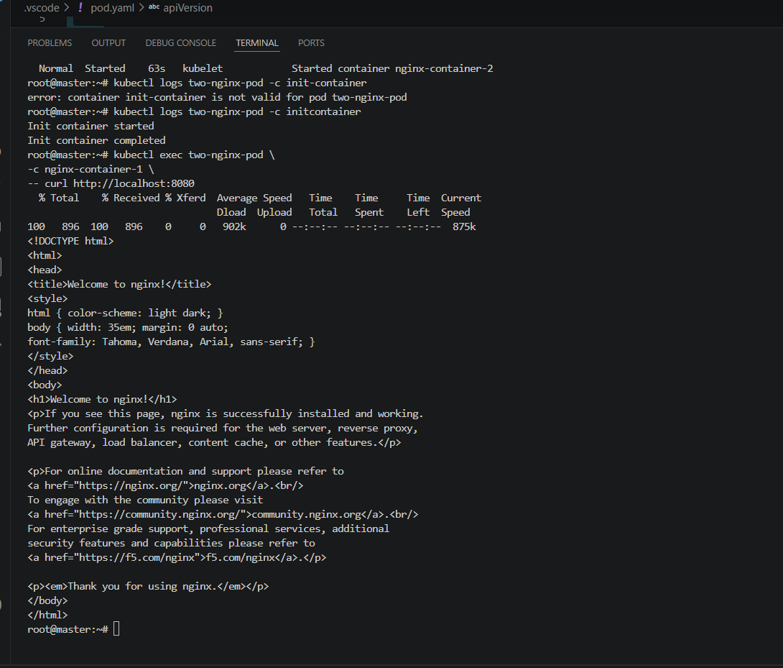

- Run a Dry Run Command to Generate YAML Task: Use the kubectl run nginx --image=nginx --dry-run=client -o yaml command to generate a Pod YAML definition. Modify the generated YAML to suit specific requirements (e.g., labels or environment variables) and deploy it.
Steps:
- Now to the existing first.yaml file edited with the below code & saved
apiVersion: v1
kind: Pod
metadata:
name: two-nginx-pod
labels:
env: prod
name: ashraff

spec:
containers:
- name: nginx-container-1
image: nginx
env:
- name: myname
value: ashraff
- name: City
value: Nellore
- Run the command, kubectl apply –dry-run=client -f first.yaml

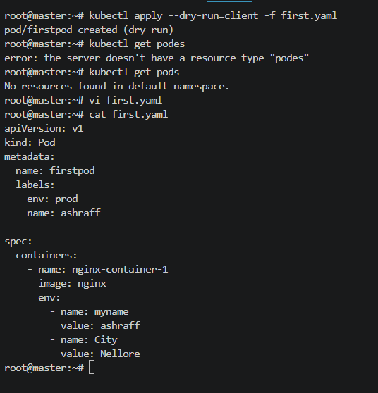
- Now done the changes to label adding app: web & in the env: changed the name to Hamna from ashraff & City as Bangalore from Nellore
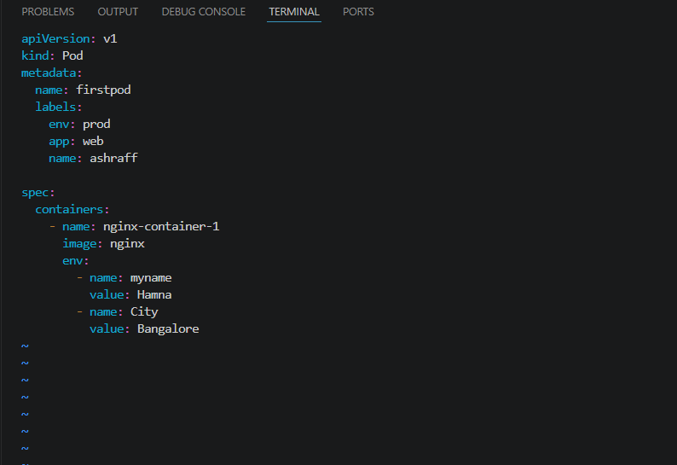
- Executed the kubectl describe pod firstpod
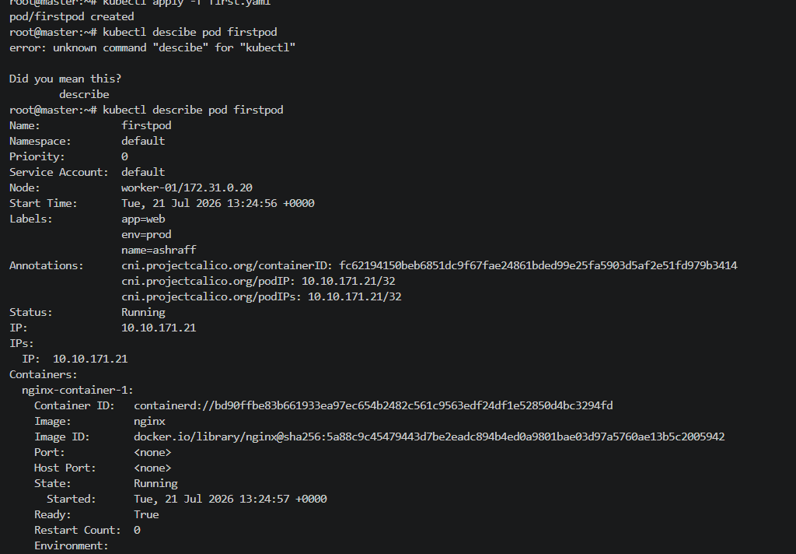
- Verified the changes by the command, kubectl get pod nginx --show-labels
- Verified the environment varibles by the command, kubectl exec firstpod -- env | grep -E 'myname|City'
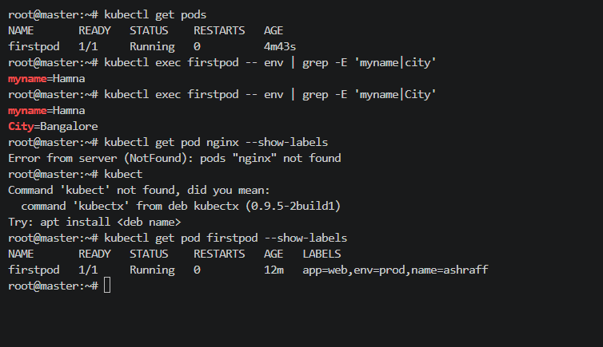

- Use kubectl apply vs kubectl create Task: Create a YAML file to define a Pod. First, deploy it using kubectl create -f <file_name>.yml and then modify the YAML (e.g., change the image version). Use kubectl apply to redeploy and verify the difference between both commands.
Steps:
- Now used the existing first.yaml file with the snapshot attached

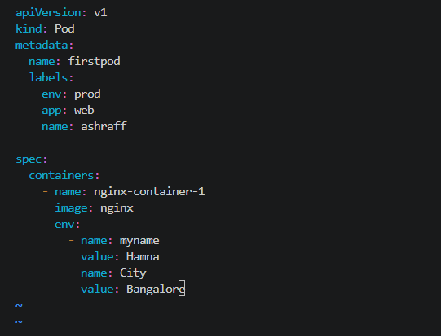
- Now deleted the existing pod, delete pod firstpod
- Now created a new pod, kubectl create -f first.yaml
- Now edit the first.yaml file with the below changes, label name as Jasmine & image as httpd
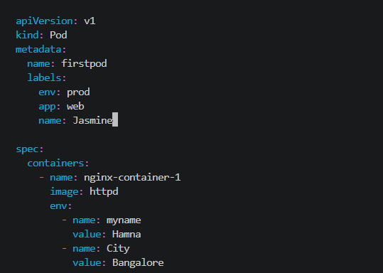
- Now run the command, kubectl apply -f first.yaml & we see the pod running with the below changes
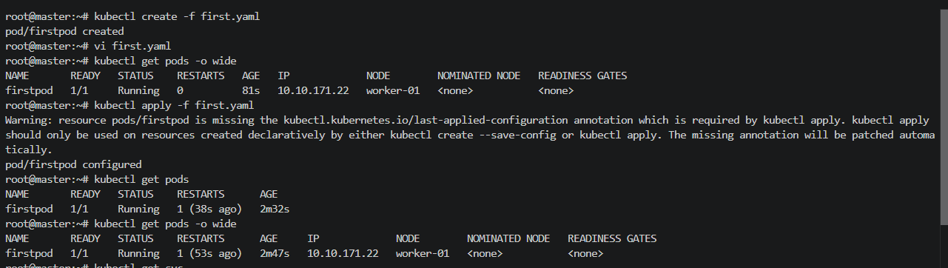
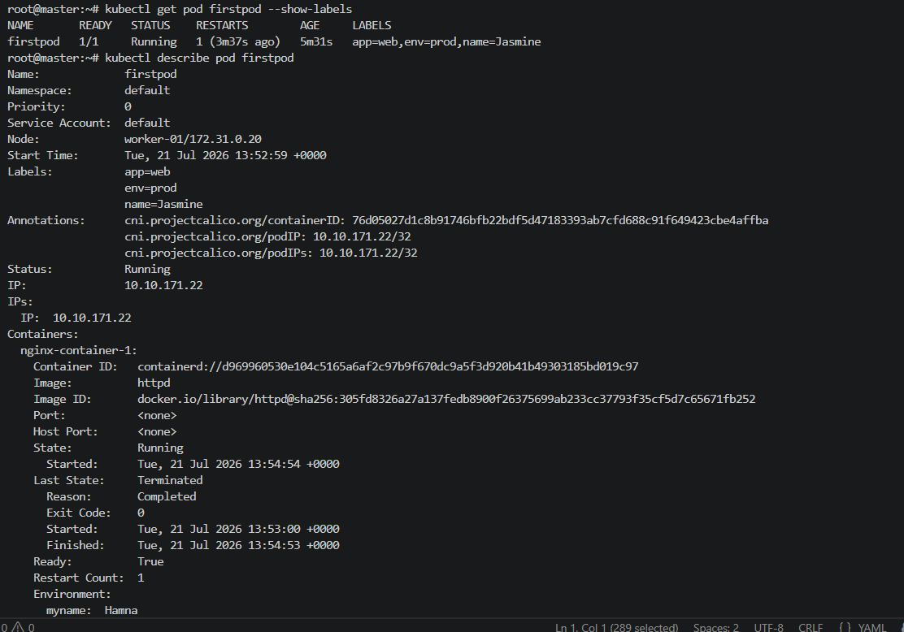
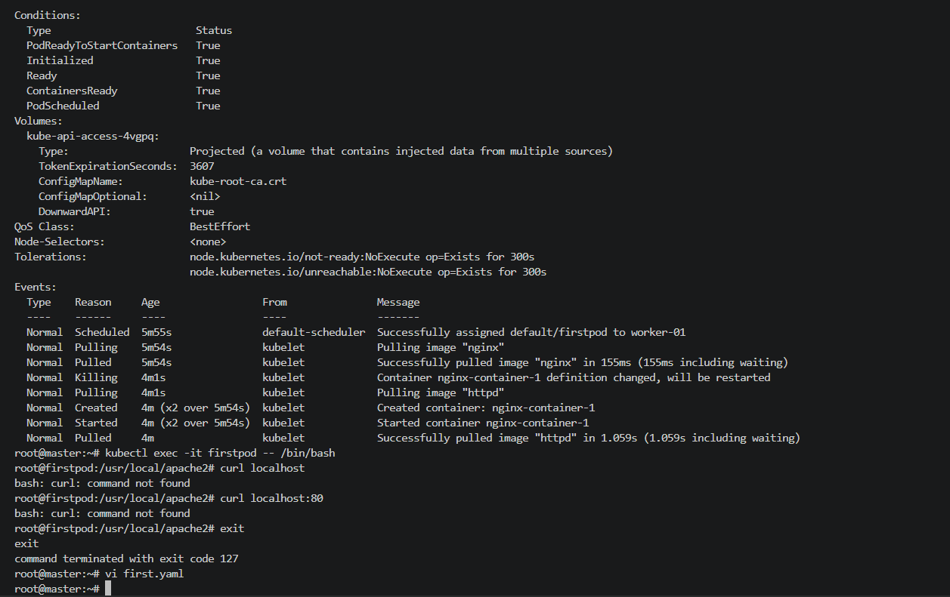

- Edit an Existing Pod Configuration Task: Use kubectl edit pod <pod_name> to modify the running Pod's environment variables or image. After making the changes, verify if they took effect by checking the container logs or environment variables using kubectl exec.
Steps:
- Done the below changes to the first.yaml file & created using kubectl create -f first.yaml
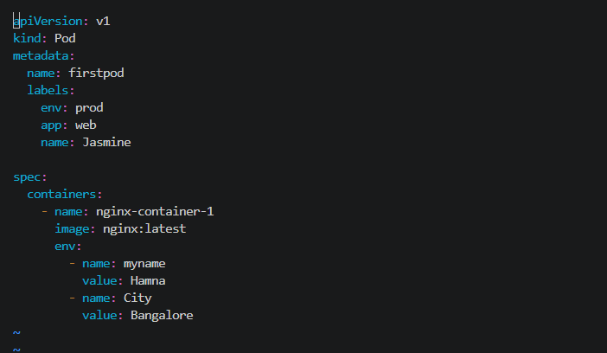
- Now kubectl edit pod firstpod and edited the tag to 1.27 from latest & save

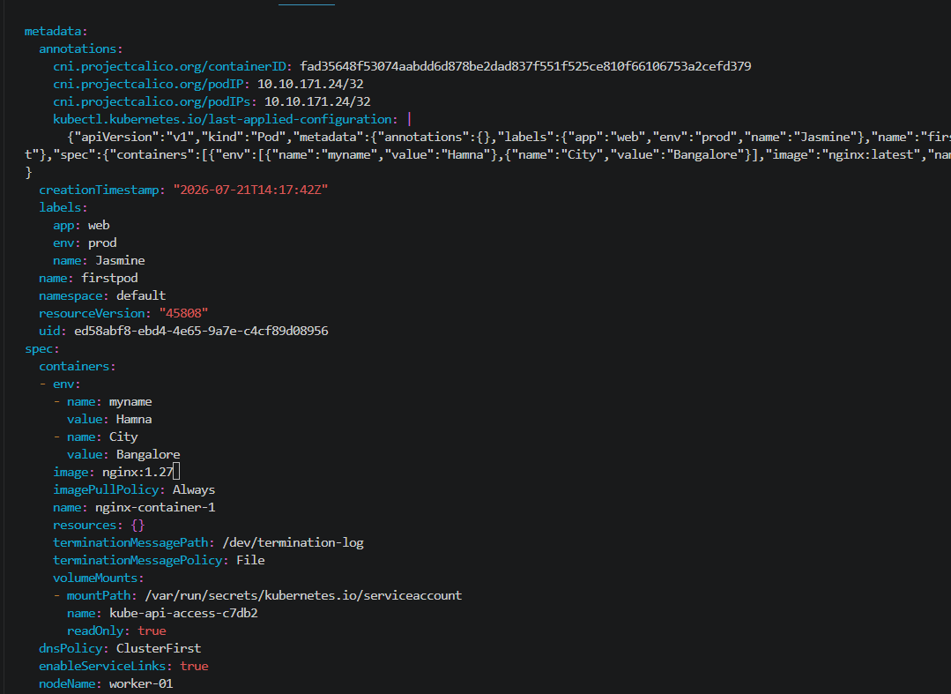

- Now run the command, kubectl apply -f first.yaml & we can see the below changes as per the snapshot when we run kubectl describe pod firstpod
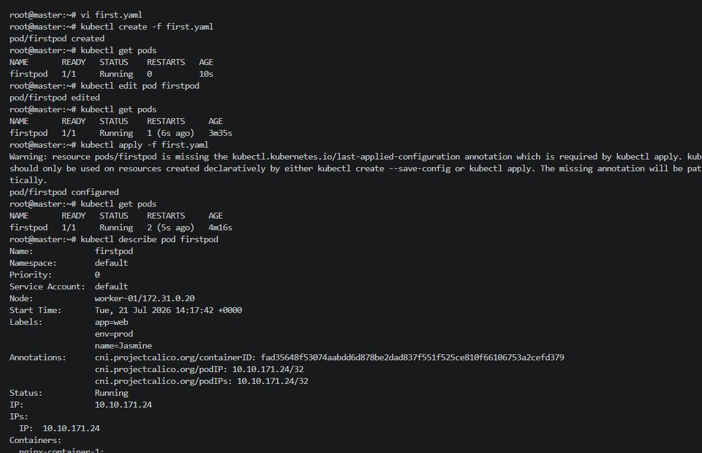
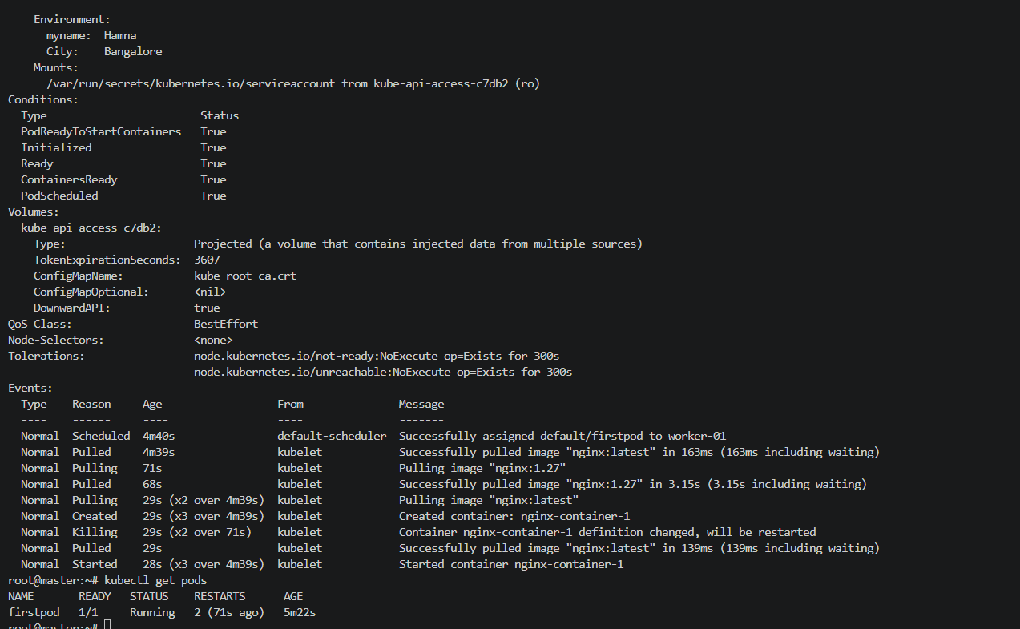

- Expose a Pod Using a Service Task: Create a YAML file to expose your firstpod using a Service (ClusterIP). Ensure that your service is exposing the Pod on port 80 and verify it using kubectl get svc.
Steps:
- Created a firstpod.yaml file with the below code & created a pod kubectl apply -f firstpod.yaml
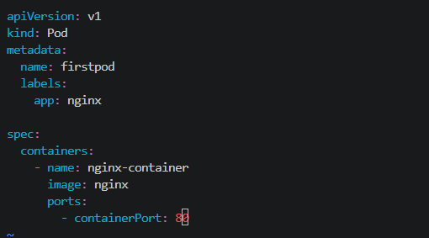
- Created a firstpod-service.yaml file with the below snapshot code:
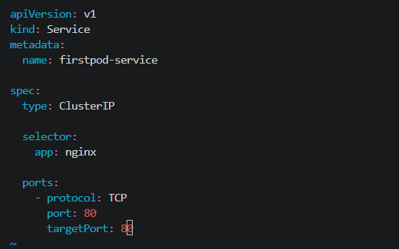
- Created the service using kubectl apply -f firstpod-service.yaml
- Verified the service, kubectl get svc & Service Port: 80 is exposed
- Got the detailed information by running kubectl describe svc firstpod-service
- Verified the service endpoints, kubectl get endpoints firstpod-service
- Tested the service from inside the cluster, kubectl run test-pod --image=curlimages/curl -it --rm – sh
- Curl http://<clusterIp>

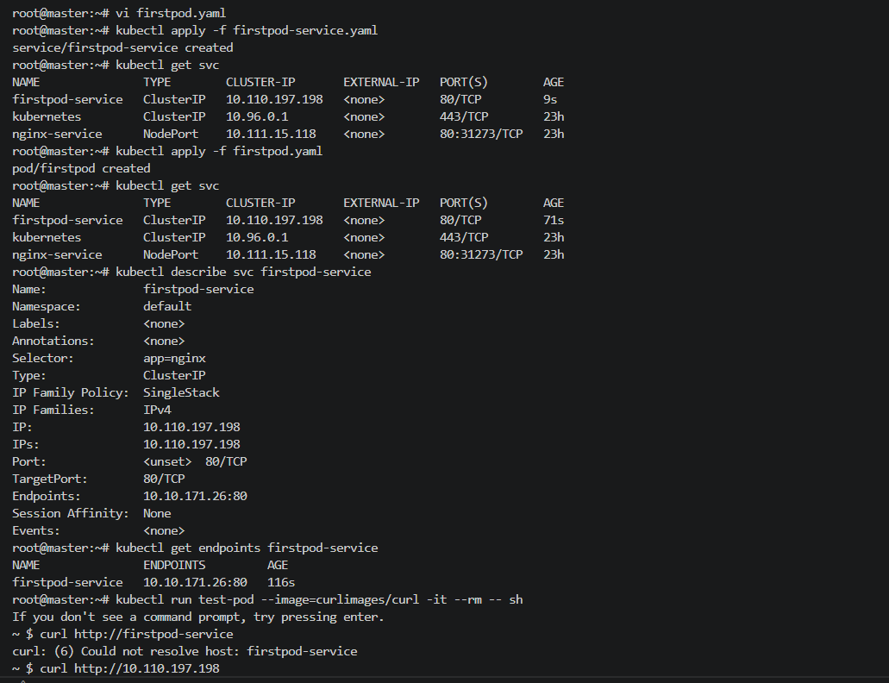
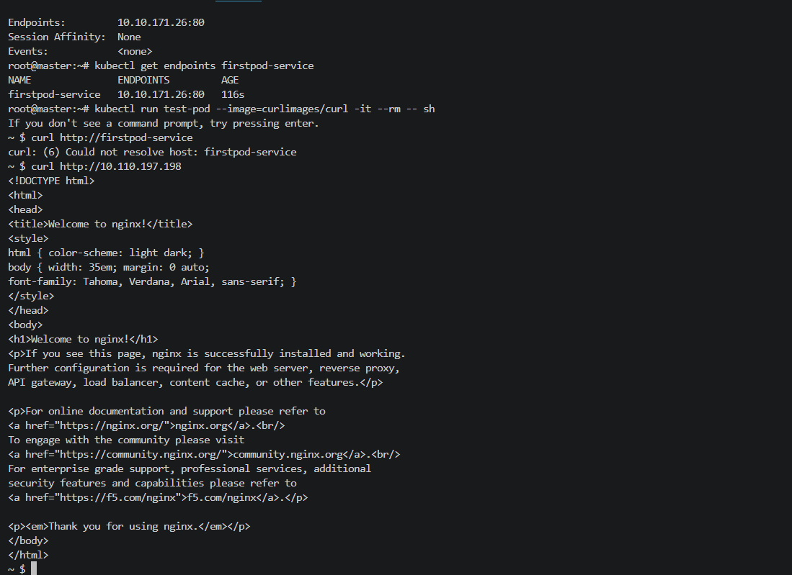
- kubectl get svc firstpod-service
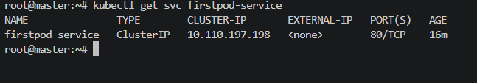

- Pod with Resource Limits and Requests Task: Add resource requests and limits to the containers in your YAML file. Specify CPU and memory requests/limits for both containers and deploy the Pod. Use kubectl describe pod to verify if the resource configurations are correctly applied.
Steps:
- Edited the firstpod.yaml file with the below code:
- apiVersion: v1
- kind: Pod
- metadata:
- name: two-nginx-resource-pod

- spec:
- containers:
- - name: nginx-container-1
- image: nginx
- resources:
- requests:
- cpu: "100m"
- memory: "128Mi"
- limits:
- cpu: "250m"
- memory: "256Mi"

- - name: nginx-container-2
- image: nginx
- command: ["/bin/sh", "-c"]
- args:
- - |
- sed -i 's/listen 80;/listen 8080;/' /etc/nginx/conf.d/default.conf
- nginx -g 'daemon off;'
- resources:
- requests:
- cpu: "100m"
- memory: "128Mi"
- limits:
- cpu: "250m"
- memory: "256Mi"

- Now run the command, kubectl apply -f firstpod.yaml to run the pod

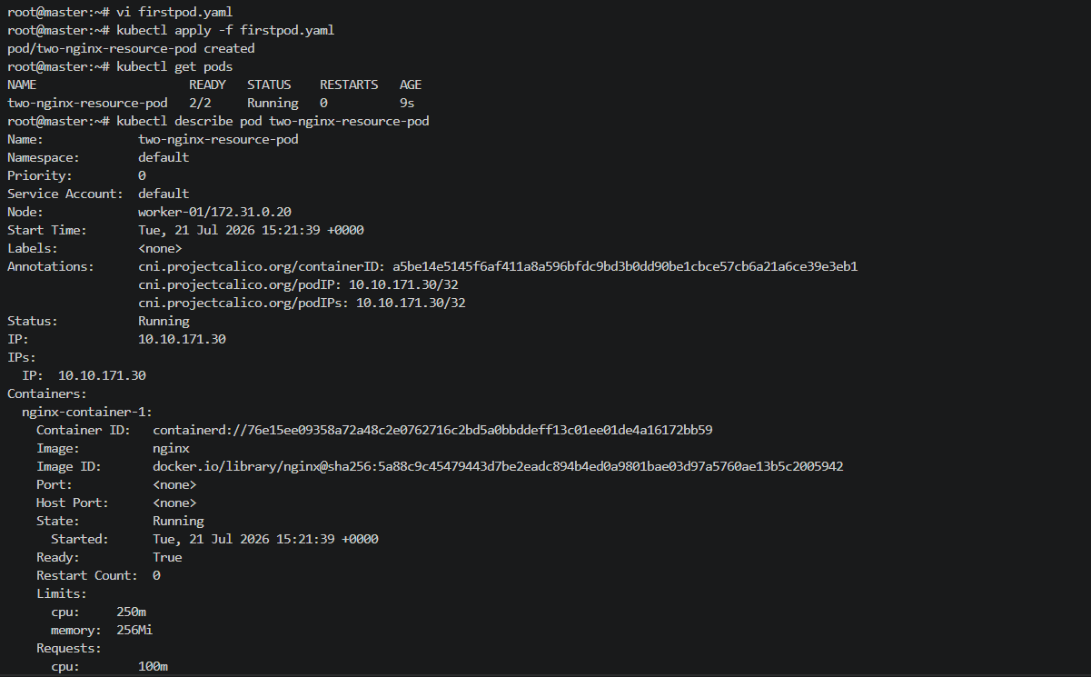
- Now run the command, kubectl describe pod two-nginx-resource-pod
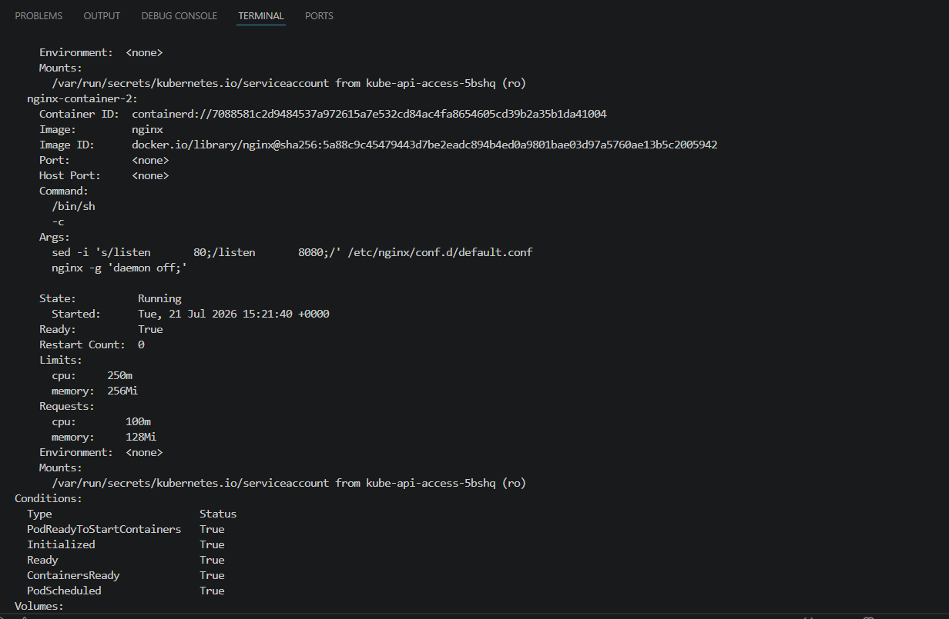
- Verified the container -2 running on port 8080
kubectl exec two-nginx-resource-pod \
-c nginx-container-1 \
-- curl http://localhost:8080
