KUBERNETES – task -03
- Create a ClusterIP service for an Apache web server pod.
Steps:
- Created a first.yaml file with below attached snapshot & run the pods by using com
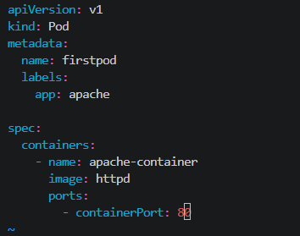
- Created a service.yaml file with below attached snapshot & run the pods by using command, kubectl apply -f service.yaml

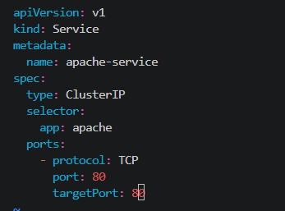
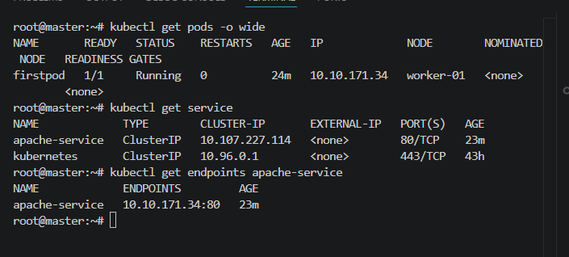
- Now run the command kubectl get pods -o wide
- Run the command to check the ClusterIP, kubectl get service
- Verified the ClusterIp using, curl <ClusterIP>: <Port> or curl <ClusterIP>
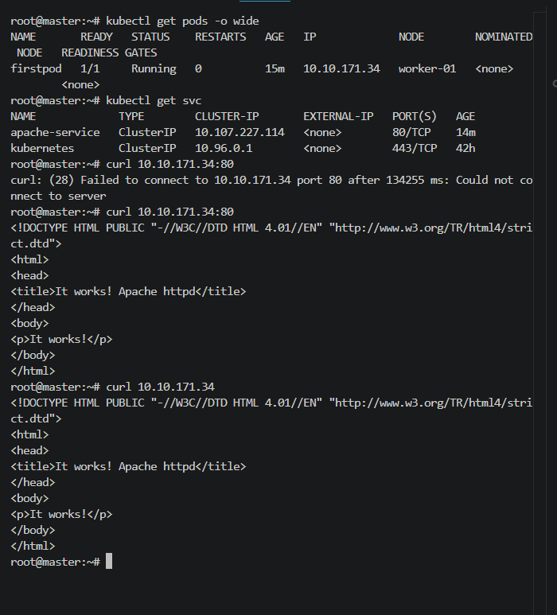

- Expose an Nginx pod externally using a NodePort service.
Steps:
- Made changes to the first.yaml file with the below snapshot & created a pod using the command, kubectl apply -f first.yaml
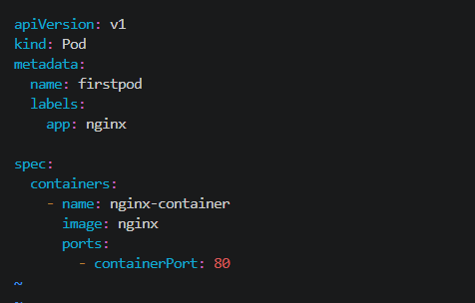
- Made changes to the service.yaml file with the below snapshot & created a pod using the command, kubectl apply -f service.yaml
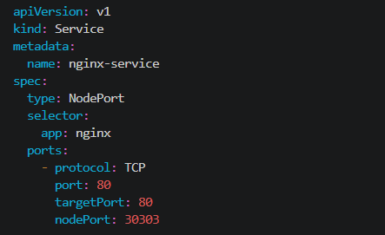
- Run the commands, kubectl get pods -o wide to see the assigned worker & IP
- Run the command, kubectl get service or kubectl get svc to see the NodePort details
- From browser check with master, worker-01, worker-02 instance publicip:<nodePort>
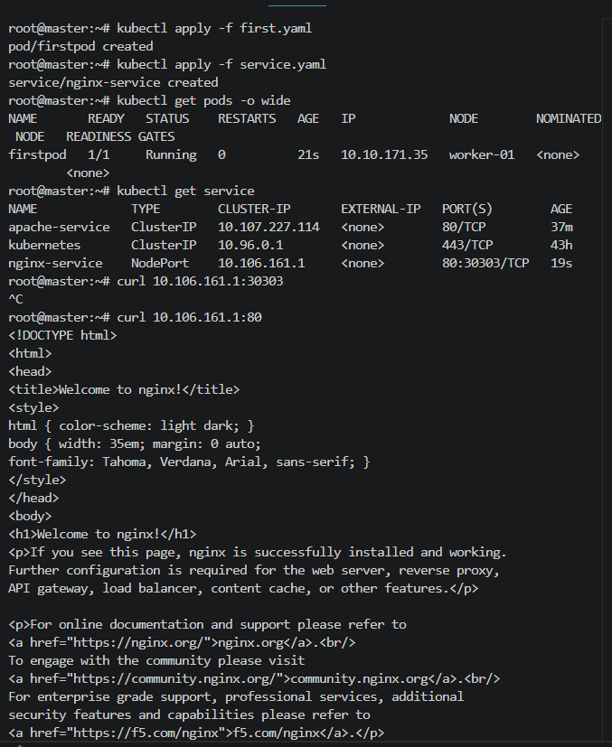
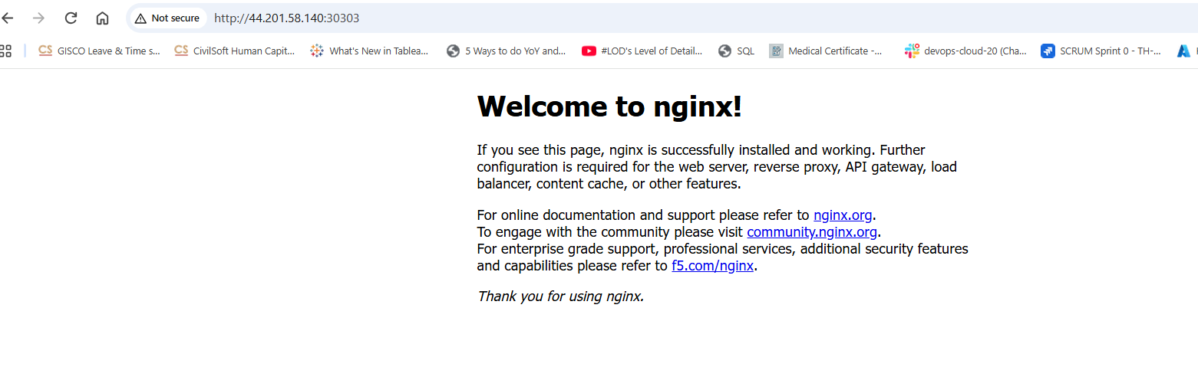
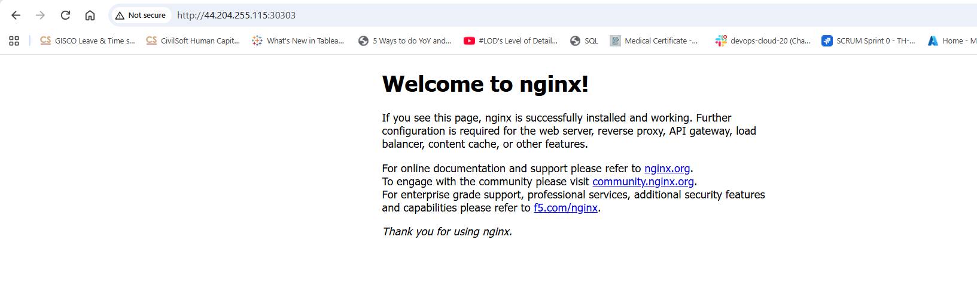
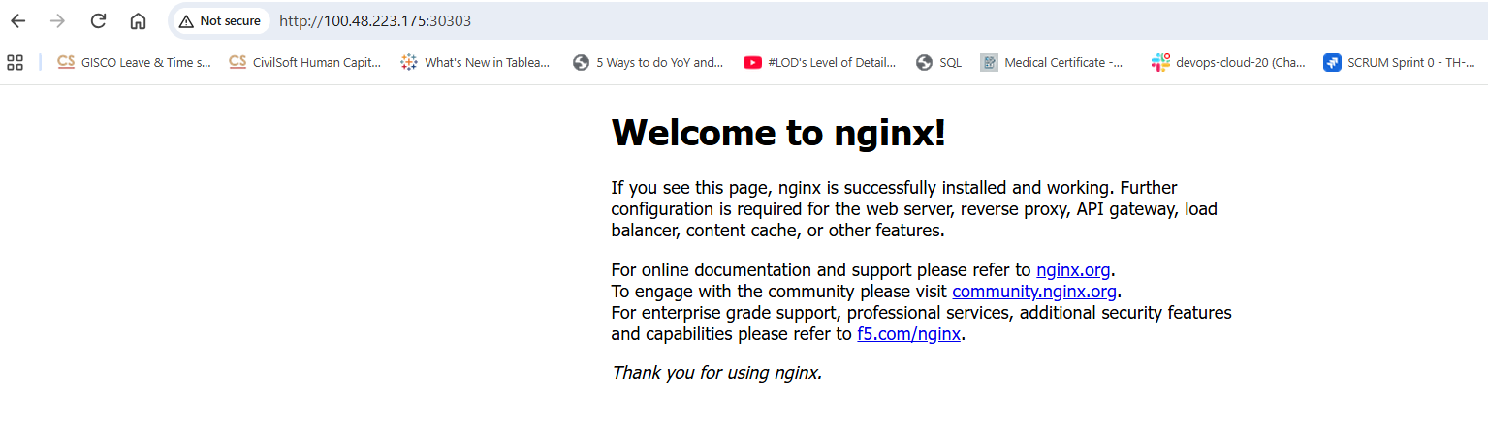
- We can see the end point created for the service, nginx-service, kubectl describe service nginx-service
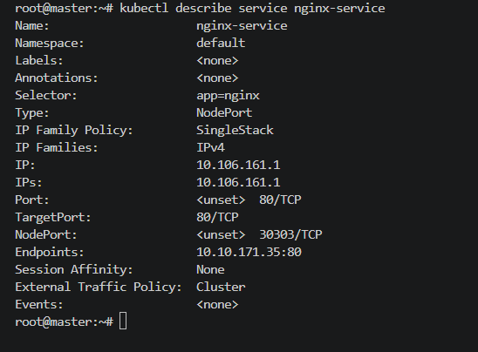
- Deploy a ReplicationController to maintain 3 replicas of an Nginx pod.
Steps:
- Created a rc.yaml file for the replicaltion controller with the below code
apiVersion: v1
kind: ReplicationController
metadata:
name: firstrc
labels:
appname: testapp
spec:
replicas: 3
selector:
app: nginx
template:
metadata:
name: firstpod
labels:
app: nginx
spec:
containers:
- name: nginx-container
image: nginx
ports:
- containerPort: 80
- Now deploy the replication controller using the command, kubectl apply -f rc.yaml
- We can see three pods running with the command, kubectl get pods -o wide

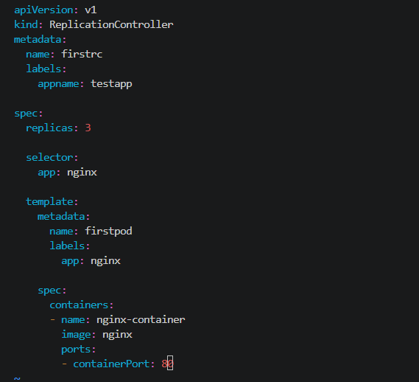
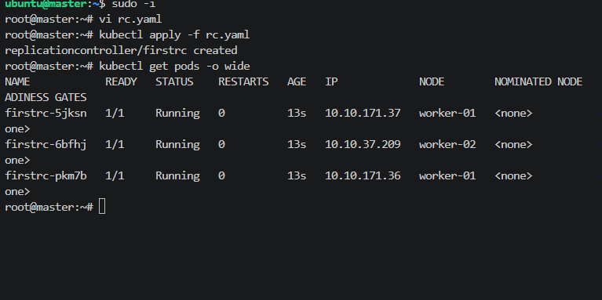

- We can see the endpoints by using the command, kubectl describe service nginx-service
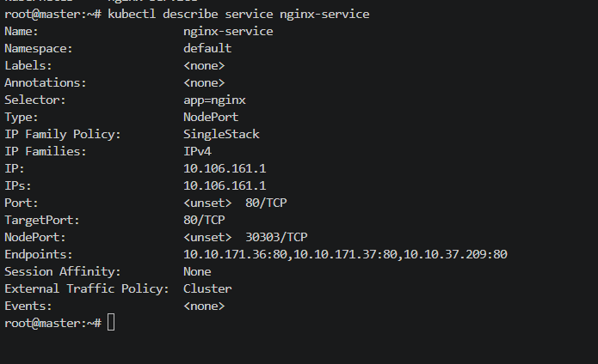

- Scale the ReplicationController from 3 replicas to 5 replicas.
Steps:
    - The rc fil created in the above task change the replicas to 5 instead of 3 & run the command, kubectl apply -f rc.yaml
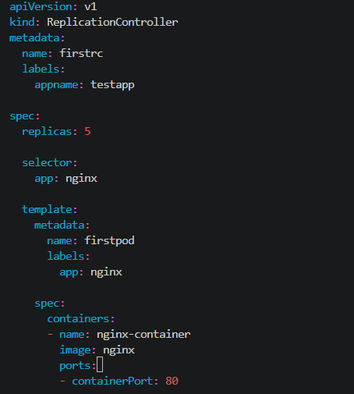
    - By using the command, kubectl get pods -0 wide we can see five pods running
    - By using the command, kubectl describe svc nginx-service we can see five endpoints got created for the five pods
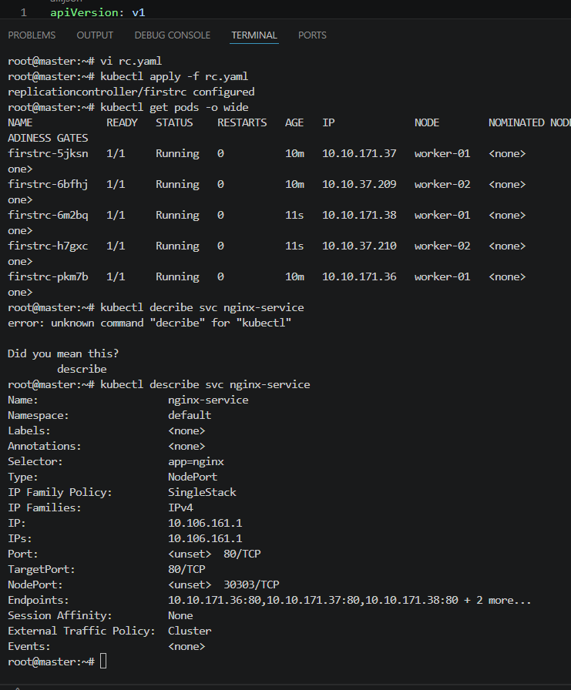
- By running the command, kubectl describe pod <pod_name> we can see the pod is controlled by ReplicationController/firstrc
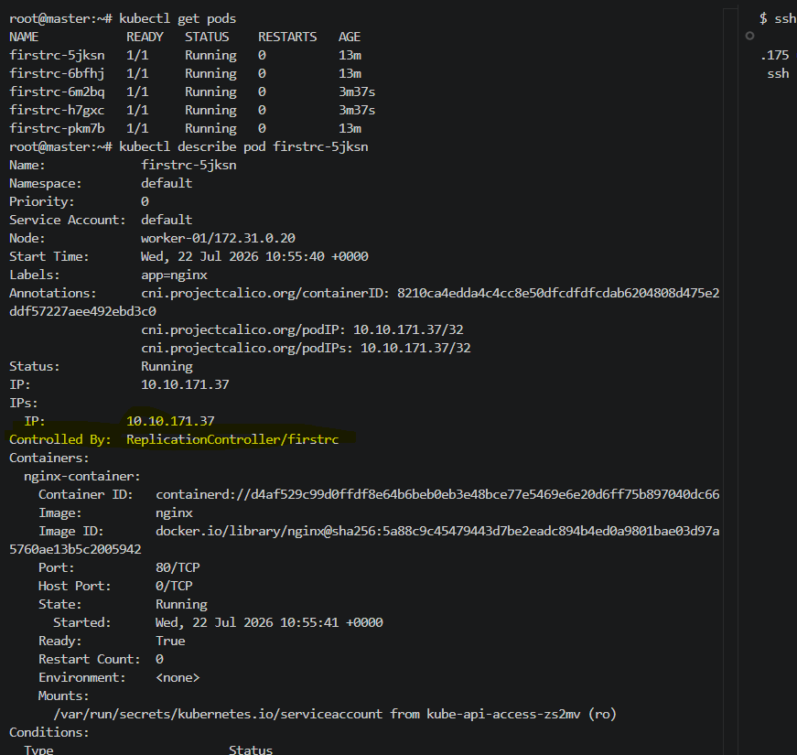

- Create a ReplicaSet to manage pods based on multiple labels (prod and test).
Steps:
- Created a rs.yaml file with the below snapshot
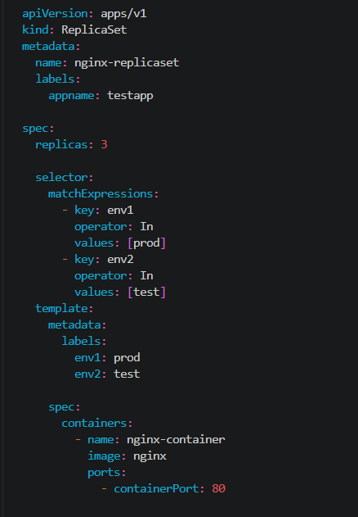

- Now run the command, kubectl apply -f rs.yaml
- We can see the pods created using the command kubectl get pods –show-labels
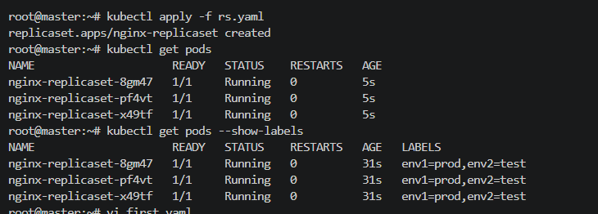

- Deploy a ReplicaSet that excludes pods with the label backend.
Steps:
- Edited the rs.yaml file with the below snapshot
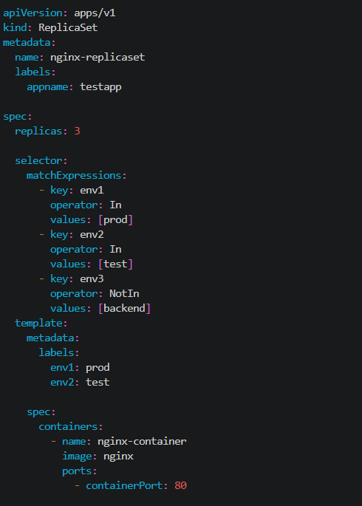
- Now deploy the pods using command, kubectl apply -f rs.yaml
- Run the command, kubectl get pods –show-labels which tells the backend label is excluded
- Now updated the first.yaml file with the below code as per the snapshot

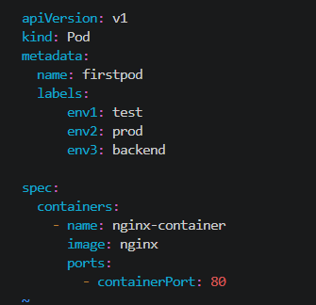

- Once we run the command, kubectl appy -f first.yaml we can see a pod created because of the env3 as backend & checked using the command, kubectl get pods --show-labels
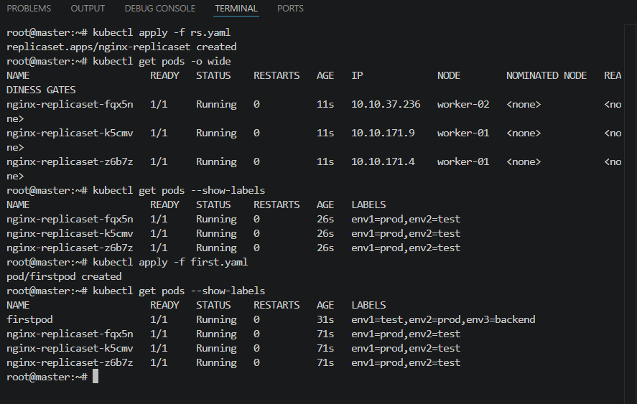
- Test load balancing across multiple pods using a NodePort service.
Steps:
- Edited the service.yaml fiel as per the snapshot by updating the labels as per my replica set & the service is NodePort
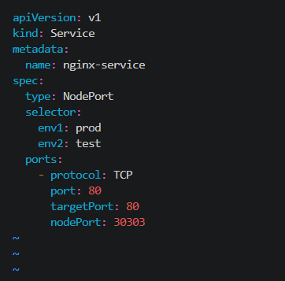
- Now run the command, kubectl apply -f service.yaml to deploy the pods
- We can see the pods status with labels, kubectl get pods --show-labels
- Run the command to see the endpoints of 3 replica sets, kubectl describe svc nginx-service as per the labels
- Now by using the command, kubectl edit pod nginx-replicaset-fqx5n changed the image to httpd
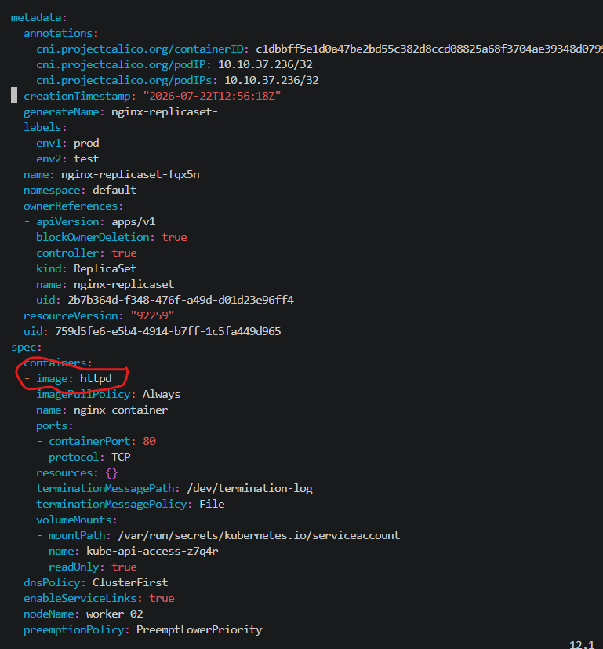
- Checked the changes reflected to pod by kubectl get pods -o wide which shows the pod is restarted & checked the apache configured by kubectl describe pod <pod_name> & checked the logs as well by kubectl logs <pod_name>

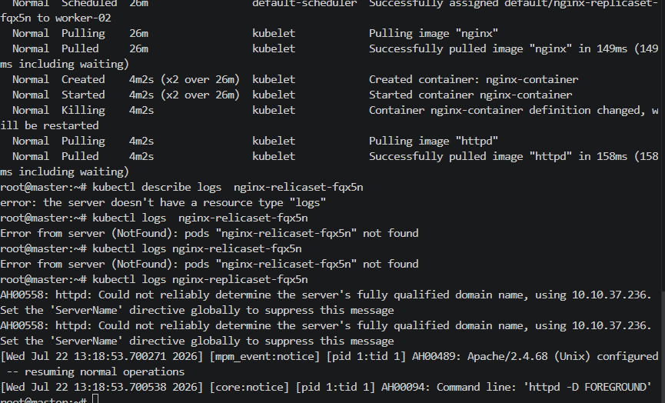
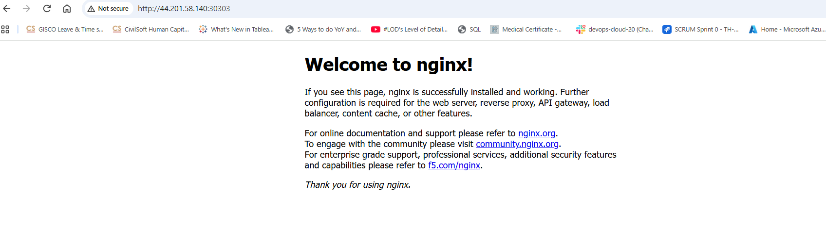

- Delete a ReplicationController without affecting the running pods.
Steps:
- Created a rc.yaml file wih the below code:
apiVersion: v1
kind: ReplicationController
metadata:
name: firstrc
labels:
appname: testapp
spec:
replicas: 3
selector:
app: nginx
template:
metadata:
name: firstpod
labels:
app: nginx
spec:
containers:
- name: nginx-container
image: nginx
ports:
- containerPort: 80
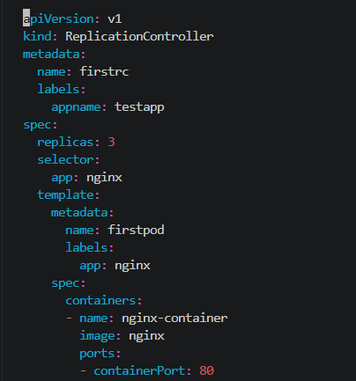
- Now run command, kubectl apply -f rc.yaml to deploy the pods
- We can check the pods status kubectl get pods where 3 are of replica controller
- Run the command to check the replica controller, kubectl get rc
- To delete the rc, kubectl delete rc firstrc –cascade=orphan
- The rc got deleted but the pods of replicacontroller are running which can be viewed by kubectl get pods
