Terraform task – 02

2). Execute all the templates shown in the video.
Steps:
- Created a main.tf file with the below code
resource "local_file" "my_pet" {
filename = "/pets.txt"
content = "My pet name is CAT"
}
- Now we need to execute terraform init to initialize & download the dependency of the providers
- A .terraform file is created & .terraform.lock.hcl is the backup of .terraform file
- Now by executing the command, terraform apply a file pets.txt has been created & the content as My pet name is CAT.

- 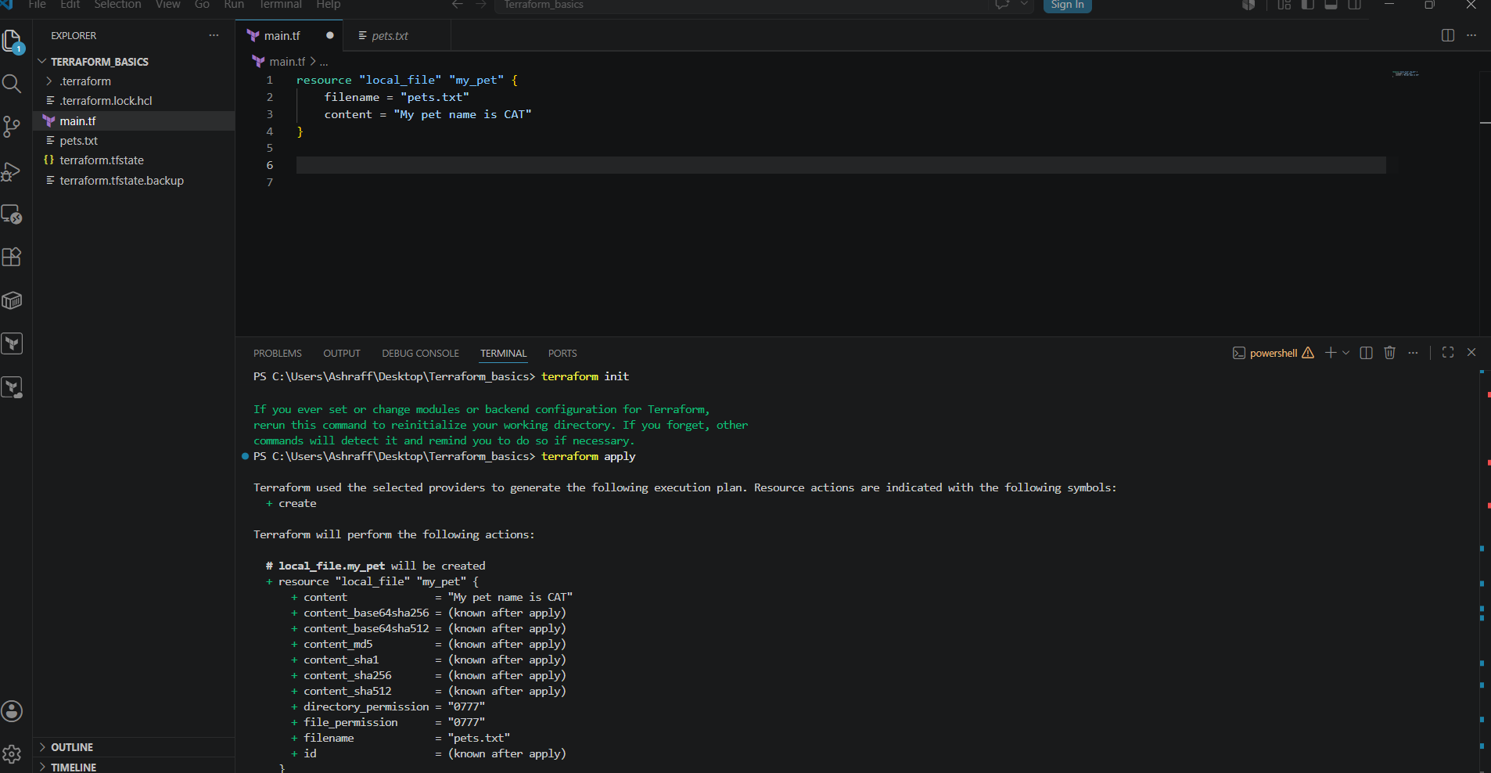
- 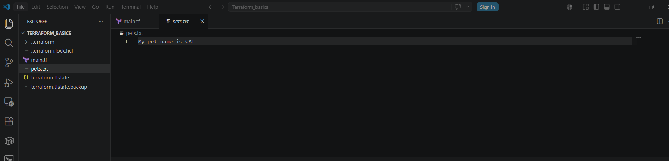

- Now add another provider as shown below:
resource "random_pet" "petname" {
prefix = "MR"
separator = "."
length = "1"
}
- We need to execute terraform init first & terraform apply & we see the output as petname as MR.pug assigned by the random_pet provider

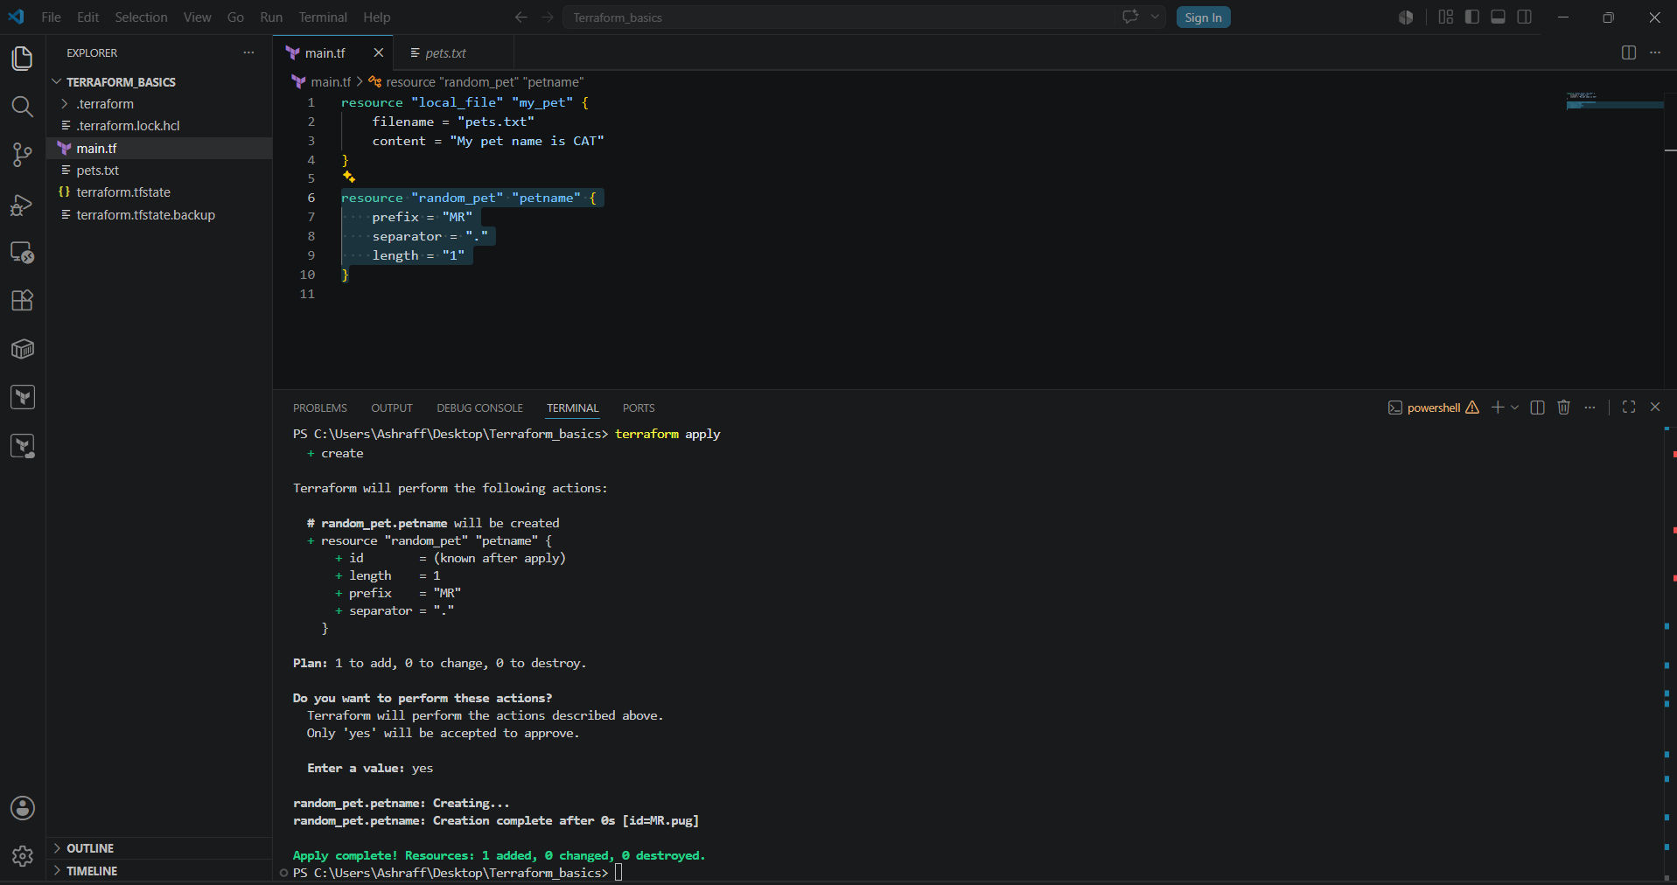

Lifecycle:

Create_before_destroy:

Now in pets.txt I will change the content as My pet name is Zebra & lifecycle as create_before_destroy = true & save the file
Now terraform apply & we can see that the change is replaced by My pet name is Zebra & creating first and destroy next instead of destroy as first.
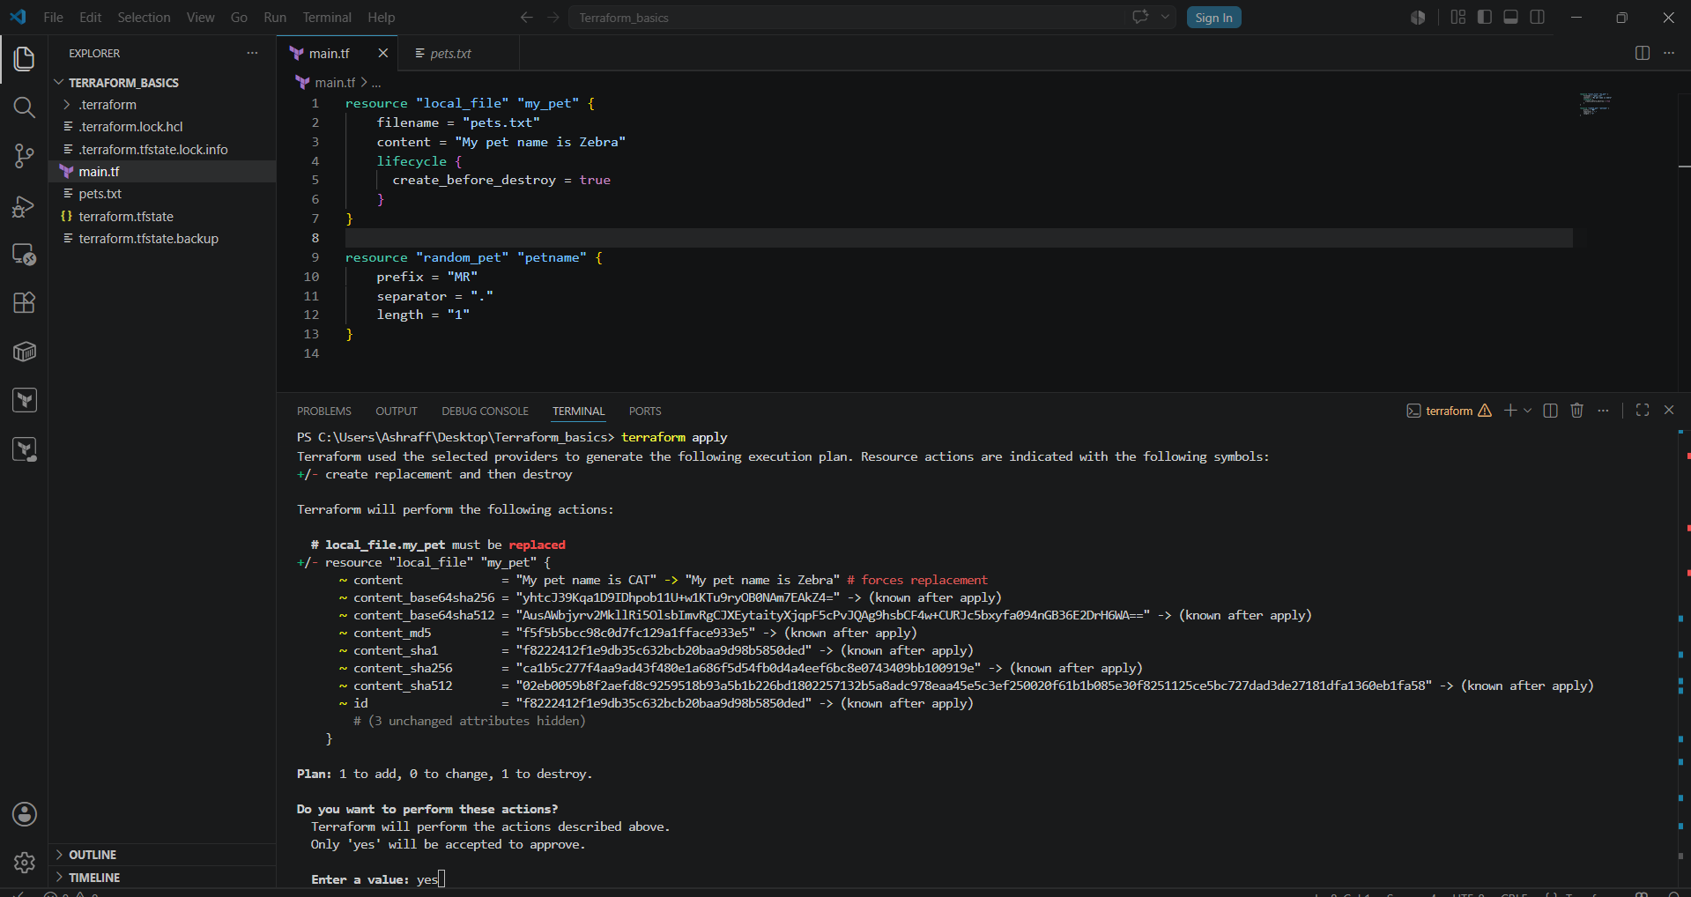
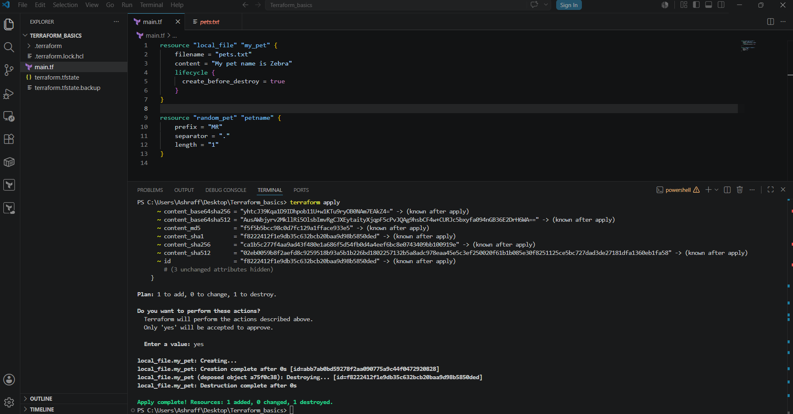
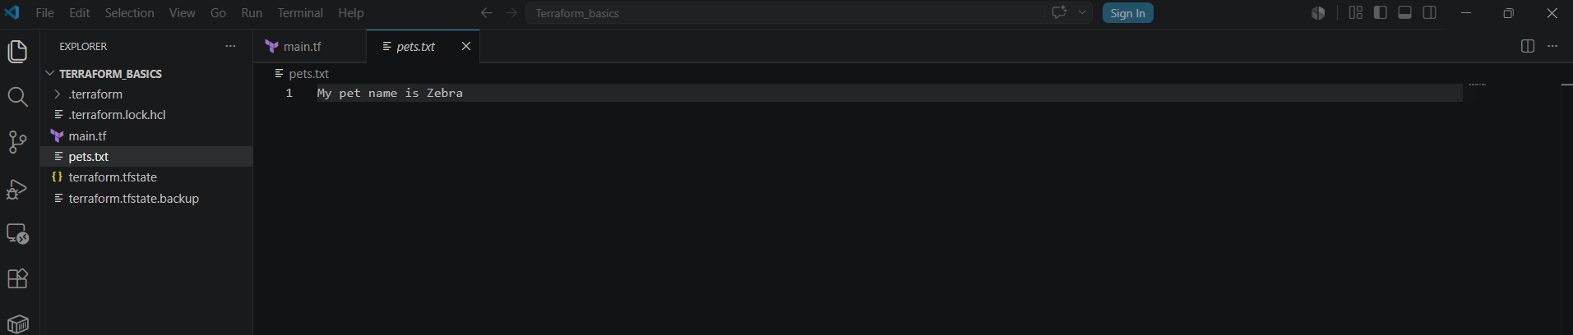

Prevent_destroy:
Now when I have done the content change as My pet name is Elephant & using lifecycle prevent_destroy = true & save the file
When execute terraform apply unable to destroy the old file because of the lifecycle, prevent_destroy

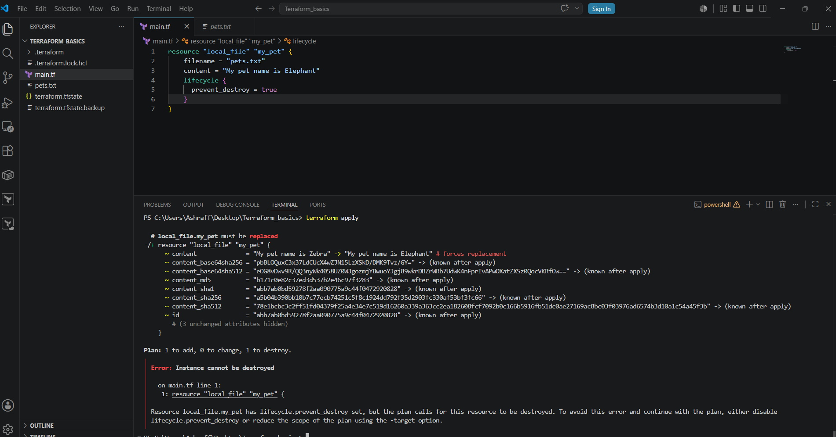

Now even I changed the pets.txt content to My pet name is Giraffe with lifecycle as prevent_destroy = true & save
Now when I execute the command, terraform destroy unable to destroy as well.
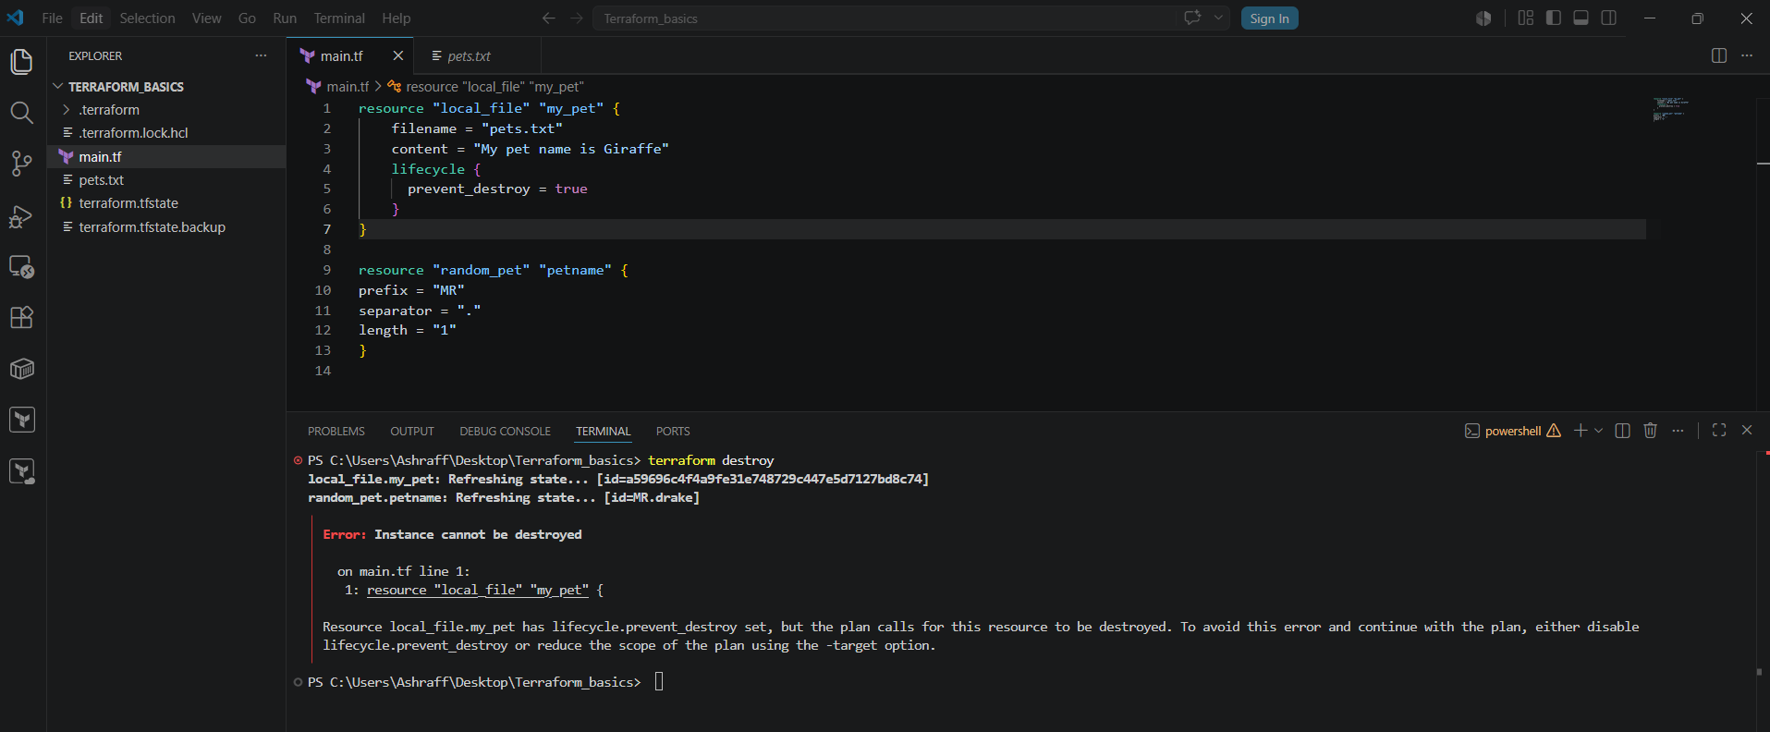

Ignore_changes:

Now even I changed the pets.txt content to My pet name is Giraffe with lifecycle as ignore_changes = [ content ] & save
When executed the terraform apply command we see that no changes ignoring the changes because of the lifecycle ignore_changes.

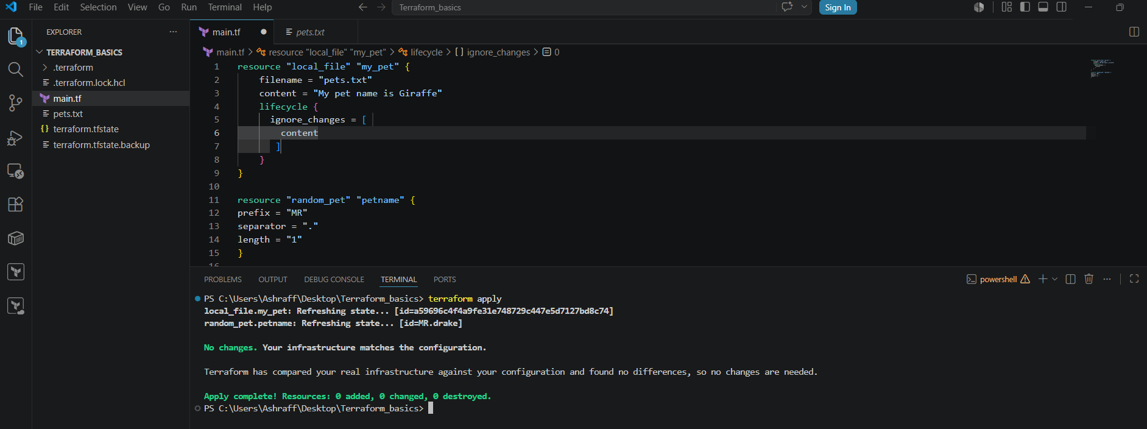
Variables.tf:
Now instead of hardcoding the content & file name, we create a variables.tf file with the below code:
variable "filename" {
default = "pets.txt"
type = string
}
variable "content" {
default = "I love cats"
}
& save
Now edit the main.tf file as below using the variables.tf file
resource "local_file" "my_pet" {
filename = var.filename
content = var.content

}
resource "random_pet" "petname" {
prefix = "MR"
separator = "."
length = "1"
}
& save the file
Now when we execute terraform apply we can see that in pets.txt the content as I love cats by using the variables.tf file.

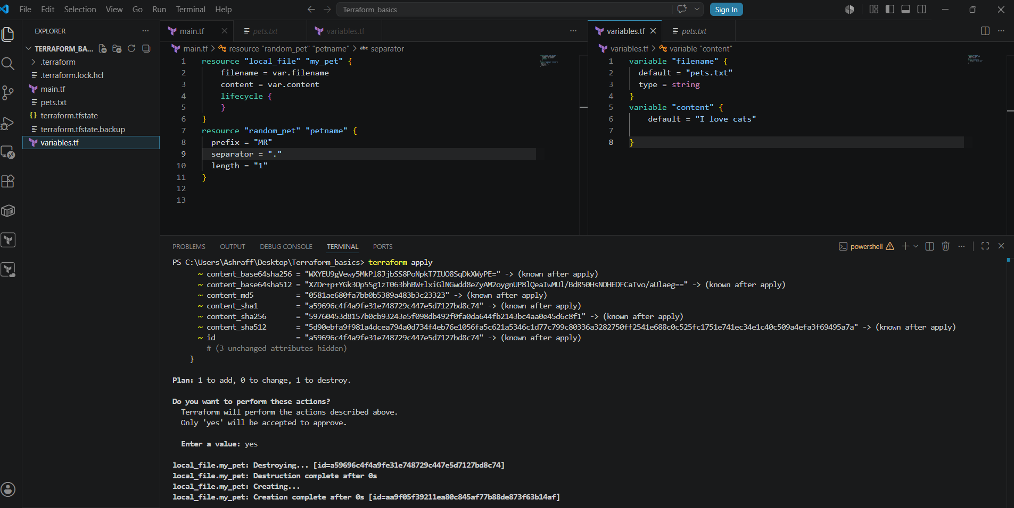

Now we use variables for the random_pet provider as well & below is the code
variable "prefix" {
default = "MR"
type = string
}
variable "length" {
default = "2"
type = number
}
& save the file
Now modify the main.tf file for the random_pet provider as below:
resource "random_pet" "petname" {
prefix = var.prefix
separator = "."
length = var.length
}
& save the file
Now when executed terraform apply we can see the prefixes as MR.next.globin since the variable length the default is 2

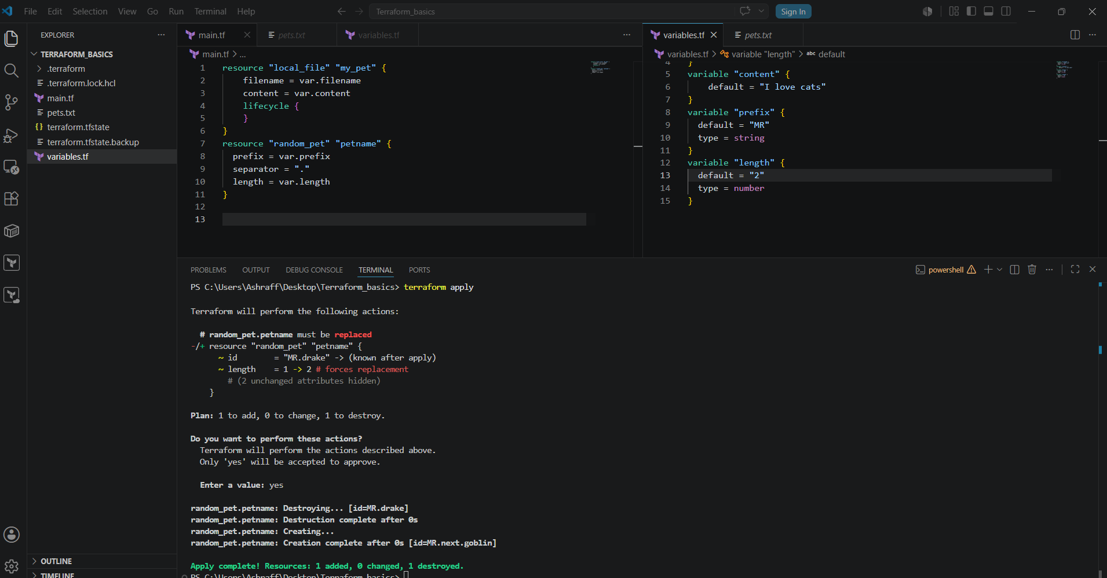
Declaring variables at run time:
- Now edit the changes of main.tf file as below:
resource "local_file" "my_pet" {
filename = var.filename
content = var.content
lifecycle {
}
}
resource "random_pet" "petname" {
prefix = "MR"
separator = "."
length = "1"
}
& save
- Now variables.tf file without declaring any variables create as below:
variable "filename" {
}
variable "content" {
}
& save
- Now when while executing we need to pass the values for file name & content as mentioned below:
Terraform apply -var “filename=wild.txt” -var “content=I love Lion” we can see the content of pets.txt updated as I love Lion.
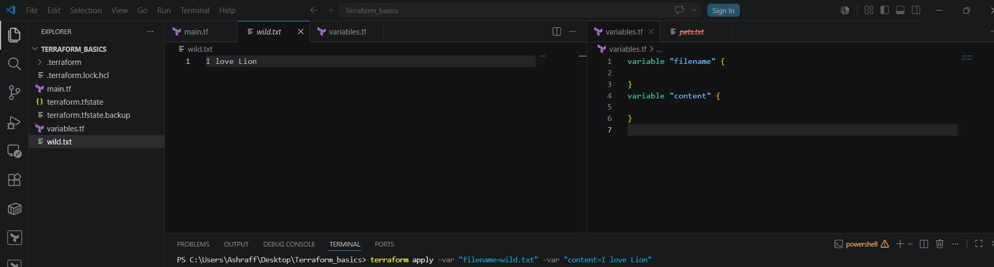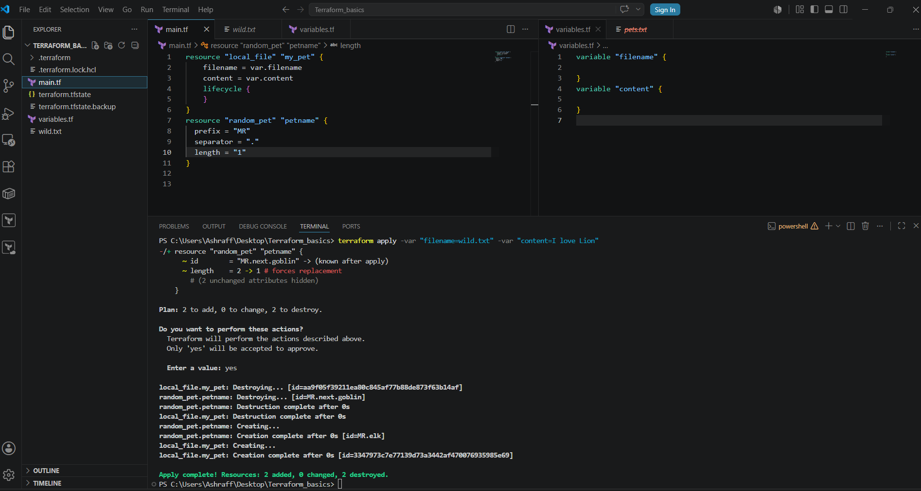

3). Integrate Terraform in Jenkins using the Terraform plugin.
Objective

Integrate Terraform with Jenkins using the Terraform Plugin so Jenkins can:

Clone Terraform code from GitHub
Run terraform init
Run terraform validate
Run terraform plan
Run terraform apply
(Optional) Run terraform destroy
Prerequisites
Jenkins installed
Terraform installed on Jenkins server
AWS CLI installed
Git plugin installed
Pipeline plugin installed
Terraform Plugin installed
AWS credentials configured
GitHub repository containing Terraform code
Steps:
- Created an ec2 instance, My-ec2-jenkins with Jenkins & terraform installed.
- Connect to Jenkins UI, with IPv4:8081
- Install Terraform Plugin
    - Login to Jenkins
    - Navigate to: Manage Jenkins
    - PluginsAvailable Plugins

    - Search for:
    - Terraform
  - Disable instant automatically
  - As I have installed terraform in my-ec2-jenkins instance mentioned the path of terraform as /usr/bin & save.
  - Created a sample freestyle job, terraform_job with build in steps using shell script to execute terraform –version & save & click Build Now
  - The job is successful & in console output I can see the terraform version matching with the My-ec2-jenkins terraform version.

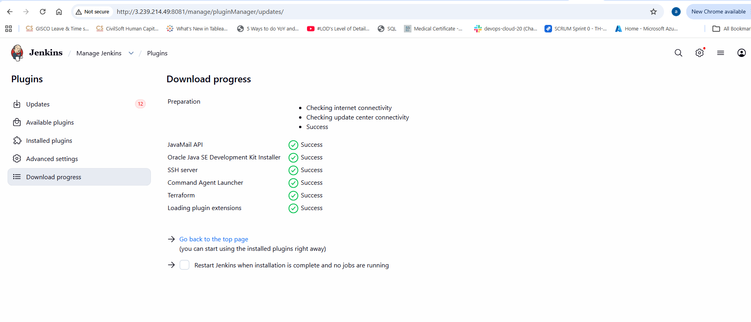
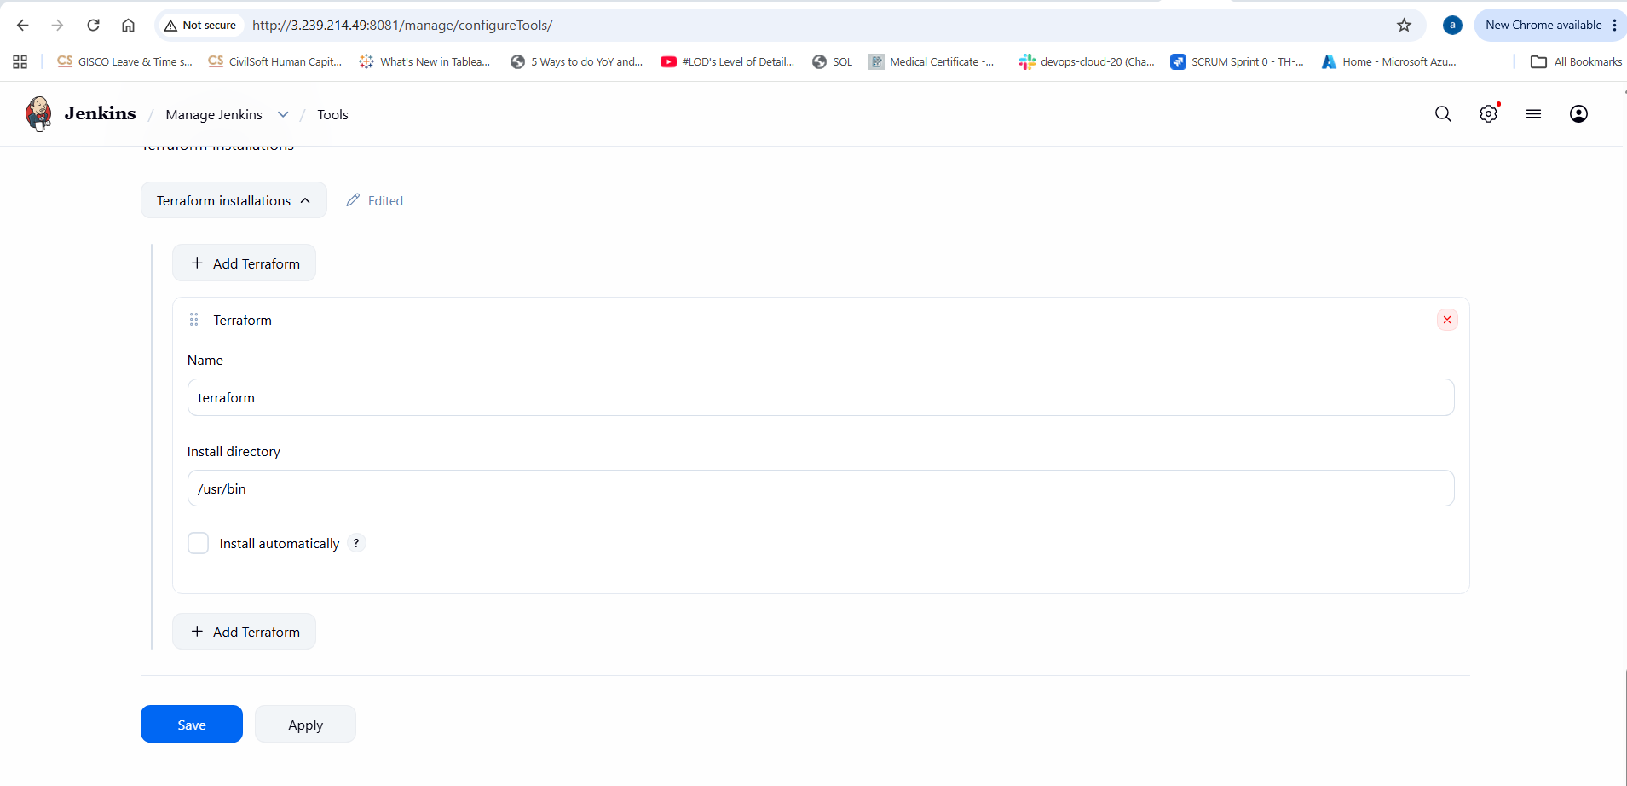
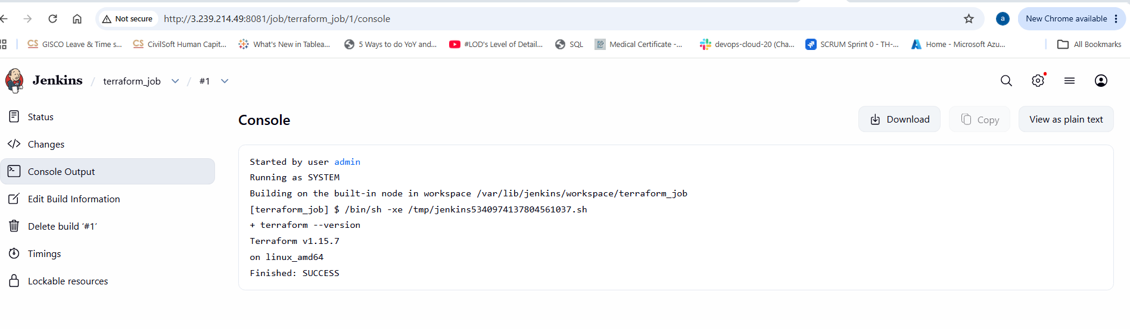
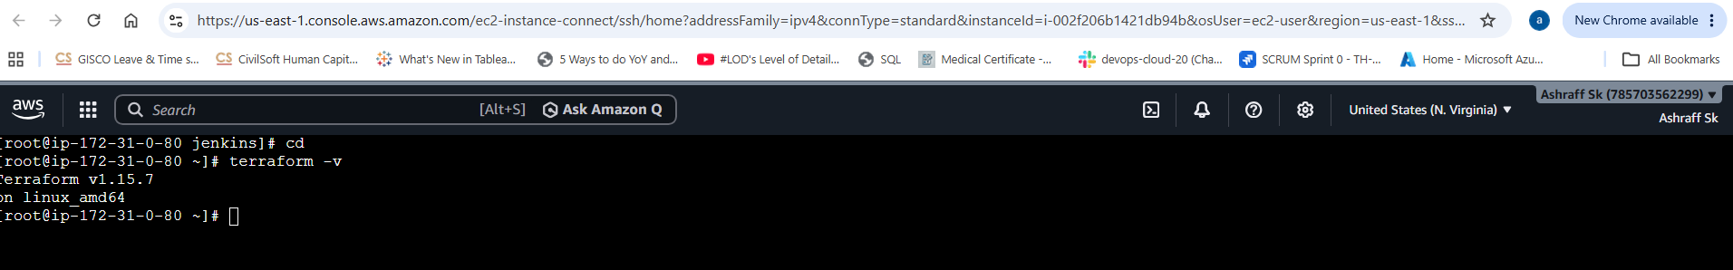
Now created a central repo, terraform-jenkins in Github with the main.tf , variables.tf & Jenkinsfile
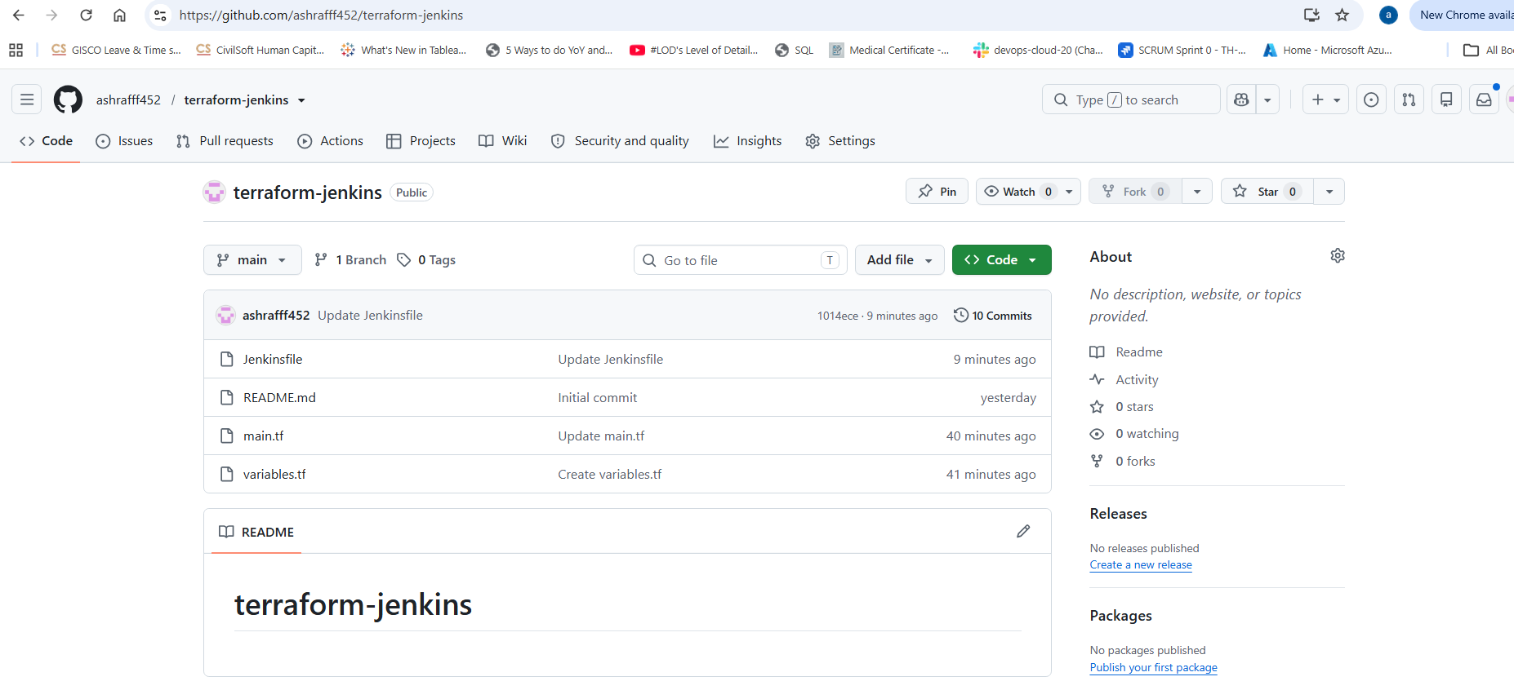
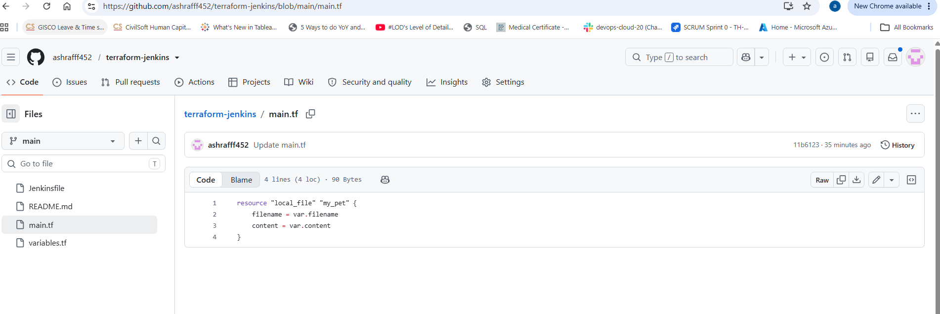
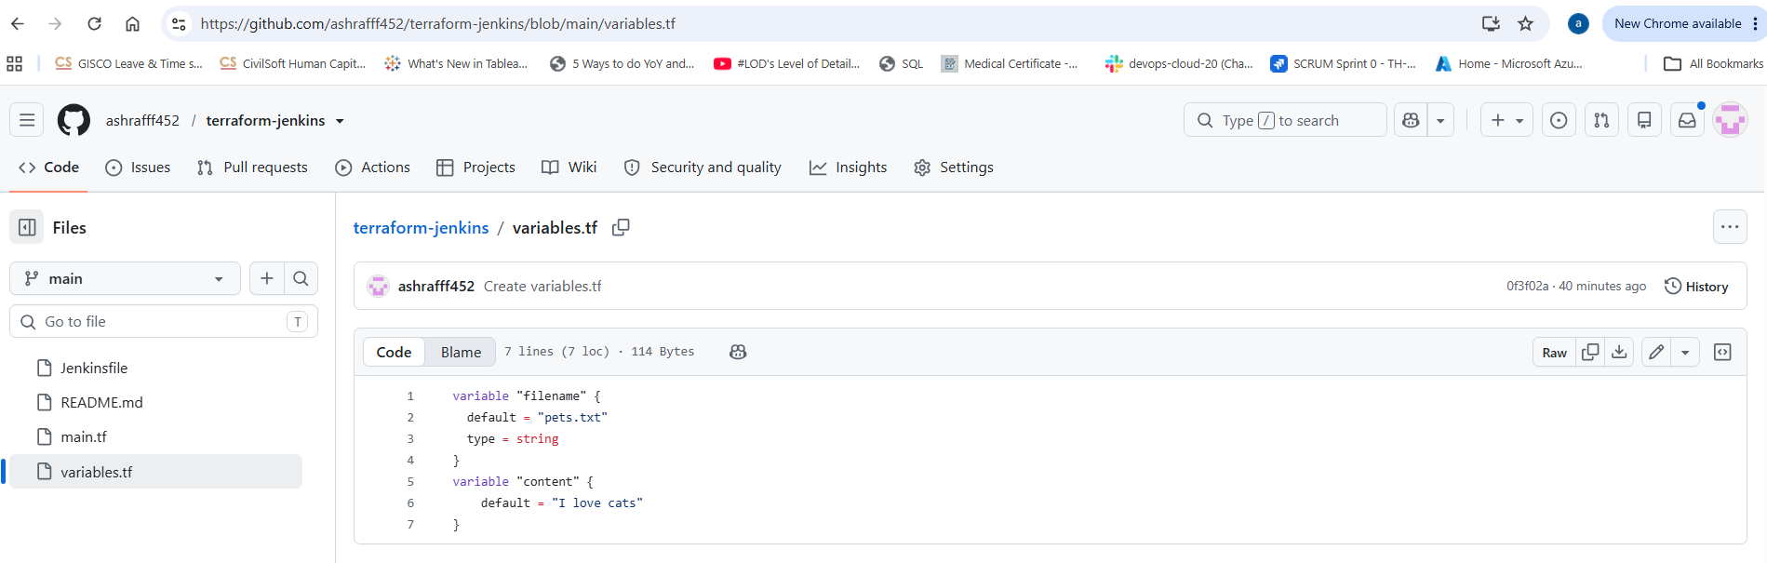

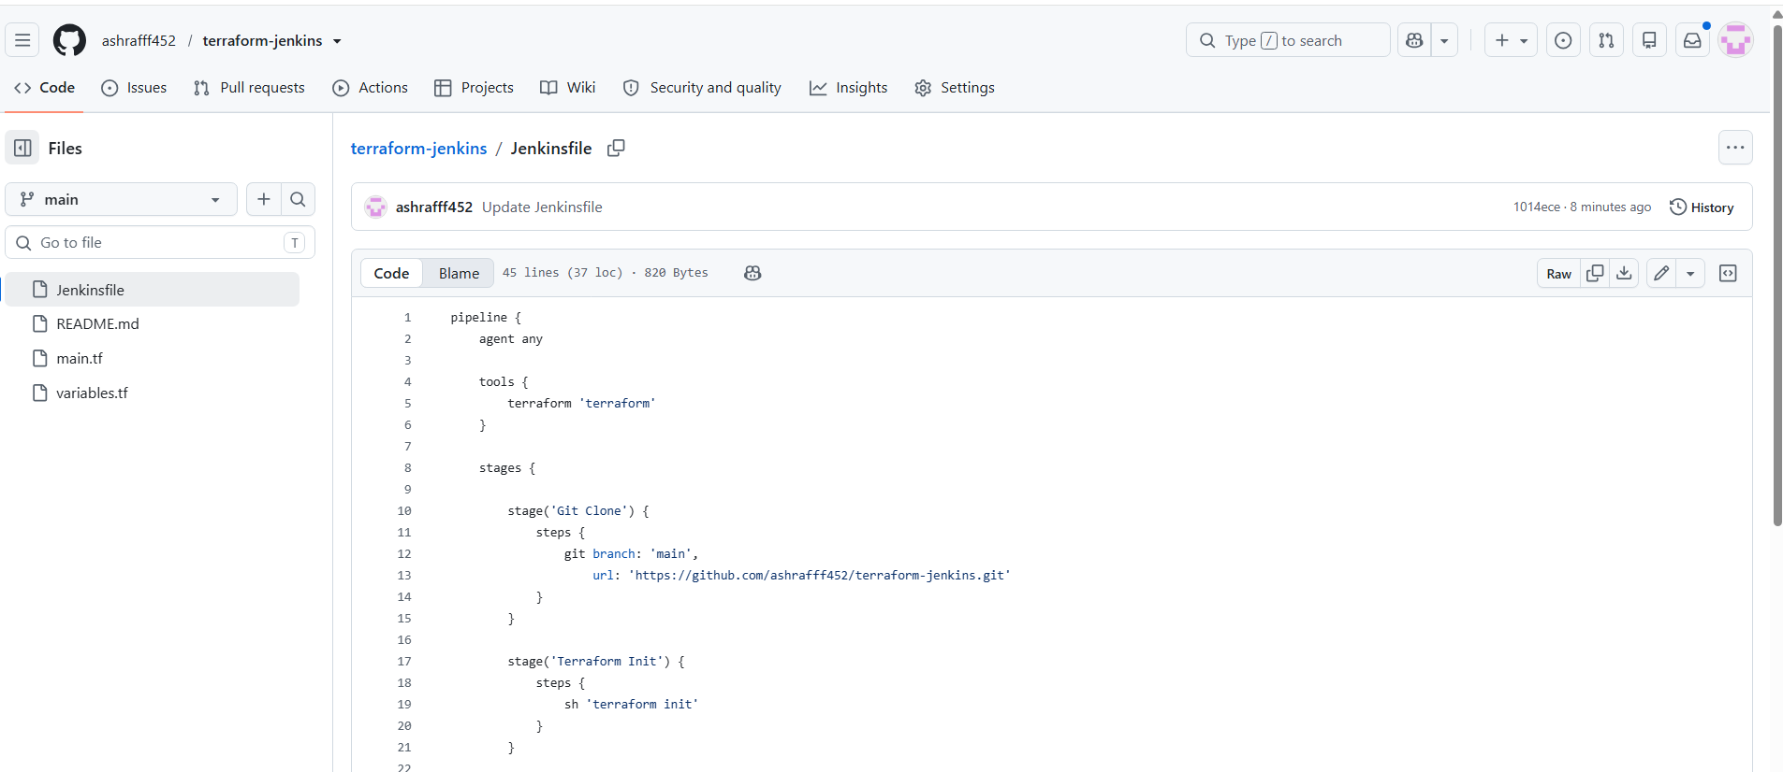

- Now I will use the repo url in Jenkins UI to create a pipeline, terraform_job1 pipeline & in configure of pipeline selected as pipeline script from SCM, SCM as Git & paste the repo Url, https://github.com/ashrafff452/terraform-jenkins.git
- Now save & click Build Now
pipeline {
agent any

tools {
terraform 'terraform'
}

stages {

stage('Git Clone') {
steps {
git branch: 'main',
url: 'https://github.com/ashrafff452/terraform-jenkins.git'
}
}

stage('Terraform Init') {
steps {
sh 'terraform init'
}
}

stage('Terraform Plan') {
steps {
sh 'terraform plan'
}
}

stage('Terraform Apply') {
steps {
sh 'terraform apply -auto-approve'
}
}
}

post {
success {
echo 'Terraform deployment successful'
}

failure {
echo 'Terraform deployment failed'
}
}
}

- Capture the console output to check whether the job is success or failure
- Check the workspace in Jenkins UI once job is success.

