Terraform task – 03
- Execute the script shown in the video.

Created main.tf file as mentioned below:
resource "local_file" "my_pet" {
filename = var.filename
content = var.content
}
resource "random_pet" "petname" {
prefix = var.prefix
separator = "."
length = "1"
}
Now save

Variables.tf:
Created a variables.tf file as below:
variable "filename" {
}
variable "content" {
}
variable "prefix" {
}
& save

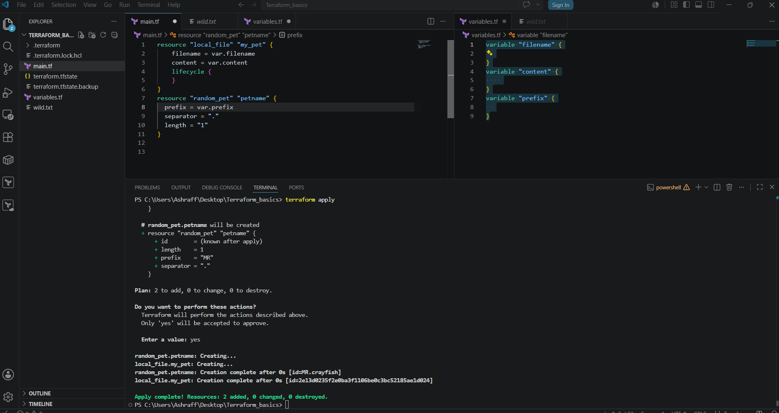

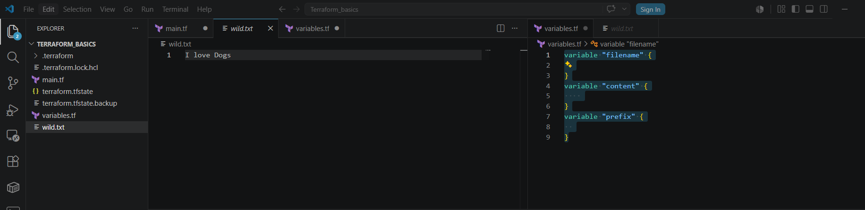

Order precedence:

Before creating the main.tf file & variables.tf file delete the wild.txt, state file & state backup files as well.
Now we create main.tf file as mentioned below:
resource "local_file" "my_pet" {
filename = var.filename
content = var.content
}
resource "random_pet" "petname" {
prefix = var.prefix
separator = "."
length = "1"
}
Now save the file
Now create the variables.tf file as mentioned below:
variable "filename" {
default = "pets.txt"
}
variable "content" {
default = "Hello world"
}
variable "prefix" {
default = "MR"
}
Now save the file.
In run command by using environment variables I will set the filename, content & prefix as below:
Set-Item -Path env:TF_VAR_filename -Value 'wild.txt'
Set-Item -Path env:TF_VAR_content -Value 'I love Dogs'
Set-Item -Path env:TF_VAR_prefix -Value 'MISS'
In run command by using command line flagsI will set the filename, content & prefix as below:
terraform apply -var "filename=CLF.txt" -var "content=CLF" -var "prefix=MR"
We can see that only the command line flags got executed by over riding the variables.tf & environment variables because of the order precedence

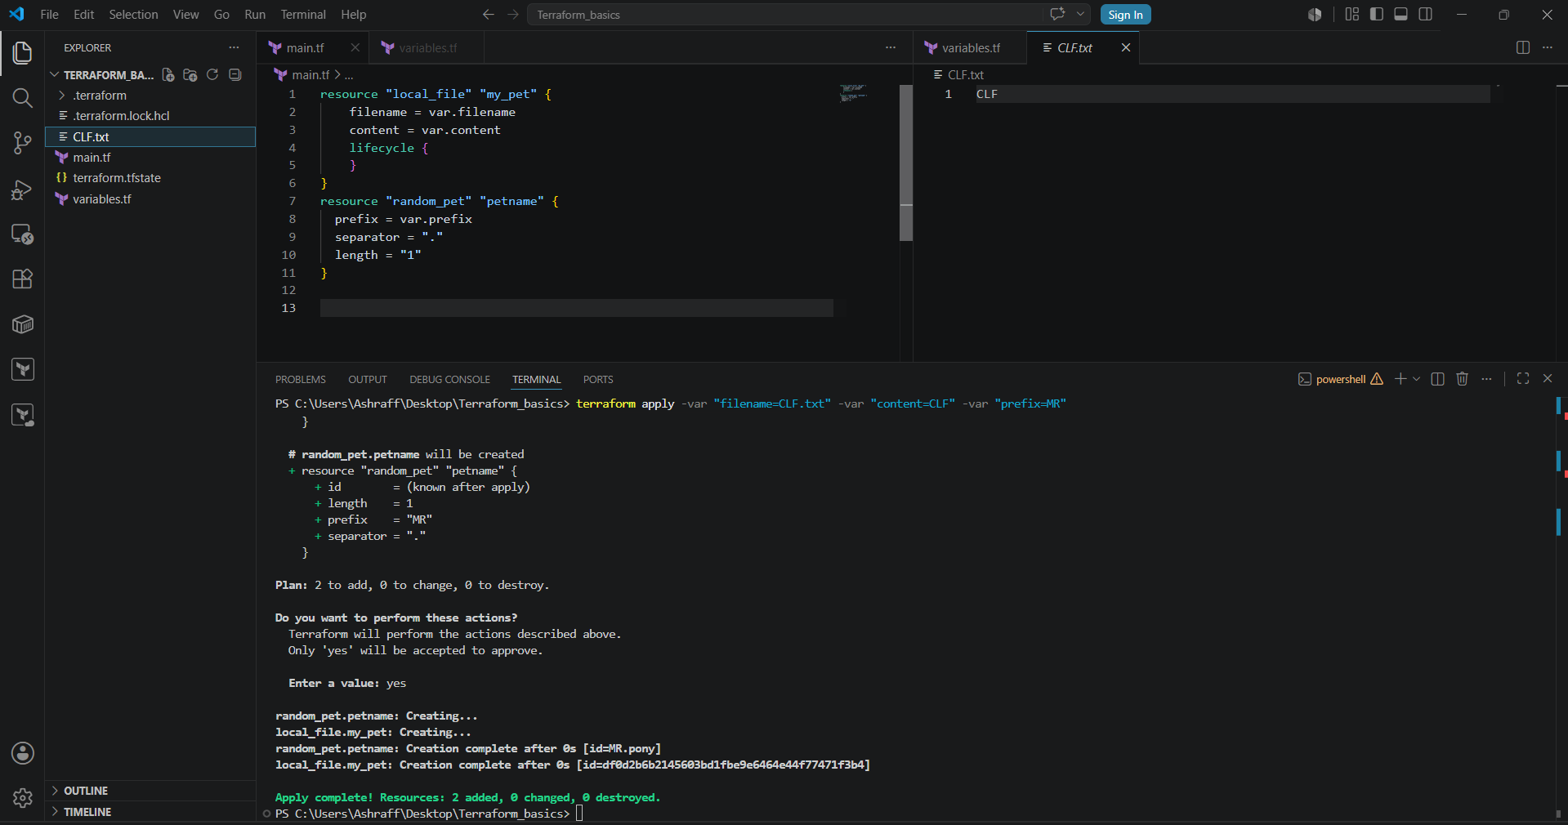

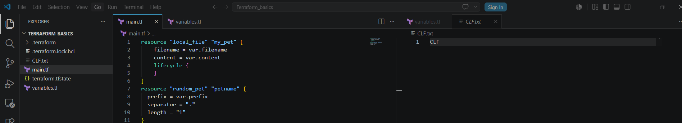

Resource dependencies:

Now delete the variables.tf file & terraform destroy to execute
Now change the main.tf file as mentioned below & save the file
resource "local_file" "my_pet" {
filename = "pets.txt"
content = "My cat name is ${random_pet.petname.id}"
}
resource "random_pet" "petname" {
prefix = "MR"
separator = "."
length = "1"
}
Now we need to capture the random petname generated in random_pet provider in local_file provider
When executed terraform apply we can see that random_pet name is created first & then the pets.txt file got created implicitly by using the random petname in pets.txt

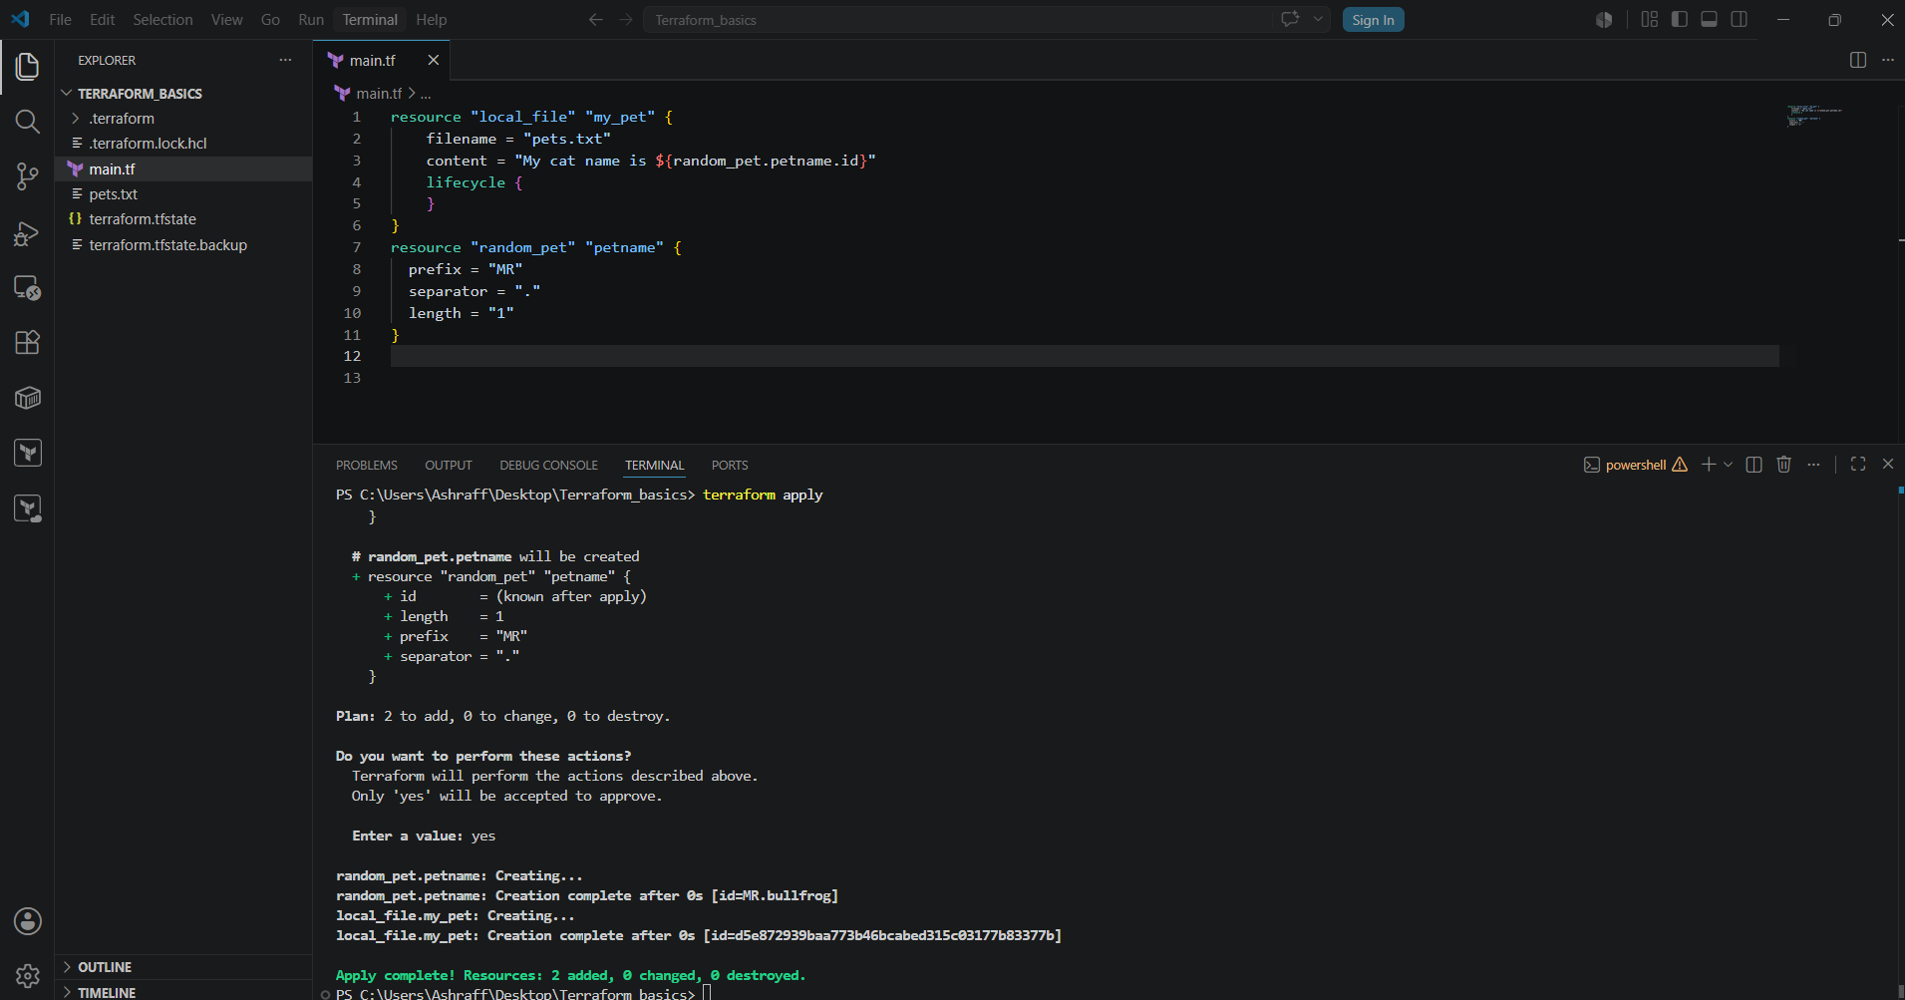

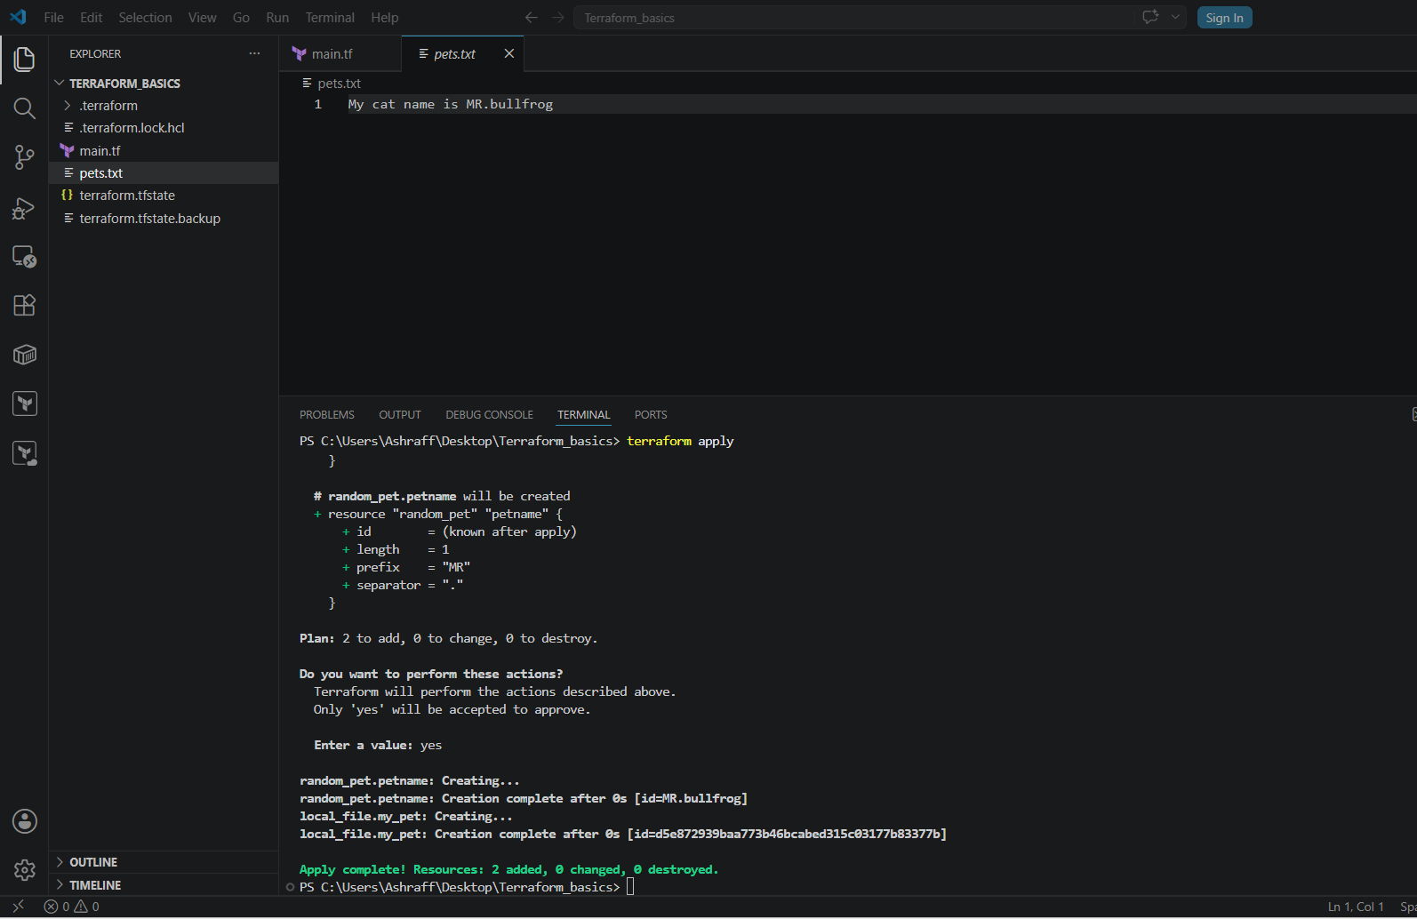

Output variables:
Now change the main.tf file as below & save the file:
resource "local_file" "my_pet" {
filename = "pets.txt"
content = "My cat name is ${random_pet.petname.id}"
}
resource "random_pet" "petname" {
prefix = "MR"
separator = "."
length = "1"
}
output "Petname" {
value = random_pet.petname.id
}
When terraform apply is executed we can see the output as Petname = “MR.bullfrog”
Terraform output while executing displays output as Petname = “MR.bullfrog”
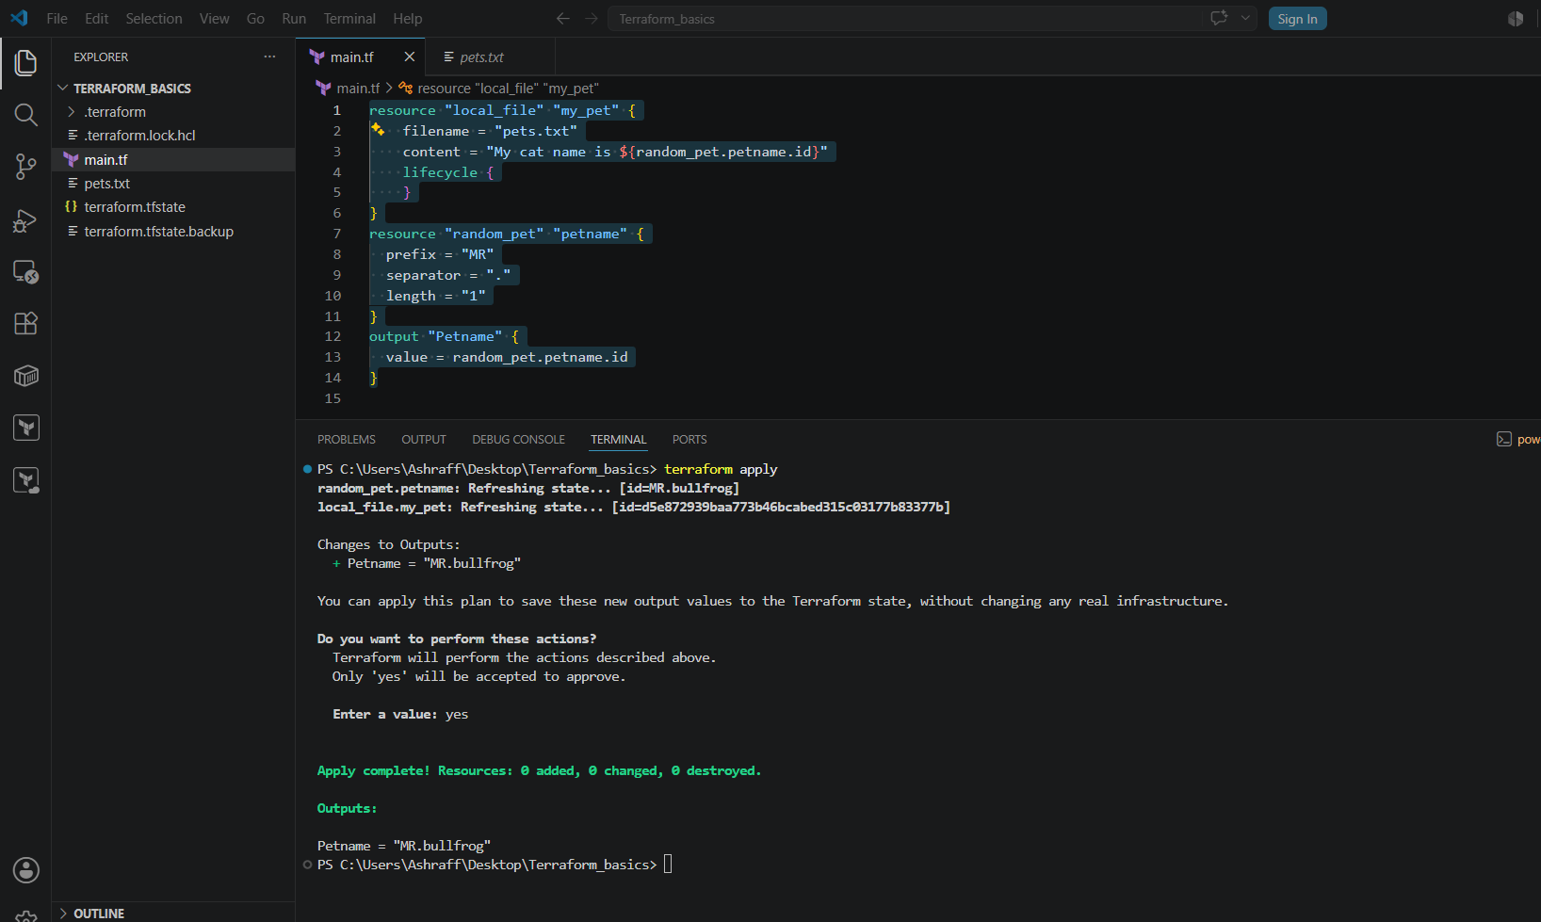
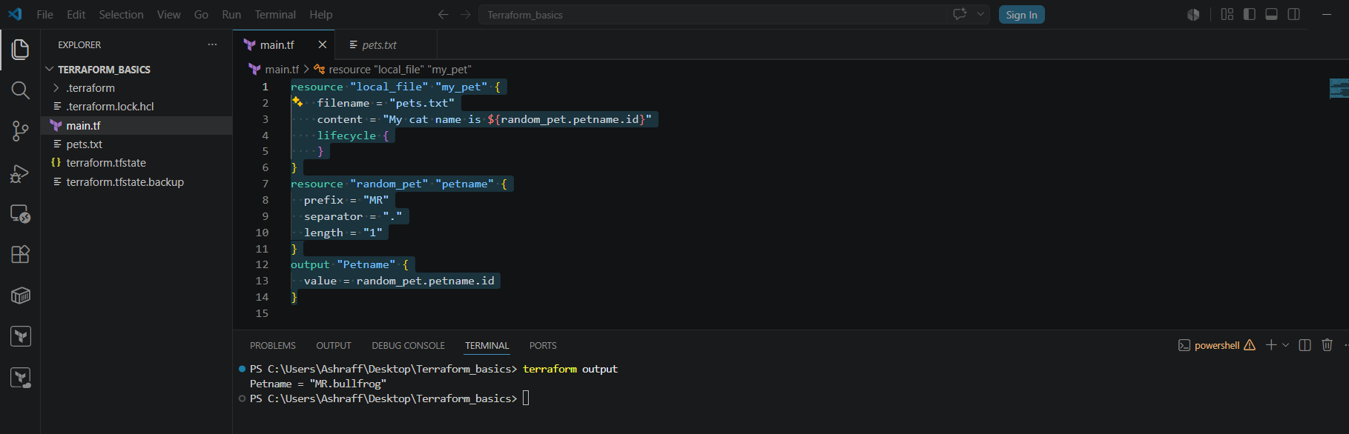
While executing terraform shows will display the statefile current state & complete information of the resources
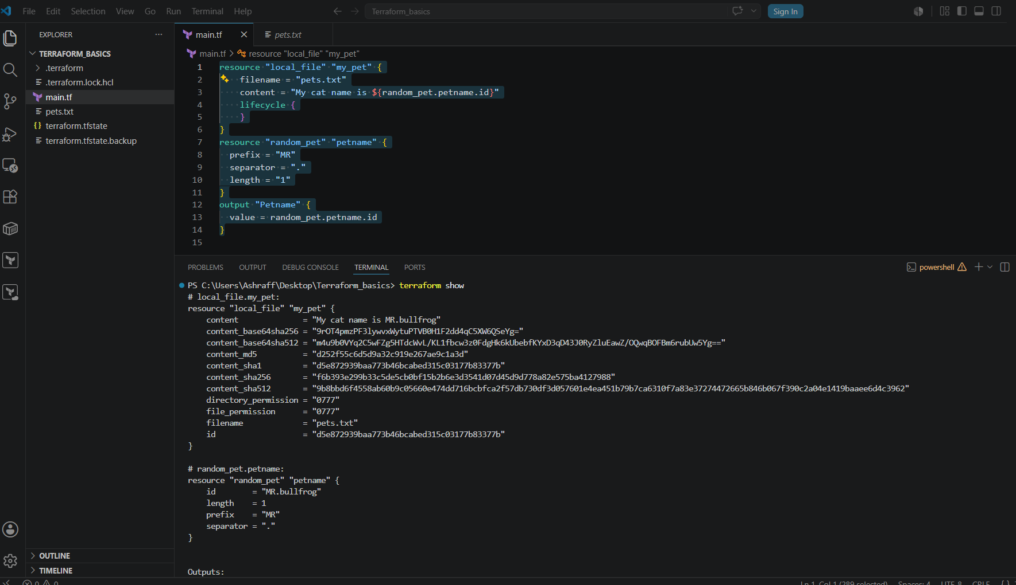

Variable definition file:
Created a main.tf file with below code:
resource "local_file" "my_pet" {
filename = var.filename
content = var.content
}
resource "random_pet" "petname" {
prefix = var.prefix
separator = "."
length = "1"
}

Created a variables.tf file with below code:
variable "filename" {
type = string
}
variable "content" {
type = string
}
variable "prefix" {
type = string
}

Created a terraform.vars file
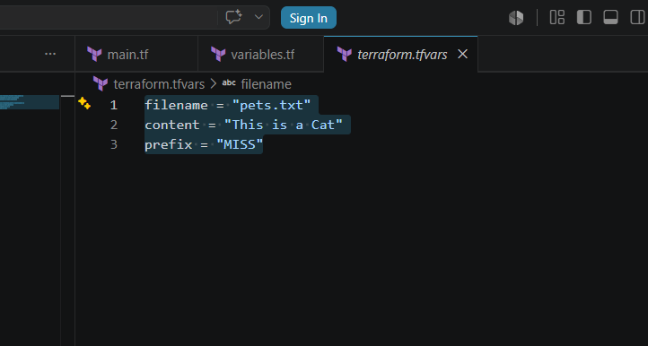

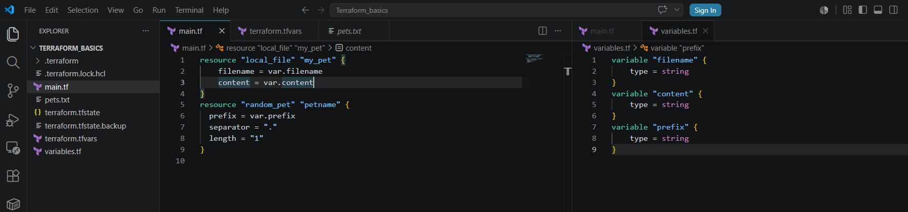
Save the three
Now when terraform apply command is executed we can see the pets.txt file created & random petname got generated.
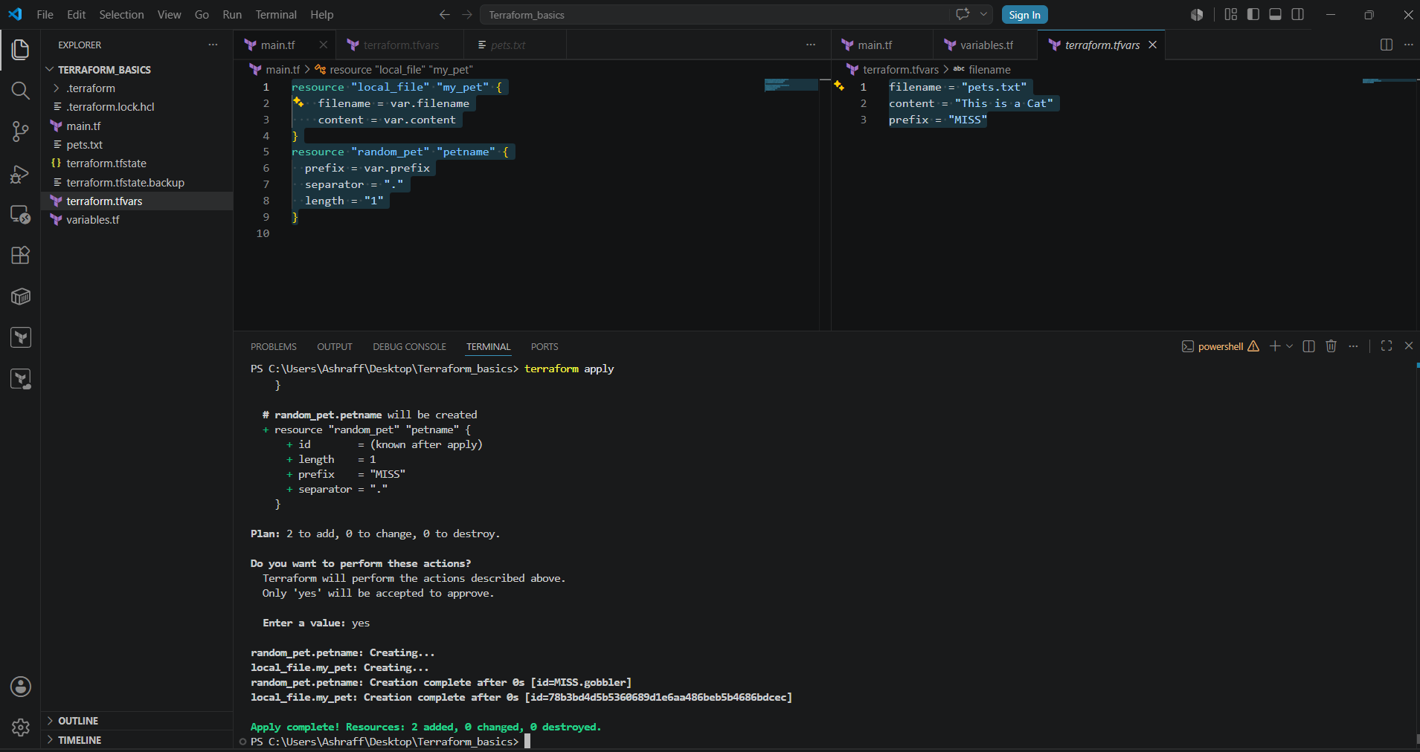

Use case:
Stores values for input variables.
Avoids hardcoding values in Terraform configuration.
Makes it easy to manage different environments
(Development, Testing, Production).
Improves readability and maintainability.

- Integrate Terraform in Jenkins using the Terraform plugin.
Steps:
Integrate Terraform with Jenkins using the Terraform Plugin so Jenkins can:

Clone Terraform code from GitHub
Run terraform init
Run terraform validate
Run terraform plan
Run terraform apply
(Optional) Run terraform destroy
Prerequisites
Jenkins installed
Terraform installed on Jenkins server
AWS CLI installed
Git plugin installed
Pipeline plugin installed
Terraform Plugin installed
AWS credentials configured
GitHub repository containing Terraform code
Steps:
- Created an ec2 instance, My-ec2-jenkins with Jenkins & terraform installed.
- Connect to Jenkins UI, with IPv4:8081
- Install Terraform Plugin
    - Login to Jenkins
    - Navigate to: Manage Jenkins
    - PluginsAvailable Plugins

    - Search for:
    - Terraform
  - Disable instant automatically
  - As I have installed terraform in my-ec2-jenkins instance mentioned the path of terraform as /usr/bin & save.
  - Created a sample freestyle job, terraform_job with build in steps using shell script to execute terraform –version & save & click Build Now
  - The job is successful & in console output I can see the terraform version matching with the My-ec2-jenkins terraform version.

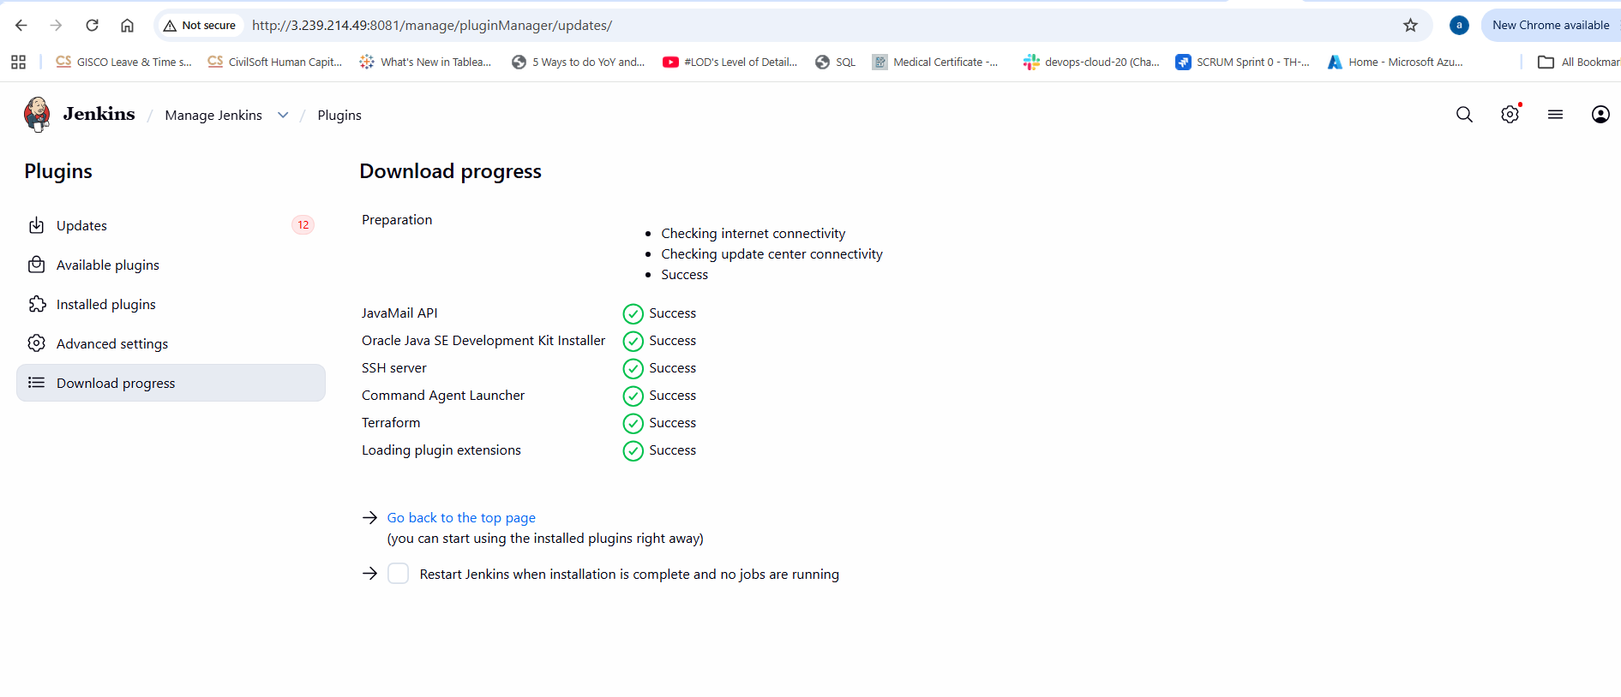
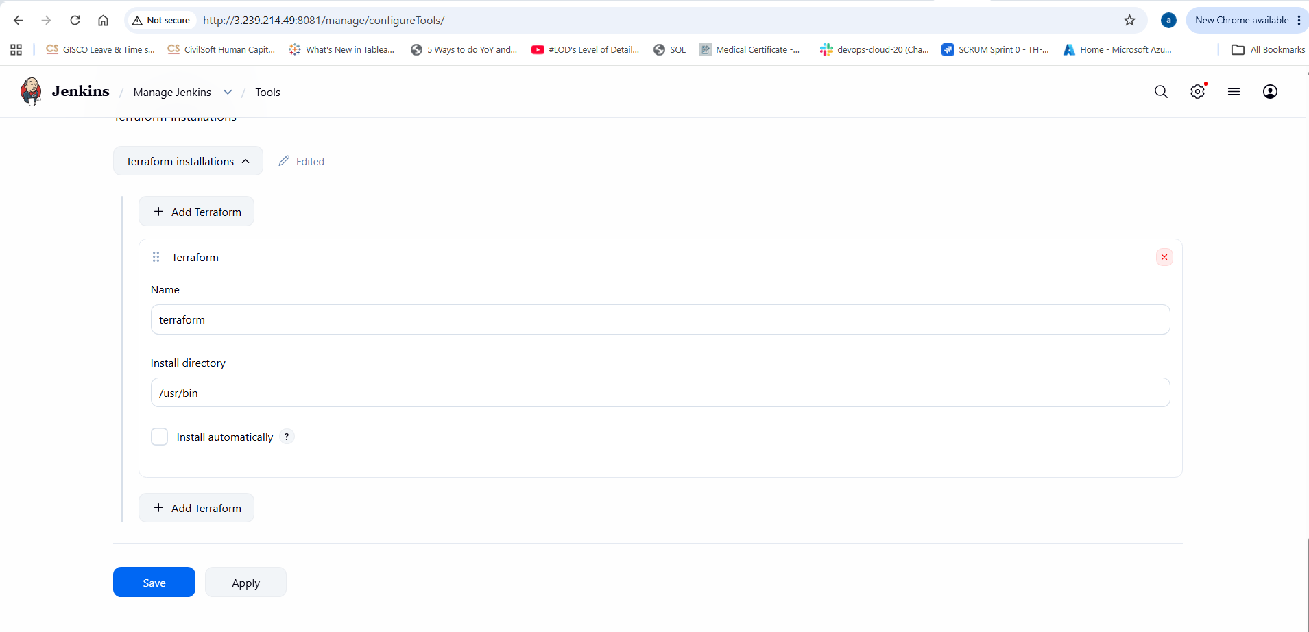
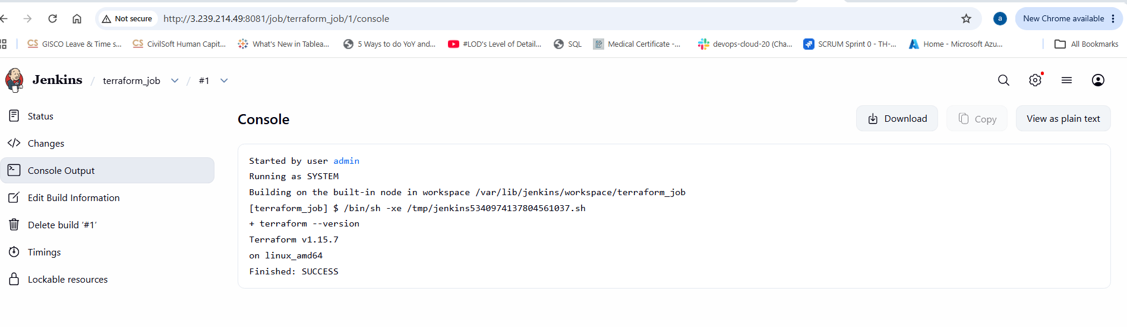
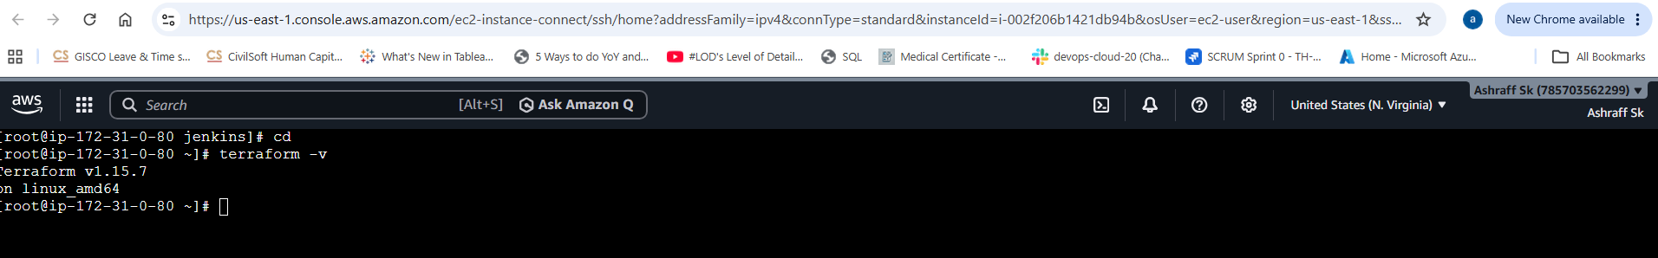
- Now created a central repo, terraform-jenkins in Github with the main.tf , variables.tf, output.tf & Jenkinsfile
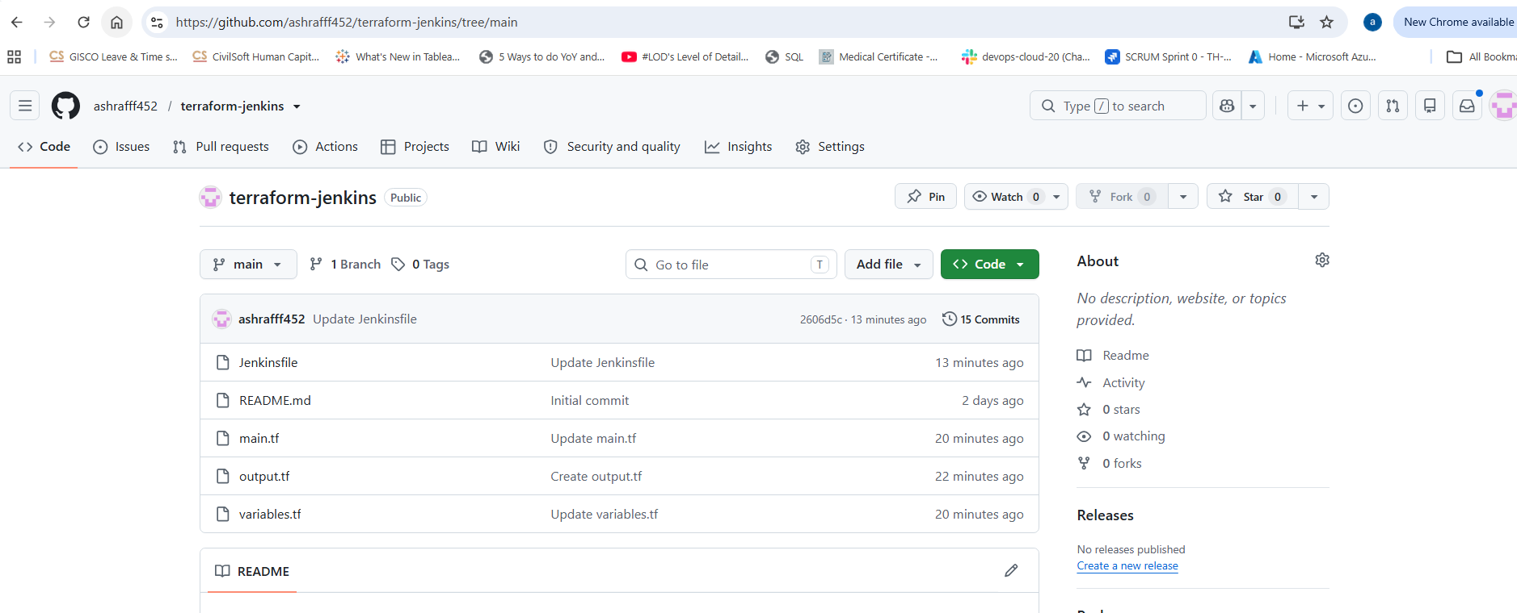
Main.tf
resource "local_file" "my_pet" {
filename = var.filename
content = "My cat name is ${random_pet.petname.id}|"
}
resource "random_pet" "petname" {
prefix = "MR"
separator = "."
length = "1"
}
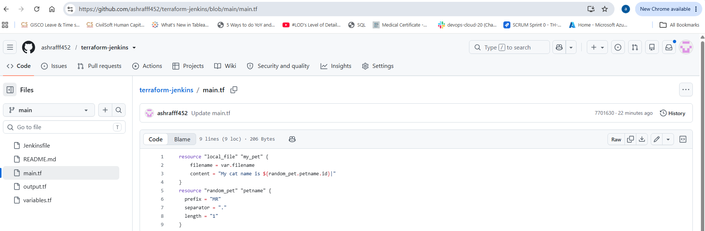
Variables.tf
variable "filename" {
default = "pets.txt"
type = string
}
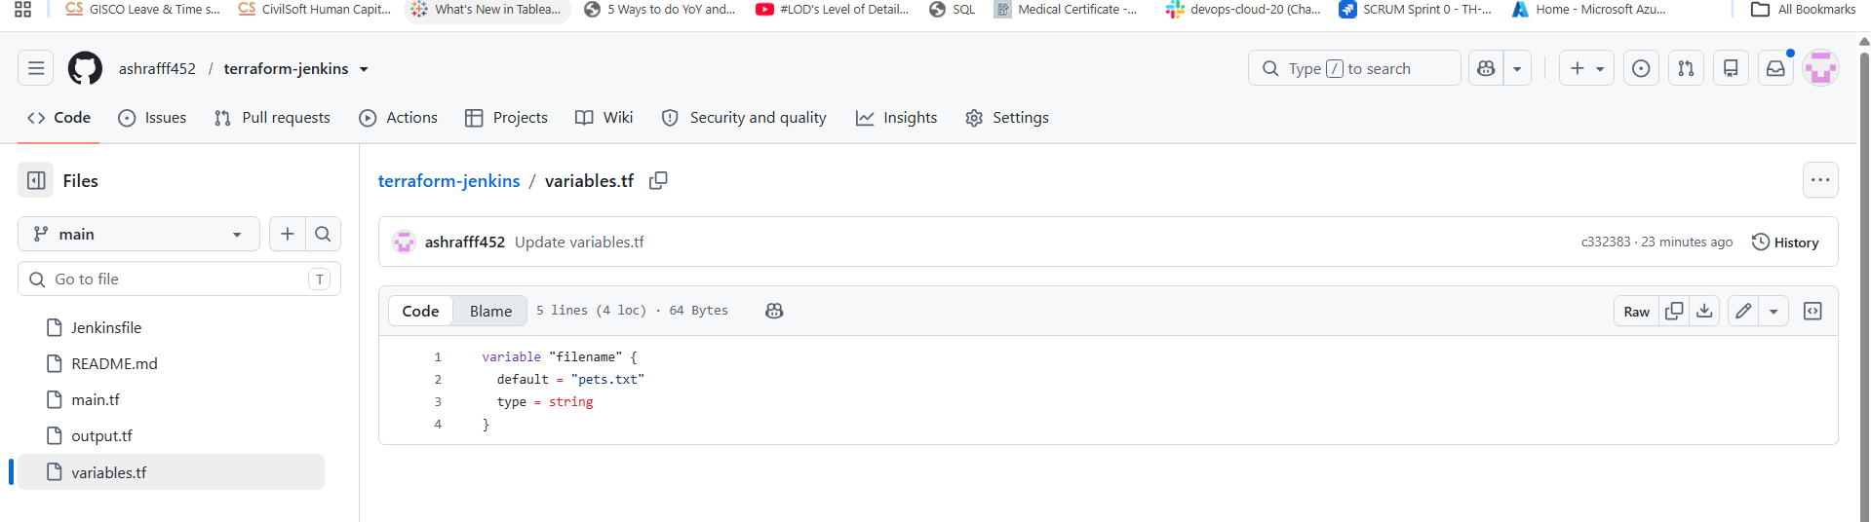
Output.tf
output "Petname" {
value = random_pet.petname.id
}
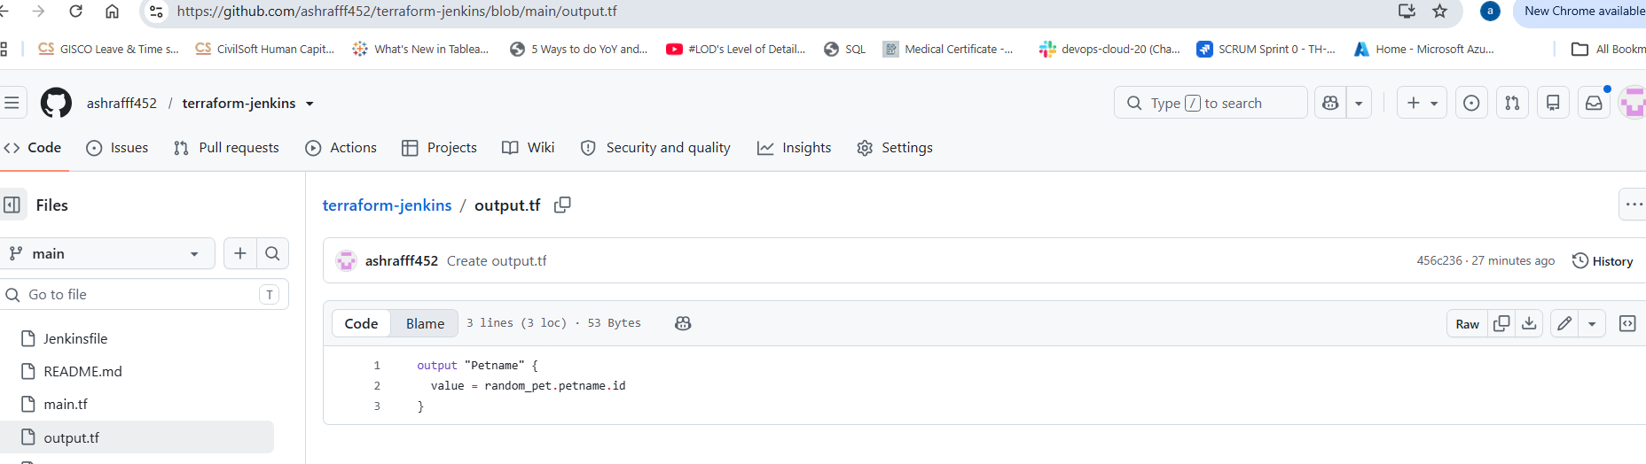
Jenkinsfile
pipeline {
agent any

tools {
terraform 'terraform'
}

stages {

stage('Git Clone') {
steps {
git branch: 'main',
url: 'https://github.com/ashrafff452/terraform-jenkins.git'
}
}

stage('Terraform Init') {
steps {
sh 'terraform init'
}
}

stage('Terraform Plan') {
steps {
sh 'terraform plan'
}
}

stage('Terraform Apply') {
steps {
sh 'terraform apply -auto-approve'
}
}
stage('Terraform Output') {
steps {
sh 'terraform output'
}
}
}

post {
success {
echo 'Terraform deployment successful'
}

failure {
echo 'Terraform deployment failed'
}
}
}
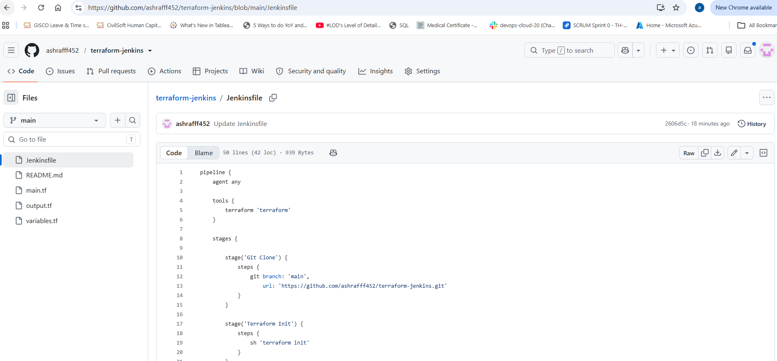
- Now I will use the repo url in Jenkins UI to create a pipeline, terraform_job1 pipeline & in configure of pipeline selected as pipeline script from SCM, SCM as Git & paste the repo Url, https://github.com/ashrafff452/terraform-jenkins.git
- Capture the console output to check whether the job is success or failure
- Check the workspace in Jenkins UI once job is success.
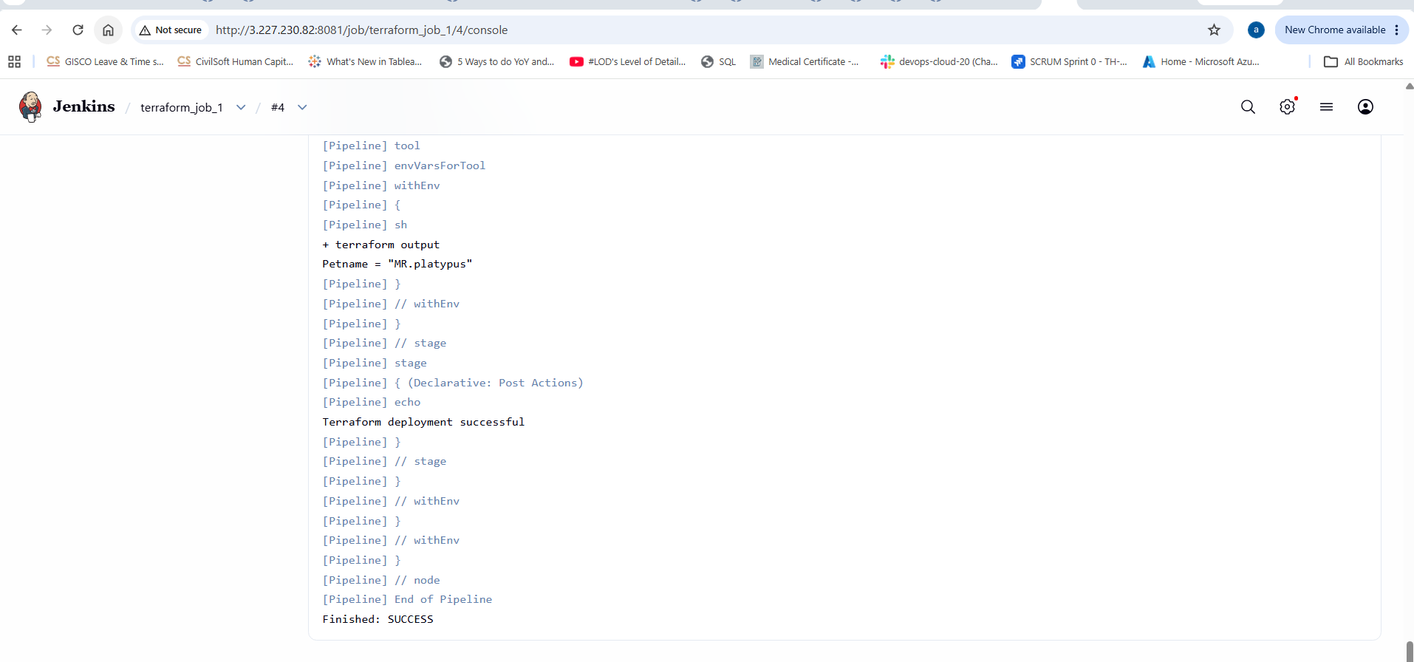
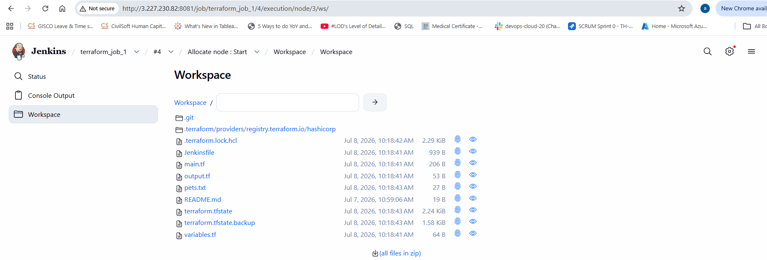
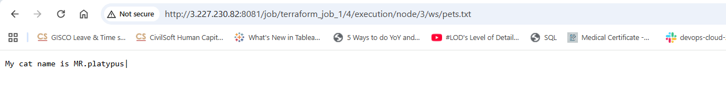
- Create one Jenkins job using Maven Project for the code below with two stages:
Stage 1:Git clone
Stage 2:Maven Compilation Code:https://github.com/betawins/java-Working-app.git

Steps:
- Connect to My-ec2-jenkins instance with Jenkins installed in it
- Maven configured & integrated in Jenkins GUI
- Connect to the Jenkins with publicIPv4:8081
- Login with the credentials & create a pipeline job, maven_job & write the below code:
pipeline {
agent any
tools {
maven 'MVN_HOME'
}
stages {
stage('Git clone') {
steps {
git branch: 'main',
url: 'https://github.com/betawins/java-Working-app.git'
}
}
stage('Maven compilation') {
steps {
sh 'mvn clean compile'
}
}
}
}
- Save the code & build now
- Capture the console output & check the workspace once the job is success
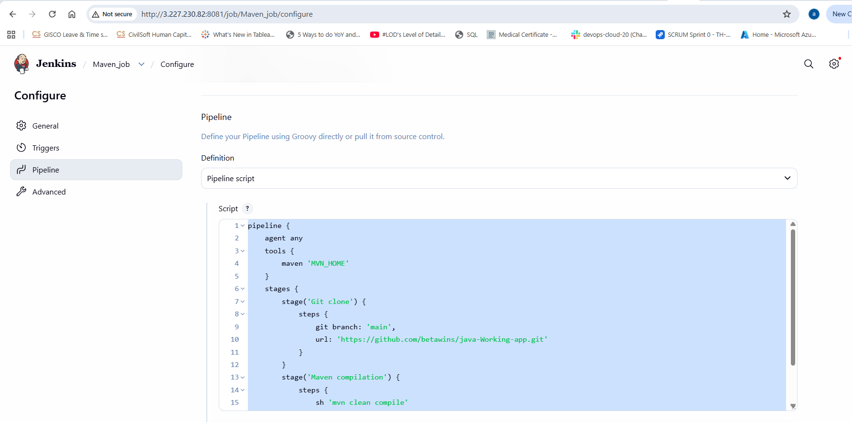
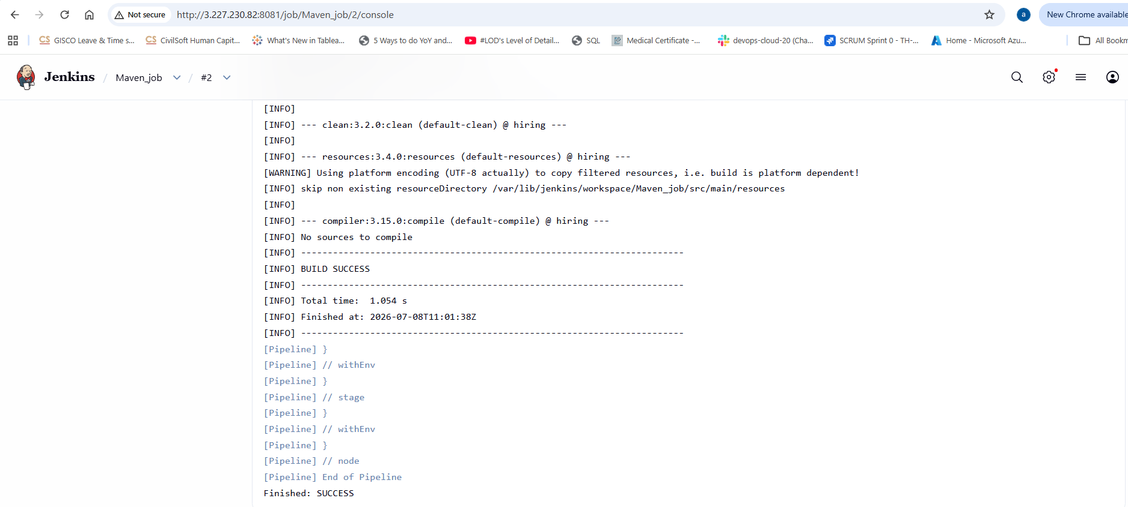
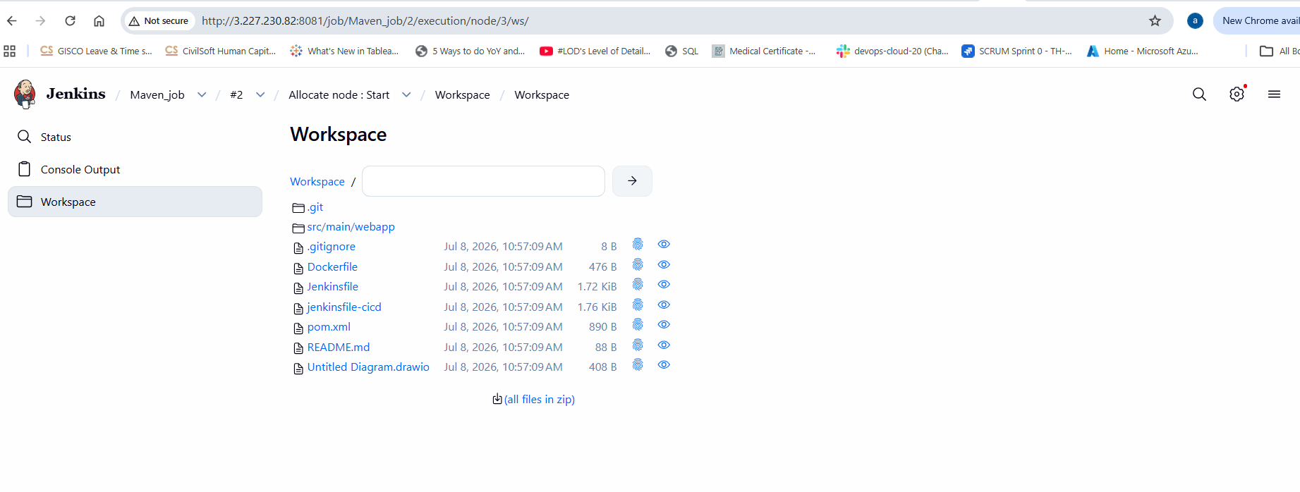
- Use the same code and create a parameterized job in Jenkins with:
Stage 1:Git clone
Stage 2:Maven CompilationCode:https://github.com/betawins/java-Working-app.git
Objective:
Create a Parameterized Maven Project in Jenkins that allows users to specify the Git branch at build time. The job performs:
- Stage 1: Git Clone
- Stage 2: Maven Compilation
Prerequisites:
Jenkins installed
Git installed
Java (JDK 21 or above)
Maven installed
Maven configured in Jenkins (e.g., MVN_HOME)
Steps:
- Created a pipeline Paramaterized_job in Jenkins UI
- In configureGeneral created a parameter, branch with default value as main with some description
- In pipeline created the below code:
pipeline {
agent any
tools {
maven 'MVN_HOME'
}
stages {
stage('Git clone') {
steps {
git branch: 'main',
url: 'https://github.com/betawins/java-Working-app.git'
}
}
stage('Maven compilation') {
steps {
sh 'mvn clean compile'
}
}
}
}
- Now save & Build Now & it will ask to build with parameters & select the branch & click build
- We can see whether job is successful or not in the console output.
- Once the job is success we can check the workspace

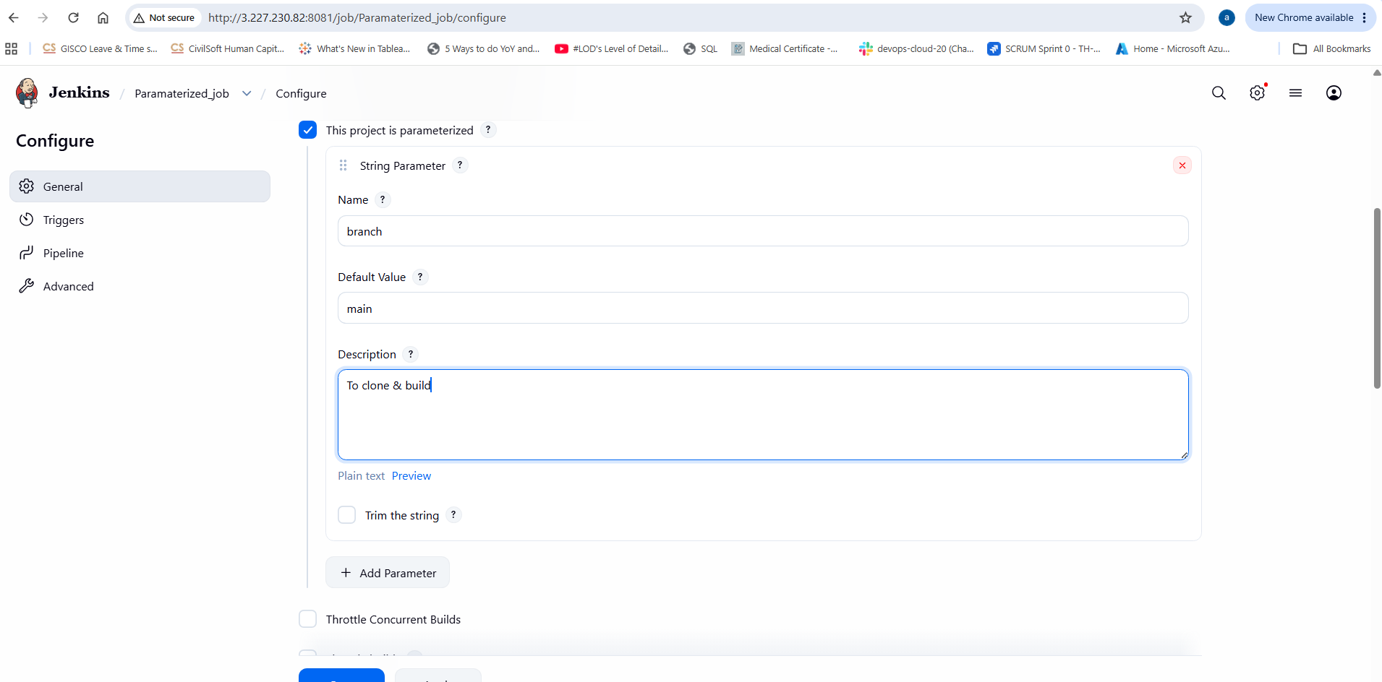
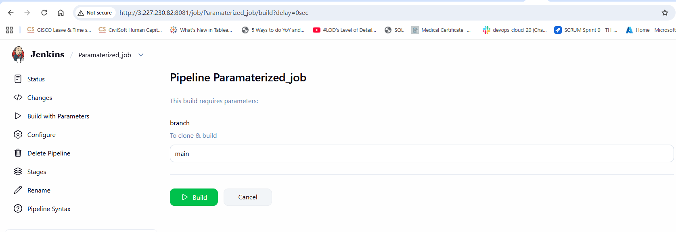
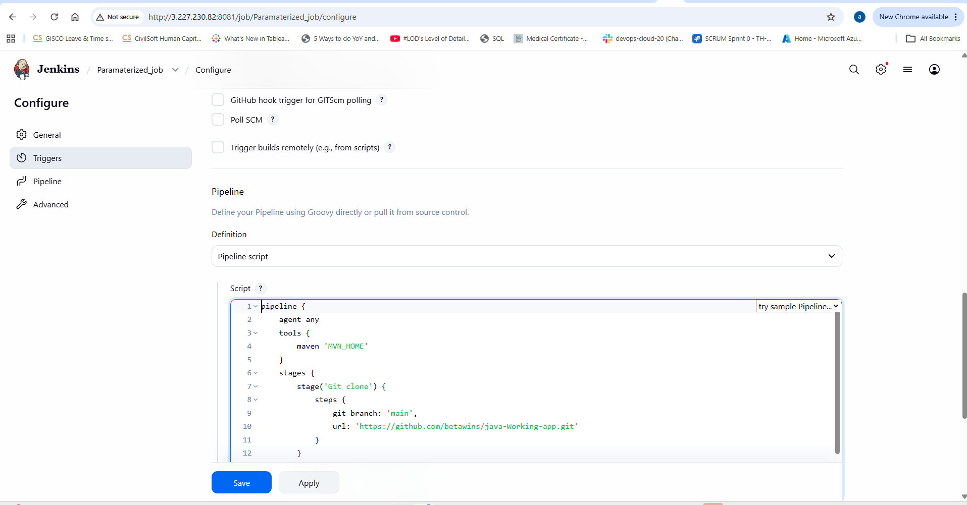

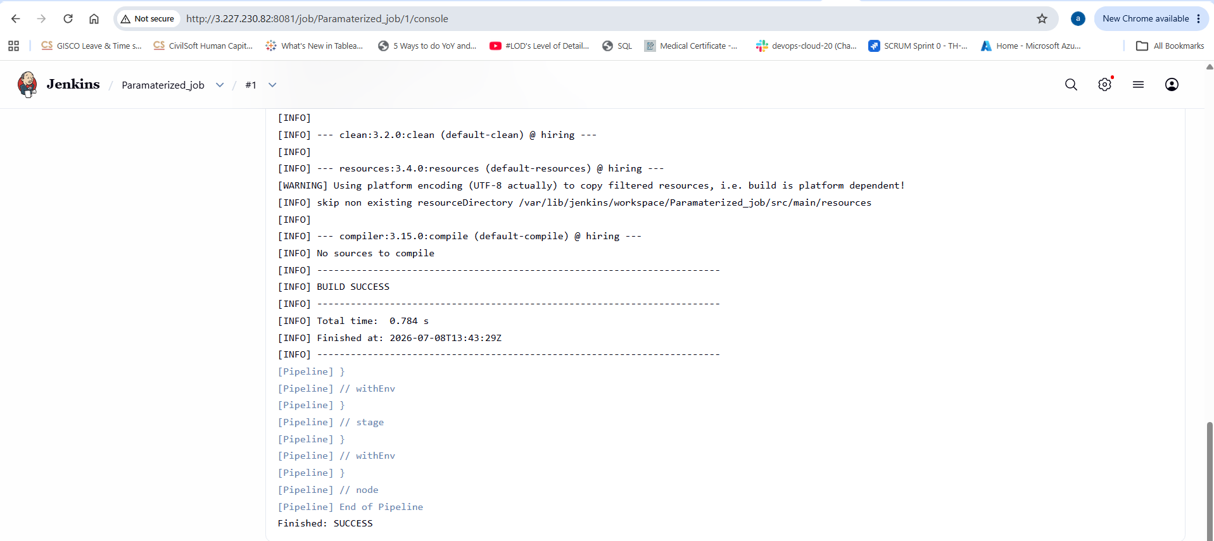

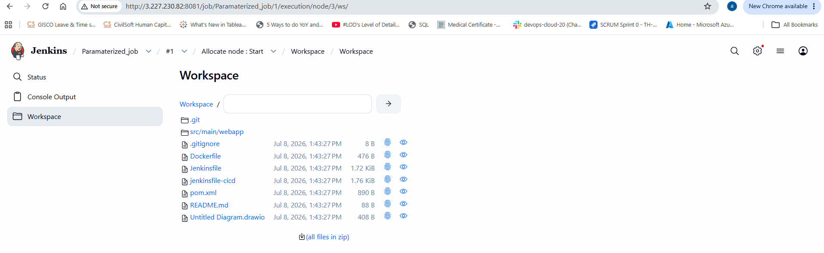

Use Case:
This parameterized job allows developers to build different branches (such as main, develop, or feature/login) without modifying the Jenkins job configuration. It is useful for testing feature branches before merging them.
Conclusion:
We have successfully created a Parameterized Jenkins Maven Project that:
- Accepts a Git branch name as a parameter.
- Stage 1: Clones the selected branch from GitHub.
- Stage 2: Compiles the Java application using Maven (clean compile).
- Can be reused for multiple branches, making it flexible for CI/CD workflows.

- What are the global variables in Jenkins?

Global variables in Jenkins are predefined environment variables that are automatically available during a build or pipeline. They provide information about the job, build, workspace, Jenkins server, and Git repository, allowing you to write dynamic pipelines without hardcoding values.

In a Declarative Pipeline, they are typically accessed using:
env.VARIABLE_NAME
or simply:
"${VARIABLE_NAME}"

Variable | Description | Example Value
BUILD_NUMBER | Current build number | 25
BUILD_ID | Unique build ID | 25
BUILD_TAG | Unique build tag | jenkins-demo-25
JOB_NAME | Name of the Jenkins job | Java-Build
JOB_BASE_NAME | Job name without folder | Java-Build
BUILD_URL | URL of the current build | http://jenkins:8080/job/demo/25/
JOB_URL | URL of the Jenkins job | http://jenkins:8080/job/demo/
WORKSPACE | Workspace directory | /var/lib/jenkins/workspace/demo
JENKINS_HOME | Jenkins home directory | /var/lib/jenkins
NODE_NAME | Name of the agent/node | Master
NODE_LABELS | Labels assigned to the node | linux docker
EXECUTOR_NUMBER | Executor number running the build | 0
BUILD_RESULT | Result of the build | SUCCESS
GIT_BRANCH | Git branch name | Main
GIT_COMMIT | Commit SHA | a1b2c3d4
GIT_URL | Git repository URL | https://github.com/example/repo.git

