PRACTICAL LAB: JAVASCRIPT OPERATORS MASTERY
Course: DFK20013 Web Design Technology
Topic: 3.1.1 Variables, Data Types, and Operators
Duration: 60 – 90 Minutes
Student Name | Muhammad Ashraff Hakimi bin Abdullah
Registration No | 10DIT25F1101
Date | 3/3/2026

1. Learning Outcomes
By the end of this lab, students should be able to:
- Implement Arithmetic Operators for calculations.
- Use Assignment Operators to update values efficiently.
- Control application states using Increment/Decrement.
- Validate user access using Relational and Logical operators.

2. Practical Task: The All-in-One Operator Workshop
Create a file named lab_operators.html. Copy and complete the coding below.
HTML
<!DOCTYPE html>
<html lang="en">
<head>
<meta charset="UTF-8">
<title>DFK20013: JS Operators Workshop</title>
<style>
body { font-family: 'Segoe UI', sans-serif; max-width: 850px; margin: 2rem auto; background-color: #f0f2f5; padding: 20px; color: #333; }
section { background: white; padding: 25px; border-radius: 12px; margin-bottom: 25px; box-shadow: 0 4px 6px rgba(0,0,0,0.1); }
h2 { color: #2c3e50; border-left: 5px solid #3498db; padding-left: 10px; margin-top: 0; }
.output-box { background: #2c3e50; color: #27ae60; padding: 15px; border-radius: 6px; font-family: 'Courier New', monospace; margin-top: 10px; }
.short-note { background: #fff3cd; color: #856404; padding: 15px; border-radius: 6px; margin-top: 15px; border-left: 5px solid #ffc107; display: none; font-size: 0.9rem; }
input { padding: 8px; width: 100px; border-radius: 4px; border: 1px solid #ccc; }
button { padding: 8px 20px; background: #3498db; color: white; border: none; border-radius: 4px; cursor: pointer; font-weight: bold; }
button:hover { background: #2980b9; }
code { background: #eee; padding: 2px 4px; border-radius: 3px; font-weight: bold; color: #d63384; }
</style>
</head>
<body>

<header style="text-align: center; margin-bottom: 30px;">
<h1>JavaScript Operators Mastery</h1>
<p>Follow the steps and observe the Console and UI outputs.</p>
</header>

<section>
<h2>Task 1: Basic Arithmetic (Check Console)</h2>
<p>This task demonstrates background calculations using <code>+</code>, <code>-</code>, <code>*</code>, <code>/</code>, <code>**</code>, and <code>%</code>.</p>
<button onclick="runTask1()">Run Console Logic</button>
</section>

<section>
<h2>Task 2: POS System (Arithmetic & Assignment)</h2>
<p>Price: RM 50.00. <strong>Promo:</strong> Buy > 4 units to get RM 20.00 discount.</p>
Quantity: <input type="number" id="qty" value="1">
<button onclick="runTask2()">Calculate Total</button>
<div id="outPOS" class="output-box">Final Total: RM 0.00</div>
<div id="notePOS" class="short-note"></div>
</section>

<section>
<h2>Task 3: Stock Control (Increment & Decrement)</h2>
<p>Simulating inventory updates.</p>
Stock Level: <span id="stockVal" style="font-size: 1.5rem; font-weight: bold;">10</span><br><br>
<button onclick="runTask3('inc')">Add (+)</button>
<button onclick="runTask3('dec')" style="background:#6c757d;">Remove (-)</button>
<div id="noteStock" class="short-note"></div>
</section>

<section>
<h2>Task 4: Gate Access (Relational & Logical)</h2>
<p>Rules: Age 18+ OR (Age 13+ AND Parent present).</p>
Age: <input type="number" id="age" placeholder="Age">
<label><input type="checkbox" id="parent"> With Parent?</label><br><br>
<button onclick="runTask4()" style="background:#27ae60;">Verify Entry</button>
<div id="outSecurity" class="output-box">Status: Waiting...</div>
<div id="noteSecurity" class="short-note"></div>
</section>

Inside the <script> tag, type all the following code:
JAVASCRIPT:
1. | 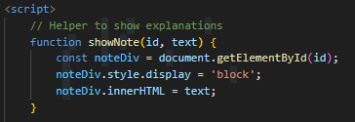
2. | 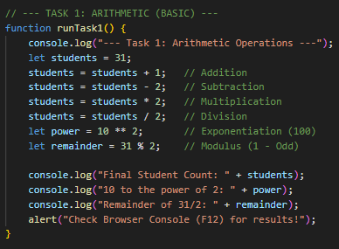
3. | 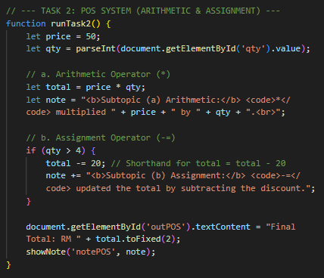
4. | 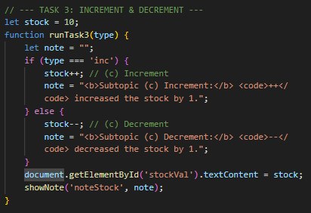
5. | 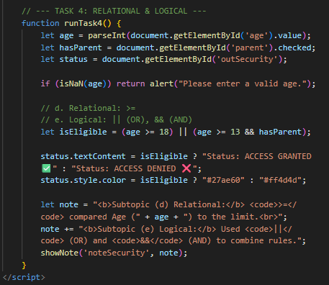

Capture a screenshot of the output from the previous steps. Observe the results and explain your understanding of the process.
1. | Screenshot of the output  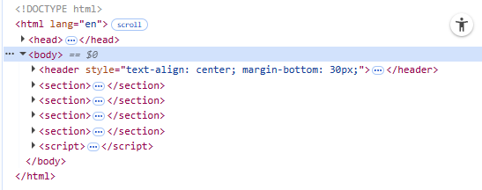
Explanation
Console doesn’t work

2. | Screenshot of the output  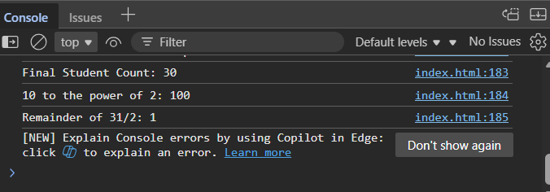
Explanation
This task demonstrates how javascript handle mathematical calculations.

3. | Screenshot of the output  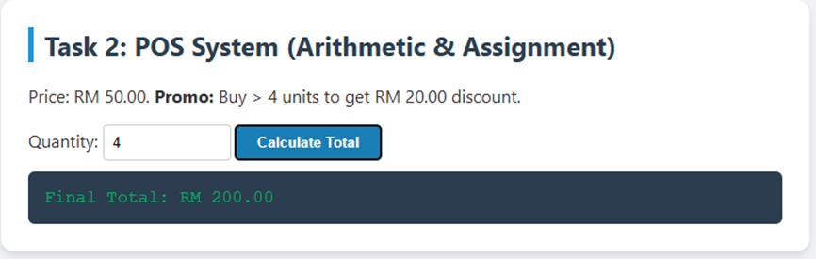  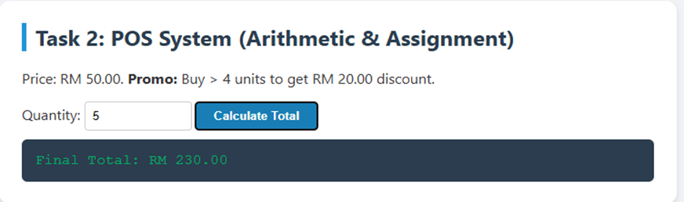
Explanation
This section calculate the total, if buy more than 4 items it will minus RM20.00 from the total

4. | Screenshot of the output  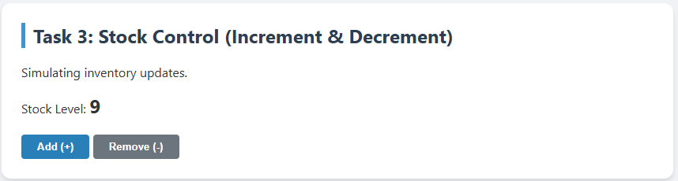  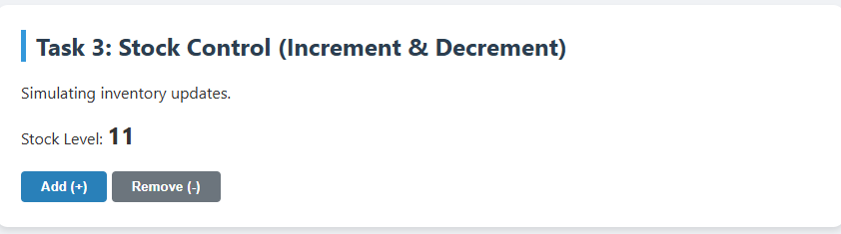
Explanation
This task simulate operators to a real world

5. | Screenshot of the output  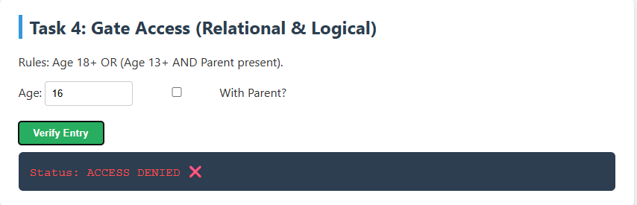  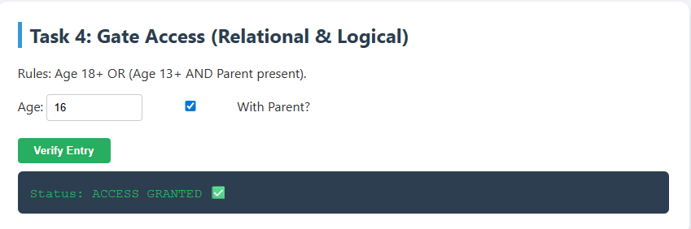  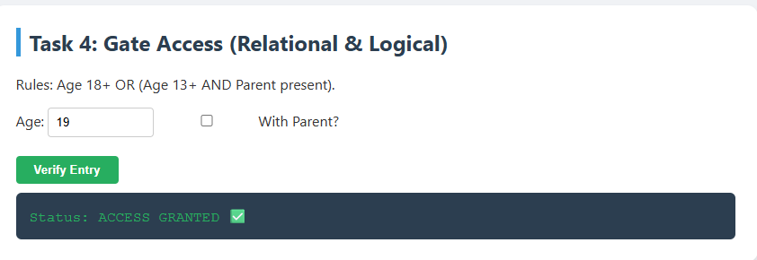
Explanation
If the age is 16 with no parent it will be denied, but if with parent it will be granted, if 18 years old and more in will be granted even with parent or not.

3. Quick Check (Reflection)
Instruction: Answer the following questions based on your coding results.
- Modulus Utility: Based on Task 1, if students % 2 returns 0, is the number even or odd?
- Shorthand Power: In Task 2, rewrite total -= 20 using the standard assignment method.
- Logical Priority: In Task 4, why did we put (age >= 13 && hasParent) in parentheses?
- Time Calculation: (Extra Challenge) If a variable totalMinutes = 130, write the formula to find the remaining minutes after converting to hours using the Modulus operator.

