LAB ACTIVITY 3 – PART 1: THE DATA FOUNDATION
Topic: 3.1.1 JavaScript Variables, Data Types, and Operators
Duration: 45–60 Minutes
Student Name | Muhammad Ashraff Hakimi bin Abdullah
Registration No | 10DIT25F1101
Date | 26/2/2026

1. Learning Outcomes
By the end of this session, you should be able to:
- Declare variables using let and const appropriately.
- Identify different JavaScript data types (String, Number, Boolean, Array).
- Perform calculations using Arithmetic and Assignment operators.
- Display data using console.log() and alert().

2. Part A: Theory (The Building Blocks)
Concept | Description | Example
Variables | Containers for storing data values. | let price = 10;
Strings | Textual data wrapped in quotes. | "Hello World"
Numbers | Numerical data (integers or decimals). | 25 or 3.14
Booleans | Logical values: True or False. | isLoggedIn = true;
Operators | Symbols used to perform operations. | +, -, *, /, %

3. Part B: Practical Step-by-Step

Step 1: Variable Declaration & Setup
Goal: Set up the file structure and define basic variables.
- Create a folder named RegNo_Lab3_Part1.
- Create an index.html file.
- Inside the <body>, insert the Header and the first Lab Card:
HTML
<header>
<h1>Lab 3.1.1: JavaScript Fundamentals</h1>
<p>Variables, Data Types, and Operators</p>
</header>

<section class="lab-card">
<h2>Steps 1 - 3: Logic & Console</h2>
<div class="instruction">
Open the <strong>Browser Console</strong> (F12 > Console) to see the output for variables and <code>typeof</code> checks.
</div>
<button onclick="runConsoleTasks()">Run Console Tasks</button>
<p class="note">*This logs Course Name, Student Count, and Data Types.</p>
</section>
- Inside the <script> tag, define the first function covering Steps 1, 2, and 3:
JavaScript
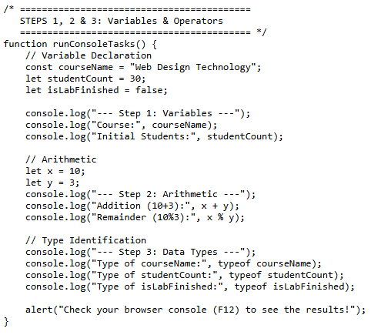

- Capture a screenshot of the output from the previous steps. Observe the results and explain your understanding of the process.
Screenshot of the output
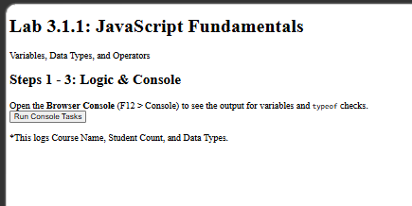

Explanation
when you press run console tasks, will be appear (Check your browser console (F12) to see the results!)

Step 4: Simple UI Interaction (Prompt & Alert)
Goal: Interact with the user using built-in browser dialog boxes.
- Add this new section to your HTML <body>:
HTML
<section class="lab-card">
<h2>Step 4: Simple UI Output</h2>
<div class="instruction">
Test the <code>prompt()</code>, <code>alert()</code>, and <code>confirm()</code> functions.
</div>
<button onclick="runInteraction()">Start Interaction</button>
</section>
- Add the function to your <script> tag (below runConsoleTasks):
JavaScript
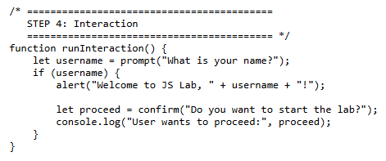
Screenshot of the output
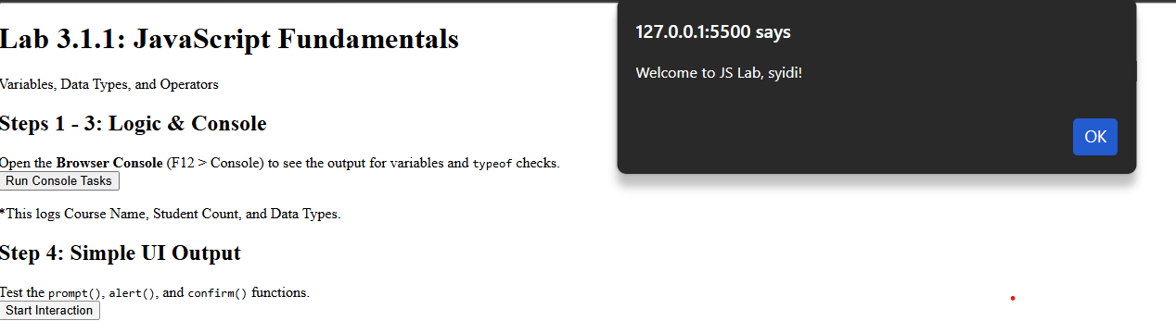

Explanation
when pressing the start interaction button, a message will appear where you need to enter your name there, after that there will be a text
(welcome to js lab "name"). when you press the yes button there will be a text (do you want to start the lab?)

4. Final Practical Task: The POS Script
Scenario: Construct a "Point-of-Sale" script to calculate a total bill including a 6% service tax.
- Add the HTML UI (The Trigger):
HTML
<section class="lab-card" style="border: 2px solid #27ae60; margin-top: 20px; padding: 15px; border-radius: 8px;">
<h2 style="color: #27ae60;">Final Task: POS Script</h2>
<div class="instruction">
<strong>Scenario:</strong> Calculate a total bill with 6% Service Tax.
</div>
<p>Price per Item: <strong>RM 15.00</strong></p>
<p>Tax Rate: <strong>6%</strong></p>

<button onclick="runPOS()" style="background-color: #27ae60; color: white; padding: 10px 20px; border: none; border-radius: 5px; cursor: pointer;">
Checkout Now
</button>
</section>
- Add the JavaScript Logic:
JavaScript

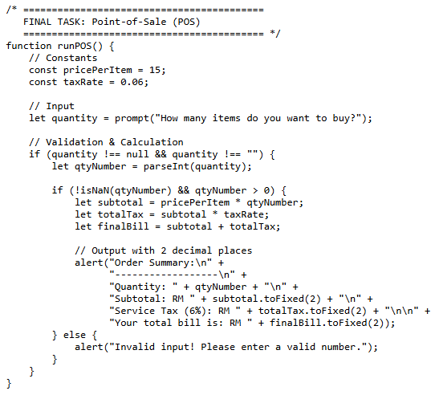

What happens when you run this?
- Prompt: Input box pops up. Type 3.
- Calculation: * Subtotal:
$$3 \times 15 = 45$$
  - Tax:
$$45 \times 0.06 = 2.70$$
  - Total:
$$45 + 2.70 = 47.70$$
- Output: An alert box appears: "Your total bill including tax (6%) is: RM 47.70".
Screenshot of the output
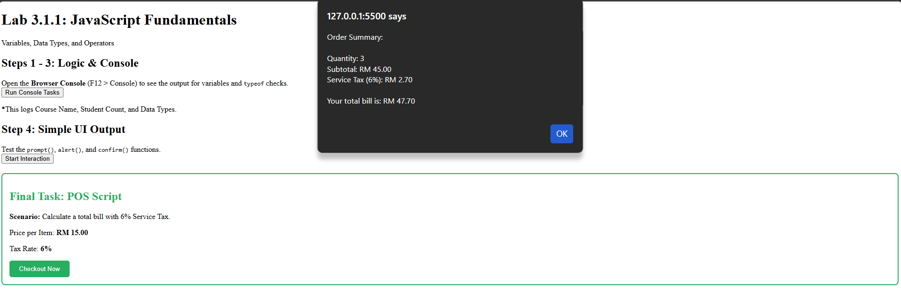

Explanation
When you insert how many item you want it will be charge for 6% where it is RM0.90 per item

5. Quick Check Questions
Part A
Question 1
Which of the following correctly describes the difference between the = and + operators in JavaScript?
- A. = is used for addition, while + is used to assign values to variables.
- B. = is the Assignment Operator (stores a value), while + is the Arithmetic or Concatenation Operator.
- C. Both are Arithmetic Operators used for mathematical calculations only.
- D. = compares two values, while + creates a new variable.
Question 2
What is the result of the expression "5" * 2 in JavaScript, and why?
- A. 55, because JavaScript repeats the string.
- B. Error, because you cannot multiply a string with a number.
- C. 10, because JavaScript performs "Type Coercion" to convert the string to a number.
- D. NaN (Not a Number), because the operation is mathematically impossible.
Question 3
In a Point-of-Sale (POS) system, why is it recommended to use const instead of let for a variable like taxRate = 0.06?
- A. const allows the tax rate to be changed easily later in the script.
- B. const makes the variable run faster in the browser memory.
- C. const prevents accidental reassignment, ensuring the fixed tax value remains consistent.
- D. const is the only keyword that supports decimal (float) numbers.

Part B
1. Which keyword is used to declare a variable whose value is intended to remain constant throughout the program?
A. let
B. var
C. const
D. static
2. What is the output of the following code? console.log(typeof "2026");
A. number
B. string
C. boolean
D. undefined
3. Which operator is used to find the remainder of a division between two numbers?
A. /
B. *
C. &
D. %
4. How do you display a message box to the user that requires them to click "OK" or "Cancel"?
A. alert()
B. prompt()
C. confirm()
D. console.log()
5. Which of the following is a valid Boolean value in JavaScript?
A. "true"
B. Yes
C. false
D. 1

6. What will be the result of the following operation: let x = "5" + 2;?
A. 7
B. 52
C. NaN
D. Error
7. Which method is used to convert a string into a whole number (integer)?
A. parseFloat()
B. toString()
C. parseInt()
D. toNumber()
8. In JavaScript, which operator is used for "Strict Equality" (checking both value and data type)?
A. =
B. ==
C. ===
D. !==

9. What is the purpose of the prompt() function?
A. To display a warning message.
B. To print data to the browser console.
C. To allow the user to input text data.
D. To permanently delete a variable.

10. If let a = 10; and let b = 3;, what is the result of a ** b (Exponentiation)?
A. 13
B. 30
C. 100
D. 1000

💡 JavaScript Quick Tips for Students

Step 1: Variables (const vs let)
- const (Constant): Gunakan untuk nilai yang tidak akan berubah. Contohnya: Nama kursus atau Kadar Cukai. Jika anda cuba ubah nilainya, JavaScript akan bagi error.
- let: Gunakan untuk nilai yang boleh berubah-ubah. Contohnya: studentCount (bilangan pelajar boleh bertambah atau berkurang).
- Boolean: Hanya ada dua nilai: true atau false. Sangat berguna untuk buat keputusan (Logic).

Step 2: Arithmetic Operators
- +, -, *, /: Berfungsi seperti kalkulator biasa.
- % (Modulus): Ini bukan peratus! Ia mencari baki pembahagian.
  - Contoh: 10 % 3 = 1 (kerana $3 \times 3 = 9$, bakinya adalah $1$).
  - Kegunaan: Selalu digunakan untuk semak nombor genap/ganjil.

Step 3: The typeof Operator
- JavaScript adalah bahasa dynamically typed. Maksudnya, kita tak perlu beritahu komputer jika pemboleh ubah itu teks atau nombor, JavaScript akan "teka" sendiri.
- Gunakan typeof untuk debug kod anda jika pengiraan matematik tidak menjadi (mungkin anda tertambah Teks dengan Nombor!).

Step 4: Interaction (prompt, alert, confirm)
- prompt(): Cara paling mudah untuk dapatkan input dari pengguna. Penting: Input dari prompt sentiasa dalam bentuk String (Teks).
- alert(): Untuk beri informasi sehala kepada pengguna.
- confirm(): Menghasilkan nilai true (jika tekan OK) atau false (jika tekan Cancel).

Final Step: POS Logic (The "Pro" Tips)
- parseInt(): Oleh kerana prompt() memberikan teks, kita perlu "paksa" ia menjadi nombor bulat menggunakan parseInt() supaya kita boleh buat pengiraan matematik.
- isNaN() (Is Not a Number): Fungsi keselamatan. Ia menyemak sama ada input pengguna itu nombor sah atau bukan (contoh: jika user taip "ABC", isNaN akan jadi true).
- .toFixed(2): Sangat penting untuk aplikasi kewangan. Ia memastikan nombor kita sentiasa ada 2 tempat perpuluhan (RM 10.00, bukan RM 10).

📝 Lab 3.1.1: JavaScript Fundamentals Quiz
1. Which keyword should you use to declare a variable that will NOT change throughout the script (e.g., a Tax Rate)?
A) let
B) var
C) const
D) fixed
2. What is the result of the expression 10 % 4 in JavaScript?
A) 2.5
B) 2
C) 4
D) 0
3. If you use let input = prompt("Enter a number") and the user types 5, what is the data type of input?
A) Number
B) Boolean
C) Null
D) String
4. What is the purpose of the parseInt() function in the POS script?
A) To round a number to the nearest decimal.
B) To convert a string (text) into an integer (number).
C) To calculate the 6% service tax.
D) To display a message on the screen.
5. Which method is used to format a number to exactly two decimal places (e.g., converting 15 to 15.00)?
A) toTwo()
B) math.round(2)
C) toFixed(2)
D) formatCurrency()

✅ Answer Key:
- C (const is for constants)
- B (10 divided by 4 is 2 with a remainder of 2)
- D (All prompt inputs are returned as strings by default)
- B (It ensures the "text" from the prompt can be used for math)
- C (toFixed(2) handles the decimal formatting)

