Lab Activity 3.3: Construct form validation using Bootstrap and JavaScript

STUDENT INFORMATION
Name | Registration No | Date

Learning Outcomes:
- Construct client-side form validation using JavaScript.
- Construct Bootstrap form components for improved user experience.
- Perform form submission and validation errors gracefully.

Step 1: Setting Up the Document Structure & Styling
Create a new file named passport_form.html. We will start by defining the Purple Theme using CSS variables and styling the passport photo container to meet the 35mm x 45mm requirement.
HTML
<head>
<meta charset="UTF-8">
<meta name="viewport" content="width=device-width, initial-scale=1.0">
<title>Lab 3.3: Passport Application Form</title>
<link href="https://cdn.jsdelivr.net/npm/bootstrap@5.3.0/dist/css/bootstrap.min.css" rel="stylesheet">
<style>
:root { --primary-purple: #6f42c1; --hover-purple: #59359a; --light-purple: #f3e5f5; }
body { background-color: var(--light-purple); padding: 40px 20px; }
.form-container { max-width: 800px; margin: auto; background: white; padding: 40px; border-radius: 15px; border-top: 8px solid var(--primary-purple); }
.text-purple { color: var(--primary-purple); }
.bg-purple { background-color: var(--primary-purple) !important; }
.btn-purple { background-color: var(--primary-purple); color: white; }
.btn-purple:hover { background-color: var(--hover-purple); color: white; }
.passport-photo { width: 3.5cm; height: 4.5cm; object-fit: cover; border: 3px solid #f8f9fa; outline: 1px solid #dee2e6; display: block; margin: 0 auto 10px auto; }
.form-control:focus, .form-select:focus { border-color: var(--primary-purple); box-shadow: 0 0 0 0.25rem rgba(111, 66, 193, 0.25); }
#rangeValue { background-color: var(--primary-purple); color: white; padding: 2px 10px; border-radius: 10px; font-size: 0.9rem; }
#successMessage { display: none; }
</style>
</head>

Step 2: Constructing the UI (Form Components)
Add the HTML body. This includes the Success Alert, Passport Image, Floating Labels, and Input Groups. Note the use of novalidate in the form tag to allow custom JavaScript handling.
HTML
<div class="container">
<div class="form-container shadow-lg">

<div class="mb-3">
<a href="LAB2_1.html" class="text-decoration-none text-purple small fw-bold">&larr; Back to Profile</a>
</div>

<h2 class="mb-4 text-center fw-bold text-purple">Passport Application</h2>
<hr class="mb-5">

<div id="successMessage" class="alert alert-success alert-dismissible fade show" role="alert">
<strong>Success!</strong> Your application has been validated and submitted gracefully.
<button type="button" class="btn-close" data-bs-dismiss="alert" aria-label="Close"></button>
</div>

<form class="row g-4 needs-validation" id="passportForm" novalidate>

<div class="col-12 text-center">
<img src="img/profile.png" class="passport-photo rounded shadow-sm" alt="Profile">
<p class="text-muted small">Standard Passport Size (35mm x 45mm)</p>
</div>

<div class="col-md-6">
<div class="form-floating">
<input type="text" class="form-control" id="firstName" placeholder="First Name" required>
<label for="firstName">First Name</label>
<div class="invalid-feedback">First name is required.</div>
</div>
</div>

<div class="col-md-6">
<div class="form-floating">
<input type="text" class="form-control" id="lastName" placeholder="Last Name" required>
<label for="lastName">Last Name</label>
<div class="invalid-feedback">Last name is required.</div>
</div>
</div>

<div class="col-md-12">
<label for="userEmail" class="form-label fw-bold">Contact Email</label>
<div class="input-group has-validation">
<span class="input-group-text bg-purple text-white">@</span>
<input type="email" class="form-control" id="userEmail" placeholder="e.g. name@mail.com" required>
<div class="invalid-feedback">Please enter a valid email address.</div>
</div>
</div>

<div class="col-md-6">
<label for="citizenStatus" class="form-label fw-bold">Citizenship</label>
<select class="form-select" id="citizenStatus" required>
<option selected disabled value="">Select status...</option>
<option>Citizen</option>
<option>Permanent Resident</option>
</select>
<div class="invalid-feedback">Selection required.</div>
</div>

<div class="col-md-6">
<label for="yearsResidency" class="form-label fw-bold">
Residency Years: <span id="rangeValue">25</span>
</label>
<input type="range" class="form-range" min="1" max="50" value="25" id="yearsResidency">
</div>

<div class="col-md-12">
<label class="form-label d-block fw-bold">Gender</label>
<div class="form-check form-check-inline">
<input class="form-check-input" type="radio" name="gender" id="male" required>
<label class="form-check-label" for="male">Male</label>
</div>
<div class="form-check form-check-inline">
<input class="form-check-input" type="radio" name="gender" id="female" required>
<label class="form-check-label" for="female">Female</label>
</div>
<div class="invalid-feedback">Please select a gender.</div>
</div>

<div class="col-12">
<div class="form-check">
<input class="form-check-input" type="checkbox" value="" id="invalidCheck" required>
<label class="form-check-label" for="invalidCheck">
I confirm that all information provided is accurate.
</label>
<div class="invalid-feedback">You must agree before submitting.</div>
</div>
</div>

<div class="col-md-6">
<div class="form-floating">
<input type="password" class="form-control" id="password" placeholder="Password" required>
<label for="password">Password</label>
<div class="invalid-feedback">Please enter a password.</div>
</div>
</div>

<div class="col-md-6">
<div class="form-floating">
<input type="password" class="form-control" id="confirmPassword" placeholder="Confirm Password" required>
<label for="confirmPassword">Confirm Password</label>
<div class="invalid-feedback" id="confirmFeedback">Passwords do not match!</div>
</div>
</div>

<div class="col-12 mt-5 d-flex gap-2">
<button class="btn btn-purple w-75 py-3 fw-bold shadow-sm" type="submit">SUBMIT APPLICATION</button>
<button class="btn btn-outline-secondary w-25 py-3 fw-bold shadow-sm" type="reset" id="resetBtn">RESET</button>
</div>

</form>
</div>
</div>

Step 3: JavaScript Logic (Validation & Interaction)
Implement the script to handle Range Slider updates, Password Matching, and Graceful Error Handling.
HTML
<script>
(function () {
'use strict'

const form = document.getElementById('passportForm');
const successDiv = document.getElementById('successMessage');
const resetBtn = document.getElementById('resetBtn');
const rangeInput = document.getElementById('yearsResidency');
const rangeValue = document.getElementById('rangeValue');

// Update range value display
rangeInput.addEventListener('input', function() {
rangeValue.textContent = this.value;
});

// Form Validation Logic
form.addEventListener('submit', function (event) {
if (!form.checkValidity()) {
event.preventDefault();
event.stopPropagation();
successDiv.style.display = 'none';
} else {
event.preventDefault();
successDiv.style.display = 'block';
window.scrollTo({ top: 0, behavior: 'smooth' });
}
form.classList.add('was-validated');
}, false);

// Reset Logic
resetBtn.addEventListener('click', function() {
form.classList.remove('was-validated');
successDiv.style.display = 'none';
rangeValue.textContent = "25"; // Reset range display to default
});

})();
(function () {
'use strict'

const form = document.getElementById('passportForm');
const password = document.getElementById('password');
const confirmPassword = document.getElementById('confirmPassword');

// Fungsi untuk menyemak padanan kata laluan
function validatePassword() {
if (password.value !== confirmPassword.value) {
// Jika tidak sama, set ralat custom
confirmPassword.setCustomValidity("Passwords do not match");
} else {
// Jika sama, kosongkan ralat (sah)
confirmPassword.setCustomValidity("");
}
}

// Jalankan fungsi setiap kali pengguna menaip
password.addEventListener('change', validatePassword);
confirmPassword.addEventListener('keyup', validatePassword);

// Kekalkan logik submit anda yang sedia ada
form.addEventListener('submit', function (event) {
// validatePassword dipanggil sekali lagi sebelum submit untuk kepastian
validatePassword();

if (!form.checkValidity()) {
event.preventDefault();
event.stopPropagation();
} else {
event.preventDefault();
document.getElementById('successMessage').style.display = 'block';
window.scrollTo({ top: 0, behavior: 'smooth' });
}
form.classList.add('was-validated');
}, false);

// ... (Logik Range dan Reset anda yang lain)
})();
</script>

<script src="https://cdn.jsdelivr.net/npm/bootstrap@5.3.0/dist/js/bootstrap.bundle.min.js"></script>

Task Recap for Students:
- Step 1: Copy CSS to define the look and the specific 3.5cm x 4.5cm image size.
- Step 2: Construct the form using Bootstrap's grid and specialized components.
- Step 3: Apply the JavaScript to enable live slider updates and ensure the passwords match before submission.
- Observation: Notice how the was-validated class triggers red/green borders and messages gracefully without refreshing the page.

STEP-BY-STEP VALIDATION:
Please provide a screenshot for every completed step. For each image, write a short observation explaining the logic behind the code you just implemented. This helps solidify your mastery of Bootstrap!
Progress Step | Screenshot of Output | Your Observation & Understanding
Step 1 | 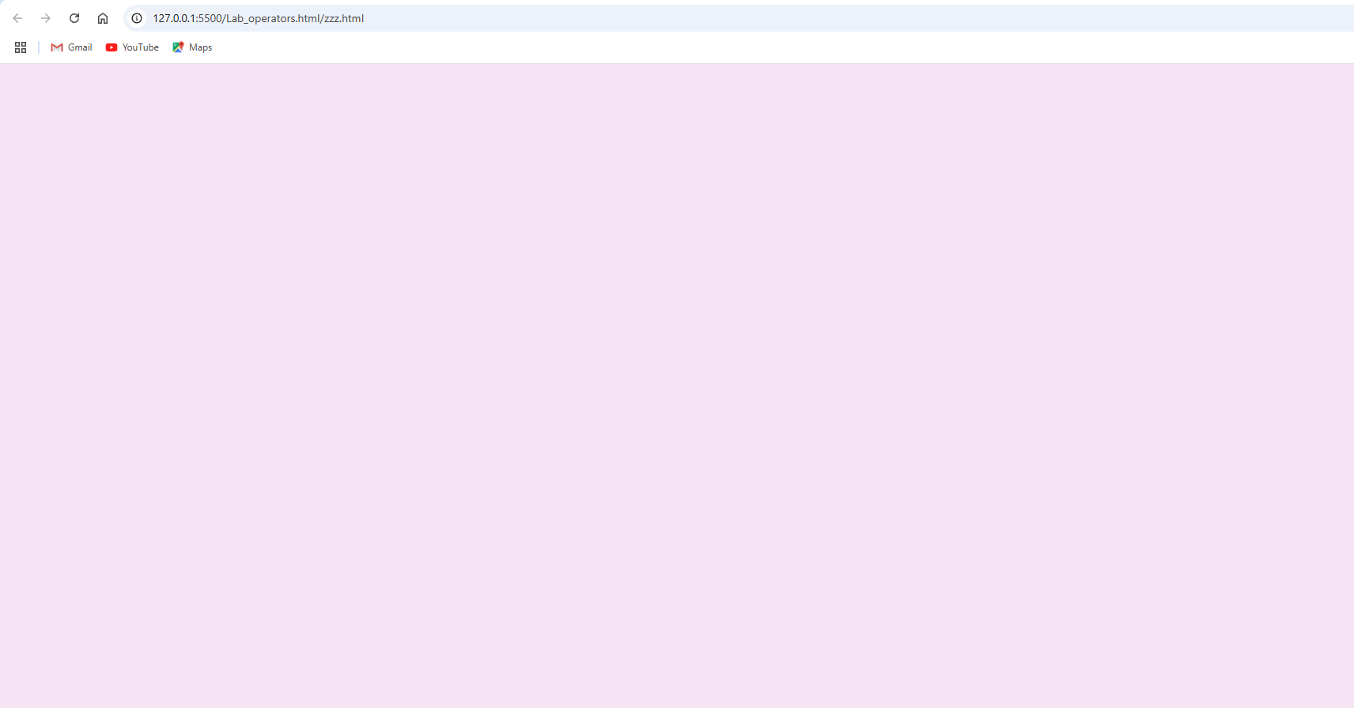 | Local host testing using Live Server (VS Code extension)
Step 2 | 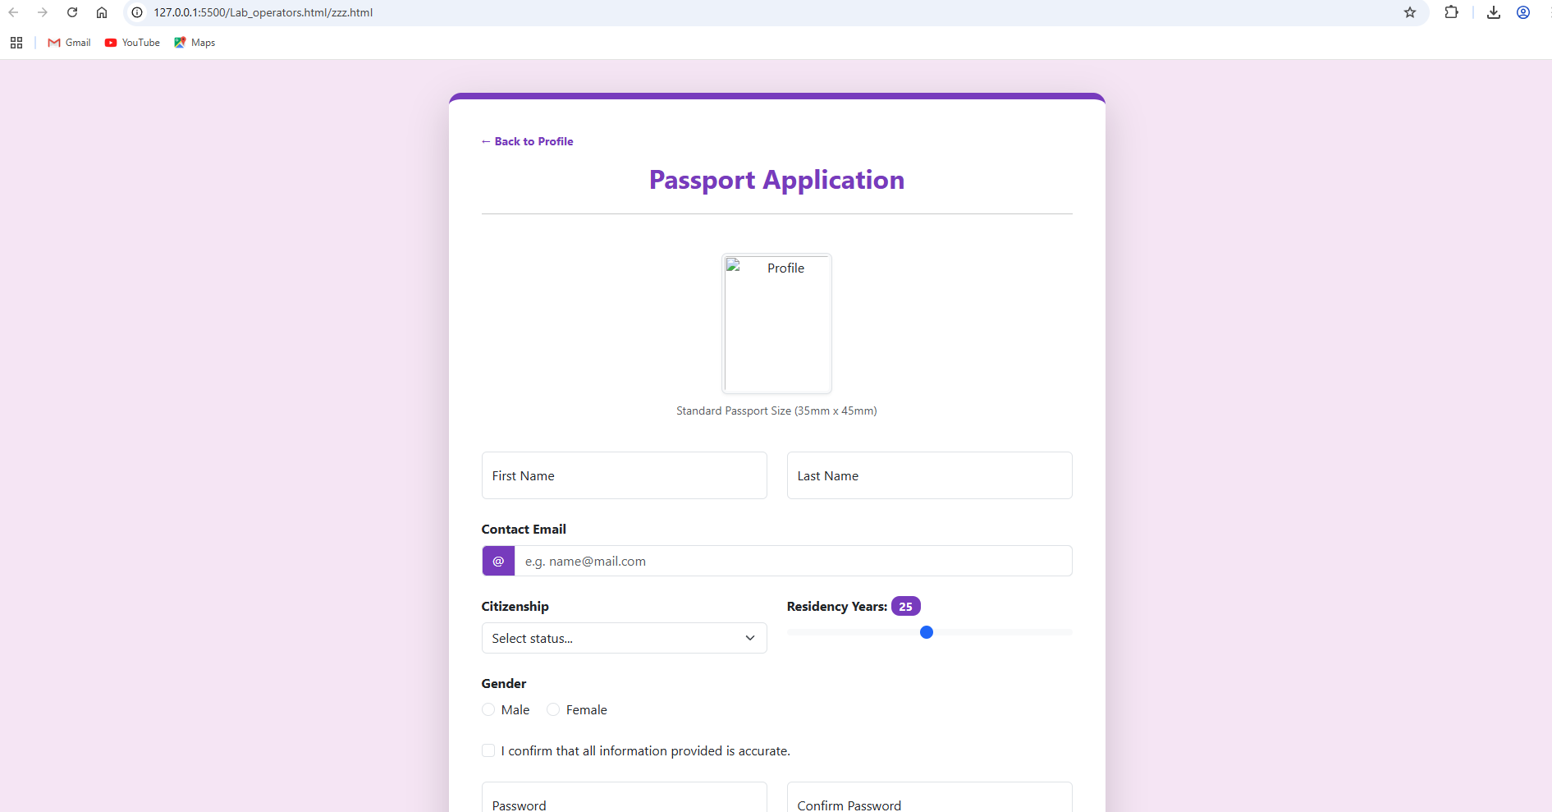 | - Clean, simple layout
Step 3 | 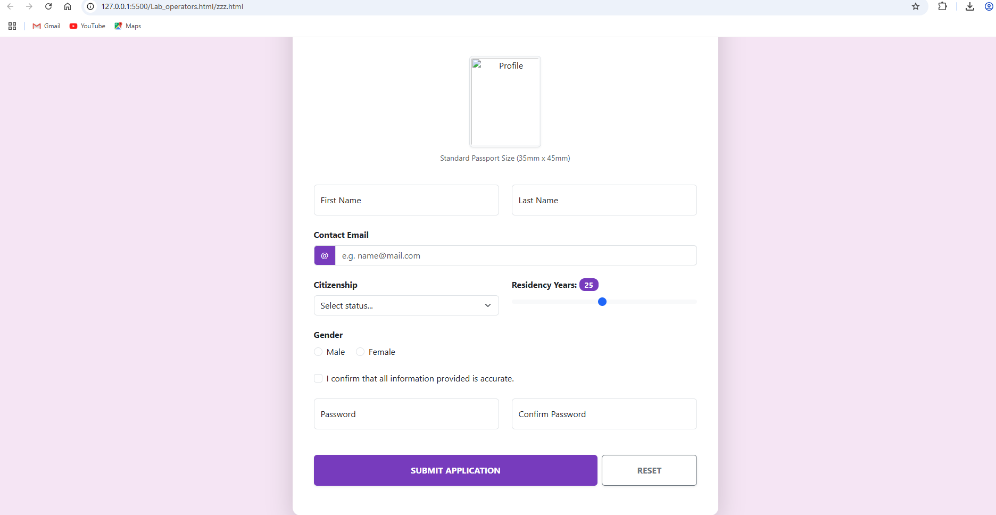 | - Hierarchy: Clean vertical flow from top to bottom  - Grouping: Related fields grouped together (Name fields, Password fields)  - Special Field: "Residency Years: 25" - appears pre-filled or static  - Button Styling: Two distinct action buttons at bottom  - Checkbox: Single confirmation before submission

5. SCREENSHOT OUTPUT (COMPLETE):
Desktop View
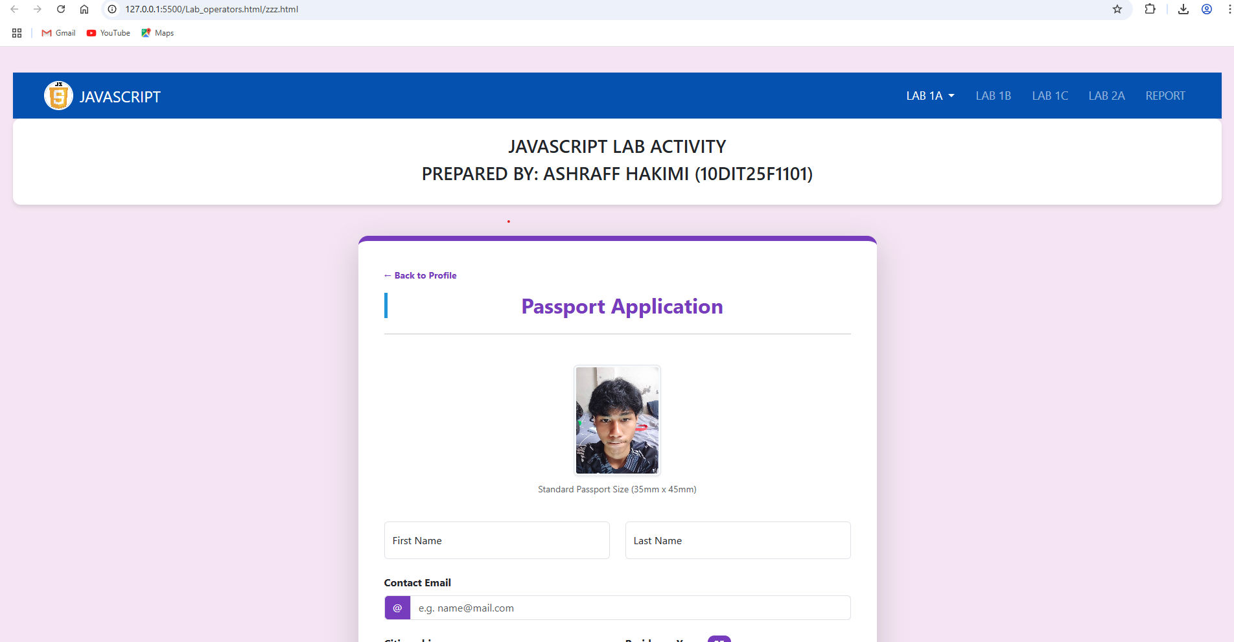

Mobile View
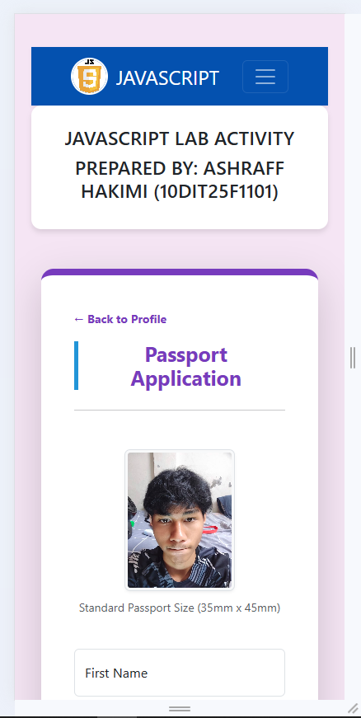

6. LAB SUBMISSION TASK
Ensure you have completed all steps successfully!
- Compress your folder: RegNo_Date.zip.
- Report: Create a PDF containing all screenshots and explanations: Report_RegNo_Date.pdf.
Happy Coding! Success is in your hands!

