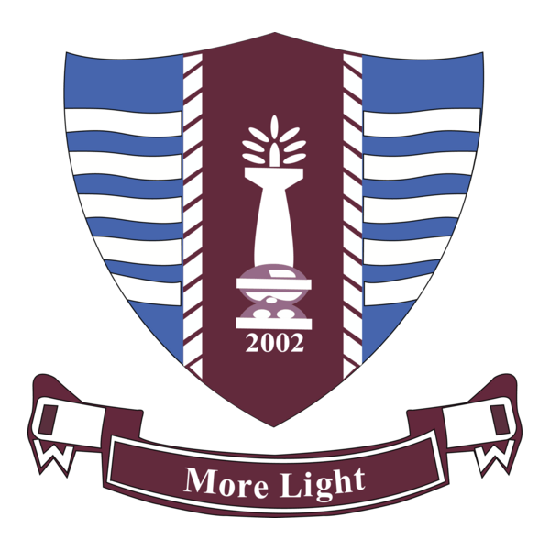
Government College University Faisalabad
Department of Information Technology

Final Year Project - Proposal

Class: | BS(IT) | [ ]Regular Morning [ ]Regular Evening  [ ]Shifted Morning [ ]Shifted Evening  [ ] Bridging A [ ] Bridging B

Particulars of the students (1 or 2 students per Group):
Sr | Roll No | Registration# | Name in Full  (Use Block Letters) | Email | Signature
1 | 248087 | 2024-GCUF-08161 | M ASHRAF
2 | 248085 | 2024-GCUF-06539 | M NAFEES

Project Title:

Domain Area | ☐ Web Application ☐ Mobile Application ☐ Artificial Intelligence  ☐ IoT / Embedded Systems ☐ Data Science ☐ Cyber Security  ☐ Other: Hardware Based Smart Gadget

Brief Description of Project (Maximum 200 words):
A Life saving smart helmet for coal miners, which can detect the leakage of hazardous gases(Methan, CH4, LPG) inside mine then generate an aler locally by generating alarm via buzzer and LED to inform miner about the threat.
It also informs the monitoring station outside the mine via a mobile app(Blynk) about the gas leakage.
An LCD is integrated on the helmet which can show the current temprature to the mine.

Major Components/Modules:

Module 1: Gas leakage detection inside mine.(Helmet Unit)

Module 2:Communication from helmet(inside mine) to mobile app (outside mine).

Module 3: Monitoring station(where a supervisor checks updates in App about alert outside the mine. Available on Engine
Tools and Technologies to be used:
- Different Sensors: MQ-5 for Gas leakage detection.
- DHT-11 a temperature sensor to sense temprature.
- ESP-32 used as microcontroller which monitor all other connected components.
- 16x2 LCD to show real time temprature.
- Buzzer and LED for locally generating alerts.
- Blynk a mobile app which received real time data from Helmet Unit.

