### **Supplementary file 4 Data and synthesis script**

#### 2023-09-26

# Dataset

|  |  |  |  |  |  |  |  |  |  |
| --- | --- | --- | --- | --- | --- | --- | --- | --- | --- |
| **id** | **ee** | **ne** | **ec** | **nc** | **factor** | **corticosteroid** | **outcome** | **RoB** | **zero** |
| Van Runnard 2006 | 1 | 15 | 1 | 16 | antepartum | prednisolone | Abruptio placenta | low | F |
| Magann 1994 | 3 | 12 | 3 | 13 | antepartum | dexa | Apgar score at 5 minutes < 7 | some concerns | F |
| Van Runnard 2006 | 1 | 16 | 2 | 17 | antepartum | prednisolone | Apgar score at 5 minutes < 7 | low | F |
| Ozer 2009 | 23 | 30 | 26 | 30 | antepartum | beta | Cesarean section | low | F |
| Van Runnard 2006 | 15 | 15 | 14 | 16 | antepartum | prednisolone | Cesarean section | low | F |
| Fonseca 2019 | 6 | 35 | 8 | 38 | mixed | dexa | Composite morbidity | low | F |
| Van Runnard 2006 | 1 | 15 | 4 | 16 | antepartum | prednisolone | Composite morbidity | low | F |
| Ozer 2009 | 1 | 30 | 0 | 30 | antepartum | beta | Dialysis | low | F |
| Fonseca 2005 | 8 | 66 | 10 | 66 | mixed | dexa | Eclampsia | low | F |
| Fonseca 2019 | 2 | 40 | 1 | 41 | mixed | dexa | Eclampsia | low | F |
| Magann 1994 | 1 | 12 | 0 | 13 | antepartum | dexa | ICH | some concerns | F |
| Van Runnard 2006 | 4 | 16 | 2 | 17 | antepartum | prednisolone | ICH | low | F |
| Fonseca 2005 | 3 | 66 | 1 | 66 | mixed | dexa | Maternal death | low | F |
| Fonseca 2019 | 0 | 42 | 2 | 45 | mixed | dexa | Maternal death | low | F |
| Katz 2008 | 2 | 56 | 2 | 49 | postpartum | dexa | Maternal death | low | F |
| Ozer 2009 | 0 | 30 | 0 | 30 | antepartum | beta | Maternal death | low | T |
| Van Runnard 2006 | 0 | 15 | 1 | 16 | antepartum | prednisolone | Maternal death | low | F |
| Vigil-De Gracia 1997 | 0 | 17 | 1 | 17 | postpartum | dexa | Maternal death | high | F |
| Ozer 2009 | 0 | 30 | 1 | 30 | antepartum | beta | Maternal liver morbidity | low | F |
| Van Runnard 2006 | 0 | 15 | 3 | 16 | antepartum | prednisolone | Maternal liver morbidity | low | F |
| Fonseca 2005 | 3 | 66 | 1 | 66 | mixed | dexa | Maternal pulmonary edema | low | F |
| Fonseca 2019 | 0 | 41 | 1 | 43 | mixed | dexa | Maternal pulmonary edema | low | F |
| Katz 2008 | 2 | 56 | 5 | 49 | postpartum | dexa | Maternal pulmonary edema | low | F |
| Ozer 2009 | 1 | 30 | 1 | 30 | antepartum | beta | Maternal pulmonary edema | low | F |
| Fonseca 2005 | 6 | 66 | 8 | 66 | mixed | dexa | Maternal renal failure | low | F |
| Fonseca 2019 | 1 | 37 | 6 | 42 | mixed | dexa | Maternal renal failure | low | F |
| Katz 2008 | 9 | 56 | 12 | 49 | postpartum | dexa | Maternal renal failure | low | F |
| Ozer 2009 | 2 | 30 | 3 | 30 | antepartum | beta | Maternal renal failure | low | F |
| Yalcin 1998 | 3 | 15 | 3 | 15 | postpartum | dexa | Maternal renal failure | some concerns | F |
| Van Runnard 2006 | 0 | 16 | 2 | 17 | antepartum | prednisolone | Necrotizing enterocolitis | low | F |
| Magann 1994 | 3 | 12 | 1 | 13 | antepartum | dexa | Neonatal RDS | some concerns | F |
| Van Runnard 2006 | 6 | 16 | 8 | 17 | antepartum | prednisolone | Neonatal RDS | low | F |
| Magann 1994 | 1 | 12 | 3 | 13 | antepartum | dexa | Perinatal death | some concerns | F |
| Van Runnard 2006 | 3 | 16 | 4 | 17 | antepartum | prednisolone | Perinatal death | low | F |
| Fonseca 2005 | 12 | 66 | 10 | 66 | mixed | dexa | Platelet transfusion | low | F |
| Fonseca 2019 | 12 | 42 | 15 | 45 | mixed | dexa | Platelet transfusion | low | F |

# **Synthesis**

**Pre-specified outcomes**

1. Maternal Death
2. Liver morbidity (hematoma, rupture, failure)
3. Acute pulmonary edema
4. Acute renal failure
5. Dialysis
6. Platelet transfusion
7. Perinatal death

## Maternal Death

Pairwise meta-analysis

|  |  |  |  |
| --- | --- | --- | --- |
| Study | RR | 95%-CI % | W(common) |
| Fonseca 2005 | 3.0000 | [0.3202; 28.1042] | 25.4 |
| Fonseca 2019 | 0.2141 | [0.0106; 4.3328] | 14.1 |
| Katz 2008 | 0.8750 | [0.1280; 5.9809] | 34.5 |
| Ozer 2009 | NA |  | 0.0 |
| Van Runnard 2006 | 0.3548 | [0.0156; 8.0730] | 13.0 |
| Vigil-De Gracia 1997 | 0.3333 | [0.0146; 7.6344] | 13.0 |

Number of studies: k = 5

Number of observations: o = 449

Number of events: e = 12

|  |  |  |  |  |
| --- | --- | --- | --- | --- |
|  | RR | 95%-CI | z | p-value |
| Common effect model | 0.7700 | [0.2492; 2.3799] | -0.45 | 0.6499 |

Quantifying heterogeneity:

tau^2 = 0 [0.0000; 7.4236]; tau = 0 [0.0000; 2.7246]

I^2 = 0.0% [0.0%; 79.2%]; H = 1.00 [1.00; 2.19]

Test of heterogeneity: Q = 2.64; d.f. = 4; p-value 0.6192

Details on meta-analytical method:

- Inverse variance method

- Restricted maximum-likelihood estimator for tau^2

- Q-Profile method for confidence interval of tau^2 and tau

- Continuity correction of 0.5 in studies with zero cell frequencies

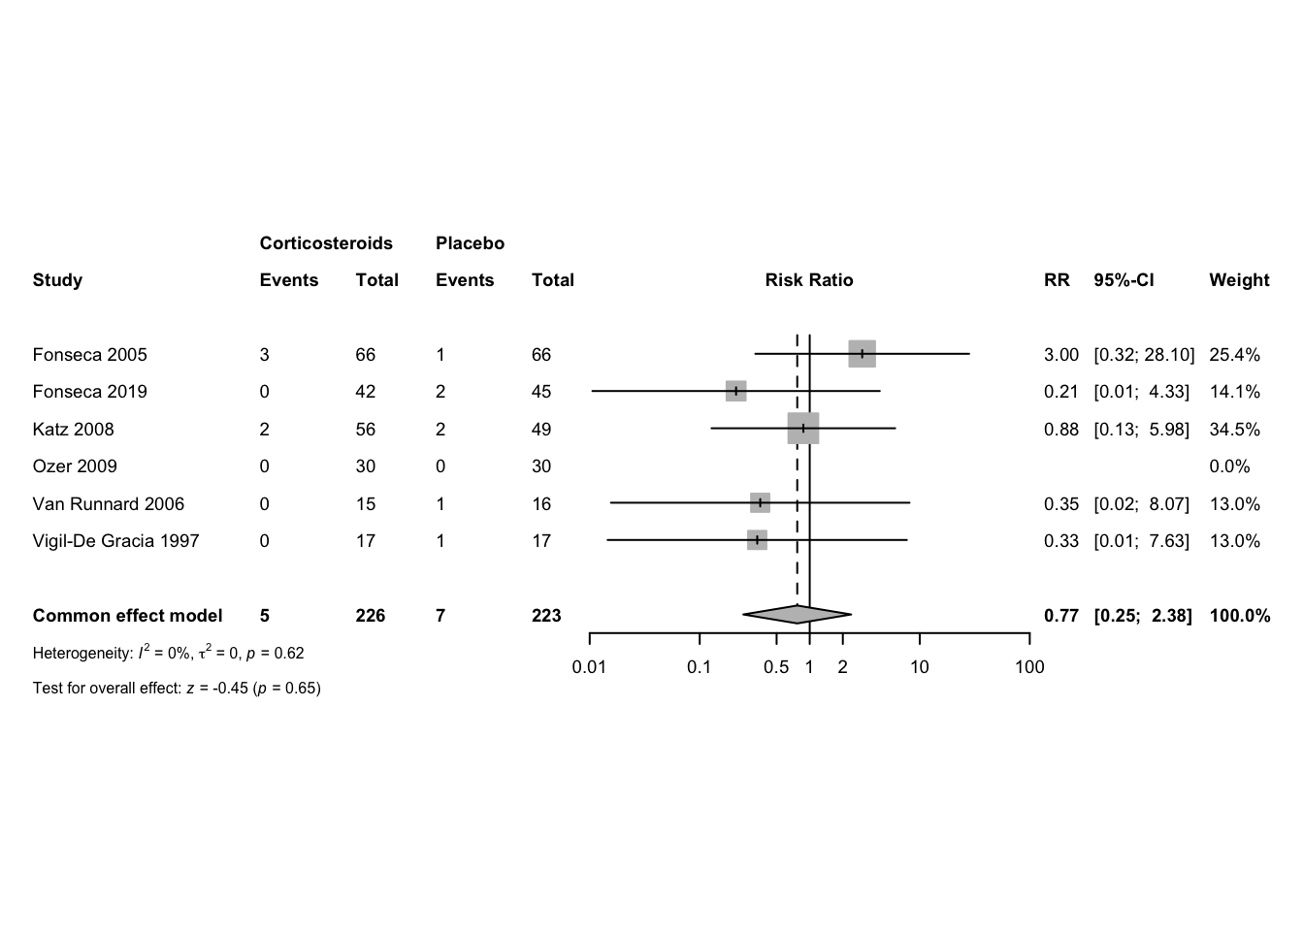

Risk of bias

Summary traffic-light plot of risk-of-bias assessments

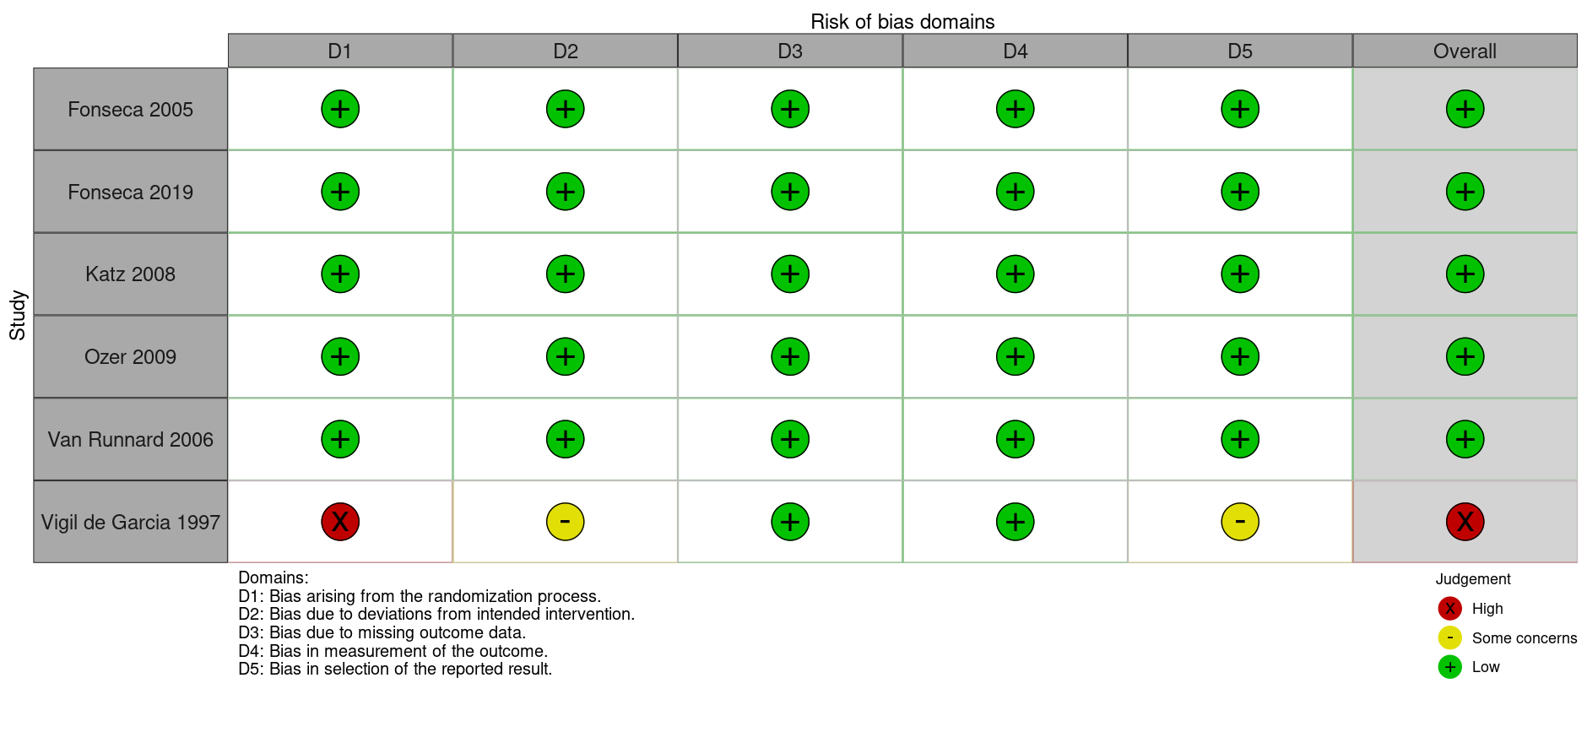

Summary weighted barplot of risk-of-bias assessments

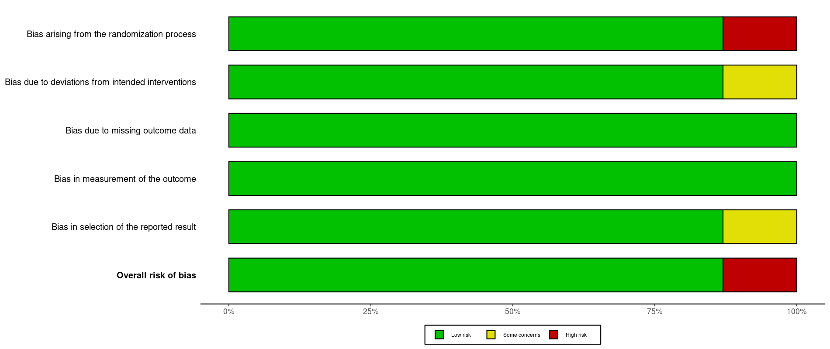

Subgroup analysis: Antepartum vs postpartum vs mixed

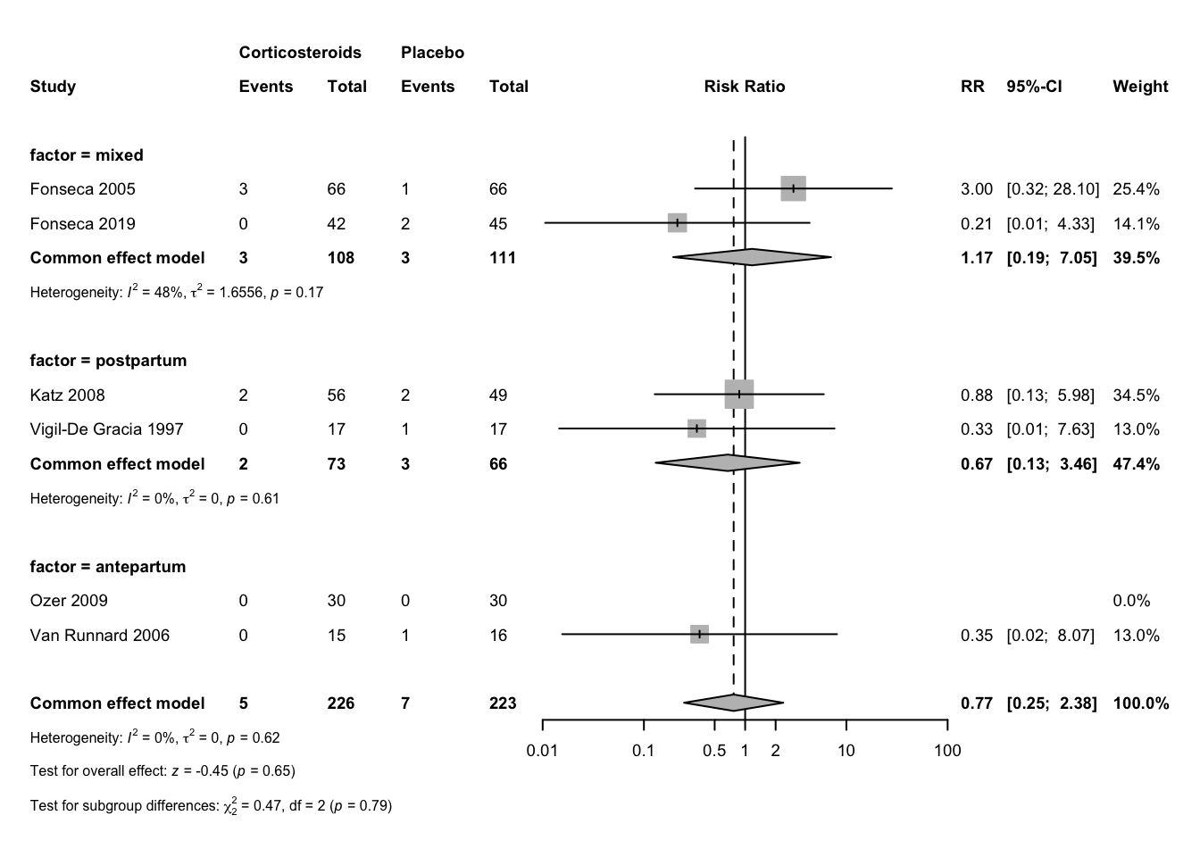

Subgroup analysis: Dexa vs Beta vs Prednisolone

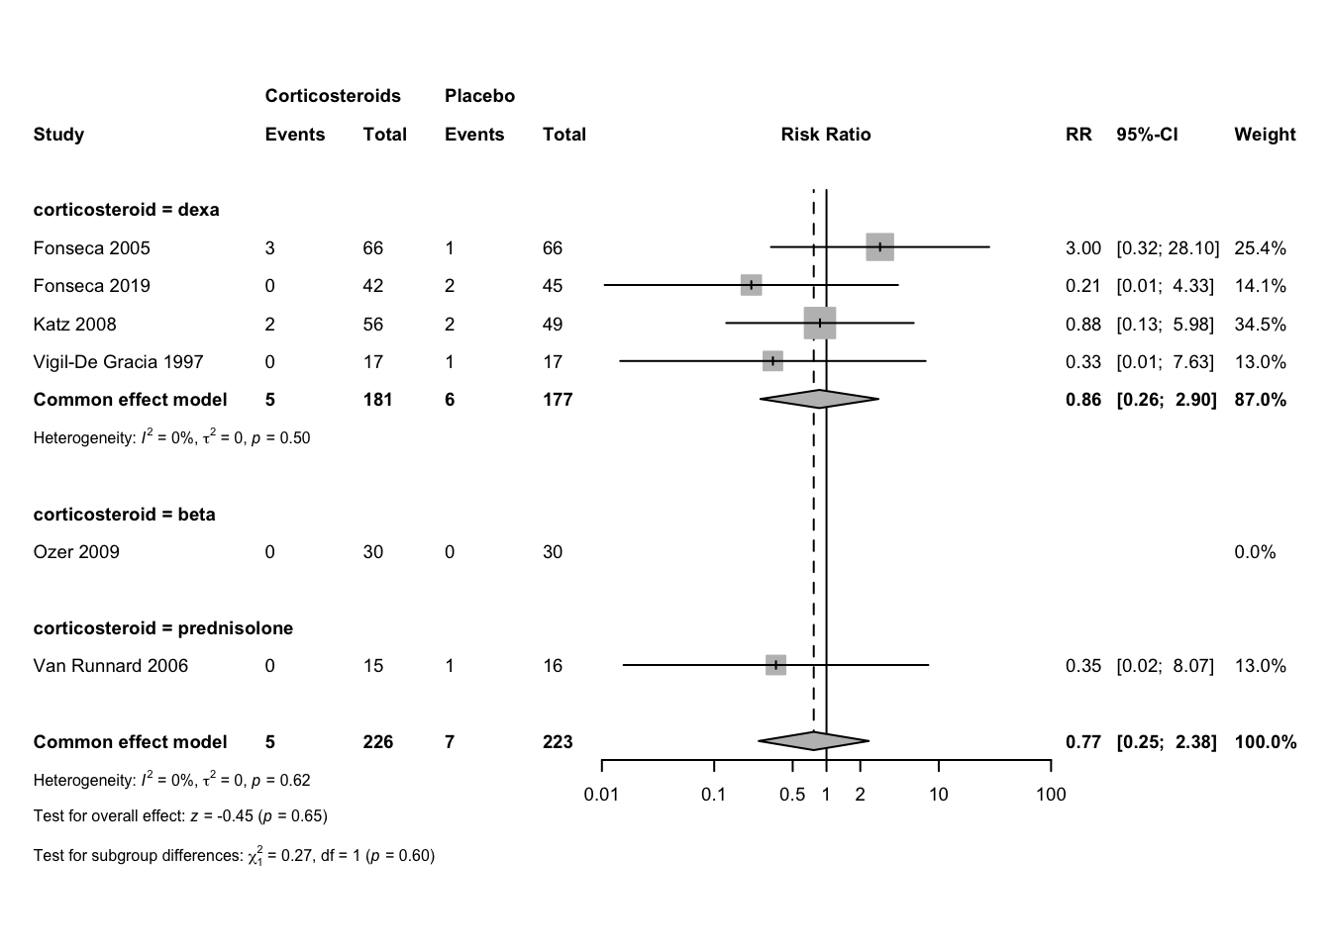

Sensitivity analysis: Low RoB

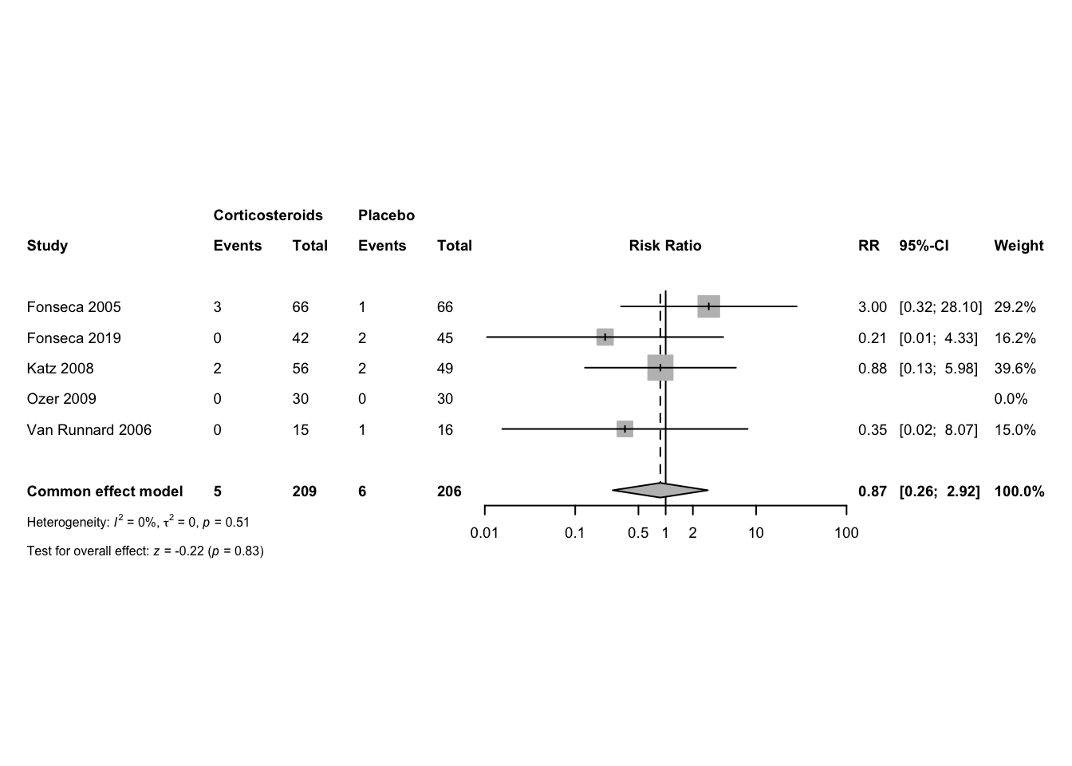

Sensitivity analysis: Studies with zero events included

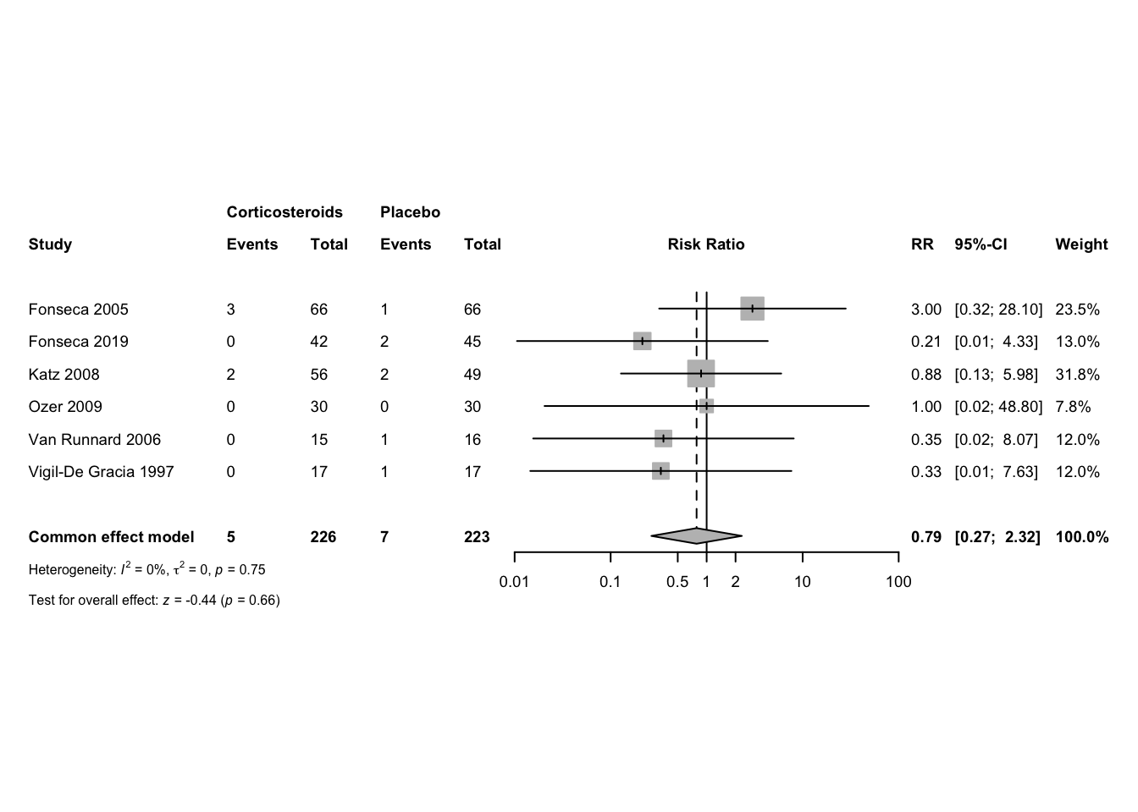

Funnel plot

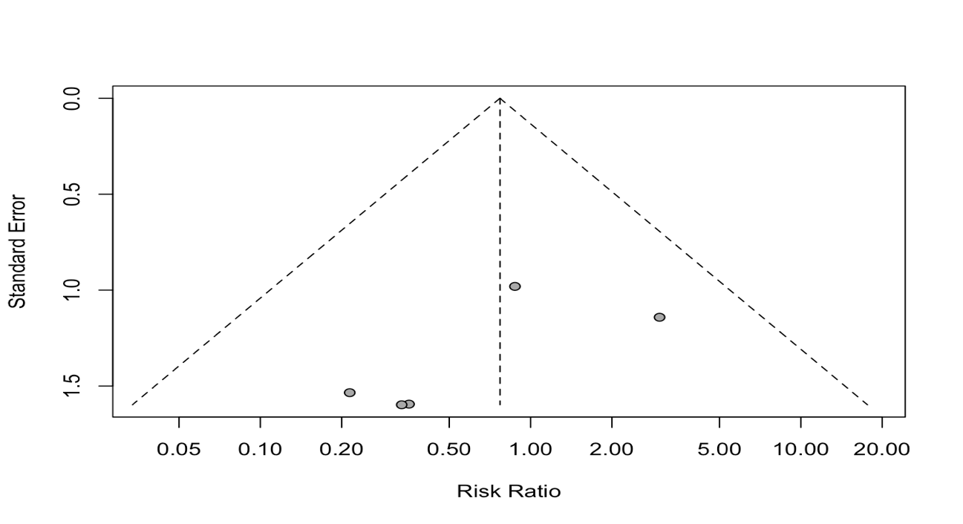

## Acute pulmonary edema

RR 95%-CI %W(common)

Fonseca 2005 3.0000 [0.3202; 28.1042] 24.2

Fonseca 2019 0.3494 [0.0146; 8.3368] 12.0

Katz 2008 0.3500 [0.0711; 1.7238] 47.6

Ozer 2009 1.0000 [0.0655; 15.2598] 16.3

Number of studies: k = 4

Number of observations: o = 381

Number of events: e = 14

RR 95%-CI z p-value

Common effect model 0.6975 [0.2323; 2.0944] -0.64 0.5207

Quantifying heterogeneity:

tau^2 = 0.1164 [0.0000; 13.2337]; tau = 0.3412 [0.0000; 3.6378]

I^2 = 0.0% [0.0%; 84.7%]; H = 1.00 [1.00; 2.56]

Test of heterogeneity:

Q d.f. p-value

2.60 3 0.4572

Details on meta-analytical method:

- Inverse variance method

- Restricted maximum-likelihood estimator for tau^2

- Q-Profile method for confidence interval of tau^2 and tau

- Continuity correction of 0.5 in studies with zero cell frequencies

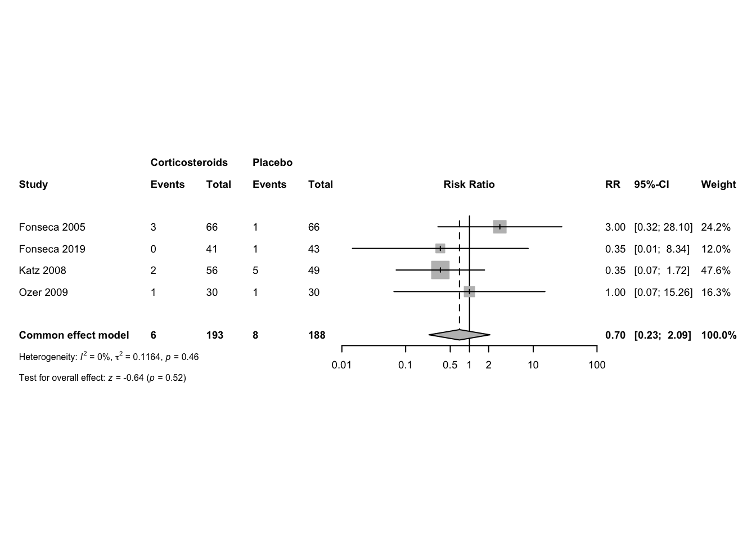

## Acute renal failure

|  |  |  |  |
| --- | --- | --- | --- |
| Study | RR | 95%-CI % | W(common) |
| Fonseca 2005 | 0.7500 | [0.2754; 2.0428] | 26.7 |
| Fonseca 2019 | 0.1892 | [0.0239; 1.4998] | 6.3 |
| Katz 2008 | 0.6563 | [0.3025; 1.4238] | 44.8 |
| Ozer 2009 | 0.6667 | [0.1198; 3.7087] | 9.1 |
| Yalcin 1998 | 1.0000 | [0.2390; 4.1844] | 13.1 |

Number of studies: k = 5

Number of observations: o = 406

Number of events: e = 53

|  |  |  |  |  |
| --- | --- | --- | --- | --- |
|  | RR | 95%-CI | z | p-value |
| Common effect model | 0.6658 | [0.3965; 1.1179] | -1.54 | 0.1239 |

Quantifying heterogeneity:

tau^2 = 0 [0.0000; 2.4607]; tau = 0 [0.0000; 1.5687]

I^2 = 0.0% [0.0%; 79.2%]; H = 1.00 [1.00; 2.19]

Test of heterogeneity: Q = 1.78 ; d.f. = 4; p-value = 0.7753

Details on meta-analytical method:

- Inverse variance method

- Restricted maximum-likelihood estimator for tau^2

- Q-Profile method for confidence interval of tau^2 and tau

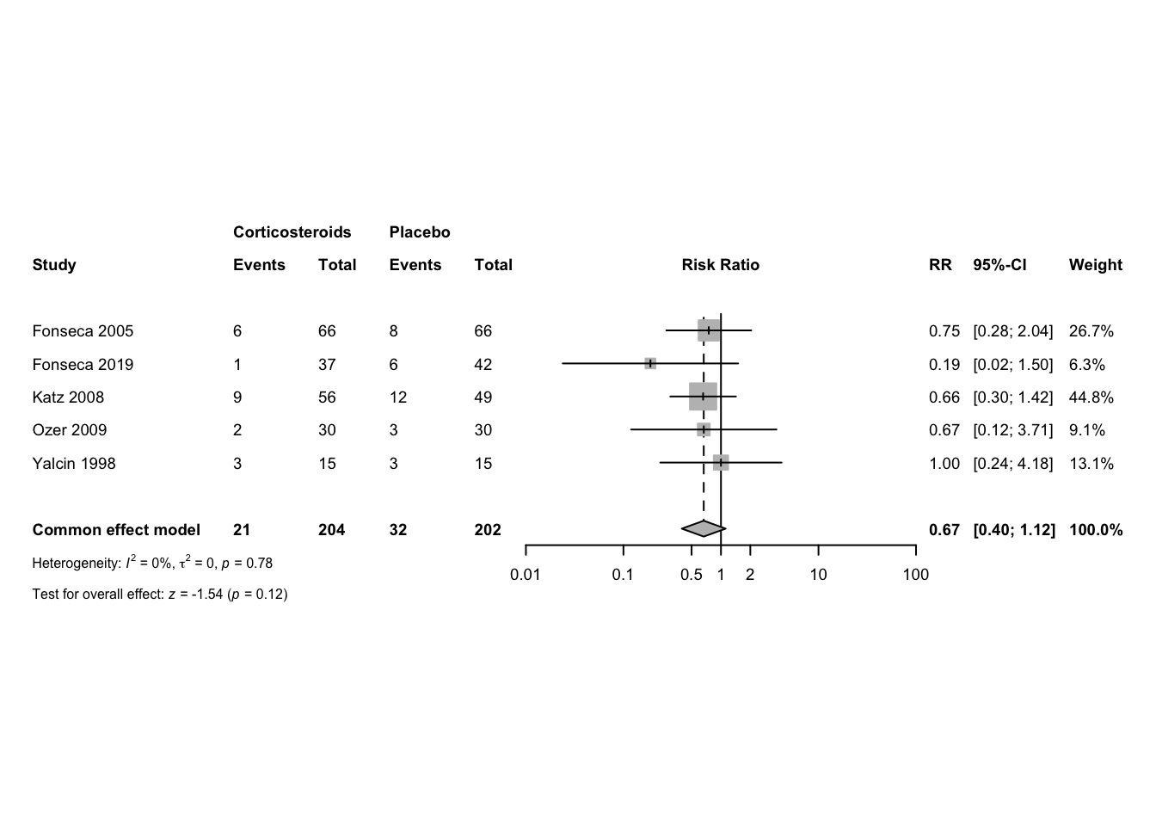

## Dialysis

Number of observations: o = 60

Number of events: e = 1

|  |  |  |  |  |
| --- | --- | --- | --- | --- |
| Study | RR | 95%-CI | z | p-value |
| Ozer 2009 | 3.0000 | [0.1271; 70.7833] | 0.68 | 0.4958 |

Details: Continuity correction of 0.5

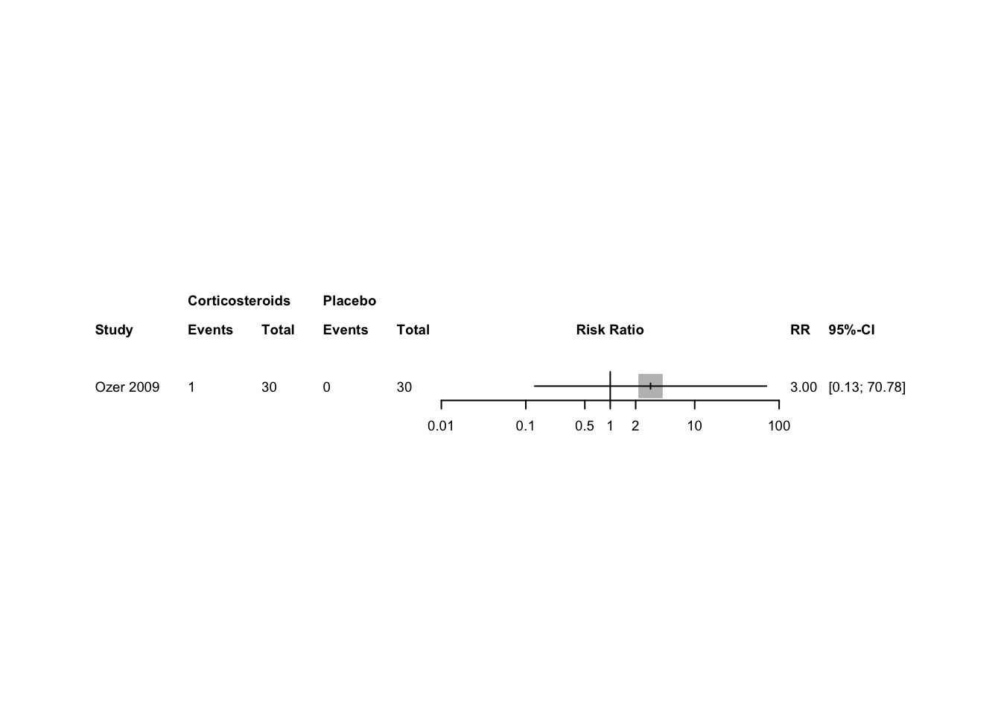

## Liver morbidity

RR 95%-CI %W(common)

Ozer 2009 0.3333 [0.0141; 7.8648] 45.4

Van Runnard 2006 0.1521 [0.0085; 2.7116] 54.6

Number of studies: k = 2

Number of observations: o = 91

Number of events: e = 4

RR 95%-CI z p-value

Common effect model 0.2171 [0.0258; 1.8257] -1.41 0.1598

Quantifying heterogeneity:

tau^2 = 0; tau = 0; I^2 = 0.0%; H = 1.00

Test of heterogeneity:

Q d.f. p-value

0.13 1 0.7191

Details on meta-analytical method:

- Inverse variance method

- Restricted maximum-likelihood estimator for tau^2

- Continuity correction of 0.5 in studies with zero cell frequencies

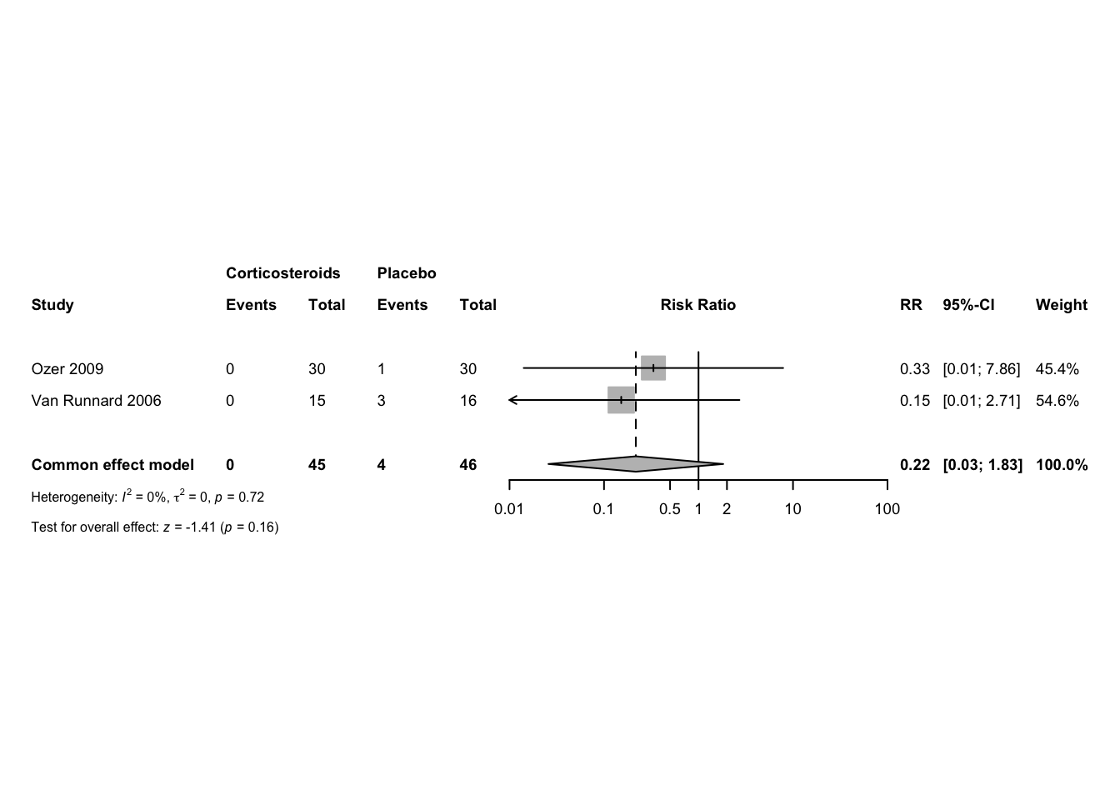

## Platelet transfusion

RR 95%-CI %W(common)

Fonseca 2005 1.2000 [0.5574; 2.5832] 40.5

Fonseca 2019 0.8571 [0.4556; 1.6126] 59.5

Number of studies: k = 2

Number of observations: o = 219

Number of events: e = 49

RR 95%-CI z p-value

Common effect model 0.9821 [0.6031; 1.5994] -0.07 0.9422

Quantifying heterogeneity:

tau^2 = 0; tau = 0; I^2 = 0.0%; H = 1.00

Test of heterogeneity:

Q d.f. p-value

0.44 1 0.5069

Details on meta-analytical method:

- Inverse variance method

- Restricted maximum-likelihood estimator for tau^2

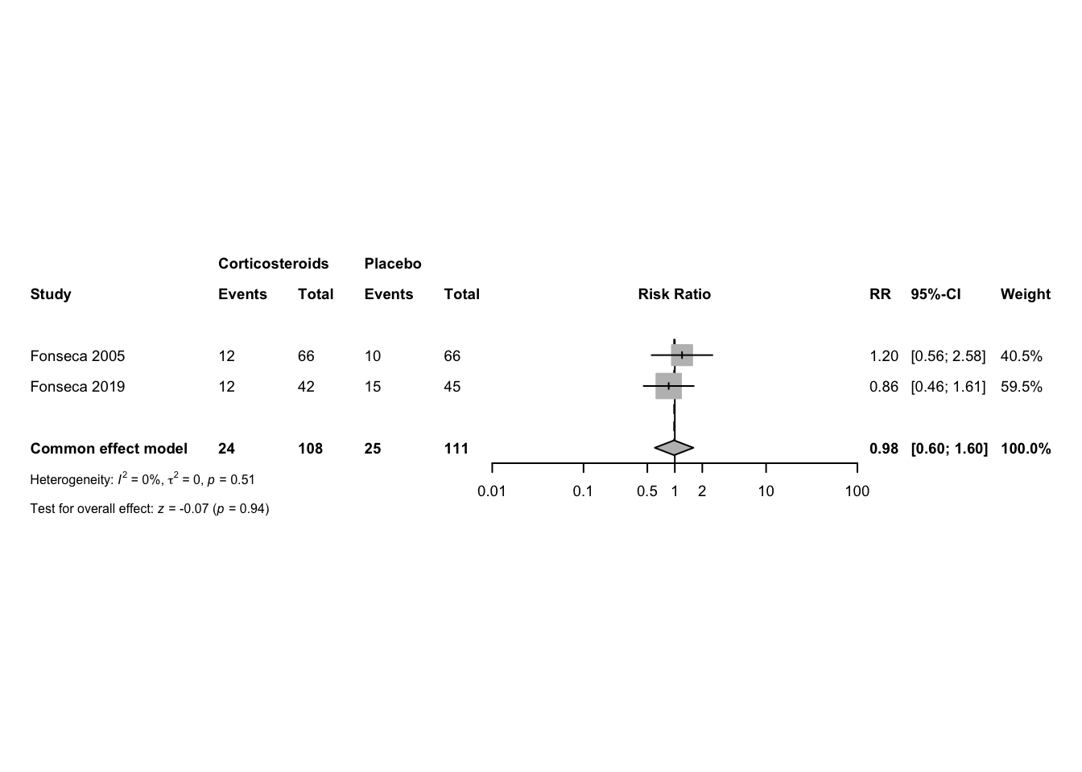

## Perinatal death

RR 95%-CI %W(common)

Magann 1994 0.3611 [0.0432; 3.0169] 28.3

Van Runnard 2006 0.7969 [0.2103; 3.0197] 71.7

Number of studies: k = 2

Number of observations: o = 58

Number of events: e = 11

RR 95%-CI z p-value

Common effect model 0.6372 [0.2062; 1.9693] -0.78 0.4337

Quantifying heterogeneity:

tau^2 = 0; tau = 0; I^2 = 0.0%; H = 1.00

Test of heterogeneity:

Q d.f. p-value

0.38 1 0.5359

Details on meta-analytical method:

- Inverse variance method

- Restricted maximum-likelihood estimator for tau^2

