Results

Descriptives
 | age | pg_years | kscore
N | 167 | 160 | 169
Missing | 2 | 9 | 0
Mean | 40.2 | 16.4 | 8.37
Median | 36.0 | 12.0 | 9
Standard deviation | 10.7 | 10.6 | 3.81
Minimum | 29.0 | 6.00 | 0
Maximum | 70.0 | 46.0 | 15
Shapiro-Wilk W | 0.832 | 0.840 | 0.963
Shapiro-Wilk p | <.001 | <.001 | <.001
25th percentile | 32.0 | 8.00 | 5.00
50th percentile | 36.0 | 12.0 | 9.00
75th percentile | 46.0 | 22.0 | 12.0

Plots

age
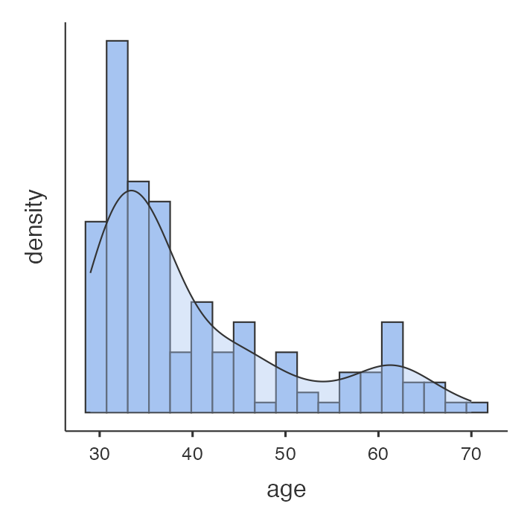
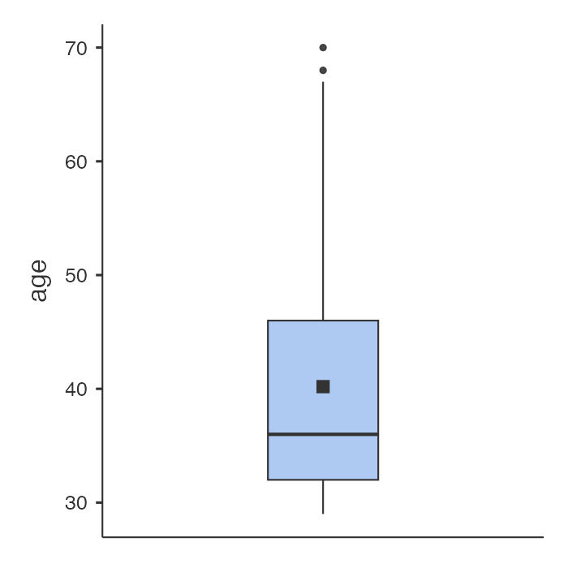

pg_years
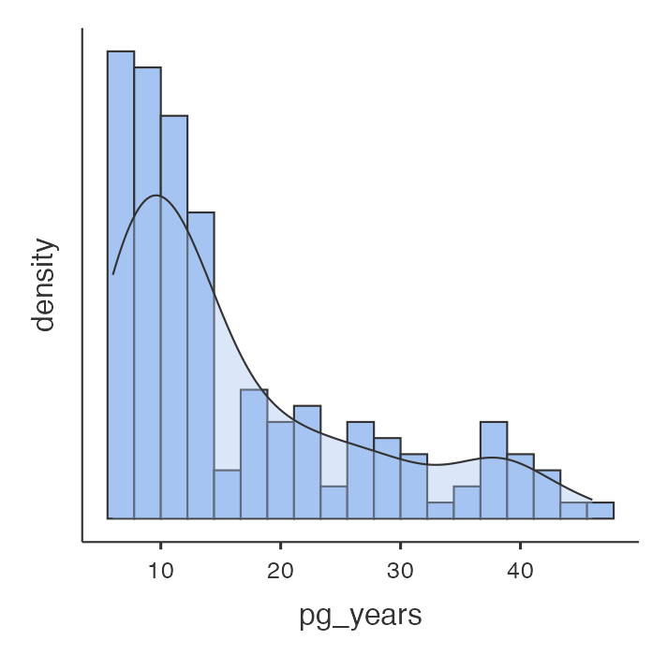
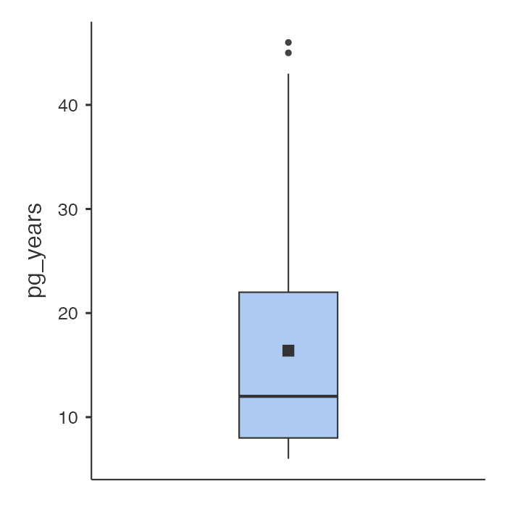

kscore
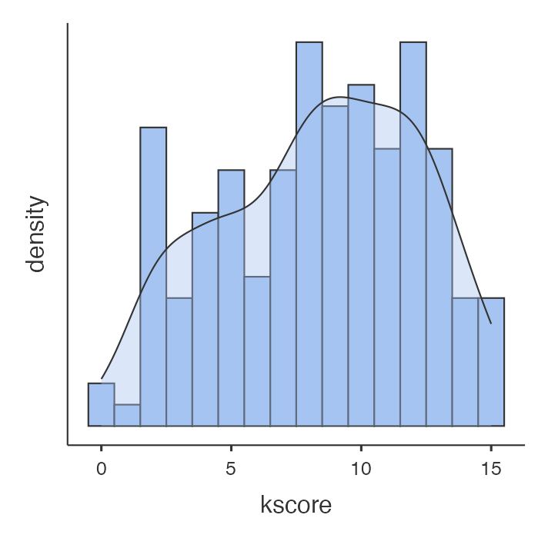
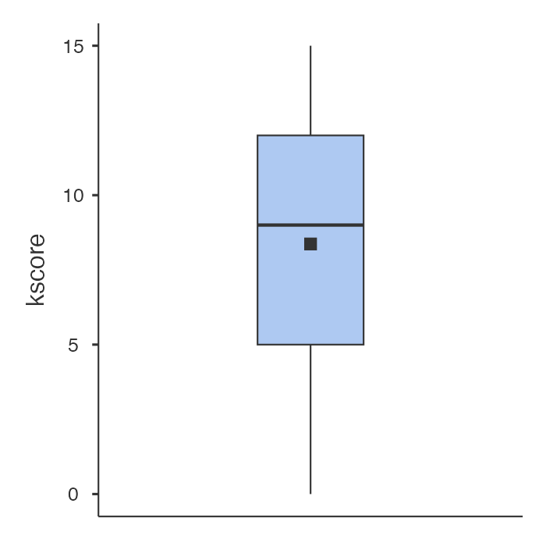

Summary Table of baseline characteristics
Characteristic | N = 169¹
age | 36 (32, 46)
pg_years | 12 (8, 22)
sex
Female | 79 (47%)
Male | 90 (53%)
degree
1 | 97 (57%)
0 | 72 (43%)
subspecialty_rei
Yes | 42 (25%)
No | 127 (75%)
provision
Yes | 142 (84%)
No | 27 (16%)
provision_duration
Less than 5 years | 52 (37%)
Five to ten years | 42 (30%)
More than 10 years | 48 (34%)
facility
Multi-setting | 102 (60%)
Private | 19 (11%)
Public | 48 (28%)
guideline_access
Yes | 106 (63%)
No | 63 (37%)
¹ Median (Q1, Q3); n (%)

Summary Table of knowledge variables
Characteristic | N = 169¹
pgt_a
Correct | 117 (69%)
Incorrect | 52 (31%)
assisted_hatching
Correct | 90 (53%)
Incorrect | 79 (47%)
lymphocyte_immunization
Correct | 72 (43%)
Incorrect | 97 (57%)
corticosteroids
Correct | 33 (20%)
Incorrect | 136 (80%)
progesterone_lps
Correct | 159 (94%)
Incorrect | 10 (5.9%)
sperm_dfi
Correct | 110 (65%)
Incorrect | 59 (35%)
ert_testing
Correct | 114 (67%)
Incorrect | 55 (33%)
hysteroscopy_pre_ivf
Correct | 103 (61%)
Incorrect | 66 (39%)
gnrh_antagonist
Correct | 143 (85%)
Incorrect | 26 (15%)
ivig
Correct | 101 (60%)
Incorrect | 68 (40%)
lif_therapy
Correct | 82 (49%)
Incorrect | 87 (51%)
intralipid
Correct | 73 (43%)
Incorrect | 96 (57%)
elective_freeze_all
Correct | 51 (30%)
Incorrect | 118 (70%)
lmwh_rif
Correct | 44 (26%)
Incorrect | 125 (74%)
endometrial_scratch
Correct | 122 (72%)
Incorrect | 47 (28%)
adequate
Adequate | 72 (43%)
Inadequate | 97 (57%)
kscore | 9 (5, 12)
¹ n (%); Median (Q1, Q3)

Cross Table
 | adequate |  | Total | p-value¹
 | Adequate | Inadequate
sex |  |  |  | 0.017
Female | 26 (36%) | 53 (55%) | 79 (47%)
Male | 46 (64%) | 44 (45%) | 90 (53%)
Total | 72 (100%) | 97 (100%) | 169 (100%)
¹ Pearson’s Chi-squared test

Cross Table
 | adequate |  | Total | p-value¹
 | Adequate | Inadequate
degree |  |  |  | 0.016
1 | 49 (68%) | 48 (49%) | 97 (57%)
0 | 23 (32%) | 49 (51%) | 72 (43%)
Total | 72 (100%) | 97 (100%) | 169 (100%)
¹ Pearson’s Chi-squared test

Cross Table
 | adequate |  | Total | p-value¹
 | Adequate | Inadequate
subspecialty_rei |  |  |  | 0.066
Yes | 23 (32%) | 19 (20%) | 42 (25%)
No | 49 (68%) | 78 (80%) | 127 (75%)
Total | 72 (100%) | 97 (100%) | 169 (100%)
¹ Pearson’s Chi-squared test

Cross Table
 | adequate |  | Total | p-value¹
 | Adequate | Inadequate
provision |  |  |  | 0.006
Yes | 67 (93%) | 75 (77%) | 142 (84%)
No | 5 (6.9%) | 22 (23%) | 27 (16%)
Total | 72 (100%) | 97 (100%) | 169 (100%)
¹ Pearson’s Chi-squared test

Cross Table
 | adequate |  | Total | p-value¹
 | Adequate | Inadequate
provision_duration |  |  |  | 0.036
Less than 5 years | 18 (27%) | 34 (45%) | 52 (37%)
Five to ten years | 20 (30%) | 22 (29%) | 42 (30%)
More than 10 years | 29 (43%) | 19 (25%) | 48 (34%)
Total | 67 (100%) | 75 (100%) | 142 (100%)
¹ Pearson’s Chi-squared test

Cross Table
 | adequate |  | Total | p-value¹
 | Adequate | Inadequate
facility |  |  |  | 0.084
Multi-setting | 49 (68%) | 53 (55%) | 102 (60%)
Private | 9 (13%) | 10 (10%) | 19 (11%)
Public | 14 (19%) | 34 (35%) | 48 (28%)
Total | 72 (100%) | 97 (100%) | 169 (100%)
¹ Pearson’s Chi-squared test

Cross Table
 | adequate |  | Total | p-value¹
 | Adequate | Inadequate
guideline_access |  |  |  | 0.3
Yes | 42 (58%) | 64 (66%) | 106 (63%)
No | 30 (42%) | 33 (34%) | 63 (37%)
Total | 72 (100%) | 97 (100%) | 169 (100%)
¹ Pearson’s Chi-squared test

Total knowledge score
Characteristic | N = 169¹ | p-value²
degree |  | <0.001
1 | 10 (7, 12)
0 | 7 (5, 10)
subspecialty_rei |  | 0.035
Yes | 10 (8, 12)
No | 8 (5, 11)
provision_duration |  | 0.040
Less than 5 years | 8 (5, 11)
Five to ten years | 9 (8, 11)
More than 10 years | 10 (8, 12)
provision |  | <0.001
Yes | 9 (7, 12)
No | 4 (2, 8)
facility |  | 0.056
Multi-setting | 9 (7, 12)
Private | 6 (4, 12)
Public | 8 (4, 10)
guideline_access |  | 0.6
Yes | 9 (5, 12)
No | 9 (6, 11)
¹ kscore: Median (Q1, Q3)
² Wilcoxon rank sum test; Kruskal-Wallis rank sum test

Multivariable Logistic Regression
Characteristic | OR | 95% CI | p-value
age | 0.92 | 0.74, 1.12 | 0.4
pg_years | 1.06 | 0.87, 1.32 | 0.6
sex
Female | — | —
Male | 0.56 | 0.28, 1.13 | 0.11
degree
1 | — | —
0 | 1.41 | 0.66, 3.01 | 0.4
subspecialty_rei
Yes | — | —
No | 1.70 | 0.76, 3.86 | 0.2
provision
Yes | — | —
No | 3.06 | 1.11, 9.90 | 0.041
Abbreviations: CI = Confidence Interval, OR = Odds Ratio

Multivariable Linear Regression
Characteristic | Coefficient | 95% CI | p-value
age | 0.19 | -0.15, 0.52 | 0.3
pg_years | -0.19 | -0.54, 0.15 | 0.3
sex
Female | — | —
Male | 0.59 | -0.58, 1.8 | 0.3
degree
1 | — | —
0 | -1.2 | -2.4, 0.09 | 0.068
subspecialty_rei
Yes | — | —
No | -0.99 | -2.4, 0.39 | 0.2
provision
Yes | — | —
No | -3.0 | -4.5, -1.4 | <0.001
Abbreviation: CI = Confidence Interval

