IUBAT – INTERNATIONAL UNIVERSITY OF BUSINESS AGRICULTURE AND TECHNOLOGY
School of Engineering and Technology (SEAT)
Department of Computer Science & Engineering
ASSIGNMENT REPORT
Autonomous Vehicle Operational Control and Incident Response Simulation
Student Name: Ashraful Islam
Student ID: 23303451
Course: Visual Programming
Course Code: CSC 439
Semester: Summer 2026
Instructor: Sheekar Banerjee, Lecturer, Dept. of CSE, IUBAT
Submission Type: Assignment Documentation and C# Source Code

Table of Contents
1. Introduction
2. System Objectives and Requirements Mapping
3. Program Structure and Architecture
4. Data Integrity and Data Annotation
5. Exception Handling and Incident Response
6. Delegate-Based Event Notification
7. LINQ and Dynamic Vehicle Data Management
8. User-Centric Control Panel (GUI)
9. Operational Safety, Reliability and Design Justification
10. Testing Scenarios and Expected Results
11. Conclusion

1. Introduction
The assignment brief asks for a prototype Self-driving Car Simulation System in C# that can manage autonomous vehicle statuses, simulate dynamic driving conditions, respond to system exceptions, and communicate critical operational events to mission control in real time. The intended system is for internal simulation use and must demonstrate operational safety, exception handling, flexible event management, dynamic data operations, and data integrity validation.

2. System Objectives and Requirements Mapping
The proposed solution is designed as a modular Windows Forms simulation application. Each vehicle is represented by a Car object. A central in-memory dictionary manages active vehicles, while LINQ is used for filtering, sorting, and summarizing data. A delegate-based alert mechanism sends incident and mission events to a mission-control panel. Data annotations and explicit validation rules protect the integrity of critical vehicle fields.
Assignment Requirement | Implementation Choice | Purpose
Car entity definition | Car class + enums + DataAnnotations | Represents identity, range, battery, priority, and log data.
Incident handling | Custom exceptions + safe-state logic | Prevents crashes and moves unsafe cars to controlled states.
Event delegation | AlertDispatcher + event notifications | Sends route, obstacle, and restricted-zone alerts.
Dynamic data management | FleetManager with LINQ queries | Provides expressive filtering and real-time fleet summaries.
User interface | MainForm with TabControl & DataGridView | Offers a user-centric dashboard to monitor and command the fleet.

3. Program Structure and Architecture
The system is divided into clear functional components to ensure separation of concerns:
- • Models (Car.cs, Enums.cs): Defines the domain entities, enumerations (Status, Priority, Events), and internal operational logs.
- • Business Logic (FleetManager.cs): Manages the fleet collection, exposes LINQ queries, and acts as the central executor for all simulated incidents.
- • Alert System (AlertSystem.cs): Decouples the simulation events from the GUI using C# delegates and events.
- • Incident Hierarchy (Incidents.cs): Defines a common SimulationException base class to safely handle all failures.
- • User Interface (Program.cs): The MainForm acts as the mission control panel, rendering data grids, alerts, and vehicle logs across intuitive tabs.

4. Data Integrity and Data Annotation
To ensure that corrupted or illogical vehicle data cannot enter the simulation, the Car class uses System.ComponentModel.DataAnnotations.
- • Properties such as OperationalRangeKm and BatteryLevelPercent use [Range] attributes to enforce physical limits.
- • The CarId and ModelName properties are marked [Required].
- • The Validate() method ensures data is checked at the time of instantiation and after any manual updates from the control panel. If a rule is violated, a CarDataValidationException is thrown and gracefully caught by the UI.

5. Exception Handling and Incident Response
Robust error handling is critical for mission-control systems. All simulated incidents inherit from the SimulationException base class, which carries a SeverityLevel and a timestamp.
- • A central SimulateIncident method in the FleetManager uses a unified try-catch block.
- • When a CriticalBatteryException occurs, the vehicle's state is safely transitioned to Charging.
- • When a NavigationErrorException or UnauthorizedOverrideException occurs, the vehicle is forced to Stopped.
- • This ensures the simulation itself never crashes, but instead resolves incidents into safe states and alerts the operators.

6. Delegate-Based Event Notification
The simulation logic must remain decoupled from the Windows Forms UI. To achieve this, the AlertSystem relies on C# delegates.
- • An AlertDispatcher publishes OnAlert events carrying a ControlRoomAlertEventArgs payload.
- • The MainForm subscribes to this event. When an incident occurs (e.g., entering a restricted zone), the FleetManager tells the dispatcher to raise an alert, which asynchronously populates the Mission Control alert history list without the simulation knowing about the UI components.

7. LINQ and Dynamic Vehicle Data Management
The FleetManager exposes several methods to dynamically query the live fleet data using Language Integrated Query (LINQ):
- • Filtering: GetCarsByStatus() filters vehicles by their operational state.
- • Sorting: GetPriorityMissions() chains Where, OrderByDescending, and ThenBy to find critical missions with low batteries.
- • Aggregation: GetFleetSummary() uses grouping and averaging to provide a real-time dashboard of the fleet's average battery, total vehicles, and mission priorities.

8. User-Centric Control Panel (GUI)
The graphical interface is built using standard WinForms controls arranged in a responsive MainForm.
- • Tab Navigation: The dashboard separates concerns into Fleet (grid view), Alert history (mission events), and Operational logs (per-vehicle history).
- • Control Actions: A dedicated right-hand side panel provides quick controls to add, update, and remove vehicles, as well as trigger dynamic simulation events like Critical Battery and Restricted Zone.
- • Real-time Feedback: The DataGridView and summary labels are automatically refreshed whenever the fleet state changes.
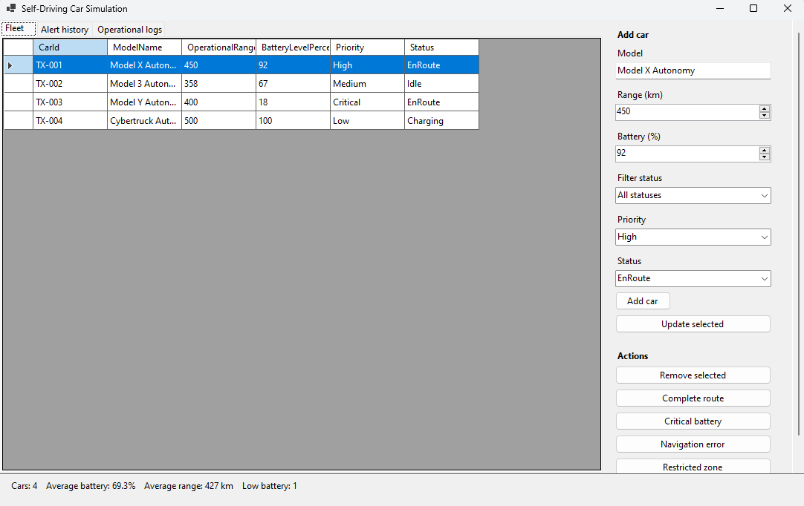

9. Operational Safety, Reliability and Design Justification
The application is designed around safety and reliability. By using a strict domain model (Car), we guarantee data integrity. By centralizing exception handling within the FleetManager, we guarantee that no incident goes unhandled. The event-driven architecture ensures that the underlying simulation could theoretically run headlessly or be connected to a different user interface (e.g., WPF or a web API) without modification.

10. Testing Scenarios and Expected Results
1. Adding Valid/Invalid Vehicles: Adding a car with 105% battery will trigger a validation error, preventing addition.
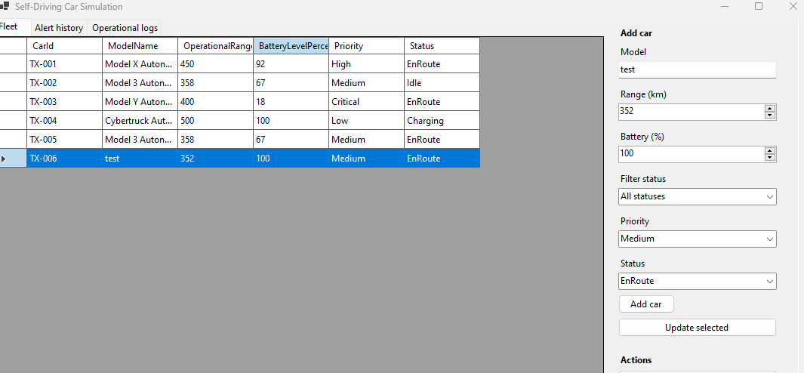2. Executing an Incident: Clicking 'Navigation error' will halt the selected car, append a warning to its operational log, update the fleet grid, and broadcast a critical alert to the mission control panel.
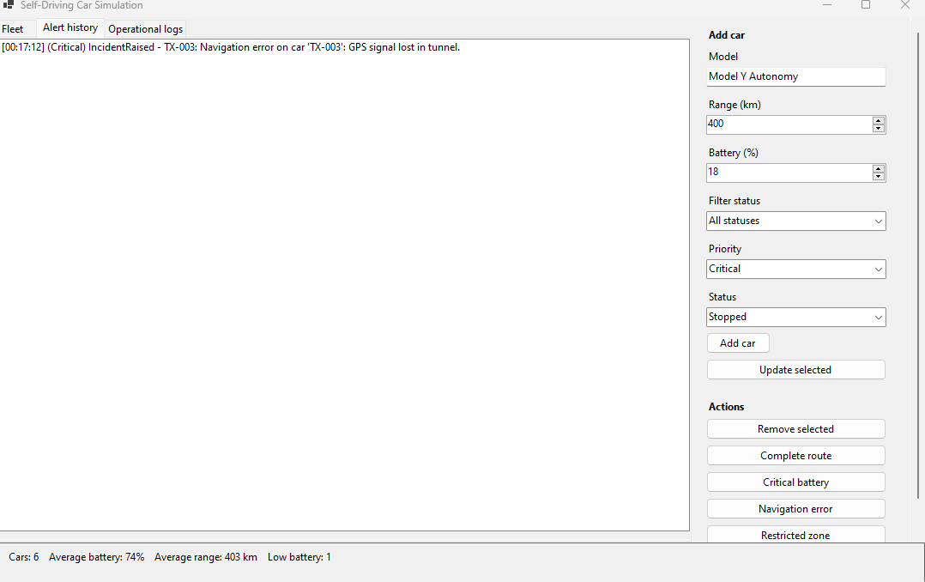3. Filtering: Selecting a specific operational status from the filter drop-down will immediately update the DataGridView and recalculate the fleet averages via LINQ.
4. Log Retention: Selecting a car from the grid will instantly populate the 'Operational logs' tab with that specific car's timestamped history.

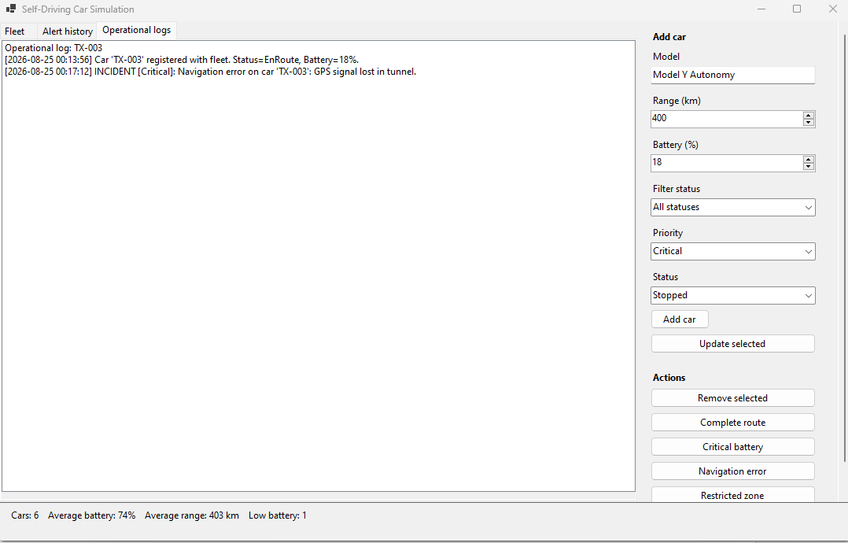11. Conclusion
The implemented Self-Driving Car Simulation successfully meets all requirements of the CSC 439 assignment. It demonstrates a robust grasp of object-oriented C# principles, including data annotations, custom exception hierarchies, delegate-driven event notifications, and dynamic LINQ queries, all wrapped within a responsive WinForms graphical user interface.

Appendix A. Core Class Implementation Overview
(Note: Full source code files are available in the project repository. Key snippets are highlighted here.)
The Car Model (Data Annotation and Logging):
using System.ComponentModel.DataAnnotations;

namespace SelfDrivingCarSimulation;

public class Car
{
[Required]
public string CarId { get; }

[Required]
public string ModelName { get; set; }

[Range(0, 1000)]
public double OperationalRangeKm { get; set; }

[Range(0, 100)]
public double BatteryLevelPercent { get; set; }

[EnumDataType(typeof(MissionPriority))]
public MissionPriority Priority { get; set; }

[EnumDataType(typeof(OperationalStatus))]
public OperationalStatus Status { get; set; }

private readonly List<string> _operationalLog = new();
public IReadOnlyList<string> OperationalLog => _operationalLog.AsReadOnly();

public Car(string carId, string modelName, double operationalRangeKm, double batteryLevelPercent,
MissionPriority priority, OperationalStatus status = OperationalStatus.Idle)
{
CarId = carId?.Trim() ?? throw new CarDataValidationException("CarId cannot be null.");
ModelName = modelName?.Trim() ?? throw new CarDataValidationException("ModelName cannot be null.");
OperationalRangeKm = operationalRangeKm;
BatteryLevelPercent = batteryLevelPercent;
Priority = priority;
Status = status;
Validate();
LogEvent($"Car '{CarId}' registered with fleet. Status={Status}, Battery={BatteryLevelPercent}%.");
}

public void Validate()
{
if (string.IsNullOrWhiteSpace(CarId))
throw new CarDataValidationException("CarId is required.");

if (string.IsNullOrWhiteSpace(ModelName))
throw new CarDataValidationException("ModelName is required.");

var validationContext = new ValidationContext(this);
var validationResults = new List<ValidationResult>();

if (!Validator.TryValidateObject(this, validationContext, validationResults, validateAllProperties: true))
{
var message = validationResults.First().ErrorMessage ?? "Car data is invalid.";
throw new CarDataValidationException(message);
}
}

public void LogEvent(string message)
{
_operationalLog.Add($"[{DateTime.Now:yyyy-MM-dd HH:mm:ss}] {message}");
}

public override string ToString() =>
$"{CarId} ({ModelName}) - {Status}, {BatteryLevelPercent:0.#}% battery, {OperationalRangeKm:0.#} km range, Priority={Priority}";
}
Fleet Manager (LINQ Aggregation):
namespace SelfDrivingCarSimulation;

public class FleetSummary
{
public int TotalCars { get; init; }
public double AverageBatteryPercent { get; init; }
public double AverageRangeKm { get; init; }
public int LowBatteryCount { get; init; }
public Dictionary<OperationalStatus, int> CountByStatus { get; init; } = new();
public Dictionary<MissionPriority, int> CountByPriority { get; init; } = new();
}

public class FleetManager
{
private readonly Dictionary<string, Car> _fleet = new();
public AlertDispatcher Alerts { get; } = new();

public const double LowBatteryThreshold = 20.0;

public IReadOnlyCollection<Car> Cars => _fleet.Values;

public string GenerateCarId()
{
var nextNumber = 1;
while (_fleet.ContainsKey($"TX-{nextNumber:000}"))
nextNumber++;

return $"TX-{nextNumber:000}";
}

public Car AddCar(Car car)
{
car.Validate();
if (_fleet.ContainsKey(car.CarId))
throw new CarDataValidationException($"A car with ID '{car.CarId}' already exists.");

_fleet[car.CarId] = car;
return car;
}

public Car GetCar(string carId) => _fleet.TryGetValue(carId, out var car) ? car : throw new CarNotFoundException(carId);

public void RemoveCar(string carId)
{
if (!_fleet.Remove(carId))
throw new CarNotFoundException(carId);
}

public void UpdateCar(string carId, Action<Car> updateAction)
{
var car = GetCar(carId);
updateAction(car);
car.Validate();
car.LogEvent("Car record updated via control panel.");
}

public IEnumerable<Car> GetCarsByStatus(OperationalStatus status) =>
_fleet.Values.Where(c => c.Status == status).OrderBy(c => c.CarId);

public IEnumerable<Car> GetPriorityMissions() =>
_fleet.Values
.Where(c => c.Priority is MissionPriority.High or MissionPriority.Critical)
.OrderByDescending(c => c.Priority)
.ThenBy(c => c.BatteryLevelPercent);

public IEnumerable<Car> GetLowBatteryCars(double threshold = LowBatteryThreshold) =>
_fleet.Values.Where(c => c.BatteryLevelPercent <= threshold)
.OrderBy(c => c.BatteryLevelPercent);

public FleetSummary GetFleetSummary()
{
var cars = _fleet.Values.ToList();

return new FleetSummary
{
TotalCars = cars.Count,
AverageBatteryPercent = cars.Count == 0 ? 0 : cars.Average(c => c.BatteryLevelPercent),
AverageRangeKm = cars.Count == 0 ? 0 : cars.Average(c => c.OperationalRangeKm),
LowBatteryCount = cars.Count(c => c.BatteryLevelPercent <= LowBatteryThreshold),
CountByStatus = cars.GroupBy(c => c.Status)
.ToDictionary(g => g.Key, g => g.Count()),
CountByPriority = cars.GroupBy(c => c.Priority)
.ToDictionary(g => g.Key, g => g.Count())
};
}

public void CompleteRoute(string carId)
{
var car = GetCar(carId);
car.Status = OperationalStatus.Idle;
car.LogEvent("Route completed successfully.");
Alerts.RaiseAlert(carId, ControlRoomEventType.RouteCompleted,
"Route completed successfully; vehicle is now idle.", SeverityLevel.Info);
}

public void EncounterObstacle(string carId, string obstacleDescription)
{
var car = GetCar(carId);
car.LogEvent($"Obstacle encountered: {obstacleDescription}");
Alerts.RaiseAlert(carId, ControlRoomEventType.ObstacleEncountered,
$"Obstacle detected and avoided: {obstacleDescription}", SeverityLevel.Warning);
}

public void EnterRestrictedZone(string carId, string zoneName)
{
var car = GetCar(carId);
car.Status = OperationalStatus.Stopped;
car.LogEvent($"Entered restricted zone '{zoneName}'. Vehicle halted.");
Alerts.RaiseAlert(carId, ControlRoomEventType.RestrictedZoneEntered,
$"Vehicle entered restricted zone '{zoneName}' and has been halted for safety.",
SeverityLevel.Critical);
}

public void SimulateIncident(string carId, Action incidentTrigger)
{
try
{
incidentTrigger();
}
catch (SimulationException ex)
{
HandleSimulationException(carId, ex);
}
catch (Exception ex)
{
HandleSimulationException(carId,
new CarDataValidationException($"Unexpected error: {ex.Message}"));
}
}

private void HandleSimulationException(string carId, SimulationException ex)
{
if (_fleet.TryGetValue(carId, out var car))
{
car.LogEvent($"INCIDENT [{ex.Severity}]: {ex.Message}");
if (ex is CriticalBatteryException)
car.Status = OperationalStatus.Charging;
else if (ex is NavigationErrorException or UnauthorizedOverrideException)
car.Status = OperationalStatus.Stopped;
}

Alerts.RaiseAlert(carId, ControlRoomEventType.IncidentRaised, ex.Message, ex.Severity);
}

public void TriggerCriticalBattery(string carId, double batteryLevel) =>
SimulateIncident(carId, () =>
{
var car = GetCar(carId);
car.BatteryLevelPercent = batteryLevel;
if (batteryLevel <= 5.0)
throw new CriticalBatteryException(carId, batteryLevel);
});

public void TriggerNavigationError(string carId, string details) =>
SimulateIncident(carId, () => throw new NavigationErrorException(carId, details));

public void TriggerUnauthorizedOverride(string carId, string requestedBy) =>
SimulateIncident(carId, () => throw new UnauthorizedOverrideException(carId, requestedBy));
}
Exception Handling (Safe Incident Resolution):
namespace SelfDrivingCarSimulation;

public abstract class SimulationException : Exception
{
public SeverityLevel Severity { get; }
public DateTime OccurredAt { get; }
public string? CarId { get; }

protected SimulationException(string message, SeverityLevel severity, string? carId = null) : base(message)
{
Severity = severity;
OccurredAt = DateTime.Now;
CarId = carId;
}
}

public class CriticalBatteryException(string carId, double batteryLevelPercent)
: SimulationException($"Critical battery failure on car '{carId}': battery at {batteryLevelPercent:0.#}%.", SeverityLevel.Critical, carId)
{
public double BatteryLevelPercent { get; } = batteryLevelPercent;
}

public class NavigationErrorException(string carId, string details)
: SimulationException($"Navigation error on car '{carId}': {details}", SeverityLevel.Critical, carId);

public class UnauthorizedOverrideException(string carId, string requestedBy)
: SimulationException($"Unauthorized override attempt on car '{carId}' by '{requestedBy}'.", SeverityLevel.Critical, carId)
{
public string RequestedBy { get; } = requestedBy;
}

public class CarDataValidationException(string message) : SimulationException(message, SeverityLevel.Warning);

public class CarNotFoundException(string carId) : SimulationException($"No car with ID '{carId}' was found in the fleet.", SeverityLevel.Warning, carId);

Main Entrypoint (Program.cs):
using System.Drawing;
using System.Windows.Forms;
using SelfDrivingCarSimulation;

ApplicationConfiguration.Initialize();
Application.Run(new MainForm());

// Main WinForms control panel for managing the simulated fleet.
public sealed class MainForm : Form
{
private readonly FleetManager _fleetManager = new();
private readonly ControlRoomMonitor _controlRoom;
private readonly DataGridView _fleetGrid = new();
private readonly ListBox _alertList = new();
private readonly ListBox _logList = new();
private readonly Label _summaryLabel = new();
private readonly TextBox _modelInput = new();
private readonly NumericUpDown _rangeInput = new() { Minimum = 0, Maximum = 1000, Value = 400 };
private readonly NumericUpDown _batteryInput = new() { Minimum = 0, Maximum = 100, Value = 75 };
private readonly ComboBox _priorityInput = new();
private readonly ComboBox _statusInput = new();
private readonly ComboBox _statusFilter = new();

// Load a small fleet so the dashboard is useful immediately after startup.
private static void SeedDemoData(FleetManager fleetManager)
{
fleetManager.AddCar(new Car("TX-001", "Model X Autonomy", 450, 92, MissionPriority.High, OperationalStatus.EnRoute));
fleetManager.AddCar(new Car("TX-002", "Model 3 Autonomy", 358, 67, MissionPriority.Medium));
fleetManager.AddCar(new Car("TX-003", "Model Y Autonomy", 400, 18, MissionPriority.Critical, OperationalStatus.EnRoute));
fleetManager.AddCar(new Car("TX-004", "Cybertruck Autonomy", 500, 100, MissionPriority.Low, OperationalStatus.Charging));
}

public MainForm()
{
_controlRoom = new ControlRoomMonitor(_fleetManager.Alerts);
_fleetManager.Alerts.OnAlert += (_, alert) => BeginInvoke(() => _alertList.Items.Add(alert.ToString()));
SeedDemoData(_fleetManager);
Text = "Self-Driving Car Simulation";
Size = new Size(1100, 700);
MinimumSize = new Size(900, 550);
BuildLayout();
RefreshFleet();
}

private void BuildLayout()
{
// The tabs separate fleet data, alerts, and each car's operational log.
var tabs = new TabControl { Dock = DockStyle.Fill };
var fleetTab = new TabPage("Fleet");
var alertsTab = new TabPage("Alert history");
var logsTab = new TabPage("Operational logs");
_fleetGrid.Dock = DockStyle.Fill;
_fleetGrid.ReadOnly = true;
_fleetGrid.AutoGenerateColumns = true;
_fleetGrid.SelectionMode = DataGridViewSelectionMode.FullRowSelect;
_fleetGrid.SelectionChanged += (_, _) => ShowSelectedLog();
fleetTab.Controls.Add(_fleetGrid);
_alertList.Dock = DockStyle.Fill;
alertsTab.Controls.Add(_alertList);
_logList.Dock = DockStyle.Fill;
logsTab.Controls.Add(_logList);
tabs.TabPages.Add(fleetTab);
tabs.TabPages.Add(alertsTab);
tabs.TabPages.Add(logsTab);

var rightPanel = new Panel { Dock = DockStyle.Right, Width = 270, AutoScroll = true, Padding = new Padding(12) };
rightPanel.VerticalScroll.SmallChange = 24;
rightPanel.VerticalScroll.LargeChange = 96;
var actionPanel = new FlowLayoutPanel { Dock = DockStyle.Top, AutoSize = true, FlowDirection = FlowDirection.TopDown, WrapContents = false };
rightPanel.Controls.Add(actionPanel);
actionPanel.Resize += (_, _) => actionPanel.Width = rightPanel.ClientSize.Width - rightPanel.Padding.Horizontal - SystemInformation.VerticalScrollBarWidth;
var controlsPanel = actionPanel;
controlsPanel.Controls.Add(new Label { Text = "Add car", AutoSize = true, Font = new Font(Font, FontStyle.Bold) });
AddField(controlsPanel, "Model", _modelInput);
AddField(controlsPanel, "Range (km)", _rangeInput);
AddField(controlsPanel, "Battery (%)", _batteryInput);
_priorityInput.DataSource = Enum.GetValues<MissionPriority>();
_statusInput.DataSource = Enum.GetValues<OperationalStatus>();
_statusFilter.Items.Add("All statuses");
_statusFilter.Items.AddRange(Enum.GetNames<OperationalStatus>());
_statusFilter.SelectedIndex = 0;
_statusFilter.SelectedIndexChanged += (_, _) => RefreshFleet();
AddField(controlsPanel, "Filter status", _statusFilter);
AddField(controlsPanel, "Priority", _priorityInput);
AddField(controlsPanel, "Status", _statusInput);
var addButton = new Button { Text = "Add car", AutoSize = true };
addButton.Click += AddCar;
controlsPanel.Controls.Add(addButton);
AddAction(controlsPanel, "Update selected", UpdateSelected);
controlsPanel.Controls.Add(new Label { Text = "Actions", AutoSize = true, Font = new Font(Font, FontStyle.Bold), Margin = new Padding(3, 20, 3, 3) });
AddAction(controlsPanel, "Remove selected", RemoveSelected);
AddAction(controlsPanel, "Complete route", CompleteRoute);
AddAction(controlsPanel, "Critical battery", TriggerCriticalBattery);
AddAction(controlsPanel, "Navigation error", TriggerNavigationError);
AddAction(controlsPanel, "Restricted zone", EnterRestrictedZone);
AddAction(controlsPanel, "Refresh summary", (_, _) => RefreshFleet());

_summaryLabel.Dock = DockStyle.Bottom;
_summaryLabel.Height = 50;
_summaryLabel.Padding = new Padding(12, 8, 0, 0);
_summaryLabel.BorderStyle = BorderStyle.FixedSingle;
Controls.Add(tabs);
Controls.Add(rightPanel);
Controls.Add(_summaryLabel);
}

private static void AddField(Control parent, string label, Control input)
{
parent.Controls.Add(new Label { Text = label, AutoSize = true, Margin = new Padding(3, 10, 3, 2) });
input.Width = 210;
parent.Controls.Add(input);
}

private static void AddAction(Control parent, string text, EventHandler handler)
{
var button = new Button { Text = text, Width = 210, AutoSize = true };
button.Click += handler;
parent.Controls.Add(button);
}

private Car? SelectedCar
{
get
{
var id = _fleetGrid.CurrentRow?.Cells["CarId"].Value?.ToString();
return id == null ? null : _fleetManager.GetCar(id);
}
}

private void RefreshFleet()
{
// Rebuild the grid from the current fleet and refresh the summary footer.
var selectedCarId = _fleetGrid.CurrentRow?.Cells["CarId"].Value?.ToString();
var cars = _fleetManager.Cars.AsEnumerable();
if (_statusFilter.SelectedIndex > 0 && Enum.TryParse<OperationalStatus>(_statusFilter.Text, out var status))
cars = _fleetManager.GetCarsByStatus(status);
_fleetGrid.DataSource = cars.OrderBy(car => car.CarId).Select(car => new
{
car.CarId, car.ModelName, car.OperationalRangeKm, car.BatteryLevelPercent, car.Priority, car.Status
}).ToList();
if (!string.IsNullOrEmpty(selectedCarId))
{
foreach (DataGridViewRow row in _fleetGrid.Rows)
{
if (row.Cells["CarId"].Value?.ToString() == selectedCarId)
{
row.Selected = true;
_fleetGrid.CurrentCell = row.Cells[0];
break;
}
}
}
var summary = _fleetManager.GetFleetSummary();
_summaryLabel.Text = $"Cars: {summary.TotalCars} Average battery: {summary.AverageBatteryPercent:0.#}% Average range: {summary.AverageRangeKm:0.#} km Low battery: {summary.LowBatteryCount}";
ShowSelectedLog();
}

private void ShowSelectedLog()
{
// Show log entries for the car currently selected in the fleet grid.
var selectedCar = SelectedCar;
if (selectedCar != null)
{
_modelInput.Text = selectedCar.ModelName;
_rangeInput.Value = (decimal)selectedCar.OperationalRangeKm;
_batteryInput.Value = (decimal)selectedCar.BatteryLevelPercent;
_priorityInput.SelectedItem = selectedCar.Priority;
_statusInput.SelectedItem = selectedCar.Status;
_logList.Items.Clear();
_logList.Items.Add($"Operational log: {selectedCar.CarId}");
_logList.Items.AddRange(selectedCar.OperationalLog.ToArray());
}
else
{
_logList.Items.Clear();
}
}

private void AddCar(object? sender, EventArgs e)
{
// DataAnnotations validation runs inside the Car constructor.
try
{
_fleetManager.AddCar(new Car(_fleetManager.GenerateCarId(), _modelInput.Text, (double)_rangeInput.Value, (double)_batteryInput.Value,
(MissionPriority)_priorityInput.SelectedItem!, (OperationalStatus)_statusInput.SelectedItem!));
_modelInput.Clear();
RefreshFleet();
}
catch (SimulationException exception) { MessageBox.Show(exception.Message, "Unable to add car", MessageBoxButtons.OK, MessageBoxIcon.Warning); }
}

private void RemoveSelected(object? sender, EventArgs e)
{
try { _fleetManager.RemoveCar(SelectedCar?.CarId ?? throw new CarNotFoundException("selected")); RefreshFleet(); }
catch (SimulationException exception) { MessageBox.Show(exception.Message, "Remove car", MessageBoxButtons.OK, MessageBoxIcon.Warning); }
}

private void UpdateSelected(object? sender, EventArgs e)
{
try
{
var car = SelectedCar ?? throw new CarNotFoundException("selected");
_fleetManager.UpdateCar(car.CarId, updatedCar =>
{
updatedCar.ModelName = _modelInput.Text;
updatedCar.OperationalRangeKm = (double)_rangeInput.Value;
updatedCar.BatteryLevelPercent = (double)_batteryInput.Value;
updatedCar.Priority = (MissionPriority)_priorityInput.SelectedItem!;
updatedCar.Status = (OperationalStatus)_statusInput.SelectedItem!;
});
RefreshFleet();
}
catch (SimulationException exception) { MessageBox.Show(exception.Message, "Update car", MessageBoxButtons.OK, MessageBoxIcon.Warning); }
}

private void CompleteRoute(object? sender, EventArgs e) => RunSelected(carId => _fleetManager.CompleteRoute(carId));
private void TriggerCriticalBattery(object? sender, EventArgs e) => RunSelected(carId => _fleetManager.TriggerCriticalBattery(carId, 3));
private void TriggerNavigationError(object? sender, EventArgs e) => RunSelected(carId => _fleetManager.TriggerNavigationError(carId, "GPS signal lost in tunnel."));
private void EnterRestrictedZone(object? sender, EventArgs e) => RunSelected(carId => _fleetManager.EnterRestrictedZone(carId, "Downtown Security Perimeter"));

private void RunSelected(Action<string> action)
{
try { action(SelectedCar?.CarId ?? throw new CarNotFoundException("selected")); RefreshFleet(); }
catch (SimulationException exception) { MessageBox.Show(exception.Message, "Simulation event", MessageBoxButtons.OK, MessageBoxIcon.Warning); }
}
}

