INTELLIGENT PRODUCT SEARCH
End-to-End Project & EC2 Deployment Documentation
NLP + Embeddings + Vector Search + Cross-Encoder Reranking + LLM Agent + FastAPI + Docker + Nginx

Deployment environment: AWS EC2
Public access: http://3.110.43.194
Backend API: FastAPI on port 8000
Reverse proxy / web server: Nginx

Document purpose
This document captures the complete Intelligent Product Search project, the workflow followed from catalog ingestion to final LLM response, the production-style EC2 deployment architecture, deployment/verification commands, Nginx routing, testing steps, troubleshooting guidance, and the planned HTTPS/catalog-expansion work.

1. Project Overview
The Intelligent Product Search project is an NLP-powered product discovery system designed to understand natural-language shopping queries instead of relying only on exact keyword matching. A user can describe the product they want using intent, attributes, gender, price constraints, spelling mistakes, and natural language. The system processes the query, converts semantic text into embeddings, searches a ChromaDB vector store, reranks candidate products with a cross-encoder, and uses an LLM agent to produce a natural final response.

Primary objective
- Understand natural-language product queries.
- Handle spelling mistakes and variations in user wording.
- Separate semantic intent from structured filters such as gender and price.
- Retrieve semantically relevant products using vector search.
- Improve ranking quality using Cross-Encoder reranking.
- Use an LLM agent to interpret the request and present the results conversationally.
- Expose the working application through an AWS EC2 instance.
- Keep the existing FastAPI/Docker backend working while adding Nginx as the public-facing web server.

Example query
comfortable ruuning shoes for male under 5000
The query-processing layer can correct the misspelling, identify the semantic intent as 'comfortable running shoes', normalize gender to Men, and extract a maximum price of ₹5,000. The semantic search and filtering stages then operate on this structured representation.

2. Final Deployment Architecture
The deployed architecture separates public web traffic from the application API. Nginx receives Internet traffic on the EC2 instance and serves the UI while proxying API requests to the FastAPI container running on port 8000.
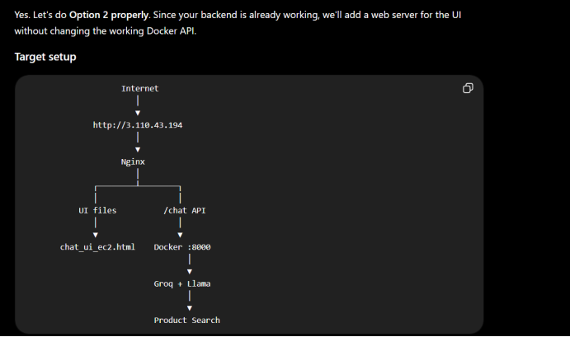
Figure 1. EC2 public-access architecture used for the deployment.

Request routing
- User opens the EC2 public IP in a browser.
- Nginx receives the HTTP request on the public web port.
- Requests for the UI are served by Nginx from the configured web directory.
- Requests intended for the chat/search API are proxied by Nginx to FastAPI on localhost:8000.
- FastAPI invokes the LLM/agent workflow.
- The agent calls the product-search tool when product retrieval is required.
- The product-search tool performs embedding generation, vector retrieval, filtering/ranking, and Cross-Encoder reranking.
- The retrieved product information is returned to the LLM.
- The LLM creates the final user-facing response, which is returned through FastAPI and Nginx.

3. Application Workflow
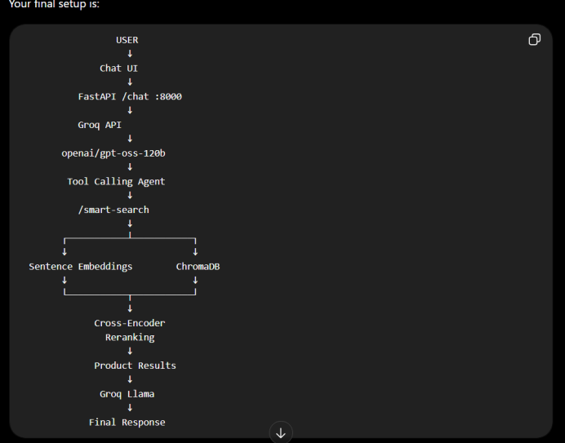
Figure 2. Application-level workflow from Chat UI to final product-search response.

Detailed workflow
1. User input: The user enters a natural-language product request in the Chat UI.
2. Chat UI: The browser sends the conversation history and current user message to the FastAPI chat endpoint.
3. FastAPI: FastAPI acts as the application/API layer and passes the request to the LLM agent.
4. Groq API: The application sends the LLM request to Groq using the configured model. The deployed flow uses openai/gpt-oss-120b as shown in the project architecture.
5. Tool-calling agent: The LLM decides whether the product-search tool is required. For product queries it invokes /smart-search.
6. Query understanding: The search layer normalizes the query, handles spelling corrections, extracts structured filters, and prepares the semantic query.
7. Sentence embeddings: The semantic query is converted into a dense vector using SentenceTransformer/all-MiniLM-L6-v2.
8. ChromaDB retrieval: The query embedding is compared with stored product embeddings in the ChromaDB collection.
9. Candidate results: The most relevant product candidates are collected from vector search and applicable structured filters.
10. Cross-Encoder reranking: Candidate products are scored again with cross-encoder/ms-marco-MiniLM-L-6-v2 to improve relevance ordering.
11. Product results: The ranked products are returned to the agent as structured search results.
12. Final LLM response: The LLM converts the retrieved information into a concise conversational answer for the user.

4. Major Components and Responsibilities
Component | Technology | Responsibility
Frontend | HTML / JavaScript Chat UI | Collects user input, displays conversation and product responses.
API layer | FastAPI | Provides chat/search HTTP endpoints and connects UI with the agent.
LLM provider | Groq API | Runs the configured LLM and supports tool-calling behavior.
LLM model | openai/gpt-oss-120b | Understands the user request and decides when to call product search.
Agent tool | /smart-search | Connects LLM reasoning to the deterministic product retrieval pipeline.
Query processing | Python / regex / catalog vocabulary | Normalizes text, spelling, gender and price constraints.
Embedding model | SentenceTransformer: all-MiniLM-L6-v2 | Creates 384-dimensional semantic embeddings.
Vector database | ChromaDB | Stores product embeddings and performs similarity retrieval.
Reranker | CrossEncoder: ms-marco-MiniLM-L-6-v2 | Reorders retrieved candidates using query-document relevance.
Deployment | AWS EC2 + Docker | Hosts the backend application.
Web server | Nginx | Public entry point, UI serving and reverse proxy to FastAPI.

5. Product Catalog and Vector Search Pipeline
The catalog is represented as structured product records containing fields such as product ID, product name, description, brand, category, subcategory, gender, price and rating. The semantic search representation combines the meaningful product text so that products can be retrieved by meaning rather than exact keyword overlap.

Indexing phase
- Load product.csv with pandas.
- Clean and normalize product fields.
- Create a searchable product text representation.
- Generate embeddings using all-MiniLM-L6-v2.
- Store embeddings and product metadata in the ChromaDB products collection.
- Persist the ChromaDB vector store so that the application can reuse the index without regenerating all embeddings on every query.

Known project indexing result
- Catalog size during the implemented phase: 50 products.
- Embedding dimension: 384.
- Vector database collection: products.
- Embedding model: all-MiniLM-L6-v2.

Query phase
- Receive the user query.
- Correct obvious spelling errors where possible.
- Extract structured filters such as gender and price.
- Create the semantic query by removing filter language that should not dominate semantic similarity.
- Generate the query embedding.
- Search ChromaDB for the most similar product vectors.
- Apply/verify structured constraints.
- Rerank the candidate set with the Cross-Encoder.
- Return the top products to the agent.

6. Query Processing and Filter Extraction
The query-processing layer was designed to separate semantic intent from explicit catalog constraints. This is important because a request such as 'comfortable running shoes under 5000 for male' contains both a semantic concept and structured conditions.

Supported filter concepts
- Gender: Men, Women and related natural-language variations.
- Maximum price: under, below, less than and similar phrases.
- Minimum price: over, above, more than and similar phrases.
- Price range: between X and Y.
- Catalog vocabulary: distinct catalog values can be used to improve recognition of known brands/categories/subcategories.

Example processing
Input | Processed representation
comfortable ruuning shoes for male under 5000 | corrected: comfortable running shoes for male under 5000
Semantic query | comfortable running shoes
Gender | Men
Maximum price | ₹5,000

7. Why Both Vector Search and Cross-Encoder Reranking Are Used
Vector search is efficient for retrieving a broad set of semantically similar products. However, embedding similarity alone does not always produce the best ordering for the exact wording of a user query. The Cross-Encoder is therefore used as a second-stage ranking model.
- Stage 1 — Bi-encoder/vector search: fast retrieval from the complete product catalog.
- Stage 2 — Cross-Encoder: deeper query-product relevance scoring on only the candidate set.
- Final output: candidates sorted by the reranker score, while retaining structured product information.

8. LLM Agent and Tool Calling
The LLM is not used as the product database. Product facts are retrieved from the application's product-search pipeline. The LLM acts as the conversational and orchestration layer, deciding when the search tool should be called and then explaining the retrieved results.
- User asks a product question.
- LLM interprets the intent.
- LLM calls /smart-search when catalog retrieval is needed.
- Search tool returns real product records from the vector-search pipeline.
- LLM uses those results to generate the final response.
- This separation reduces the risk of the LLM inventing catalog information.

9. AWS EC2 Deployment
The application was deployed to an AWS EC2 Linux instance. The backend remained available on port 8000, while Nginx was added as the public web server/reverse proxy. The public deployment was verified using the EC2 public IP.

Public endpoint used during deployment
http://3.110.43.194
The EC2 public IP can change if an Elastic IP is not associated with the instance. For a stable production URL, an Elastic IP and domain name should be used.

9.1 EC2 verification commands
# Verify the EC2 instance's public IP
curl http://checkip.amazonaws.com
# Verify Nginx installation/version
nginx -v
# Check Nginx configuration syntax
sudo nginx -t
# Check Nginx service
sudo systemctl status nginx
# Start Nginx if required
sudo systemctl start nginx
# Enable Nginx at boot
sudo systemctl enable nginx
# Reload Nginx after configuration changes
sudo systemctl reload nginx

9.2 Docker/backend verification commands
# List running containers
docker ps
# List all containers
docker ps -a
# View backend logs
docker logs <container_name>
# Follow backend logs
docker logs -f <container_name>
# Restart the backend container
docker restart <container_name>
The Docker commands above are operational verification commands for the deployed container. Use the actual container name returned by docker ps on the EC2 instance.

9.3 Groq API configuration
# Set the Groq API key for the current shell session
export GROQ_API_KEY=<your_groq_api_key>
# Verify that the variable is present without printing the secret
if [ -n "$GROQ_API_KEY" ]; then echo "GROQ_API_KEY is set"; else echo "GROQ_API_KEY is not set"; fi
Security
Do not place the actual Groq API key in documentation, Git repositories, screenshots, HTML/JavaScript, or a public Docker image. The key should be injected through environment variables or a secrets-management mechanism.

10. Nginx Configuration and Reverse Proxy
Nginx provides the public HTTP entry point. The intended routing is to serve the static Chat UI directly and proxy the API path to FastAPI on port 8000.
# Typical Nginx configuration pattern
server {
listen 80;
server_name _;
# Static Chat UI
location / {
root /var/www/product-search;
index chat_ui_ec2.html;
try_files $uri $uri/ /chat_ui_ec2.html;
}
# FastAPI chat/search API
location /chat {
proxy_pass http://127.0.0.1:8000;
proxy_http_version 1.1;
proxy_set_header Host $host;
proxy_set_header X-Real-IP $remote_addr;
proxy_set_header X-Forwarded-For $proxy_add_x_forwarded_for;
proxy_set_header X-Forwarded-Proto $scheme;
}
}
If the deployed FastAPI endpoint uses a different route (for example /chat, /chat/, or another API prefix), the Nginx location block must match the actual FastAPI route. The application-level product-search tool itself is /smart-search according to the project workflow.

Nginx validation cycle
sudo nginx -t
sudo systemctl reload nginx
curl -I http://3.110.43.194

11. EC2 Security Group / Network Requirements
- TCP 80 must be allowed for public HTTP access.
- TCP 443 should be allowed when HTTPS is enabled.
- TCP 8000 should preferably NOT be exposed publicly if Nginx is the public entry point; FastAPI can remain accessible locally on the EC2 host/container network.
- SSH port 22 should be restricted to trusted IPs where possible.
- Avoid opening broad inbound access simply to make testing easier.

12. API and End-to-End Testing

12.1 Basic public connectivity
# Test that the public web server responds
curl -I http://3.110.43.194

12.2 Backend connectivity
# If FastAPI is bound to localhost on EC2
curl http://127.0.0.1:8000/docs
# Health/API route can be tested if your application exposes one
curl http://127.0.0.1:8000/<health-or-api-route>

12.3 Product-search testing
# Example conceptual request
curl -X POST http://127.0.0.1:8000/smart-search \
-H "Content-Type: application/json" \
-d '{"query":"comfortable running shoes for male under 5000"}'
Use the exact request body defined by the deployed FastAPI schema. The example above is illustrative because the final request model depends on the endpoint implementation.

Recommended test cases
- comfortable running shoes
- comfortable running shoes under 5000
- running shoes for male under 5000
- comfortable ruuning shoes for male under 5000
- Nike shoes
- shoes above 3000
- shoes between 3000 and 6000
- a query with no matching product
- a general conversational question that should not call product search

13. Troubleshooting Guide
Problem | Checks / Fix
Browser cannot open EC2 IP | Check EC2 instance state, Security Group inbound TCP 80, Nginx status, and curl the public IP from the server/client.
Nginx is running but UI does not load | Check the root directory, file permissions, index filename, and Nginx configuration using sudo nginx -t.
UI loads but API fails | Check the FastAPI container with docker ps, inspect docker logs, and verify the Nginx proxy_pass target.
FastAPI returns connection refused | Confirm the container is running and the backend is listening on the expected port/interface.
LLM responses fail | Verify GROQ_API_KEY is available to the backend process/container and inspect backend logs for provider/API errors.
Product search returns no results | Check the ChromaDB persistent directory, collection name, embedding model, query filters, and whether the catalog was indexed.
Search results are semantically close but poorly ordered | Inspect the Cross-Encoder stage and ensure the same query and candidate text format are used for reranking.
EC2 public IP changed | Associate an Elastic IP and use a domain name for a stable deployment.

14. Adding More Products to the Catalog
The catalog can be expanded without redesigning the overall architecture. The important requirement is that new products follow the same schema and are embedded into the same vector database collection.
- Add new product records to product.csv or the chosen catalog source.
- Validate required fields such as product ID, product name, description, brand, category, gender, price and rating.
- Run the catalog/indexing pipeline to create embeddings for the new records.
- Upsert the new embeddings and metadata into the ChromaDB products collection.
- Avoid creating duplicate product IDs.
- Restart the backend only if the application loads the vector store at process startup and the update requires a reload.
- Test several queries that should retrieve the newly added products.
- For larger catalogs, move toward an automated ingestion/indexing pipeline instead of manually rebuilding the complete index.

15. Next Deployment Step: HTTPS
The current architecture uses Nginx as the public entry point. The next step is to configure HTTPS so users access the application through a secure URL. A recommended production flow is: domain name → DNS → EC2 Elastic IP → Nginx → FastAPI/Docker.
- Associate an Elastic IP with the EC2 instance.
- Register/use a domain name.
- Create an A record pointing the domain to the Elastic IP.
- Allow TCP 443 in the EC2 Security Group.
- Install/configure Certbot or another trusted certificate-management method.
- Issue a TLS certificate for the domain.
- Configure Nginx to listen on 443 with the certificate.
- Redirect HTTP traffic from port 80 to HTTPS.
- Verify the secure URL and test the API through the HTTPS origin.
- Configure automatic certificate renewal.
Current status
Nginx/public HTTP deployment is the completed foundation. HTTPS/domain configuration should be treated as the next hardening step rather than exposing FastAPI directly to the Internet.

16. Security and Production Hardening
- Never expose the Groq API key in the frontend.
- Never commit .env files containing credentials.
- Restrict EC2 Security Group rules to required ports.
- Keep FastAPI internal when Nginx is the public gateway.
- Use HTTPS for all browser traffic.
- Add request validation and rate limiting before wider public sharing.
- Log errors and operational events without logging API keys or sensitive user data.
- Use an Elastic IP and domain instead of relying on a changing EC2 public IP.
- Consider a process supervisor/container restart policy so the backend recovers automatically after failures or reboots.
- Regularly update the EC2 OS, Docker images and Python dependencies.

17. Recommended Project Structure
product-search/
├── product.csv
├── vector_db/
│ └── chroma persistent data
├── semantic_search.py
├── filter_extraction.py
├── query_processor.py
├── <reranking module>
├── <FastAPI application>
├── chat_ui_ec2.html
├── Dockerfile
├── requirements.txt
├── .env # local/server secret configuration; never commit
└── README.md
The exact filenames can differ from the deployed repository. The structure above represents the logical separation of the components implemented in the project.

18. Deployment Command Cheat Sheet
# EC2 public IP
curl http://checkip.amazonaws.com
# Nginx
nginx -v
sudo nginx -t
sudo systemctl status nginx
sudo systemctl start nginx
sudo systemctl enable nginx
sudo systemctl reload nginx
# Docker
docker ps
docker ps -a
docker logs <container_name>
docker logs -f <container_name>
docker restart <container_name>
# Groq configuration
export GROQ_API_KEY=<your_groq_api_key>
# Public HTTP verification
curl -I http://3.110.43.194
# Local FastAPI verification
curl http://127.0.0.1:8000/docs
# Example search request (adapt to the deployed request schema)
curl -X POST http://127.0.0.1:8000/smart-search \
-H "Content-Type: application/json" \
-d '{"query":"comfortable running shoes for male under 5000"}'

19. How to Explain This Project in an Interview
A concise technical explanation is:
Interview summary
I built an intelligent product-search application that combines NLP, Sentence-Transformer embeddings, ChromaDB vector search and Cross-Encoder reranking. The application accepts natural-language shopping queries, extracts structured constraints such as gender and price, retrieves semantically relevant products, reranks them, and uses an LLM agent through Groq for conversational responses. I deployed the FastAPI backend in Docker on AWS EC2 and placed Nginx in front of it to serve the Chat UI and reverse-proxy API requests. The next production step is domain-based HTTPS.

Key technical points to highlight
- NLP query understanding and spelling correction.
- Semantic embeddings using SentenceTransformer.
- 384-dimensional product/query vectors.
- ChromaDB persistent vector store.
- Two-stage retrieval: vector search followed by Cross-Encoder reranking.
- LLM tool calling rather than using the LLM as the product database.
- FastAPI API layer.
- Dockerized backend deployment.
- AWS EC2 hosting.
- Nginx reverse proxy and static UI serving.
- Security separation between frontend, Nginx, FastAPI and the external LLM provider.

20. Conclusion
The project has progressed from a local NLP/vector-search implementation to an externally accessible application deployed on AWS EC2. The final architecture separates the conversational interface, API, LLM orchestration, deterministic product retrieval and infrastructure layers. This makes the solution easier to extend with a larger product catalog, automated indexing, authentication, HTTPS, monitoring and production-grade deployment practices.

Planned next enhancements
- Enable HTTPS with a domain name and TLS certificate.
- Add more products to the catalog and automate incremental vector indexing.
- Add product filters for brand/category/rating in addition to price and gender.
- Add authentication if the application is shared beyond controlled testing.
- Add API rate limiting and monitoring.
- Add structured product cards/images to the Chat UI.
- Improve search evaluation using a labeled query-product relevance dataset.
- Add automated deployment/CI-CD for future releases.

