AL-MAJARRAT
PROJECT DOCUMENTATION
Evidence-Grounded Quran and Hadith
Research Assistant
A local-first retrieval-augmented generation system

Prepared by: Ashraf Mohammad Shaikh
Guided by: Mr. Rajesh Yadav
Institution: SIES College of Art, Science and Commerce, Sion(W)
Department: Computer Science
Academic year: 2026-27

Abstract
Al-Majarrat is a locally operated research assistant for exploring Quranic verses and Hadith passages. It combines a structured SQLite corpus, SQLite FTS5 lexical search, locally generated text embeddings, rank fusion, and an optional local large language model (LLM). A command-line interface supports direct search and question answering; a browser interface exposes question entry, source filters, retrieved references, answer copying, locally retained conversation history, and a responsive sidebar. The system is designed to ground generated answers in retrieved source passages, attach reference tags, and present source text for user verification.
The implemented data store contains 34,157 Hadith records from six collections and 56,124 Quran rows representing Arabic text and translation records. The current vector tables contain 34,157 Hadith embeddings and 6,236 Quran verse embeddings. These are database coverage counts, not measures of answer accuracy. The project health test suite contains four tests; all four passed in the validation run recorded for this report. Data-file and SQLite schema checks also passed. Ollama-dependent validation was intentionally skipped during that run, and no independent retrieval-quality benchmark or user study is claimed.
This document describes the implemented scope, architecture, data preparation, retrieval and generation workflow, verified results, limitations, operation, and future work. Al-Majarrat is a research aid, not a religious authority; users should verify translations, references, and interpretations against the cited source editions and qualified scholarship.
Keywords: Quran, Hadith, SQLite FTS5, semantic search, embeddings, retrieval-augmented generation, Ollama, local AI.

Contents
Abstract 2
Contents 3
Preface 10
Acknowledgement 11
Chapter 1 — Introduction 12
1.1 Background of the Study 12
For millions of Muslims, understanding their faith begins with a simple question: what do the Quran and Hadith actually say about this? Yet finding a trustworthy answer is harder than it sounds. The sources are vast, spread across dozens of collections, narrators, and translations, and searching them by hand is slow and discouraging. General-purpose AI chatbots seem like an easy shortcut, but they carry a hidden risk: they often answer from popularity rather than evidence, producing confident replies with uncertain or missing citations. Quick answers build familiarity, but not trust. What readers truly lack is a way to ask questions in plain language and see exactly where each answer comes from. 12
The rise of Artificial Intelligence has opened the door to a more conversational, source-grounded approach to Islamic research. Rather than relying on keyword lookups or unverified chatbot replies, an AI-driven system can act as a careful research companion, searching authenticated texts and presenting the evidence alongside the answer. This is the inspiration behind Al-Majarrat. Built for students, researchers, and everyday learners, Al-Majarrat is a web-based knowledge assistant at the heart of which sits a conversational chatbot system. Users simply type a question, whether by verse reference, topic, wording, collection, or narrator, and the chatbot searches the platform's local Quran and Hadith corpora using both lexical and semantic retrieval to find the most relevant passages. Each result is returned with its reference and source text, so nothing is hidden. When the optional local language model is available, the retrieved passages are passed to it as constrained context, allowing the chatbot to respond in clear, natural language while staying tied to the sources. Ultimately, Al-Majarrat bridges the gap between classical Islamic texts and conversational AI, giving readers a transparent, evidence-first way to explore, verify, and learn. 12
1.2 Problem Definition 12
Readers of the Quran and Hadith often have difficulty finding relevant source material because they may not know the exact wording, verse reference, or collection needed to locate it. Existing search methods generally rely on keyword matching and do not always consider the meaning behind a user's question. As a result, a person asking about a theme may miss passages that discuss the same idea in different words. Another challenge is that general-purpose AI tools can produce fluent answers without a verifiable source, making it difficult for readers to tell which statements are supported by the texts and which are generated. Therefore, simply returning search results or generating answers is not sufficient; users also need a way to see the evidence behind every response. 12
The problem addressed by this project is to develop a locally operable system that provides a reliable and interactive research experience by using lexical and semantic retrieval to find relevant Quran and Hadith passages, presenting each result with its reference and source text, and generating natural-language explanations that are clearly separated from the source evidence. 12
1.3 Objectives of the Project 13
1.4 Scope of the Project 13
The scope of Al-Majarrat is focused on helping students, researchers, and learners explore Quran and Hadith sources in an interactive environment. The system allows users to ask questions in English through a local browser interface or a command-line tool. The question is processed using full-text and semantic retrieval to find the most relevant passages. For the Quran, the system supports direct verse-key and Surah queries and displays Uthmani Arabic text alongside selected English translations. For Hadith, the system covers Sahih al-Bukhari, Sahih Muslim, Sunan an-Nasa'i, Sunan Abi Dawud, Jami' at-Tirmidhi, and Sunan Ibn Majah. When a local Ollama-compatible model is available, the retrieved passages are passed to it as constrained context to generate a natural-language response, and the references are displayed with the answer for verification. A fine-tuning dataset export and a QLoRA training script are included as development utilities, but the default system uses the configured Ollama chat model and does not automatically load a trained adapter. 13
The project is mainly intended for research assistance and self-study. It does not provide user accounts, a hosted multi-user service, scholarly adjudication, or a validated fatwa workflow. Citations are provided to help users verify the evidence, but they do not prove that a generated answer is correct. The system is not a substitute for qualified Islamic scholarship. 13
1.5 Motivation 13
Chapter 2 — Literature Review 15
2.1 Existing Systems / Related Works 15
2.1.1 Quran.com 15
2.1.2 Sunnah.com 15
2.1.3 Tanzil 15
2.1.3 Al Quran Cloud API 16
2.1.4 Quranic Arabic Corpus 16
2.1.5 Dorar.net 16
2.1.6 IslamQA and Fatwa Websites 16
2.1.7 Ansari Chat 17
2.1.8 General-Purpose AI Chatbots 17
2.2 Related Technical Approaches 17
2.3 Research Gap 17
2.4 Proposed Approach 18
Chapter 3 — System Analysis 19
3.1 System Requirements 19
3.1.1 Hardware Requirements 19
Al-Majarrat uses a local SQLite database and can use locally hosted Ollama models. Hardware needs therefore depend on whether the user is performing database search only or running the Al models locally. The project has not been formally benchmarked to establish a minimum configuration. 19
3.1.2 Software Requirements 19
3.1.3 Functional Requirements 19
3.1.4 Non-Functional Requirements 20
3.1.5 User Requirements 21
3.2 Feasibility Study 21
3.2.1 Technical Feasibility 21
3.2.2 Economic Feasibility 21
3.2.3 Operational Feasibility 21
3.2.4 Schedule Feasibility 21
3.3 Methodology Used 22
Chapter 4 — System Design 23
4.1 System Architecture 23
4.2 UML Diagrams 24
4.2.1 Use Case Diagram 24
4.2.2 Sequence Diagram 24
4.2.3 ER Diagram 25
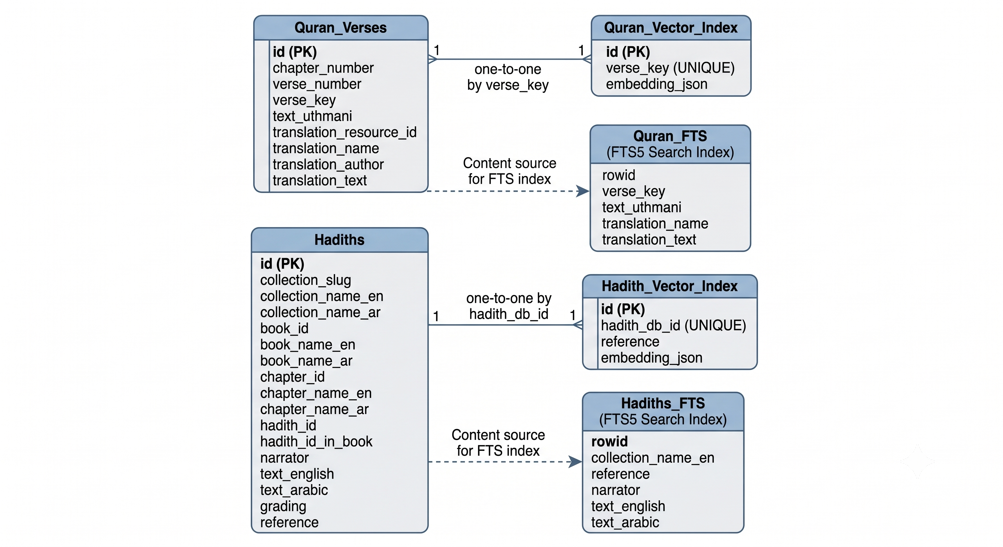 25
4.2.4 Data Flow Diagram (DFD Level 0) 25
4.2.5 DFD Level 1 26
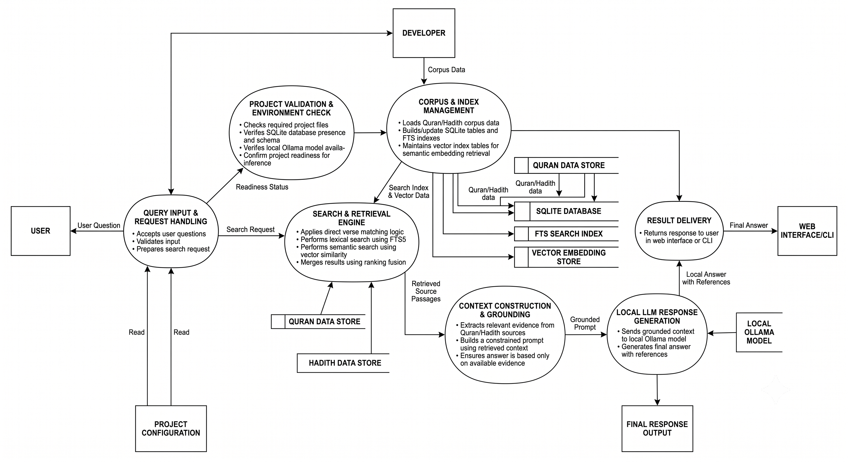 26
4.2.6 DFD Level 2 26
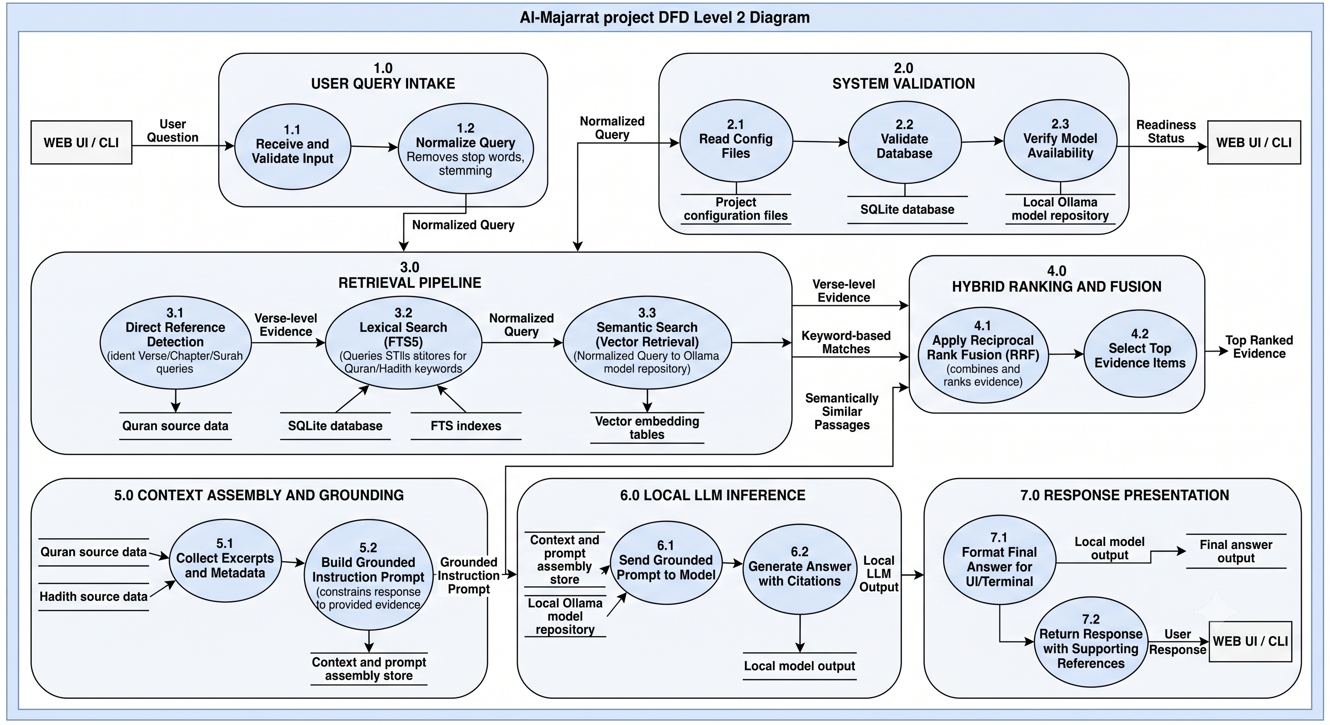 27
4.2.7 Activity Diagram 27
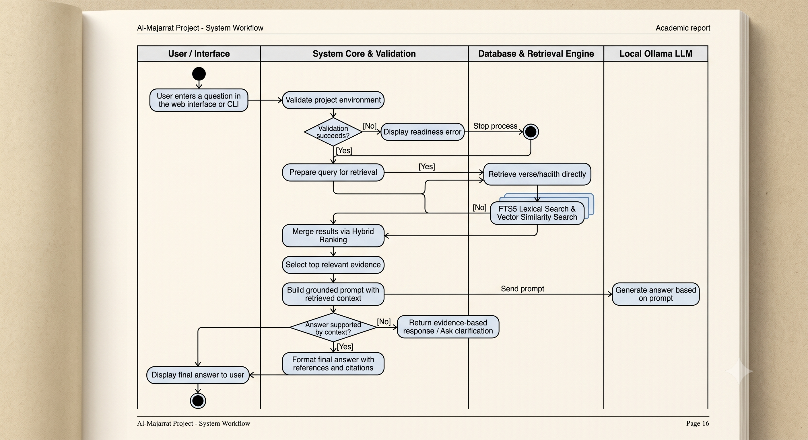 27
4.2.8 Collaboration / Communication Diagram 28
4.2.9 Component Diagram 28
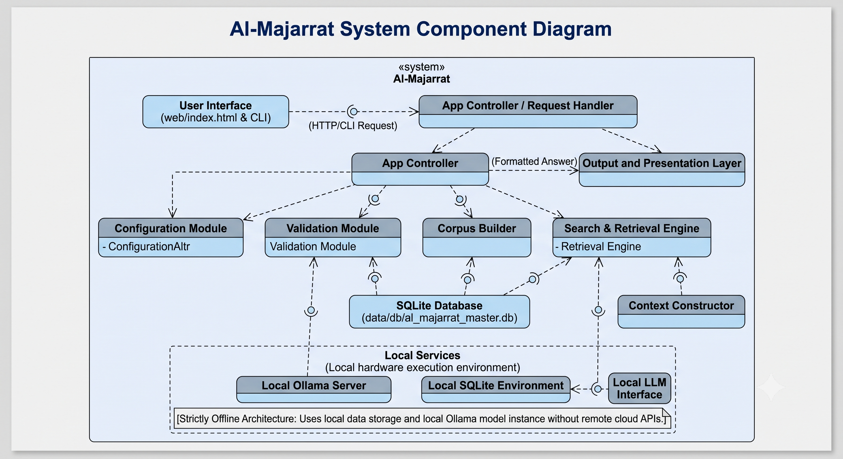 29
4.3 Database Design 29
4.4 Modules and Data Flow 29
4.5 Use Cases and Sequence 30
4.5.1 Primary Actor and Use Cases 30
4.5.2 Answer Request Sequence 30
Chapter 5 — Implementation 31
5.1 Technology Stack 31
5.1.1 Frontend Technologies 31
5.1.2 Backend Technologies 31
5.1.3 Database 31
5.1.4 Search and Retrieval 31
5.1.5 Artificial Intelligence 32
5.1.6 Quran and Hadith Data Sources 32
5.1.7 Training Utilities 32
5.1.8 Development and Testing Tools 32
5.2 Algorithms and Pseudocode 33
5.2.1 Corpus Construction 33
5.2.2 Embedding Indexing 34
5.2.3 Hybrid Retrieval 34
5.2.4 Grounded Answer Generation 35
5.3 Implementation Steps 36
5.4 Project Folder Structure 37
5.5 Screenshots / Operational User Interface 38
5.6 Source Code / Important Implementation 39
project_config.py 39
create_master_corpus.py 40
build_vector_index.py 48
al_majarrat.py 54
search_majarrat.py 74
serve_web_ui.py 83
validate_project.py 87
Chapter 6 — Results and Discussion 93
6.1 Sample Input and Output 93
6.1.1 Sample Input 93
6.1.2 Processing Path 93
6.1.3 Sample Output 93
6.2 Graphs and Charts 94
6.2.1 Current level of Islamic knowledge 94
6.2.2 Seeking Islamic knowledge online 94
4.2.3 Biggest challenge 94
4.2.4 Using of AI Tools 95
4.2.5 Trustworthiness of answer by AI 95
4.2.6 Reference provided by AI Tools 96
4.2.7 Concern on AI providing misleading information 96
4.2.8 Source of trust 96
4.2.9 Showing authenticity grading on hadith 97
4.2.9 Interested in using AI assistance which answer from quran and hadith 97
6.3 Analysis of Results 97
Chapter 7 — Conclusion and Future Scope 99
7.1 Summary of Work 99
Al-Majarrat was developed as a local, AI-based research assistant for students, researchers, and learners who want to explore Quran and Hadith sources. The main purpose of the system is to provide users with an environment where they can ask questions in natural language and see the supporting evidence behind every answer. The system consolidates the Quran and Hadith corpora into a SQLite database with full-text search tables and vector indexes. After that, users can look up passages directly by reference or ask a question and receive the most relevant passages, found through hybrid retrieval that combines lexical and semantic rankings using Reciprocal Rank Fusion. When the local model is available, the retrieved passages are passed to it as constrained context, and the response is returned along with its references and source text 99
The system can be used through both a command-line interface and a responsive web interface that keeps browser conversation history. Health validation and tests check that the required files, database tables, and model services are ready. The code, data, tests, web assets, and documentation are kept separate so that individual components can be modified without affecting the complete application. 99
7.2 Achievements 99
7.3 Limitations 99
7.4 Future Enhancements 100
Chapter 8 — References 101
Chapter 9 — Appendix 102
9.1 Database Structure Summary 102
9.2 Local API Summary 102
9.3 Validation and Test Evidence 102
9.4 Main Project Files 102
9.5 User Operation Quick Reference 103

The table of contents is generated from the document headings. In Word, right-click it and choose Update Field → Update entire table if you edit the report.

Preface
I am pleased to present my project, "Al-Majarrat," an AI-powered Quran and Hadith Research Assistant designed to help students, researchers, and learners explore Islamic sources with confidence and verify what they find. The project aims to provide a structured and interactive platform where users can ask questions in natural language, search by verse reference or topic, and receive relevant passages together with their references and source text. Developed using Python, SQLite with FTS5 full-text search, locally generated embeddings, Ollama-hosted language models, and a browser interface built with HTML, CSS, and JavaScript, the system combines lexical and semantic retrieval to deliver accurate and transparent results while running entirely on the user's own machine. Every effort has been made to make Al-Majarrat practical, reliable, and useful for individuals who want a source-grounded way to study the Quran and Hadith, while keeping the primary texts and qualified scholarship at the center of learning.

Acknowledgement
The successful completion of any project is the result of continuous guidance, support, and contribution from several individuals. I would like to express my sincere gratitude to everyone who supported me throughout the development of “Al Majarrat.”
I would like to extend my heartfelt thanks to Prof. Rajesh Yadav, my project guide, for his valuable guidance, continuous support, and constructive feedback throughout the development of this project. His encouragement and suggestions were instrumental in shaping and improving the project.
I would also like to express my gratitude to Prof. Dr. Manoj Singh, Head of the Department, for providing the necessary resources, support, and a conducive environment for successfully completing this project.
I am also thankful to our Principal, Dr.Radhika Birmole, for her kind cooperation and support during the completion of this project.
Finally, I would like to thank my friends, classmates, and everyone who directly or indirectly contributed to the successful completion of PrePilot.

Chapter 1 — Introduction

1.1 Background of the Study

For millions of Muslims, understanding their faith begins with a simple question: what do the Quran and Hadith actually say about this? Yet finding a trustworthy answer is harder than it sounds. The sources are vast, spread across dozens of collections, narrators, and translations, and searching them by hand is slow and discouraging. General-purpose AI chatbots seem like an easy shortcut, but they carry a hidden risk: they often answer from popularity rather than evidence, producing confident replies with uncertain or missing citations. Quick answers build familiarity, but not trust. What readers truly lack is a way to ask questions in plain language and see exactly where each answer comes from.

The rise of Artificial Intelligence has opened the door to a more conversational, source-grounded approach to Islamic research. Rather than relying on keyword lookups or unverified chatbot replies, an AI-driven system can act as a careful research companion, searching authenticated texts and presenting the evidence alongside the answer. This is the inspiration behind Al-Majarrat. Built for students, researchers, and everyday learners, Al-Majarrat is a web-based knowledge assistant at the heart of which sits a conversational chatbot system. Users simply type a question, whether by verse reference, topic, wording, collection, or narrator, and the chatbot searches the platform's local Quran and Hadith corpora using both lexical and semantic retrieval to find the most relevant passages. Each result is returned with its reference and source text, so nothing is hidden. When the optional local language model is available, the retrieved passages are passed to it as constrained context, allowing the chatbot to respond in clear, natural language while staying tied to the sources. Ultimately, Al-Majarrat bridges the gap between classical Islamic texts and conversational AI, giving readers a transparent, evidence-first way to explore, verify, and learn.

1.2 Problem Definition

Readers of the Quran and Hadith often have difficulty finding relevant source material because they may not know the exact wording, verse reference, or collection needed to locate it. Existing search methods generally rely on keyword matching and do not always consider the meaning behind a user's question. As a result, a person asking about a theme may miss passages that discuss the same idea in different words. Another challenge is that general-purpose AI tools can produce fluent answers without a verifiable source, making it difficult for readers to tell which statements are supported by the texts and which are generated. Therefore, simply returning search results or generating answers is not sufficient; users also need a way to see the evidence behind every response.

The problem addressed by this project is to develop a locally operable system that provides a reliable and interactive research experience by using lexical and semantic retrieval to find relevant Quran and Hadith passages, presenting each result with its reference and source text, and generating natural-language explanations that are clearly separated from the source evidence.

1.3 Objectives of the Project
- To develop a web-based platform for source-grounded Quran and Hadith research.
- To prepare and consolidate Quran and Hadith source files into a structured local database.
- To provide full-text search and semantic retrieval using locally generated embeddings.
- To combine lexical and semantic rankings to find the most relevant passages for a user's question.
- To provide a command-line and browser-based experience for searching and asking questions.
- To generate natural-language answers using a local language model that is constrained to the retrieved passages.
- To display references and source text with every response so users can verify the evidence.
- To ensure the system is reliable through health checks and tests covering file paths, source data, and the database schema.

1.4 Scope of the Project

The scope of Al-Majarrat is focused on helping students, researchers, and learners explore Quran and Hadith sources in an interactive environment. The system allows users to ask questions in English through a local browser interface or a command-line tool. The question is processed using full-text and semantic retrieval to find the most relevant passages. For the Quran, the system supports direct verse-key and Surah queries and displays Uthmani Arabic text alongside selected English translations. For Hadith, the system covers Sahih al-Bukhari, Sahih Muslim, Sunan an-Nasa'i, Sunan Abi Dawud, Jami' at-Tirmidhi, and Sunan Ibn Majah. When a local Ollama-compatible model is available, the retrieved passages are passed to it as constrained context to generate a natural-language response, and the references are displayed with the answer for verification. A fine-tuning dataset export and a QLoRA training script are included as development utilities, but the default system uses the configured Ollama chat model and does not automatically load a trained adapter.

The project is mainly intended for research assistance and self-study. It does not provide user accounts, a hosted multi-user service, scholarly adjudication, or a validated fatwa workflow. Citations are provided to help users verify the evidence, but they do not prove that a generated answer is correct. The system is not a substitute for qualified Islamic scholarship.

1.5 Motivation
The main motivation behind this project is the difficulty readers face when trying to find reliable answers in Quran and Hadith sources, especially when they are unsure of the exact wording or reference. Many learners can ask a question about a theme, but they do not always have an easy way to locate the relevant passages or confirm where an answer comes from. General-purpose AI tools can respond instantly, but they often present statements without verifiable sources, which makes it hard to trust them on a subject that depends on authentic evidence. A system that combines thematic search with visible references can give users a way to explore the texts without relying on unsupported claims.

Using a local-first approach also makes the system more accessible and private. Because retrieval and generation can run on the user's own machine, research queries do not need to be sent to a hosted language model provider, depending on the installed local model and hardware. The addition of both lexical and semantic retrieval is intended to help users find relevant passages even when their wording does not match the text exactly. Instead of simply receiving an answer, the user can see the supporting source material and review it directly. The overall aim of Al-Majarrat is therefore not to replace the primary texts, established scholarship, or qualified guidance, but to give learners an accessible way to locate and review sources before drawing their own conclusions.

Chapter 2 — Literature Review

2.1 Existing Systems / Related Works
Islamic text research has traditionally involved reading printed Quran and Hadith collections, consulting scholars, searching websites and mobile applications, or looking up verses and narrations by reference. With the growth of Artificial Intelligence, several platforms have introduced semantic search, conversational assistants, and AI-generated answers on Islamic topics.
The following systems were studied to understand the current solutions available for Quran and Hadith research.

2.1.1 Quran.com
Quran.com is a widely used web and mobile platform for reading, searching, and studying the Quran. It is maintained by the Quran Foundation.
Relevant features:
- Quran text with Arabic script and multiple translations.
- Tafsir (commentary) and word-by-word study tools.
- Search by keyword and verse reference.
- Audio recitation.
Observation: The platform is reliable for reading and looking up the Quran, but it is mainly a reference tool. Users must still know suitable keywords or references, and it does not answer natural-language questions across both the Quran and Hadith.

2.1.2 Sunnah.com
Sunnah.com is an online library of Hadith collections, presenting narrations with Arabic text, English translations, and reference details.
Relevant features:
- Major Hadith collections organized by book and chapter.
- Arabic text with English translation.
- Hadith grading and reference information.
- Keyword search across collections.
Observation: Sunnah.com is a dependable source of Hadith with clear references, but its search is mostly keyword-based. It does not combine Quran and Hadith retrieval or retrieve passages by meaning when the user's wording differs from the text.

2.1.3 Tanzil
Tanzil is a Quran navigation and text resource that provides verified Quran text and a wide range of translations, which are also used as source data by other projects.
Relevant features:
- Verified Quran text in Uthmani and other scripts.
- Many translations in downloadable formats.
- Basic navigation and search.
Observation: Tanzil is valuable as a trusted data source, but it is not designed as a question-answering or semantic retrieval system, and it does not cover Hadith.

2.1.3 Al Quran Cloud API
Al Quran Cloud provides a programming interface that lets developers access Quran text, translations, and related data in structured form.
Relevant features:
- Quran text and translations through an API.
- Retrieval by Surah, verse, and edition.
- Easy integration into other applications.
Observation: The API is useful for building applications, but it supplies data rather than a research workflow. Search, ranking, and answer generation must be built separately, and it depends on an online service.

2.1.4 Quranic Arabic Corpus
The Quranic Arabic Corpus is an academic resource that provides linguistic annotation of the Quran, including morphology and syntax.
Relevant features:
- Word-by-word grammar and morphology.
- Syntactic analysis of verses.
- Search based on linguistic features.
Observation: The corpus is strong for Arabic language study, but it is aimed at linguistic analysis rather than answering thematic questions or retrieving Hadith.

2.1.5 Dorar.net
Dorar.net is an Arabic-language Hadith platform known for its Hadith search and authenticity ruling information.
Relevant features:
- Hadith search by text.
- Ruling and grading details for narrations.
- Narrator and source information.
Observation: The platform is useful for checking Hadith authenticity, but it is mainly in Arabic and does not offer conversational, English-language question handling or Quran retrieval in the same workflow.

2.1.6 IslamQA and Fatwa Websites
Websites such as IslamQA provide answers to religious questions written by scholars and organized by topic.
Relevant features:
- Scholar-written answers to common questions.
- Topic-based browsing.
- Searchable archive of questions.
Observation: These sites offer human-reviewed guidance, but users must find a question that matches their own, and answers are not generated from a defined corpus of Quran and Hadith with passages shown beside each response.

2.1.7 Ansari Chat
Ansari Chat is an AI-based assistant designed to answer questions about Islam using Quran and Hadith as references.
Relevant features:
- Conversational question answering
- References to Quran and Hadith.
- Support for follow-up questions.
Observation: It demonstrates the potential of conversational AI for Islamic knowledge, but it is a hosted service. The proposed project instead emphasizes a local-first workflow in which retrieved evidence stays visible, and queries need not be sent to an external provider.

2.1.8 General-Purpose AI Chatbots
General-purpose language models such as ChatGPT can answer questions about Islam in natural language.
Relevant features:
- Fluent, conversational answers.
- Wide general knowledge.
- Support for multiple languages.
Observation: These tools are convenient, but they are not tied to a verified corpus. They can produce unsupported statements or inaccurate citations, which is the main limitation Al-Majarrat tries to address by restricting answers to retrieved passages.

2.2 Related Technical Approaches
2.2.1 Retrieval-Augmented Generation
Retrieval-Augmented Generation (RAG) combines a retrieval step with a language model, so the model answers using retrieved documents rather than relying only on its internal knowledge. This reduces unsupported statements and allows sources to be shown with the answer, which is the approach adopted in this project.
2.2.2 Hybrid Search and Rank Fusion
Lexical search, such as full-text search with SQLite FTS5, finds passages containing the query words, while semantic search compares embeddings to find passages with similar meaning. Reciprocal Rank Fusion (RRF) combines both rankings into one list, so passages that rank well in both are placed first. This allows the system to find relevant passages even when the user's wording does not match the text.

2.3 Research Gap
The systems studied provide reliable Quran or Hadith text, translations, commentary, or conversational answers, but most address only part of the problem. Reference websites rely mainly on keyword search, data services supply text without a research workflow, and AI chatbots can generate answers that are not tied to a verifiable source. Few of them combine Quran and Hadith retrieval, hybrid lexical and semantic search, visible references, and constrained answer generation in a single tool that can run locally. Al-Majarrat is proposed to fill this gap.

2.4 Proposed Approach
The proposed system, Al-Majarrat, is designed as a local, source-grounded AI research assistant for the Quran and Hadith. The process begins when the user opens the command-line or browser interface and submits a question in English, or looks up a passage directly by verse reference or Surah. The system validates the input and cleans and expands the query terms so that they can be used for search. The question is also converted into an embedding using the configured Ollama embedding model.
The system then searches the local SQLite database using both lexical and semantic retrieval. SQLite FTS5 finds passages that contain the query terms, while cosine similarity over the stored embeddings finds passages with a similar meaning. The two rankings are combined using Reciprocal Rank Fusion, and the most relevant Quran verses and Hadith are selected along with their references, source text, and Hadith grading. If embeddings are unavailable, the system falls back to lexical search.
When the local model is available, the retrieved passages are supplied to the Ollama chat model as constrained context, with instructions to use only the retrieved evidence, include exact references, and avoid fabricating verses, Hadith, or citations. The response is then displayed alongside the supporting passages, so that the user can compare the answer against the sources. If the model is offline, the system still returns the retrieved passages with their references. Users can filter results by Quran, Hadith, or both, and the browser interface keeps a history of previous conversations in local storage.
The proposed approach is therefore focused on providing an accessible and transparent research environment rather than replacing the primary texts, established scholarship, or qualified guidance. The system is intended to help users locate and review relevant sources, and to verify what they find before drawing their own conclusions.

Chapter 3 — System Analysis

3.1 System Requirements

3.1.1 Hardware Requirements

Al-Majarrat uses a local SQLite database and can use locally hosted Ollama models. Hardware needs therefore depend on whether the user is performing database search only or running the Al models locally. The project has not been formally benchmarked to establish a minimum configuration.
A computer with the following configuration is suitable for development and use:
- Processor: 64-bit, multi-core processor
- RAM: 8 GB for database search and basic development; 16 GB or more recommended when running local Ollama models
- Storage: Sufficient free space for the project files, SQLite database, vector indexes, and downloaded Ollama models
- Internet: Required to download dependencies, source data, and Ollama models; generally not required for local searches or inference once these are installed
- GPU: Not required, though a compatible GPU may improve local model performanc

3.1.2 Software Requirements
Component | Technology
Runtime | Python; verified environment: Python 3.14.7.
Database | SQLite with FTS5 virtual tables.
Embedding service | Ollama; configured model nomic-embed-text.
Generation service | Ollama OpenAI-compatible endpoint; qwen2.5:3b.
Browser UI | HTML, CSS, JavaScript; Python standard-library HTTP server.
Training utilities | PyTorch, Transformers, PEFT, Accelerate, bitsandbytes.
Testing | Python unittest; four project health tests.

3.1.3 Functional Requirements
FR-01: Hadith Search
The system shall allow the user to search Hadith collections through both a command-line interface and the web-backed retrieval service.
FR-02: Quran Search
The system shall allow the user to search Quran text and look up passages directly by verse reference.
FR-03: Hybrid Retrieval
The system shall retrieve relevant passages using both lexical and semantic signals, combining SQLite FTS5 full-text search with locally generated vector embeddings, cosine similarity, and Reciprocal Rank Fusion (RRF) to rank the results.
FR-04: Local Answer Generation
The system shall use a local language model to generate natural-language answers based on the retrieved passages. This feature requires the local model service to be running.
FR-05: Source Filtering
The system shall allow the user to filter search results by All, Quran, or Hadith in the web interface.
FR-06: Source Display
The system shall display the retrieved source passages along with their references, so that the user can verify the evidence behind each answer.
FR-07: Conversation History
The system shall retain completed conversations in the browser using localStorage and allow the user to reopen them later.
FR-08: Conversation Deletion
The system shall allow the user to delete an individual conversation from the saved history.
FR-09: System Readiness Check
The system shall report the basic readiness of the source data and backend services through a validator and a status API.

3.1.4 Non-Functional Requirements
Portability
The application should resolve all configured file paths from the project root, so that it can be moved or run on different machines without breaking.
Traceability
The system should retain references and source evidence in both the retrieved results and the prompt instructions, so that every answer can be traced back to its original passages.
Local Operation
The web server should default to the loopback address, and all model endpoints should be local, so that research queries stay on the user's own machine.
Security and Input Limits
The system should limit web questions to 2,000 characters and request bodies to 16 KB, to prevent oversized or malformed inputs from affecting the application.
Maintainability
The code, data, tests, and user interface assets should be organized separately so that individual components can be modified without affecting the complete application.
Reliability
The system should run health checks that validate the required files and database tables, so that missing or incomplete data is detected before it causes errors during use.
Usability
The interface should be simple enough for students and learners to use without requiring technical knowledge about how the retrieval or language model works.
Compatibility
The application should work on modern web browsers that support the required browser features, including localStorage for conversation history.

3.1.5 User Requirements
The Al-Majarrat system is intended for users who need a local, evidence-based way to search Quran and Hadith material and ask grounded questions. Based on the implemented functionality, the project supports the following user requirements:
- Run a local search for Quran verses or Hadith text without relying on a remote hosted service.
- Query the Quran, Hadith collections, or both together through a single interface.
- Submit a natural-language question and receive references tied to the retrieved source passages.
- Inspect the source text, translation, reference, and collection details before trusting an answer.
- Use the project from either the command line or the browser interface.
- View the current database and model readiness through validation or status endpoints.
- Reopen previous conversations and delete individual sessions from local browser storage.
- Keep the entire workflow local, using the configured Ollama model and the local SQLite database..

3.2 Feasibility Study

3.2.1 Technical Feasibility
The project uses Python, SQLite/FTS5, local HTTP model APIs, and browser technologies. A populated database, vector indexes, and passing health tests demonstrate that principal data components work in the checked environment. End-to-end generation depends on Ollama and configured models.

3.2.2 Economic Feasibility
Local models can avoid per-query hosted LLM fees. Costs include hardware, storage, electricity, initial downloads, and maintenance. No formal cost study has been conducted.

3.2.3 Operational Feasibility
The CLI supports direct search and interactive questions; the web app provides a browser workflow. Setup requires corpus/database preparation and Ollama for full semantic/generative operation. Users should verify AI responses against displayed sources.

3.2.4 Schedule Feasibility
The repository contains extraction, indexing, application, training, and validation stages. No schedule, effort estimate, or milestone record was found in the reviewed implementation evidence; no schedule-completion claim is made.

3.3 Methodology Used
The Al-Majarrat project follows an iterative development approach. This approach was suitable because the project consists of separate data preparation, database, search, vector indexing, local Al, and user-interface components that needed to be developed and checked together.
Development progressed through stages: reviewing the project requirements and data sources; preparing the Quran and Hadith corpora; building the SQLite database and FTS5 search indexes; implementing vector indexing and hybrid retrieval; connecting the CLI and web interface to the local Ollama services; and carrying out validation, testing, and documentation.
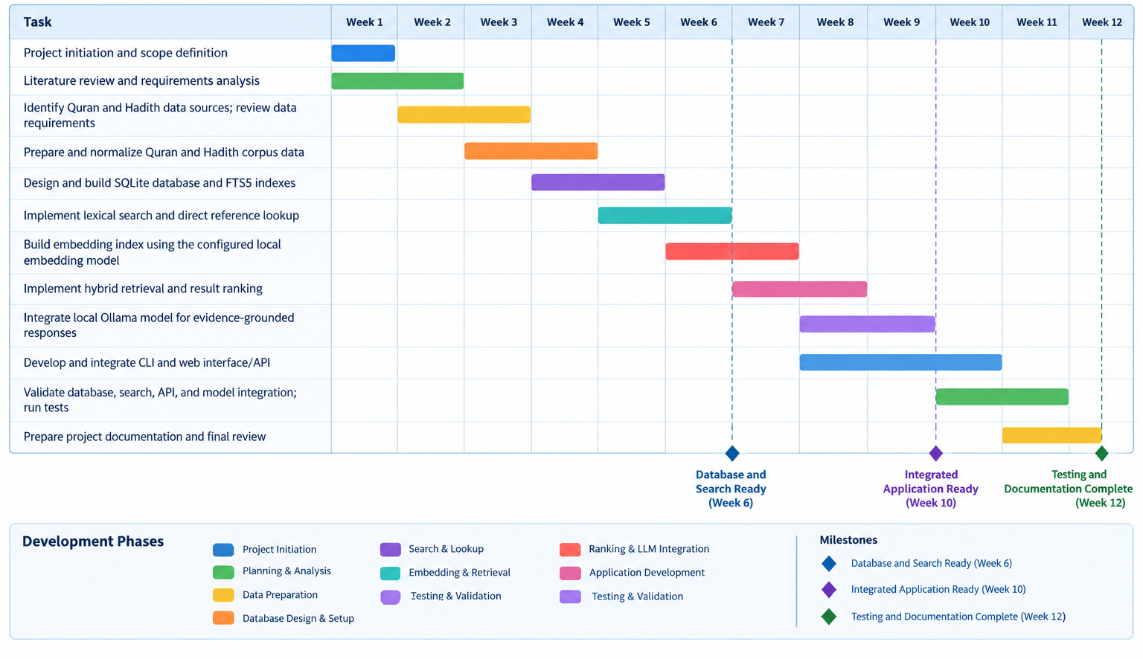
Figure 3.1 – Gantt chart

Chapter 4 — System Design

4.1 System Architecture
The architecture of Al-Majarrat follows a local, layered approach using Python, SQLite, and locally hosted AI models. The HTML, CSS, and JavaScript browser interface handles user interaction, while the Python backend handles corpus processing, retrieval, and communication with the local model services. A command-line interface provides a second way to access the same core logic. SQLite stores the Quran and Hadith records along with the full-text and vector indexes. The browser keeps conversation history in local storage, so no user accounts are needed.
When a question is submitted, the core retrieval logic handles direct verse and Surah references, runs lexical and semantic retrieval over the database, and builds a grounded prompt from the ranked passages. The optional local Ollama chat model generates an answer from this prompt, which is displayed together with its source references. If the embedding service is unavailable, the system falls back to lexical retrieval. Because all components run locally, the system does not rely on cloud hosting or external AI APIs. Generated answers are not guaranteed to be correct, so the retrieved sources are always displayed for verification.

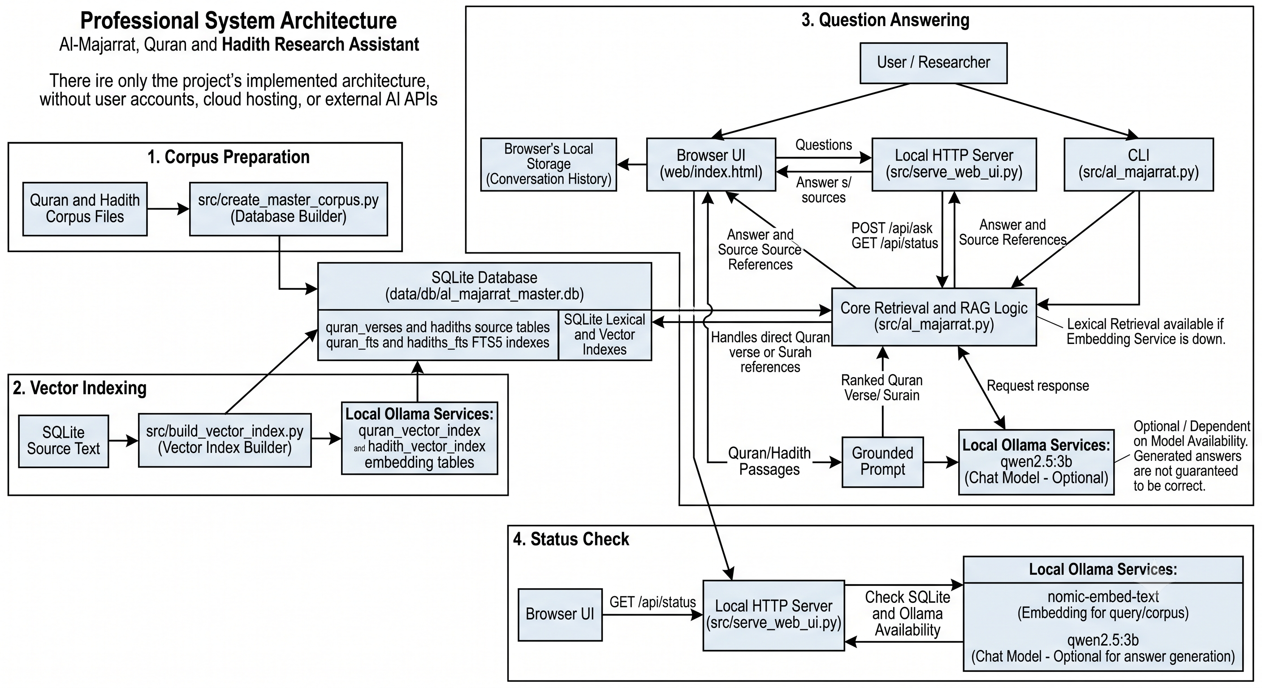

Figure 4.1 System architect

4.2 UML Diagrams

4.2.1 Use Case Diagram
The Use Case Diagram represents the interaction between the user and the major functions of Al-Majarrat. The primary actor is the User, who can submit a question, search by verse reference or Surah, filter results by Quran or Hadith, view the retrieved sources with their references, read the generated answer, manage previous conversations, and check the system status.
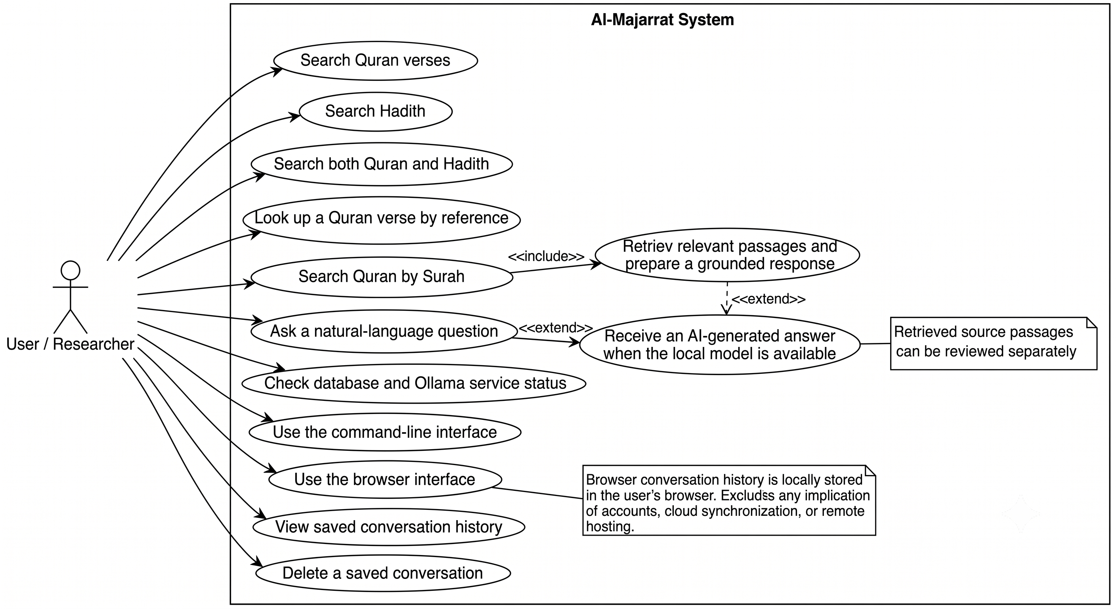
Figure 4.2 Use case diagram

4.2.2 Sequence Diagram
The Sequence Diagram represents the order in which components communicate when a user asks a question. The browser sends the question to the local server, which passes it to the retrieval logic to search the SQLite database and the Ollama embedding service. The retrieved passages are then sent to the Ollama chat model, and the answer is returned to the browser with its source references.

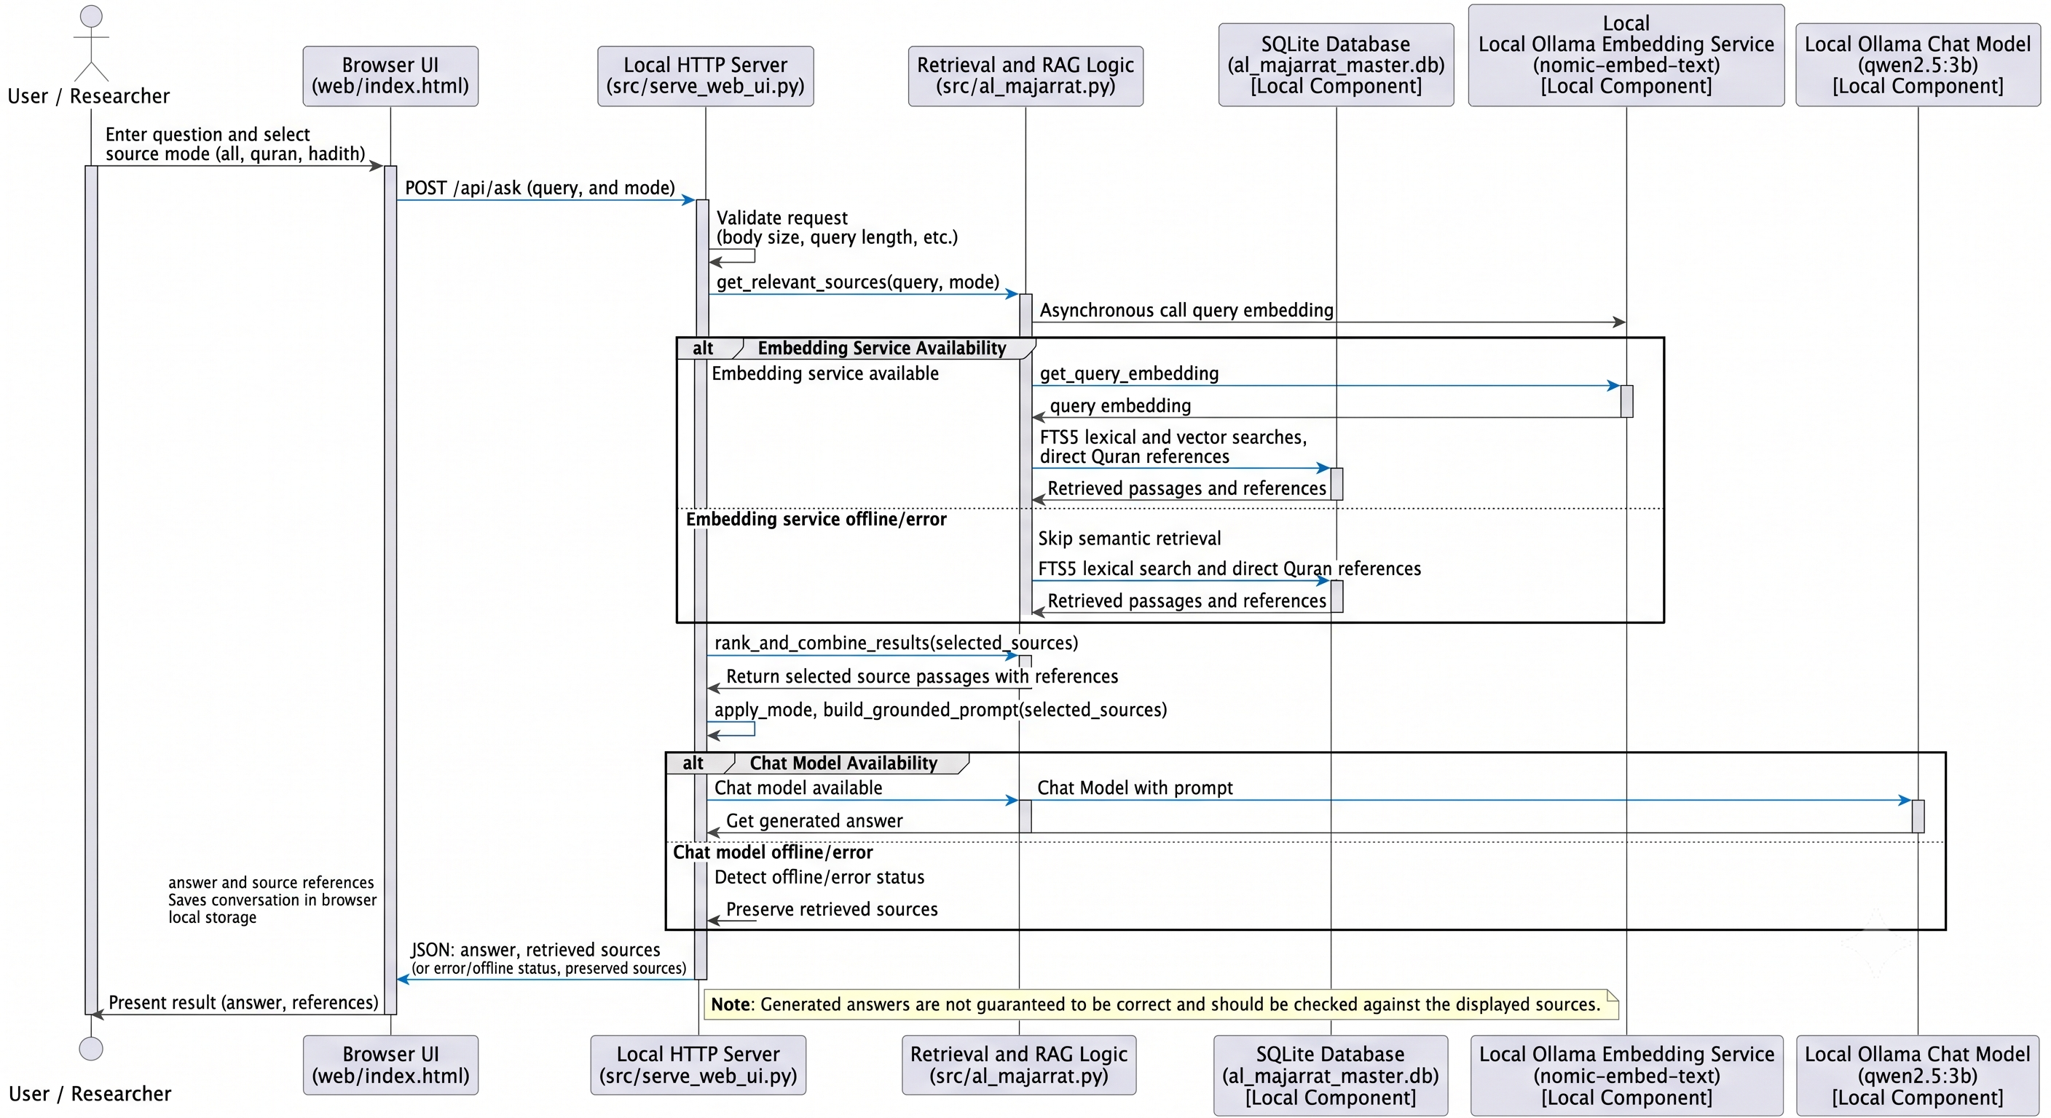
Figure 4.3 Sequence Diagram

4.2.3 ER Diagram
The Entity Relationship Diagram represents the major data entities stored in the SQLite database of Al-Majarrat. The main entities are quran_verses and hadiths, which store the source text and references, along with the quran_fts and hadiths_fts full-text indexes and the quran_vector_index and hadith_vector_index embedding tables that are linked to the source records by verse key or Hadith ID.
Figure 4.4 ER diagram

4.2.4 Data Flow Diagram (DFD Level 0)
The Level 0 Data Flow Diagram, also known as the context diagram, represents the complete Al-Majarrat system as a single process. The User is the external entity that sends questions and source filters to the system and receives answers with source references. The local Ollama service acts as a supporting external component that provides embeddings and generated answers.
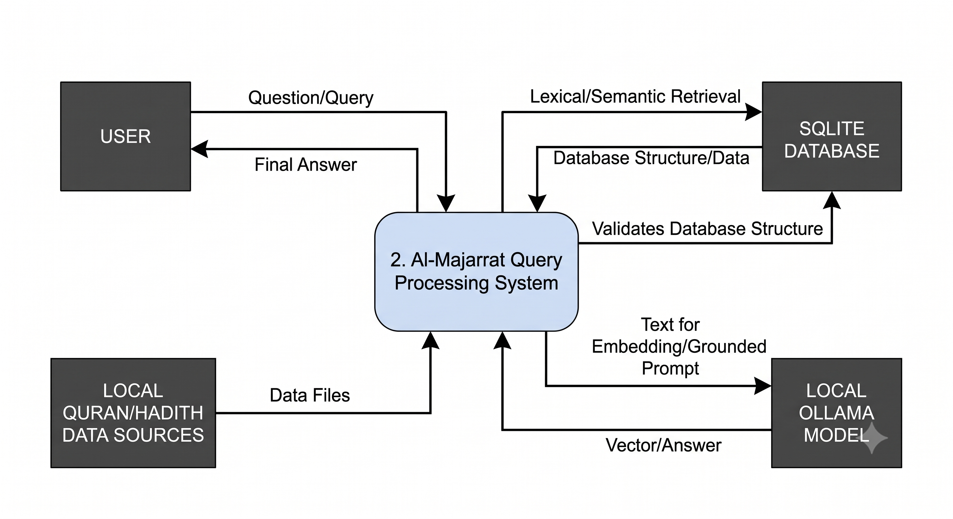
Figure 4.5 DFD Level 0

4.2.5 DFD Level 1
The Level 1 DFD divides the Al-Majarrat system into its major processes: corpus preparation, vector indexing, question handling and retrieval, answer generation, and status checking. Data flows between the user, the SQLite database, and the local Ollama service, with the user receiving the final answer and its source references.
Figure 4.6 DFD Level 1

4.2.6 DFD Level 2
The Level 2 DFD provides a more detailed representation of the question answering process. It shows how a question is validated and embedded, how lexical and semantic results are retrieved from the SQLite database and combined using Reciprocal Rank Fusion, and how the selected passages are placed in a grounded prompt for the local chat model before the answer and its references are returned to the user.
Figure 4.7 DFD Level 2

4.2.7 Activity Diagram
The Activity Diagram represents the workflow followed by a user in Al-Majarrat. The user submits a question, the system retrieves and ranks the relevant Quran and Hadith passages, and the local model generates an answer if it is available. The answer and its source references are then displayed, and the conversation is saved in the browser.
Figure 4.8 Activity diagram

4.2.8 Collaboration / Communication Diagram
The Collaboration Diagram represents how different objects in Al-Majarrat communicate with each other while answering a question. The browser interface sends the question to the local HTTP server, which calls the core retrieval logic. This logic exchanges data with the SQLite database and the Ollama embedding and chat models, and the answer with its source references is returned to the browser.
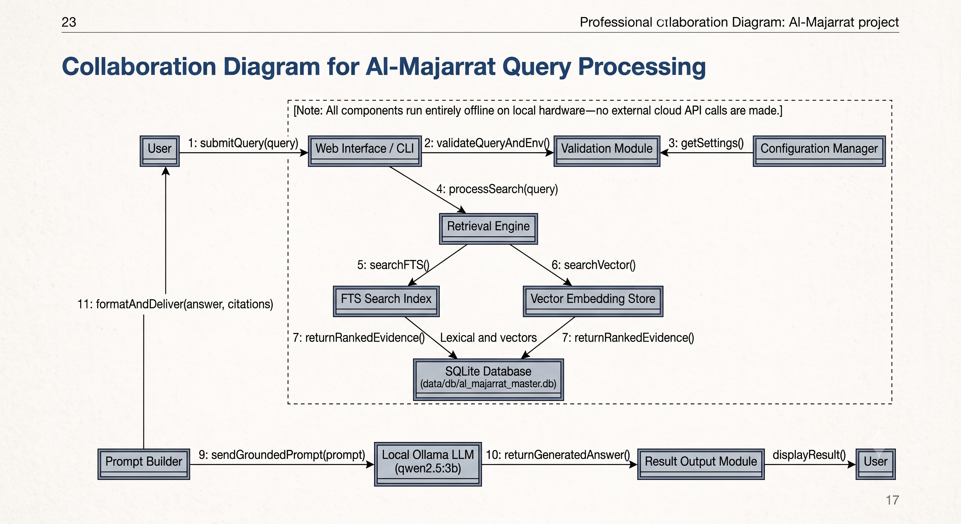
Figure 4.9 Collaboration diagram

4.2.9 Component Diagram
The Component Diagram represents the major software components of Al-Majarrat and their dependencies. The browser interface communicates with the local Python HTTP server through the /api/ask and /api/status endpoints, while the command-line interface calls the same core retrieval logic directly. The core logic depends on the SQLite database for Quran and Hadith data and on the local Ollama service for embeddings and answer generation.
Figure 4.10 Component diagram

4.3 Database Design
Table | Key fields / role
hadiths | id; collection/book/chapter; narrator; Arabic/English text; grading; reference.
quran_verses | id; chapter/verse; verse_key; Uthmani text; translation resource/name/author/text.
hadiths_fts | FTS5 external-content index over collection, reference, narrator, and texts.
quran_fts | FTS5 external-content index over verse key, Arabic and translation text.
hadith_vector_index | hadith_db_id unique key, reference, serialized embedding JSON.
quran_vector_index | verse_key unique key and embedding JSON for preferred English translation.

4.4 Modules and Data Flow
Module | Responsibility
src/extract_*.py | Acquire/transform Quran and six Hadith collections.
src/create_master_corpus.py | Build source tables, indexes, and FTS5 tables.
src/build_vector_index.py | Generate embeddings in batches and persist vectors.
src/al_majarrat.py | Resolve references, retrieve/fuse sources, prompt, call Ollama, CLI.
src/search_majarrat.py | Interactive and command-line lexical search.
src/serve_web_ui.py + web/index.html | Serve UI/API, validate requests, report status, render results.
src/validate_project.py + tests/ | Health checks and project tests.
export/train scripts | Create fine-tuning data and optional QLoRA adapter; separate from default serving.

4.5 Use Cases and Sequence

4.5.1 Primary Actor and Use Cases
The primary actor is a local researcher. Use cases include searching text or a reference, selecting Quran/Hadith/all, reviewing sources, copying answers, reopening saved history, and deleting an individual conversation. The app does not implement accounts or login.

4.5.2 Answer Request Sequence
(1) User submits question and mode.
(2) UI sends bounded JSON to /api/ask.
(3) Server validates the request and invokes shared retrieval.
(4) Retrieval obtains an embedding when available, searches FTS/direct references, ranks vectors, fuses candidates, and returns evidence.
(5) Server builds a constrained prompt and requests local chat completion.
(6) API returns answer and sources.
(7) Browser renders and stores the completed conversation locally.

Chapter 5 — Implementation

5.1 Technology Stack
Al-Majarrat is implemented as a web-based application using Python and SQLite along with locally hosted AI models. The technologies were selected because they are suitable for developing a lightweight research tool and allow the AI functionality to run on the user's own machine without developing a language model from scratch.

5.1.1 Frontend Technologies
HTML - HTML is used to structure the browser interface. It provides the question input, source filters, and the areas where answers and retrieved references are displayed.
CSS - CSS is used to design the application interface and support a responsive layout, making the different components visually consistent and easy to use.
JavaScript - JavaScript handles browser interactions. It sends questions to the local API, displays the returned answers and sources, and manages conversation history using the browser's local storage.

5.1.2 Backend Technologies
Python - Python is used as the main language for the backend application. It handles the application logic, corpus preparation, search, vector indexing, the local API server, and validation tools.0
Python Standard Library HTTP Server - The built-in HTTP server is used to serve the web interface and provide local endpoints, including POST /api/ask for submitting questions and GET /api/status for checking system readiness.
JSON and HTTP - JSON is used to exchange question and response data between the browser interface, the local server, and the Ollama services.

5.1.3 Database
SQLite - SQLite is used as the database for storing the Quran and Hadith records along with the search indexes in a local file. The main data tables are:
- quran_verses - stores Quran verse text, verse references, and translation information.
- hadiths - stores Hadith text, collection and chapter details, narrator, grading, and reference information.
- quran_fts and hadiths_fts - full-text search indexes for Quran and Hadith content.
- quran_vector_index and hadith_vector_index - stored embeddings used for semantic retrieval.

5.1.4 Search and Retrieval
SQLite FTS5 - FTS5 is used for lexical full-text search across the stored Quran and Hadith content.
Embeddings and Cosine Similarity - The application compares query embeddings with stored vectors to retrieve passages based on semantic similarity.
Reciprocal Rank Fusion (RRF) - RRF is used to combine the lexical and semantic rankings into a single hybrid set of passages. If embeddings are unavailable, the application falls back to lexical search.

5.1.5 Artificial Intelligence
Ollama - Ollama is used to run the configured AI models locally and exposes the endpoints used by the project
nomic-embed-text - This embedding model is used to generate the text embeddings required for semantic search.
qwen2.5:3b - This chat model is used to generate responses based on the Quran and Hadith passages retrieved by the application. The resume of the retrieved passages is provided to the model as context, which returns a response tied to those sources. Model availability depends on the local Ollama setup.

5.1.6 Quran and Hadith Data Sources
The project prepares local Quran and Hadith corpus files for use in its SQLite database. The Quran Foundation Content API and the fawazahmed0 Hadith API are used as source materials. The corpus preparation scripts process these data files, and ordinary searching uses the prepared local database rather than calling the source APIs for each query.

5.1.7 Training Utilities
The project includes scripts for exporting fine-tuning datasets and attempting QLoRA training with Qwen-related tooling. These are development utilities and are separate from the default application workflow. The default system uses the configured Ollama model and does not automatically load a trained adapter.

5.1.8 Development and Testing Tools
Tool / Technology | Purpose
Python | Application, data processing, search, and validation scripts
SQLite | Local database and FTS5 full-text indexes
Ollama | Local embedding and chat model services
Web Browser | Application testing and execution
unittest | Running the project's health tests
src/validate_project.py | Checking corpus files, database readiness, and Ollama availability

Layer | Technology / details
Application | Python and standard library HTTP, SQLite, JSON, HTTP client.
Data store | SQLite: data/db/al_majarrat_master.db.
Lexical index | SQLite FTS5 external-content tables.
Vector index | JSON-serialized embeddings; cosine similarity in application code.
Embedding model | nomic-embed-text served by Ollama.
Chat model | qwen2.5:3b at Ollama OpenAI-compatible endpoint.
Frontend | Static HTML/CSS/JavaScript; responsive UI and localStorage.
Training | Transformers/PEFT QLoRA utilities; CUDA PyTorch needed.

5.2 Algorithms and Pseudocode
The project does not implement a machine-learning model from scratch. Instead, AI capabilities are obtained through locally hosted models served by Ollama. The main algorithms implemented in the application are therefore related to corpus preparation, query handling, lexical and semantic retrieval, hybrid ranking, constrained answer generation, and system readiness validation.

5.2.1 Corpus Construction
BEGIN

DEFINE the six Hadith collection files and their collection details
CREATE or overwrite the Hadith master CSV

FOR each Hadith collection file
IF the file does not exist THEN
skip the file
ELSE
READ each record
CHECK trimmed English and Arabic text
IF both are empty THEN
skip the record
ELSE
ADD collection details and the original record fields
WRITE the record to the master CSV
END IF
END IF
END FOR

IF the SQLite database already exists THEN
DELETE the existing database
END IF

CREATE a new SQLite database
CREATE the Hadith table and supporting indexes
LOAD Hadith records from the master CSV into the database

CREATE the Quran verses table and supporting indexes

IF the Quran corpus file exists THEN
READ each Quran record
SKIP records with translation resource ID "57"
INSERT the remaining records into the Quran table
END IF

CREATE and populate the Hadith FTS5 index from the Hadith table
CREATE and populate the Quran FTS5 index from the Quran table

SAVE database changes
CLOSE the database

END

5.2.2 Embedding Indexing
BEGIN

IF the SQLite database does not exist THEN
REPORT error and EXIT
END IF

CONNECT to the database
CREATE the Quran and Hadith vector-index tables if they do not exist

FOR each eligible Quran verse
SELECT a non-empty translation
EXCLUDE Arabic-only records and translation resource ID "57"
PREFER the configured Quran translation when available
IF the verse key is not already indexed THEN
ADD the verse to the pending Quran records
END IF
END FOR

FOR each batch of up to 64 pending Quran verses
SEND the translation text to the local Ollama embedding API
IF the API fails or returns an unexpected number of embeddings THEN
STOP Quran indexing and continue to Hadith indexing
ELSE
STORE each embedding as JSON with its verse key
SAVE database changes
END IF
END FOR

FOR each Hadith record with non-empty English text
IF its database ID is not already indexed THEN
ADD the Hadith to the pending records
END IF
END FOR

FOR each batch of up to 64 pending Hadith records
SEND the English text to the local Ollama embedding API
IF the API fails or returns an unexpected number of embeddings THEN
STOP Hadith indexing
ELSE
STORE each embedding as JSON with its Hadith database ID and reference
SAVE database changes
END IF
END FOR

COUNT indexed Quran verses and Hadith records
REPORT vector coverage
CLOSE the database

END

5.2.3 Hybrid Retrieval
BEGIN

OPEN SQLite database
CREATE query embedding using the configured Ollama embedding model
CLEAN and expand query terms for lexical search

// Quran retrieval
CHECK whether the query contains a direct verse reference
IF a verse reference is found:
retrieve the matching verse using the preferred available translation
ELSE:
CHECK whether the query identifies a Surah
IF a Surah is identified:
retrieve its verses using the preferred available translation
ELSE:
SEARCH Quran FTS5 index using cleaned query terms
KEEP up to 15 lexical results

IF a query embedding is available:
compare it with stored Quran embeddings using cosine similarity
KEEP the top 15 semantic results
END IF

COMBINE lexical and semantic rankings using RRF
SELECT up to 6 Quran results
END IF
END IF

// Hadith retrieval
SEARCH Hadith FTS5 index using cleaned query terms
KEEP up to 25 lexical results

IF fewer than 5 Hadith lexical results were found:
use keyword matching as a fallback to find additional Hadith records
END IF

IF a query embedding is available:
compare it with stored Hadith embeddings using cosine similarity
KEEP the top 20 semantic results
END IF

COMBINE lexical and semantic rankings using RRF
SELECT up to 5 Hadith results

FORMAT selected Quran verses and Hadiths with their references
RETURN the Quran and Hadith source passages
CLOSE the database

END

5.2.4 Grounded Answer Generation
BEGIN

RECEIVE the user's question and retrieved Quran and Hadith passages

CREATE the system prompt with instructions to:
answer in English
use only the retrieved passages as evidence
include exact references for claims and citations
include English source text for cited verses and Hadith
avoid fabricating verses, Hadith, or references
state when no matching references were retrieved

IF Quran passages were retrieved:
ADD them to the grounding context
ELSE:
ADD a note that no matching Quran verses were found
END IF

IF Hadith passages were retrieved:
ADD them to the grounding context
ELSE:
ADD a note that no matching Hadith passages were found
END IF

ADD the user's question to the prompt

SEND the system prompt and grounding context to the configured local Ollama chat model

IF the model returns a response:
RETURN the response
ELSE IF Ollama cannot be reached:
RETURN a local-model-offline message
ELSE:
RETURN a model error message
END IF

END

5.3 Implementation Steps
The development of Al-Majarrat was carried out in multiple stages so that each major part of the application could be implemented and tested separately.
Step 1: Environment Setup
A Python virtual environment was created and activated, and the required dependencies were installed from the requirements.txt file.
Step 2: Corpus Preparation
The required Quran and Hadith corpus CSV files were placed under the data/corpora folder. The system checks that these files exist before the database is built.
Step 3: Database Construction
The master corpus builder was run to consolidate the corpus files into the SQLite database, including the full-text search indexes. The builder deletes and recreates the configured database each time it runs, so the data should be backed up before rebuilding.
Step 4: Local Model Setup
Ollama was installed and started, and the nomic-embed-text embedding model and the qwen2.5:3b chat model were pulled so that semantic search and answer generation can run locally.
Step 5: Vector Index Building
The vector index builder was run to generate embeddings for the Quran and Hadith records and store them in the database. Records that are already indexed are skipped, and the builder reports the vector coverage when it finishes.
Step 6: Validation and Testing
The validation script and the unit tests were run to check the corpus files, database tables, and model availability, confirming that the system is ready for use.
Step 7: Launching the Application
The command-line interface or the web interface was launched, and the local address printed by the server was opened in a browser to begin asking questions.

python -m pip install -r requirements.txt
python src/create_master_corpus.py
ollama pull nomic-embed-text
ollama pull qwen2.5:3b
python src/build_vector_index.py
python src/validate_project.py --skip-ollama
python src/serve_web_ui.py

5.4 Project Folder Structure
Project AL Majarrat/
project_config.py shared paths and model defaults
src/ application, extraction, indexing, validation
data/corpora/ source/master CSV files
data/db/ SQLite database
data/datasets/ fine-tuning JSONL outputs
data/raw/ raw data area
data/models/ model artifacts area
tests/ project health tests
web/ browser interface
docs/ project documentation

Project AL Majarrat/
│
├── .gitignore
├── README.md
├── project_config.py
├── requirements.txt
├── requirements-training.txt
│
├── data/
│ ├── corpora/
│ │ ├── abudawud_corpus.csv
│ │ ├── bukhari_corpus.csv
│ │ ├── hadith_master_corpus.csv
│ │ ├── ibnmajah_corpus.csv
│ │ ├── muslim_corpus.csv
│ │ ├── nasai_corpus.csv
│ │ ├── quran_corpus.csv
│ │ └── tirmidhi_corpus.csv
│ │
│ ├── datasets/
│ │ ├── majarrat_finetune_alpaca.jsonl
│ │ └── majarrat_finetune_chat.jsonl
│ │
│ ├── db/
│ │ └── al_majarrat_master.db
│ │
│ ├── logs/
│ ├── models/
│ └── raw/
│ ├── bukhari_raw.json
│ ├── fawaz_abudawud_ara.json
│ ├── fawaz_abudawud_eng.json
│ ├── fawaz_bukhari_ara.json
│ ├── fawaz_bukhari_eng.json
│ ├── fawaz_ibnmajah_ara.json
│ ├── fawaz_ibnmajah_eng.json
│ ├── fawaz_muslim_ara.json
│ ├── fawaz_muslim_eng.json
│ ├── fawaz_nasai_ara.json
│ ├── fawaz_nasai_eng.json
│ ├── fawaz_tirmidhi_ara.json
│ └── fawaz_tirmidhi_eng.json
│
├── docs/
│ ├── Al-Majarrat-Project-Documentation.docx
│ ├── Al-Majarrat-Project-Documentation.pdf
│ ├── al-majarrat-web-ui.png
│ └── build_report.py
│
├── src/
│ ├── al_majarrat.py
│ ├── build_vector_index.py
│ ├── create_master_corpus.py
│ ├── export_finetuning_dataset.py
│ ├── extract_abudawud_corpus.py
│ ├── extract_bukhari_corpus.py
│ ├── extract_bukhari_corpus_v2.py
│ ├── extract_ibnmajah_corpus.py
│ ├── extract_muslim_corpus.py
│ ├── extract_nasai_corpus.py
│ ├── extract_quran_corpus.py
│ ├── extract_tirmidhi_corpus.py
│ ├── search_majarrat.py
│ ├── serve_web_ui.py
│ ├── test_offline_llm.py
│ ├── train_qwen_lora.py
│ └── validate_project.py
│
├── tests/
│ └── test_project_health.py
│
└── web/
└── index.html

5.5 Screenshots / Operational User Interface
CLI examples: python src/al_majarrat.py --ask "What does the Quran say about patience?"; python src/al_majarrat.py --test-retrieval "2:255"; python src/search_majarrat.py. The web app defaults to 127.0.0.1:8765 and supports all/Quran/Hadith filters, suggested queries, answer copying, saved conversations, and per-conversation deletion. History is browser-local and is not synchronized to another device.
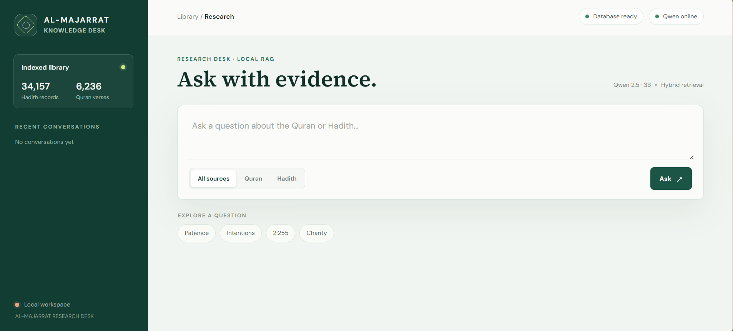
Figure 5.1 — Browser interface

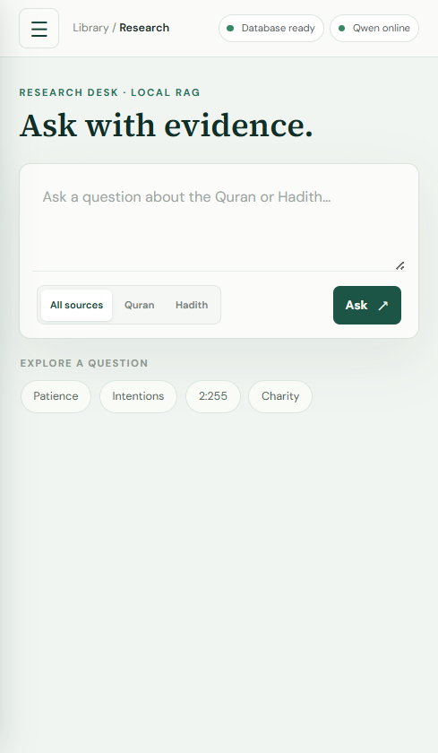
Figure 5.1 — Browser interface in its responsive mobile layout.

5.6 Source Code / Important Implementation

project_config.py
rom pathlib import Path

BASE_DIR = Path(__file__).resolve().parent
DATA_DIR = BASE_DIR / "data"
CORPUS_DIR = DATA_DIR / "corpora"
DB_DIR = DATA_DIR / "db"
DATASETS_DIR = DATA_DIR / "datasets"
RAW_DIR = DATA_DIR / "raw"
MODELS_DIR = DATA_DIR / "models"

DB_PATH = DB_DIR / "al_majarrat_master.db"
HADITH_MASTER_CSV = CORPUS_DIR / "hadith_master_corpus.csv"
QURAN_CORPUS_CSV = CORPUS_DIR / "quran_corpus.csv"
ALPACA_DATASET = DATASETS_DIR / "majarrat_finetune_alpaca.jsonl"
CHAT_DATASET = DATASETS_DIR / "majarrat_finetune_chat.jsonl"

DEFAULT_LOCAL_ENDPOINT = "http://localhost:11434/v1/chat/completions"
DEFAULT_MODEL = "qwen2.5:3b"
EMBEDDING_MODEL = "nomic-embed-text"
OLLAMA_EMBED_API = "http://localhost:11434/api/embeddings"
OLLAMA_TAGS_URL = "http://localhost:11434/api/tags"
PREFERRED_QURAN_TRANSLATION_ID = "20"

REQUIRED_DATA_FILES = (
CORPUS_DIR / "bukhari_corpus.csv",
CORPUS_DIR / "muslim_corpus.csv",
CORPUS_DIR / "nasai_corpus.csv",
CORPUS_DIR / "abudawud_corpus.csv",
CORPUS_DIR / "tirmidhi_corpus.csv",
CORPUS_DIR / "ibnmajah_corpus.csv",
QURAN_CORPUS_CSV,
)

def project_path(*parts):
return str(BASE_DIR.joinpath(*parts))

create_master_corpus.py
import csv
import os
import sqlite3
import sys
from pathlib import Path

ROOT_DIR = Path(__file__).resolve().parents[1]
if str(ROOT_DIR) not in sys.path:
sys.path.insert(0, str(ROOT_DIR))

from project_config import BASE_DIR, CORPUS_DIR, DB_PATH, QURAN_CORPUS_CSV

HADITH_FILES = [
("bukhari", "Sahih al-Bukhari", "صحيح البخاري", CORPUS_DIR / "bukhari_corpus.csv"),
("muslim", "Sahih Muslim", "صحيح مسلم", CORPUS_DIR / "muslim_corpus.csv"),
("nasai", "Sunan an-Nasa'i", "سنن النسائي", CORPUS_DIR / "nasai_corpus.csv"),
("abudawud", "Sunan Abi Dawud", "سنن أبي داود", CORPUS_DIR / "abudawud_corpus.csv"),
("tirmidhi", "Jami` at-Tirmidhi", "جامع الترمذي", CORPUS_DIR / "tirmidhi_corpus.csv"),
("ibnmajah", "Sunan Ibn Majah", "سنن ابن ماجه", CORPUS_DIR / "ibnmajah_corpus.csv")
]

QURAN_FILE = QURAN_CORPUS_CSV
OUTPUT_HADITH_CSV = CORPUS_DIR / "hadith_master_corpus.csv"
OUTPUT_DB = DB_PATH

def build_hadith_master_csv():
print(f"Building {OUTPUT_HADITH_CSV}...")
fieldnames = [
"collection_slug",
"collection_name_en",
"collection_name_ar",
"book_id",
"book_name_en",
"book_name_ar",
"chapter_id",
"chapter_name_en",
"chapter_name_ar",
"hadith_id",
"hadith_id_in_book",
"narrator",
"text_english",
"text_arabic",
"grading",
"reference"
]

total_count = 0
with open(str(OUTPUT_HADITH_CSV), "w", newline="", encoding="utf-8") as out_f:
writer = csv.DictWriter(out_f, fieldnames=fieldnames)
writer.writeheader()

for slug, name_en, name_ar, filepath in HADITH_FILES:
if not os.path.exists(filepath):
print(f"Warning: {filepath} not found, skipping...")
continue

count = 0
with open(str(filepath), "r", encoding="utf-8") as in_f:
reader = csv.DictReader(in_f)
for row in reader:
text_eng = row.get("text_english", "").strip()
text_ara = row.get("text_arabic", "").strip()
if not text_eng and not text_ara:
continue

row_out = {
"collection_slug": slug,
"collection_name_en": name_en,
"collection_name_ar": name_ar,
"book_id": row.get("book_id", ""),
"book_name_en": row.get("book_name_en", name_en),
"book_name_ar": row.get("book_name_ar", name_ar),
"chapter_id": row.get("chapter_id", ""),
"chapter_name_en": row.get("chapter_name_en", ""),
"chapter_name_ar": row.get("chapter_name_ar", ""),
"hadith_id": row.get("hadith_id", ""),
"hadith_id_in_book": row.get("hadith_id_in_book", ""),
"narrator": row.get("narrator", ""),
"text_english": row.get("text_english", ""),
"text_arabic": row.get("text_arabic", ""),
"grading": row.get("grading", ""),
"reference": row.get("reference", "")
}
writer.writerow(row_out)
count += 1
print(f" Added {count:,} hadiths from {name_en}")
total_count += count

print(f"Saved {total_count:,} total hadiths to {OUTPUT_HADITH_CSV}\n")
return total_count

def build_sqlite_db():
print(f"Building SQLite database {OUTPUT_DB}...")
if OUTPUT_DB.exists():
OUTPUT_DB.unlink()

conn = sqlite3.connect(str(OUTPUT_DB))
cursor = conn.cursor()

# 1. Create Hadith Table
cursor.execute("""
CREATE TABLE hadiths (
id INTEGER PRIMARY KEY AUTOINCREMENT,
collection_slug TEXT,
collection_name_en TEXT,
collection_name_ar TEXT,
book_id TEXT,
book_name_en TEXT,
book_name_ar TEXT,
chapter_id TEXT,
chapter_name_en TEXT,
chapter_name_ar TEXT,
hadith_id INTEGER,
hadith_id_in_book TEXT,
narrator TEXT,
text_english TEXT,
text_arabic TEXT,
grading TEXT,
reference TEXT
)
""")

# Index for fast lookup
cursor.execute("CREATE INDEX idx_hadiths_collection ON hadiths(collection_slug);")
cursor.execute("CREATE INDEX idx_hadiths_hadith_id ON hadiths(hadith_id);")
cursor.execute("CREATE INDEX idx_hadiths_grading ON hadiths(grading);")

# Populate Hadiths
with open(str(OUTPUT_HADITH_CSV), "r", encoding="utf-8") as f:
reader = csv.DictReader(f)
hadith_rows = []
for r in reader:
hadith_rows.append((
r["collection_slug"],
r["collection_name_en"],
r["collection_name_ar"],
r["book_id"],
r["book_name_en"],
r["book_name_ar"],
r["chapter_id"],
r["chapter_name_en"],
r["chapter_name_ar"],
int(r["hadith_id"]) if r["hadith_id"].isdigit() else None,
r["hadith_id_in_book"],
r["narrator"],
r["text_english"],
r["text_arabic"],
r["grading"],
r["reference"]
))

cursor.executemany("""
INSERT INTO hadiths (
collection_slug, collection_name_en, collection_name_ar,
book_id, book_name_en, book_name_ar,
chapter_id, chapter_name_en, chapter_name_ar,
hadith_id, hadith_id_in_book, narrator,
text_english, text_arabic, grading, reference
) VALUES (?, ?, ?, ?, ?, ?, ?, ?, ?, ?, ?, ?, ?, ?, ?, ?)
""", hadith_rows)
print(f" Inserted {len(hadith_rows):,} rows into 'hadiths' table.")

# 2. Create Quran Table
cursor.execute("""
CREATE TABLE quran_verses (
id INTEGER PRIMARY KEY AUTOINCREMENT,
chapter_number INTEGER,
verse_number INTEGER,
verse_key TEXT,
text_uthmani TEXT,
translation_resource_id TEXT,
translation_name TEXT,
translation_author TEXT,
translation_text TEXT
)
""")

cursor.execute("CREATE INDEX idx_quran_verse_key ON quran_verses(verse_key);")
cursor.execute("CREATE INDEX idx_quran_chapter_verse ON quran_verses(chapter_number, verse_number);")
cursor.execute("CREATE INDEX idx_quran_translation_id ON quran_verses(translation_resource_id);")

if QURAN_FILE.exists():
with open(str(QURAN_FILE), "r", encoding="utf-8") as f:
reader = csv.DictReader(f)
quran_rows = []
for r in reader:
if r["translation_resource_id"] == "57":
continue
quran_rows.append((
int(r["chapter_number"]) if r["chapter_number"].isdigit() else None,
int(r["verse_number"]) if r["verse_number"].isdigit() else None,
r["verse_key"],
r["text_uthmani"],
r["translation_resource_id"],
r["translation_name"],
r["translation_author"],
r["translation_text"]
))

cursor.executemany("""
INSERT INTO quran_verses (
chapter_number, verse_number, verse_key,
text_uthmani, translation_resource_id, translation_name,
translation_author, translation_text
) VALUES (?, ?, ?, ?, ?, ?, ?, ?)
""", quran_rows)
print(f" Inserted {len(quran_rows):,} rows into 'quran_verses' table.")

# 3. Create Full-Text Search (FTS5) Tables
cursor.execute("""
CREATE VIRTUAL TABLE hadiths_fts USING fts5(
collection_name_en,
reference,
narrator,
text_english,
text_arabic,
content='hadiths',
content_rowid='id'
);
""")

cursor.execute("""
INSERT INTO hadiths_fts(rowid, collection_name_en, reference, narrator, text_english, text_arabic)
SELECT id, collection_name_en, reference, narrator, text_english, text_arabic FROM hadiths;
""")

cursor.execute("""
CREATE VIRTUAL TABLE quran_fts USING fts5(
verse_key,
text_uthmani,
translation_name,
translation_text,
content='quran_verses',
content_rowid='id'
);
""")

cursor.execute("""
INSERT INTO quran_fts(rowid, verse_key, text_uthmani, translation_name, translation_text)
SELECT id, verse_key, text_uthmani, translation_name, translation_text FROM quran_verses;
""")

conn.commit()
conn.close()
print(f"Successfully built SQLite database: {OUTPUT_DB}\n")

def main():
build_hadith_master_csv()
build_sqlite_db()

if __name__ == "__main__":
main()

build_vector_index.py
import sqlite3
import urllib.request
import json
import sys
import time

ROOT_DIR = __import__('os').path.dirname(__import__('os').path.dirname(__import__('os').path.abspath(__file__)))
if ROOT_DIR not in sys.path:
sys.path.insert(0, ROOT_DIR)

from project_config import DB_PATH, EMBEDDING_MODEL, PREFERRED_QURAN_TRANSLATION_ID

if sys.stdout.encoding != 'utf-8':
try:
sys.stdout.reconfigure(encoding='utf-8')
except AttributeError:
pass

OLLAMA_API = "http://localhost:11434/api/embed"
BATCH_SIZE = 64

def get_connection():
if not DB_PATH.exists():
print(f"Error: {DB_PATH} not found.")
sys.exit(1)
return sqlite3.connect(str(DB_PATH), timeout=30.0)

def get_embeddings(texts):
if not texts:
return []
payload = {
"model": EMBEDDING_MODEL,
"input": [text[:1000] for text in texts]
}
req = urllib.request.Request(OLLAMA_API, data=json.dumps(payload).encode('utf-8'), headers={'Content-Type': 'application/json'}, method='POST')
try:
with urllib.request.urlopen(req, timeout=120) as response:
res = json.loads(response.read().decode('utf-8'))
embeddings = res.get("embeddings", [])
if len(embeddings) != len(texts):
print(f"Embedding API returned {len(embeddings)} vectors for {len(texts)} inputs.")
return None
return embeddings
except Exception as e:
print(f"Embedding API Error: {e}")
return None

def init_tables(conn):
cursor = conn.cursor()
cursor.execute("""
CREATE TABLE IF NOT EXISTS quran_vector_index (
id INTEGER PRIMARY KEY,
verse_key TEXT UNIQUE,
embedding_json TEXT
)
""")
cursor.execute("""
CREATE TABLE IF NOT EXISTS hadith_vector_index (
id INTEGER PRIMARY KEY,
hadith_db_id INTEGER UNIQUE,
reference TEXT,
embedding_json TEXT
)
""")
conn.commit()

def index_quran(conn, limit=None):
cursor = conn.cursor()
sql = """
SELECT q.id, q.verse_key, q.translation_text
FROM quran_verses q
WHERE q.id = (
SELECT q2.id
FROM quran_verses q2
WHERE q2.verse_key = q.verse_key
AND q2.translation_text != ''
AND q2.translation_resource_id NOT IN ('ARABIC', '57')
ORDER BY CASE WHEN q2.translation_resource_id = ? THEN 0 ELSE 1 END, q2.id
LIMIT 1
)
ORDER BY q.chapter_number, q.verse_number
"""
params = [PREFERRED_QURAN_TRANSLATION_ID]
if limit is not None:
sql += " LIMIT ?"
params.append(max(0, limit))
cursor.execute(sql, params)
verses = cursor.fetchall()
existing_keys = {row[0] for row in cursor.execute("SELECT verse_key FROM quran_vector_index")}
pending = [verse for verse in verses if verse[1] not in existing_keys]
print(f"\n[Vector Indexer] {len(pending):,} of {len(verses):,} Quran verses need indexing...")

indexed = 0
failed = False
start_t = time.time()
for offset in range(0, len(pending), BATCH_SIZE):
batch = pending[offset:offset + BATCH_SIZE]
embeddings = get_embeddings([verse[2] for verse in batch])
if embeddings is None:
print(" Embedding failed; stopping Quran indexing. Re-run after the embedding service is available.")
failed = True
break
cursor.executemany(
"INSERT OR REPLACE INTO quran_vector_index (verse_key, embedding_json) VALUES (?, ?)",
((verse[1], json.dumps(embedding)) for verse, embedding in zip(batch, embeddings))
)
indexed += len(batch)
conn.commit()
if indexed % 512 == 0:
print(f" Indexed {indexed}/{len(pending)} verses...")

conn.commit()
elapsed = time.time() - start_t
status = "Stopped" if failed else "Completed"
print(f" {status} Quran Vector Indexing: {indexed} new verses indexed in {elapsed:.1f}s.")

def index_hadiths(conn, limit=None):
cursor = conn.cursor()
sql = "SELECT id, reference, text_english FROM hadiths WHERE text_english != '' ORDER BY id"
params = []
if limit is not None:
sql += " LIMIT ?"
params.append(max(0, limit))
cursor.execute(sql, params)
hadiths = cursor.fetchall()
existing_ids = {row[0] for row in cursor.execute("SELECT hadith_db_id FROM hadith_vector_index")}
pending = [hadith for hadith in hadiths if hadith[0] not in existing_ids]
print(f"\n[Vector Indexer] {len(pending):,} of {len(hadiths):,} Hadiths need indexing...")

indexed = 0
failed = False
start_t = time.time()
for offset in range(0, len(pending), BATCH_SIZE):
batch = pending[offset:offset + BATCH_SIZE]
embeddings = get_embeddings([hadith[2] for hadith in batch])
if embeddings is None:
print(" Embedding failed; stopping Hadith indexing. Re-run after the embedding service is available.")
failed = True
break
cursor.executemany(
"INSERT OR REPLACE INTO hadith_vector_index (hadith_db_id, reference, embedding_json) VALUES (?, ?, ?)",
((hadith[0], hadith[1], json.dumps(embedding)) for hadith, embedding in zip(batch, embeddings))
)
indexed += len(batch)
conn.commit()
if indexed % 1024 == 0:
print(f" Indexed {indexed}/{len(pending)} hadiths...")

conn.commit()
elapsed = time.time() - start_t
status = "Stopped" if failed else "Completed"
print(f" {status} Hadith Vector Indexing: {indexed} new Hadiths indexed in {elapsed:.1f}s.")

def main():
import argparse
parser = argparse.ArgumentParser(description="Build Vector Embeddings for Al-Majarrat Database")
parser.add_argument("--quran-limit", type=int, default=None, help="Limit number of Quran verses to index")
parser.add_argument("--hadith-limit", type=int, default=None, help="Limit number of Hadiths to index")
args = parser.parse_args()

conn = get_connection()
init_tables(conn)
index_quran(conn, limit=args.quran_limit)
index_hadiths(conn, limit=args.hadith_limit)
cursor = conn.cursor()
quran_total = cursor.execute("""
SELECT COUNT(DISTINCT verse_key)
FROM quran_verses
WHERE translation_text != '' AND translation_resource_id NOT IN ('ARABIC', '57')
""").fetchone()[0]
quran_indexed = cursor.execute("""
SELECT COUNT(*) FROM quran_vector_index v
WHERE EXISTS (SELECT 1 FROM quran_verses q WHERE q.verse_key = v.verse_key)
""").fetchone()[0]
hadith_total = cursor.execute("SELECT COUNT(*) FROM hadiths WHERE text_english != ''").fetchone()[0]
hadith_indexed = cursor.execute("""
SELECT COUNT(*) FROM hadith_vector_index v
JOIN hadiths h ON h.id = v.hadith_db_id
WHERE h.text_english != ''
""").fetchone()[0]
print(f"Vector coverage: Quran {quran_indexed:,}/{quran_total:,}; Hadith {hadith_indexed:,}/{hadith_total:,}.")
conn.close()

if __name__ == "__main__":
main()

al_majarrat.py
import time
import sqlite3
import json
import urllib.request
import urllib.error
import argparse
import sys
import os
import math
import re
import difflib

ROOT_DIR = os.path.dirname(os.path.dirname(os.path.abspath(__file__)))
if ROOT_DIR not in sys.path:
sys.path.insert(0, ROOT_DIR)

from project_config import (
DB_PATH,
DEFAULT_LOCAL_ENDPOINT,
DEFAULT_MODEL,
EMBEDDING_MODEL,
OLLAMA_EMBED_API,
PREFERRED_QURAN_TRANSLATION_ID,
)

if sys.stdout.encoding != 'utf-8':
try:
sys.stdout.reconfigure(encoding='utf-8')
except AttributeError:
pass

def get_preferred_quran_verse_id(cursor, verse_key):
cursor.execute("""
SELECT id
FROM quran_verses
WHERE verse_key = ?
AND translation_text != ''
AND translation_resource_id NOT IN ('ARABIC', '57')
ORDER BY CASE WHEN translation_resource_id = ? THEN 0 ELSE 1 END, id
LIMIT 1
""", (verse_key, PREFERRED_QURAN_TRANSLATION_ID))
row = cursor.fetchone()
return row[0] if row else None

def validate_runtime_requirements():
if not DB_PATH.exists():
raise FileNotFoundError(f"Database '{DB_PATH}' not found. Run python create_master_corpus.py first.")

required_tables = {"hadiths", "quran_verses", "hadiths_fts", "quran_fts"}
with sqlite3.connect(str(DB_PATH), timeout=5.0) as conn:
existing = {
row[0] for row in conn.execute("SELECT name FROM sqlite_master WHERE type='table' AND name NOT LIKE 'sqlite_%'")
}
missing = sorted(required_tables - existing)
if missing:
raise RuntimeError(f"Database schema missing required tables: {', '.join(missing)}")

def get_db_connection():
if not DB_PATH.exists():
print(f"Error: Database '{DB_PATH}' not found.")
sys.exit(1)
conn = sqlite3.connect(str(DB_PATH), timeout=30.0)
try:
conn.execute("PRAGMA journal_mode=WAL;")
except sqlite3.OperationalError:
pass
return conn

def cosine_similarity(v1, v2):
if not v1 or not v2 or len(v1) != len(v2):
return 0.0
dot_product = sum(a * b for a, b in zip(v1, v2))
magnitude1 = math.sqrt(sum(a * a for a in v1))
magnitude2 = math.sqrt(sum(b * b for b in v2))
if magnitude1 == 0 or magnitude2 == 0:
return 0.0
return dot_product / (magnitude1 * magnitude2)

def get_query_embedding(query_text):
payload = {
"model": EMBEDDING_MODEL,
"prompt": query_text
}
req = urllib.request.Request(OLLAMA_EMBED_API, data=json.dumps(payload).encode('utf-8'), headers={'Content-Type': 'application/json'}, method='POST')
try:
with urllib.request.urlopen(req, timeout=1.5) as response:
res = json.loads(response.read().decode('utf-8'))
return res.get("embedding", [])
except Exception:
# Instant fallback to FTS5 lexical matching if embedding server takes > 1.5s
return None

STOP_WORDS = {"what", "does", "islam", "say", "about", "is", "the", "in", "a", "an", "tell", "me", "how", "why", "who", "which", "where", "can", "you", "hadith", "quran", "verse"}
SEARCH_SYNONYMS = {
"zakaat": ("zakat", "zakah"),
"zakat": ("zakaat", "zakah"),
"zakah": ("zakat", "zakaat"),
}
_SEARCH_TERM_FREQUENCIES = None
_SEARCH_TERMS = None

def get_search_vocabulary(cursor):
global _SEARCH_TERM_FREQUENCIES, _SEARCH_TERMS
if _SEARCH_TERM_FREQUENCIES is not None:
return _SEARCH_TERM_FREQUENCIES

frequencies = {}
for vocab_table, fts_table in (("hadith_search_vocab", "hadiths_fts"), ("quran_search_vocab", "quran_fts")):
try:
cursor.execute(f"CREATE VIRTUAL TABLE IF NOT EXISTS temp.{vocab_table} USING fts5vocab(main, {fts_table}, 'row')")
cursor.execute(f"SELECT term, doc FROM temp.{vocab_table}")
for term, document_count in cursor:
frequencies[term] = frequencies.get(term, 0) + document_count
except sqlite3.Error:
return None

_SEARCH_TERM_FREQUENCIES = frequencies
_SEARCH_TERMS = sorted(frequencies)
return _SEARCH_TERM_FREQUENCIES

def get_fuzzy_search_term(word):
if _SEARCH_TERMS is None or word in _SEARCH_TERM_FREQUENCIES or len(word) < 4:
return None

max_distance = 1 if len(word) < 8 else 2
candidates = difflib.get_close_matches(word, _SEARCH_TERMS, n=12, cutoff=0.68)
ranked = []
for candidate in candidates:
if abs(len(word) - len(candidate)) > max_distance:
continue
distance = edit_distance_with_transposition(word, candidate, max_distance)
if distance <= max_distance:
ranked.append((distance, -_SEARCH_TERM_FREQUENCIES[candidate], candidate))
return min(ranked)[2] if ranked else None

def edit_distance_with_transposition(left, right, cutoff):
if abs(len(left) - len(right)) > cutoff:
return cutoff + 1

previous_previous = None
previous = list(range(len(right) + 1))
for left_index, left_char in enumerate(left, 1):
current = [left_index]
row_minimum = left_index
for right_index, right_char in enumerate(right, 1):
cost = 0 if left_char == right_char else 1
distance = min(
previous[right_index] + 1,
current[right_index - 1] + 1,
previous[right_index - 1] + cost,
)
if (
previous_previous is not None
and left_index > 1
and right_index > 1
and left_char == right[right_index - 2]
and left[left_index - 2] == right_char
):
distance = min(distance, previous_previous[right_index - 2] + 1)
current.append(distance)
row_minimum = min(row_minimum, distance)
if row_minimum > cutoff:
return cutoff + 1
previous_previous, previous = previous, current
return previous[-1]

def clean_search_query(user_query, cursor=None):
# Basic typo fix for common words
typos = {"smilling": "smile", "smill": "smile", "praye": "prayer", "fastin": "fasting"}
if cursor:
get_search_vocabulary(cursor)

words = re.findall(r'\w+', user_query.lower())
terms = []
for w in words:
if w in typos:
w = typos[w]
if w not in STOP_WORDS and len(w) > 2:
fuzzy_term = get_fuzzy_search_term(w) if cursor else None
variants = (w, *SEARCH_SYNONYMS.get(w, ()), *((fuzzy_term,) if fuzzy_term else ()))
for variant in variants:
terms.append(variant)
if len(variant) >= 4:
terms.append(f"{variant[:-1]}*") # Wildcard search for stemming
terms.append(f"{variant}*")

if not terms:
return user_query.strip()
return " OR ".join(dict.fromkeys(terms))

SURAH_NAME_MAP = {
# 1 - 10
"fatiha": 1, "al-fatiha": 1, "opening": 1,
"baqarah": 2, "al-baqarah": 2, "cow": 2,
"imran": 3, "ali-imran": 3, "al-imran": 3, "family-of-imran": 3,
"nisa": 4, "an-nisa": 4, "women": 4,
"maidah": 5, "al-maidah": 5, "table-spread": 5,
"anam": 6, "al-anam": 6, "cattle": 6,
"araf": 7, "al-araf": 7, "heights": 7,
"anfal": 8, "al-anfal": 8, "spoils-of-war": 8,
"tawbah": 9, "at-tawbah": 9, "repentance": 9,
"yunus": 10, "jonah": 10,

# 11 - 20
"hud": 11,
"yusuf": 12, "joseph": 12,
"rad": 13, "ar-rad": 13, "thunder": 13,
"ibrahim": 14, "abraham": 14,
"hijr": 15, "al-hijr": 15,
"nahl": 16, "an-nahl": 16, "bee": 16,
"isra": 17, "al-isra": 17, "night-journey": 17,
"kahf": 18, "al-kahf": 18, "cave": 18,
"maryam": 19, "mary": 19,
"taha": 20, "ta-ha": 20,

# 21 - 30
"anbiya": 21, "al-anbiya": 21, "prophets": 21,
"hajj": 22, "al-hajj": 22, "pilgrimage": 22,
"muminun": 23, "al-muminun": 23, "believers": 23,
"nur": 24, "an-nur": 24, "light": 24,
"furqan": 25, "al-furqan": 25, "criterion": 25,
"shuara": 26, "ash-shuara": 26, "poets": 26,
"naml": 27, "an-naml": 27, "ant": 27,
"qasas": 28, "al-qasas": 28, "stories": 28,
"ankabut": 29, "al-ankabut": 29, "spider": 29,
"rum": 30, "ar-rum": 30, "romans": 30,

# 31 - 40
"luqman": 31,
"sajdah": 32, "as-sajdah": 32, "prostration": 32,
"ahzab": 33, "al-ahzab": 33,
"saba": 34, "sheba": 34,
"fatir": 35, "originator": 35,
"yaseen": 36, "yasin": 36, "ya-sin": 36,
"saffat": 37, "as-saffat": 37,
"sad": 38,
"zumar": 39, "az-zumar": 39, "troops": 39,
"ghafir": 40, "mumin-surah": 40, "forgiver": 40,

# 41 - 50
"fussilat": 41,
"shura": 42, "ash-shura": 42, "consultation": 42,
"zukhruf": 43, "az-zukhruf": 43, "ornaments": 43,
"dukhan": 44, "ad-dukhan": 44, "smoke": 44,
"jathiyah": 45, "al-jathiyah": 45,
"ahqaf": 46, "al-ahqaf": 46,
"muhammad": 47,
"fath": 48, "al-fath": 48, "victory": 48,
"hujurat": 49, "al-hujurat": 49, "rooms": 49,
"qaf": 50,

# 51 - 60
"dhariyat": 51, "adh-dhariyat": 51,
"tur": 52, "at-tur": 52, "mount": 52,
"najm": 53, "an-najm": 53, "star": 53,
"qamar": 54, "al-qamar": 54, "moon": 54,
"rahman": 55, "ar-rahman": 55, "beneficent": 55,
"waqiah": 56, "al-waqiah": 56, "inevitable": 56,
"hadid": 57, "al-hadid": 57, "iron": 57,
"mujadila": 58, "al-mujadila": 58,
"hashr": 59, "al-hashr": 59, "exile": 59,
"mumtahanah": 60, "al-mumtahanah": 60,

# 61 - 70
"saff": 61, "as-saff": 61, "ranks": 61,
"jumuah": 62, "al-jumuah": 62, "friday": 62,
"munafiqun": 63, "al-munafiqun": 63, "hypocrites": 63,
"taghabun": 64, "at-taghabun": 64,
"talaq": 65, "at-talaq": 65, "divorce": 65,
"tahrim": 66, "at-tahrim": 66, "prohibition": 66,
"mulk": 67, "al-mulk": 67, "dominion": 67,
"qalam": 68, "al-qalam": 68, "pen": 68,
"haqqah": 69, "al-haqqah": 69,
"maarij": 70, "al-maarij": 70,

# 71 - 80
"nuh": 71, "noah": 71,
"jinn": 72, "al-jinn": 72,
"muzzammil": 73, "al-muzzammil": 73,
"muddaththir": 74, "al-muddaththir": 74,
"qiyamah": 75, "al-qiyamah": 75, "resurrection": 75,
"insan": 76, "al-insan": 76, "dahr": 76,
"mursalat": 77, "al-mursalat": 77,
"naba": 78, "an-naba": 78, "tidings": 78,
"naziat": 79, "an-naziat": 79,
"abasa": 80,

# 81 - 90
"takwir": 81, "at-takwir": 81,
"infitar": 82, "al-infitar": 82,
"mutaffifin": 83, "al-mutaffifin": 83,
"inshiqaq": 84, "al-inshiqaq": 84,
"buruj": 85, "al-buruj": 85,
"tariq": 86, "at-tariq": 86, "morning-star": 86,
"ala": 87, "al-ala": 87,
"ghashiyah": 88, "al-ghashiyah": 88,
"fajr": 89, "al-fajr": 89, "dawn": 89,
"balad": 90, "al-balad": 90, "city": 90,

# 91 - 100
"shams": 91, "ash-shams": 91, "sun": 91,
"layl": 92, "al-layl": 92, "night": 92,
"duha": 93, "ad-duha": 93,
"sharh": 94, "ash-sharh": 94, "inshirah": 94,
"tin": 95, "at-tin": 95, "fig": 95,
"alaq": 96, "al-alaq": 96, "clot": 96,
"qadr": 97, "al-qadr": 97,
"bayyinah": 98, "al-bayyinah": 98,
"zilzal": 99, "az-zilzal": 99, "zalzalah": 99, "earthquake": 99,
"adiyat": 100, "al-adiyat": 100,

# 101 - 114
"qariah": 101, "al-qariah": 101,
"takathur": 102, "at-takathur": 102,
"asr": 103, "al-asr": 103,
"humazah": 104, "al-humazah": 104,
"fil": 105, "al-fil": 105, "elephant": 105,
"quraish": 106, "quraysh": 106,
"maun": 107, "al-maun": 107,
"kawthar": 108, "al-kawthar": 108, "kauthar": 108,
"kafirun": 109, "al-kafirun": 109,
"nasr": 110, "an-nasr": 110,
"masad": 111, "al-masad": 111, "lahab": 111,
"ikhlas": 112, "al-ikhlas": 112, "purity": 112,
"falaq": 113, "al-falaq": 113, "daybreak": 113,
"nas": 114, "an-nas": 114, "naas": 114, "an-naas": 114, "mankind": 114
}

def retrieve_hybrid_context(user_query, max_quran=6, max_hadith=5):
conn = get_db_connection()
cursor = conn.cursor()

# 1. Get Query Vector Embedding
query_vec = get_query_embedding(user_query)

# ------------------- QURAN HYBRID RETRIEVAL -------------------
# A. Direct Verse Key / Surah Pattern Match (e.g. 2:255 or Surah 2 verse 60)
direct_quran_ids = []

# Check for chapter:verse format like 2:255 or "Surah 2 verse 60"
verse_key_match = re.search(r'\b(\d{1,3}):(\d{1,3})\b', user_query)
surah_verse_text_match = re.search(r'\bsurah\s*(\d{1,3})\s*verse\s*(\d{1,3})\b', user_query.lower())

if verse_key_match:
vk_pattern = f"{verse_key_match.group(1)}:{verse_key_match.group(2)}"
verse_id = get_preferred_quran_verse_id(cursor, vk_pattern)
direct_quran_ids = [verse_id] if verse_id is not None else []
elif surah_verse_text_match:
vk_pattern = f"{surah_verse_text_match.group(1)}:{surah_verse_text_match.group(2)}"
verse_id = get_preferred_quran_verse_id(cursor, vk_pattern)
direct_quran_ids = [verse_id] if verse_id is not None else []

# Check for Surah number format (e.g. "surah 114") or Surah name (e.g. "surah an-nas", "surah nas")
if not direct_quran_ids:
s_num = None
surah_num_match = re.search(r'\bsurah\s*(\d{1,3})\b', user_query.lower())
if surah_num_match:
s_num = int(surah_num_match.group(1))
else:
query_tokens = re.findall(r'[a-z\-]+', user_query.lower())
for t in query_tokens:
clean_t = t.replace("-", "")
if t in SURAH_NAME_MAP:
s_num = SURAH_NAME_MAP[t]
break
elif clean_t in SURAH_NAME_MAP:
s_num = SURAH_NAME_MAP[clean_t]
break

if s_num:
# Fetch all verses of the requested Surah (up to 300) so no verses or core contexts are missed
cursor.execute("SELECT verse_key FROM quran_verses WHERE chapter_number = ? GROUP BY verse_number ORDER BY verse_number LIMIT 300", (s_num,))
for (verse_key,) in cursor.fetchall():
verse_id = get_preferred_quran_verse_id(cursor, verse_key)
if verse_id is not None:
direct_quran_ids.append(verse_id)

# B. FTS5 Lexical Search for Quran
fts_term = clean_search_query(user_query, cursor)
fts_quran_ids = list(direct_quran_ids)
if not direct_quran_ids:
try:
cursor.execute("""
SELECT q.verse_key
FROM quran_verses q
JOIN quran_fts fts ON q.id = fts.rowid
WHERE quran_fts MATCH ?
GROUP BY q.verse_key
ORDER BY MIN(rank)
LIMIT 15
""", (fts_term,))
for (verse_key,) in cursor.fetchall():
verse_id = get_preferred_quran_verse_id(cursor, verse_key)
if verse_id is not None and verse_id not in fts_quran_ids:
fts_quran_ids.append(verse_id)
except Exception:
pass

# B. Vector Cosine Search
vector_quran_scores = {}
if query_vec:
cursor.execute("""
SELECT q.id, v.embedding_json
FROM quran_vector_index v
JOIN quran_verses q ON q.id = (
SELECT q2.id
FROM quran_verses q2
WHERE q2.verse_key = v.verse_key
AND q2.translation_text != ''
AND q2.translation_resource_id NOT IN ('ARABIC', '57')
ORDER BY CASE WHEN q2.translation_resource_id = ? THEN 0 ELSE 1 END, q2.id
LIMIT 1
)
""", (PREFERRED_QURAN_TRANSLATION_ID,))
for q_id, emb_str in cursor:
emb = json.loads(emb_str)
score = cosine_similarity(query_vec, emb)
vector_quran_scores[q_id] = score

# Reciprocal Rank Fusion (RRF) for Quran
rrf_quran = {}
for rank, q_id in enumerate(fts_quran_ids):
rrf_quran[q_id] = rrf_quran.get(q_id, 0) + (1.0 / (60 + rank + 1))

sorted_vector_quran = sorted(vector_quran_scores.items(), key=lambda x: x[1], reverse=True)[:15]
for rank, (q_id, v_score) in enumerate(sorted_vector_quran):
rrf_quran[q_id] = rrf_quran.get(q_id, 0) + (1.0 / (60 + rank + 1))

if direct_quran_ids:
final_quran_ids = direct_quran_ids[:max_quran]
else:
final_quran_ids = [q_id for q_id, _ in sorted(rrf_quran.items(), key=lambda x: x[1], reverse=True)[:max_quran]]

quran_context = []
if final_quran_ids:
placeholders = ",".join("?" * len(final_quran_ids))
cursor.execute(f"SELECT verse_key, text_uthmani, translation_name, translation_text FROM quran_verses WHERE id IN ({placeholders})", final_quran_ids)
for vk, ar, tn, en in cursor.fetchall():
quran_context.append(f"• [Surah {vk}] (Translation: {tn})\n Arabic: {ar}\n English: {en}")

# ------------------- HADITH HYBRID RETRIEVAL -------------------
# A. FTS5 BM25 Relevance Search (Searches across all 34,157 Hadiths by relevance rank)
fts_hadith_ids = []
try:
cursor.execute("SELECT h.id FROM hadiths h JOIN hadiths_fts fts ON h.id = fts.rowid WHERE hadiths_fts MATCH ? ORDER BY rank LIMIT 25", (fts_term,))
fts_hadith_ids = [r[0] for r in cursor.fetchall()]
except Exception:
pass

# Fallback keyword match if FTS returns fewer than max_hadith
if len(fts_hadith_ids) < max_hadith:
query_words = [w for w in re.findall(r'\w+', user_query.lower()) if w not in STOP_WORDS and len(w) > 2]
for qw in query_words:
if qw in ["smilling", "smill"]:
qw = "smile"
try:
cursor.execute("SELECT id FROM hadiths WHERE text_english LIKE ? LIMIT 10", (f"%{qw}%",))
for r in cursor.fetchall():
if r[0] not in fts_hadith_ids:
fts_hadith_ids.append(r[0])
except Exception:
pass

# B. Vector Cosine Search
vector_hadith_scores = {}
if query_vec:
cursor.execute("SELECT h.id, v.embedding_json FROM hadiths h JOIN hadith_vector_index v ON h.id = v.hadith_db_id")
for h_id, emb_str in cursor:
emb = json.loads(emb_str)
score = cosine_similarity(query_vec, emb)
vector_hadith_scores[h_id] = score

# RRF Fusion for Hadiths
rrf_hadith = {}
for rank, h_id in enumerate(fts_hadith_ids):
rrf_hadith[h_id] = rrf_hadith.get(h_id, 0) + (1.0 / (60 + rank + 1))

sorted_vector_hadith = sorted(vector_hadith_scores.items(), key=lambda x: x[1], reverse=True)[:20]
for rank, (h_id, v_score) in enumerate(sorted_vector_hadith):
rrf_hadith[h_id] = rrf_hadith.get(h_id, 0) + (1.0 / (60 + rank + 1))

final_hadith_ids = [h_id for h_id, _ in sorted(rrf_hadith.items(), key=lambda x: x[1], reverse=True)[:max_hadith]]

hadith_context = []
if final_hadith_ids:
placeholders = ",".join("?" * len(final_hadith_ids))
cursor.execute(f"SELECT reference, collection_name_en, narrator, text_english, grading FROM hadiths WHERE id IN ({placeholders})", final_hadith_ids)
for ref, coll, narrator, en, grading in cursor.fetchall():
narrator_str = f" ({narrator})" if narrator else ""
grading_str = f" [Grading: {grading}]" if grading else ""
hadith_context.append(f"• [{ref}] {coll}{narrator_str}{grading_str}\n English: {en}")

return quran_context, hadith_context

def build_prompt(user_query, quran_context, hadith_context):
system_prompt = (
"You are an authentic Islamic Knowledge AI Assistant powered by Project Al-Majarrat.\n"
"Your duty is to answer the user's question accurately using ONLY the retrieved authentic Quran verses and Hadiths provided below.\n"
"MANDATORY RULES:\n"
"1. LANGUAGE: Always write your full response in ENGLISH. Always include the English translation text for every Hadith or Quranic verse cited.\n"
"2. CITATIONS: For EVERY point, quote, or claim in your response, you MUST include the exact bracketed reference tag (e.g., [Sahih al-Bukhari 6114] or [Surah 114:1]) directly from the provided context.\n"
"3. SURAH EXPLANATIONS: Explain only the verses included in the retrieved context. State when the context is a selection; never imply that every verse is listed unless every verse is present.\n"
"4. NO FABRICATION: Do NOT invent, fabricate, or paraphrase unverified Hadiths or verses.\n"
"5. If no relevant context is provided below, state clearly that no direct references were found in the database for this query."
)

context_str = "=== RETRIEVED GROUNDING CONTEXT FROM AL-MAJARRAT DATABASE ===\n\n"

if quran_context:
context_str += "--- QURAN VERSES ---\n" + "\n\n".join(quran_context) + "\n\n"
else:
context_str += "--- QURAN VERSES ---\nNo matching Quran verses found for this query.\n\n"

if hadith_context:
context_str += "--- HADITH PASSAGES ---\n" + "\n\n".join(hadith_context) + "\n\n"
else:
context_str += "--- HADITH PASSAGES ---\nNo matching Hadith passages found for this query.\n\n"

user_message = f"{context_str}=== USER QUESTION ===\n{user_query}\n\nRemember to write your answer in English and explicitly cite the bracketed references (e.g., [Sahih al-Bukhari ...]) for every point."

return system_prompt, user_message

def query_local_llm(system_prompt, user_message, endpoint=DEFAULT_LOCAL_ENDPOINT, model=DEFAULT_MODEL):
headers = {"Content-Type": "application/json"}
payload = {
"model": model,
"messages": [
{"role": "system", "content": system_prompt},
{"role": "user", "content": user_message}
],
"temperature": 0.3,
"max_tokens": 1024
}

req = urllib.request.Request(endpoint, data=json.dumps(payload).encode('utf-8'), headers=headers, method='POST')

try:
with urllib.request.urlopen(req, timeout=30) as response:
res_data = json.loads(response.read().decode('utf-8'))
choices = res_data.get("choices", [])
if choices:
return choices[0].get("message", {}).get("content", "")
return "No response content generated by local LLM."
except urllib.error.URLError as e:
return f"LOCAL_LLM_OFFLINE: Could not connect to Local LLM at '{endpoint}'. Error: {e.reason}"
except Exception as e:
return f"LOCAL_LLM_ERROR: {str(e)}"

def process_rag_query(user_query, endpoint=DEFAULT_LOCAL_ENDPOINT, model=DEFAULT_MODEL, verbose=True):
validate_runtime_requirements()
if verbose:
print(f"\n[Step 1/2] Searching database via FTS5 + Vectors for: '{user_query}'...")

quran_ctx, hadith_ctx = retrieve_hybrid_context(user_query)

if verbose:
print(f"[Step 1/2] Found {len(quran_ctx)} Quran verses and {len(hadith_ctx)} Hadiths.")

system_prompt, user_message = build_prompt(user_query, quran_ctx, hadith_ctx)

if verbose:
print(f"[Step 2/2] Generating AI answer via {model} (GPU)... Please wait a few seconds...\n")

response = query_local_llm(system_prompt, user_message, endpoint=endpoint, model=model)
return response, quran_ctx, hadith_ctx

def main():
parser = argparse.ArgumentParser(description="Al-Majarrat Hybrid AI RAG Engine (FTS5 + Vector Embeddings)")
parser.add_argument("-a", "--ask", type=str, help="Ask a natural language question")
parser.add_argument("-t", "--test-retrieval", type=str, help="Test Hybrid retrieval without querying local LLM")
parser.add_argument("-e", "--endpoint", type=str, default=DEFAULT_LOCAL_ENDPOINT, help=f"Local LLM API endpoint URL")
parser.add_argument("-m", "--model", type=str, default=DEFAULT_MODEL, help=f"Local LLM model name")

args = parser.parse_args()

if args.test_retrieval:
query = args.test_retrieval
print(f"=== TESTING HYBRID RETRIEVAL FOR: '{query}' ===")
quran_ctx, hadith_ctx = retrieve_hybrid_context(query)
sys_p, user_m = build_prompt(query, quran_ctx, hadith_ctx)
print("\n--- GROUNDED USER MESSAGE ---")
print(user_m)
return

if args.ask:
response, quran_ctx, hadith_ctx = process_rag_query(args.ask, endpoint=args.endpoint, model=args.model)

if "LOCAL_LLM_OFFLINE" in response or "LOCAL_LLM_ERROR" in response:
print(f"\n⚠️ {response}\n")
print("=== RETRIEVED GROUNDING CONTEXT ===")
for q in quran_ctx:
print(q)
for h in hadith_ctx:
print(h)
else:
print("=== AI RESPONSE (HYBRID GROUNDED) ===")
print(response)
return

# Interactive Loop Mode
print("==========================================================")
print(" PROJECT AL-MAJARRAT - HYBRID AI RAG ENGINE (FTS5 + VECTORS) ")
print("==========================================================")
print(f"Embedding Model: {EMBEDDING_MODEL}")
print(f"Local LLM Model: {DEFAULT_MODEL}")
print("Type your questions naturally. Type 'exit' to quit.\n")

while True:
try:
time.sleep(0.1)
sys.stdout.flush()
user_input = input("\nHybrid Al-Majarrat AI> ").strip()
if not user_input:
continue

# Exact command match for exit/quit
if user_input.lower() in ["exit", "quit", "q!", "bye", "/exit", "/quit"]:
print("\nGoodbye!")
break

response, quran_ctx, hadith_ctx = process_rag_query(user_input, endpoint=args.endpoint, model=args.model)

if "LOCAL_LLM_OFFLINE" in response or "LOCAL_LLM_ERROR" in response:
print(f"\n⚠️ {response}\n")
print("=== RETRIEVED GROUNDED CONTEXT ===")
for q in quran_ctx:
print(q)
for h in hadith_ctx:
print(h)
print()
else:
print("\n=== AI RESPONSE ===")
print(response.strip())
print("\n" + "="*60)

sys.stdout.flush()

except KeyboardInterrupt:
print("\nExiting RAG Engine...")
break
except Exception as e:
print(f"Error: {e}\n")

if __name__ == "__main__":
main()

search_majarrat.py
import sqlite3
import argparse
import sys
import os

ROOT_DIR = os.path.dirname(os.path.dirname(os.path.abspath(__file__)))
if ROOT_DIR not in sys.path:
sys.path.insert(0, ROOT_DIR)

from project_config import DB_PATH, PREFERRED_QURAN_TRANSLATION_ID

if sys.stdout.encoding != 'utf-8':
try:
sys.stdout.reconfigure(encoding='utf-8')
except AttributeError:
pass

if sys.stderr.encoding != 'utf-8':
try:
sys.stderr.reconfigure(encoding='utf-8')
except AttributeError:
pass

def get_connection():
if not DB_PATH.exists():
print(f"Error: Database file '{DB_PATH}' not found. Please run create_master_corpus.py first.")
sys.exit(1)
return sqlite3.connect(str(DB_PATH))

def format_hadith(row):
(hid, slug, name_en, name_ar, book_id, book_en, book_ar,
chap_id, chap_en, chap_ar, hadith_id, hadith_in_book,
narrator, text_en, text_ar, grading, reference) = row

header = f"[{reference}] {name_en} ({name_ar})"
divider = "-" * len(header)
output = [header, divider]

if narrator:
output.append(f"Narrator: {narrator}")
if grading:
output.append(f"Grading: {grading}")
if text_en:
output.append(f"\nEnglish:\n{text_en}")
if text_ar:
output.append(f"\nArabic:\n{text_ar}")

output.append("=" * 60)
return "\n".join(output)

def format_quran(row):
(qid, ch_num, v_num, v_key, text_uthmani, t_id, t_name, t_author, t_text) = row

header = f"[Surah {ch_num}:{v_num} ({v_key})] ({t_name} by {t_author})"
divider = "-" * len(header)
output = [header, divider]
output.append(f"Arabic (Uthmani):\n{text_uthmani}")
output.append(f"\nTranslation ({t_name}):\n{t_text}")
output.append("=" * 60)
return "\n".join(output)

def search_hadiths(query, collection=None, limit=10):
conn = get_connection()
cursor = conn.cursor()

# Escape quotes for SQLite FTS match query
sanitized_query = query.replace('"', '""')
fts_query = f'"{sanitized_query}"'

sql = """
SELECT h.*
FROM hadiths h
JOIN hadiths_fts fts ON h.id = fts.rowid
WHERE hadiths_fts MATCH ?
"""
params = [fts_query]

if collection:
sql += " AND h.collection_slug = ?"
params.append(collection.lower())

sql += " LIMIT ?"
params.append(limit)

try:
cursor.execute(sql, params)
rows = cursor.fetchall()
return rows
except sqlite3.OperationalError:
# Fallback to simple query if FTS syntax fails
sql_fallback = """
SELECT * FROM hadiths
WHERE (text_english LIKE ? OR text_arabic LIKE ? OR narrator LIKE ? OR reference LIKE ?)
"""
like_param = f"%{query}%"
params_fb = [like_param, like_param, like_param, like_param]

if collection:
sql_fallback += " AND collection_slug = ?"
params_fb.append(collection.lower())

sql_fallback += " LIMIT ?"
params_fb.append(limit)

cursor.execute(sql_fallback, params_fb)
return cursor.fetchall()

def search_quran(query, limit=10):
conn = get_connection()
cursor = conn.cursor()

sanitized_query = query.replace('"', '""')
fts_query = f'"{sanitized_query}"'

sql = """
SELECT q.*
FROM (
SELECT q.verse_key, MIN(rank) AS search_rank
FROM quran_verses q
JOIN quran_fts fts ON q.id = fts.rowid
WHERE quran_fts MATCH ?
GROUP BY q.verse_key
ORDER BY search_rank
LIMIT ?
) matches
JOIN quran_verses q ON q.id = (
SELECT q2.id
FROM quran_verses q2
WHERE q2.verse_key = matches.verse_key
AND q2.translation_text != ''
AND q2.translation_resource_id NOT IN ('ARABIC', '57')
ORDER BY CASE WHEN q2.translation_resource_id = ? THEN 0 ELSE 1 END, q2.id
LIMIT 1
)
ORDER BY matches.search_rank
"""
try:
cursor.execute(sql, (fts_query, limit, PREFERRED_QURAN_TRANSLATION_ID))
rows = cursor.fetchall()
return rows
except sqlite3.OperationalError:
# Fallback to LIKE
like_param = f"%{query}%"
sql_fallback = """
SELECT q.* FROM quran_verses q
WHERE q.id = (
SELECT q2.id
FROM quran_verses q2
WHERE q2.verse_key = q.verse_key
AND q2.translation_text != ''
AND q2.translation_resource_id NOT IN ('ARABIC', '57')
ORDER BY CASE WHEN q2.translation_resource_id = ? THEN 0 ELSE 1 END, q2.id
LIMIT 1
)
AND (q.translation_text LIKE ? OR q.text_uthmani LIKE ? OR q.verse_key LIKE ?)
LIMIT ?
"""
cursor.execute(sql_fallback, (PREFERRED_QURAN_TRANSLATION_ID, like_param, like_param, like_param, limit))
return cursor.fetchall()

def interactive_mode():
print("==================================================")
print(" PROJECT AL-MAJARRAT - QURAN & HADITH SEARCH ")
print("==================================================")
print("Commands:")
print(" h <query> - Search Hadiths across all collections")
print(" h:<collection> <q> - Search within specific collection (bukhari, muslim, tirmidhi, etc.)")
print(" q <query> - Search Quran verses")
print(" all <query> - Search both Quran and Hadiths")
print(" exit / quit - Exit the search CLI\n")

while True:
try:
user_input = input("Al-Majarrat Search> ").strip()
if not user_input:
continue
if user_input.lower() in ["exit", "quit", "q!"]:
print("Goodbye!")
break

parts = user_input.split(" ", 1)
cmd = parts[0].lower()
query = parts[1].strip() if len(parts) > 1 else ""

if not query:
print("Please enter a search query.\n")
continue

if cmd == "q":
print(f"\n--- Searching Quran for: '{query}' ---")
results = search_quran(query)
if not results:
print("No matching Quran verses found.\n")
else:
for r in results:
print(format_quran(r))
print(f"Found {len(results)} results.\n")

elif cmd.startswith("h"):
collection = None
if ":" in cmd:
collection = cmd.split(":", 1)[1]

coll_str = f" in [{collection}]" if collection else " across all collections"
print(f"\n--- Searching Hadiths{coll_str} for: '{query}' ---")
results = search_hadiths(query, collection=collection)
if not results:
print("No matching Hadiths found.\n")
else:
for r in results:
print(format_hadith(r))
print(f"Found {len(results)} results.\n")

elif cmd == "all":
print(f"\n=== QURAN RESULTS FOR: '{query}' ===")
q_results = search_quran(query)
for r in q_results:
print(format_quran(r))
print(f"Quran matches: {len(q_results)}\n")

print(f"=== HADITH RESULTS FOR: '{query}' ===")
h_results = search_hadiths(query)
for r in h_results:
print(format_hadith(r))
print(f"Hadith matches: {len(h_results)}\n")

else:
# Default search all
query = user_input
print(f"\n=== QURAN RESULTS FOR: '{query}' ===")
q_results = search_quran(query)
for r in q_results:
print(format_quran(r))

print(f"=== HADITH RESULTS FOR: '{query}' ===")
h_results = search_hadiths(query)
for r in h_results:
print(format_hadith(r))

except KeyboardInterrupt:
print("\nExiting search...")
break
except Exception as e:
print(f"Error: {e}\n")

def main():
parser = argparse.ArgumentParser(description="Al-Majarrat Quran & Hadith SQLite FTS5 Search CLI")
parser.add_argument("-q", "--quran", type=str, help="Search Quran verses")
parser.add_argument("-H", "--hadith", type=str, help="Search Hadith text")
parser.add_argument("-c", "--collection", type=str, help="Hadith collection slug (bukhari, muslim, nasai, abudawud, tirmidhi, ibnmajah)")
parser.add_argument("-a", "--all", type=str, help="Search across both Quran and Hadiths")
parser.add_argument("-l", "--limit", type=int, default=10, help="Maximum number of results to return (default: 10)")
parser.add_argument("-i", "--interactive", action="store_true", help="Start interactive search prompt")

args = parser.parse_args()

if len(sys.argv) == 1 or args.interactive:
interactive_mode()
return

if args.quran:
print(f"\n=== QURAN SEARCH RESULTS: '{args.quran}' ===")
results = search_quran(args.quran, limit=args.limit)
for r in results:
print(format_quran(r))
print(f"Total results: {len(results)}")

if args.hadith:
print(f"\n=== HADITH SEARCH RESULTS: '{args.hadith}' ===")
results = search_hadiths(args.hadith, collection=args.collection, limit=args.limit)
for r in results:
print(format_hadith(r))
print(f"Total results: {len(results)}")

if args.all:
print(f"\n=== QURAN SEARCH RESULTS: '{args.all}' ===")
q_results = search_quran(args.all, limit=args.limit)
for r in q_results:
print(format_quran(r))

print(f"\n=== HADITH SEARCH RESULTS: '{args.all}' ===")
h_results = search_hadiths(args.all, collection=args.collection, limit=args.limit)
for r in h_results:
print(format_hadith(r))

if __name__ == "__main__":
main()

serve_web_ui.py
import argparse
import json
import sqlite3
import sys
import urllib.error
import urllib.request
from http.server import SimpleHTTPRequestHandler, ThreadingHTTPServer
from pathlib import Path

ROOT_DIR = Path(__file__).resolve().parents[1]
if str(ROOT_DIR) not in sys.path:
sys.path.insert(0, str(ROOT_DIR))

import al_majarrat as rag
from project_config import BASE_DIR, DB_PATH as PROJECT_DB_PATH, OLLAMA_TAGS_URL

ROOT = BASE_DIR
WEB_ROOT = ROOT / "web"
DB_PATH = PROJECT_DB_PATH
MAX_REQUEST_BYTES = 16_384

def get_status():
database = {"ready": False, "hadiths": 0, "verses": 0, "quran_vectors": 0, "hadith_vectors": 0}
if DB_PATH.exists():
try:
uri = f"file:{DB_PATH.as_posix()}?mode=ro"
with sqlite3.connect(uri, uri=True, timeout=3) as conn:
database.update({
"ready": True,
"hadiths": conn.execute("SELECT COUNT(*) FROM hadiths").fetchone()[0],
"verses": conn.execute("SELECT COUNT(DISTINCT verse_key) FROM quran_verses").fetchone()[0],
"quran_vectors": conn.execute("SELECT COUNT(*) FROM quran_vector_index").fetchone()[0],
"hadith_vectors": conn.execute("SELECT COUNT(*) FROM hadith_vector_index").fetchone()[0],
})
except sqlite3.Error as error:
database["error"] = str(error)

ollama = {"ready": False, "models": [], "chat_model": rag.DEFAULT_MODEL, "embedding_model": rag.EMBEDDING_MODEL}
try:
with urllib.request.urlopen(OLLAMA_TAGS_URL, timeout=2) as response:
model_rows = json.loads(response.read().decode("utf-8")).get("models", [])
ollama["models"] = [item.get("name", "") for item in model_rows]
ollama["ready"] = True
ollama["chat_model_available"] = any(
name == rag.DEFAULT_MODEL or name.startswith(f"{rag.DEFAULT_MODEL}:")
for name in ollama["models"]
)
ollama["embedding_model_available"] = any(
name == rag.EMBEDDING_MODEL or name.startswith(f"{rag.EMBEDDING_MODEL}:")
for name in ollama["models"]
)
except (OSError, urllib.error.URLError, json.JSONDecodeError) as error:
ollama["error"] = str(error)

return {"database": database, "ollama": ollama}

class WebHandler(SimpleHTTPRequestHandler):
def __init__(self, *args, **kwargs):
super().__init__(*args, directory=str(WEB_ROOT), **kwargs)

def do_GET(self):
if self.path == "/api/status":
self.send_json(200, get_status())
return
if self.path == "/":
self.path = "/index.html"
super().do_GET()

def do_POST(self):
if self.path != "/api/ask":
self.send_json(404, {"error": "Endpoint not found."})
return

try:
length = int(self.headers.get("Content-Length", "0"))
if length <= 0 or length > MAX_REQUEST_BYTES:
self.send_json(413, {"error": "Request must be under 16 KB."})
return
payload = json.loads(self.rfile.read(length).decode("utf-8"))
query = str(payload.get("query", "")).strip()
mode = payload.get("mode", "all")
if not query:
self.send_json(400, {"error": "Enter a question to search."})
return
if len(query) > 2_000:
self.send_json(400, {"error": "Question is limited to 2,000 characters."})
return
if mode not in {"all", "quran", "hadith"}:
self.send_json(400, {"error": "Choose Quran, Hadith, or all sources."})
return

quran, hadith = rag.retrieve_hybrid_context(query)
if mode == "quran":
hadith = []
elif mode == "hadith":
quran = []
system_prompt, user_message = rag.build_prompt(query, quran, hadith)
answer = rag.query_local_llm(system_prompt, user_message)
self.send_json(200, {
"query": query,
"mode": mode,
"answer": answer,
"quran": quran,
"hadith": hadith,
"generated": not answer.startswith(("LOCAL_LLM_OFFLINE:", "LOCAL_LLM_ERROR:")),
})
except (UnicodeDecodeError, json.JSONDecodeError, AttributeError, TypeError) as error:
self.send_json(400, {"error": f"Invalid request: {error}"})
except Exception as error:
self.send_json(500, {"error": f"Search failed: {error}"})

def send_json(self, status, payload):
body = json.dumps(payload, ensure_ascii=False).encode("utf-8")
self.send_response(status)
self.send_header("Content-Type", "application/json; charset=utf-8")
self.send_header("Content-Length", str(len(body)))
self.send_header("Cache-Control", "no-store")
self.end_headers()
self.wfile.write(body)

def log_message(self, format_string, *args):
print(f"[Web UI] {self.address_string()} - {format_string % args}")

def main():
parser = argparse.ArgumentParser(description="Local Al-Majarrat Quran and Hadith research UI")
parser.add_argument("--host", default="127.0.0.1", help="Bind address (defaults to localhost only)")
parser.add_argument("--port", type=int, default=8765)
args = parser.parse_args()

if not WEB_ROOT.is_dir():
raise SystemExit(f"Web assets not found: {WEB_ROOT}")

server = ThreadingHTTPServer((args.host, args.port), WebHandler)
print(f"Al-Majarrat Research Desk: http://{args.host}:{args.port}")
print("Press Ctrl+C to stop.")
try:
server.serve_forever()
except KeyboardInterrupt:
print("\nStopping Al-Majarrat Research Desk.")
finally:
server.server_close()

if __name__ == "__main__":
main()

validate_project.py
import argparse
import json
import sqlite3
import sys
import urllib.error
import urllib.request
from pathlib import Path

ROOT_DIR = Path(__file__).resolve().parents[1]
if str(ROOT_DIR) not in sys.path:
sys.path.insert(0, str(ROOT_DIR))

from project_config import (
BASE_DIR,
DB_PATH,
DEFAULT_LOCAL_ENDPOINT,
DEFAULT_MODEL,
EMBEDDING_MODEL,
OLLAMA_EMBED_API,
OLLAMA_TAGS_URL,
REQUIRED_DATA_FILES,
)

def check_data_files():
missing = [str(path) for path in REQUIRED_DATA_FILES if not path.exists()]
if missing:
return {"ok": False, "messages": [f"Missing dataset file(s): {', '.join(missing)}"]}
return {"ok": True, "messages": ["All source corpus files are present."]}

def check_database(db_path=DB_PATH):
database_path = Path(db_path)
if not database_path.exists():
return {"ok": False, "messages": [f"Database file not found: {database_path}"]}

required_tables = {"hadiths", "quran_verses", "hadiths_fts", "quran_fts"}
try:
with sqlite3.connect(str(database_path), timeout=5.0) as conn:
tables = {
row[0]
for row in conn.execute(
"SELECT name FROM sqlite_master WHERE type='table' AND name NOT LIKE 'sqlite_%'"
)
}
missing = sorted(required_tables - tables)
if missing:
return {"ok": False, "messages": [f"Missing required tables: {', '.join(missing)}"]}

hadith_count = conn.execute("SELECT COUNT(*) FROM hadiths").fetchone()[0]
quran_count = conn.execute("SELECT COUNT(*) FROM quran_verses").fetchone()[0]
return {
"ok": True,
"messages": [
f"Database is valid: {hadith_count} hadith rows, {quran_count} quran rows.",
"Required tables are present.",
],
}
except sqlite3.Error as exc:
return {"ok": False, "messages": [f"Database validation failed: {exc}"]}

def check_ollama_models(endpoint=DEFAULT_LOCAL_ENDPOINT, model_name=DEFAULT_MODEL, embedding_model=EMBEDDING_MODEL):
try:
with urllib.request.urlopen(OLLAMA_TAGS_URL, timeout=3) as response:
payload = json.loads(response.read().decode("utf-8"))
models = [item.get("name", "") for item in payload.get("models", [])]
except (OSError, urllib.error.URLError, json.JSONDecodeError):
return {
"ok": False,
"messages": [f"Ollama is not responding at {OLLAMA_TAGS_URL}."] ,
"models": [],
}

available = {name for name in models}
chat_ok = any(name == model_name or name.startswith(f"{model_name}:") for name in available)
embedding_ok = any(name == embedding_model or name.startswith(f"{embedding_model}:") for name in available)

messages = []
if not chat_ok:
messages.append(f"Chat model '{model_name}' is not installed in Ollama.")
if not embedding_ok:
messages.append(f"Embedding model '{embedding_model}' is not installed in Ollama.")
if not messages:
messages.append("Ollama backend and required models are available.")

return {
"ok": chat_ok and embedding_ok,
"messages": messages,
"models": sorted(models),
}

def run_validation(db_path=DB_PATH):
steps = [
("data_files", check_data_files()),
("database", check_database(db_path)),
("ollama", check_ollama_models()),
]

all_ok = True
for name, result in steps:
if not result["ok"]:
all_ok = False
print(f"[{name}] {'OK' if result['ok'] else 'FAIL'}")
for message in result.get("messages", []):
print(f" - {message}")

return all_ok

def main():
parser = argparse.ArgumentParser(description="Validate the Al-Majarrat project environment.")
parser.add_argument("--db-path", type=str, default=str(DB_PATH), help="Path to the SQLite database file.")
parser.add_argument("--skip-ollama", action="store_true", help="Skip Ollama connectivity validation.")
args = parser.parse_args()

steps = [
("data_files", check_data_files()),
("database", check_database(args.db_path)),
]
if not args.skip_ollama:
steps.append(("ollama", check_ollama_models()))

all_ok = True
for name, result in steps:
print(f"[{name}] {'OK' if result['ok'] else 'FAIL'}")
for message in result.get("messages", []):
print(f" - {message}")
all_ok = all_ok and result["ok"]

return 0 if all_ok else 1

if __name__ == "__main__":
sys.exit(main())

File | Purpose / role | Inputs | Primary output
project_config.py | Stores project paths, DB path, model endpoints, and translation preference. | Project root and environment flags. | Stable absolute paths for all modules.
src/create_master_corpus.py | Builds the master Hadith CSV and SQLite database, including FTS5 tables. | CSV corpus files. | Database with hadiths, quran_verses, and search indexes.
src/build_vector_index.py | Generates embedding batches and persists vector JSON for Quran and Hadith texts. | Eligible text and Ollama embedding endpoint. | quran_vector_index and hadith_vector_index tables.
src/al_majarrat.py | Core retrieval and generation logic; resolves direct references, searches, ranks, and prompts the local model. | User query and database state. | Retrieved evidence and grounded answer.
src/search_majarrat.py | Interactive CLI search for Quran and Hadith records using SQLite search functions. | User query or command input. | Matched source passages and references.
src/serve_web_ui.py | Hosts the browser UI and REST endpoints, including /api/status and /api/ask. | HTTP requests and DB/model status. | JSON answer payload plus status reporting.
web/index.html | Browser interface for prompt input, source display, conversation history, and copy actions. | User interaction and API responses. | Rendered UI with dynamic answer card.
src/validate_project.py | Checks corpus completeness, database readiness, and Ollama connectivity. | Project files and local services. | Validation status and error messages.
tests/test_project_health.py | Regression tests for data presence, DB validity, and missing-file behavior. | Python test runner. | Pass/fail result for project health.

The most important implementation logic remains in the shared retrieval module and the UI server. These components are the actual bridge between project data, evidence selection, and answer generation.

Chapter 6 — Results and Discussion

6.1 Sample Input and Output
The developed Al-Majarrat system was tested using sample questions to check whether the complete retrieval and answer workflow functions as expected. The system accepts a natural-language question and a source filter as input, and uses lexical and semantic retrieval to find relevant Quran and Hadith passages. It supports real query execution through both the command-line interface and the browser interface.

6.1.1 Sample Input
A sample question was submitted to the system through the command-line interface.
- Sample Input:Query: What does the Quran say about patience?
- Source Filter: All
- Command: python src/al_majarrat.py --ask "What does the Quran say about patience?"
After the question is received, the system validates the input and uses it as the basis for retrieving relevant passages.

6.1.2 Processing Path
The question passes through the following stages:
Query validation → Lexical and semantic retrieval → Source ranking → Prompt assembly → Local model response
The Quran and Hadith passages are retrieved from the local database, ranked using Reciprocal Rank Fusion, and supplied to the local language model as constrained context. The actual passages returned may differ depending on the question, the source filter, and the data in the local database.

6.1.3 Sample Output
After processing the question, the system returns a structured result containing the following information:
- Query: the original question submitted by the user
- Mode: the source filter used for the search (for example, all)
- Quran: the retrieved verses with their references
- Hadith: the retrieved Hadith with their references
- Answer: the natural-language response generated by the local model
Output shape: {
"query": "...",
"mode": "all",
"quran": [verses and references],
"hadith": [hadith references],
"answer": "..."
}

6.2 Graphs and Charts
No graphs or charts have been generated for this report because the project does not include a validated retrieval benchmark, user survey, or standardized evaluation dataset. The available project evidence is numerical and operational rather than comparative performance data.

6.2.1 Current level of Islamic knowledge
Out of 15 respondents, 66.7% rate their Islamic knowledge as moderately knowledgeable and 33.3% as having a basic understanding.
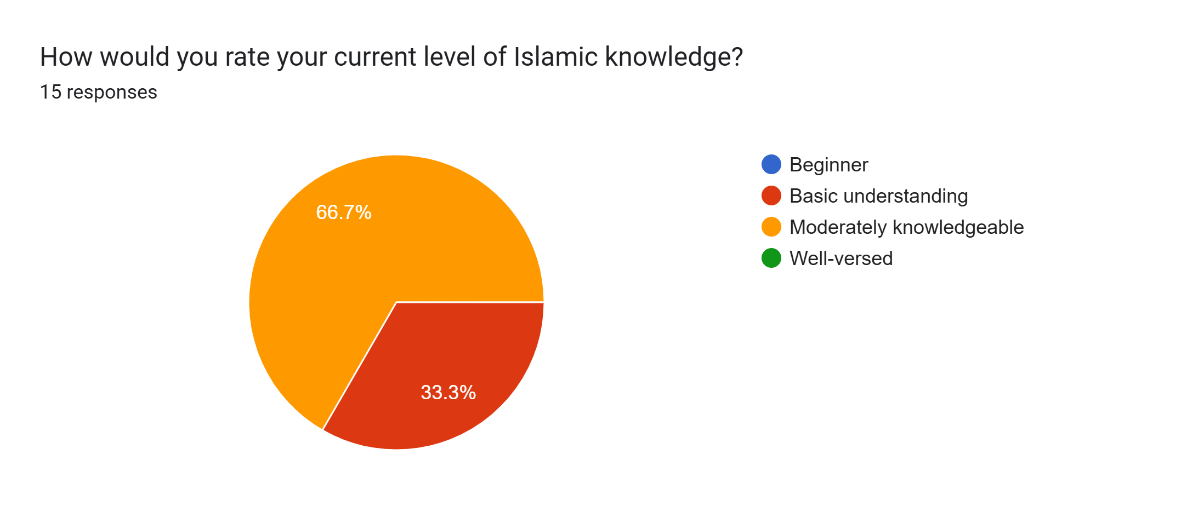

6.2.2 Seeking Islamic knowledge online
Out of 15 respondents, over half (53.3%) rarely seek answers to Islamic questions online, while the remainder do so a few times a week (26.7%), a few times a month (13.3%), or daily (6.7%).
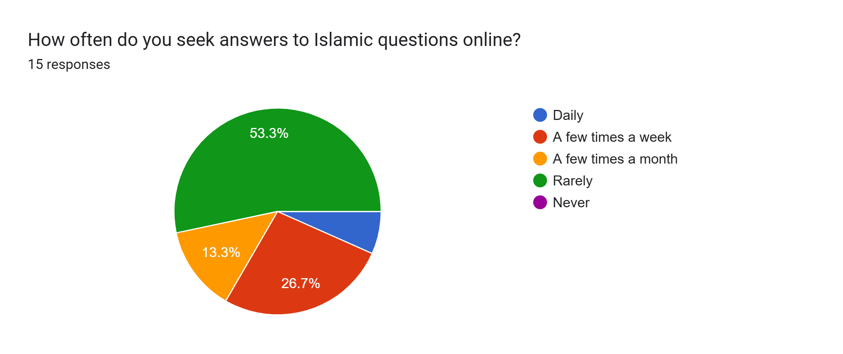

4.2.3 Biggest challenge
Out of 15 respondents, the biggest challenges when researching Islamic topics online are verifying authenticity (66.7%), dealing with conflicting sources (40%), language barriers (26.7%), and overly scholarly content (13.3%).
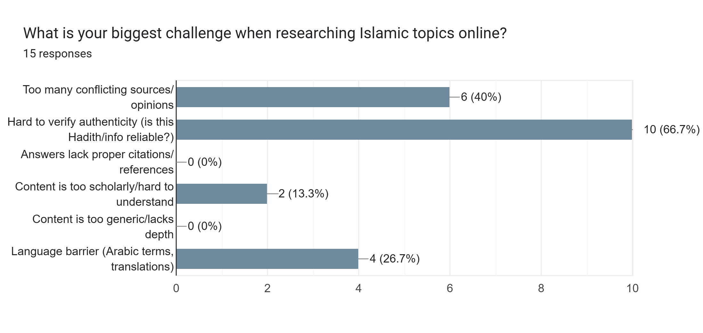

4.2.4 Using of AI Tools
Out of 15 respondents, a vast majority (86.7%) have used AI tools to ask Islamic questions—either once or twice (46.7%), occasionally (26.7%), or frequently (13.3%)—while only 13.3% have never used them.
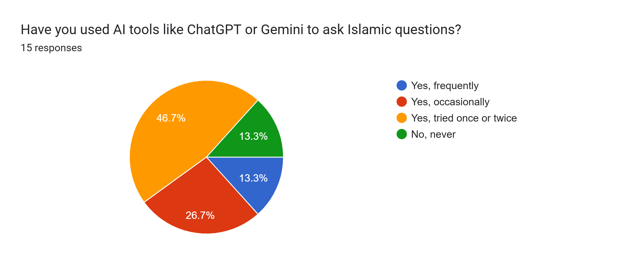

4.2.5 Trustworthiness of answer by AI
Out of 13 respondents who used AI tools for Islamic questions, trustworthiness ratings were mixed, peaking at a moderate score of 3 (30.8%), with the remainder split between ratings of 2 (23.1%) and ratings of 1, 4, and 5 at 15.4% each.
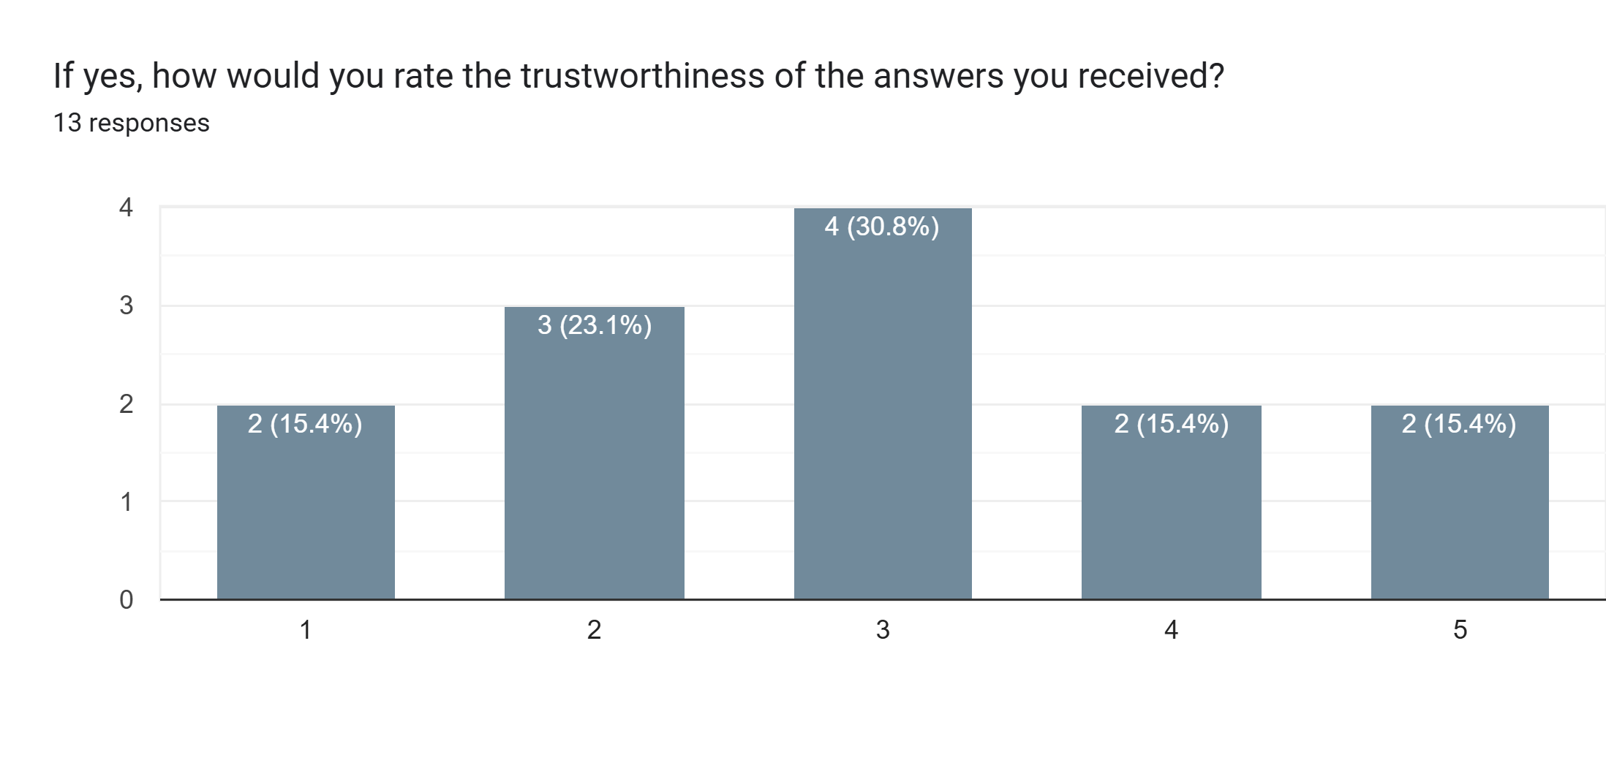

4.2.6 Reference provided by AI Tools
Out of 15 respondents, 40% were unsure or didn't check if AI tools provided references, while the rest reported that references were provided sometimes (33.3%), always (13.3%), or rarely (13.3%).
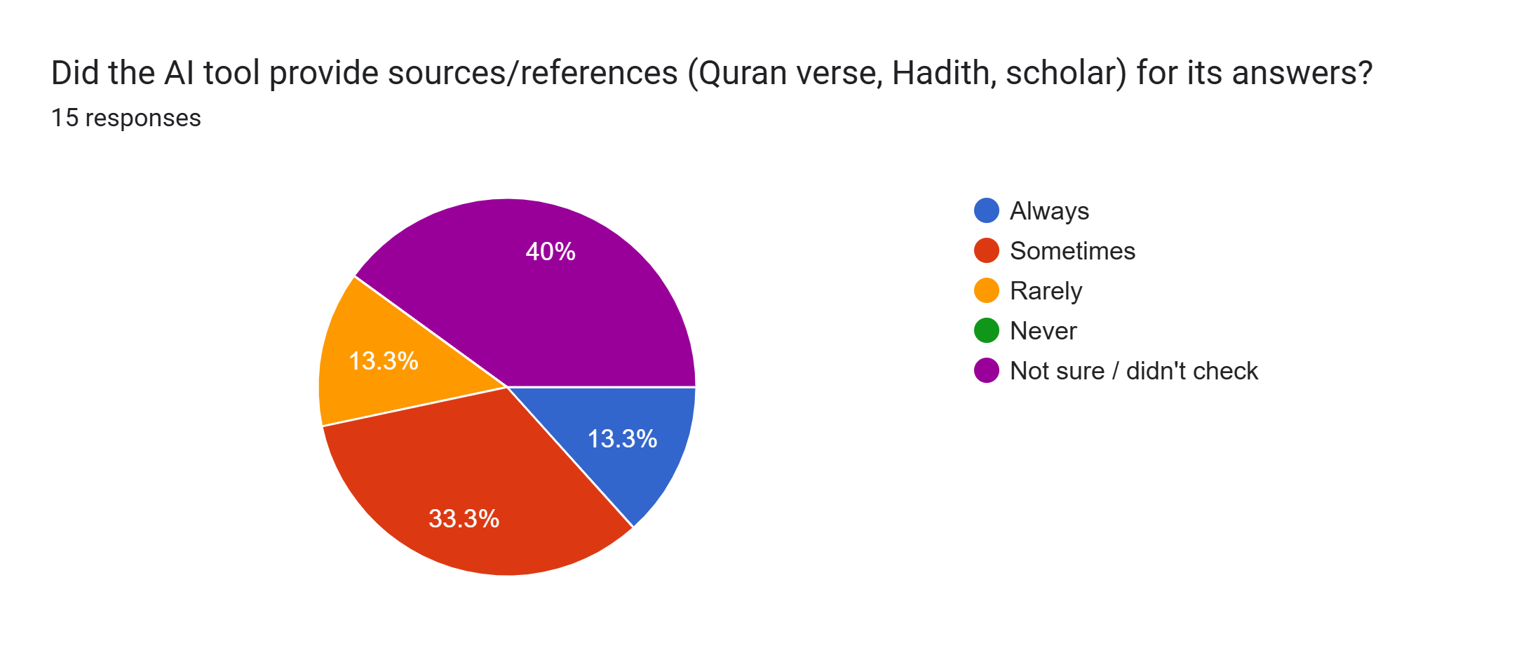

4.2.7 Concern on AI providing misleading information
Out of 15 respondents, a large majority show high levels of concern about AI providing incorrect or misleading Islamic information, with 80% rating their concern at a 4 or 5 (33.3% and 46.7%, respectively), while 13.3% rated it a 3 and 6.7% rated it a 1.
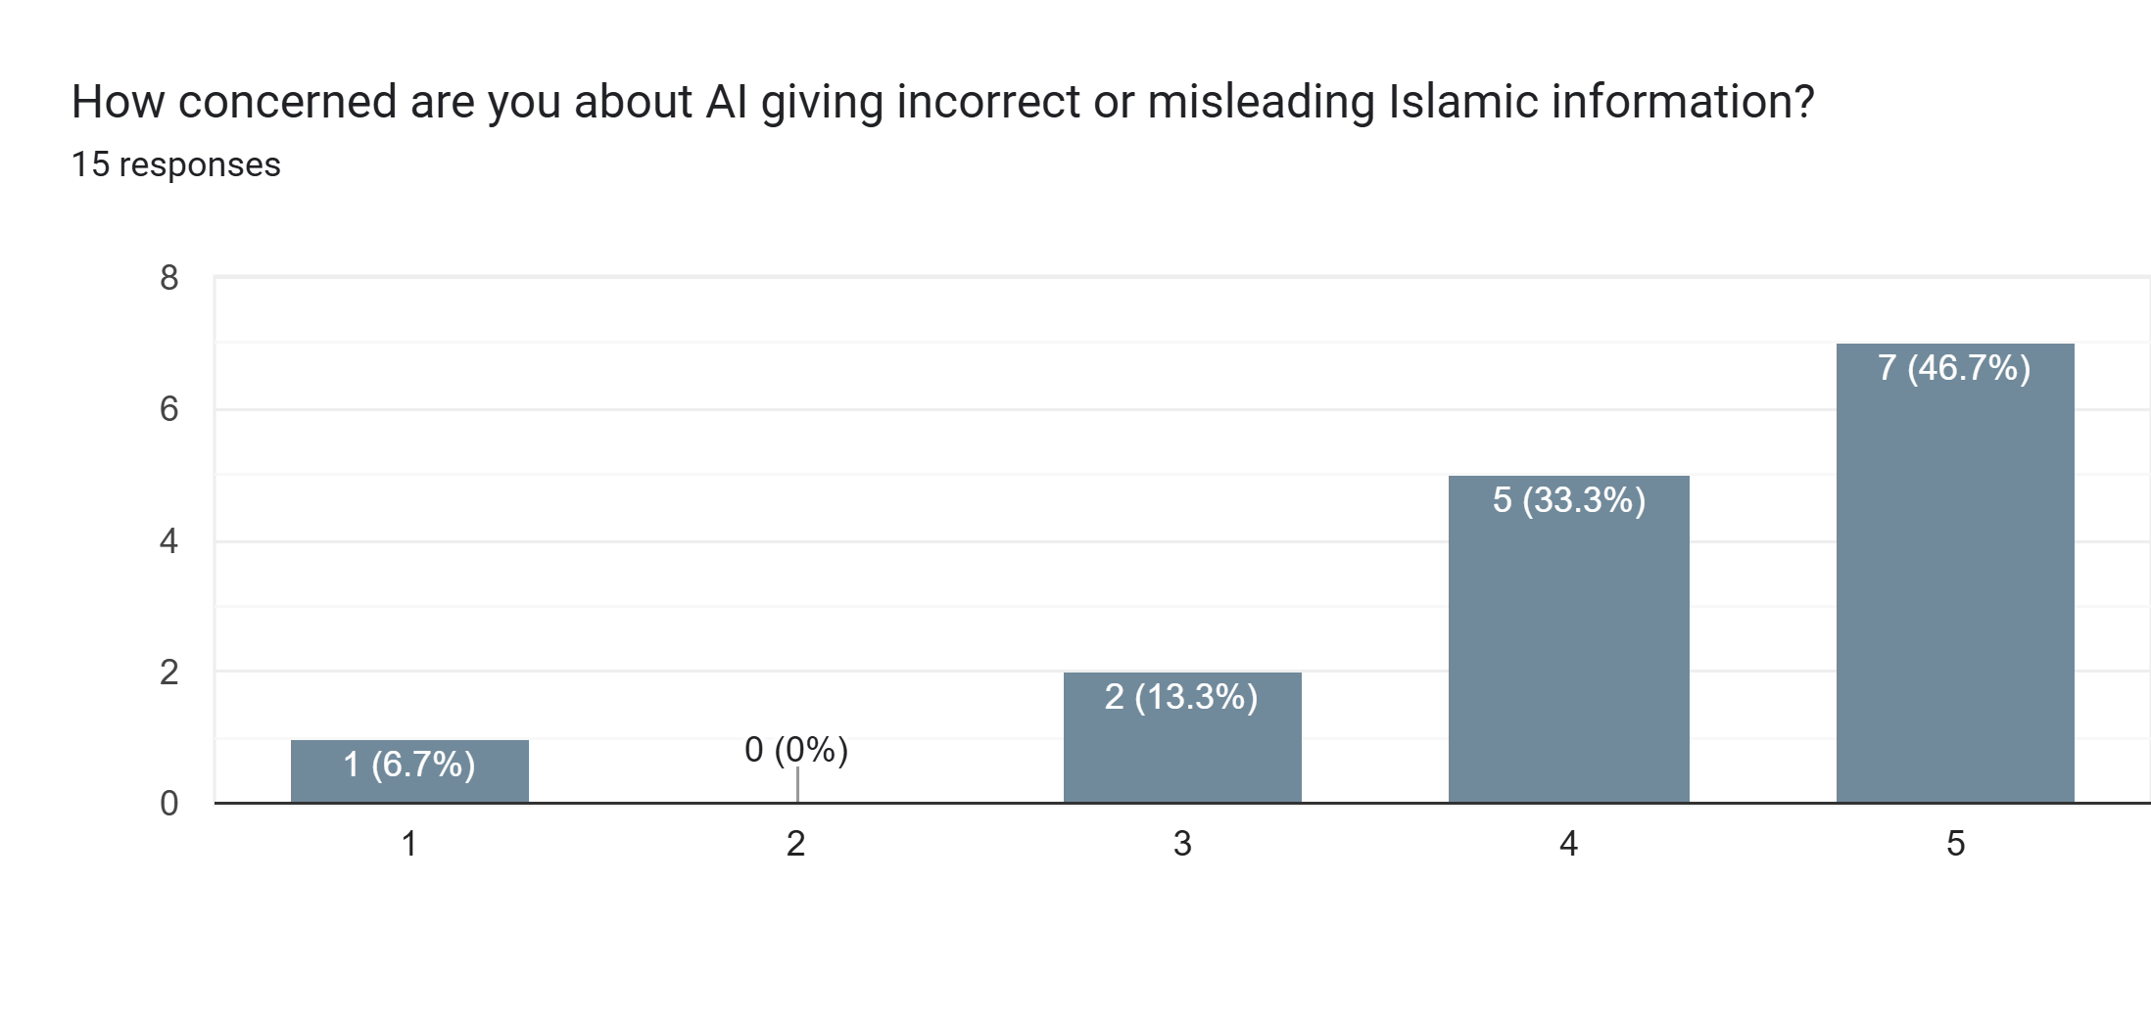

4.2.8 Source of trust
Out of 15 respondents, Islamic websites/apps are the most trusted source for Islamic questions (40%), followed by local Imams/Scholars and books (20% each), social media (13.3%), and family/friends (6.7%), while none selected General AI tools (0%).
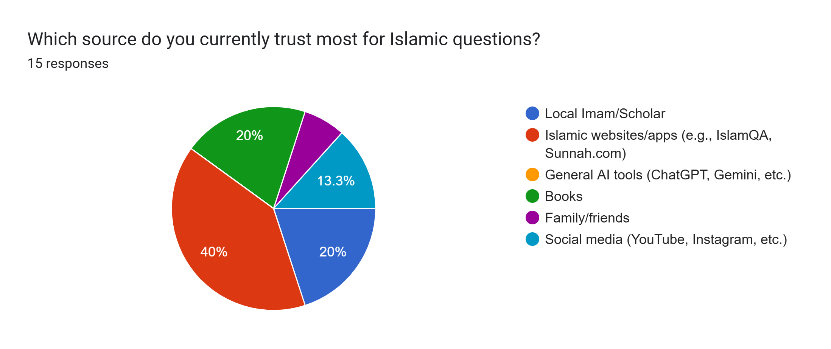

4.2.9 Showing authenticity grading on hadith
Out of 15 respondents, displaying Hadith authenticity grading in an Islamic Q&A tool is highly important to most, with 60% rating it a 5, 13.3% rating it a 4, and 26.7% rating it a 3, while none rated it lower.
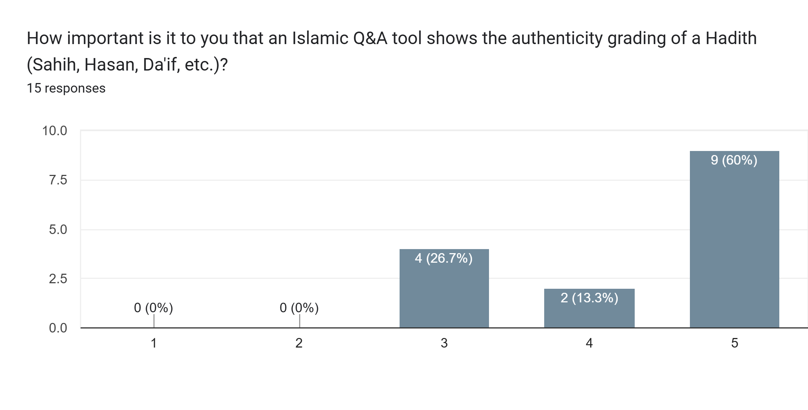

4.2.9 Interested in using AI assistance which answer from quran and hadith
Out of 15 respondents, a solid majority (66.7%) express interest in an AI assistant that answers strictly from verified Quran/Hadith sources with references—with 46.7% saying "Definitely yes" and 20% "Probably yes"—while 26.7% are not sure and 6.7% answered "Definitely not".

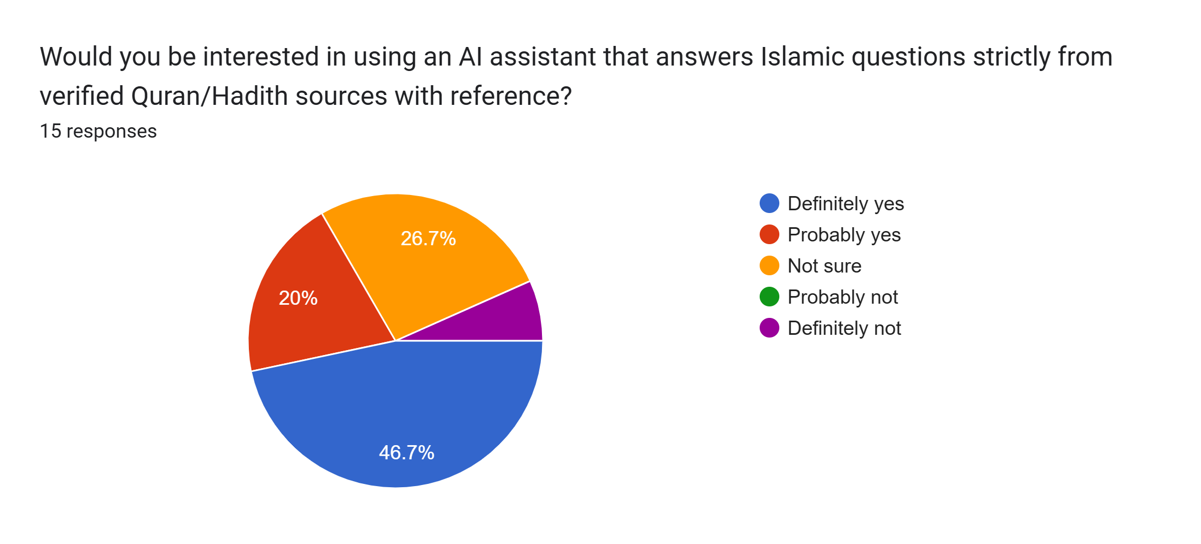

6.3 Analysis of Results
Counts below were read from the populated SQLite database during report preparation. They describe stored rows and vector coverage, not answer accuracy.
Measure | Count | Interpretation
Hadith source rows | 34,157 | Six loaded collections.
Quran database rows | 56,124 | Arabic and translation rows; not unique verses.
Distinct Quran verse keys | 6,236 | Unique verse references in this database.
Hadith vector rows | 34,157 | Count matches Hadith source row total.
Quran vector rows | 6,236 | Count matches unique Quran verse keys.
FTS Hadith rows | 34,157 | External-content index rows.
FTS Quran rows | 56,124 | External-content index rows.

Hadith collection | Rows
Sahih al-Bukhari | 7,580
Sahih Muslim | 7,360
Sunan an-Nasa’i | 5,679
Sunan Abi Dawud | 5,272
Jami‘ at-Tirmidhi | 3,926
Sunan Ibn Majah | 4,340
Total | 34,157

The current database has vector coverage for all Hadith rows and for all distinct Quran verse keys in the snapshot. Health tests confirm the presence of required files, tables, and database structure. These results support operational readiness of the local data layer but do not validate answer quality or retrieval accuracy.
The live Ollama chat endpoint was intentionally skipped in the recorded health run, so the project cannot claim verified live-model inference without an explicit environment check. Similarly, no retrieval-quality benchmark or user study was performed. The system therefore remains a functional local research assistant with evidence-aware retrieval, but not a formally benchmarked academic evaluation system.

Chapter 7 — Conclusion and Future Scope

7.1 Summary of Work

Al-Majarrat was developed as a local, AI-based research assistant for students, researchers, and learners who want to explore Quran and Hadith sources. The main purpose of the system is to provide users with an environment where they can ask questions in natural language and see the supporting evidence behind every answer. The system consolidates the Quran and Hadith corpora into a SQLite database with full-text search tables and vector indexes. After that, users can look up passages directly by reference or ask a question and receive the most relevant passages, found through hybrid retrieval that combines lexical and semantic rankings using Reciprocal Rank Fusion. When the local model is available, the retrieved passages are passed to it as constrained context, and the response is returned along with its references and source text

The system can be used through both a command-line interface and a responsive web interface that keeps browser conversation history. Health validation and tests check that the required files, database tables, and model services are ready. The code, data, tests, web assets, and documentation are kept separate so that individual components can be modified without affecting the complete application.
The project therefore combines corpus processing, direct reference lookup, hybrid retrieval, prompt-constrained local generation, and a simple user interface into a single local platform. It is intended to assist in locating and reviewing sources, not to replace the primary texts, established scholarship, or qualified guidance.

7.2 Achievements
- Prepared a database with 34,157 Hadith records and 56,124 Quran rows.
- Populated vectors for 34,157 Hadiths and 6,236 distinct Quran verse keys.
- Implemented lexical and semantic retrieval with reciprocal-rank fusion.
- Added direct Quran reference and Surah handling.
- Implemented a local web UI/API and CLI.
- Added browser conversation persistence, reopen, and individual deletion.
- Passed all four project health tests and configured corpus/database checks.

7.3 Limitations
- Generated answers may be wrong or overstate evidence; prompt rules cannot guarantee factuality.
- No expert-labeled retrieval benchmark, factuality evaluation, performance study, or user survey was conducted.
- The live Ollama chat endpoint was not checked in the recorded health run.
- Translation, edition, grading, provenance, and license details should be verified before scholarly use or redistribution.
- Browser history lives in one browser's localStorage; clearing browser data removes it.
- The RAG workflow currently targets English answers; Arabic-first interaction is not its documented focus.
- Vector storage/query scaling and latency have not been profiled.
- The training utilities do not automatically load their adapter into default inference.

7.4 Future Enhancements
- Build an expert-reviewed evaluation set and measure the system using Recall@k, MRR, citation precision, and the rate of unsupported claims.
- Record source provenance, edition and version details, license notices, and procedures for refreshing the corpus.
- Add a personal guidance module with a dua library, a verse and Hadith of the day, and prayer times, so users can use the platform for daily spiritual support as well as research.
- Expand the corpus with additional Hadith collections and Tafsir sources, such as Ibn Kathir, so users can review commentary alongside the verses.
- Add more English translations and support questions asked in Arabic, since the current system handles English-language questions only.
- Evaluate retrieval filters, rank fusion, reranking, and translation-specific indexing to improve the quality of the retrieved passages.
- Add a model readiness and smoke-test workflow, along with reproducible runtime benchmarks.
- Profile response latency and memory usage on defined hardware, including low-VRAM machines.
- If fine-tuning is pursued, add adapter loading to the default serving path and evaluate the model on a held-out test set.
- Add history export and import, retention controls, and privacy documentation for the browser conversation history.
- Improve deployment hardening, logging, error reporting, and operational guidance before the system is exposed beyond the local machine.
- Introduce user accounts and a hosted multi-user version, once the security and privacy requirements above have been met.

Chapter 8 — References
Technical references reviewed for this report (accessed 4 October 2026):
[1] SQLite, “FTS5 Extension.” https://www.sqlite.org/fts5.html
[2] Ollama, “OpenAI compatibility.” https://docs.ollama.com/api/openai-compatibility
[3] Ollama, “Embeddings.” https://docs.ollama.com/capabilities/embeddings
[4] Quran Foundation, Content API documentation. https://api-docs.quran.foundation/
[5] fawazahmed0, “Hadith API” dataset repository. https://github.com/fawazahmed0/hadith-api
[6] Qwen, Qwen2.5-3B-Instruct model card. https://huggingface.co/Qwen/Qwen2.5-3B-Instruct
[7] Python Software Foundation, “sqlite3.” https://docs.python.org/3/library/sqlite3.html
[8] Project files reviewed: project_config.py; src/al_majarrat.py; corpus, index, search, web, validation and training scripts; tests/test_project_health.py.
[9] Al-Majarrat README, setup and operational instructions.
Dataset/API terms and model licenses may vary by source or change over time. Verify current terms, attribution, and translation permissions before publishing or redistributing corpus data.

Chapter 9 — Appendix

9.1 Database Structure Summary
hadiths(id, collection_slug, collection_name_en/ar, book_id/name, chapter_id/name,
hadith_id, hadith_id_in_book, narrator, text_english, text_arabic, grading, reference)
quran_verses(id, chapter_number, verse_number, verse_key, text_uthmani,
translation_resource_id, translation_name, translation_author, translation_text)
hadiths_fts: FTS5 external-content index -> hadiths.id
quran_fts: FTS5 external-content index -> quran_verses.id
hadith_vector_index(id, hadith_db_id UNIQUE, reference, embedding_json)
quran_vector_index(id, verse_key UNIQUE, embedding_json)

9.2 Local API Summary
Method / route | Purpose
GET / | Serve web/index.html.
GET /api/status | Return database counts and best-effort Ollama availability.
POST /api/ask | Accept {"query":"...", "mode":"all|quran|hadith"} and return answer/sources.

POST /api/ask enforces a non-empty query, a 2,000-character query limit, allowed source modes, and a 16 KB request body limit. The server defaults to 127.0.0.1.

9.3 Validation and Test Evidence
python src/validate_project.py --skip-ollama
python -m unittest tests/test_project_health.py
Recorded result: source checks and database validation passed; the validator reported 34,157 Hadith rows and 56,124 Quran rows; all four unittest cases passed. Ollama was skipped, so this does not certify a live model request.

9.4 Main Project Files
Path | Description
project_config.py | Shared paths, DB path, model endpoints, preferred translation.
src/al_majarrat.py | Hybrid RAG, prompt composition, local generation, CLI.
src/create_master_corpus.py | Master corpus and SQLite/FTS builder.
src/build_vector_index.py | Embedding generation and persistence.
src/search_majarrat.py | Lexical Quran/Hadith CLI search.
src/serve_web_ui.py | Local HTTP server, status endpoint, ask API.
web/index.html | Responsive UI and browser-local conversation history.
src/validate_project.py and tests/ | Health checks and unit tests.
src/export_finetuning_dataset.py; src/train_qwen_lora.py | Dataset export and optional QLoRA utilities.

9.5 User Operation Quick Reference
Start web UI: python src/serve_web_ui.py
Ask a question: python src/al_majarrat.py --ask "What does the Quran say about patience?"
Test retrieval: python src/al_majarrat.py --test-retrieval "2:255"
Lexical search: python src/search_majarrat.py
Validate data/DB: python src/validate_project.py --skip-ollama
Full model check: python src/validate_project.py

