Medicine Inventory
Management System
Database Systems Course – Project 1
Entity | 8 tables
Triggers | 5 triggers
Views | 3 views
Test Records | ≥12 per table
Bonus UI | Flask Web App

1. Introduction
This report documents the design and implementation of a relational database for a Medicine Inventory Management System. The system enables hospitals and pharmacies to digitally manage prescriptions, medicines, disease catalogues, doctors, patients, and automated billing.
The database was designed following the entity-relationship (ER) modelling approach, then converted to a normalised relational schema, and finally implemented in MySQL with full DDL, DML, views, and triggers.

2. Conceptual Design

2.1 Entities and Attributes

DISEASE
- disease_id (PK)
- disease_name
- disease_type {Infectious | Deficiency | Genetic Hereditary | Non-Genetic Hereditary}

DOCTOR
- doctor_id (PK)
- doctor_name
- qualification
- specialization

PATIENT
- patient_id (PK)
- patient_name
- birth_date
- phone

MEDICINE
- medicine_id (PK)
- medicine_name
- manufacture_date
- expiry_date
- price
- dosage

PRESCRIPTION
- prescription_id (PK)
- issuing_date
- doctor_id (FK → DOCTOR)
- patient_id (FK → PATIENT)

PRESCRIPTION_MEDICINE (associative entity)
- prescription_id (PK, FK → PRESCRIPTION)
- medicine_id (PK, FK → MEDICINE)
- quantity

MEDICINE_DISEASE (associative entity)
- medicine_id (PK, FK → MEDICINE)
- disease_id (PK, FK → DISEASE)

BILL
- bill_id (PK)
- prescription_id (FK → PRESCRIPTION, UNIQUE)
- subtotal
- tax (%)
- discount (%)
- total

2.2 Relationships
Relationship | Entities | Cardinality | Participation
ISSUES | DOCTOR – PRESCRIPTION | 1 : N | Total on PRESCRIPTION side
HAS | PATIENT – PRESCRIPTION | 1 : N | Total on PRESCRIPTION side
CONTAINS | PRESCRIPTION – MEDICINE | M : N | Partial both sides
TREATS | MEDICINE – DISEASE | M : N | Partial both sides
GENERATES | PRESCRIPTION – BILL | 1 : 1 | Total on BILL side

3. ER Diagram
The following ER diagram uses Chen notation. Rectangles represent entities, diamonds represent relationships, ellipses represent attributes, and dashed double-border rectangles represent associative (weak) entities that resolve many-to-many relationships.
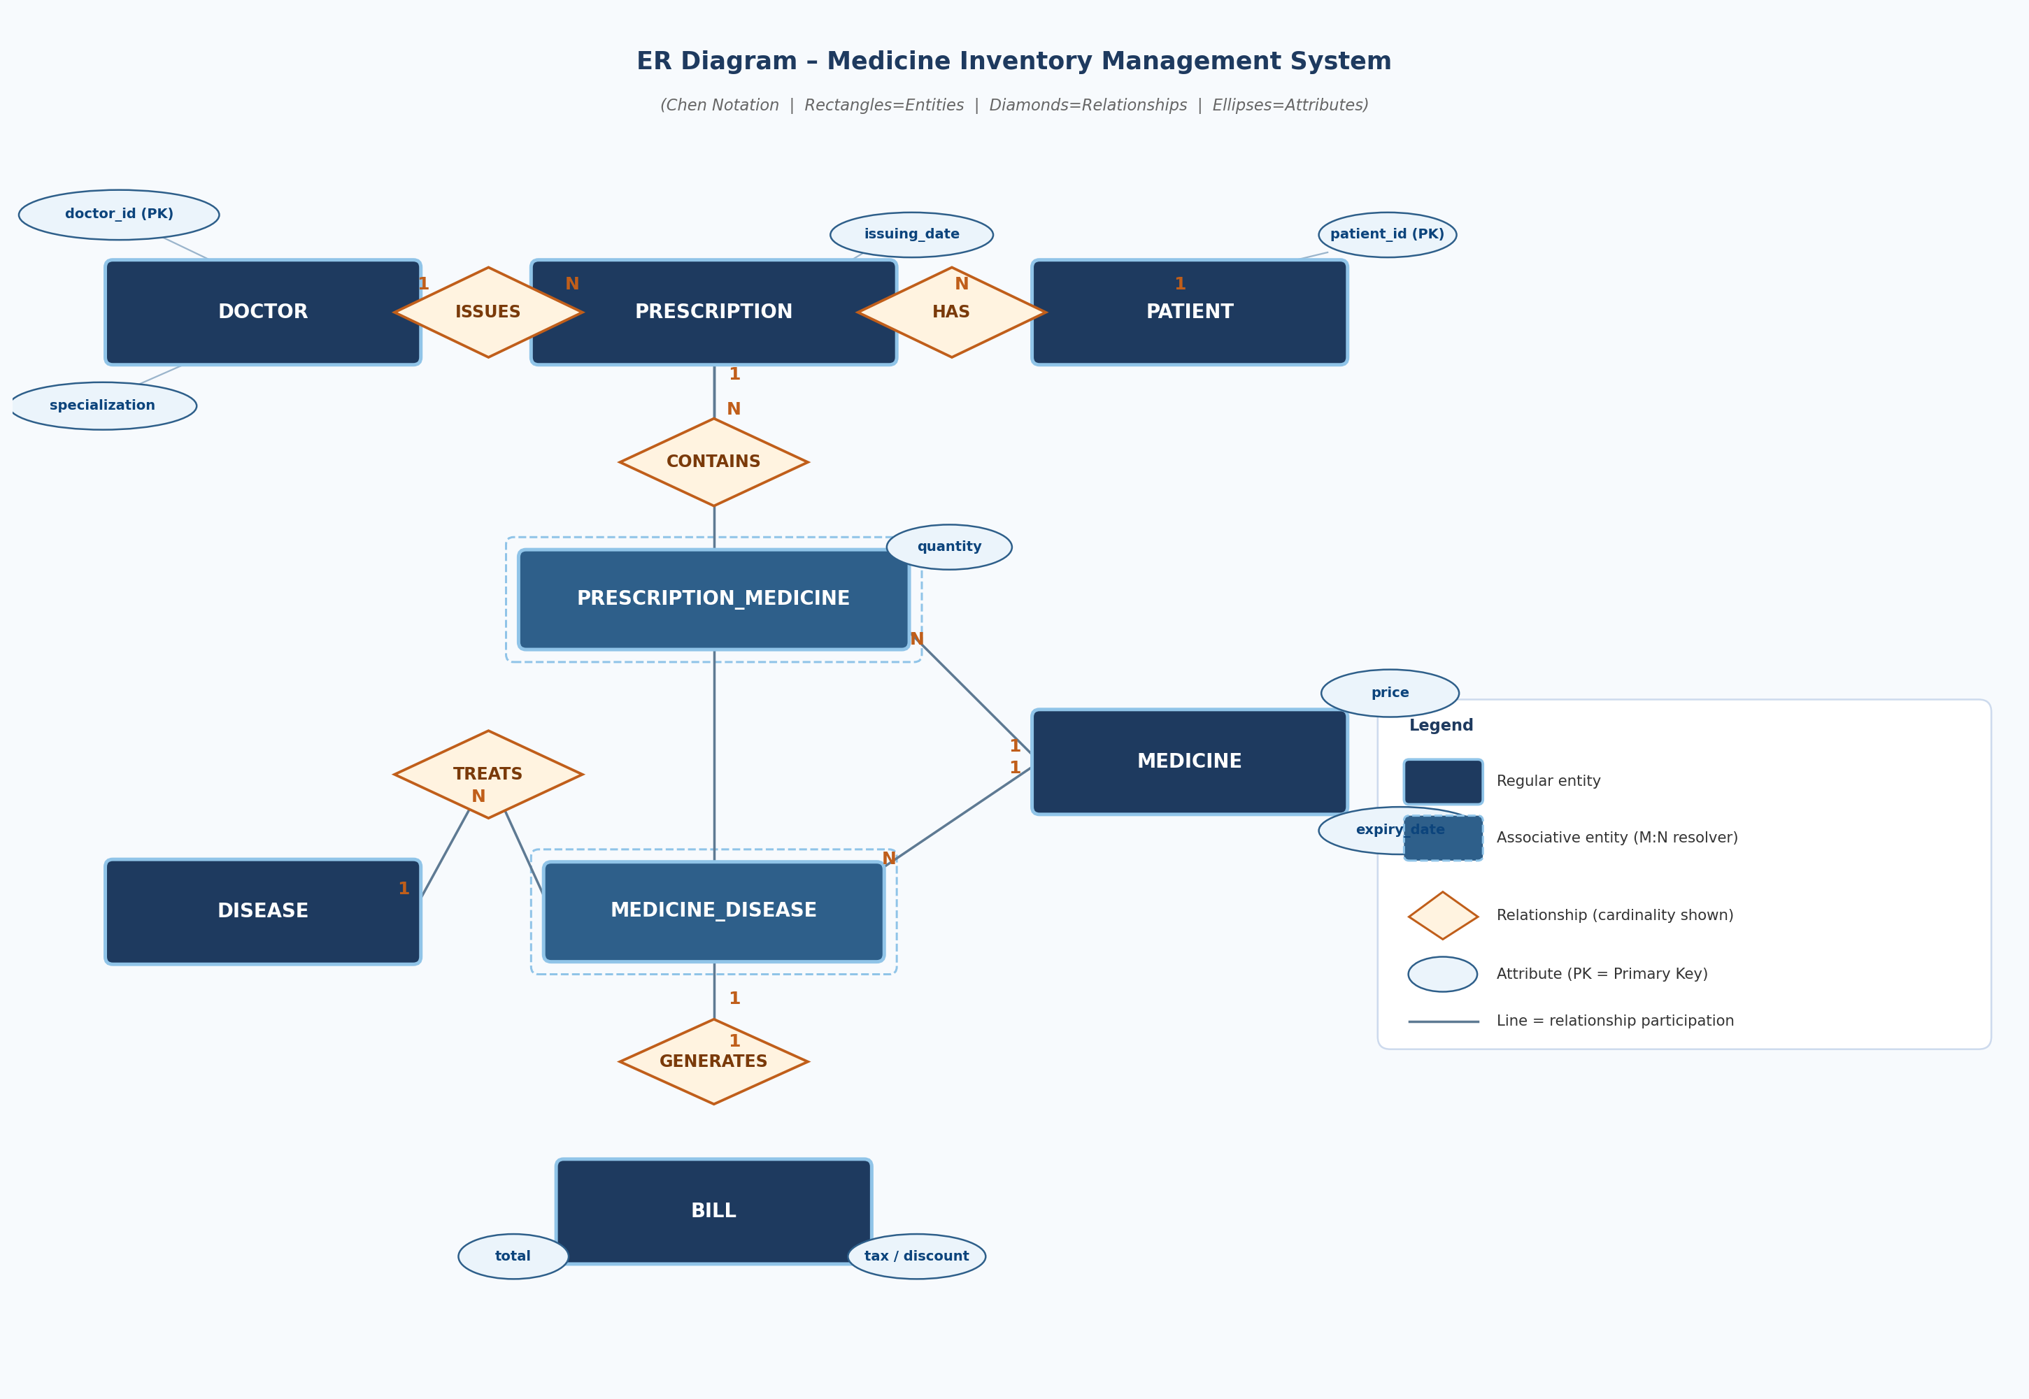
Figure 1: ER Diagram – Medicine Inventory Management System

3.1 Notation Key
- Rectangle = Entity (strong)
- Dashed double rectangle = Associative entity (resolves M:N relationship)
- Diamond = Relationship with cardinality ratios (1, N) shown
- Ellipse = Attribute
- Underlined attribute = Primary Key (PK)
- 1:N cardinality = one entity on the '1' side, many on the 'N' side
- M:N cardinality = both sides can relate to many (resolved via associative table)

4. Relational Schema
All primary keys are underlined; foreign keys are marked with FK.
DISEASE ( disease_id PK, disease_name, disease_type )
DOCTOR ( doctor_id PK, doctor_name, qualification, specialization )
PATIENT ( patient_id PK, patient_name, birth_date, phone )
MEDICINE ( medicine_id PK, medicine_name, manufacture_date, expiry_date, price, dosage )
MEDICINE_DISEASE ( medicine_id PK/FK, disease_id PK/FK )
PRESCRIPTION ( prescription_id PK, doctor_id FK, patient_id FK, issuing_date )
PRESCRIPTION_MEDICINE ( prescription_id PK/FK, medicine_id PK/FK, quantity )
BILL ( bill_id PK, prescription_id FK UNIQUE, subtotal, tax, discount, total )

5. Data Definition Language (DDL)

5.1 CREATE TABLE Statements (excerpts)
CREATE TABLE DISEASE (
disease_id INT PRIMARY KEY,
disease_name VARCHAR(100) NOT NULL UNIQUE,
disease_type VARCHAR(60) NOT NULL
CHECK (disease_type IN (
'Infectious','Deficiency',
'Genetic Hereditary','Non-Genetic Hereditary'))
);

CREATE TABLE BILL (
bill_id INT PRIMARY KEY,
prescription_id INT NOT NULL UNIQUE,
subtotal DECIMAL(12,2) NOT NULL DEFAULT 0.00,
tax DECIMAL(5,2) NOT NULL DEFAULT 14.00
CHECK (tax BETWEEN 0 AND 100),
discount DECIMAL(5,2) NOT NULL DEFAULT 0.00
CHECK (discount BETWEEN 0 AND 100),
total DECIMAL(12,2) NOT NULL DEFAULT 0.00,
FOREIGN KEY (prescription_id) REFERENCES PRESCRIPTION(prescription_id)
);

5.2 Views
CREATE VIEW v_prescription_details AS
SELECT p.prescription_id, p.issuing_date,
d.doctor_name, pat.patient_name,
m.medicine_name, pm.quantity,
m.price, (pm.quantity * m.price) AS line_total
FROM PRESCRIPTION p
JOIN DOCTOR d ON p.doctor_id = d.doctor_id
JOIN PATIENT pat ON p.patient_id = pat.patient_id
JOIN PRESCRIPTION_MEDICINE pm ON p.prescription_id = pm.prescription_id
JOIN MEDICINE m ON pm.medicine_id = m.medicine_id;

6. Triggers
Trigger Name | Event | Purpose
trg_after_prescription_insert | AFTER INSERT on PRESCRIPTION | Auto-create BILL row for new prescription
trg_after_pmed_insert | AFTER INSERT on PRESCRIPTION_MEDICINE | Recalculate bill subtotal & total
trg_after_pmed_update | AFTER UPDATE on PRESCRIPTION_MEDICINE | Recalculate on quantity change
trg_after_pmed_delete | AFTER DELETE on PRESCRIPTION_MEDICINE | Recalculate when medicine removed
trg_check_medicine_expiry | BEFORE INSERT on PRESCRIPTION_MEDICINE | Reject expired medicines

Bill Auto-Calculation Formula
total = subtotal + (subtotal * tax / 100) - (subtotal * discount / 100)

7. Sample Queries

Q1 – Doctors specializing in Heart Disease
SELECT doctor_name, qualification, specialization
FROM DOCTOR
WHERE LOWER(specialization) LIKE '%heart disease%';
Result: Dr. Dina Sabry (MD, PhD) and Dr. Amr Galal (MD).

Q2 – Deficiency Diseases
SELECT disease_id, disease_name
FROM DISEASE
WHERE disease_type = 'Deficiency'
ORDER BY disease_name;
Result: Iodine Deficiency, Iron Deficiency Anemia, Vitamin B12 Deficiency, Vitamin D Deficiency.

Q3 – Most Sold Medicine in 2023
SELECT m.medicine_name, SUM(pm.quantity) AS total_units_sold
FROM PRESCRIPTION_MEDICINE pm
JOIN MEDICINE m ON pm.medicine_id = m.medicine_id
JOIN PRESCRIPTION p ON pm.prescription_id = p.prescription_id
WHERE YEAR(p.issuing_date) = 2023
GROUP BY m.medicine_id, m.medicine_name
ORDER BY total_units_sold DESC
LIMIT 1;
Result: Paracetamol 500mg – highest units sold in 2023.

8. Test Data Summary
Table | # Records | Key Coverage
DISEASE | 12 | All 4 disease types covered
DOCTOR | 12 | Multiple specializations
PATIENT | 12 | Various ages and backgrounds
MEDICINE | 12 | All expiry dates in future
MEDICINE_DISEASE | 15 | Multi-disease medicines
PRESCRIPTION | 12 | Spread across 2023-2024
PRESCRIPTION_MEDICINE | 15 | Varied quantities
BILL | 12 | Auto-generated via trigger

9. Bonus UI – Flask Web Application
A Python/Flask web application was developed to provide a graphical interface for the database, qualifying for the 5-mark bonus.
- Dashboard – system-wide statistics
- Prescriptions – list and create prescriptions
- Medicines – catalogue with diseases
- Doctors and Patients – directories
- Bills – auto-generated bill records
- Queries page – runs all 3 required queries live

Setup
pip install flask mysql-connector-python
cd src && python app.py
Open: http://localhost:5000

10. Design Rationale
- MEDICINE_DISEASE resolves the M:N between medicines and diseases.
- PRESCRIPTION_MEDICINE carries the attribute 'quantity' so it is a full associative entity, not just a join table.
- BILL has UNIQUE on prescription_id enforcing the 1:1 relationship.
- Trigger trg_check_medicine_expiry guards data integrity at the database level.
- DECIMAL(12,2) used for all monetary values to avoid floating-point errors.
- CHECK constraint on disease_type enforces exactly the 4 defined categories.

