Food Demand Forecasting
Week 5: Model Optimization and Validation
Ashraf | Data Science Internship

1. Objective and summary
The goal this week was to improve the Week 4 predictive model and to prove that the improvement is real, meaning the model performs well on weeks it has never seen. The model predicts weekly food orders for each meal and fulfilment center, on the log scale (log1p of the order count). All error scores below are therefore RMSLE, where lower is better.
Main findings. Tuning the HistGradientBoosting model reduced the hold-out RMSLE from 0.4823 to 0.4786 (0.76% lower) and the average error from 62.7 to 61.9 orders per meal-week. The improvement is small but consistent: it appears in 3 of 4 cross-validation folds, in every hold-out week, and in every demand level. A separate leakage test showed that these results do not depend on the known Week 3 weakness in the mean-encoded features (the leak-free hold-out scores are 0.4829 and 0.4789).

2. Starting point
The Week 4 comparison of three models (Ridge, Random Forest and Gradient Boosting) showed that Gradient Boosting was best. Its Week 4 settings (500 trees, learning rate 0.05, 63 leaves per tree) are the baseline for this report. The same time-based split is used: weeks 1 to 135 for training (423,727 rows) and weeks 136 to 145 as the hold-out set (32,821 rows). Three columns (checkout_price_scaled, base_price_scaled and op_area_scaled) were removed because they are exact copies of the raw columns and removing them did not change the Week 4 score (0.4823 before and after). The model therefore uses 43 features.

3. Validation design
Choosing how to validate was the most important decision of the week. A standard random K-fold split would let the model train on weeks that come after the weeks it is tested on. Real forecasting never has that advantage, so random folds would make the scores look better than they truly are.
Instead, expanding-window cross-validation was built from the week number. Each fold trains on all weeks before a 10-week block and validates on that block:
Fold | Training weeks | Validation weeks | Validation rows
1 | 1-95 (292,958 rows) | 96-105 | 32,408
2 | 1-105 (325,366 rows) | 106-115 | 32,707
3 | 1-115 (358,073 rows) | 116-125 | 32,834
4 | 1-125 (390,907 rows) | 126-135 | 32,820

The data file is sorted by meal and center and then by week, not by week alone, so the standard time-series splitter (which cuts by row order) would have produced wrong folds. The folds were therefore built directly from the week column. The hold-out weeks 136 to 145 were not used in any tuning decision and were scored only once, at the end.

4. Hyperparameter tuning
Random search was used instead of an exhaustive grid, because the dataset has more than 420,000 rows and every configuration must be trained once per fold. Fifteen random configurations were tried and each was scored on the four time-based folds above. The number of trees was chosen automatically with early stopping (up to 1,000 trees). The settings explored and their meaning:
Setting | Values tried | What it controls
learning_rate | 0.03, 0.05, 0.08, 0.1 | Size of each boosting step
max_leaf_nodes | 31, 63, 127, 255 | Complexity of each tree
max_depth | None, 8, 12, 16 | Maximum tree depth
min_samples_leaf | 20, 50, 100, 200, 400 | Minimum rows per leaf (smoothing)
l2_regularization | 0, 0.1, 1, 10 | Penalty on extreme leaf values

Best configuration: learning_rate 0.05, max_leaf_nodes 127, max_depth 12, min_samples_leaf 20, l2_regularization 1.0 (cross-validated RMSLE 0.5055).
An important observation is how flat the search results were. The ten best configurations scored between 0.5055 and 0.5072, a spread of only 0.0017, while the fold-to-fold variation is about 0.02. This tells us that the Week 4 settings were already close to a good solution, and that no single hyperparameter has a dramatic effect on this dataset. The gain from tuning is therefore expected to be modest, which is what the results show.

5. Results

5.1 Cross-validation
Fold | Baseline RMSLE | Tuned RMSLE | Improvement
1 (weeks 96-105) | 0.5286 | 0.5242 | 0.0045
2 (weeks 106-115) | 0.5276 | 0.5243 | 0.0033
3 (weeks 116-125) | 0.4932 | 0.4900 | 0.0032
4 (weeks 126-135) | 0.4816 | 0.4835 | -0.0018
Mean (std) | 0.5078 (0.0208) | 0.5055 (0.0189) | 0.0023

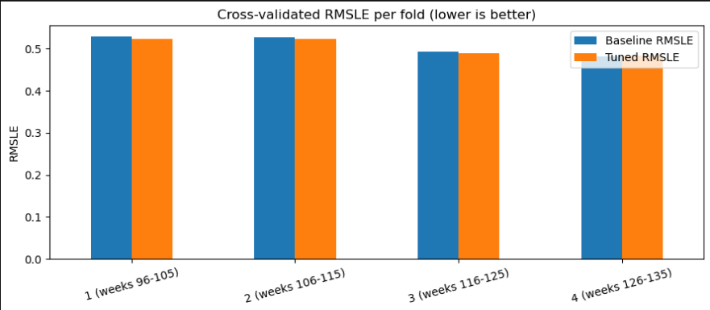
Figure 1: Cross-validated RMSLE per fold, baseline vs tuned (lower is better).
The tuned model is better in three of the four folds and slightly worse in the last one (by 0.0018). The average gain is small compared with the fold-to-fold spread, so the honest conclusion is a small but consistent improvement, not a large one. The errors also fall from fold 1 to fold 4 for both models, which shows that the model benefits from having more weeks of history to learn from. This is also why the hold-out score (0.4786) is lower than the cross-validation mean (0.5055): the early folds are simply harder.

5.2 Hold-out evaluation (weeks 136-145)
Model | RMSLE | MAE (log) | R2 (log) | MAE (orders)
Baseline (Week 4) | 0.4823 | 0.3718 | 0.8239 | 62.7
Tuned (Week 5) | 0.4786 | 0.3680 | 0.8265 | 61.9

After the final refit on all training weeks, the tuned model improves every metric: RMSLE is 0.76% lower, the average log error falls from 0.3718 to 0.3680, R2 rises from 0.8239 to 0.8265, and the average miss falls by 0.9 orders per meal-week. The R2 of 0.83 means the model explains about 83% of the variation in log demand on weeks it has never seen.

5.3 Does the model generalize?
Model | Train RMSLE | CV RMSLE | CV std | Hold-out | Hold-out minus train
Baseline | 0.4722 | 0.5078 | 0.0208 | 0.4823 | 0.0101
Tuned | 0.4405 | 0.5055 | 0.0189 | 0.4786 | 0.0381

A model that memorises the training data shows a very low training error and a much higher error on new data. Tuning made the model fit the training data more closely (0.4722 to 0.4405), so the gap between training and hold-out error grew from 0.010 to 0.038. However, the error on new data also went down, both in cross-validation and on the hold-out. A model that was overfitting would have got worse on new data. The gap is still small relative to the error itself, so the model is generalizing well, and the validation error is a more trustworthy measure than the training error.

5.4 Tuning the Ridge model
As a comparison, the Ridge baseline was tuned over alpha values from 0.01 to 100 on the same folds. The best alpha (100) gave a hold-out RMSLE of 0.5251, exactly the same as the untuned model. This shows that the gain does not come from tuning in general: a linear model has little to tune, while boosted trees can use the extra flexibility to capture interactions between price, promotion and recent demand.

6. Leakage check on the mean-encoded features
In Week 3, two features (center_avg_orders_log and meal_avg_orders_log) were calculated as the average log demand of each center and each meal using the whole dataset, including the hold-out weeks. Because meal_avg_orders_log is the most important feature in the model, this could have made every score in this report slightly too optimistic.
To test this, the center and meal identifiers were recovered by matching the feature file back to the original data (99.72% of rows matched; the remaining 0.28% received the overall average). Both features were then recomputed from training weeks only, and in cross-validation from each fold's training weeks only. Recomputing the averages from the full data reproduced the original columns with a correlation of 1.0000, which confirms the features were plain means of the log target.
Score | Baseline | Tuned | Baseline (original) | Tuned (original)
Hold-out RMSLE, leak-free | 0.4829 | 0.4789 | 0.4823 | 0.4786
CV RMSLE, leak-free (mean) | 0.5078 | 0.5065 | 0.5078 | 0.5055

Removing the leak changed the hold-out scores by only 0.0003 to 0.0006, and the tuned model still beats the baseline in both settings (0.4789 against 0.4829 on the hold-out). In the leak-free cross-validation the tuned model again wins the first three folds (0.5254 vs 0.5294, 0.5253 vs 0.5269, 0.4913 vs 0.4943) and loses the last (0.4840 vs 0.4806). The effect is so small because each center and meal has a very stable average level over 145 weeks, so the average computed from weeks 1 to 135 is almost identical to the average over all weeks. The conclusion is that the Week 3 limitation did not distort the results and the improvement is real.

7. Interpretation: where did the model improve?

7.1 By demand level
Hold-out rows were split into five equal groups by actual demand. Bias is the actual minus the predicted value, so a positive bias means the model under-predicts.
Demand level | Rows | MAE baseline | MAE tuned | Bias baseline | Bias tuned
Lowest 20% | 6,624 | 0.5201 | 0.5139 | -0.4256 | -0.4143
Low | 6,827 | 0.3958 | 0.3939 | 0.0520 | 0.0540
Middle | 6,385 | 0.3661 | 0.3635 | 0.1284 | 0.1295
High | 6,500 | 0.3043 | 0.3014 | 0.1398 | 0.1357
Highest 20% | 6,485 | 0.2682 | 0.2627 | 0.1848 | 0.1756

The tuned model has a lower error in every group, with the largest gains at the two extremes (0.0062 for the lowest and 0.0055 for the highest demand). The pattern of bias, however, is almost unchanged. The model still over-predicts the lowest-demand rows (bias around -0.41) and under-predicts the highest-demand rows (bias around +0.18). This is the usual tendency of a regression model to pull extreme values toward the average. Tuning reduced it slightly but did not remove it, which suggests that a different approach would be needed for further gains at the extremes, such as extra features describing demand spikes.
The positive bias in the four upper groups also shows that the model tends to under-predict on these ten weeks overall, so a real deployment should be aware of a slight tendency to forecast too low.

7.2 Negative-discount rows
Group | Rows | MAE baseline | MAE tuned | Bias baseline | Bias tuned
No negative discount | 23,822 | 0.3761 | 0.3725 | 0.0123 | 0.0119
Negative discount | 8,999 | 0.3605 | 0.3561 | 0.0188 | 0.0208

Rows where the checkout price is above the base price (about 27% of the hold-out) are predicted as accurately as the others, and the tuned model improves both groups. The model therefore handles negative discounts without special treatment, which matches the Week 4 finding that removing the flag or clipping the discount made no difference.

7.3 By week
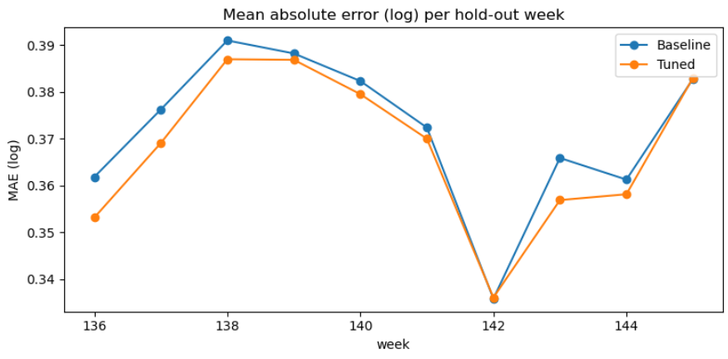
Figure 2: Mean absolute error (log) per hold-out week, baseline vs tuned.
The tuned model is at least as good as the baseline in every one of the ten hold-out weeks. The gains are clearest in weeks 136, 137, 143 and 144, while weeks 142 and 145 are essentially unchanged. The error does not grow steadily as the weeks move further from the training period, which means the model keeps its accuracy over a ten-week forecast horizon.

7.4 Actual vs predicted and residuals
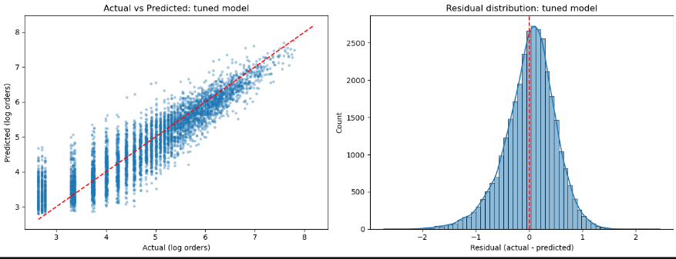
Figure 3: Actual vs predicted log orders (left) and residual distribution (right) for the tuned model.
[Add 2-3 sentences describing your own plot here: how closely the points follow the red diagonal line, and whether the residual histogram is centred on zero. The demand-level table above gives the numbers behind what the plot shows at the extremes.]

7.5 Feature importance after tuning
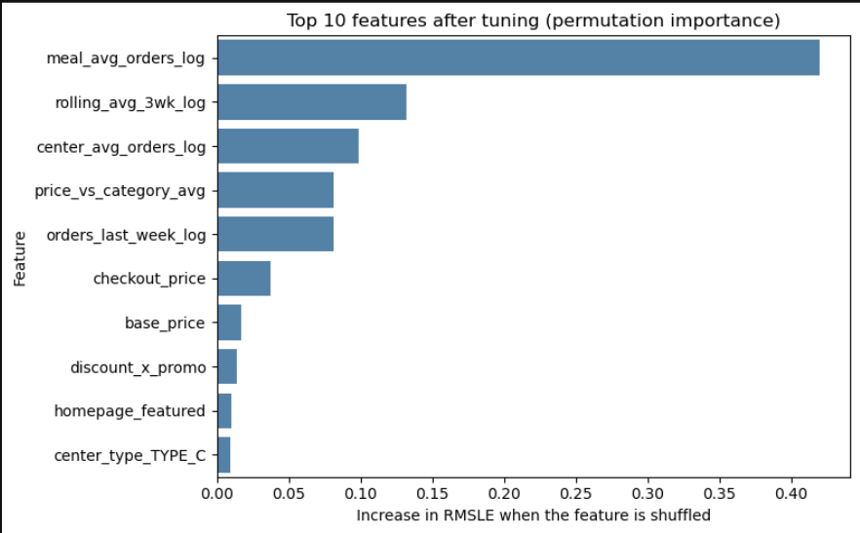
Figure 4: Top 10 features by permutation importance (increase in RMSLE when the feature is shuffled).
The ranking is the same as in Week 4. The average demand of the meal (meal_avg_orders_log) is by far the most important feature, with an RMSLE increase of about 0.42 when shuffled, followed by the three-week rolling average of recent orders (about 0.13), the average demand of the center (about 0.10), the price relative to the category average (about 0.08) and last week's orders (about 0.08). The model therefore relies mainly on two things: which meal it is, and how that meal has been selling recently. Price and promotion features matter, but much less. Tuning changed how the model uses these features, not which ones it depends on.

7.6 A worked example
The table below shows five hold-out rows with above-median demand where tuning helped the most in real order counts. These rows were chosen to show the largest gains, so they illustrate the best case and are not typical.
Week | Actual orders | Baseline predicted | Tuned predicted | Miss baseline | Miss tuned
136 | 1,526 | 598 | 909 | 928 | 617
136 | 998 | 651 | 907 | 347 | 91
140 | 1,500 | 1,135 | 1,386 | 365 | 114
136 | 1,054 | 602 | 842 | 452 | 212
136 | 1,309 | 793 | 1,015 | 516 | 294

In the second row, the meal actually sold 998 orders. The baseline predicted 651 (347 short), while the tuned model predicted 907 (91 short). In all five rows the original model under-forecasts by a large margin and the tuned model moves the forecast clearly in the right direction. Note that all of these rows still under-predict, which is consistent with the high-demand bias described in section 7.1.

8. What this means for the business
- Forecast accuracy. The average miss fell by 0.9 orders per meal-week. Over the 32,821 meal-center-weeks in the hold-out, that is about 29,000 fewer orders of absolute forecast error across the ten weeks.
- Stockouts. Because the model tends to under-forecast high-demand meals, a kitchen following it blindly could run short on its best sellers. Adding a safety margin for high-demand meals would be a sensible rule while the bias remains.
- Wastage. Low-demand meals are over-forecast by a larger amount (bias -0.41), which can lead to over-purchased ingredients for slow sellers. These are the rows where better forecasts would save the most waste.
- Planning horizon. Because accuracy does not fall across the ten hold-out weeks, the forecasts are usable for planning about two months ahead, as long as the model is refreshed regularly with new weeks of data.

9. Limitations and next steps
- The improvement is small (0.0037 RMSLE) relative to the variation between folds (about 0.02), and the tuned model lost one of the four folds. It should be described as a modest, consistent gain, not a breakthrough.
- The tuned model used all 1,000 trees allowed, so early stopping never triggered. It may still be slightly under-trained, and allowing more trees is a simple next experiment.
- Only 15 random configurations were tried. A larger search could find slightly better settings, although the flat search results suggest the gain would be small.
- The model still under-predicts demand spikes and over-predicts the lowest-demand rows. Features designed to capture spikes (for example holiday or event indicators, if available) are the most promising way to improve this.
- The hold-out is a single ten-week period. A longer hold-out, or repeating the final test on several periods, would give a more reliable estimate.
- In the leakage check, 0.28% of rows could not be matched to a center and meal and received the overall average as their encoding. The effect on the comparison is negligible.

10. Conclusion
The Week 4 model was optimized with a time-aware validation process, and the final model was tested on weeks that were never used for tuning. Hold-out RMSLE improved from 0.4823 to 0.4786 and the improvement is consistent across folds, hold-out weeks, demand levels and discount types. A dedicated check confirmed that the results are not inflated by the Week 3 mean-encoded features. The model explains about 83% of the variation in demand on unseen weeks and keeps its accuracy across the ten-week horizon. Its main weakness is a tendency to under-predict demand spikes, which is where future work should focus.

