Exploratory Data Analysis
Food Demand Forecasting Dataset
Week 1 Task: Exploratory Data Analysis
Data Analysis Internship
Prepared by: Ashraf
Dataset source: Kaggle — kannanaikkal/food-demand-forecasting

1. Introduction
This report presents an exploratory data analysis (EDA) of a food demand forecasting dataset. The objective is to uncover patterns, relationships, and insights within the data that could be useful for subsequent predictive analysis, following the standard EDA workflow: data collection, data cleaning, univariate, bivariate and multivariate analysis, and a summary of findings.
The dataset used is the Food Demand Forecasting dataset, publicly available on Kaggle (kannanaikkal/food-demand-forecasting), originally derived from a meal-delivery demand forecasting competition. The business scenario: a meal delivery company operates fulfilment centers across multiple cities and needs to forecast weekly demand for various meals so that raw materials (which are perishable) can be procured in advance and staffing can be planned accordingly.
The dataset consists of three related CSV files:
- train.csv — weekly transactional data: number of orders, checkout price, base price, and promotion flags per center-meal combination (the fact table)
- fulfilment_center_info.csv — descriptive details about each fulfilment center: city, region, center type, operating area (a dimension table)
- meal_info.csv — descriptive details about each meal: category and cuisine (a dimension table)
These three files were merged into a single dataframe of 456,548 rows and 15 columns for analysis, following the standard fact-table / dimension-table (star schema) pattern used in data warehousing.

2. Data Collection
The three source files were loaded independently and inspected before merging, to confirm their structure and the join keys available (center_id for the center info table, meal_id for the meal info table).
import numpy as np
import pandas as pd
import matplotlib.pyplot as plt
import seaborn as sns

# Load all files
train = pd.read_csv('./Data/train.csv')
center_info = pd.read_csv('./Data/fulfilment_center_info.csv')
meal_info = pd.read_csv('./Data/meal_info.csv')

# Quick look at each before merging
print(train.head())
print(center_info.head())
print(meal_info.head())

The three tables were then merged using left joins on center_id and meal_id:
# Left Join train with center_info on center_id
df = train.merge(center_info, on='center_id', how='left')

# Left Join that with meal_info on meal_id
df = df.merge(meal_info, on='meal_id', how='left')

The resulting merged dataframe contains 456,548 rows and 15 columns, combining transactional measures (num_orders, checkout_price, base_price) with descriptive attributes (center_type, city_code, region_code, category, cuisine).

3. Data Cleaning & Quality Checks

3.1 Structure and Data Types
print(df.shape)
print(df.head())
print(df.info())
print(df.describe())
df.info() confirmed the dataframe has 456,548 non-null entries across all 15 columns, with dtypes: float64(3) — checkout_price, base_price, op_area; int64(9) — id, week, center_id, meal_id, emailer_for_promotion, homepage_featured, num_orders, city_code, region_code; and object(3) — center_type, category, cuisine. All data types were appropriate for their respective columns, requiring no type conversion.

3.2 Missing Values and Duplicates
print(df.isnull().sum())
Result: zero missing values across all 15 columns — no imputation was required.
print(df.duplicated().sum())
Result: 0 duplicate rows found.

3.3 Data Quality Flag: Negative Discount Values
As a sanity check, a derived 'discount' column was created (base_price − checkout_price) to verify that checkout price never exceeds base price, which would represent a logically invalid negative discount.
df['discount'] = df['base_price'] - df['checkout_price']
print((df['discount'] < 0).sum())
df[df['discount'] < 0][['category','base_price','checkout_price','discount']].head()
This check flagged 116,101 rows (about 25% of the dataset) where checkout_price marginally exceeds base_price. Further investigation of the distribution of these negative values showed:
print(df[df['discount'] < 0]['discount'].value_counts())
print(df[df['discount'] < 0]['category'].value_counts())
print(df[df['discount'] < 0]['center_type'].value_counts())
print(df[df['discount'] < 0]['week'].describe())
- The vast majority of negative discounts are small: -1.00 (73,668 rows) and -2.00 (36,902 rows) together account for over 94% of all flagged rows
- A long tail of 699 distinct negative values exists, including a small number of larger deviations (down to about -156), which may represent genuine anomalies
- The pattern is proportionally distributed across categories, center types, and the full week range (1–145) — it is not concentrated in any single category, center, or time period
Conclusion: this is most likely a systematic characteristic of how prices were recorded (e.g. rounding or a small fixed markup applied at checkout) rather than data corruption, since it is small in magnitude, evenly distributed, and dominated by just two round values. The small number of larger negative-discount rows may warrant exclusion if this dataset were used for predictive modelling.

3.4 Outlier Detection on num_orders
The IQR method was applied to the primary measure of interest, num_orders, to identify unusually high or low demand weeks:
Q1 = df['num_orders'].quantile(0.25)
Q3 = df['num_orders'].quantile(0.75)
IQR = Q3 - Q1
lower = Q1 - 1.5*IQR
upper = Q3 + 1.5*IQR
outliers = df[(df['num_orders'] < lower) | (df['num_orders'] > upper)]
print(f"Number of outliers: {len(outliers)} out of {len(df)}")
print(f"Outlier bounds: {lower} to {upper}")
Result: 32,937 outliers out of 456,548 rows (about 7.2%), with bounds of -351 to 729. Since num_orders cannot be negative, the lower bound is not meaningful — all flagged outliers are high-demand weeks (orders greater than 729).
Rather than removing these outliers, they were treated as a signal worth investigating, since high-demand spikes are of direct business interest. A comparison of outlier rows against the overall dataset revealed:
print(outliers['category'].value_counts().head())
print(f"Overall emailer_for_promotion rate: {df['emailer_for_promotion'].mean():.3f}")
print(f"Outlier emailer_for_promotion rate: {outliers['emailer_for_promotion'].mean():.3f}")
print(f"Overall homepage_featured rate: {df['homepage_featured'].mean():.3f}")
print(f"Outlier homepage_featured rate: {outliers['homepage_featured'].mean():.3f}")
- Category breakdown of outliers: Beverages (13,614), Rice Bowl (8,137), Sandwich (5,769), Salad (2,401), Pizza (1,313)
- emailer_for_promotion rate: 28.4% among outliers vs. 8.1% overall — a 3.5x increase
- homepage_featured rate: 38.4% among outliers vs. 10.9% overall — a 3.5x increase
This is a key early finding: high-demand weeks are strongly associated with promotional activity, and Beverages, Rice Bowl, and Sandwich are disproportionately represented among demand spikes.

4. Univariate Analysis
Each variable was examined individually to understand its distribution before looking at relationships between variables.

4.1 num_orders
plt.figure(figsize=(10,4))
sns.histplot(df['num_orders'], bins=50)
plt.title('Distribution of Number of Orders')
plt.show()

plt.figure(figsize=(10,2))
sns.boxplot(x=df['num_orders'])
plt.title('Boxplot of Number of Orders')
plt.show()
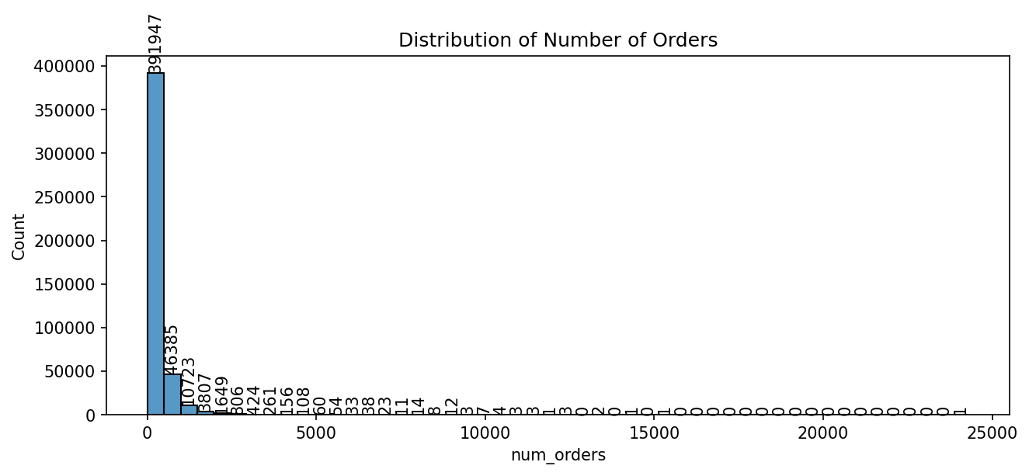

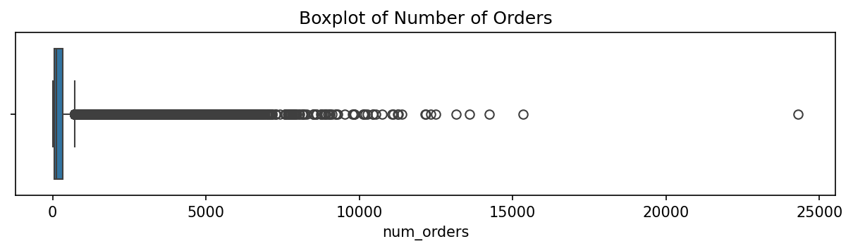

Histogram and boxplot of num_orders
num_orders is strongly right-skewed: mean of approximately 262 orders/week versus a maximum of 24,299, with a large concentration of low-to-moderate values and a long tail of high-demand weeks, consistent with the outlier analysis above.

4.2 checkout_price and base_price
for col in ['checkout_price', 'base_price']:
plt.figure(figsize=(10,4))
sns.histplot(df[col], bins=50)
plt.title(f'Distribution of {col}')
plt.show()

plt.figure(figsize=(10,2))
sns.boxplot(x=df[col])
plt.title(f'Boxplot of {col}')
plt.show()
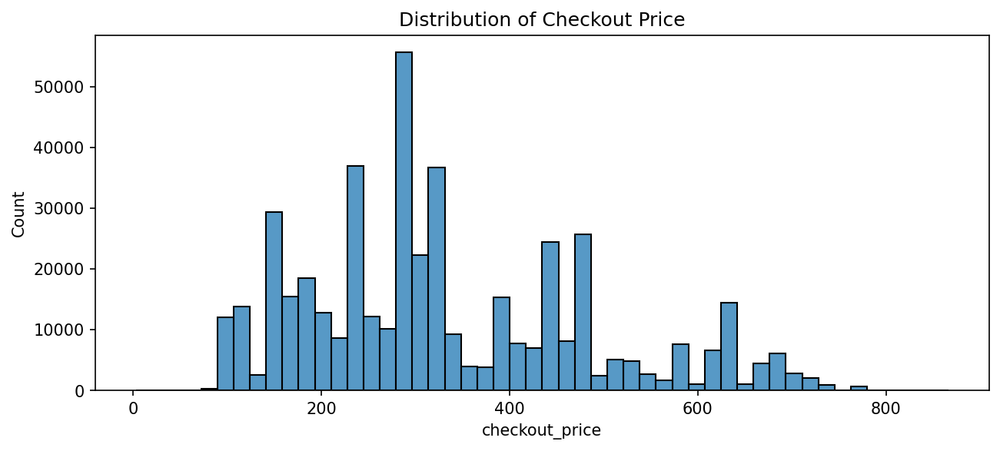

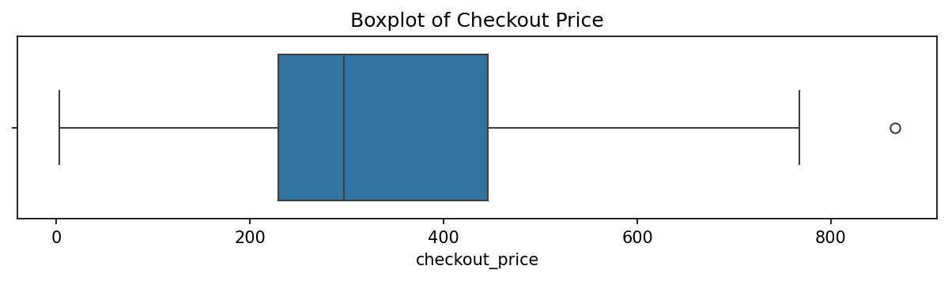

Histogram and boxplot of checkout_price
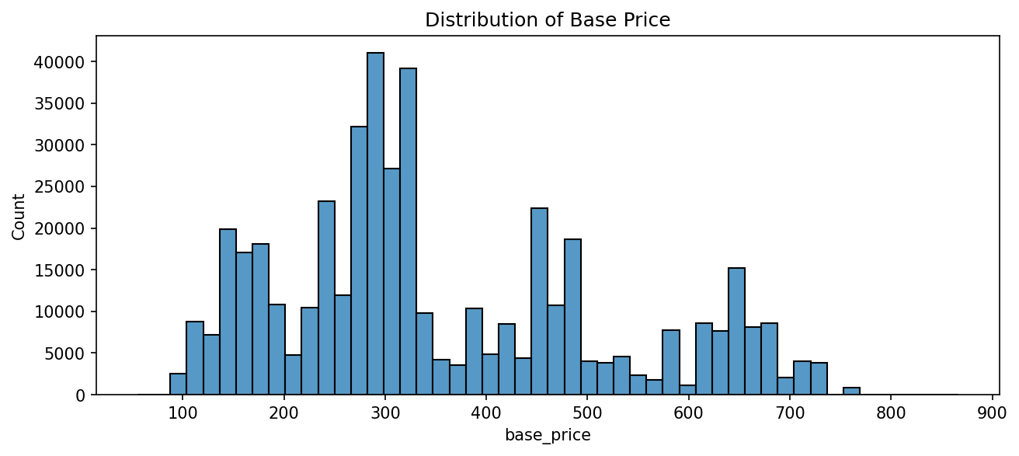
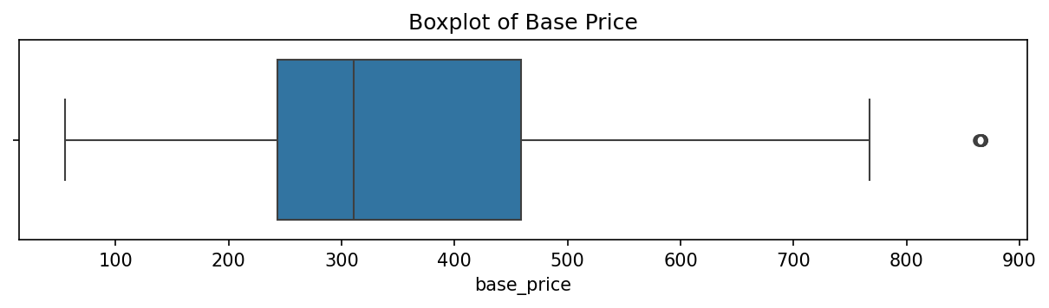

Histogram and boxplot of base_price
Both price columns show a multimodal distribution with several distinct peaks (roughly around 150, 250–300, 450–500 and 650) rather than a single smooth curve. This suggests prices cluster into tiers that likely correspond to different meal categories rather than following one continuous pricing scheme. The boxplots show medians around 290–310 with a small number of outliers above approximately 750–850; otherwise both distributions are well-behaved.

4.3 Categorical Variables: category, cuisine, center_type, region_code
for col in ['category', 'cuisine', 'center_type', 'region_code']:
plt.figure(figsize=(10,5))
ax = sns.countplot(x=col, data=df, order=df[col].value_counts().index)
for container in ax.containers:
ax.bar_label(container)
plt.xticks(rotation=45, ha='right')
plt.title(f'Count by {col}')
plt.tight_layout()
plt.show()
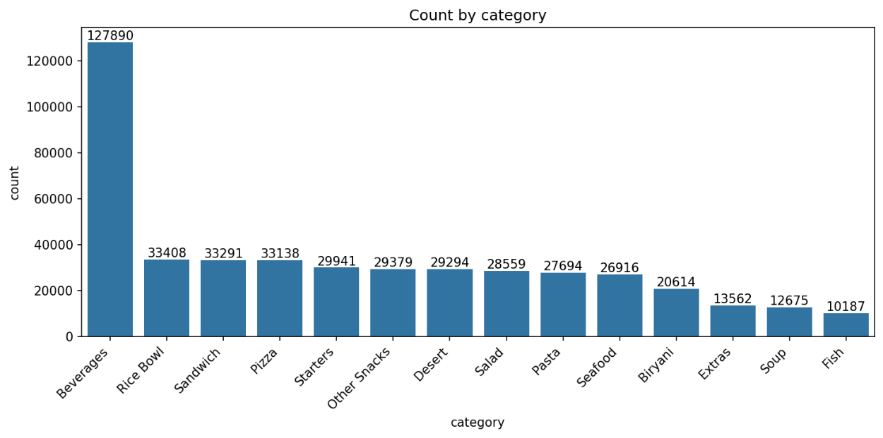
Count plot of the category column
Beverages dominates the category column with 127,890 rows — nearly 4x the next most frequent category, Rice Bowl (33,408). The remaining categories (Sandwich, Pizza, Starters, Other Snacks, Desert, Salad, Pasta, Seafood, Biryani, Extras, Soup, Fish) decrease steadily from around 33,000 down to 10,000 rows.
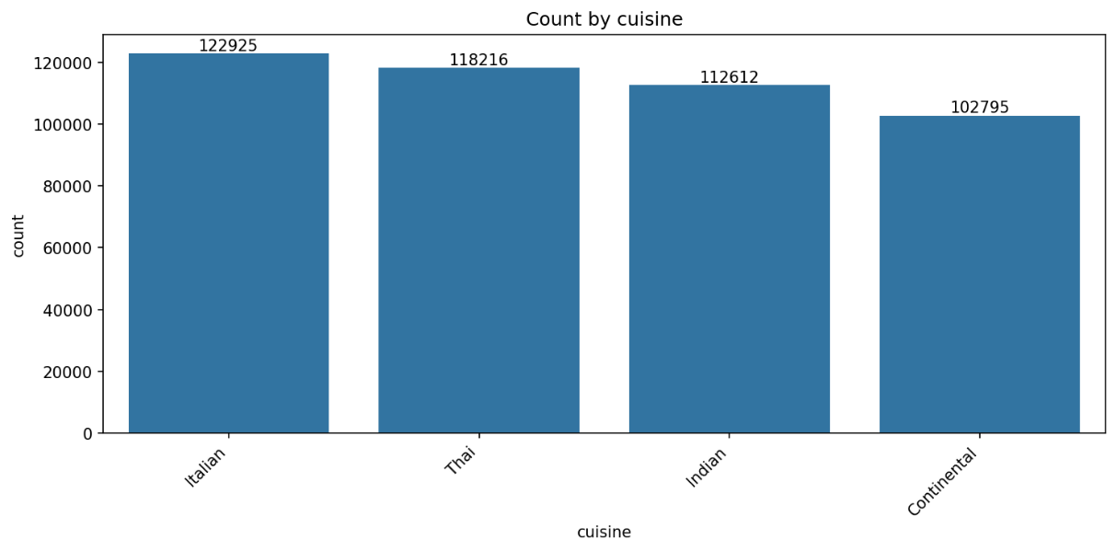
Count plot of the cuisine column
Cuisine is relatively balanced across the four categories: Italian (122,925), Thai (118,216), Indian (112,612), and Continental (102,795) — no cuisine dominates the dataset.
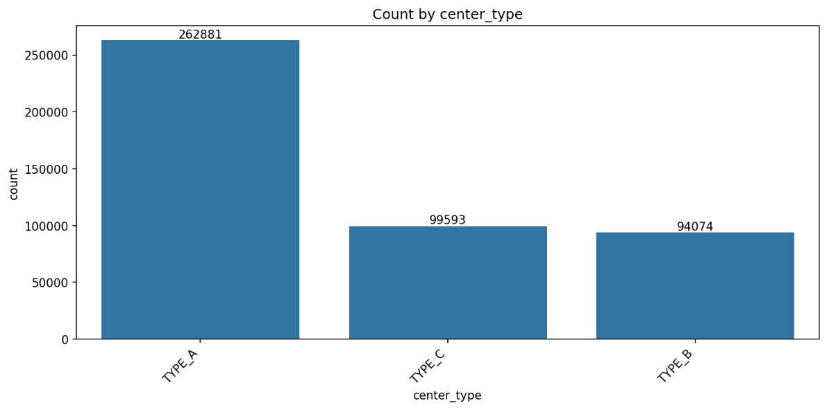

Count plot of the center_type column
TYPE_A is the most common center type (262,881 rows, over half the dataset), followed by TYPE_C (99,593) and TYPE_B (94,074).
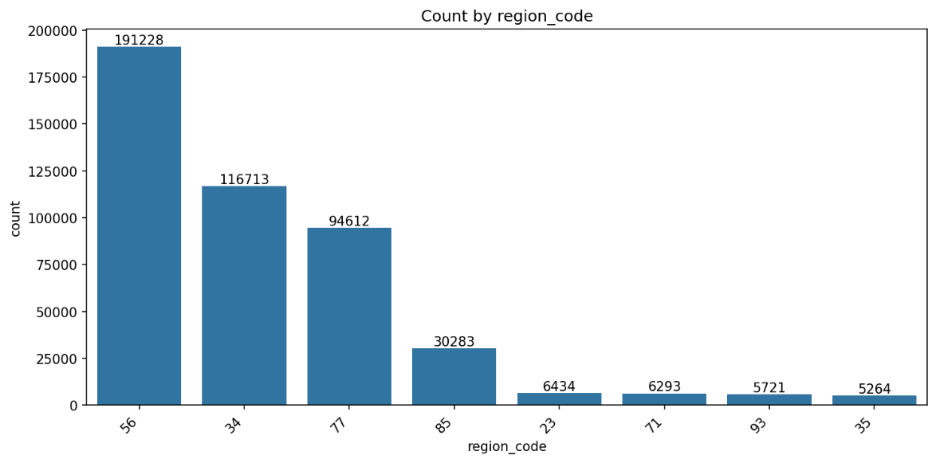

Count plot of the region_code column
Region code is heavily skewed: region 56 alone accounts for 191,228 rows (about 42% of the dataset), while the smallest regions (23, 71, 93, 35) each contain only 5,000–6,500 rows. Any regional comparisons in the following sections should account for this imbalance, since smaller regions have far less data to draw statistically reliable conclusions from.

5. Bivariate Analysis
This section examines relationships between pairs of variables.

5.1 Checkout Price vs. Number of Orders
plt.figure(figsize=(8,5))
sns.scatterplot(x='checkout_price', y='num_orders', data=df, alpha=0.3)
plt.title('Checkout Price vs Number of Orders')
plt.show()

print("Correlation:", df['checkout_price'].corr(df['num_orders']))
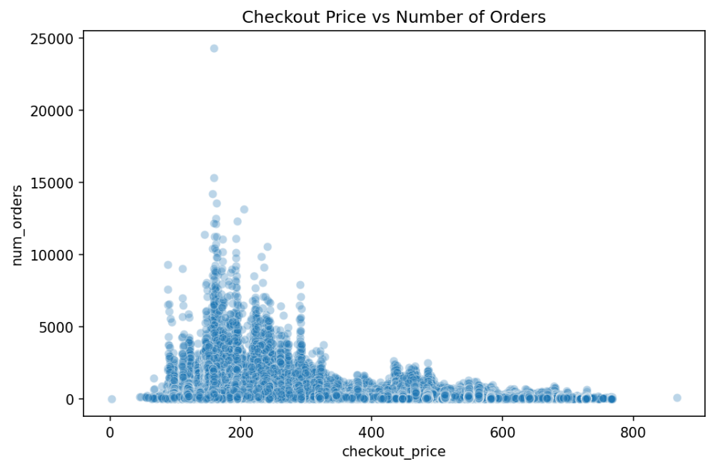

Scatter plot of checkout_price vs num_orders
The correlation between checkout_price and num_orders is -0.28 — a weak-to-moderate negative relationship, consistent with basic demand-curve intuition (higher price, lower demand). However, the relationship is not strongly linear: most of the highest-demand spikes occur at lower price points (roughly ₹100–300), suggesting that price alone does not fully explain demand and that other factors (category, promotion) play a larger role.

5.2 Average Orders by Category
avg_by_cat = df.groupby('category')['num_orders'].mean().sort_values(ascending=False)
ax = sns.barplot(x=avg_by_cat.index, y=avg_by_cat.values)
for container in ax.containers:
ax.bar_label(container, fmt='%.0f')
plt.xticks(rotation=45, ha='right')
plt.title('Average Orders by Category')
plt.tight_layout()
plt.show()
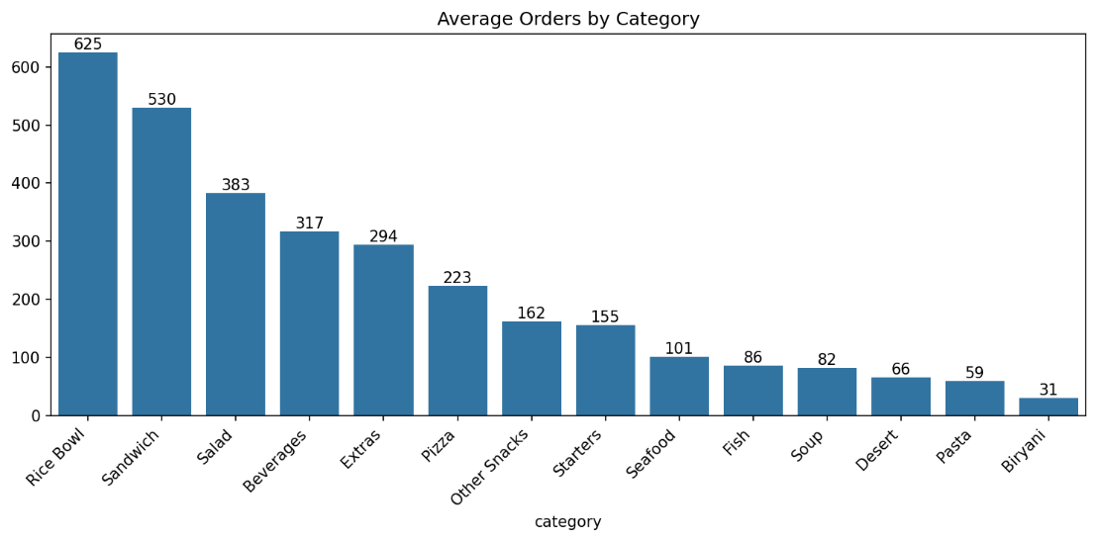

Bar chart of average num_orders per category
This reveals an important distinction from the univariate count-by-category chart. Rice Bowl has the highest average demand per listing (625 orders), followed by Sandwich (530) and Salad (383) — even though these categories appear far less frequently in the dataset than Beverages. Beverages, despite being the most commonly listed category, ranks only 4th in average demand per listing (317).
In other words, frequency of listing and typical demand performance are two distinct dimensions: Beverages is offered far more often and therefore contributes the most to total order volume overall, while Rice Bowl performs better on a per-listing basis.

5.3 Impact of Promotions on Orders
ax = sns.barplot(x='emailer_for_promotion', y='num_orders', data=df)
for container in ax.containers:
ax.bar_label(container, fmt='%.0f')
plt.title('Avg Orders: Promotion vs No Promotion')
plt.show()

ax = sns.barplot(x='homepage_featured', y='num_orders', data=df)
for container in ax.containers:
ax.bar_label(container, fmt='%.0f')
plt.title('Avg Orders: Homepage Featured vs Not')
plt.show()
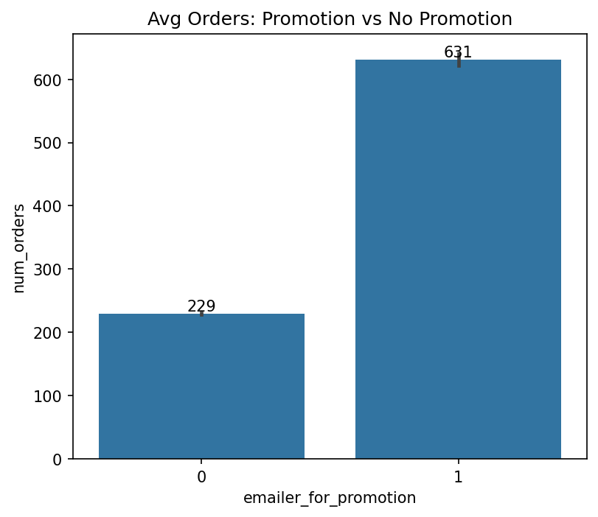

Bar chart comparing average orders with/without email promotion
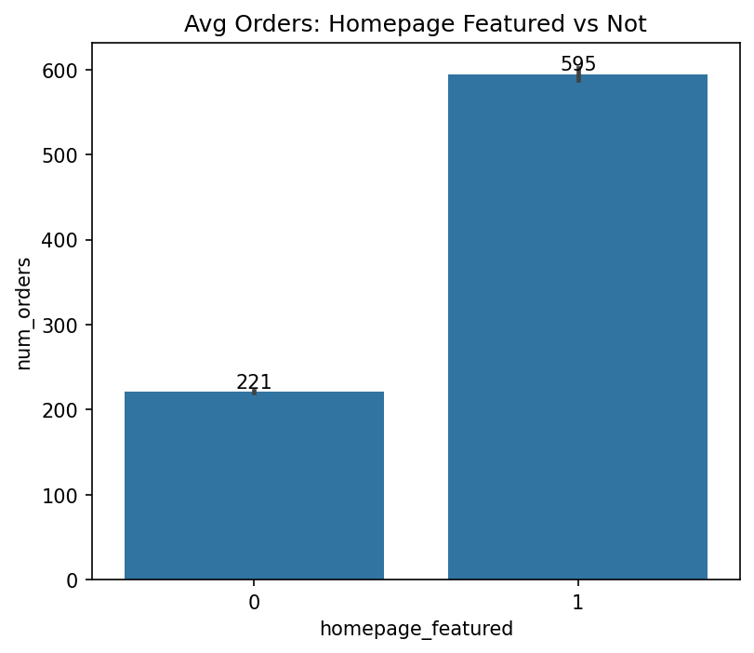
Bar chart comparing average orders with/without homepage feature
- Email promotion: 631 average orders vs. 229 without — approximately 2.75x increase
- Homepage feature: 595 average orders vs. 221 without — approximately 2.7x increase
Both promotion channels roughly triple average demand, confirming and quantifying what the outlier analysis in Section 3.4 had already suggested.

6. Multivariate Analysis
This section combines three or more variables at once to identify interaction effects that bivariate analysis alone cannot reveal.

6.1 Correlation Heatmap
numeric_cols = ['checkout_price', 'base_price', 'emailer_for_promotion',
'homepage_featured', 'num_orders', 'op_area']
corr = df[numeric_cols].corr()
sns.heatmap(corr, annot=True, cmap='coolwarm', fmt='.2f', center=0)
plt.title('Correlation Heatmap')
plt.tight_layout()
plt.show()
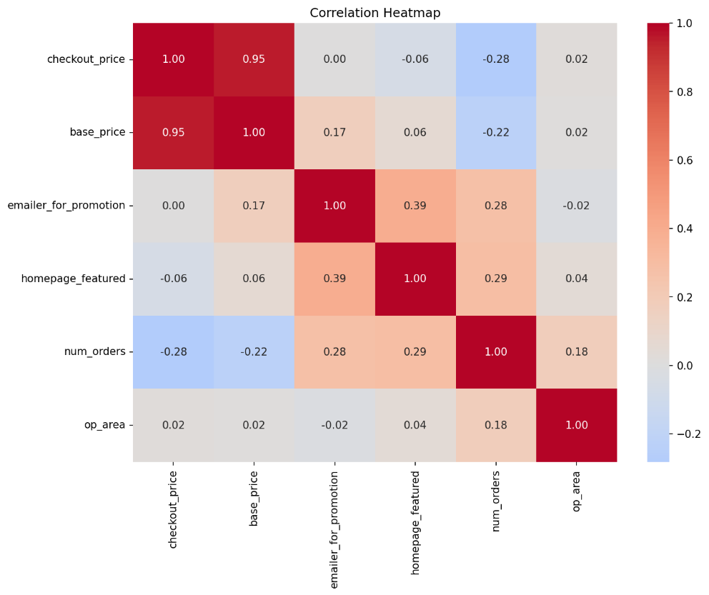
Correlation heatmap of the numeric columns
- checkout_price and base_price correlate strongly (0.95), as expected since checkout price is derived from base price
- emailer_for_promotion and homepage_featured correlate moderately (0.39), suggesting these two promotional channels are often used together
- num_orders correlates positively with both promotion flags (0.28, 0.29) and negatively with both price columns (-0.28, -0.22)
- op_area shows negligible correlation with all other variables (close to 0), meaning center size alone does not meaningfully predict demand

6.2 Promotion Effect by Category
promo_by_cat = df.groupby(['category', 'emailer_for_promotion'])['num_orders'].mean().unstack()
promo_by_cat.plot(kind='bar')
plt.title('Avg Orders by Category, Split by Promotion Status')
plt.ylabel('Avg num_orders')
plt.legend(title='Promotion', labels=['No', 'Yes'])
plt.xticks(rotation=45, ha='right')
plt.tight_layout()
plt.show()
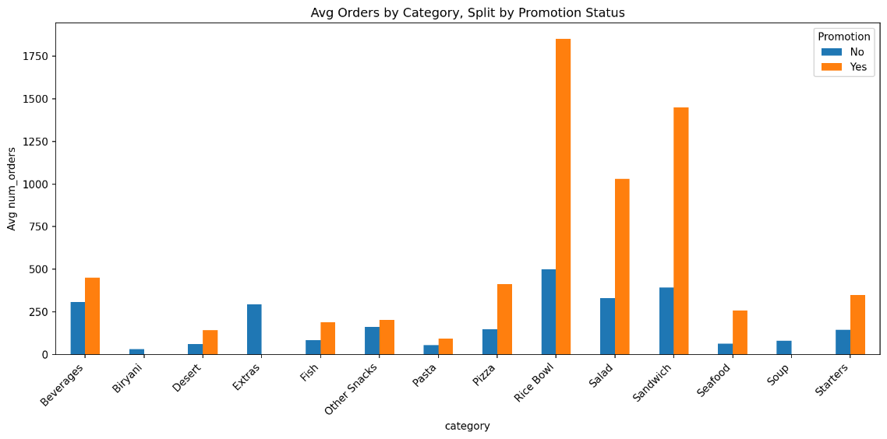
Grouped bar chart of average orders by category, split by promotion status
This is one of the most valuable findings in the analysis: the effect of promotion is not uniform across categories. Rice Bowl shows the largest lift, rising from approximately 500 to 1,850 average orders when promoted (about 3.7x), and Sandwich shows a similarly strong lift (about 400 to 1,450, roughly 3.6x). By contrast, Beverages — the most frequently listed category — shows a much smaller lift (approximately 320 to 450, about 1.4x) despite being the largest category overall. This suggests that promotional spend would generate a higher return if concentrated on categories like Rice Bowl and Sandwich rather than spread evenly across all categories.

6.3 Promotion Effect by Region
promo_by_region = df.groupby(['region_code', 'emailer_for_promotion'])['num_orders'].mean().unstack()
promo_by_region.plot(kind='bar')
plt.title('Avg Orders by Region, Split by Promotion Status')
plt.ylabel('Avg num_orders')
plt.legend(title='Promotion', labels=['No', 'Yes'])
plt.xticks(rotation=45, ha='right')
plt.tight_layout()
plt.show()
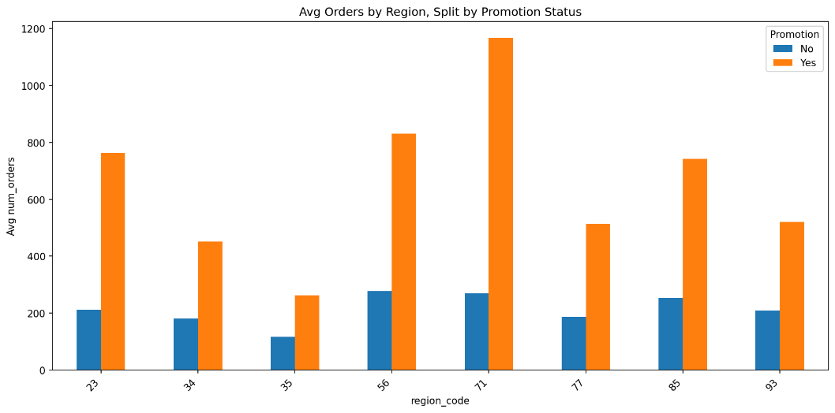
Grouped bar chart of average orders by region, split by promotion status
Every region benefits from promotion, but both the baseline demand and the size of the promotional lift vary by region. Region 71 shows the strongest response to promotion (reaching roughly 1,175 average orders when promoted), while region 35 shows the weakest baseline and the smallest promotional lift. As noted in Section 4.3, smaller regions have far less underlying data, so these regional comparisons should be treated with appropriate caution.

6.4 Discount vs. Orders, by Category
df['discount'] = df['base_price'] - df['checkout_price']
plt.figure(figsize=(10,6))
sns.scatterplot(x='discount', y='num_orders', hue='category', data=df, alpha=0.4)
plt.title('Discount Amount vs Orders (colored by category)')
plt.legend(bbox_to_anchor=(1.05, 1), loc='upper left', title='Category')
plt.tight_layout()
plt.show()
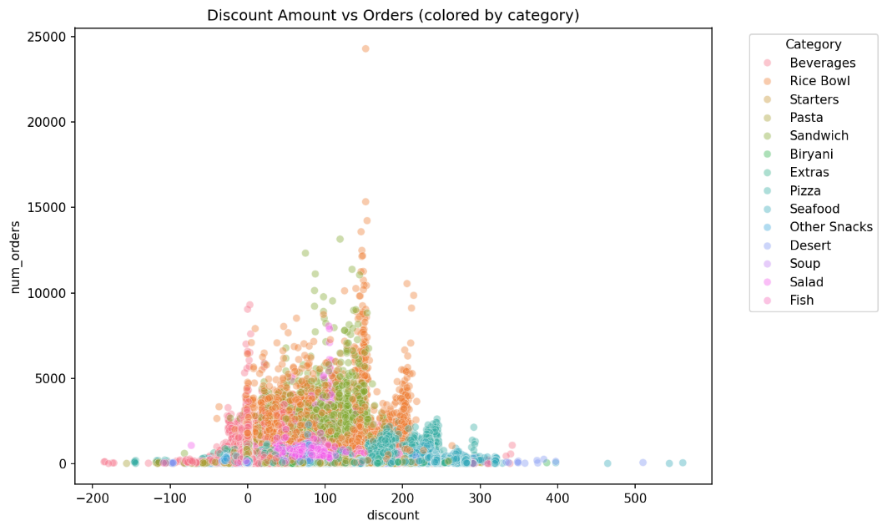
Scatter plot of discount amount vs num_orders, coloured by category
Most of the high-demand activity is concentrated in the ₹0–200 discount range, spread mainly across Rice Bowl, Sandwich, Beverages and Pizza; demand drops off noticeably beyond roughly ₹250–300 of discount regardless of category. The single most extreme point (approximately 24,000 orders) corresponds to a Rice Bowl listing at around ₹150 discount — the same outlier identified in Section 3.4. The cluster of points with negative discount values corresponds to the data quality pattern discussed in Section 3.3.

7. Key Findings Summary
1. Demand is highly right-skewed with significant outliers
num_orders has a mean of approximately 262 but a maximum of 24,299, with about 7.2% of rows (32,937) falling outside the IQR-based outlier bounds (above 729 orders/week). These are not noise — they correlate strongly with promotional activity.
2. Promotions nearly triple average demand
Email promotion raises average orders from 229 to 631 (about 2.75x); homepage feature raises average orders from 221 to 595 (about 2.7x). Both promotion types are also over-represented among outlier rows (28.4% vs. 8.1% baseline for email promotion; 38.4% vs. 10.9% for homepage feature).
3. Promotion effectiveness varies sharply by category
Rice Bowl (about 3.7x lift) and Sandwich (about 3.6x lift) respond far more strongly to promotion than Beverages (about 1.4x lift), despite Beverages being the most frequently listed category. Promotional spend would likely be more effective if targeted at Rice Bowl and Sandwich.
4. Promotion effectiveness also varies by region
All regions benefit from promotion, but baseline demand and promotional lift differ meaningfully — region 71 shows the strongest response, region 35 the weakest.
5. Frequency of listing does not equal demand performance
Beverages is the most commonly listed category (127,890 rows) but ranks only 4th in average demand per listing (317). Rice Bowl is listed far less often (33,408 rows) but has the highest average demand per listing (625).
6. Price has a weak negative relationship with demand
Checkout price correlates with num_orders at -0.28 — a real but not strong effect. Price distributions are multimodal, reflecting distinct pricing tiers across categories rather than one smooth continuous range.
7. Data quality is strong overall, with one notable pattern to flag
No missing values or duplicate rows were found. Checkout and base price correlate at 0.95, as expected. However, about 25% of rows (116,101) show checkout_price marginally exceeding base_price, dominated by small deviations of -1 and -2 units spread evenly across categories, center types, and weeks — likely a rounding or fixed-markup artifact rather than a data error.
8. Promotional channels tend to be used together
emailer_for_promotion and homepage_featured correlate at 0.39 — a moderate relationship suggesting these two channels are often deployed as a combined push rather than independently.

8. Conclusion
This exploratory data analysis of the Food Demand Forecasting dataset achieved its objective of uncovering patterns and relationships useful for subsequent analysis. The data was found to be clean and well-structured, with one notable systematic pricing pattern flagged for attention. Univariate analysis revealed a right-skewed, promotion-driven demand distribution and multimodal pricing tiers. Bivariate analysis quantified the impact of price and promotion on demand, while multivariate analysis uncovered meaningful interaction effects — most notably, that promotional effectiveness varies substantially by both meal category and region.
These findings — particularly the category- and region-specific promotion effects — provide a strong foundation for the original forecasting objective of this dataset, and could directly inform more targeted promotional strategy as well as feature selection for a future predictive demand model.

Repository
The full analysis notebook and code are available on GitHub at: https://github.com/ashraful-ahmad/Food-Forecasting

