Week 4: Building a Predictive Model
Food Demand Forecasting: Internship Project
GitHub: https://github.com/ashraful-ahmad/Food-Forecasting

1. Objective and Problem Definition
The aim of Week 4 is to build, evaluate and interpret a predictive model on the preprocessed and feature-engineered dataset produced in Weeks 1 to 3. The outcome chosen for prediction is weekly food demand, measured as the number of orders (num_orders) for a given meal at a given fulfilment center in a given week.
This outcome is directly relevant to food processing, because demand forecasts drive three costly decisions:
- Procurement: how much raw material to buy before the week starts.
- Production planning: how many meals to prepare and which centers need the most capacity.
- Waste and stock-outs: over-prediction leads to unsold, perishable food; under-prediction leads to lost sales.
The model is considered successful if it (a) beats a simple linear baseline, (b) stays stable across unseen weeks, and (c) shows drivers of demand that can be explained and acted upon.

2. Data Used
The input is feature_engineered_food_demand.csv: 456,548 rows and 49 columns, built from the Kaggle food demand forecasting dataset (train.csv merged with fulfilment_center_info.csv and meal_info.csv) and processed in Weeks 1 to 3. After removing the target columns and the week index (explained in Section 3), 46 predictor columns remain.
Feature group | Columns | Role in the model
Price and promotion | checkout_price, base_price, discount, discount_pct, price_vs_category_avg, emailer_for_promotion, homepage_featured, has_negative_discount, discount_x_promo | How price levels and marketing push demand up or down
Recent demand history | orders_last_week_log, rolling_avg_3wk_log | Short-term momentum of each meal and center
Aggregated demand level | center_avg_orders_log, meal_avg_orders_log | Typical demand of the meal and of the center
Center and meal attributes | op_area, one-hot columns for region, center type, meal category and cuisine | Structural differences between centers and meals

3. Target Choice and Feature Selection
Every selection decision below was made for a specific reason, and where possible it was tested rather than assumed.
Item | Decision | Reasoning and evidence
num_orders_log | Used as the target | Demand is right-skewed with genuine spikes. The log1p transform makes errors behave like percentage errors, so a miss on a small meal is not hidden by a miss on a large one. Predictions are converted back with expm1 for reporting.
num_orders and num_orders_log | Excluded from the inputs | They are the answer itself. Leaving either in would let the model copy the target and produce a meaningless, near-perfect score (data leakage).
week | Used only to split the data; excluded from the inputs | Tested both ways with HistGradientBoosting: RMSLE was 0.5084 with week and 0.4823 without it, a 0.0261 improvement (5.1%). Tree models cannot extrapolate to weeks 136 to 145 that they never saw, and the lag and rolling features already carry the time information.
center_id, meal_id | Dropped after feature construction (Week 3) | Raw IDs are arbitrary labels, not quantities. Their useful information is kept through center_avg_orders_log and meal_avg_orders_log.
meal_avg_orders_log, center_avg_orders_log | Kept, with a documented limitation | They are among the strongest predictors (Section 8). They were computed on the full dataset, so they carry slight information from the test weeks (see Section 10).
0/1 and one-hot columns | Never scaled | They are already on a 0 to 1 scale; scaling would only make coefficients harder to read.

3.1 Interpreting negative discounts
About 25% of rows have checkout_price higher than base_price, which gives a negative discount. In the first meal-center series of the dataset, week 2 has base price 182.36 and checkout price 183.36 (discount of -1, 782 orders), and week 3 has a discount of -2 (851 orders). In these rows the gap is only 1 to 2 currency units, about 0.5% to 1.1% of the base price. This looks like a small price adjustment or surcharge rather than a data error, although the data alone cannot confirm the cause.
Decision: the rows were flagged with has_negative_discount instead of being deleted. Removing them would discard a quarter of the data and teach the model only about discount situations, which would not match real operations. The model also receives price_vs_category_avg, so it can tell a meal that is expensive for its category from one that is cheap.

3.2 Interpreting outliers
Demand spikes in this dataset are real promotional events, not measurement errors. In the same meal-center series, orders were 648, 770 and 663 in weeks 14 to 16, then jumped to 1,404 in week 17 (2.1 times the previous week), when the email promotion and homepage feature were both switched on and the price was 21.34 below base (an 11.6% discount). Capping this value would have erased exactly the pattern the business most wants to forecast. The Week 3 analysis also showed that promotional lift varies strongly by category: about 3.7x for Rice Bowl, 3.6x for Sandwich and only 1.4x for Beverages.
Decision: outliers were kept and handled with the log1p transform instead of capping. The cost of this choice is visible in the results: the largest model errors occur at the demand extremes (Section 8.2).

4. Train/Test Split
The data was split by time, not at random:
- Training set: weeks 1 to 135 ( 423,727 rows).
- Test set: the last 10 weeks, 136 to 145 ( 32,821 rows).
A random split would allow the model to learn from week 140 and then be tested on week 139, which means it would have seen the future. That makes the score look better than it would in real use. In practice a planner forecasts upcoming weeks using only the past, and the time-based split reproduces that situation.

5. Model Selection
Three models of increasing complexity were compared, so that the benefit of each step up could be measured.
Model | How it works (short) | Why it was chosen | Scaling
Ridge Regression (baseline) | Linear regression with a penalty on large coefficients | Price columns such as checkout_price, base_price and discount are closely related. Ridge keeps their weights stable. It sets the bar the other models must beat. | Yes (continuous columns only)
Random Forest | Averages many decision trees trained on random subsets | Captures non-linear effects and interactions (for example promotion combined with price) without manual setup. | No
Gradient Boosting (HistGradientBoosting) | Builds trees one after another, each correcting the errors of the previous ones | Usually the strongest model on tabular data of this size and handles 456,548 rows quickly. | No

The gradient boosting model used is scikit-learn HistGradientBoostingRegressor, which follows the same histogram-based boosting approach as LightGBM. It was used because LightGBM was not installed in the environment.

6. Model Training
Ridge was trained inside a scikit-learn Pipeline with a ColumnTransformer. The StandardScaler was applied to the continuous columns only and fitted on the training weeks only, so no information from the test weeks reached the model. The settings used were:
Model | Settings
Ridge | alpha = 1.0; StandardScaler on continuous columns; binary columns passed through unchanged
Random Forest | n_estimators = 100, max_depth = 20, min_samples_leaf = 5, random_state = 42
HistGradientBoosting | max_iter = 500, learning_rate = 0.05, max_leaf_nodes = 63, random_state = 42

Hyperparameters were fixed to sensible values and not tuned by search. Limiting depth and requiring at least 5 rows per leaf in Random Forest reduces overfitting. This is noted as an area for improvement in Section 10.

7. Model Evaluation

7.1 Metrics used
Metric | Meaning | Why it is used here
RMSLE | Root mean squared error on log1p values (equal to RMSE on num_orders_log) | Main metric. Measures percentage-style error and penalises large misses.
MAE (log) | Average size of the error on the log scale | Easy to read: 0.37 means about 45% off, since exp(0.37) is 1.45.
R2 | Share of the variation in demand explained by the model | Shows overall explanatory power.
MAE (orders) | Average error in real order counts after expm1 | Gives a business-friendly number.

7.2 Results
Model | RMSLE (log) | MAE (log) | R2 (log) | MAE (orders)
Ridge (baseline) | 0.5251 | 0.4053 | 0.7912 | 70.1374
Random Forest | 0.4945 | 0.3799 | 0.8148 | 63.7210
HistGradientBoosting (best) | 0.4823 | 0.3718 | 0.8239 | 62.7337

HistGradientBoosting achieved the lowest RMSLE of the three models (0.4823), compared with 0.5251 for Ridge and 0.4945 for Random Forest. That is an improvement of 4.13% over the baseline, which shows that non-linear relationships between price, promotion and demand history carry real signal that a linear model misses.
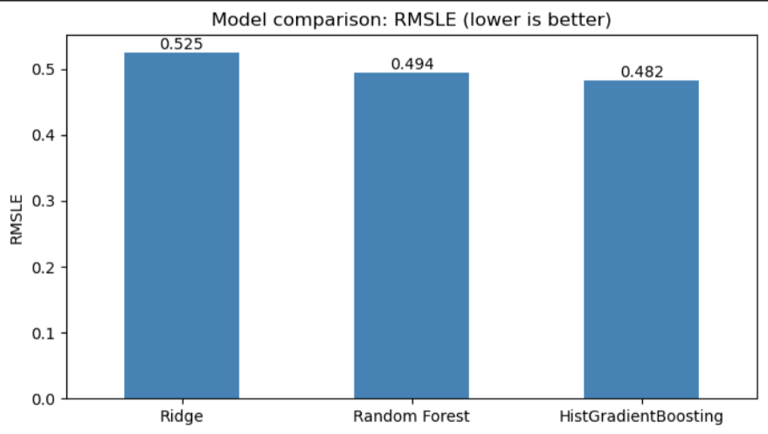
Figure 1: RMSLE of the three models on the test weeks (lower is better).

7.3 What the error means in practice
An RMSLE of 0.4823 means the typical prediction is off by a factor of about 1.6 (exp(0.4823) = 1.62). A typical weekly MAE of about 0.37 on the log scale is a factor of about 1.45. As a worked example, take a meal-center that really sold 865 orders (week 1 of the first series, log1p = 6.764). An error of +0.37 would give a prediction of about 1,253 orders, and an error of -0.37 would give about 597 orders. Planners should therefore treat each forecast as a range and not as a single exact number, and this range is used in the recommendations in Section 9.

7.4 Feature selection experiment
Removing the week index lowered RMSLE from 0.5084 to 0.4823 (Section 3). This shows that carefully choosing what the model sees improved performance more than adding an extra column would have.

8. Interpretation of Results

8.1 Which features drive demand
Importance was measured with permutation importance on 20,000 test rows. For each feature, its values are randomly shuffled and the drop in model score is recorded. A larger drop means the model relies on that feature more. The approximate values read from the chart are:
Rank | Feature | Importance (approx.) | What it tells us
1 | meal_avg_orders_log | 0.40 | Each meal has a typical demand level, and that level explains the most. Popular meals stay popular.
2 | rolling_avg_3wk_log | 0.13 | The last three weeks of demand are a strong guide to next week.
3 | orders_last_week_log | 0.09 | Last week alone adds further information on short-term momentum.
4 | center_avg_orders_log | 0.06 | Some fulfilment centers are consistently busier than others.
5 | price_vs_category_avg | 0.05 | A meal priced above or below its category average sells differently.
6 | checkout_price | 0.02 | The actual price paid has a smaller direct effect once the features above are known.
7 to 9 | discount_x_promo, base_price, homepage_featured | 0.01 or less | Promotion flags matter, but their effect is already captured in recent-demand features.

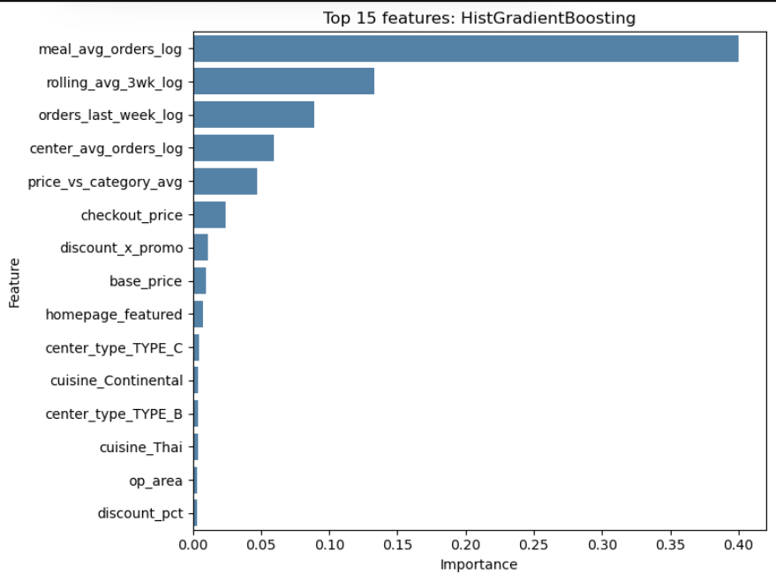
Figure 2: Top 15 features by permutation importance (HistGradientBoosting).
The first four features together account for roughly 0.68 of the total importance shown, which means demand is mostly explained by how well a meal and a center have been selling, with price and promotion adjusting that baseline.

8.2 Where the model makes mistakes
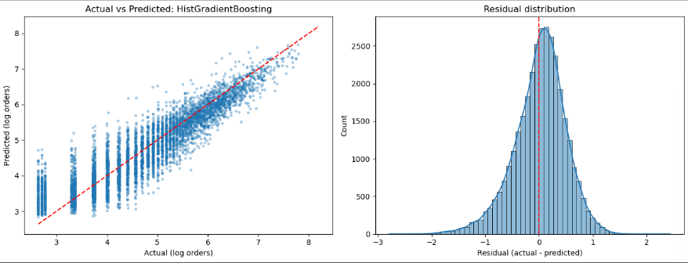Figure 3: Actual vs predicted values (left) and residual distribution (right).
- Middle range: between about 4.5 and 7 in log orders (roughly 90 to 1,100 orders) predictions sit close to the perfect-prediction line, which is where most of the data lies.
- Low demand is over-predicted: when actual demand is very small (log 2.7 to 3.5, about 14 to 32 orders) the model predicts higher than reality.
- High demand is under-predicted: for the biggest spikes (log above 7, about 1,100 orders or more) predictions drift below the line.
- Residuals: the distribution is bell-shaped and centred close to zero, with a slight lean to the positive side (a small under-prediction on average) and a longer negative tail down to about -2.8, which comes from the low-demand over-predictions. Most errors fall within about +/-1 on the log scale.
This is the expected cost of keeping outliers (Section 3.2): the model is safest when predicting near the average and has the least information to anticipate rare extremes.

8.3 Stability over the test period

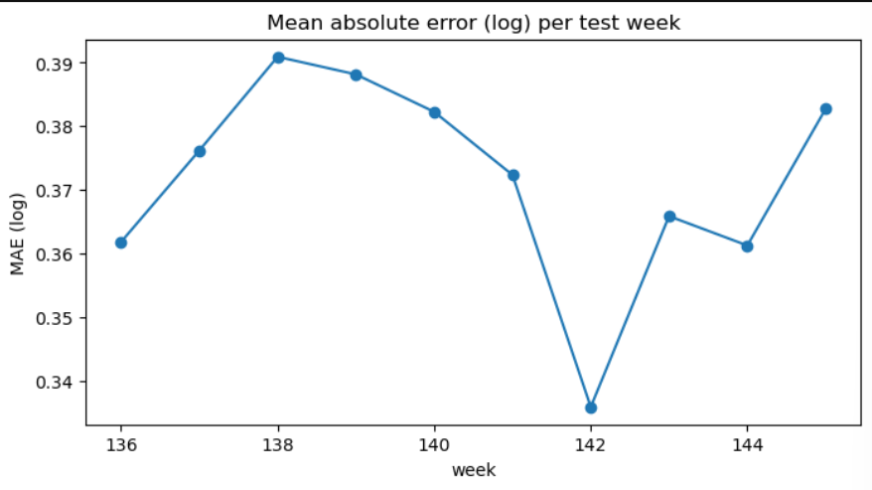
Figure 4: Mean absolute error (log) for each of the 10 test weeks.
The weekly MAE stays between about 0.336 (week 142) and 0.391 (week 138), a spread of only about 0.055, with no steady upward trend. This indicates the model does not degrade quickly over a 10-week horizon, so it can be reused for several weeks before retraining.

8.4 Evidence from the data: price and promotion effects
The model results agree with what the raw data shows. In the first meal-center series, weeks 1 to 5 had almost no discount (discount values of 0, -1, -2, 1, -2) and an average checkout price of 182.97. Average orders were 931.6 per week ((865 + 782 + 851 + 1,202 + 958) / 5). In weeks 6 to 11 the average checkout price fell to 161.38, an average reduction of about 11.8%, and average orders rose to 1,312.3 per week ((1,094 + 1,513 + 1,149 + 1,282 + 1,473 + 1,363) / 6), an increase of about 40.9%. In weeks 19 to 23, discounts of 21 to 26 units kept orders elevated between 1,241 and 1,553 even without the email and homepage promotions.
This also explains why the promotion flags rank low in Section 8.1. Once a discount starts, it feeds into orders_last_week_log and rolling_avg_3wk_log, so the history features carry the promotional effect forward. The caveat is that this is one meal-center series, and demand also moves for other reasons, so it supports the model findings but is not proof that a given discount causes a given lift.

8.5 Cautions when reading these results
- Leakage in aggregation features: meal_avg_orders_log and center_avg_orders_log used the full dataset, so part of their importance may be inflated.
- Correlated features share credit: rolling_avg_3wk_log and orders_last_week_log carry similar information, so permutation importance understates how important recent demand is as a group.
- Importance is not causation: a high score shows what the model relies on, not what causes demand.

9. Business Implications and Recommendations
Finding | Recommended action
Meal-level average demand is the top driver (importance about 0.40) | Set the base weekly procurement plan per meal from its historical average, and use the model to adjust it each week. Review the plan per meal, not only per center.
Last three weeks of demand strongly predict next week | Refresh rolling averages every week and feed them into planning so production follows real momentum. Retrain the model on a regular schedule, for example every few weeks.
Promotional lift differs by category (Rice Bowl about 3.7x, Sandwich about 3.6x, Beverages about 1.4x) | Focus discounts and email or homepage promotions on high-lift categories, and avoid heavy discounting on categories where lift is small.
Model under-predicts the biggest spikes (Section 8.2) | In promotion weeks, add a safety stock buffer for perishable ingredients. A practical way is to size the buffer from the model residuals observed in past promotion weeks.
Model over-predicts very low-demand meals | Do not prepare low-volume meals at the full predicted quantity. Cap production for them or review whether the meal should stay on the menu, to limit food waste.
Typical error is a factor of about 1.45 (Section 7.3) | Use forecasts as ranges. For the 865-order example, plan between about 600 and 1,250 orders, and choose the point in that range based on how costly waste is compared with a stock-out for that meal.

10. Limitations and Future Work
- Leakage in mean-encoded features: recompute meal_avg_orders_log and center_avg_orders_log from the training weeks only and measure how much the score drops. This would give an honest estimate of real-world performance.
- Single train/test split: only one 10-week window was tested. Using several time-ordered splits (rolling-origin validation) would show how stable the results are.
- No hyperparameter tuning: a search over tree depth, learning rate and number of trees may reduce the error further.
- No naive benchmark: comparing against a simple rule such as "next week equals last week" would show how much value the model adds beyond recent history.
- Negative discounts: the cause of price above base was not confirmed. Checking the size distribution of these rows would clarify whether they are surcharges or data issues.
- Missing external drivers: holidays, weather and competitor activity are not in the data and could explain part of the spikes.

11. Conclusion
A time-based evaluation of three models showed that gradient boosting performed best, with an RMSLE of 0.4823 on 10 unseen weeks. Careful feature selection mattered: excluding the target columns prevented leakage, and excluding the week index improved RMSLE by 5.1%. Demand is driven mainly by how well a meal and a center have been selling recently, with price and promotion adjusting that baseline. The model is stable over the test period but under-predicts large spikes and over-predicts very small orders, so forecasts should be used as ranges with a safety buffer in promotion weeks. These findings translate into concrete actions for procurement, promotion planning and waste reduction, and the limitations above define the next improvements.

Appendix: Reproducibility
- Notebook: Week4_Model_Building.ipynb
- Input file: feature_engineered_food_demand.csv
- Saved figures: Charts folder (model_comparison.png, feature_importance.png, actual_vs_predicted_and_residuals.png, error_by_week.png)
- Repository: https://github.com/ashraful-ahmad/Food-Forecasting

