EAST WEST UNIVERSITY
Department of Business Administration

────────────────────────────────────────────
SYSTEM DESIGN DIAGRAM
DSA Trivia Challenge
A Console-Based Competitive Quiz & Ranking System in C
────────────────────────────────────────────
Course | : | Data Structures and Algorithms (DSA)
Document | : | System Design Diagram
Prepared By | : | Group [Your Group Number]
Supervised By | : | [Ma'am's Name]
Submission Date | : | 10 October 2026
Version | : | 1.0
TABLE OF CONTENTS

1. System Architecture — Module Overview ··············· 3
2. Main Program Flowchart ······························ 4
3. Data Structure Diagram (C Structs) ·················· 5
4. Sorting Algorithm Flowcharts ························ 6
5. File Input / Output Diagram ························· 7
6. DSA Concepts Summary ································ 8

1. System Architecture — Module Overview
This diagram illustrates how the six functional modules of the DSA Trivia Challenge system are organised and how they interact with the Main Program. Each module handles a specific responsibility, keeping the code modular and maintainable.

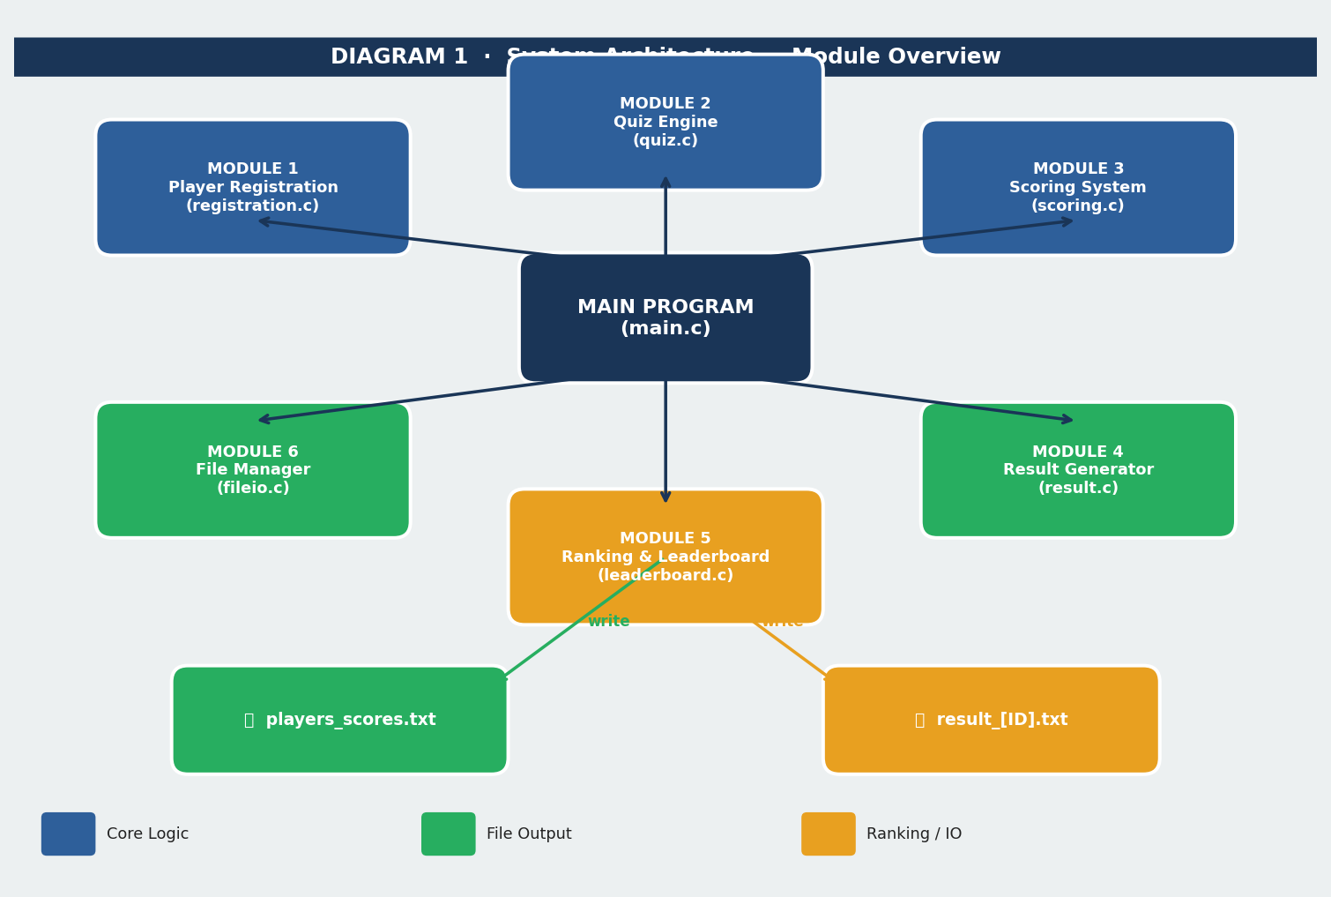
Figure 1.1 — System Architecture showing all 6 modules and their connections

2. Main Program Flowchart
The flowchart below shows the complete execution flow of the program from start to finish. It covers player registration, duplicate ID checking, the question loop, answer validation, score calculation, and leaderboard generation.

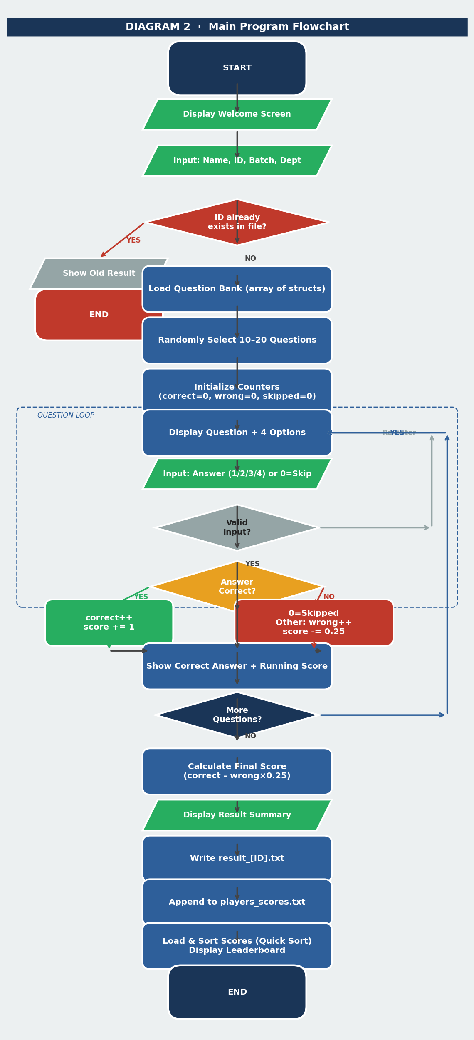
Figure 2.1 — Complete program flowchart with all decision branches

3. Data Structure Diagram (C Structs)
The system uses two primary structs defined in C. The Player struct stores all information about each participant. The Question struct stores each quiz question with its four options and the index of the correct answer. Both are used as arrays in memory.

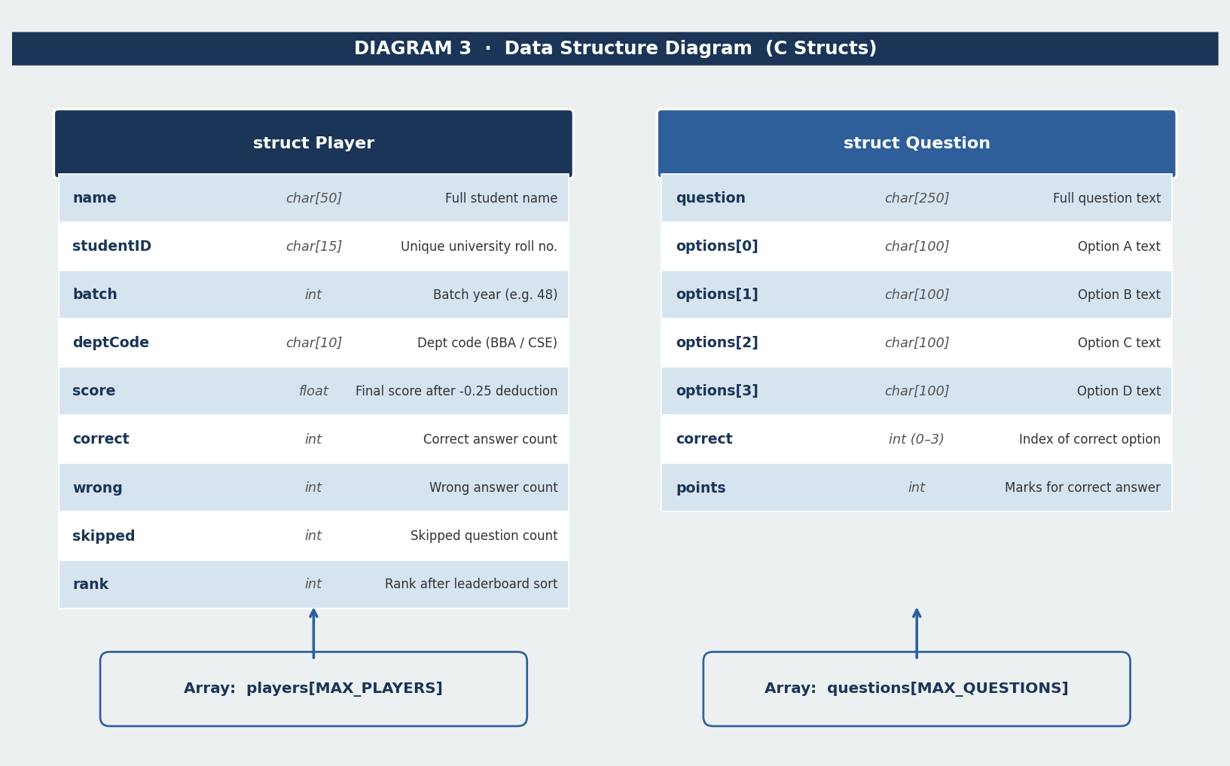
Figure 3.1 — Player and Question struct field definitions

4. Sorting Algorithm Flowcharts
Two sorting algorithms are implemented from scratch. Quick Sort (O(n log n)) is the primary algorithm used to sort the leaderboard. Bubble Sort (O(n²)) is implemented as a secondary option so players can choose and compare both algorithms — directly demonstrating DSA concepts in a practical context.

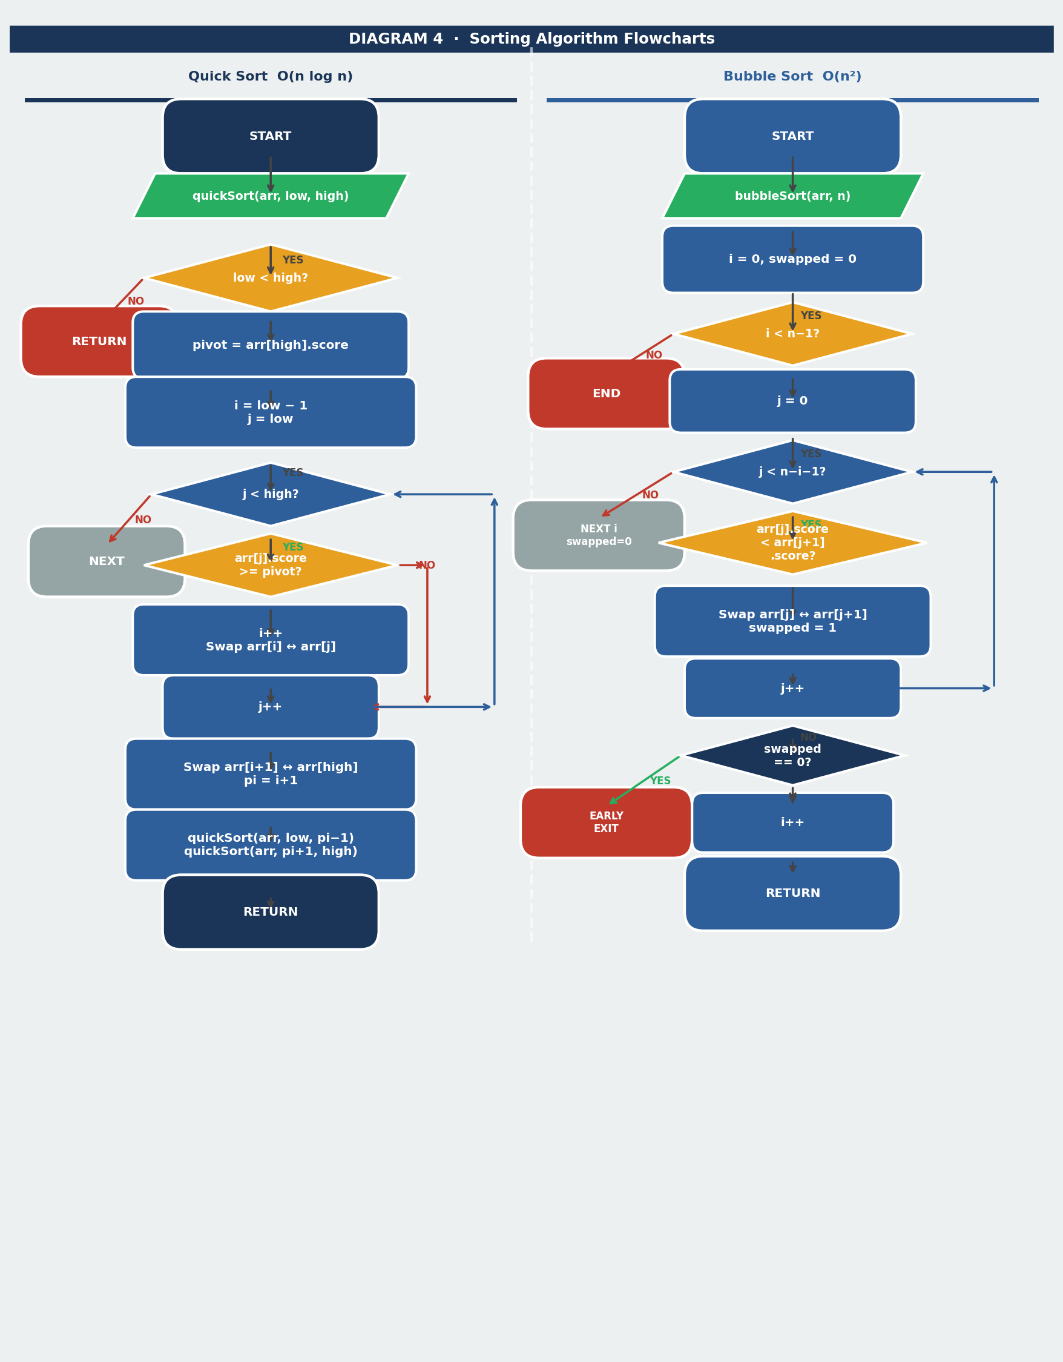
Figure 4.1 — Quick Sort (left) and Bubble Sort (right) flowcharts side by side

5. File Input / Output Diagram
The system generates and reads two text files. players_scores.txt is a shared, persistent file updated after every session and kept sorted by score. result_[StudentID].txt is a per-player file generated at the end of each quiz containing the full question-by-question breakdown and final result.

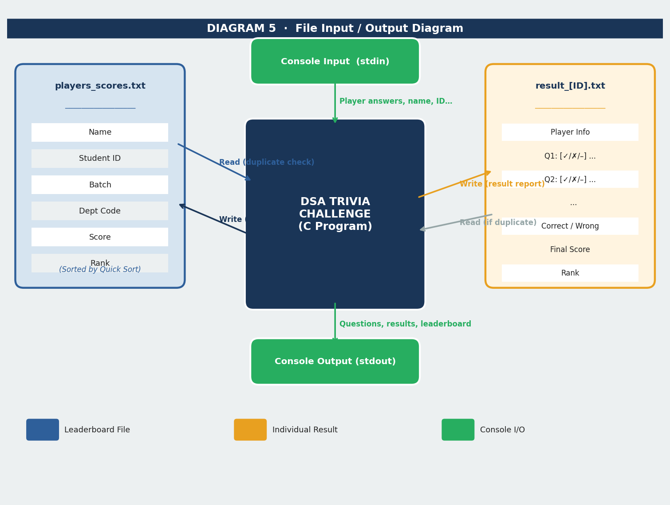
Figure 5.1 — File I/O interactions between the program and stored data

6. DSA Concepts Summary
The table below summarises all Data Structures and Algorithm concepts demonstrated in this project, mapped to their specific use case and complexity.

DSA Concept | Where Used | Time Complexity | Space
Quick Sort | Leaderboard ranking — sorts all players by score (descending) | O(n log n) avg | O(log n)
Bubble Sort | Secondary sort — demonstrates O(n²) vs Quick Sort comparison | O(n²) worst | O(1)
Linear Search | Duplicate ID detection before quiz starts (scans scores file) | O(n) | O(1)
Array of Structs | Stores Player data and Question bank in memory | O(1) access | O(n)
File I/O | Persistent storage of scores and per-player result reports | O(n) r/w | O(1)
Random Selection | Shuffles question order each session (prevents memorisation) | O(n) | O(n)

Prepared by Group [Group Number] | East West University | August 2026

