EAST WEST UNIVERSITY
Department of Business Administration

────────────────────────────────────────────
SYSTEM DESIGN DIAGRAM
DSA Trivia Challenge
A Console-Based Competitive Quiz & Ranking System in C
Version 2.0 — Updated to match final dsa_trivia_full.c
────────────────────────────────────────────
Course | : | Data Structures and Algorithms (DSA)
Document | : | System Design Diagram (v2.0 — Final Code Matched)
Source File | : | dsa_trivia_full.c (single-file, 1167 lines, C11)
Prepared By | : | Group [Your Group Number]
Supervised By | : | [Ma'am's Name]
Submission Date | : | 10 October 2026
Version | : | 2.0
GROUP MEMBERS

SL | Student Name | Registration No. | Department | Role
01 | [Your Name] | [Reg No.] | [Dept] | Team Leader / Developer
02 | [Member 2] | [Reg No.] | [Dept] | Documentation
03 | [Member 3] | [Reg No.] | [Dept] | Research & Slides
04 | [Member 4] | [Reg No.] | [Dept] | Testing & Q&A
TABLE OF CONTENTS

1. System Architecture — Single-File Module Overview · 4
2. Main Menu Loop — main() Flowchart ················· 5
3. "Take Quiz" Complete Flow — handleTakeQuiz() ······ 6
4. Data Structures — All Three C Structs ············· 7
5. Sorting Algorithm Flowcharts — Quick Sort & Bubble Sort 8
6. File I/O Diagram — Three Output Files ············· 9
7. Function Reference Table ·························· 10
8. DSA Concepts Summary ······························ 11

v2.0 — What Changed from the Original Design
The diagrams in this document have been fully rebuilt to match the final submitted source file (dsa_trivia_full.c). The table below summarises every structural change between the original design submission (v1.0) and the actual implemented code (v2.0).

Aspect | v1.0 Original Design | v2.0 Final Code (Actual)
File structure | 6 separate .c files  (main, registration, quiz,  scoring, leaderboard, fileio) | 1 single file  dsa_trivia_full.c  (12 labelled sections)
Output files | players_scores.txt  result_[ID].txt | players_scores.txt  result_[ID].txt  leaderboard_report.txt (new)
Program flow | Linear, single run  (start → quiz → end) | DO-WHILE menu loop  (runs until user exits)
Data structures | 2 structs  Player, Question | 3 structs  Player, Question, AnswerRecord
Duplicate ID check | loadAllPlayers + linear scan  before quiz | Same — findPlayerIndexByID()  using Linear Search O(n)
Score storage | Running sum clamped to 0  after every question | Live running sum for feedback  + exact formula recalculated  at session end to avoid mismatch
Diagrams | 5 diagrams  (architecture, flowchart,  structs, sorting, file I/O) | 6 diagrams  (+ separate menu-loop  and take-quiz flow)

1. System Architecture — Single-File Module Overview
The entire project is contained in one file (dsa_trivia_full.c) organised into 12 clearly labelled sections. main() at the top orchestrates two layers below it: the Menu Handlers (Section 11) which handle each user choice, and the six specialist modules (Sections 3–10) that do the actual work. Three output files are created at runtime.

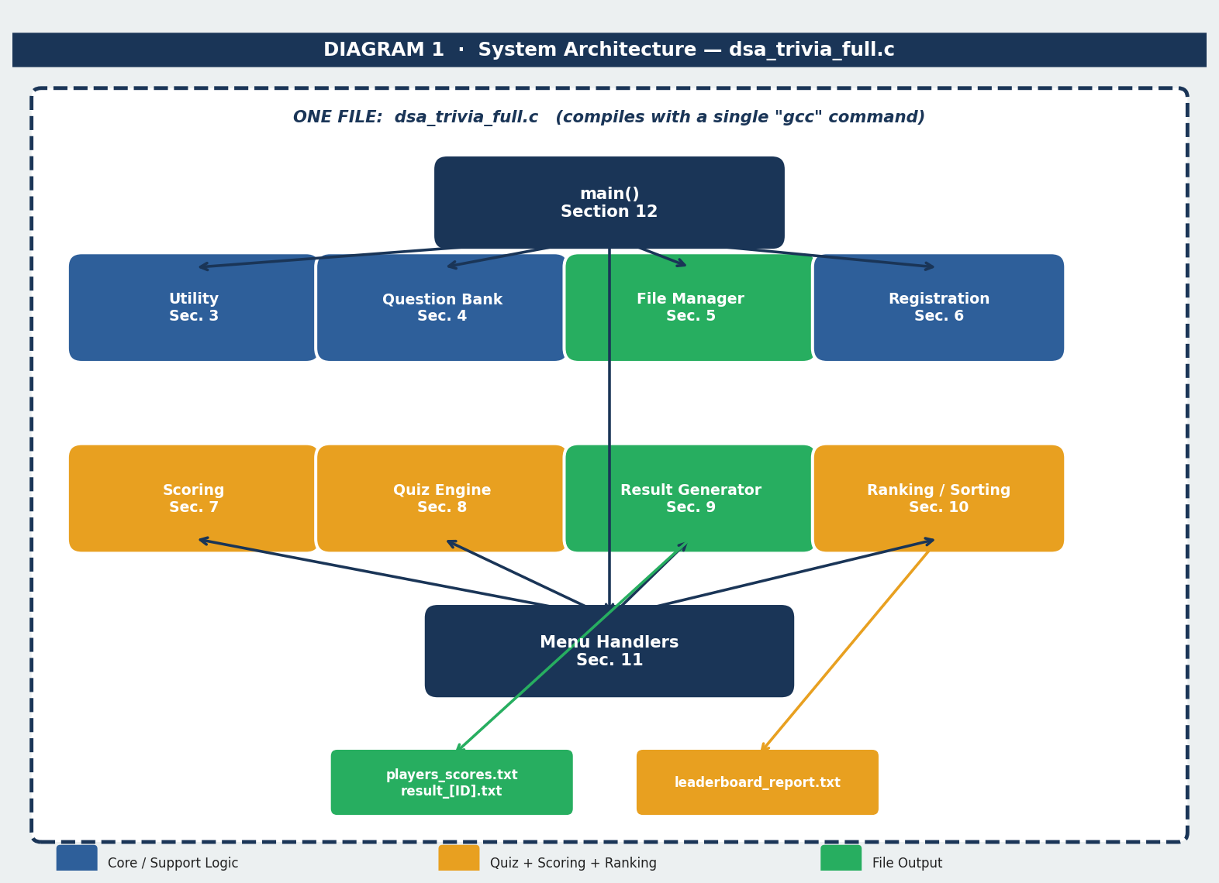
Figure 1.1 — All 12 sections of dsa_trivia_full.c and their relationships

2. Main Menu Loop — main() Flowchart
main() uses a DO-WHILE loop so the menu always appears at least once. After any menu handler returns, the program checks whether the user chose Exit (4). If not, it loops back and redraws the menu. This continues until the user explicitly selects option 4.

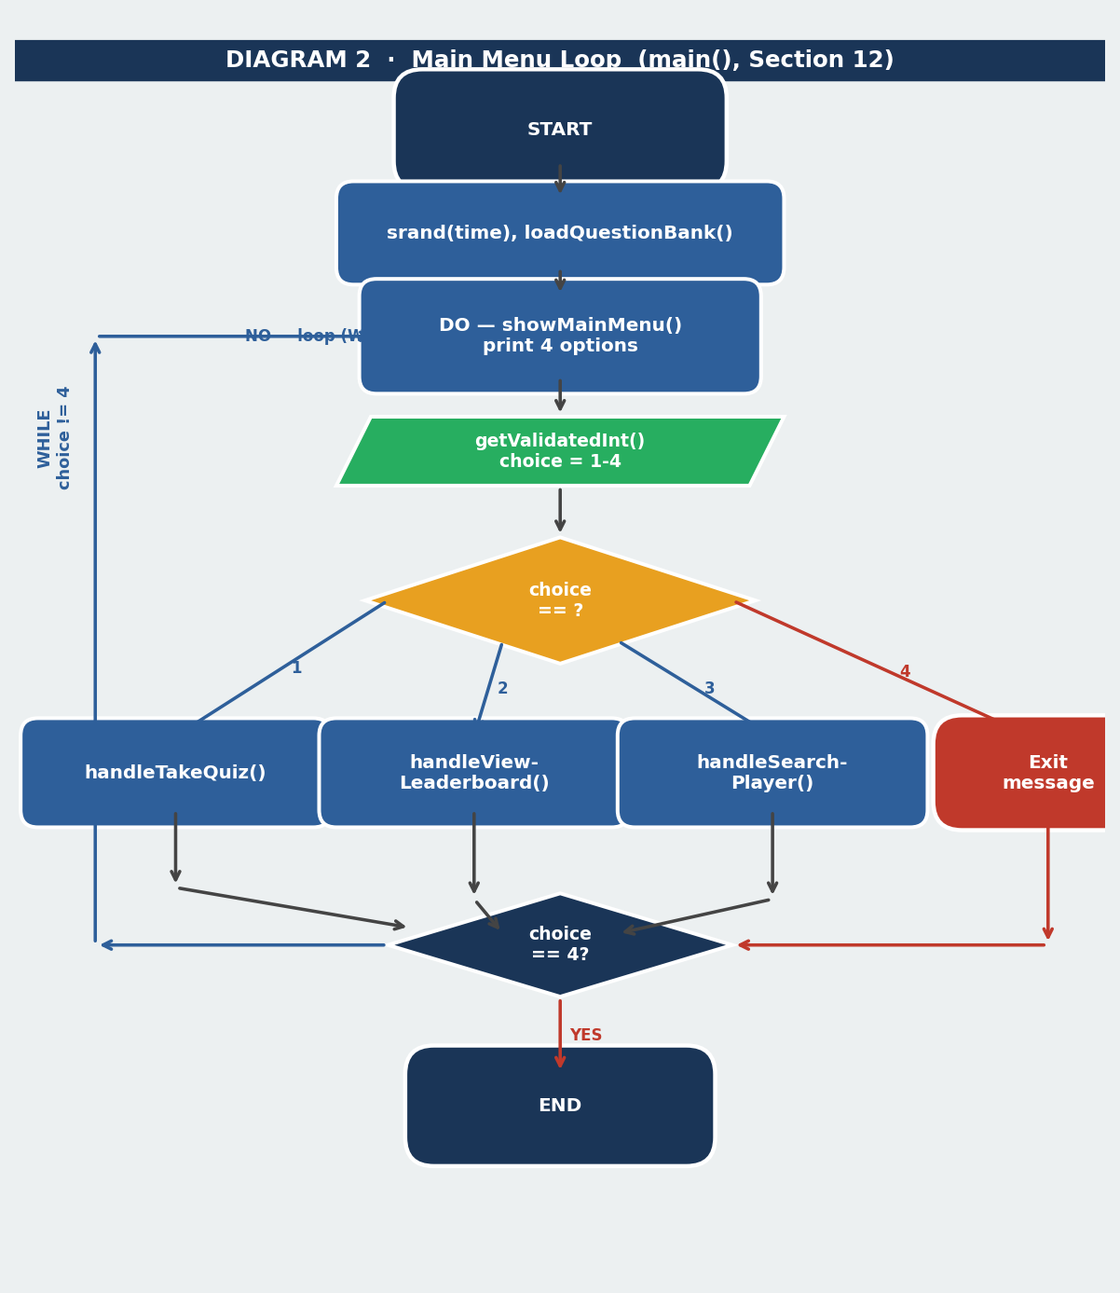
Figure 2.1 — DO-WHILE menu loop showing all four branches and the exit condition

3. "Take Quiz" Complete Flow — handleTakeQuiz()
This is the most complex path in the program. It spans five modules: Registration (Sec. 6), Quiz Engine (Sec. 8), Scoring (Sec. 7), Result Generator (Sec. 9), and Ranking/Sorting (Sec. 10). The diagram shows every step from the duplicate-ID check at the top to the leaderboard report saved at the bottom.

Key design decision shown here: the score is recomputed from the formula (correct × 1.00) − (wrong × 0.25) once at the END of the session, not trusted from the running accumulator which was clamped to 0 mid-quiz for display purposes. This guarantees the stored score always matches the formula printed in the result file.

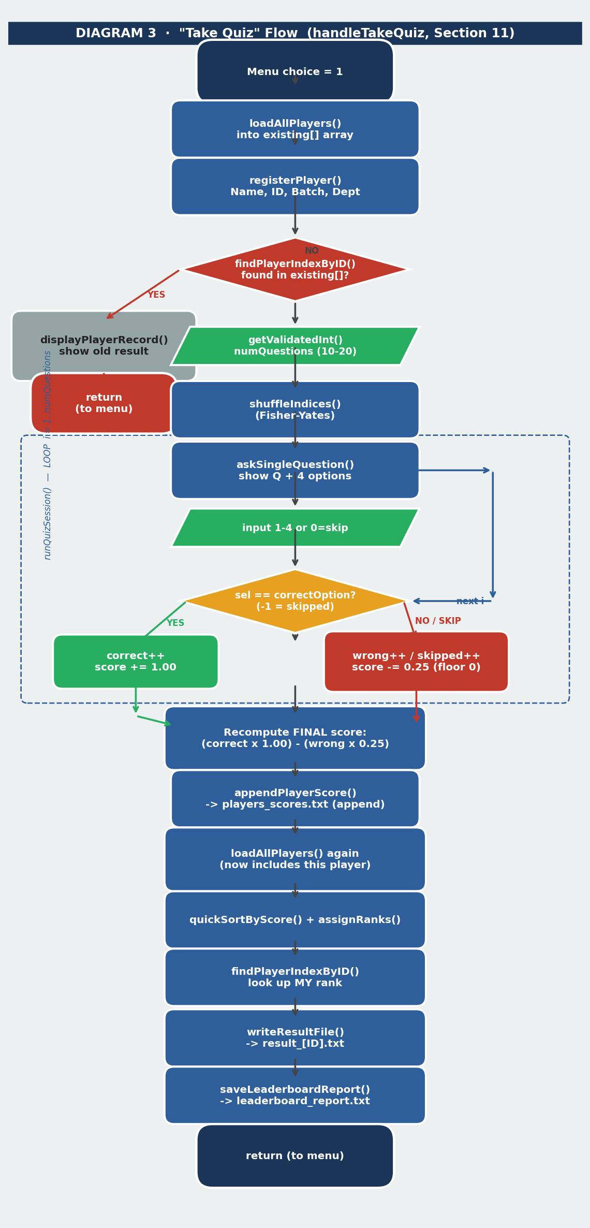
Figure 3.1 — Full handleTakeQuiz() flow from duplicate check to leaderboard save

4. Data Structures — All Three C Structs
The project uses three structs defined in Section 1. struct Player holds all information about a quiz-taker — note that the rank field is NOT saved to file because it changes whenever a new player joins; it is recomputed every time by assignRanks(). struct Question holds one MCQ entry. struct AnswerRecord stores only an index and a selection per question — the actual text is looked up from the bank when needed, keeping a single source of truth.

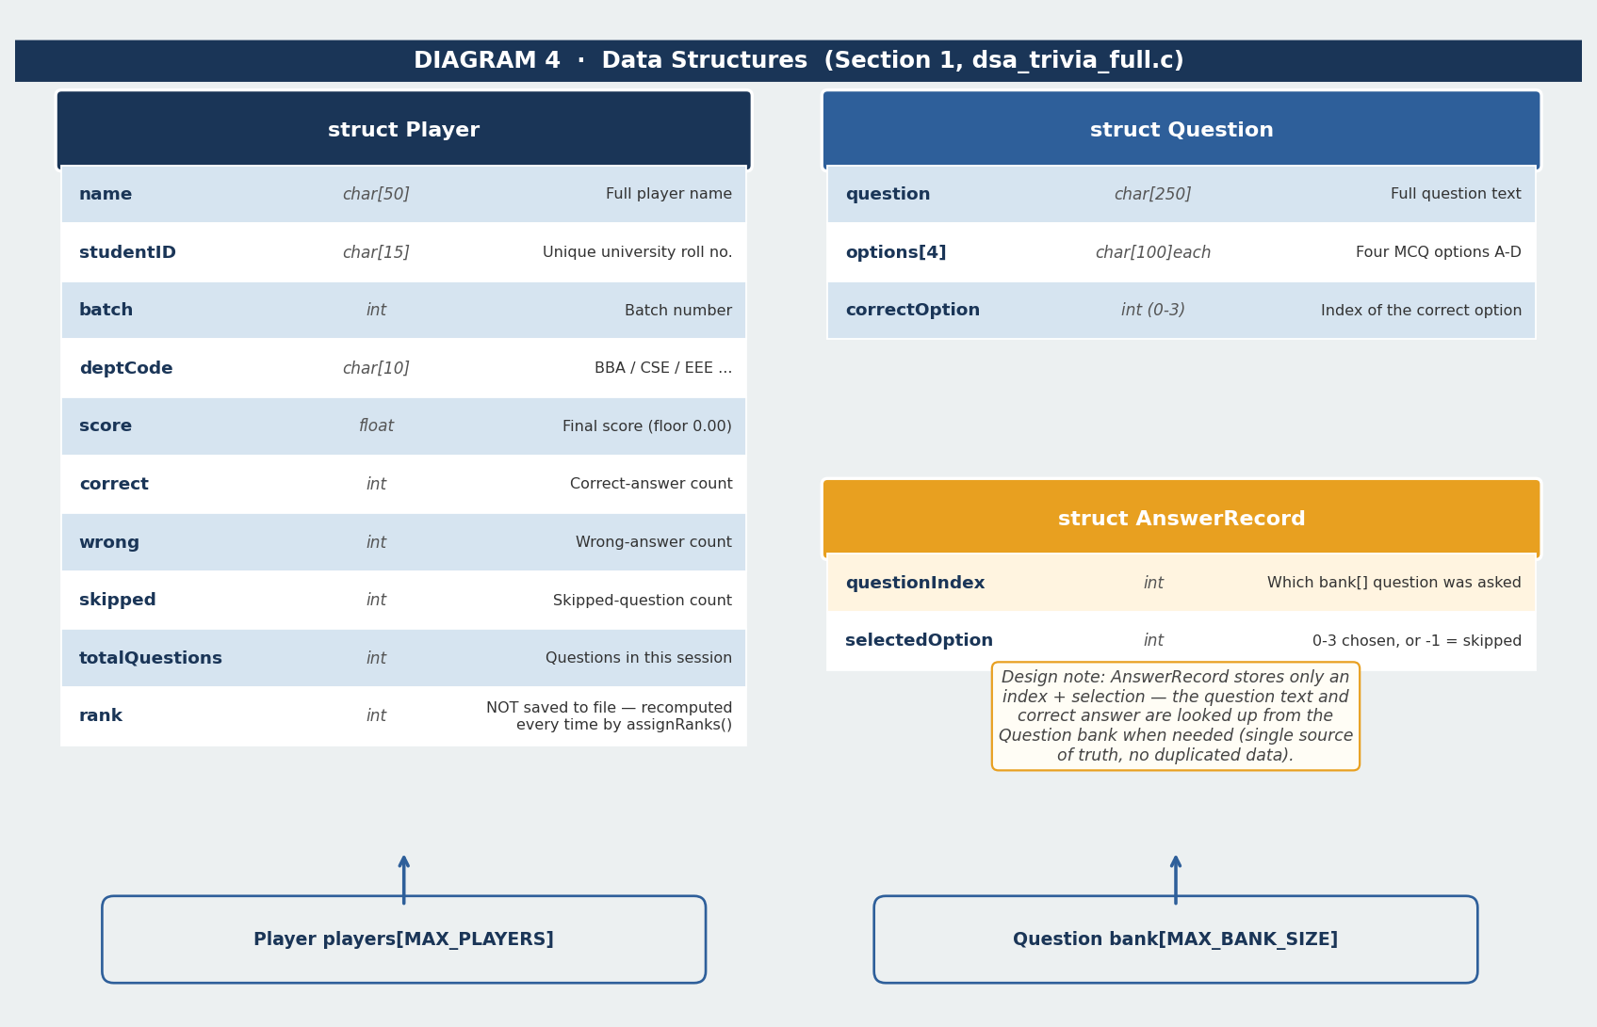
Figure 4.1 — struct Player (10 fields), struct Question (3 fields), struct AnswerRecord (2 fields)

5. Sorting Algorithm Flowcharts
Two sorting algorithms are implemented from scratch in Section 10, both sorting the Player array in descending order of score. Quick Sort is the primary algorithm used after every quiz session. Bubble Sort is the secondary option offered in the leaderboard menu — specifically so the user can pick either one and compare the real execution time (measured with clock()) on live data.

Bubble Sort Optimisation
The Bubble Sort implementation includes a swapped flag. If a full inner-loop pass completes without any swaps, the array is already sorted and the outer loop exits early. This makes the best case O(n) instead of always O(n²).

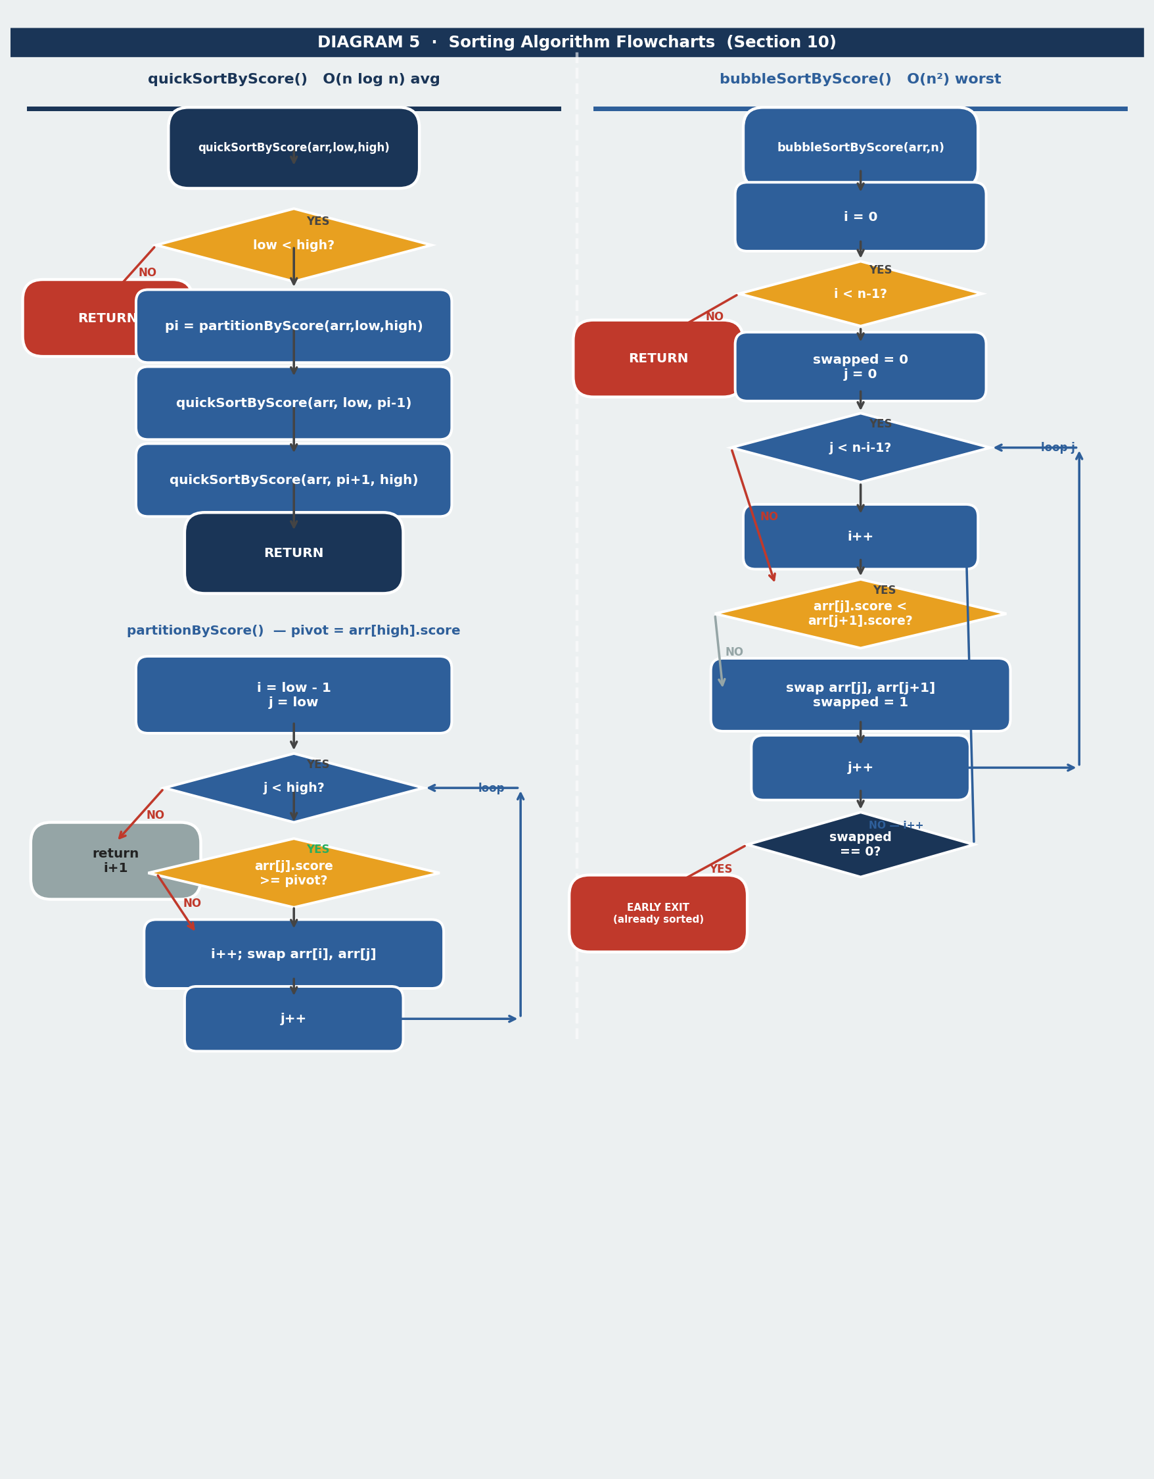
Figure 5.1 — quickSortByScore() with partitionByScore() (left) and bubbleSortByScore() with early-exit flag (right)

6. File I/O Diagram — Three Output Files
The program creates and manages three text files, each with a different write strategy. Understanding this distinction is important for the viva:
players_scores.txt — append-only log. One pipe-delimited line added per quiz session. Never rewritten or reordered on disk. Sorted in memory each time the leaderboard is needed.
result_[StudentID].txt — individual result file. Created fresh (overwritten) each time the same player retakes the quiz. Contains every question, the player's answer, and the score formula.
leaderboard_report.txt — human-readable snapshot. Overwritten each time the leaderboard is viewed or a quiz session ends. Always reflects the current sorted state.

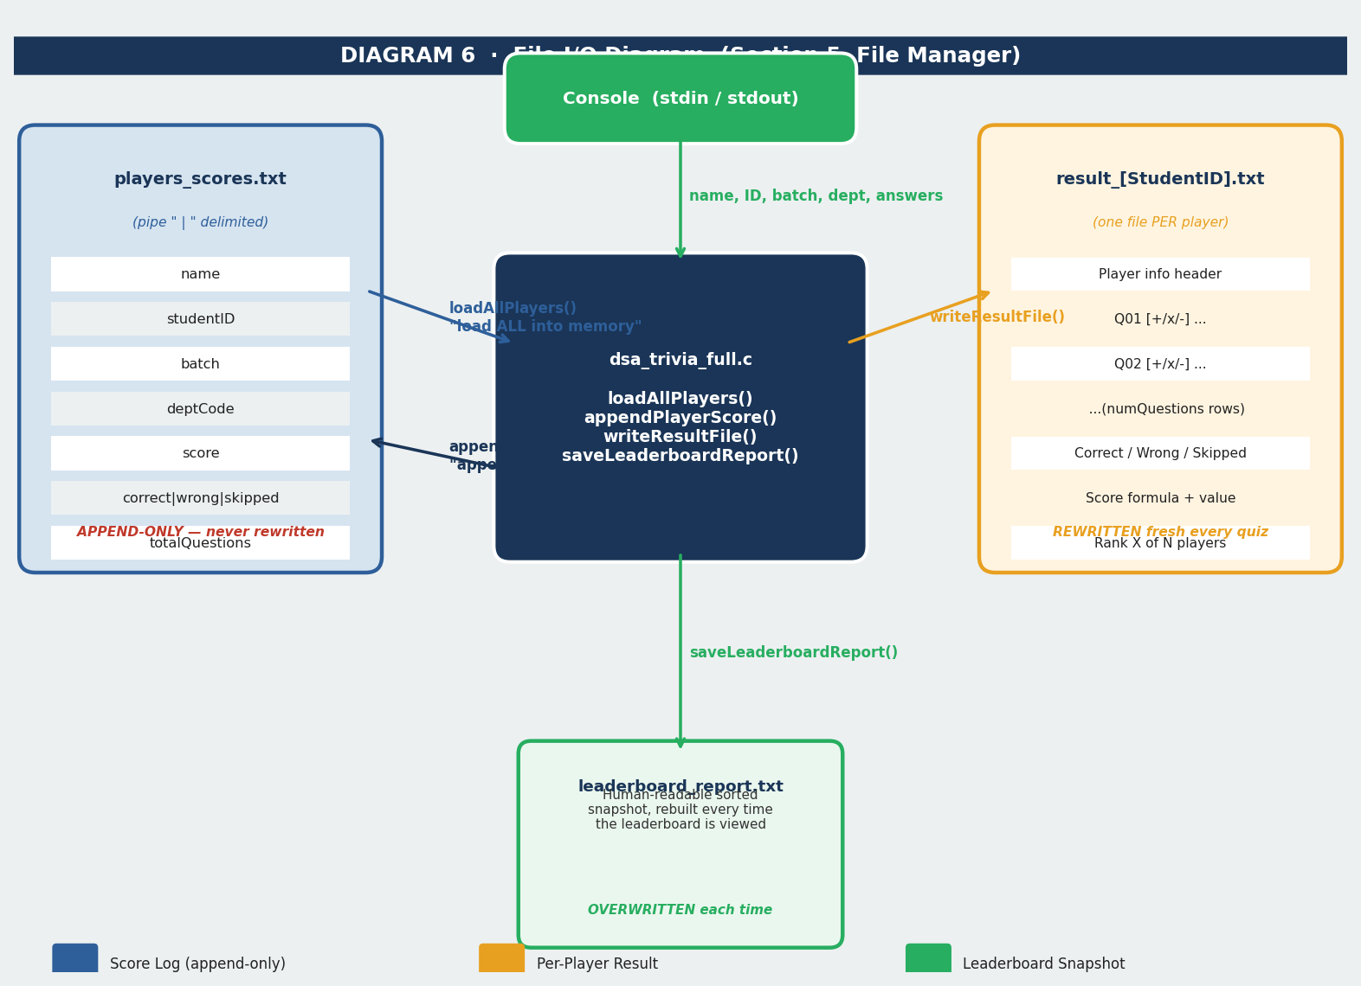
Figure 6.1 — File I/O strategy: append-only score log, per-player result, overwritten leaderboard snapshot

7. Function Reference Table
Every function in dsa_trivia_full.c is listed below with its section, module, purpose, and the DSA concept it demonstrates (if any). Use this table during the viva to locate any function quickly.

Function Name | Section | Module | Purpose / DSA Concept
clearInputBuffer() | Sec. 3 | Utility | Flushes leftover stdin chars after scanf()
pauseScreen() | Sec. 3 | Utility | Waits for ENTER before clearing screen
printDivider() | Sec. 3 | Utility | Prints a line of repeated characters
printBanner() | Sec. 3 | Utility | Prints a titled section header
getValidatedInt() | Sec. 3 | Utility | Input validation loop — safe integer read
findPlayerIndexByID() | Sec. 3 | Utility | LINEAR SEARCH O(n) — find player by ID
loadQuestionBank() | Sec. 4 | Question Bank | Fills the Question bank[] array
loadAllPlayers() | Sec. 5 | File Manager | Reads all records from players_scores.txt
appendPlayerScore() | Sec. 5 | File Manager | Appends one new record to scores file
registerPlayer() | Sec. 6 | Registration | Collects Name/ID/Batch/Dept from user
displayPlayerRecord() | Sec. 6 | Registration | Shows one player's saved result + rank
applyAnswerResult() | Sec. 7 | Scoring | Applies +1.00 / -0.25 / 0 marking rule
shuffleIndices() | Sec. 8 | Quiz Engine | FISHER-YATES SHUFFLE O(n) — randomise Qs
askSingleQuestion() | Sec. 8 | Quiz Engine | Displays one Q and reads validated answer
runQuizSession() | Sec. 8 | Quiz Engine | Full question loop for one player session
writeResultFile() | Sec. 9 | Result Generator | Writes result_[ID].txt with full Q&A log
printResultSummary() | Sec. 9 | Result Generator | Prints short result to console after quiz
bubbleSortByScore() | Sec. 10 | Ranking / Sorting | BUBBLE SORT O(n²) — sort by score desc
partitionByScore() | Sec. 10 | Ranking / Sorting | Quick Sort partition helper
quickSortByScore() | Sec. 10 | Ranking / Sorting | QUICK SORT O(n log n) — primary sort
assignRanks() | Sec. 10 | Ranking / Sorting | Stamps rank field after sort
displayLeaderboard() | Sec. 10 | Ranking / Sorting | Prints leaderboard table to console
saveLeaderboardReport() | Sec. 10 | Ranking / Sorting | Writes leaderboard_report.txt
showMainMenu() | Sec. 11 | Menu Handlers | Clears screen, prints 4 menu options
handleTakeQuiz() | Sec. 11 | Menu Handlers | Full quiz flow for one new player
handleViewLeaderboard() | Sec. 11 | Menu Handlers | Sort picker + timed leaderboard display
handleSearchPlayer() | Sec. 11 | Menu Handlers | Search any player by Student ID
main() | Sec. 12 | Entry Point | srand, loadBank, DO-WHILE menu loop

8. DSA Concepts Summary
The table below maps every Data Structure and Algorithm concept used in the project to its specific function, practical use case, and complexity — ready for viva reference.

DSA Concept | Function(s) | What It Does in the Project | Time | Space
Struct + Array | Player[], Question[]  AnswerRecord[] | Stores all player data, quiz questions,  and per-session answer logs in memory | O(1) access | O(n)
Linear Search | findPlayerIndexByID() | Scans players_scores.txt records to  detect a duplicate Student ID before quiz | O(n) | O(1)
Fisher-Yates  Shuffle | shuffleIndices() | Randomises question order each session  so players get different question sequences | O(n) | O(1)
Bubble Sort | bubbleSortByScore() | Secondary sort for leaderboard — shows  O(n²) vs Quick Sort speed comparison | O(n²) worst  O(n) best | O(1)
Quick Sort  (Divide & Conquer) | quickSortByScore()  partitionByScore() | Primary leaderboard sort — faster on  large datasets, timed with clock() | O(n log n) avg  O(n²) worst | O(log n)
File I/O | loadAllPlayers()  appendPlayerScore()  writeResultFile()  saveLeaderboardReport() | Persistent storage: append-only score log,  per-player result file, sorted snapshot | O(n) r/w | O(1)

Prepared by Group [Group Number] | East West University | August 2026

