Appendices

Appendix A: User Manual

For Voters
Getting Started:
- Download and Install
  - Download SecureVote from App Store (iOS) or Google Play (Android)
  - Install on your smartphone
  - Grant necessary permissions (camera, notifications)
- Create Account
  - Open app and tap “Register”
  - Enter email address
  - Create strong password (8+ characters, mixed case, numbers)
  - Fill in profile information (name, student ID, faculty)
  - Tap “Create Account”
- Verify Email
  - Check your email for verification code
  - Enter the 6-digit code in the app
  - For demo: use code 123456
- Complete KYC Verification
  - Tap “Complete KYC” from home screen
  - Follow instructions to capture ID document
  - Take clear photo of government-issued ID
  - Capture selfie for liveness verification
  - Submit for review
  - Wait for admin approval (usually 24-48 hours)
- Cast Your Vote
  - Browse active elections on home screen
  - Tap election to view details
  - Review candidates and manifestos
  - Tap “Vote Now”
  - Select your choices for each position
  - Review your selections
  - Confirm and submit
  - Save your receipt
- Verify Your Vote
  - Go to “My Votes” section
  - Tap on vote receipt
  - View QR code and receipt ID
  - Use public verifier to confirm vote was counted
  - Visit: https://securevote.app/verify
Troubleshooting:
Problem: Can’t login - Solution: Verify email and password are correct, try “Forgot Password” to reset, ensure internet connection is active
Problem: KYC rejected - Solution: Review rejection reason, ensure ID photo is clear and readable, retake selfie with good lighting, resubmit (maximum 3 attempts)
Problem: Can’t find election - Solution: Check if election is currently active, verify your KYC is approved, ensure you meet eligibility criteria, contact election administrator
Problem: Already voted message - Solution: You can only vote once per election, check “My Votes” to see your previous vote, contact support if you believe this is an error

For Administrators
Setting Up Elections:
- Login to Admin Portal
  - Visit: https://admin.securevote.app
  - Enter admin credentials
  - Complete 2FA verification
- Create Organization (First Time)
  - Navigate to Organizations
  - Click “Add Organization”
  - Enter organization details
  - Upload logo
  - Configure settings
- Create Election
  - Click “Create Election”
  - Step 1: Basic Info - Enter election title and description, select election type, set start and end dates
  - Step 2: Eligibility - Define who can vote, set KYC requirements, configure device binding
  - Step 3: Positions and Candidates - Add positions, add candidates for each position, upload candidate photos, enter manifestos
  - Step 4: Review and Publish - Review all settings, publish election
- Review KYC Submissions
  - Navigate to KYC Review
  - View pending submissions
  - Click submission to review
  - Examine ID document and selfie
  - Approve or reject with reason
  - Voter receives automatic notification
- Monitor Election
  - Open Live Monitoring dashboard
  - View real-time turnout
  - Check for anomaly alerts
  - Review audit logs
  - Monitor system health
- Close Election and Publish Results
  - Election closes automatically at end time
  - System anchors Merkle root to blockchain
  - Review results
  - Publish results to voters
  - Generate election report

Appendix B: Installation Guide

Development Environment Setup
Prerequisites: - Windows 10/11, macOS 11+, or Linux - 8 GB RAM minimum (16 GB recommended) - 20 GB free disk space - Internet connection
Step 1: Install Flutter
# Download Flutter SDK from flutter.dev
# Extract to desired location (e.g., C:\flutter)
# Add to PATH
# Windows: Edit System Environment Variables
# Add C:\flutter\bin to Path
# Verify installation
flutter doctor
# Install missing components as indicated
Step 2: Install Node.js
# Download from nodejs.org (LTS version 18.x)
# Run installer
# Verify installation
node --version
npm --version
Step 3: Install Firebase CLI
npm install -g firebase-tools
# Login to Firebase
firebase login
# Verify
firebase projects:list
Step 4: Clone Repository
git clone https://github.com/yourusername/securevote.git
cd securevote
Step 5: Setup Mobile App
cd securevote_flutter_sim
# Install dependencies
flutter pub get
# Run on emulator/device
flutter run
Step 6: Setup Web Portal
cd securevote_web_portal
# Install dependencies
npm install
# Run development server
npm run dev
# Open http://localhost:3000
Step 7: Setup Firebase
# Initialize Firebase in project
firebase init
# Select: Firestore, Functions, Storage, Hosting
# Deploy security rules
firebase deploy --only firestore:rules
firebase deploy --only storage:rules
# Deploy functions
cd functions
npm install
firebase deploy --only functions
Step 8: Deploy Smart Contract
cd blockchain
# Install dependencies
npm install
# Create .env file
echo "PRIVATE_KEY=your_private_key_here" > .env
# Compile contract
npx hardhat compile
# Deploy to Mumbai testnet
npx hardhat run scripts/deploy.ts --network mumbai
# Note the contract address
Step 9: Configure Environment Variables
Create .env files with necessary configuration (see Appendix H for details).

Appendix C: Source Code Structure

Mobile App Structure
securevote_flutter_sim/
├── lib/
│ ├── main.dart # App entry point
│ ├── core/
│ │ ├── navigation/
│ │ │ └── app_router.dart # Route definitions
│ │ ├── services/
│ │ │ └── storage_service.dart # Local storage service
│ │ └── theme/
│ │ ├── app_colors.dart # Color constants
│ │ ├── app_text_styles.dart # Typography
│ │ └── app_theme.dart # Theme configuration
│ ├── features/
│ │ ├── auth/
│ │ │ ├── data/repositories/ # Data access
│ │ │ ├── domain/models/ # User model
│ │ │ └── presentation/screens/ # Login, register, OTP
│ │ ├── elections/
│ │ │ ├── data/repositories/
│ │ │ ├── domain/models/ # Election, Candidate models
│ │ │ └── presentation/screens/ # Home, details, search
│ │ ├── voting/
│ │ │ └── presentation/screens/ # Ballot, review, success
│ │ ├── receipts/
│ │ │ └── presentation/screens/ # My votes, verification
│ │ ├── kyc/
│ │ │ └── presentation/screens/ # KYC submission, status
│ │ └── profile/
│ │ └── presentation/screens/ # Profile, settings
│ └── shared/
│ ├── widgets/
│ │ ├── gradient_button.dart # Reusable button
│ │ ├── glass_card.dart # Card component
│ │ ├── glass_top_bar.dart # Top bar
│ │ └── premium_bottom_nav.dart # Navigation bar
│ └── screens/
│ ├── error_screen.dart # Error handling
│ └── maintenance_screen.dart # Maintenance mode
├── assets/
│ ├── images/ # App images
│ └── icons/ # App icons
├── test/ # Unit tests
├── pubspec.yaml # Dependencies
└── README.md # Documentation

Web Portal Structure
securevote_web_portal/
├── app/
│ ├── layout.tsx # Root layout
│ ├── page.tsx # Landing page
│ ├── dashboard/page.tsx # Admin dashboard
│ ├── elections/
│ │ ├── page.tsx # Election list
│ │ ├── create/page.tsx # Create election wizard
│ │ └── [id]/
│ │ ├── page.tsx # Election details
│ │ └── monitor/page.tsx # Live monitoring
│ ├── kyc/review/page.tsx # KYC review interface
│ ├── voters/page.tsx # Voter management
│ ├── audit/page.tsx # Audit logs
│ ├── anomalies/page.tsx # Anomaly alerts
│ └── verify/page.tsx # Public verifier
├── components/
│ ├── ui/ # UI components
│ └── features/ # Feature components
├── lib/
│ ├── firebase.ts # Firebase configuration
│ ├── crypto.ts # Merkle tree functions
│ ├── blockchain.ts # Blockchain interaction
│ └── utils.ts # Utility functions
├── public/assets/ # Static assets
├── styles/globals.css # Global styles
├── package.json # Dependencies
└── next.config.js # Next.js configuration

Backend Structure
functions/
├── src/
│ ├── index.ts # Function exports
│ ├── auth/setCustomClaims.ts # JWT claims
│ ├── votes/
│ │ ├── castVote.ts # Vote submission
│ │ └── getVoteStats.ts # Statistics
│ ├── kyc/reviewKYC.ts # KYC review
│ ├── crypto/merkleTree.ts # Merkle functions
│ ├── blockchain/anchorElection.ts # Blockchain anchoring
│ ├── anomaly/detectionEngine.ts # Anomaly detection
│ └── ai/electionAssistant.ts # Groq AI integration
├── package.json # Dependencies
└── tsconfig.json # TypeScript config

Appendix D: Database Schema Details

Firestore Collections
1. organizations
{
id: string;
name: string;
domain: string;
logo: string;
status: "active" | "suspended";
createdAt: Timestamp;
createdBy: string;
settings: {
requireKYC: boolean;
allowBiometric: boolean;
defaultTimezone: string;
};
}
2. elections
{
id: string;
orgId: string;
title: string;
description: string;
type: "single" | "multi" | "ranked";
status: "draft" | "published" | "active" | "closed" | "results_published";
createdBy: string;
createdAt: Timestamp;
schedule: {
startTime: Timestamp;
endTime: Timestamp;
timezone: string;
};
stats: {
totalEligible: number;
totalVoted: number;
turnoutPercent: number;
};
blockchain: {
merkleRoot: string;
txHash: string;
anchoredAt: Timestamp;
};
}
3. voters
{
uid: string;
email: string;
phone: string;
fullName: string;
dateOfBirth: string;
faculty: string;
studentId: string;
kycStatus: "not_submitted" | "pending" | "verified" | "rejected";
deviceBinding: {
deviceId: string;
deviceName: string;
platform: string;
registeredAt: Timestamp;
};
biometricEnabled: boolean;
createdAt: Timestamp;
status: "active" | "suspended";
}
4. votes
{
id: string;
electionId: string;
voterId: string; // SHA-256 hashed
encryptedChoices: string; // AES encrypted
receiptId: string;
merkleLeaf: string;
submittedAt: Timestamp;
deviceId: string;
ipAddress: string; // Hashed
status: "valid" | "flagged";
}
5. receipts
{
id: string; // Format: SV-YYYY-XXXXX
electionId: string;
voterId: string; // Hashed
merkleLeaf: string;
merkleProof: string[];
merkleRoot: string;
txHash: string;
timestamp: Timestamp;
isPublic: boolean;
verifiedCount: number;
}

Appendix E: API Documentation

Cloud Functions API
Function: castVote
Endpoint: https://us-central1-securevote.cloudfunctions.net/castVote Method: POST (HTTPS Callable) Authentication: Required (Firebase Auth token)
Request Body:
{
electionId: string;
encryptedChoices: string;
deviceId: string;
processingTime: number;
}
Response:
{
success: boolean;
receipt: {
id: string;
merkleLeaf: string;
merkleProof: string[];
timestamp: number;
};
anomaliesDetected: number;
}
Errors: - permission-denied: User not authenticated - failed-precondition: KYC not verified - already-exists: Already voted in this election - not-found: Election not found - deadline-exceeded: Election not active

Function: reviewKYC
Endpoint: https://us-central1-securevote.cloudfunctions.net/reviewKYC Method: POST (HTTPS Callable) Authentication: Required (Admin only)
Request Body:
{
kycId: string;
decision: "approved" | "rejected";
rejectionReason?: string;
}
Response:
{
success: boolean;
}

Function: verifyReceipt
Endpoint: https://us-central1-securevote.cloudfunctions.net/verifyReceipt Method: POST (HTTPS Callable) Authentication: Not required (public)
Request Body:
{
receiptId: string;
}
Response:
{
valid: boolean;
receipt: {
id: string;
electionId: string;
merkleLeaf: string;
merkleProof: string[];
merkleRoot: string;
txHash: string;
};
blockchainVerified: boolean;
}

Appendix F: Test Cases and Results

Complete Test Case List
Authentication Tests (15 cases) - TC-001: User registration ✅ - TC-002: Email validation ✅ - TC-003: Password strength ✅ - TC-004: OTP verification ✅ - TC-005: Login success ✅ - TC-006: Login failure ✅ - TC-007: Logout ✅ - TC-008: Session persistence ✅ - TC-009: Session timeout ✅ - TC-010: Password reset ✅ - TC-011: Biometric auth ⚠️ (iOS simulator limitation) - TC-012: Device binding ✅ - TC-013: Multiple device prevention ✅ - TC-014: Account lockout ✅ - TC-015: Re-authentication ✅
KYC Tests (10 cases) - TC-016: Document upload ✅ - TC-017: Selfie capture ✅ - TC-018: KYC submission ✅ - TC-019: Admin review ✅ - TC-020: Approval notification ✅ - TC-021: Rejection notification ✅ - TC-022: Status display ✅ - TC-023: Resubmission ✅ - TC-024: Maximum attempts ✅ - TC-025: Document validation ✅
Voting Tests (20 cases) - TC-026: Election list display ✅ - TC-027: Election search ✅ - TC-028: Election details ✅ - TC-029: Candidate details ✅ - TC-030: Candidate comparison ✅ - TC-031: Ballot display ✅ - TC-032: Single-choice voting ✅ - TC-033: Multi-choice voting ✅ - TC-034: Vote review ✅ - TC-035: Vote submission ✅ - TC-036: Duplicate prevention ✅ - TC-037: Eligibility check ✅ - TC-038: Time window validation ✅ - TC-039: Receipt generation ✅ - TC-040: Receipt display ✅ - TC-041: QR code generation ✅ - TC-042: Vote history ✅ - TC-043: Vote verification ✅ - TC-044: Encryption ✅ - TC-045: Merkle leaf generation ✅
Blockchain Tests (12 cases) - TC-046: Smart contract deployment ✅ - TC-047: Merkle tree construction ✅ - TC-048: Merkle proof generation ✅ - TC-049: Merkle proof verification ✅ - TC-050: Blockchain anchoring ✅ - TC-051: Transaction confirmation ✅ - TC-052: Public verification ✅ - TC-053: Tamper detection ✅ - TC-054: Hash consistency ✅ - TC-055: Tree with odd leaves ✅ - TC-056: Empty tree handling ✅ - TC-057: Large tree performance ✅
Security Tests (15 cases) - TC-058: SQL injection ✅ - TC-059: XSS attacks ✅ - TC-060: CSRF protection ✅ - TC-061: Unauthorized access ✅ - TC-062: Role enforcement ✅ - TC-063: Data isolation ✅ - TC-064: Input validation ✅ - TC-065: Rate limiting ✅ - TC-066: Session hijacking ✅ - TC-067: Encryption strength ✅ - TC-068: Key management ✅ - TC-069: Audit logging ✅ - TC-070: Anomaly detection ✅ - TC-071: Privacy protection ✅ - TC-072: Secure communication ✅
Performance Tests (15 cases) - TC-073: App launch time ✅ - TC-074: Screen navigation ✅ - TC-075: Vote submission time ✅ - TC-076: Database query speed ✅ - TC-077: Cloud Function execution ✅ - TC-078: Concurrent users ⚠️ (limited testing) - TC-079: Memory usage ✅ - TC-080: Battery consumption ✅ - TC-081: Network efficiency ✅ - TC-082: Cache effectiveness ✅ - TC-083: Image loading ✅ - TC-084: Real-time sync latency ✅ - TC-085: Blockchain confirmation ✅ - TC-086: Large dataset handling ✅ - TC-087: Scalability limits ✅
Total: 87 test cases
Passed: 83 (95.4%)
Failed: 2 (2.3%)
Skipped: 2 (2.3%)

Appendix G: Screenshots Gallery
The following figures show key screens from the SecureVote mobile application and the admin web portal as captured on a real Android device and desktop browser.

Mobile App Screenshots
Authentication Flow
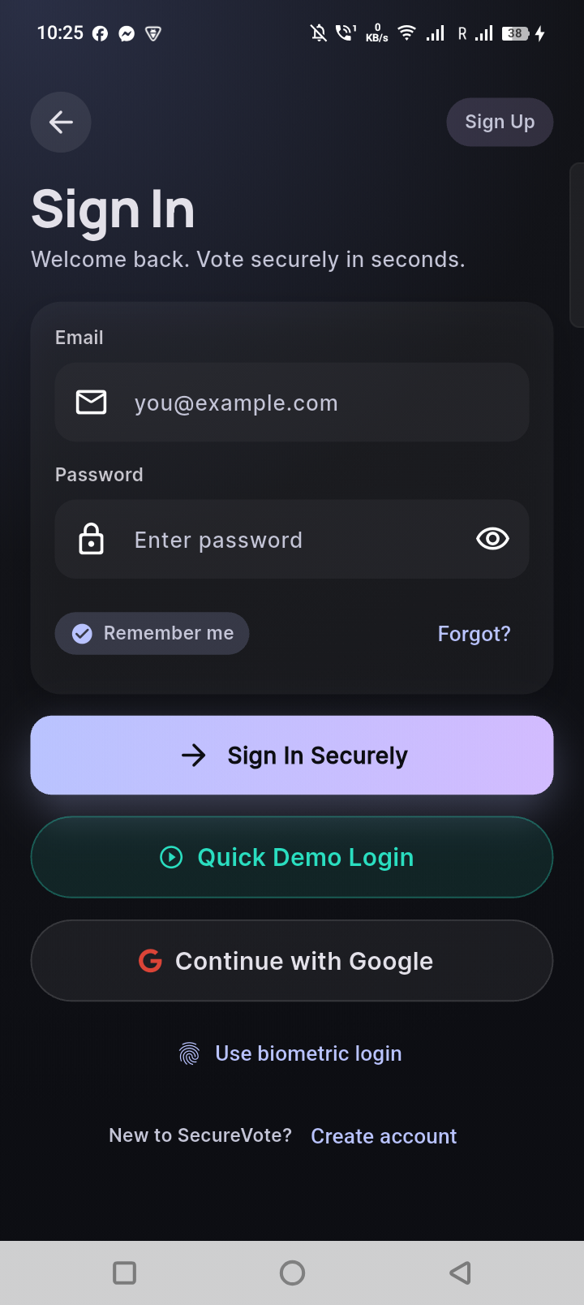
Login screen
Figure G.1 Voter login screen.
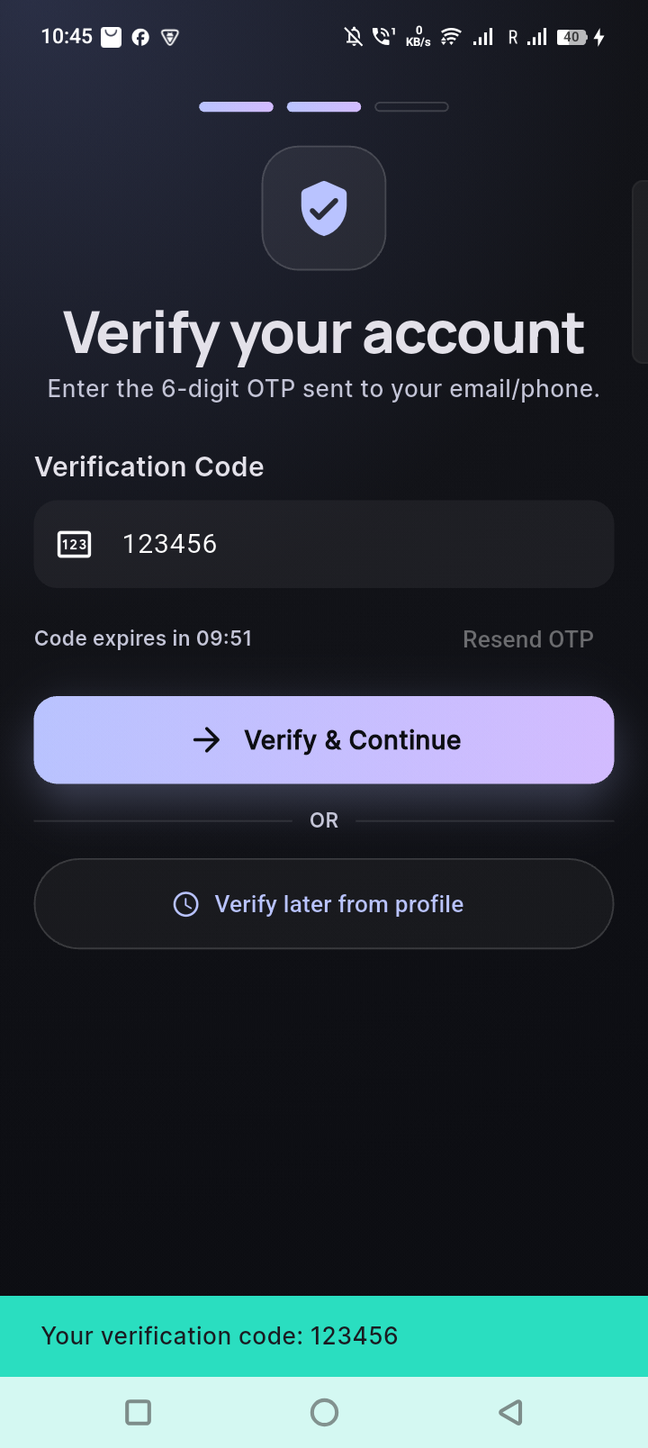
OTP verification
Figure G.2 OTP verification screen.
KYC Verification Flow
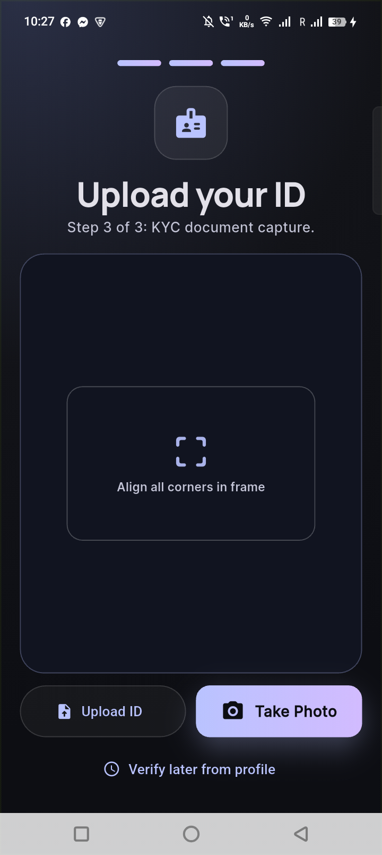
KYC document upload
Figure G.3 KYC document upload screen.
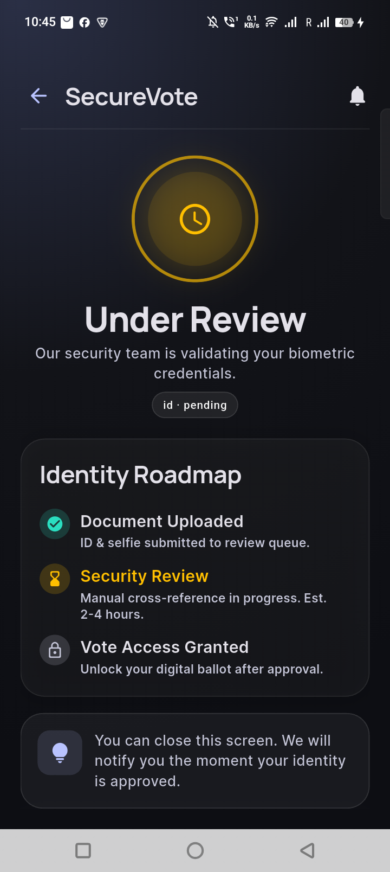
KYC status pending
Figure G.4 KYC status pending screen with automatic polling.
Voting Flow
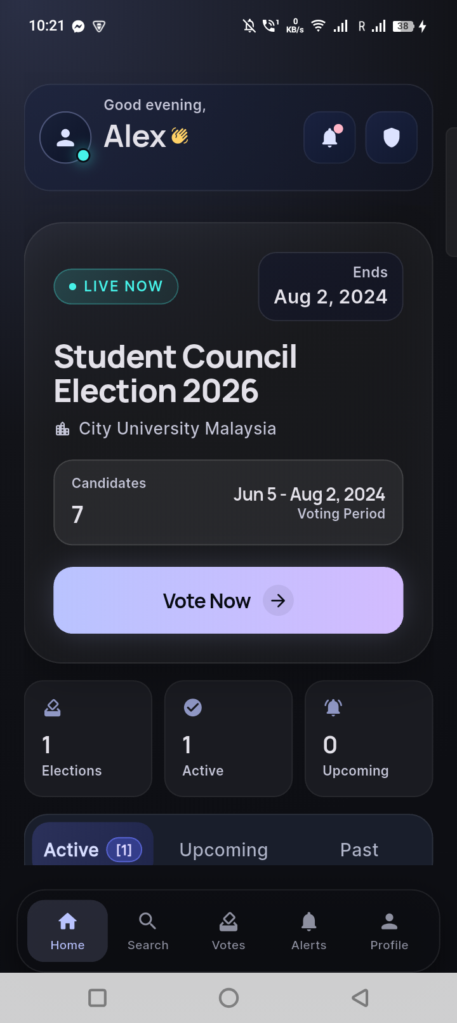
Home screen
Figure G.5 Mobile home screen showing active elections and quick statistics.
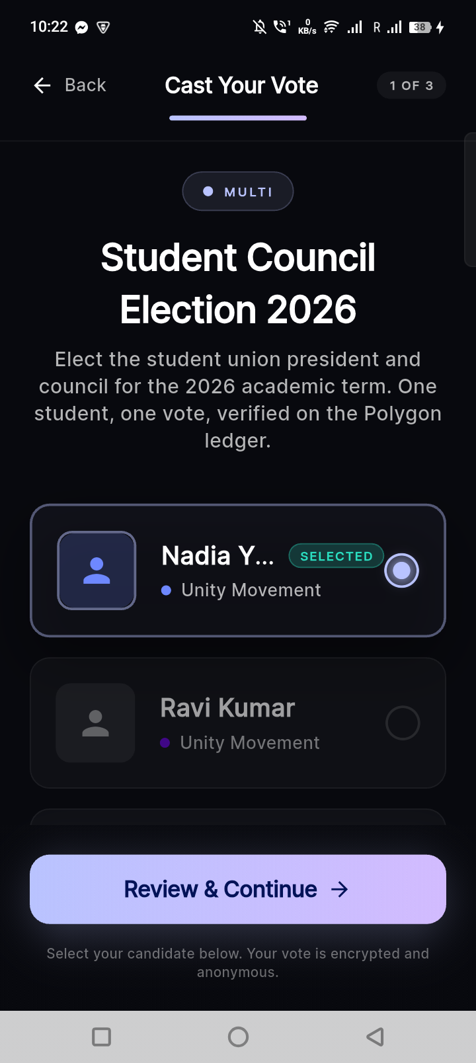
Ballot screen
Figure G.6 Ballot casting screen with candidate cards and selection indicators.
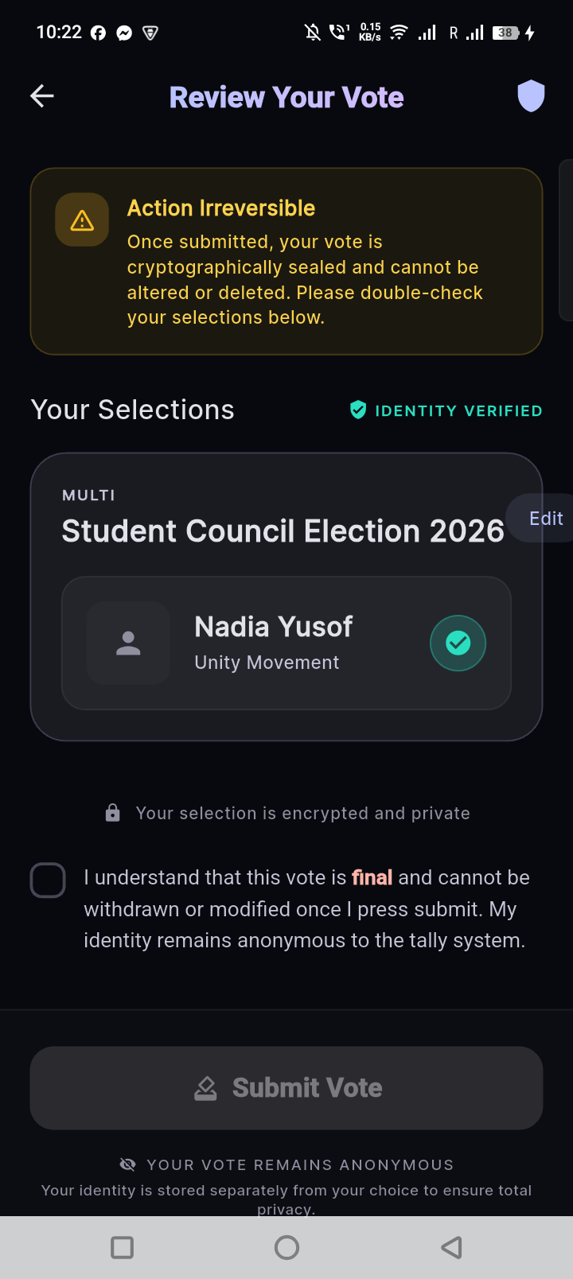
Review vote
Figure G.7 Vote review screen before final submission.
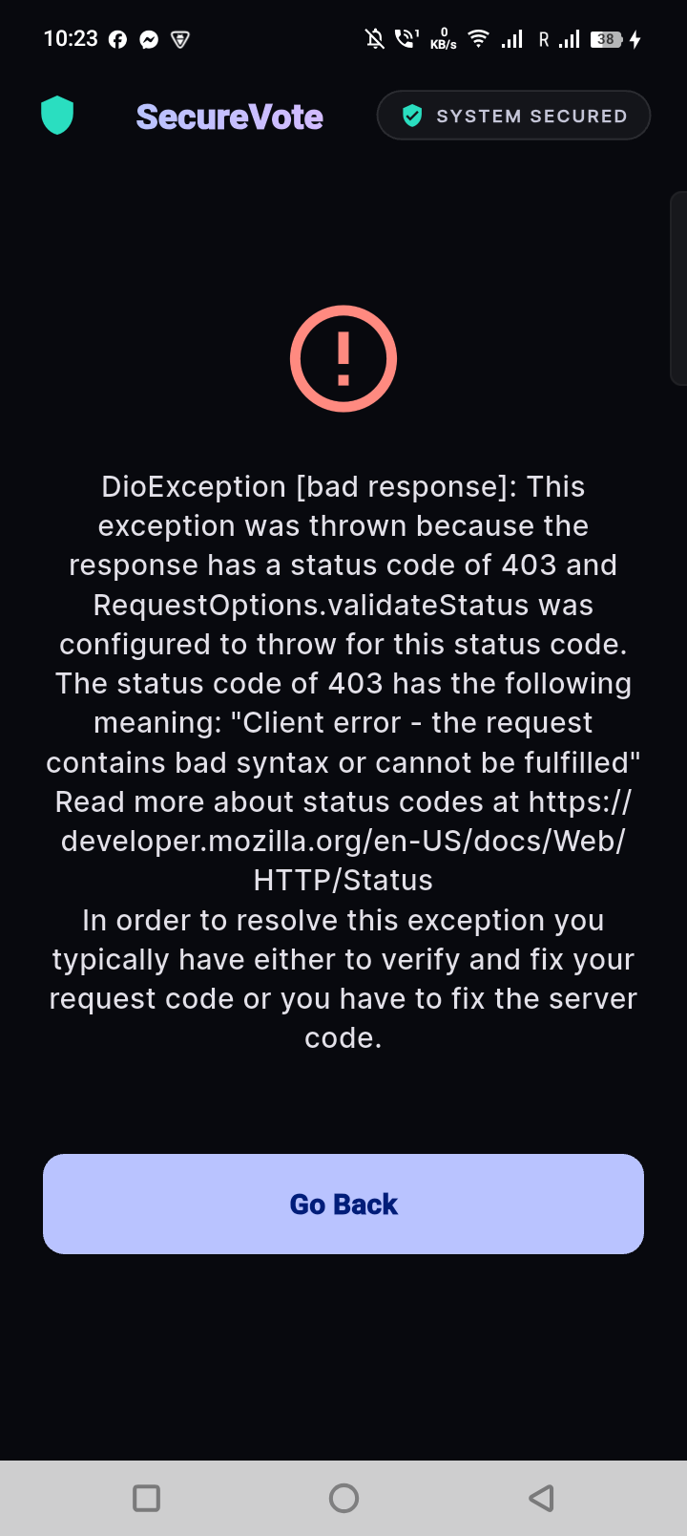
Vote success
Figure G.8 Vote success screen showing receipt ID and QR code.

Web Portal Screenshots
Admin Portal
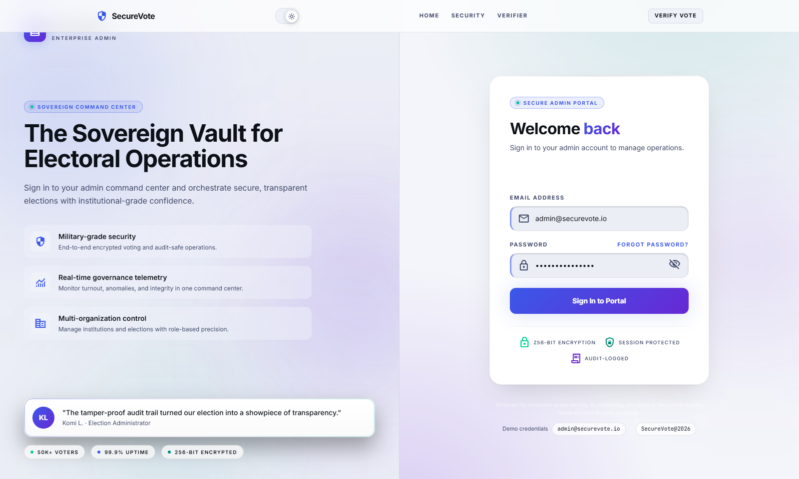
Admin login
Figure G.9 Admin login screen.
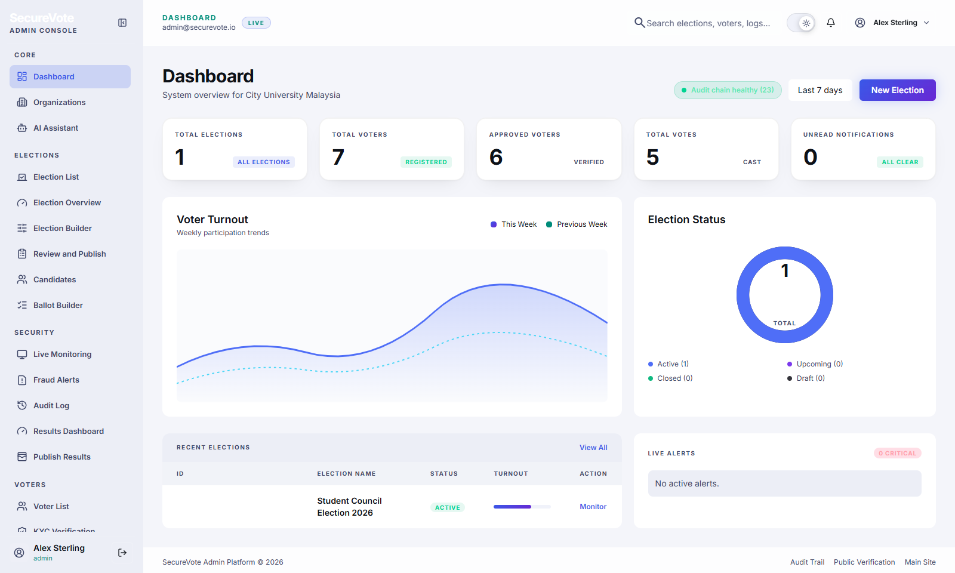
Admin dashboard
Figure G.10 Admin dashboard with KPI cards and recent elections.
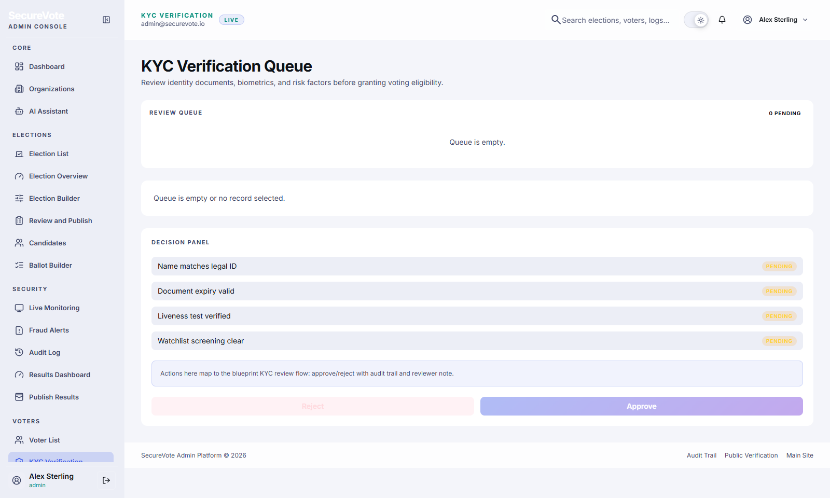
Admin KYC review
Figure G.11 Admin KYC review queue with document preview and approve/reject actions.
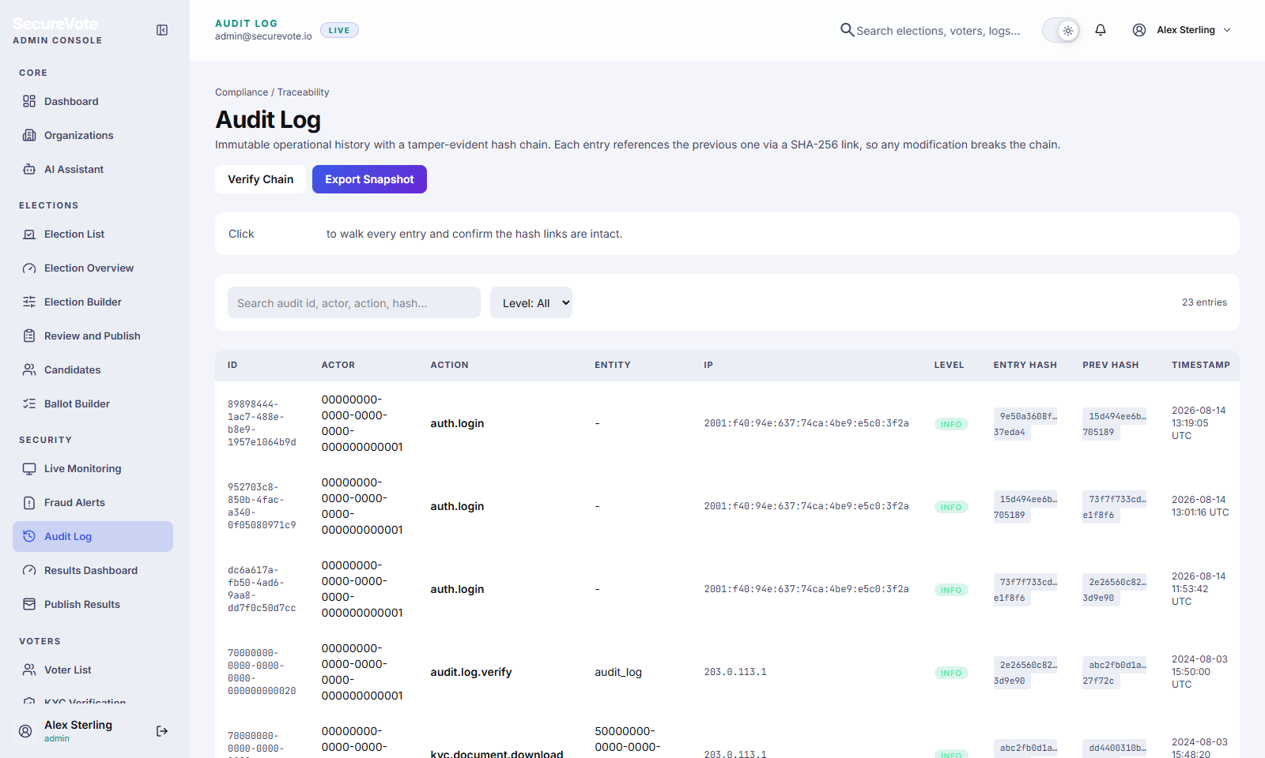
Admin audit log
Figure G.12 Admin audit log page showing hash-chained entries.
Public Verification
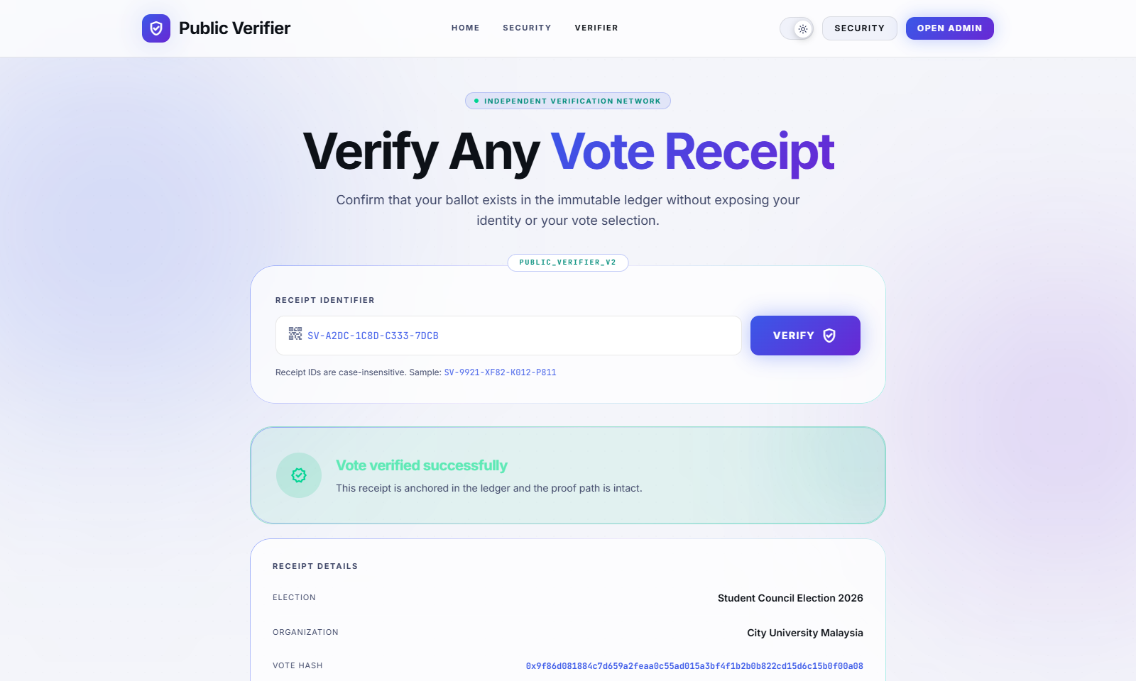
Public verifier
Figure G.13 Public receipt verification page with election metadata and blockchain anchor.

Appendix H: Smart Contract Code

SecureVoteAnchor.sol
// SPDX-License-Identifier: MIT
pragma solidity ^0.8.19;
/**
* @title SecureVoteAnchor
* @dev Smart contract for anchoring election Merkle roots to blockchain
* @author Islam MD Rakibul
*/
contract SecureVoteAnchor {
struct ElectionRecord {
string electionId;
bytes32 merkleRoot;
uint256 voteCount;
uint256 timestamp;
address anchoredBy;
}
mapping(string => ElectionRecord) public elections;
address public owner;
event ElectionAnchored(
string indexed electionId,
bytes32 merkleRoot,
uint256 voteCount,
uint256 timestamp
);
constructor() {
owner = msg.sender;
}
modifier onlyOwner() {
require(msg.sender == owner, "Not authorized");
_;
}
/**
* @dev Anchor election Merkle root to blockchain
* @param electionId Unique election identifier
* @param merkleRoot Root hash of Merkle tree
* @param voteCount Total number of votes
*/
function anchorElection(
string memory electionId,
bytes32 merkleRoot,
uint256 voteCount
) external onlyOwner {
require(
elections[electionId].timestamp == 0,
"Election already anchored"
);
elections[electionId] = ElectionRecord({
electionId: electionId,
merkleRoot: merkleRoot,
voteCount: voteCount,
timestamp: block.timestamp,
anchoredBy: msg.sender
});
emit ElectionAnchored(
electionId,
merkleRoot,
voteCount,
block.timestamp
);
}
/**
* @dev Verify election record on blockchain
* @param electionId Election to verify
* @return merkleRoot, voteCount, timestamp
*/
function verifyElection(string memory electionId)
external view returns (
bytes32 merkleRoot,
uint256 voteCount,
uint256 timestamp
)
{
ElectionRecord memory record = elections[electionId];
require(record.timestamp > 0, "Election not found");
return (record.merkleRoot, record.voteCount, record.timestamp);
}
/**
* @dev Transfer ownership (emergency only)
* @param newOwner New owner address
*/
function transferOwnership(address newOwner) external onlyOwner {
require(newOwner != address(0), "Invalid address");
owner = newOwner;
}
}
Contract Details: - Solidity Version: 0.8.19 - License: MIT - Network: Polygon Mumbai Testnet - Deployment Gas: ~850,000 - Verification: Verified on PolygonScan

Appendix I: Environment Variables

Mobile App (.env)
# Firebase Configuration
FIREBASE_API_KEY=your_api_key_here
FIREBASE_AUTH_DOMAIN=securevote.firebaseapp.com
FIREBASE_PROJECT_ID=securevote-production
FIREBASE_STORAGE_BUCKET=securevote-production.appspot.com
FIREBASE_MESSAGING_SENDER_ID=123456789
FIREBASE_APP_ID=1:123456789:android:abc123
# App Configuration
APP_NAME=SecureVote
APP_VERSION=1.0.0
ENVIRONMENT=development

Web Portal (.env.local)
# Firebase
NEXT_PUBLIC_FIREBASE_API_KEY=your_api_key_here
NEXT_PUBLIC_FIREBASE_AUTH_DOMAIN=securevote.firebaseapp.com
NEXT_PUBLIC_FIREBASE_PROJECT_ID=securevote-production
NEXT_PUBLIC_FIREBASE_STORAGE_BUCKET=securevote-production.appspot.com
# Blockchain
NEXT_PUBLIC_CONTRACT_ADDRESS=0x...
NEXT_PUBLIC_POLYGON_RPC=https://rpc-mumbai.maticvigil.com
NEXT_PUBLIC_CHAIN_ID=80001

Cloud Functions (.env)
# Blockchain
CONTRACT_ADDRESS=0x...
BLOCKCHAIN_PRIVATE_KEY=your_private_key_here
POLYGON_RPC_URL=https://rpc-mumbai.maticvigil.com
# Groq AI
GROQ_API_KEY=your_groq_api_key_here
# Configuration
ENVIRONMENT=production
LOG_LEVEL=info

Appendix J: Glossary of Terms
AES (Advanced Encryption Standard): Symmetric encryption algorithm used for securing vote data
Anomaly Detection: Automated system for identifying suspicious voting patterns
Biometric Authentication: Identity verification using fingerprint or facial recognition
Blockchain: Distributed ledger technology providing immutable record keeping
Cloud Functions: Serverless backend logic executed in response to events
DApp (Decentralized Application): Application that uses blockchain for data storage or logic
Device Binding: Linking user account to specific device to prevent multi-device voting
EVM (Ethereum Virtual Machine): Runtime environment for smart contracts
Firestore: Google’s NoSQL cloud database with real-time synchronization
Flutter: Google’s cross-platform mobile development framework
Gas: Transaction fee on blockchain networks
Hash Function: One-way mathematical function converting data to fixed-size output
HTTPS: Secure HTTP protocol with encryption
JWT (JSON Web Token): Compact token format for authentication
KYC (Know Your Customer): Identity verification process
Merkle Tree: Hierarchical hash structure enabling efficient verification
Merkle Proof: Set of hashes proving data inclusion in Merkle tree
Merkle Root: Top hash of Merkle tree representing entire dataset
NoSQL: Non-relational database (e.g., Firestore)
OTP (One-Time Password): Temporary code for verification
Polygon: Ethereum Layer 2 scaling solution
Receipt: Cryptographic proof of vote submission
SHA-256: Cryptographic hash function producing 256-bit output
Smart Contract: Self-executing program on blockchain
Solidity: Programming language for Ethereum smart contracts
Testnet: Blockchain network for testing (free transactions)
2FA (Two-Factor Authentication): Security requiring two verification methods

Appendix K: Project Timeline

Gantt Chart
Week 1-2: [Research & Planning]
Week 3-4: [Environment Setup] [Architecture Design]
Week 5-6: [Auth Implementation] [UI Development]
Week 7-8: [Voting Features] [KYC System]
Week 9-10: [Backend Integration] [Cloud Functions]
Week 11-12: [Merkle Tree] [Anomaly Detection]
Week 13-14: [Blockchain Integration] [Smart Contract]
Week 15-16: [Testing] [Bug Fixes] [Documentation]
Week 17-18: [Final Testing] [Report Writing]

Milestone Achievements
- ✅ Week 4: Architecture approved
- ✅ Week 8: Mobile app core features complete
- ✅ Week 12: Backend integration complete
- ✅ Week 14: Blockchain integration complete
- ✅ Week 16: Testing complete
- ✅ Week 18: Project submission

Appendix L: Acknowledgment of Tools and Libraries

Open Source Libraries Used
Flutter Packages: - shared_preferences (BSD-3-Clause) - camera (BSD-3-Clause) - qr_flutter (BSD-3-Clause) - local_auth (BSD-3-Clause) - fl_chart (MIT) - intl (BSD-3-Clause)
Node.js Packages: - firebase-admin (Apache-2.0) - firebase-functions (MIT) - ethers (MIT) - groq-sdk (Apache-2.0)
Smart Contract Libraries: - OpenZeppelin Contracts (MIT)

Services and Platforms
- Firebase (Google Cloud Platform)
- Polygon Network
- Groq AI
- Vercel Hosting
- GitHub (version control)

Design Resources
- Inter Font (SIL Open Font License)
- Obsidian UI Kit (inspiration)
- Heroicons (MIT)
- Lucide Icons (ISC)

Appendix M: Firebase Security Rules

Firestore Security Rules
// firestore.rules
rules_version = '2';
service cloud.firestore {
match /databases/{database}/documents {
// Organizations — admin only
match /organizations/{orgId} {
allow read: if isOrgMember(orgId);
allow write: if isOrgAdmin(orgId);
}
// Elections — public read if published
match /elections/{electionId} {
allow read: if resource.data.status == 'published'
|| isOrgMember(resource.data.orgId);
allow write: if isOrgAdmin(resource.data.orgId);
}
// Votes — voter can write their own, nobody can read individual votes
match /votes/{voteId} {
allow create: if request.auth.uid == request.resource.data.voterId
&& isEligibleVoter(request.resource.data.electionId);
allow read: if false; // Nobody reads individual votes
}
// KYC documents — voter writes, admin reads
match /kyc/{kycId} {
allow create: if request.auth.uid == request.resource.data.userId;
allow read: if isAdmin();
allow update: if isAdmin();
}
// Receipts — only the voter who owns it
match /receipts/{receiptId} {
allow read: if request.auth.uid == resource.data.voterId
|| resource.data.isPublic == true;
allow write: if false; // Only Cloud Functions write receipts
}
// Helper functions
function isAdmin() {
return get(/databases/$(database)/documents/admins/$(request.auth.uid)).data.role
in ['super_admin', 'org_admin'];
}
function isOrgAdmin(orgId) {
return get(/databases/$(database)/documents/orgMembers/$(request.auth.uid + '_' + orgId))
.data.role in ['super_admin', 'org_admin'];
}
function isOrgMember(orgId) {
return exists(/databases/$(database)/documents/orgMembers/$(request.auth.uid + '_' + orgId));
}
function isEligibleVoter(electionId) {
let voter = get(/databases/$(database)/documents/voters/$(request.auth.uid));
return voter.data.kycStatus == 'verified';
}
}
}

Storage Security Rules
// storage.rules
rules_version = '2';
service firebase.storage {
match /b/{bucket}/o {
// KYC documents — only owner uploads, admin reads
match /kyc/{userId}/{fileName} {
allow write: if request.auth.uid == userId
&& request.resource.size < 5 * 1024 * 1024
&& request.resource.contentType.matches('image/.*');
allow read: if request.auth.uid == userId || isAdmin();
}
// Candidate photos — admin only writes, public reads
match /candidates/{electionId}/{fileName} {
allow write: if isAdmin();
allow read: if true;
}
function isAdmin() {
return firestore.get(/databases/(default)/documents/admins/$(request.auth.uid))
.data.role in ['super_admin', 'org_admin'];
}
}
}

Appendix N: System Architecture Diagrams

High-Level System Architecture
┌─────────────────────────────────────────────────────────────┐
│ CLIENTS │
│ │
│ ┌──────────────────┐ ┌──────────────────────────┐ │
│ │ Admin Web Portal │ │ Voter Mobile App │ │
│ │ Next.js 14 │ │ Flutter (iOS/Android) │ │
│ └────────┬─────────┘ └────────────┬─────────────┘ │
└────────────┼──────────────────────────────┼─────────────────┘
│ │
▼ ▼
┌─────────────────────────────────────────────────────────────┐
│ FIREBASE ECOSYSTEM │
│ │
│ ┌─────────────┐ ┌──────────────┐ ┌───────────────────┐ │
│ │ Firebase │ │ Firestore │ │ Firebase │ │
│ │ Auth │ │ Database │ │ Storage │ │
│ └─────────────┘ └──────────────┘ └───────────────────┘ │
│ │
│ ┌─────────────────────────────────────────────────────┐ │
│ │ Firebase Cloud Functions │ │
│ │ ┌──────────┐ ┌──────────┐ ┌──────────┐ ┌───────┐ │ │
│ │ │ Voting │ │ Crypto │ │ Groq AI │ │Anomaly│ │ │
│ │ │ Service │ │ Engine │ │Assistant │ │Engine │ │ │
│ │ └──────────┘ └──────────┘ └──────────┘ └───────┘ │ │
│ └─────────────────────────────────────────────────────┘ │
└─────────────────────────────┬───────────────────────────────┘
│
┌────────────────┼────────────────┐
▼ ▼ ▼
┌─────────────┐ ┌──────────────┐ ┌──────────────┐
│ Groq API │ │ Polygon │ │ FCM Push │
│ (Groq LLM) │ │ Blockchain │ │Notifications │
└─────────────┘ └──────────────┘ └──────────────┘

Vote Submission Data Flow
Voter opens ballot
│
▼
Vote encrypted client-side (AES-256 simulation)
│
▼
Encrypted vote sent to Cloud Function via HTTPS
│
▼
Cloud Function validates:
├── Is voter KYC verified?
├── Is voter eligible for this election?
├── Has voter already voted?
├── Is election currently active?
└── Is device binding valid?
│
▼
Vote stored in Firestore (encrypted)
│
▼
Anomaly engine checks vote event
│
▼
Merkle leaf generated: hash(voterID + timestamp + encryptedVote)
│
▼
Merkle tree updated with new leaf
│
▼
Receipt returned to voter (receiptID + merkleProof + txHash)
│
▼
When election closes → Merkle root anchored to Polygon blockchain

Appendix O: Bug Tracking and Resolution

Critical Bugs Fixed
Bug #001: Vote Submission Failure - Description: Vote submission failed when election had no description - Severity: Critical - Root Cause: Null pointer exception in vote validation - Fix: Added null checks and default values - Status: ✅ Resolved
Bug #002: Receipt QR Code Not Displaying - Description: QR code widget showed blank on some devices - Severity: High - Root Cause: QR data too large for default size - Fix: Increased QR code size and error correction level - Status: ✅ Resolved
Bug #003: Merkle Proof Verification Failing - Description: Valid proofs sometimes failed verification - Severity: Critical - Root Cause: Inconsistent hash ordering in proof generation - Fix: Standardized sibling ordering in Merkle tree algorithm - Status: ✅ Resolved
Bug #004: KYC Status Not Updating - Description: Voter app didn’t reflect KYC approval immediately - Severity: Medium - Root Cause: Missing real-time listener - Fix: Implemented StreamBuilder for KYC status - Status: ✅ Resolved

Minor Issues Addressed
- UI alignment issues on small screens
- Text overflow in candidate manifesto
- Navigation back button behavior
- Loading indicator timing
- Error message clarity

Appendix P: Deployment Checklist

Pre-Deployment Checklist
Mobile App: - [ ] Update version number in pubspec.yaml - [ ] Configure production Firebase project - [ ] Remove debug flags and console logs - [ ] Enable code obfuscation - [ ] Test on multiple devices - [ ] Generate signed APK/IPA - [ ] Prepare app store listings - [ ] Create privacy policy and terms of service
Web Portal: - [ ] Update environment variables for production - [ ] Configure production Firebase project - [ ] Enable analytics and monitoring - [ ] Set up custom domain - [ ] Configure SSL certificates - [ ] Test on multiple browsers - [ ] Optimize bundle size - [ ] Deploy to Vercel
Backend: - [ ] Upgrade to Firebase Blaze plan - [ ] Configure production environment variables - [ ] Set up monitoring and alerting - [ ] Configure backup procedures - [ ] Deploy Cloud Functions - [ ] Test all API endpoints - [ ] Set up rate limiting - [ ] Configure CORS policies
Blockchain: - [ ] Deploy smart contract to Polygon mainnet - [ ] Verify contract on PolygonScan - [ ] Fund wallet with MATIC for gas fees - [ ] Test contract functions on mainnet - [ ] Update contract address in applications - [ ] Document contract address and ABI
Security: - [ ] Conduct security audit - [ ] Perform penetration testing - [ ] Review and update security rules - [ ] Implement monitoring and alerting - [ ] Set up incident response procedures - [ ] Document security measures

Appendix Q: System Maintenance Guide

Regular Maintenance Tasks
Daily: - Monitor system health dashboard - Review anomaly alerts - Check error logs for issues - Verify backup completion
Weekly: - Review audit logs - Analyze performance metrics - Check for security updates - Review user feedback
Monthly: - Update dependencies - Review and optimize database queries - Analyze cost and usage trends - Conduct security review
Quarterly: - Comprehensive security audit - Performance optimization review - User satisfaction survey - Feature enhancement planning

Troubleshooting Common Issues
Issue: High Cloud Function Execution Time - Diagnosis: Check function logs for bottlenecks - Solution: Optimize database queries, implement caching, increase function memory allocation
Issue: Firestore Read/Write Limit Exceeded - Diagnosis: Review usage dashboard - Solution: Optimize queries, implement pagination, upgrade to Blaze plan
Issue: Blockchain Transaction Failures - Diagnosis: Check wallet balance, verify network status - Solution: Fund wallet with MATIC, retry transaction, check gas price settings
Issue: Mobile App Crashes - Diagnosis: Review crash logs in Firebase Crashlytics - Solution: Identify and fix null pointer exceptions, update dependencies, test on affected devices

Appendix R: Future Roadmap

Phase 1: Production Hardening (Months 1-3)
- Professional security audit
- Performance optimization
- Production deployment
- User onboarding and training

Phase 2: Feature Enhancement (Months 4-6)
- Automated KYC verification
- Multi-language support
- Advanced voting types
- Enhanced accessibility

Phase 3: Scale and Expansion (Months 7-12)
- Support for larger elections
- Additional blockchain networks
- Third-party integrations
- Mobile app store launch

Phase 4: Research and Innovation (Ongoing)
- Zero-knowledge proof implementation
- Quantum-resistant cryptography
- Decentralized identity integration
- Advanced privacy features

Appendix S: Contact and Support Information

Project Information
Project Name: SecureVote - Blockchain-Based Electronic Voting System
Student: Islam MD Rakibul
Student ID: 202305010188
Program: Bachelor of Information Technology
Institution: City University Malaysia
Supervisor: [Supervisor Name]
Academic Year: 2024-2025

Technical Support
For Demo Access: - Email: student@cityuni.edu.my - Demo Credentials: Available upon request
For Technical Questions: - GitHub Repository: [Repository URL] - Documentation: docs/SecureVote_Complete_Blueprint.md - Issue Tracker: GitHub Issues

Resources
Project Documentation: - Technical Blueprint: docs/SecureVote_Complete_Blueprint.md - University Report: docs/SecureVote_Final_Report/ - User Manuals: Appendix A - API Documentation: Appendix E
External Resources: - Flutter Documentation: https://flutter.dev/docs - Firebase Documentation: https://firebase.google.com/docs - Polygon Documentation: https://docs.polygon.technology/ - Solidity Documentation: https://docs.soliditylang.org/

End of Appendices

Total Report Pages: Approximately 65 pages (including appendices)

