1. Write a C program that will take a character as input and convert it into uppercase if it is given as lowercase and vice-versa.

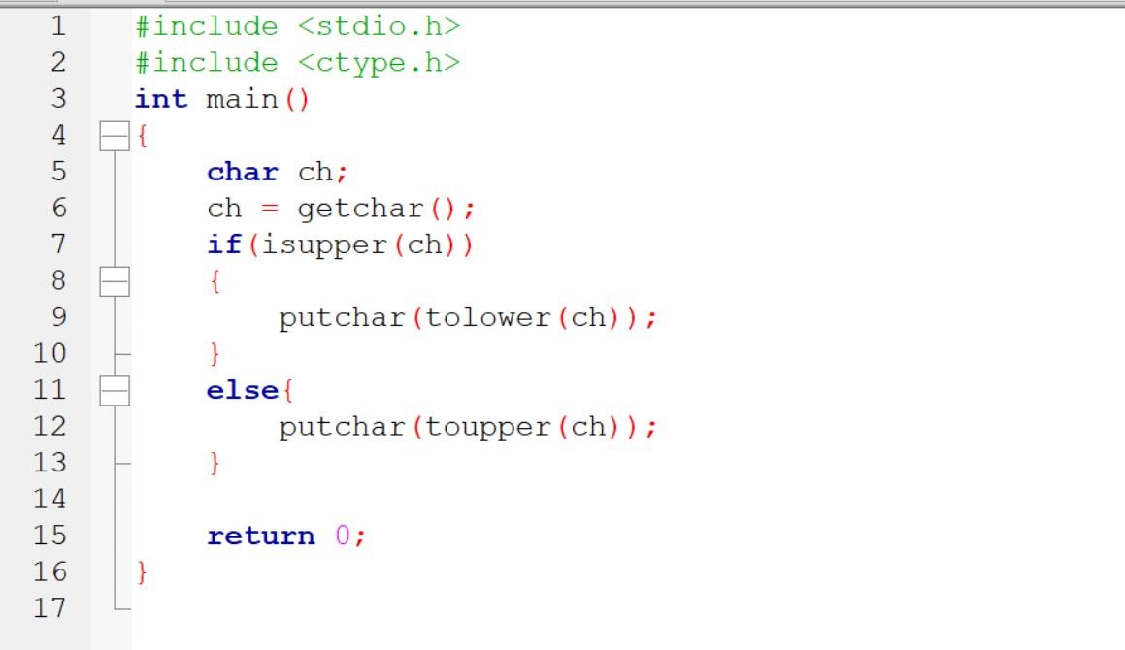

Output:

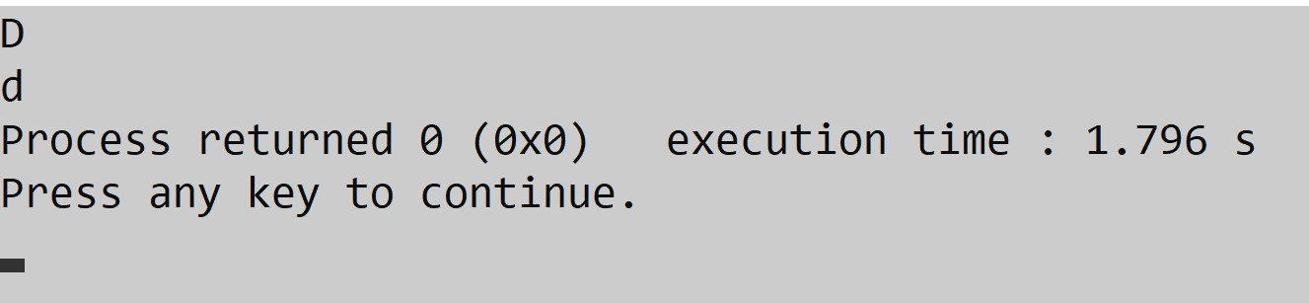

2.Write a C program to perform various formatted input/output operations on floating point numbers.

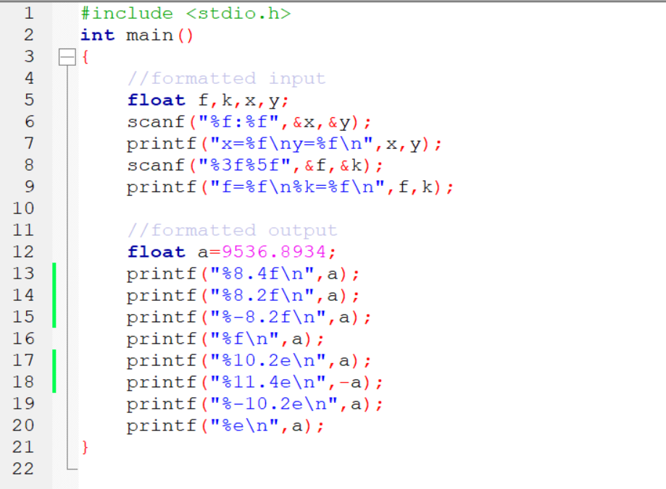

Output: 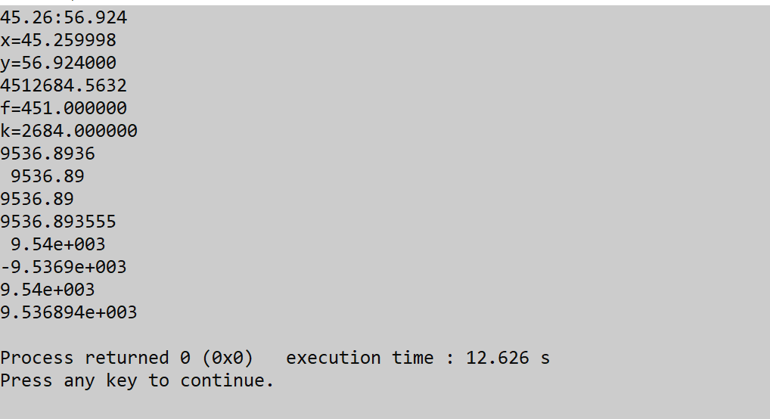

3.Write a C program for converting days into years, months and days.

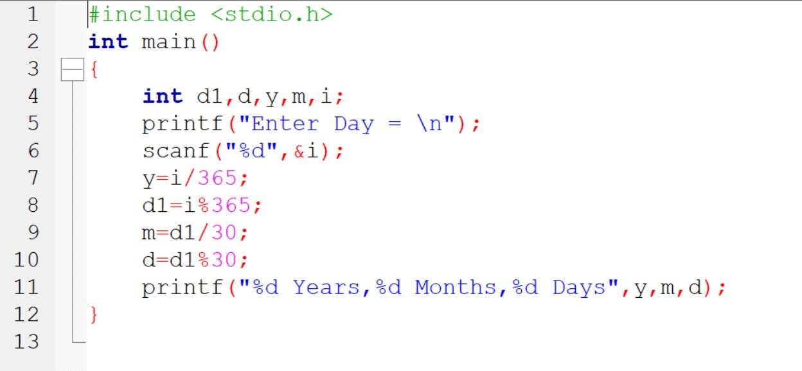

Output:

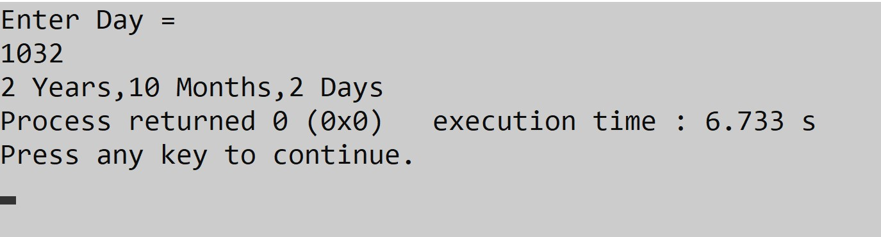

4.Write a C program for assigning (1 > 4 || 3 ! = 5) to a variable and print its value.

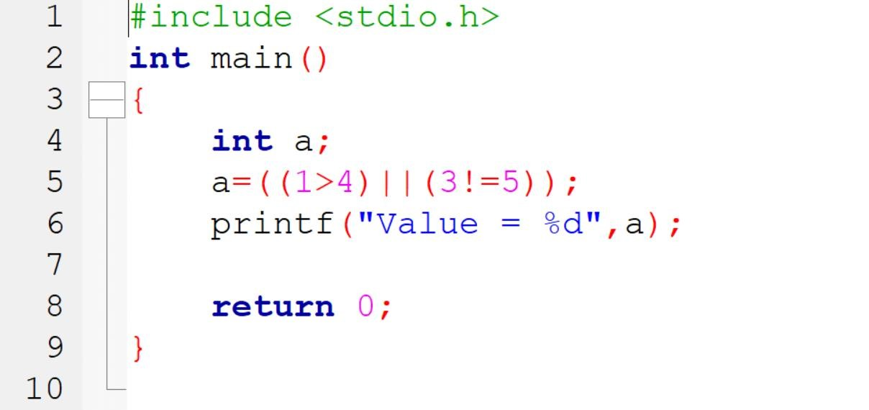

Output:

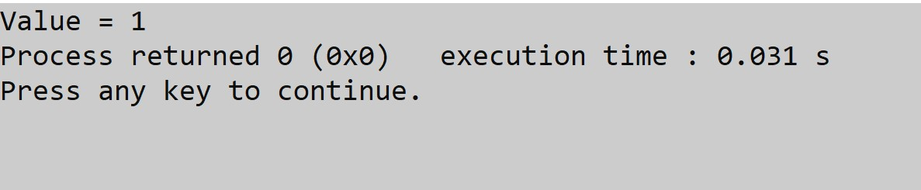

5.Write a C program to check whether a number is even or odd using bitwise operator.

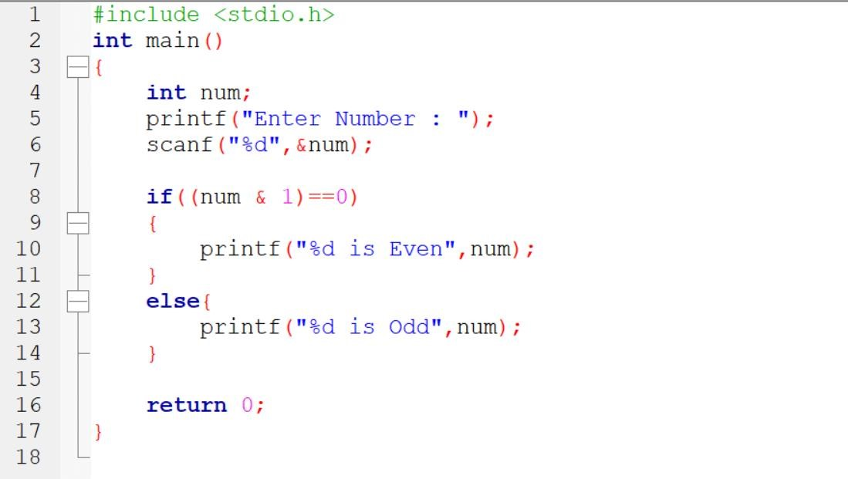

Output:

