1. The apk is there in the APK folder and also present in app>release>app-release.apk

2.Code comprises of three Activities.

a.login.java(main)

b.Register.java

c.DashboardActivity.java

3.It comprises of three layouts respectively.

a.activity_main.xml

b.activity_register.xml

c.activity_dashboard.xml

**********************************************************************************

Steps to run the app.

1.Signup using the asked details and full fill all the requirements.

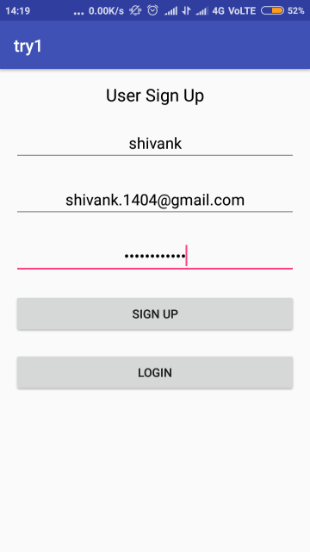

2.check the email ,if the mail is not present in inbox check in AllMails option of the Email id or check Internet connection.

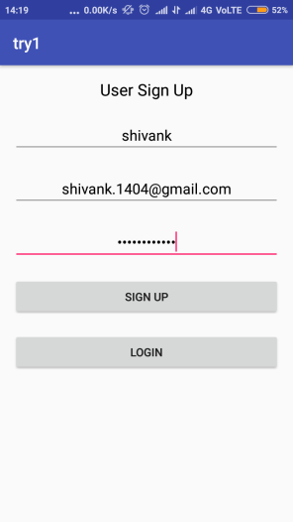 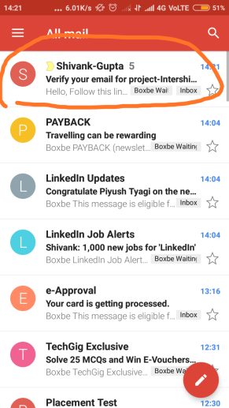 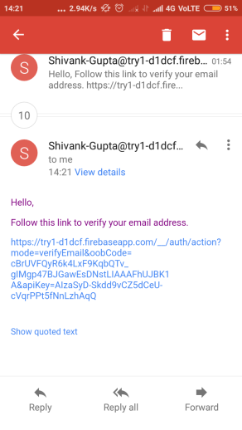 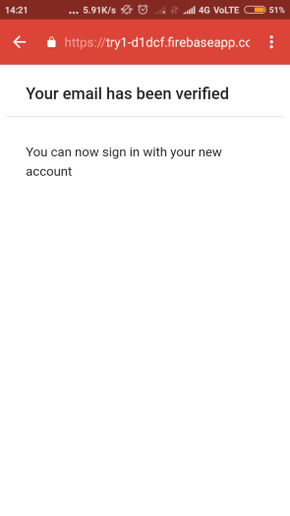

3. verify the email address by clicking on the link provided.

4.Now sign in with the details you provided.

