

**Bangladesh University of Business and Technology**

**Department of Computer Science and Engineering**

**Smart Health Monitoring System Using IoT**

By

Md. Ashraful Hossain ID: 18192103137

Sk. Md. Rumman ID: 18192103138

Arup Raton Chowdhury ID: 18192103155

Arman Hossain ID: 18192103156

Shaminur Rahman ID: 18192103158

Rakibul Hasan Shafin ID: 18192103165

Shoumik Islam ID: 18192103088

**Submitted To:**

**Md Reazul Islam**

**Lecturer, Dept. of CSE, BUBT**

***Abstract—*Smart Healthcare is important for people who need continuous monitoring which cannot be provided outside hospitals. It is also important at rural areas or villages where nearby clinics can be in touch with city hospitals about their patient’s health condition. As a result, this project is an attempt to solve a healthcare problem currently society is facing. This work presents a smart health monitoring system that uses biomedical sensors to check patient’s condition and uses internet to inform the concerned. Early recognition of chronic diseases can be easy with these technologies. The body temperature, heart rate, respiration rate are prime parameters to diagnose and detect the patient‘s condition. This project kit helps to know the temperature, ECG and heart rate values using IoT. This wearable platforms which can be used to collect the needed information of the user and its ambient atmosphere and correspond such information wirelessly, where it is progression or stored for tracking the condition of the user. Such connectivity with peripheral devices and services will allow for taking the precautionary measure or providing instant and immediate care. For more versatile medical applications, this project can be improvised, by incorporating blood pressure monitoring systems, dental sensors and annunciation systems, thereby making it useful in hospitals as a very efficient and dedicated patient care system.**

**LIST OF FIGURES**

Figure 1: Flow of research

**Table of Contents**

**Abstract**

**Chapter 1: Introduction**

**Chapter 2: Literature Review**

**Chapter 3: Theoretical Analysis**

**Chapter 4: Software Design**

**Chapter 5: Abstract**

**Chapter 6: Hardware Design and Software Design**

**Chapter 7: Flowchart**

**Chapter 8: Results**

**Chapter 9: Advantages and Disadvantages**

**Chapter 10: Application**

**Chapter 11: Conclusion**

**Chapter 12: Future Work**

**Chapter 13: Reference**

**Chapter 14: Appendix**

**1. INTRODUCTION**

**Overview:**

Health is characterized as a full state of physical, mental, and social well-being and not merely a lack of illness. Health is a fundamental element of people’s need for a better life. Unfortunately, the global health problem has created a dilemma because of certain factors, such as poor health services, the presence of large gaps between rural and urban areas, physicians, and nurse’s unavailability during the hardest time. According to the constitutions of World Health Organization (WHO) the highest attainable standard of health is a fundamental right for an individual. As we are truly inspired by this, we attempt to propose an innovative system that puts forward a smart patient health tracking system that uses sensors to track patient vital parameters and uses internet to update the doctors so that they can help in case of any issues at the earliest preventing death rates.

**Purpose:**

We have tried to develop a wearable health monitoring system that monitors the user’s heart rate and body temperature, ECG rate, and visualizes the data in real-time. Authorized users will have access to the collected data stored in the cloud server to keep track of the patient’s health data. The system is capable of sending alert notifications to phones and emails when the person wearing the health system is having abnormal body temperature or sudden changes in heart rate. Thus, the objectives of the project are to propose an Internet of Things (IoT) based health monitoring system that collects and monitors the user’s body temperature ,ECG rate and heart rate in real-time. To propose a system that visualizes and stores the health data in the database while tracking the location of the user by using geolocation.

**2. LITERATURE SURVEY**

**Existing Problem**

In the traditional healthcare system, people are required to visit clinics or medical centers regularly for medical checkups, which is less effective and time-consuming. The high medical cost and long waiting will discourage people from performing medical checkups regularly. A health monitoring system that collects and monitors the health status of the user in real-time will benefits the people by saving their money and time of visiting clinics and medical centers unless there is a need for it.

**Proposed Solution**

In this project, a system is designed to continuously monitor the vital parameters such as heart rate, ECG rate and body temperature. The information is stored on a cloud server and can be displayed through and OLED display or an online website by authorized personnel only. The main objective of this system is to update the data online and send an alert to the doctors and family members for any abnormality and also predict if the patient is having any disease. This system has much future scope as the data collected by monitoring is so valuable and can be used for any kind of research by the medical community.

**3. THEORITICAL ANALYSIS**

NodeMCU

LED Lights

ECG SENSOR

Figure 1. System Block Diagram

Battery

PC

OLED Display

Buzzer

Pulse Oximeter

Heartbeat Sensor

Temperature Sensor

**4. SOFTWARE DESIGN**

The IoT-based health monitoring system keeps track of the changes in patients' heart rate, blood pressure, pulse rate, and body temperature. These health-related data can be accessed by using sensors. With the help of ECG and heart sensors, cardiac disease can be detected. The condition of the patients will be conveyed to the doctors and they will suggest the treatment or the medicines to the patient accordingly. If an abnormality is detected in the health of the patient, then the doctors and the patient's family members will be alerted with a red signal otherwise it will give a green signal.

1. **Ubidots IoT Platform:**

Ubidots is an IoT Application Enablement Platform (AEP) enabling System Integrators (SIs) and SMBs to rapidly assemble and launch IoT applications. Ubidots building blocks include drag-and-drop dashboards, device-friendly APIs, analytics, reports and alerts. Ubidots is an Internet of Things (IoT) application builder with data analytics and visualization. We turn sensor data into information that matters for business-decisions, machine-to-machine interactions, educational research, and an increased economization of global resources. Hiring an engineering team to develop a platform that both functions and looks great is costly in both time and money so we did it for you. Ubidots exists as an easy and affordable means to integrate the power and value of the IoT into businesses and research. Founded in 2013, Ubidots is an investor-backed startup providing an IoT Application Enablement Platform for tinkerers, educators, and professionals.

1. **Arduino IDE**

The Arduino Integrated Development Environment - or Arduino Software (IDE) - contains a text editor for writing code, a message area, a text console, a toolbar with buttons for common functions and a series of menus. It connects to the Arduino hardware to upload programs and communicate with them. The Arduino IDE is an open-source software, which is used to write and upload code to the Arduino boards. The IDE application is suitable for different operating systems such as Windows, Mac OS X, and Linux. It supports the programming languages C and C++. Here, IDE stands for Integrated Development Environment. The program or code written in the Arduino IDE is often called as sketching. We need to connect the Genuino and Arduino board with the IDE to upload the sketch written in the Arduino IDE software. The sketch is saved with the extension '.ino.'

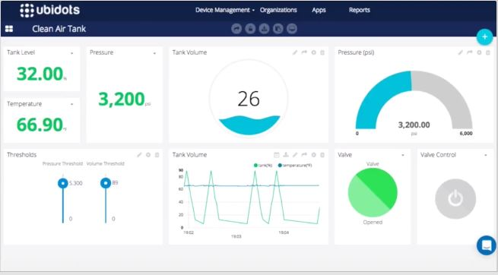

Figure 2. Ubidots

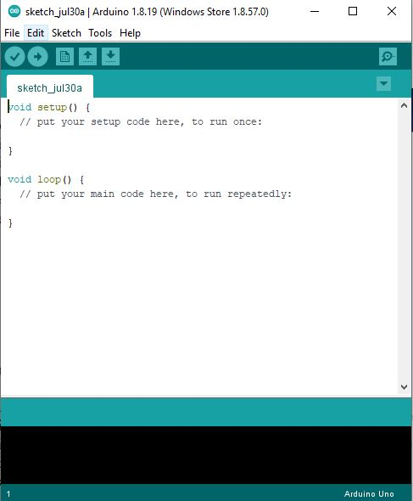

Figure 3. Arduino IDE



Figure 4. Arduino Loading Screen

**5. Hardware Design with circuit diagram**

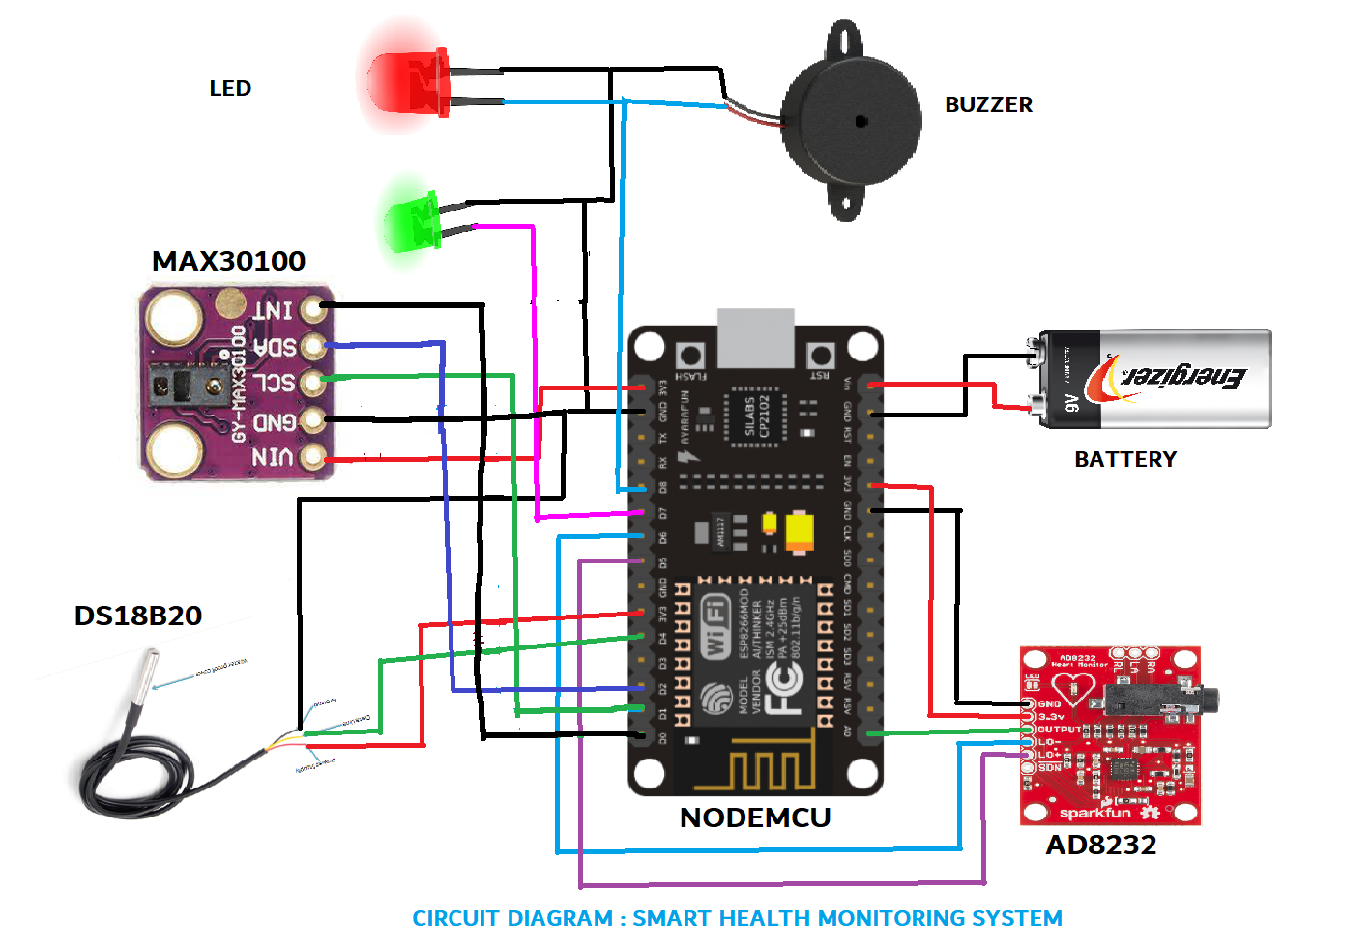

**6. Flowchart**

**Figure 5. Flowchart**



**5. ADVANTAGE AND DISADVANTAGE**

**Advantages:**

1. **Remote monitoring**: Real-time remote monitoring via connected IoT devices and smart alerts can diagnose illnesses, treat diseases and save lives in case of a medical emergency.
2. **Prevention**: Smart sensors analyze health conditions, lifestyle choices and the environment and recommend preventative measures, which will reduce the occurrence of diseases and acute states.
3. **Reduction of healthcare costs**: IoT reduces costly visits to doctors and hospital admissions and makes testing more affordable.
4. **Medical data accessibility**: Accessibility of electronic medical records allows patients to receive quality care and help healthcare providers make the right medical decisions and prevent complications.
5. **Improved treatment management**: IoT devices help track the administration of drugs and the response to the treatment and reduce medical error.
6. **Improved healthcare management**: Using IoT devices, healthcare authorities can get valuable information about equipment and staff effectiveness and use it to suggest innovations.
7. **Research**: Since IoT devices are able to collect and analyze a massive amount of data, they have a high potential for medical research purposes.

**Disadvantages:**

1. **Security and privacy**: Security and privacy remain a major concern deterring users from using IoT technology for medical purposes, as[healthcare monitoring solutions](https://www.fpt-software.com/white-paper/healthcare-collaboration-monitoring-solutions/) have the potential to be breached or hacked. The leak of sensitive information about the patient’s health and location and meddling with sensor data can have grave consequences, which would counter the benefits of IoT.
2. **Risk of failure**: Failure or bugs in the hardware or even power failure can impact the performance of sensors and connected equipment placing healthcare operations at risk. In addition, skipping a scheduled software update may be even more hazardous than skipping a doctor checkup.
3. **Integration**: There’s no consensus regarding IoT protocols and standards, so devices produced by different manufacturers may not work well together. The lack of uniformity prevents full-scale integration of IoT, therefore limiting its potential effectiveness.
4. **Cost**: While IoT promises to reduce the cost of healthcare in the long-term, the cost of its implementation in hospitals and staff training is quite high.

**7. Application**

The global health problem has been increasing day by day due to poor health services and lack of medical experts and high-quality hospitals. Several health complications are also increasing especially heart and lung-related issues. Many patients are not getting proper help during these critical conditions.

Several life-threatening diseases can be easily monitored by IoT-based systems. Cardiovascular Disease (CVD) is a common disease that is the cause behind most of the deaths in the world. At present, with the revolution of information and technology, smartphone-based health monitoring systems are becoming more popular. These systems can be used to collect real-time health information and give feedback to patients and medical specialists. Allowing every single person to examine their health, and advising them to find immediate treatment in case of emergencies, can result in saving that person’s life. The use of these monitoring systems can decrease medical fees for the nation in the long run.

**IX. FUTURE SCOPE**

The system is getting only four parameters as input. In future more sensors can be added to get more parameters in order to increase the accuracy. Other diseases can also be predicted by using different data sets. This system can be made more compact and user friendly.

**Smart Health Monitoring System using IoT**

**Sensors**

**DS18B20**

**Pulse Oximeter**

**Hearbeat Sensor**

**Temperature Sensor**

**AD8232**

**GY – MAX30100**

**NodeMCU**

**Body Monitoring**

**Oxygen Monitoring**

**Heartbeat Monitoring**

**ECG Monitoring**

**Services**

**Applications**

**ECG Sensor**

**VII. CONCLUSION**

Smart Health monitoring using IoT is a technology to enable monitoring of patients outside of conventional clinical settings (e.g. in the home), which may increase access to care and decrease healthcare delivery costs. This can significantly improve an individual's quality of life. It allows patients to maintain independence, prevent complications, and minimize personal costs. This system facilitates these goals by delivering care right to the home. In addition, patients and their family members feel comfort knowing that they are being monitored and will be supported if a problem arises.

**X. REFERENCES**

[1] S. J. Jung and W. Y. Chung, “Flexible and scalable patient’s health monitoring system in 6LoWPAN,” Sensor Lett., vol. 9,no. 2, pp. 778–785, Apr. 2011.

[2] W. Y. Chung, C. Yau, K. S. Shin, and R. Myllylä, “A cell phone based health monitoring system with selfanalysis processor using wireless sensor network technology,” in Proc. 29th Annu. Int. Conf. Eng. Med. Biol. Soc., Lyon, France, 2007, pp.

[3] G. Lawton, “Machine-to-machine technology gears up for growth,” Computer, vol. 37, no. 9, pp. 12–15, Sep. 2004.

[4] C. Kim, A. Soong, M. Tseng, and X. Zhixian, “Global wireless machineto- machine standardization,” IEEE Internet Comput., vol. 15, no. 2, pp. 64–69, Mar.–Apr. 2011.

[5] Real time wireless health monitoring application using mobile devices, International Journal of Computer Networks & Communications (IJCNC) Vol.7, No.3, May 2015, Amna Abdullah, Asma Ismael, Aisha Rashid, Ali Abou-ElNour, and Mohammed Tarique.

[6] Secured Smart Healthcare Monitoring System Based on Iot, International Journal on Recent and Innovation Trends in Computing and Communication Volume: 3 Issue: 7, Bhoomika.B.K, Dr. K N Muralidhara.

[7] Real time wireless health monitoring application using mobile devices, International Journal of Computer Networks & Communications (IJCNC) Vol.7, No.3, May 2015, Amna Abdullah, Asma Ismael, Aisha Rashid, Ali Abou-ElNour, and Mohammed ,Tarique.

[8] Secured Smart Healthcare Monitoring System Based on Iot, International Journal on Recent and Innovation Trends in Computing and Communication Volume: 3 Issue: 7, Bhoomika.B.K, Dr. K N Muralidhara.

[9] Goutam Motika, Abinash Prusty,” Wireless FetalHeartbeat Monitoring System Using ZigBee & IEEE 802.15.4 Standard”, 2011 Second International Conference on Emerging Applications of Information Technology, 978-0- 7695-4329-1/11, 2011 IEEE DOI 10.1109/EAIT.2011.89 .

[10] S. M. Mahalle, P. V. Ingole, “Design and Implementation of Wireless Body Area Sensor Network Based Health Monitoring System”, International Journal of Engineering Research & Technology, Vol. 2 Issue 6, pp. 105- 113, June 2013.

[11] M.Prakash, CJ Kavitha Priya, “An Analysis of Types of Protocol Implemented in Internet of Things Based on Packet Loss Ratio”, Proceedings of International Journal of Information and Communication Technology for Competitive Strategies, ISBN: 978-1-4503-3962-9, DOI: https://doi.org/10.1145/2905055.2905085, 4th – 5 th Mar 2016

[12] M. Prakash, U. Gowshika, T. Ravichandran, “A Smart Device Integrated with an Android for Alerting a Person’s Health Condition: Internet of Things” Indian Journal of Science and Technology, Vol 9 (6), February 2016. DOI: <https://doi.org/10.17485/ijst/2016/v9i6/69545>

[13] Dr.A.Sabanayagam, G.Anish Girija,” DESIGN AND MODELING OF MOBILE HEALTH MONITORING SYSTEM”, International Journal of Innovations in Scientific and Engineering Research (IJISER),vol4,no 2,pp.63- 65,2017.

[14] “Healthcare Monitoring System Using Wireless Sensor Network”, D. Mahesh Kumar, Department of Electronics, PSG College of Arts and Science, Coimbatore - 641 014.Volume 04, Issue 01 Pages:1497-1500 (2012), ISSN:0975-0290.