Q1:
adjacency lists:
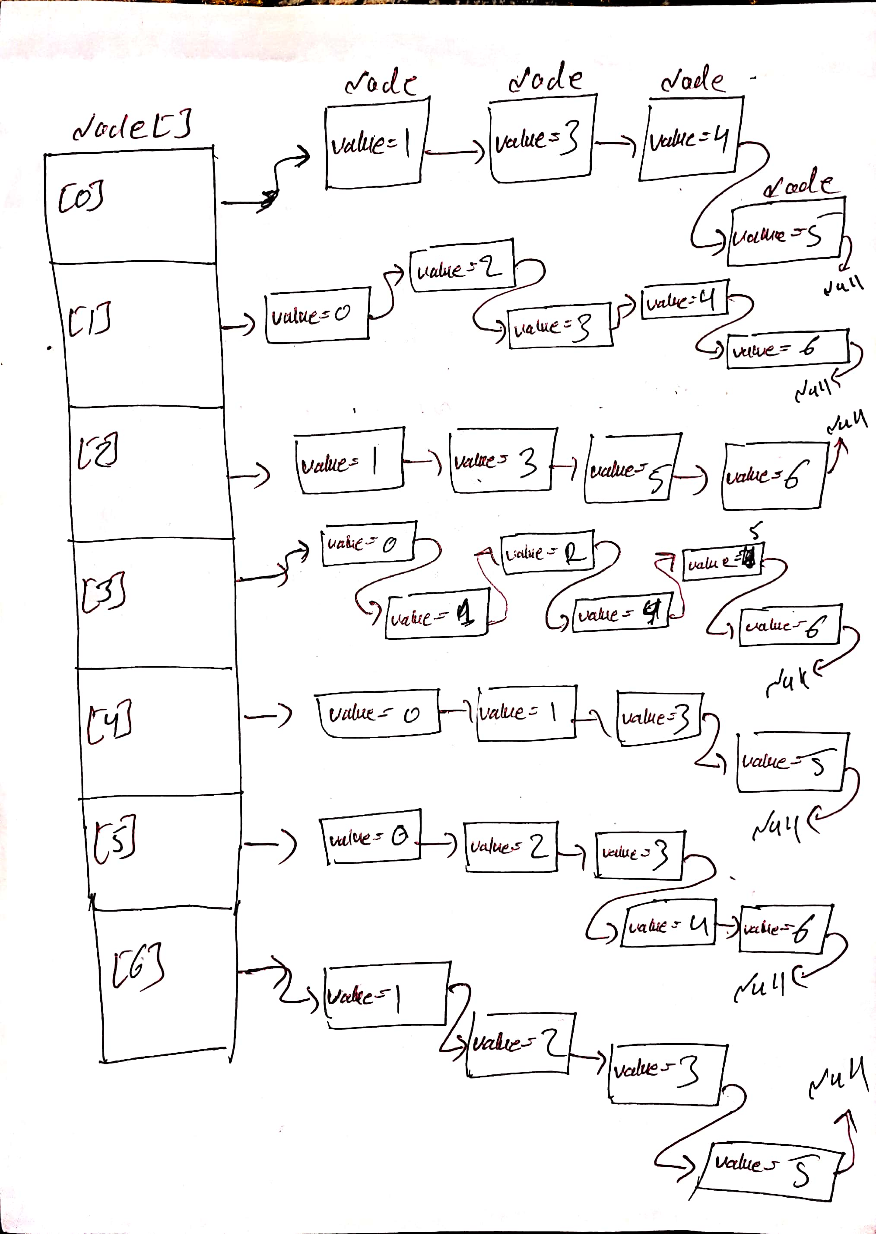
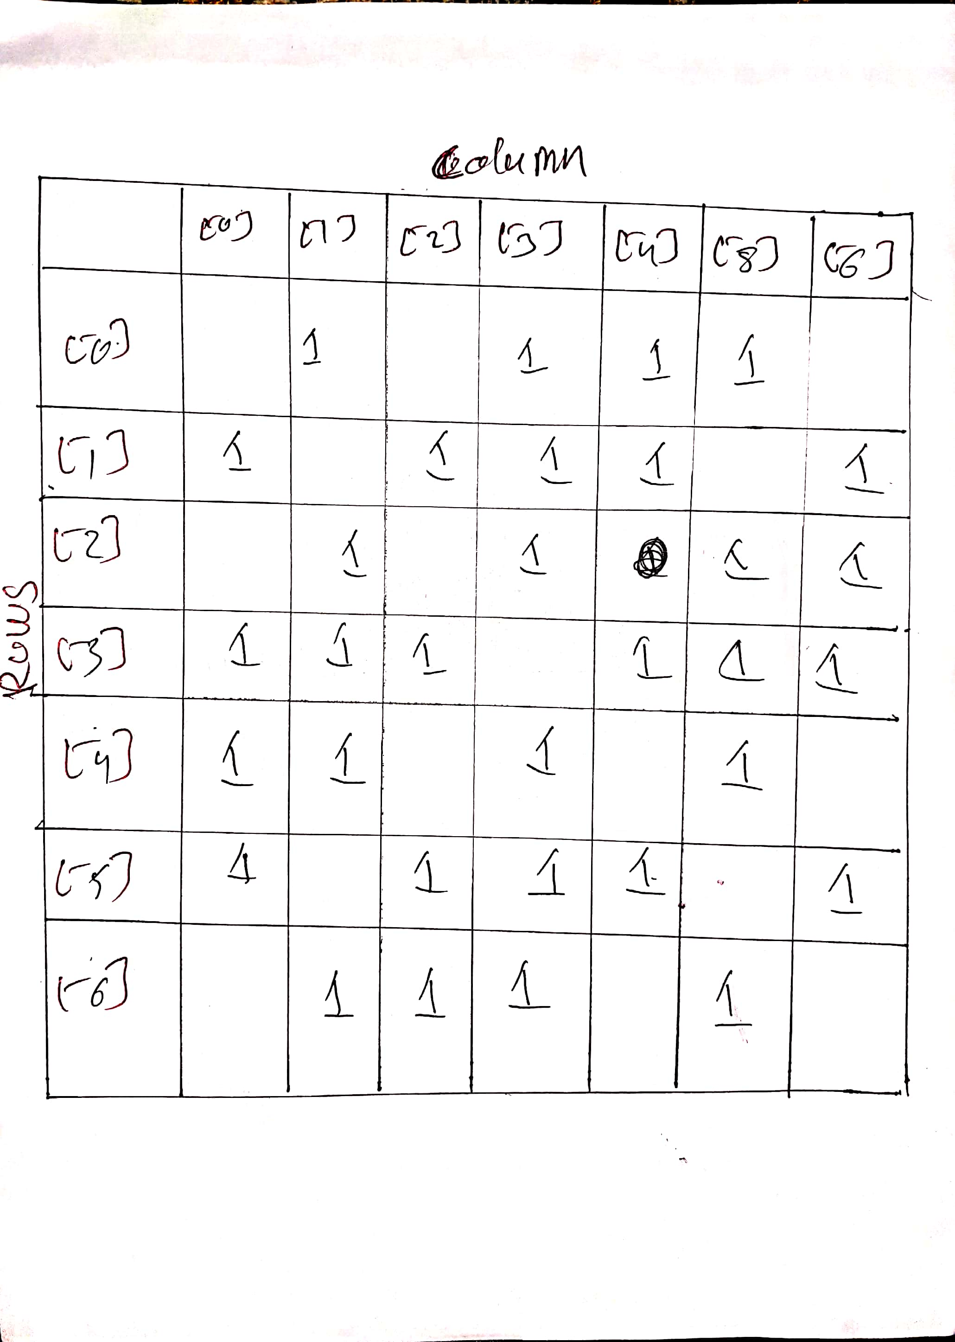

the |V| = n for above graph is 7 and the |E| = m for above graph is 17.

density of a graph:

D = |E| / |V|²

|E| = 7 , |V| = 17 , |V|² = 289 D = 7 / 289 = 0.0242

for this graph the adjacency matrix
representation is better since it is a dense graph.

DFS:

2
1
0
Discovery (Visit) order:
6
5
4
3
2

Finish order:
unvisited being visited visited

2
1
0
Discovery (Visit) order:
6
5
4
3
2,6

Finish order:
unvisited being visited visited

2
1
0
Discovery (Visit) order:
6
5
4
3
2,6,5

Finish order:
unvisited being visited visited

2
1
0
Discovery (Visit) order:
6
5
4
3
2,6,5,4

Finish order:
unvisited being visited visited

2
1
0
Discovery (Visit) order:
6
5
4
3
2,6,5,4,3

Finish order:
unvisited being visited visited

2
1
0
Discovery (Visit) order:
6
5
4
3
2,6,5,4,3,1

Finish order:
unvisited being visited visited

2
1
0
Discovery (Visit) order:
6
5
4
3
2,6,5,4,3,1,0

Finish order:
unvisited being visited visited

2
1
0
Discovery (Visit) order:
6
5
4
3
2,6,5,4,3,1

Finish order:
0
unvisited being visited visited

2
1
0
Discovery (Visit) order:
6
5
4
3
2,6,5,4,3

Finish order:
0,1
unvisited being visited visited

2
1
0
Discovery (Visit) order:
6
5
4
3
2,6,5,4

Finish order:
0,1,3
unvisited being visited visited

2
1
0
Discovery (Visit) order:
6
5
4
3
2,6,5

Finish order:
0,1,3,4
unvisited being visited visited

2
1
0
Discovery (Visit) order:
6
5
4
3
2,6

Finish order:
0,1,3,4,5
unvisited being visited visited

2
1
0
Discovery (Visit) order:
6
5
4
3
2

Finish order:
0,1,3,4,5,6
unvisited being visited visited

2
1
0
Discovery (Visit) order:
6
5
4
3

Finish order:
0,1,3,4,5,6,2
unvisited being visited visited

BFS:

2
1
0
Queue:
6
5
4
3

Visit sequence:
2
unvisited identified visited

2
1
0
Queue:
6
5
4
3

6,5,3,1
Visit sequence:
2
unvisited identified visited

2
1
0
Queue:
6
5
4
3

6,5,3,1
Visit sequence:
2
unvisited identified visited

2
1
0
Queue:
6
5
4
3

5,3,1
Visit sequence:
2,6
unvisited identified visited

2
1
0
Queue:
6
5
4
3

5,3,1
Visit sequence:
2,6
unvisited identified visited

2
1
0
Queue:
6
5
4
3

3,1,4,0
Visit sequence:
2,6,5
unvisited identified visited

2
1
0
Queue:
6
5
4
3

3,1,4,0
Visit sequence:
2,6,5
unvisited identified visited

2
1
0
Queue:
6
5
4
3

1,4,0
Visit sequence:
2,6,5,3
unvisited identified visited

2
1
0
Queue:
6
5
4
3

4,0
Visit sequence:
2,6,5,3,1
unvisited identified visited

2
1
0
Queue:
6
5
4
3

0
Visit sequence:
2,6,5,3,1,4
unvisited identified visited

2
1
0
Queue:
6
5
4
3

Visit sequence:
2,6,5,3,1,4,0
unvisited identified visited

FOR SECOND GRAPH:
ADJECENCY LIST:
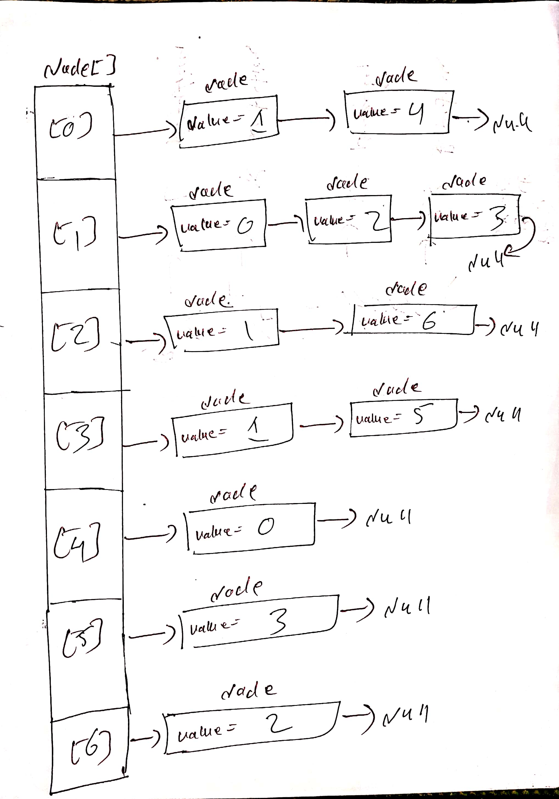
ADJECENCY MATRIX:

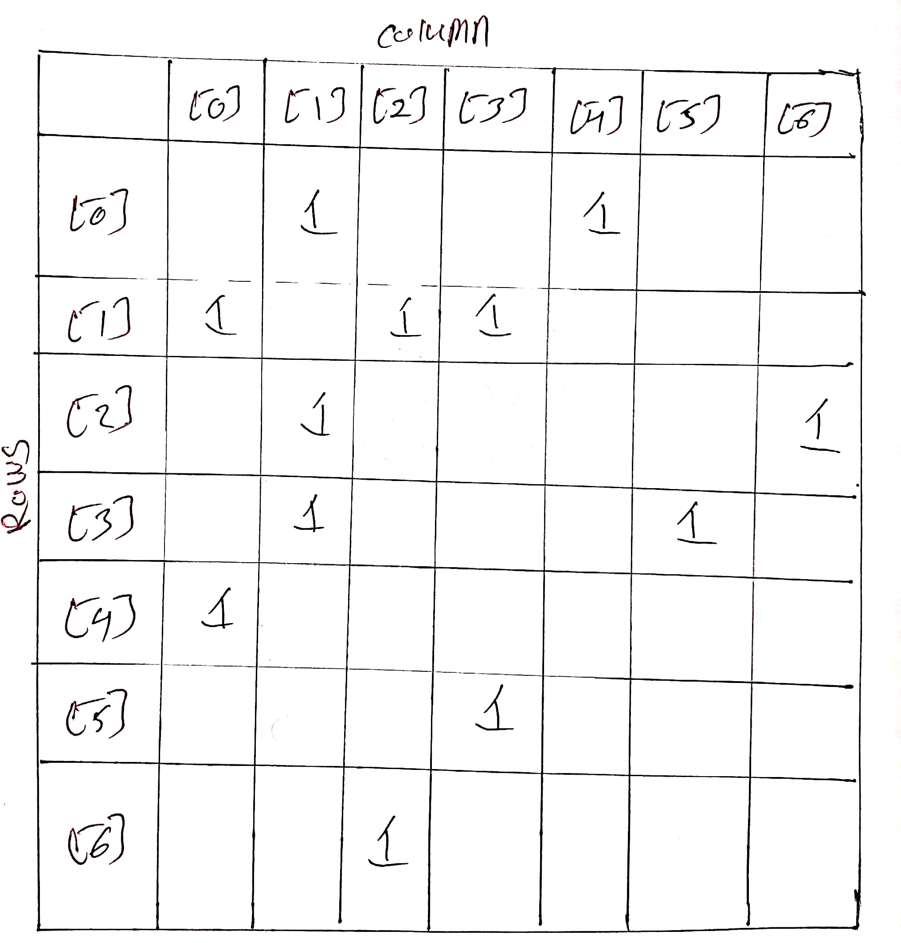

the |V| = n for above graph is 6 and the |E| = m for above graph is 7.

density of a graph:

D = |E| / |V|²

|E| = 6 , |V| = 7 , |V|² = 49 D = 6 / 49 = 0.1224

for this graph the adjacency list
representation is better since it is a sparse graph.

DFS:

2
1
0
Discovery (Visit) order:
6
5
2

Finish order:
4
3

unvisited being visited visited

2
1
0
Discovery (Visit) order:
6
5
2,6

Finish order:
4
3

unvisited being visited visited

2
1
0
Discovery (Visit) order:
6
5
2

Finish order:
4
3
6

unvisited being visited visited

2
1
0
Discovery (Visit) order:
6
5
2,1

Finish order:
4
3
6

unvisited being visited visited

2
1
0
Discovery (Visit) order:
6
5
2,1,3

Finish order:
4
3
6

unvisited being visited visited

2
1
0
Discovery (Visit) order:
6
5
2,1,3,5

Finish order:
4
3
6

unvisited being visited visited

2
1
0
Discovery (Visit) order:
6
5
2,1,3

Finish order:
4
3
6,5

unvisited being visited visited

2
1
0
Discovery (Visit) order:
6
5
2,1

Finish order:
4
3
6,5,3

unvisited being visited visited

2
1
0
Discovery (Visit) order:
6
5
2,1,0

Finish order:
4
3
6,5,3

unvisited being visited visited

2
1
0
Discovery (Visit) order:
6
5
2,1,0,4

Finish order:
4
3
6,5,3

unvisited being visited visited

2
1
0
Discovery (Visit) order:
6
5
2,1,0

Finish order:
4
3
6,5,3,4

unvisited being visited visited

2
1
0
Discovery (Visit) order:
6
5
2,1

Finish order:
4
3
6,5,3,4,0

unvisited being visited visited

2
1
0
Discovery (Visit) order:
6
5
2

Finish order:
4
3
6,5,3,4,0,1

unvisited being visited visited

2
1
0
Discovery (Visit) order:
6
5

Finish order:
4
3
6,5,3,4,0,1,2

unvisited being visited visited

BFS:

2
1
0
QUEUE:
6
5

6,1
VISIT SEQUENCE:
4
3
2

unvisited being visited visited

2
1
0
QUEUE:
6
5
1

VISIT SEQUENCE:
4
3
2,6

unvisited being visited visited

2
1
0
QUEUE:
6
5
1

VISIT SEQUENCE:
4
3
2,6

unvisited being visited visited

2
1
0
QUEUE:
6
5
3,0

VISIT SEQUENCE:
4
3
2,6,1

unvisited being visited visited

2
1
0
QUEUE:
6
5
3,0

VISIT SEQUENCE:
4
3
2,6,1

unvisited being visited visited

2
1
0
QUEUE:
6
5
0,5

VISIT SEQUENCE:
4
3
2,6,1,3

unvisited being visited visited

2
1
0
QUEUE:
6
5
5,4

VISIT SEQUENCE:
4
3
2,6,1,3 ,0

unvisited being visited visited

2
1
0
QUEUE:
6
5
4

VISIT SEQUENCE:
4
3
2,6,1,3 ,0,5

unvisited being visited visited

2
1
0
QUEUE:
6
5
4

VISIT SEQUENCE:
4
3
2,6,1,3 ,0,5

unvisited being visited visited

2
1
0
QUEUE:
6
5

VISIT SEQUENCE:
4
3
2,6,1,3 ,0,5,4

unvisited being visited visited

