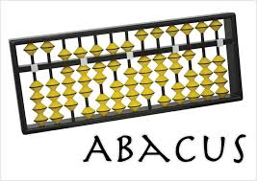
Computer science over view

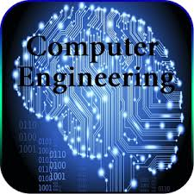
Indexes
what is the computers
History of computers
Biography of some computer engineers

Teacher name:Dr. Fatih Erdogan Sevilgen

What is the computer?
The word of (computer) has taken from the word of compute, which means calculating and computing . Computer is an electronic machine and nowadays one of the most effective and useful electronic machine entire world. Computer has the capacity of receive and keep the databases according to the given instructions with a high speed and thousands of time faster than human .I want to talk about a bit about history of computer first then about the details of it.
History of computer science
2500BC people used to use the Abacus.Abacus is the first know calculating machine used for counting(addition, subtraction,division and multiplication) it is made of beads and rods. So how to use abacus ? Let me explain it to you :
there is some instruction about how to use abacus let’s do it setup by setup.
1: Learning numbers:Play a simple game with the abacus. When it's your turn, you say a number, such as 42, and the child "makes" it or shows it on the abacus. Then the child says a number for you and you show it on the abacus. Continue taking turns like this.
2: Going over 10 in addition: Choose for example 6 beads on one wire and 8 on the next one. You can show how the five and five on those two wires makes ten, and some are left over.
In the year 1614AD Napier’s bones was invented by (John Napier) a Scottish mathematician .A set of bones consisted of nine rods,one for each digits and one through nine and a constant rod for the digit zero(0).In the year 1633AD the slide rule was invented by (William Oughtred).

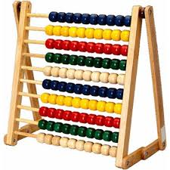
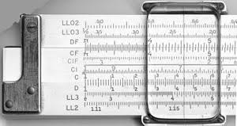
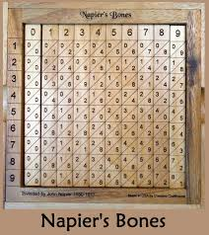
In 1642 AD the rotating wheel calculator was first developed by French philosopher (Blaise
Pascal) .

The first big digital computer in 1937 was designed by
”Howard Icon” and in 1944 was made by I M B company. in the first days this computer was named as a “ automatic calculator “. But after that the name has changed to “mark” and it had a mechanical structure .The features of mark computers were:
1: 15.5m length and 61cm width and 2.4m height.
2: It’s weight was more than 5 Ton.
3: it had the capability of execution less than 6 seconds.

E N I AC COMPUTERS:
the first electronic computer was by the name of (Electronic Numerical Integrator and Computer) that has made by two American scientists (J.prosper Eckert) and (Jhon Wiliam Mauchly) in 1946.this computer has used in world war two by American army.
ENAIC Computers had the following features:
1: it’s limit of the mass was 1500ft square.
2:it’s weight has reached till 30000kg.
3:more than 18000 (vacuum tubes)have used on it.
4:it was 2000 times faster than mechanical calculators because it was and electronic computer.
5:the price of that kind of computer have reached until 487000$.
E D V A C Computers:
In the year 1952” Ikuurt and Machily” two American scientists, for the first time were able to make a kind of computer which was able to save data called (Electronic Discrete Variable Automatic Computer).
U N I V A C Computers:
UNIVAC or ( Universal Atomatic Computer)
Was the first common commercial computer of united states of America. It was the first product of (Eckert and mauchly) in (Remongton Rand-INC) has produced.building of this computer has started in 1947 and has ended in 1951.

Biography of Charles Babbage(1791-1871)
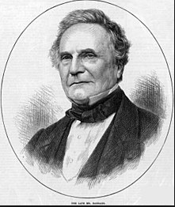
Charles Babbage was known for his contribution to the first mechanical computers,which laid groundwork for more complex future designs.Charles Babbage an English mathematician, philosopher and and inventor was born on December 16 ,1791 in London England. Often called “the father of computing”.Babbage detailed plans for mechanical calculating engines, difference engines and analytical engines.After that Charles Babbage aimed to make a machine which should work by automatic program called (analytical engine).But he could not make it because of his economical problem and the technology was not developed enough. the analytic engine that Charles Babbage has made it , has five attitudes which were An key inspiration to built todays computer:
1:having input devises
2:having storage devices
3:having processor
4:having control section
5:having output devices
Charles Babbage has passed away on October 18, 1871 in London.
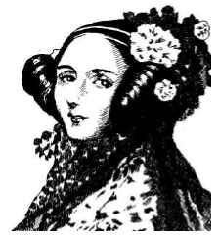
AUGUSTA ADA (1815-1851)
Augusta Ada an English woman has helped to Charles Babbage about programming the analystical engine. This woman was one of the co-workers of Charles Babbage. Augusta for the first time in the history of computer has mentioned about designing a program. This design appears IN 1842 when the Charels Babbage has invited to turin university about give a speech about his analyctical Engine.his speech was written by a mathematician called ||Louchy munara) in french.Augusta Ada was haiered to translate this speech fron french to English .and she translated wheten 9 months.and she added something neew to this speech.and she gave it to Babbage.there was 6 parts of speech in that article and Augusta has added her ideas in the last part which was the longest instruction and explanation on that speech and she has added her new assumptions and ideas about using Algoratim in Analystic engine that people can calculate bernoly digits with it .ADA was the first person who has written and used algoritam in computer.Babbage himself has said about Ada’s masterpeace in the year 1846.
if we say that Charles Babage is the founter of computer so we can confidently can say that Augusta Ada is the first computer programmer of computer’s history.

