TOPIC 6 : BACKTRACKING

1.

AIM :
To solve the N-Queens Problem using the backtracking technique and visualize the placement of queens on the chessboard such that no two queens attack each other.

ALGORITHM :

Step 1:
Create an empty N×NN \times NN×N chessboard.

Step 2:
Start placing queens column by column.

Step 3:
For each column:
- Check every row for a safe position.

Step 4:
A position is safe if:
- No queen exists in the same row.
- No queen exists in the upper-left diagonal.
- No queen exists in the lower-left diagonal.

Step 5:
If a safe position is found:
- Place the queen.
- Recursively place queens in the next column.

Step 6:
If placing a queen leads to conflict:
- Remove the queen (Backtracking).
- Try the next row.

Step 7:
Repeat until all queens are placed successfully.

Step 8:
Display the chessboard configuration.

PROGRAM :

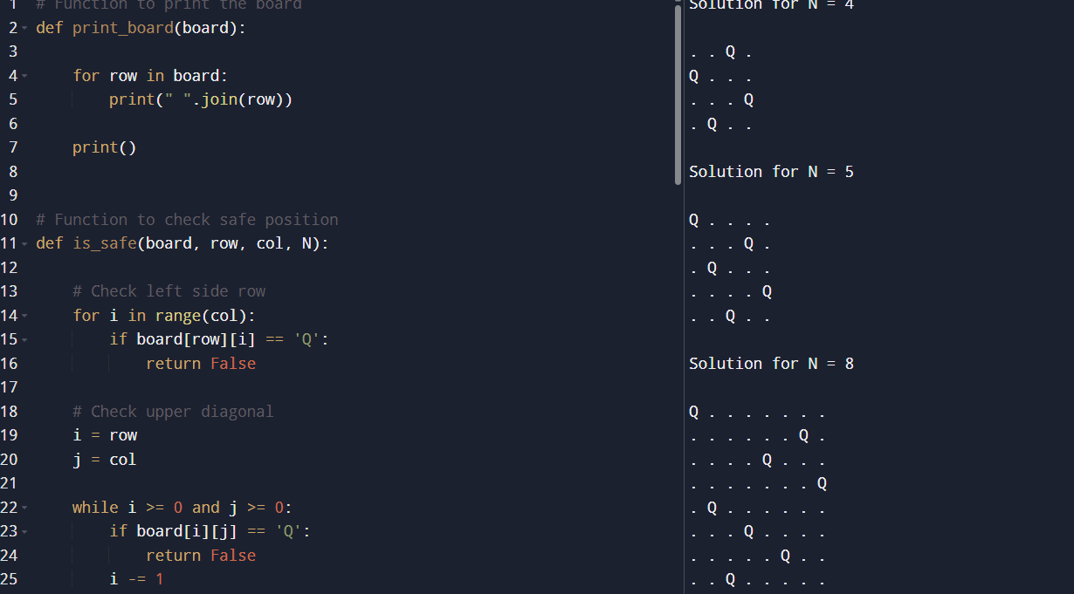

RESULT :
The program successfully solves the N-Queens Problem using the backtracking technique for different values of NNN.
- For N=4N = 4N=4, the queens are placed on the 4 × 4 chessboard such that no two queens attack each other horizontally, vertically, or diagonally.
- For N=5N = 5N=5, the algorithm correctly identifies a valid arrangement of 5 queens on the board while satisfying all safety conditions.
- For N=8N = 8N=8, the program efficiently generates a valid solution for the standard 8-Queens Problem and displays the chessboard configuration.

2.

AIM :
To study the generalized N-Queens Problem for different board sizes and constraints such as rectangular boards, obstacles, and restricted positions, and to adapt the backtracking algorithm to solve these variations.

Algorithm

Step 1:
Create the chessboard according to the given dimensions.

Step 2:
Define additional constraints:
- Obstacle positions
- Restricted rows or columns
- Rectangular board dimensions

Step 3:
Place queens column by column using backtracking.

Step 4:
Before placing a queen, check:
- No queen exists in the same row.
- No queen exists in upper-left diagonal.
- No queen exists in lower-left diagonal.
- Position is not blocked by obstacles.
- Position is not restricted.

Step 5:
If a safe position is found:
- Place the queen.
- Move to the next column recursively.

Step 6:
If no valid position exists:
- Remove the previously placed queen.
- Backtrack and try another position.

Step 7:
Repeat until all queens are placed successfully.

Step 8:
Display the valid board configuration.

PROGRAM :

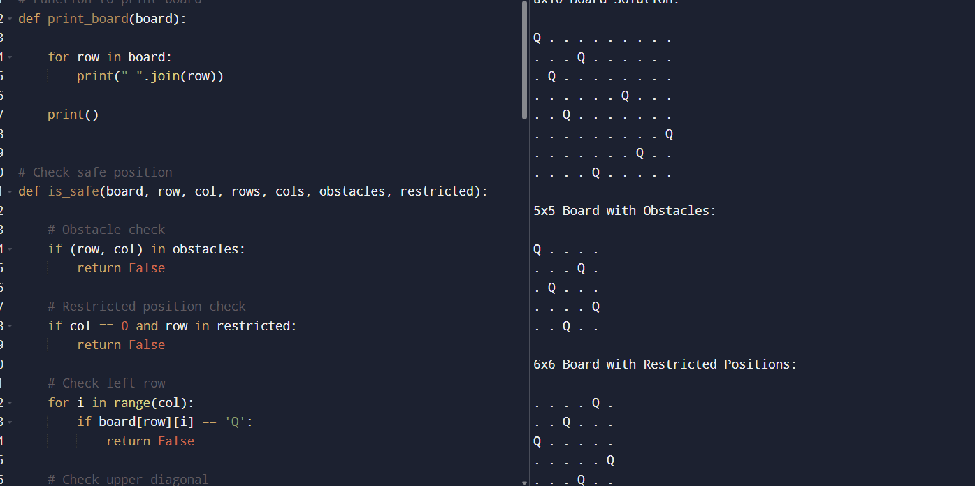

RESULT :

8×10 Board
The algorithm successfully places 8 queens on an 8×10 rectangular board while ensuring that no two queens attack each other.

5×5 Board with Obstacles
The algorithm successfully avoids placing queens on obstacle positions such as (2,2) and (4,4). The obstacle constraints are checked before placing each queen, ensuring a valid arrangement.

6×6 Board with Restricted Positions : The algorithm correctly handles restricted positions by preventing the first queen from being placed in restricted columns.
3.
AIM :
To solve a Sudoku puzzle by filling the empty cells using the backtracking algorithm while satisfying all Sudoku rules.

Algorithm

Step 1:
Read the 9×9 Sudoku board.

Step 2:
Find an empty cell represented by '.'.

Step 3:
Try placing digits from 1 to 9 in the empty cell.

Step 4:
Check whether the digit placement is valid:
- The digit must not already exist in the same row.
- The digit must not already exist in the same column.
- The digit must not already exist in the corresponding 3×3 sub-grid.

Step 5:
If the placement is valid:
- Place the digit.
- Recursively solve the remaining board.

Step 6:
If no digit leads to a solution:
- Remove the digit (Backtracking).
- Try the next possible digit.

Step 7:
Repeat until the board is completely filled.

Step 8:
Display the solved Sudoku board.
PROGRAM :
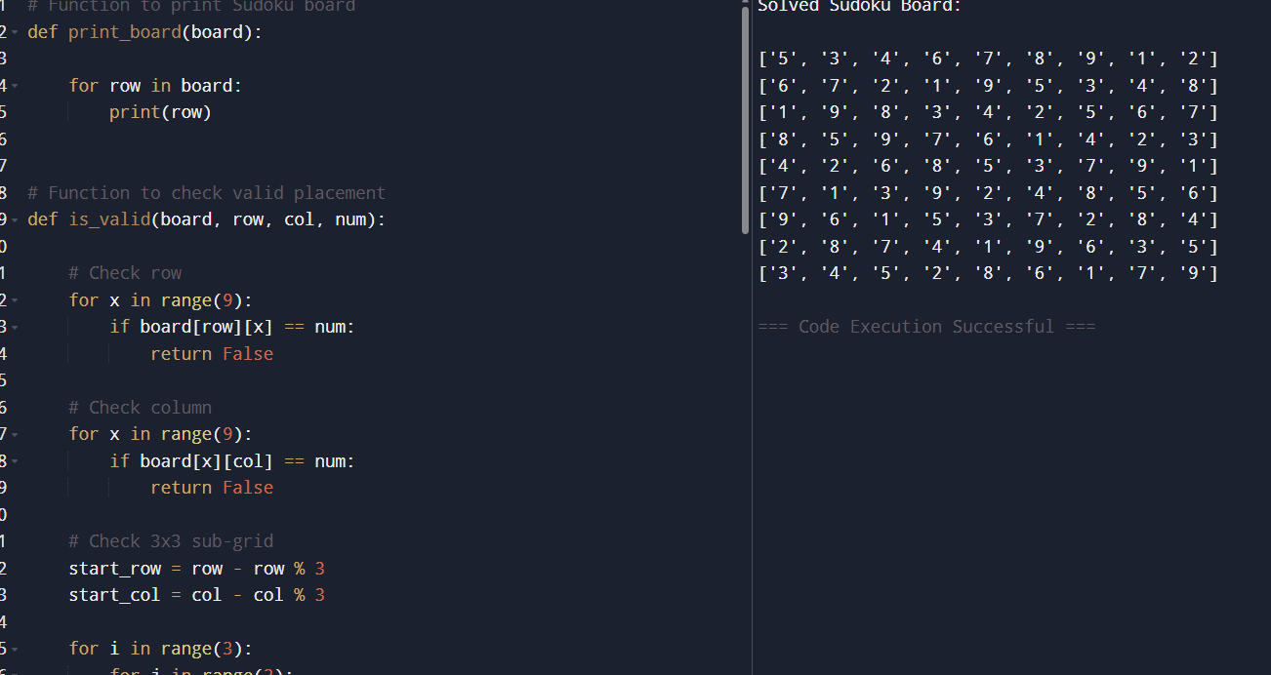
RESULT :
The program successfully solves the Sudoku puzzle using the backtracking algorithm.
- Each digit from 1 to 9 appears exactly once in every row.
- Each digit from 1 to 9 appears exactly once in every column.
- Each digit from 1 to 9 appears exactly once in every 3×3 sub-grid.
Solved Sudoku Board
["5","3","4","6","7","8","9","1","2"]
["6","7","2","1","9","5","3","4","8"]
["1","9","8","3","4","2","5","6","7"]
["8","5","9","7","6","1","4","2","3"]
["4","2","6","8","5","3","7","9","1"]
["7","1","3","9","2","4","8","5","6"]
4.
AIM :
To solve a Sudoku puzzle by filling all empty cells using the backtracking algorithm while satisfying Sudoku constraints.

Algorithm

Step 1:
Read the 9×9 Sudoku board containing digits and empty cells (.).

Step 2:
Find an empty cell in the board.

Step 3:
Try placing digits from 1 to 9 in the empty cell.

Step 4:
Check whether the placement is valid:
- The digit should not already exist in the same row.
- The digit should not already exist in the same column.
- The digit should not already exist in the corresponding 3×3 sub-grid.

Step 5:
If the placement is valid:
- Place the digit.
- Recursively solve the remaining board.

Step 6:
If no valid digit can be placed:
- Remove the previously placed digit.
- Backtrack and try another number.

Step 7:
Continue until all cells are filled correctly.

Step 8:
Display the solved Sudoku board.
PROGRAM :
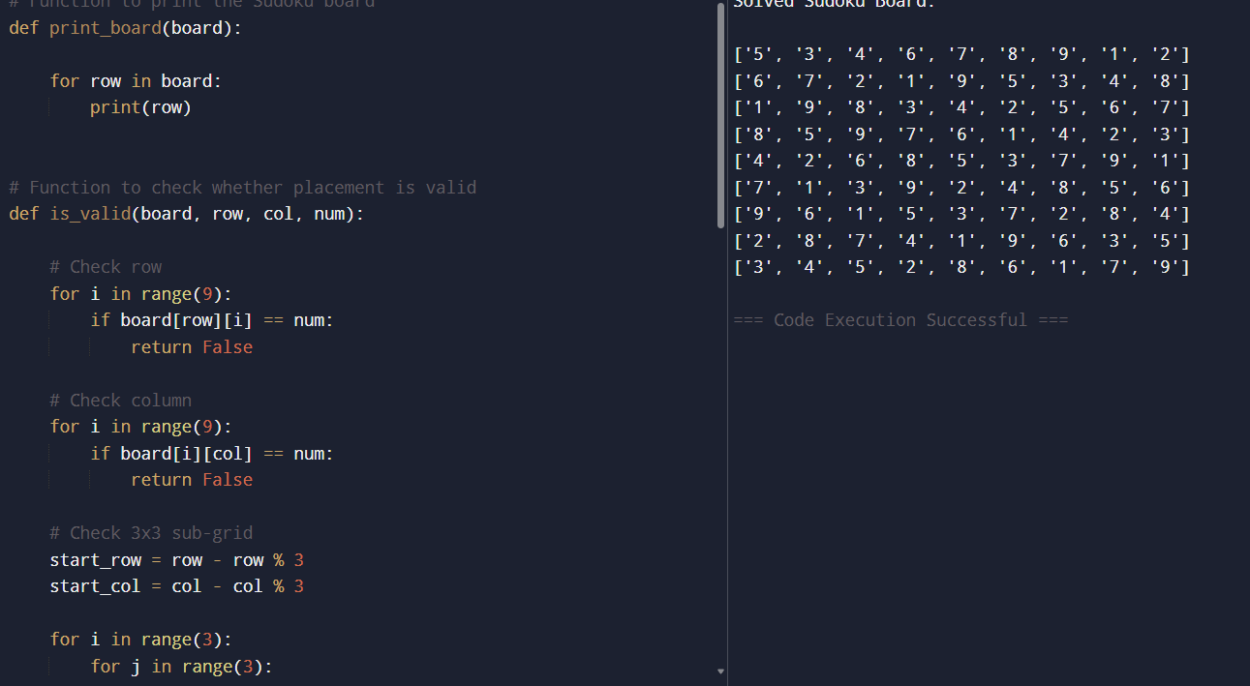

RESULT :
The program successfully solves the Sudoku puzzle using the backtracking technique.
The empty cells represented by '.' are filled correctly such that:
- Each digit from 1 to 9 appears exactly once in every row.
- Each digit from 1 to 9 appears exactly once in every column.
- Each digit from 1 to 9 appears exactly once in every 3×3 sub-grid.
Solved Sudoku Board:
["5","3","4","6","7","8","9","1","2"]
["6","7","2","1","9","5","3","4","8"]
["1","9","8","3","4","2","5","6","7"]
5.

AIM :
To find the number of different ways to assign + and - signs to elements in an array such that the resulting expression evaluates to a given target sum.

Algorithm

Step 1:
Start from the first index of the array with an initial sum of 0.

Step 2:
At each index, we have two choices:
- Add the current number (+nums[i])
- Subtract the current number (-nums[i])

Step 3:
Recursively explore both possibilities for each element.

Step 4:
If we reach the end of the array:
- Check if the current sum equals the target.
- If yes, count this as one valid expression.

Step 5:
Return the total count of valid expressions.

Step 6 (Optimization idea):
Memoization can be used to store repeated states (index, current_sum).

PROGRAM :
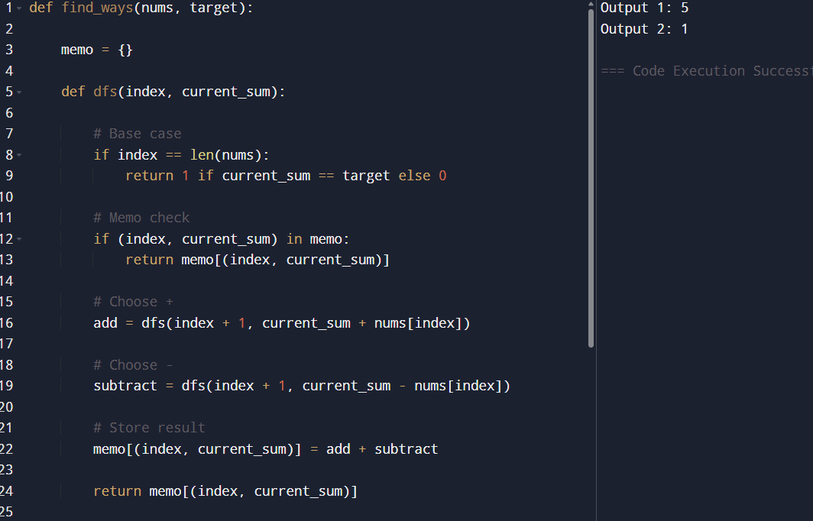

RESULT :
For Example 1:
Input:
- nums = [1,1,1,1,1]
- target = 3
Output:
5
Explanation:
There are 5 different ways to assign + and - signs to reach the target sum of 3.

6.

AIM :
To find the sum of the minimum values of all possible contiguous subarrays of a given array using an efficient stack-based approach.

Algorithm

Step 1:
For each element, determine how many subarrays it is the minimum in.

Step 2:
Use a monotonic increasing stack to find:
- Previous smaller element (PLE)
- Next smaller element (NSE)

Step 3:
For each element arr[i]:
- Count how many subarrays it contributes as minimum:
  - Left distance = distance to previous smaller element
  - Right distance = distance to next smaller element

Step 4:
Contribution formula:
arr[i]×(left count)×(right count)arr[i] \times (\text{left count}) \times (\text{right count})arr[i]×(left count)×(right count)

Step 5:
Sum all contributions and return result modulo 109+710^9 + 7109+7.

PROGRAM :

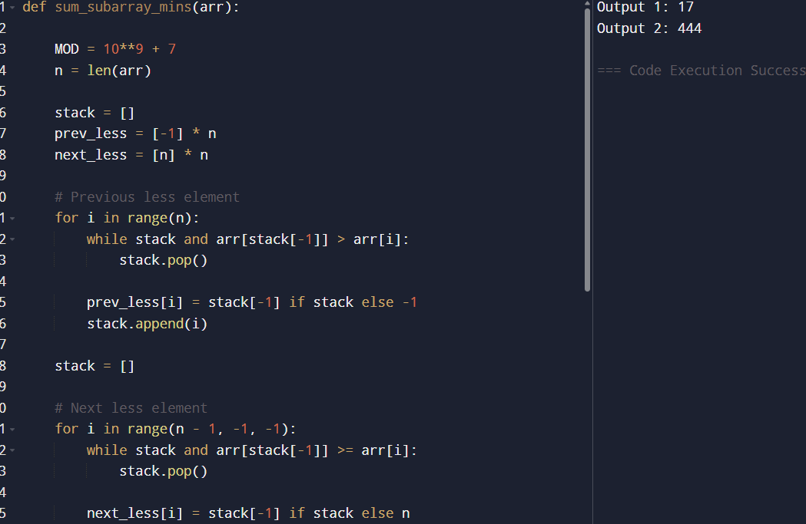

RESULT :
Input:
- arr = [3,1,2,4]
Output:
17
Explanation:
All subarray minimums sum up to 17.

7.
AIM :
To find all unique combinations of given candidate numbers that sum up to a target value, where each number can be used unlimited times, using a backtracking approach.

Algorithm

Step 1:
Sort the candidates array (helps in pruning and avoiding unnecessary recursion).

Step 2:
Use backtracking starting from index 0.

Step 3:
At each step:
- Include the current number and reduce the target.
- Since repetition is allowed, stay at the same index.

Step 4:
If target becomes:
- 0 → valid combination found
- < 0 → invalid path, stop exploration

Step 5:
Backtrack and try next candidate.

Step 6:
Store all valid combinations.

PROGRAM :

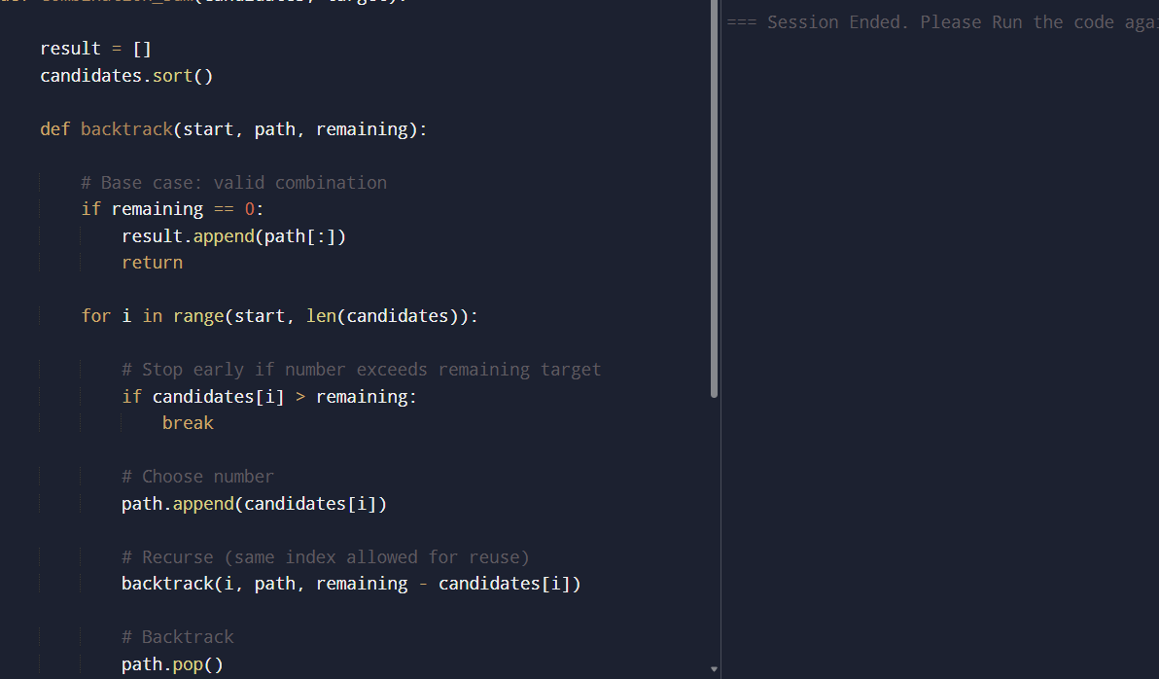

RESULT :
The program successfully generates all unique combinations that sum to the target using backtracking. It efficiently explores valid paths while pruning invalid ones, ensuring no duplicates and optimal performance for constrained inputs.
Input:
- candidates = [2,3,5]
- target = 8
Output:
[[2, 2, 2, 2], [2, 3, 3], [3, 5]]
Explanation:
All unique combinations are found using backtracking with repetition allowed.

8.

AIM :
To find all unique combinations of candidate numbers that sum to a given target where each number can be used only once in each combination.

Algorithm

Step 1:
Sort the candidate array to handle duplicates efficiently.

Step 2:
Use backtracking to generate combinations.

Step 3:
At each recursive call:
- Choose a candidate number.
- Reduce the remaining target value.
- Move to the next index since each number can be used only once.

Step 4:
Skip duplicate elements to avoid repeated combinations.

Step 5:
If the remaining target becomes:
- 0 → valid combination found
- < 0 → stop recursion

Step 6:
Store all unique valid combinations.

PROGRAM :

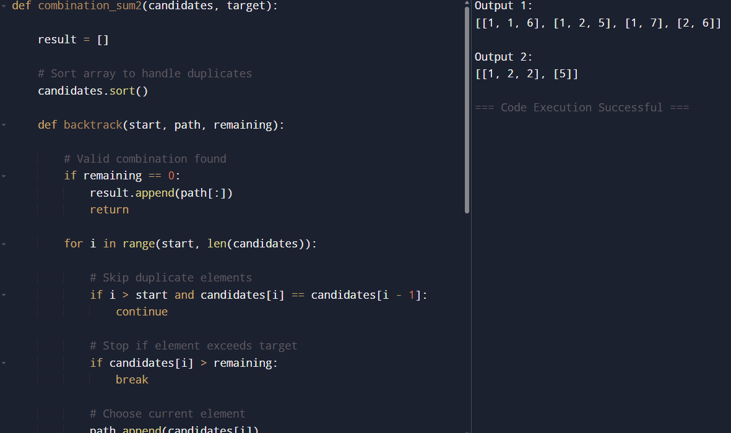

RESULT :
Input:
- candidates = [10,1,2,7,6,1,5]
- target = 8
Output:
[
[1,1,6],
[1,2,5],
[1,7],
[2,6]
]
Explanation:
Each number is used only once, and duplicate combinations are avoided
9.
AIM :
To generate all possible permutations of a given array of distinct integers using the backtracking technique.

Algorithm

Step 1:
Create an empty list to store all permutations.

Step 2:
Use backtracking to build permutations.

Step 3:
At each recursive call:
- Choose an unused element.
- Add it to the current permutation.

Step 4:
Mark the chosen element as visited.

Step 5:
Recursively generate the remaining permutation.

Step 6:
When the current permutation length equals the array length:
- Store the permutation in the result list.

Step 7:
Backtrack by:
- Removing the last element.
- Marking it as unvisited.

Step 8:
Repeat until all permutations are generated.
PROGRAM :
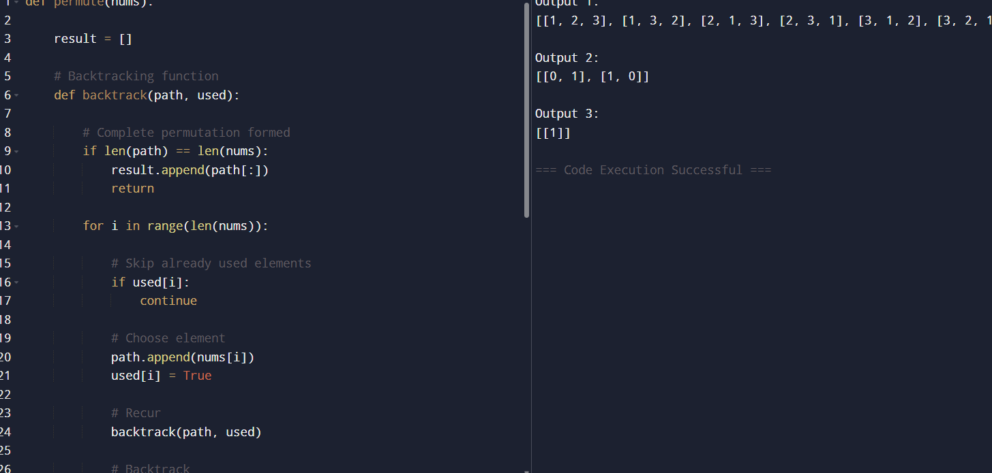

RESULT :
Input:
- nums = [0,1]
Output:
[[0,1],
[1,0]]
Explanation:
Two possible permutations are generated

10.

AIM :
To generate all unique permutations of a given array that may contain duplicate elements using the backtracking technique.

Algorithm

Step 1:
Sort the input array to easily detect duplicates.

Step 2:
Create:
- A result list to store permutations.
- A visited array to track used elements.

Step 3:
Use backtracking to generate permutations.

Step 4:
At each recursive step:
- Skip already used elements.
- Skip duplicate elements if the previous duplicate has not been used.

Step 5:
Choose the current element:
- Add it to the current permutation.
- Mark it as visited.

Step 6:
Recursively continue building the permutation.

Step 7:
When permutation length equals array length:
- Store the permutation in the result list.

Step 8:
Backtrack by:
- Removing the element.
- Marking it as unused.
PROGRAM :
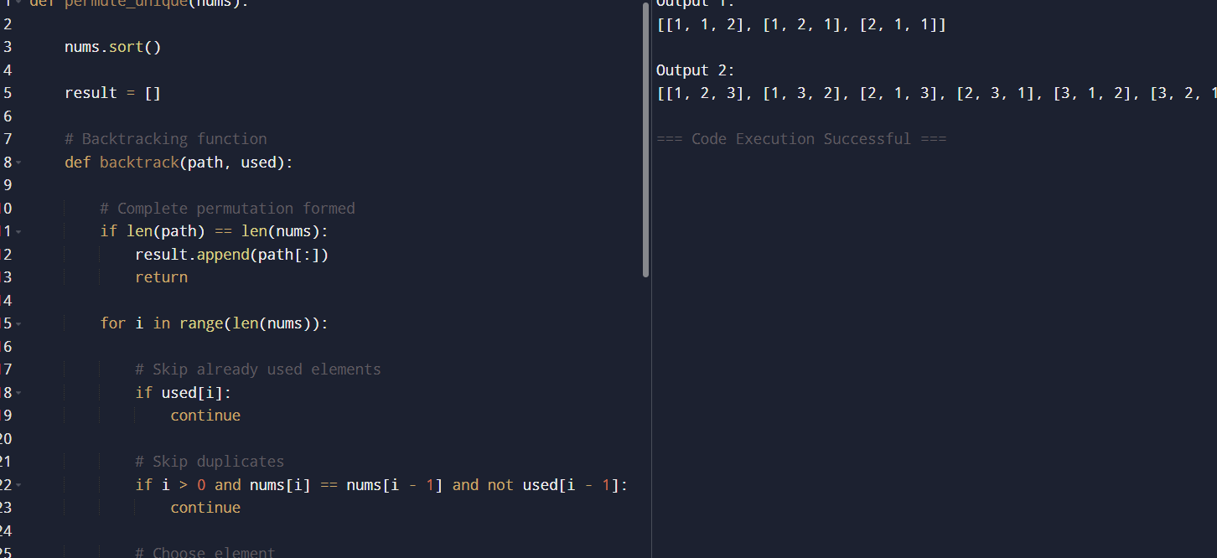

RESULT :
Input:
- nums = [1,2,3]
Output:
[
[1,2,3],
[1,3,2],
[2,1,3],
[2,3,1],
[3,1,2],
[3,2,1]
]
Explanation:
All possible unique permutations are generated since all elements are distinct

11.

AIM :
To implement the Graph Coloring technique for an undirected graph using the minimum number of colors and determine the maximum number of regions that can be colored by the first player.

Algorithm

Step 1:
Represent the graph using an adjacency list.

Step 2:
Initialize all vertices as uncolored.

Step 3:
Use backtracking to assign colors to vertices such that:
- No two adjacent vertices have the same color.

Step 4:
For each vertex:
- Try assigning one of the available colors.
- Check whether the color assignment is safe.

Step 5:
If safe:
- Assign the color.
- Move to the next vertex.

Step 6:
Continue until all vertices are colored.

Step 7:
Simulate turns among:
- You
- Alice
- Bob

Step 8:
Count the number of vertices colored by you.

Step 9:
Display the valid coloring and maximum regions colored by you.

PROGRAM :

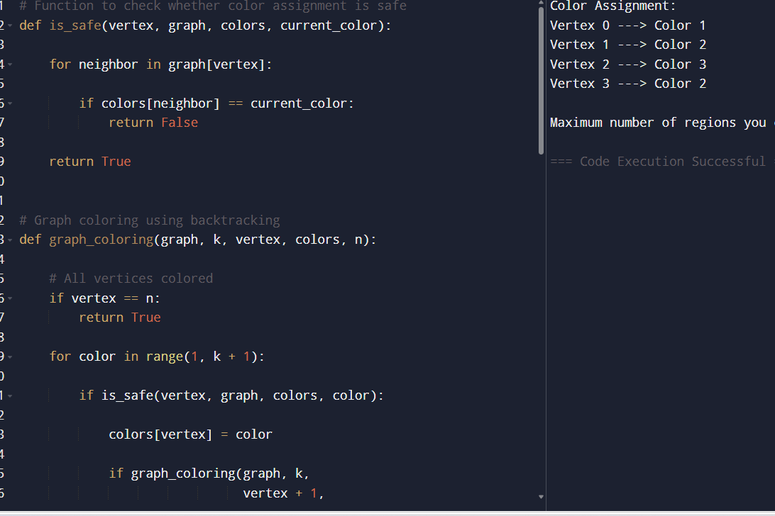

RESULT :

Thus, the program successfully implements graph coloring using the minimum number of colors and computes the maximum regions colored by the first player.

12.

AIM :
To determine whether a Hamiltonian Cycle exists in a given undirected graph using the backtracking algorithm.

Algorithm

Step 1:
Represent the graph using an adjacency list.

Step 2:
Start the path with vertex 0.

Step 3:
Recursively try to add vertices to the path.

Step 4:
Before adding a vertex, check:
- The vertex is adjacent to the previously added vertex.
- The vertex has not already been included in the path.

Step 5:
If all vertices are included:
- Check whether the last vertex connects back to the starting vertex.
- If yes, a Hamiltonian Cycle exists.

Step 6:
If no valid vertex can be added:
- Remove the last added vertex.
- Backtrack and try another vertex.

Step 7:
Return:
- True if Hamiltonian Cycle exists.
- False otherwise

PROGRAM :

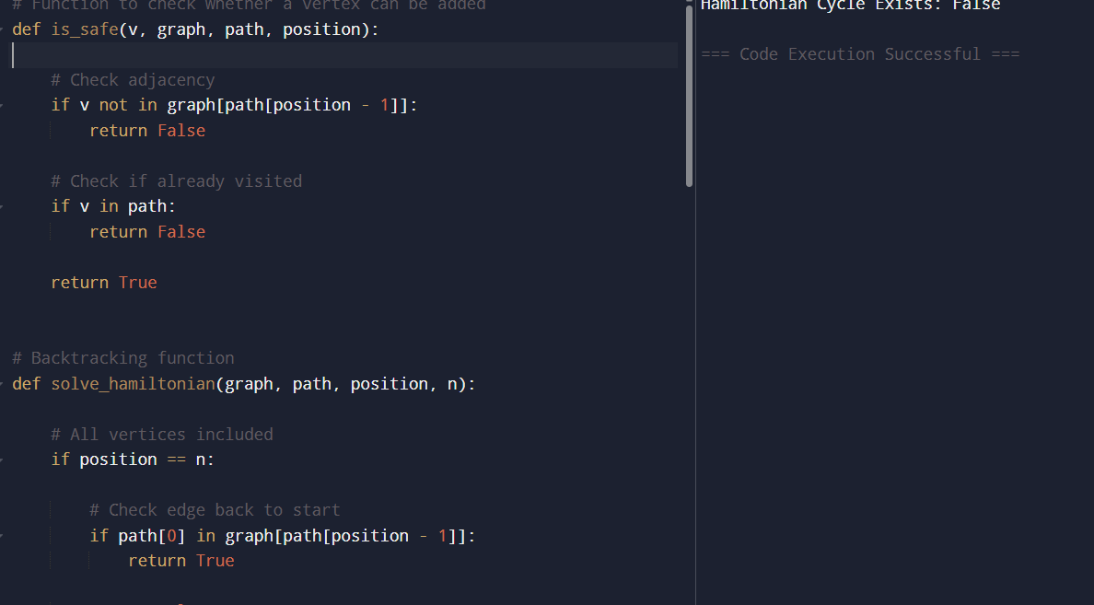

RESULT :
Input:
- Number of vertices = 5
- Edges = [(0,1), (1,2), (2,3), (3,0), (0,2), (2,4), (4,0)]
Output:
Hamiltonian Cycle Exists: True
Example cycle:
0 -> 1 -> 2 -> 4 -> 3 -> 0
Explanation:
The graph contains a Hamiltonian Cycle because every vertex is visited exactly once and the path returns to the starting vertex.
Thus, the program successfully checks for the existence of a Hamiltonian Cycle using the backtracking technique.

13.

AIM :
To determine whether a Hamiltonian Cycle exists in a given undirected graph using the backtracking algorithm.

Algorithm

Step 1:
Represent the graph using an adjacency list.

Step 2:
Start the cycle from vertex 0.

Step 3:
Add vertices one by one to the path.

Step 4:
Before adding a vertex, check:
- The vertex is adjacent to the previously added vertex.
- The vertex has not already been visited.

Step 5:
If all vertices are included in the path:
- Check whether the last vertex connects back to the starting vertex.
- If yes, Hamiltonian Cycle exists.

Step 6:
If a vertex cannot be added:
- Remove the last vertex.
- Backtrack and try another vertex.

Step 7:
Return True if a Hamiltonian Cycle exists; otherwise return False.

PROGRAM :
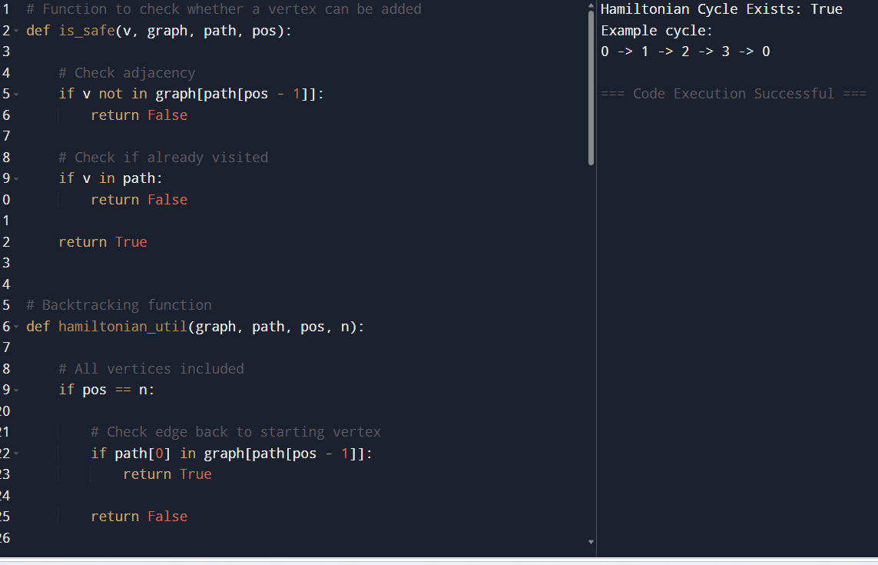

RESULT :
Input:
- Number of vertices = 4
- Edges = [(0,1), (1,2), (2,3), (3,0), (0,2)]
Output:
Hamiltonian Cycle Exists: True
Example cycle:
0 -> 1 -> 2 -> 3 -> 0
Explanation:
The graph contains a Hamiltonian Cycle because every vertex is visited exactly once and the cycle returns to the starting vertex.
Thus, the program successfully determines the existence of a Hamiltonian Cycle using the backtracking technique.

14.
AIM :
To generate all possible subsets of a given set in lexicographical order using the backtracking technique and analyze how duplicate elements are handled.
Algorithm :

Step 1:
Sort the input array to maintain lexicographical order.

Step 2:
Initialize an empty list to store all subsets.

Step 3:
Use backtracking to generate subsets.

Step 4:
At each recursive call:
- Add the current subset to the result list.
- Recursively include the next elements.

Step 5:
Continue until all elements are processed.

Step 6:
If duplicate elements exist:
- Skip repeated elements to avoid duplicate subsets.

Step 7:
Return the list of all subsets.

PROGRAM :
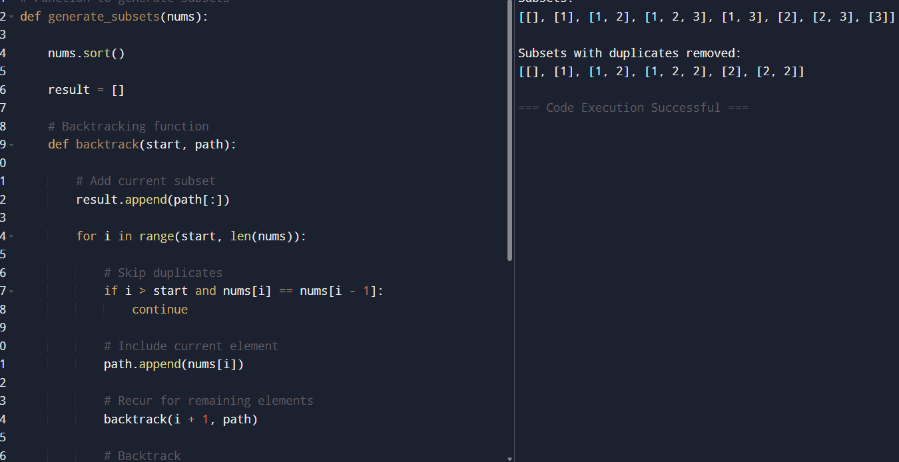

RESULT :
Input:
- A = [1, 2, 3]
Output:
[
[],
[1],
[1, 2],
[1, 2, 3],
[1, 3],
[2],
[2, 3],
[3]
]
Explanation:
All possible subsets of the set are generated in lexicographical order.

15.

AIM :
To generate all possible subsets (power set) of a given set of unique integers and specifically generate subsets containing a given element using the backtracking technique.

Algorithm

Step 1:
Initialize an empty list to store all subsets.

Step 2:
Use backtracking to generate subsets.

Step 3:
At each recursive call:
- Add the current subset to the result list.
- Include the next element recursively.

Step 4:
To generate subsets containing a specific element x:
- Filter only those subsets that contain x.

Step 5:
Continue until all elements are processed.

Step 6:
Return:
- All subsets (power set)
- Subsets containing the given element

PROGRAM :
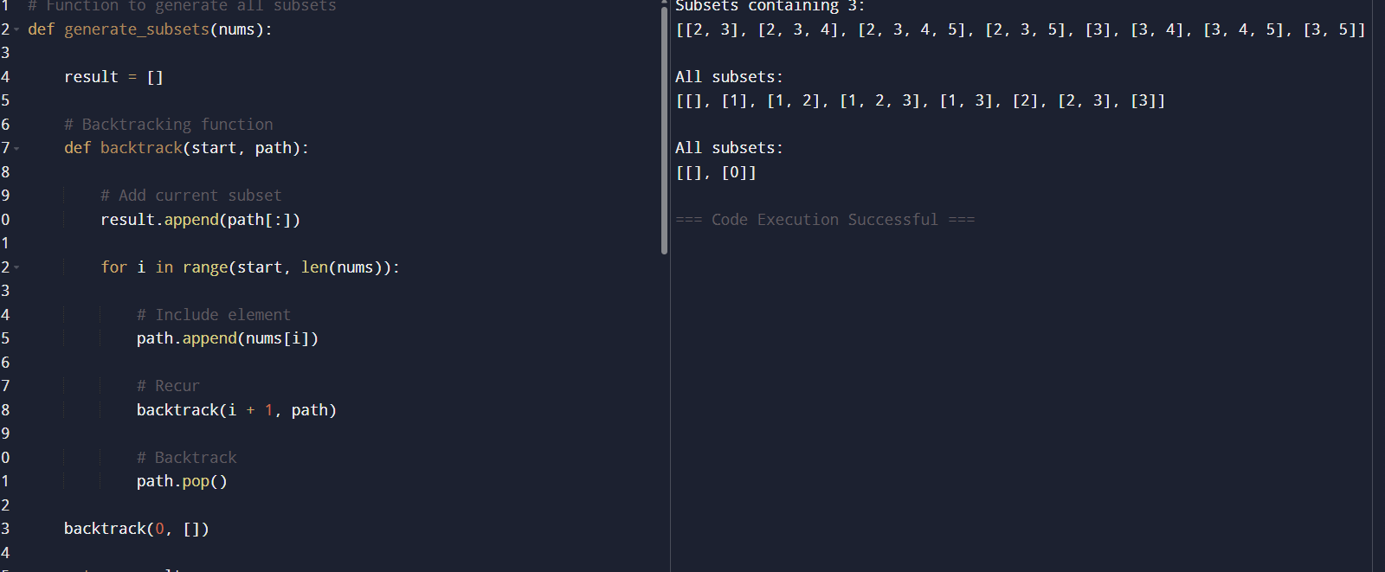

RESULT :
Input:
- E = [2, 3, 4, 5]
- x = 3
Output:
[
[3],
[2, 3],
[3, 4],
[3, 5],
[2, 3, 4],
[2, 3, 5],
[3, 4, 5],
[2, 3, 4, 5]
]
Explanation:
All subsets containing the element 3 are generated successfully.

16.

AIM :
To find all universal strings in words1 such that every string in words2 is a subset of those strings.

Algorithm

Step 1:
For each word in words2, calculate the maximum frequency required for every character.

Step 2:
Create a combined frequency map representing the highest occurrence of each character needed.

Step 3:
For every word in words1:
- Count the frequency of each character.
- Check whether it satisfies all frequency requirements from words2.

Step 4:
If the word contains all required characters with correct multiplicity:
- Add it to the result list.

Step 5:
Return the list of universal strings.

PROGRAM :

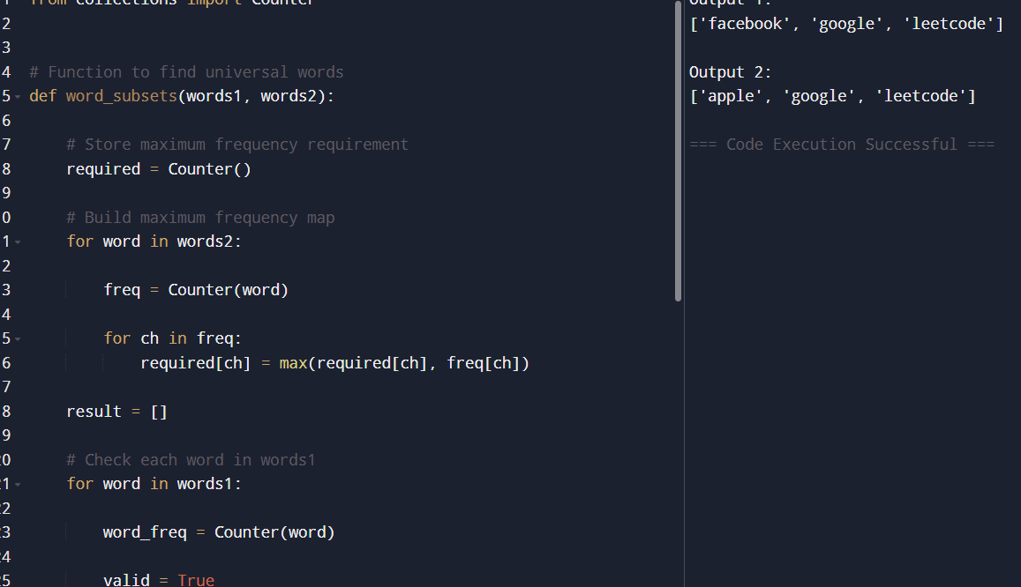

RESULT :
Input:
- words1 = ["amazon","apple","facebook","google","leetcode"]
- words2 = ["e","o"]
Output:
["facebook", "google", "leetcode"]
Explanation:
These words contain both 'e' and 'o'.

