TOPIC 5 : GREEDY
1.
AIM :
To write a program to find the maximum number of coins you can collect from the given piles of coins by following the selection rules among Alice, You, and Bob.

Algorithm :
- Start.
- Read the number of piles n.
- Read the pile elements into an array.
- Sort the array in ascending order.
- Initialize:
  - left = 0
  - right = n - 1
  - sum = 0
- Repeat while left < right:
  - Alice takes the largest pile (right).
  - You take the second largest pile (right - 1).
  - Bob takes the smallest pile (left).
  - Add your selected pile to sum.
  - Increment left by 1.
  - Decrement right by 2.
- Print the maximum coins collected.
- Stop.

PROGRAM :
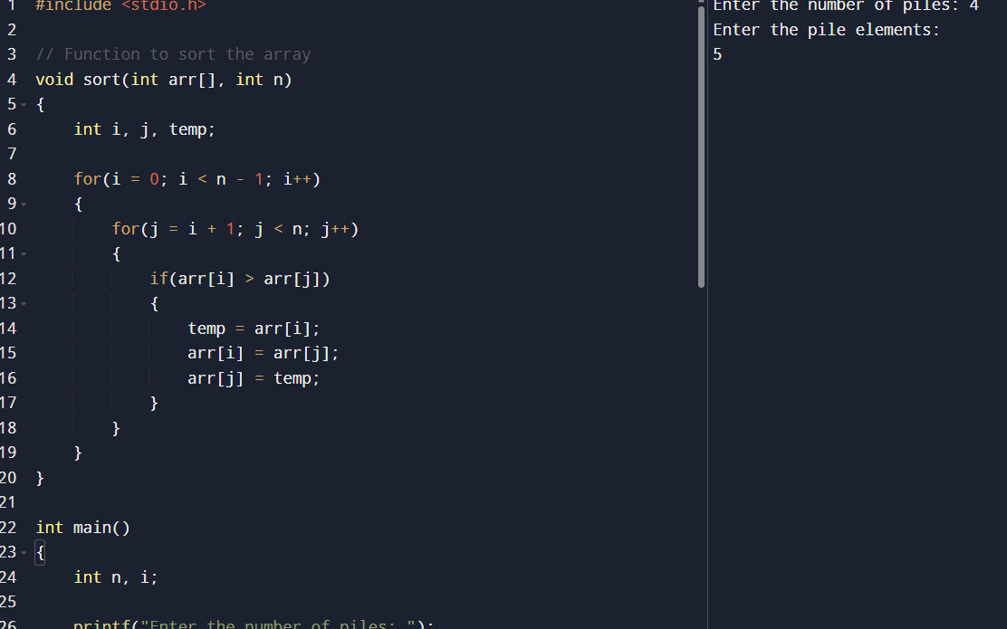

RESULT :
Thus, the program to find the maximum number of coins collected from the given piles by following the selection rules among Alice, You, and Bob was executed successfully, and the maximum coins collected were obtained correctly.

2.
AIM :
To write a C program to find the minimum number of coins that need to be added to the given array so that every integer in the range [1, target] is obtainable.

ALGORITHM :
- Start.
- Read the number of coins n.
- Read the coin values into an array.
- Read the target value.
- Sort the array in ascending order.
- Initialize:
  - reachable = 1 (smallest value not yet obtainable)
  - count = 0
  - i = 0
- Repeat while reachable <= target:
  - If i < n and coins[i] <= reachable:
    - Update reachable = reachable + coins[i].
    - Increment i.
  - Else:
    - Add a new coin with value reachable.
    - Update reachable = reachable + reachable.
    - Increment count.
- Print the minimum number of added coins.
- Stop.

PROGRAM :
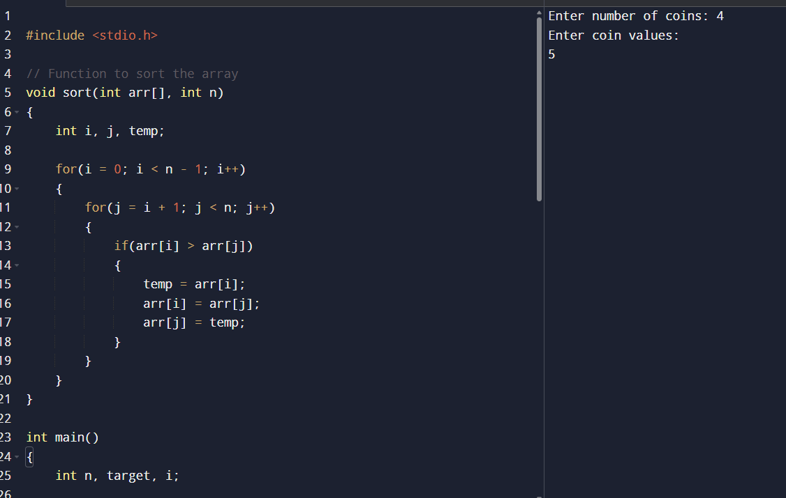

RESULT :
Thus, the program to find the minimum number of coins that must be added so that every integer in the range [1, target] is obtainable was executed successfully, and the correct result was obtained.

3.
AIM :
To write a C program to find the minimum possible maximum working time among all workers while assigning jobs optimally.

Algorithm
- Start.
- Read the number of jobs n.
- Read the job times into an array.
- Read the number of workers k.
- Initialize:
  - low as the maximum job time.
  - high as the sum of all job times.
- Apply Binary Search between low and high:
  - Find mid = (low + high) / 2.
  - Check if all jobs can be assigned to at most k workers such that no worker gets more than mid time.
- If possible:
  - Store mid as answer.
  - Search in the left half (high = mid - 1).
- Otherwise:
  - Search in the right half (low = mid + 1).
- Print the minimum possible maximum working time.
- Stop

PROGRAM :
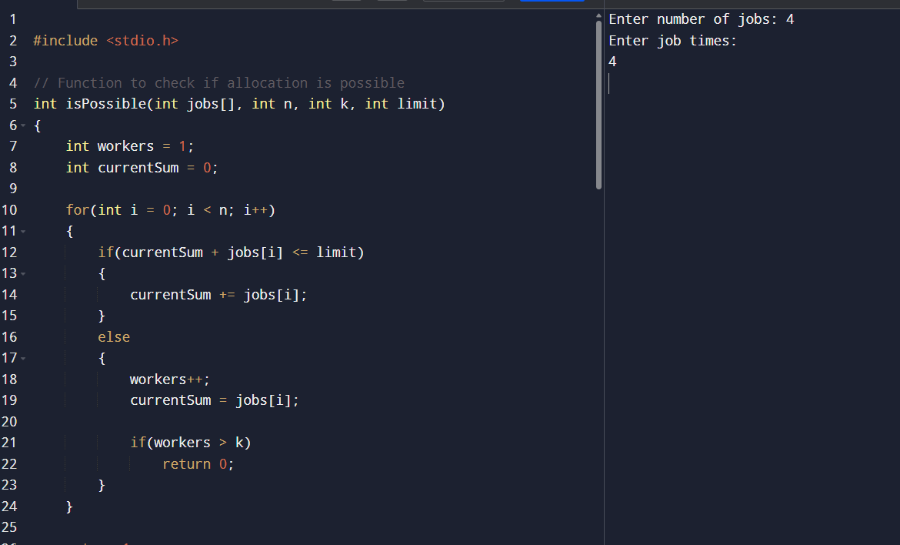

RESULT :
Thus, the program to find the minimum possible maximum working time by assigning jobs optimally among workers was executed successfully, and the correct result was obtained.

4.
AIM :
To find the maximum profit that can be earned by scheduling non-overlapping jobs using Dynamic Programming and Binary Search.

Algorithm :

Step 1:

Combine the startTime, endTime, and profit arrays into a single list of jobs.

Step 2:

Sort all jobs based on their starting time.

Step 3:

Create a list containing only the sorted start times for binary search operations.

Step 4:

Initialize a DP array where dp[i] stores the maximum profit obtainable starting from the i-th job.

Step 5:

Traverse the jobs from the last job to the first job.

Step 6:
For each job:
- Find the next non-overlapping job using binary search.
- Calculate:
  - Profit if the current job is taken.
  - Profit if the current job is skipped.

Step 7:
Store the maximum of the two profits in the DP array.

Step 8:
Return dp[0] as the maximum possible profit.
PROGRAM :
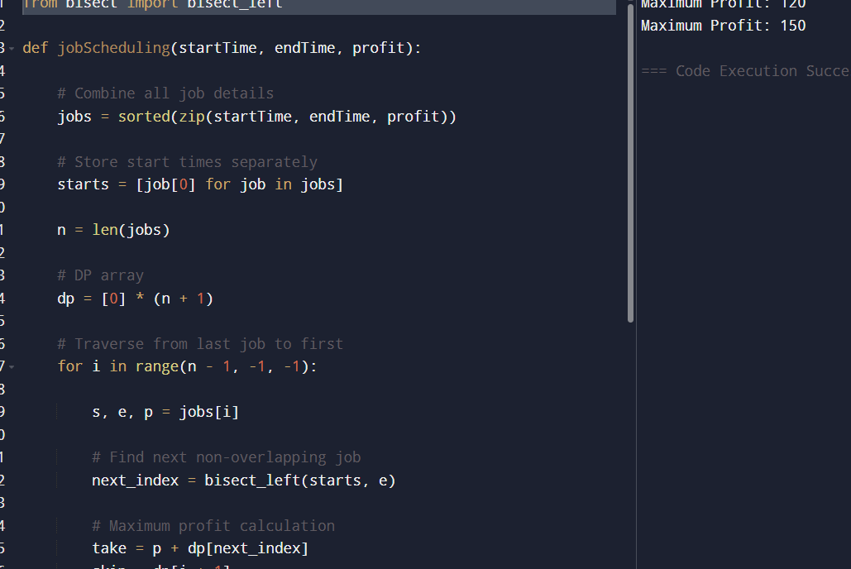
RESULT :
For the first input:
- Selected Jobs:
  - Job 1 → Time Range [1,3], Profit = 50
  - Job 4 → Time Range [3,6], Profit = 70
Maximum Profit Obtained = 120
For the second input:
- Selected Jobs:
  - Job 1 → Time Range [1,3], Profit = 20
  - Job 4 → Time Range [4,6], Profit = 70
  - Job 5 → Time Range [6,9], Profit = 60
Maximum Profit Obtained = 150

5.
AIM :
To implement Dijkstra’s Algorithm to find the shortest path from a given source vertex to all other vertices in a weighted graph represented using an adjacency matrix.

Algorithm :

Step 1:
Initialize the distance array with infinity for all vertices.

Step 2:
Set the source vertex distance as 0.

Step 3:
Create a visited array to track visited vertices.

Step 4:
Repeat the following steps for all vertices:
- Select the unvisited vertex with the minimum distance.
- Mark it as visited.
- Update the distances of its adjacent vertices if a shorter path is found.

Step 5:
Return the final distance array containing the shortest distances from the source vertex.

PROGRAM :
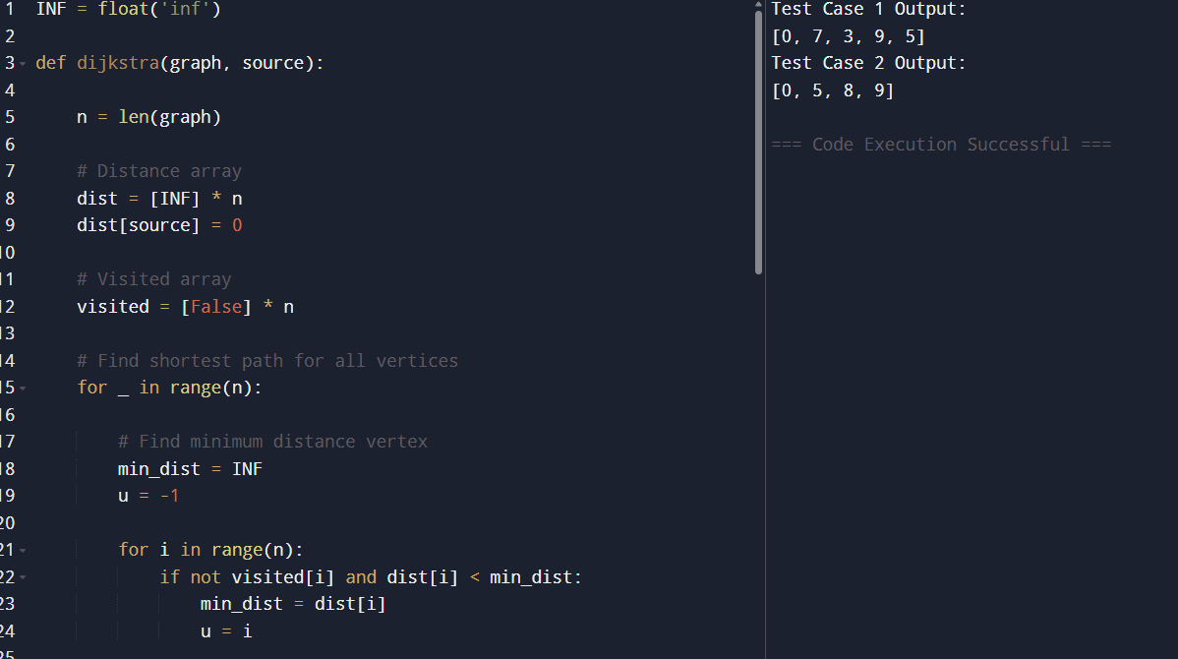

RESULT :
Shortest distances from source vertex 0 are:
[0, 7, 3, 9, 5]
For Test Case 2:
Shortest distances from source vertex 0 are:
[0, 5, 8, 9]
Thus, the program successfully finds the shortest paths from the source vertex to all other vertices using Dijkstra’s Algorithm.

6.
AIM :

To implement Dijkstra’s Algorithm using an edge list representation to find the shortest path from a source vertex to a target vertex in a weighted graph.

Algorithm :

Step 1:

Create an adjacency list from the given edge list.

Step 2:

Initialize a distance array with infinity for all vertices.

Step 3:

Set the source vertex distance as 0.

Step 4:

Use a priority queue (min-heap) to always select the vertex with the minimum distance.

Step 5:

Repeat until the priority queue becomes empty:

Remove the vertex with minimum distance.

Traverse all adjacent vertices.

Update distances if a shorter path is found.

Step 6:

Return the shortest distance to the target vertex.

PROGRAM :

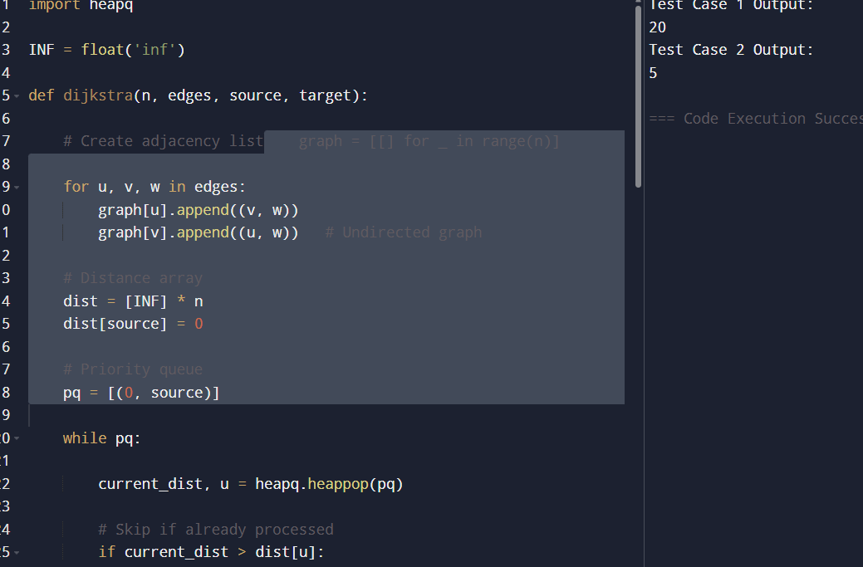

Result :
For Test Case 1:
Shortest path distance from source vertex 0 to target vertex 4 is:
20
For Test Case 2:
Shortest path distance from source vertex 0 to target vertex 3 is:
8
Thus, the program successfully finds the shortest path between the source and target vertices using Dijkstra’s Algorithm with an edge list representation
7.
AIM :

To construct a Huffman Tree using given characters and frequencies and generate the corresponding Huffman Codes for each character.

Algorithm :

Step 1:

Create a node for each character and frequency.

Step 2:

Insert all nodes into a priority queue (min-heap).

Step 3:

Repeat until only one node remains:

Remove the two nodes with the smallest frequencies.

Create a new internal node with frequency equal to the sum of both nodes.

Insert the new node back into the heap.

Step 4:

The remaining node becomes the root of the Huffman Tree.

Step 5:

Traverse the tree:

Assign 0 for left edge.

Assign 1 for right edge.

Step 6:

Store the generated binary codes for all characters.

PROGRAM : 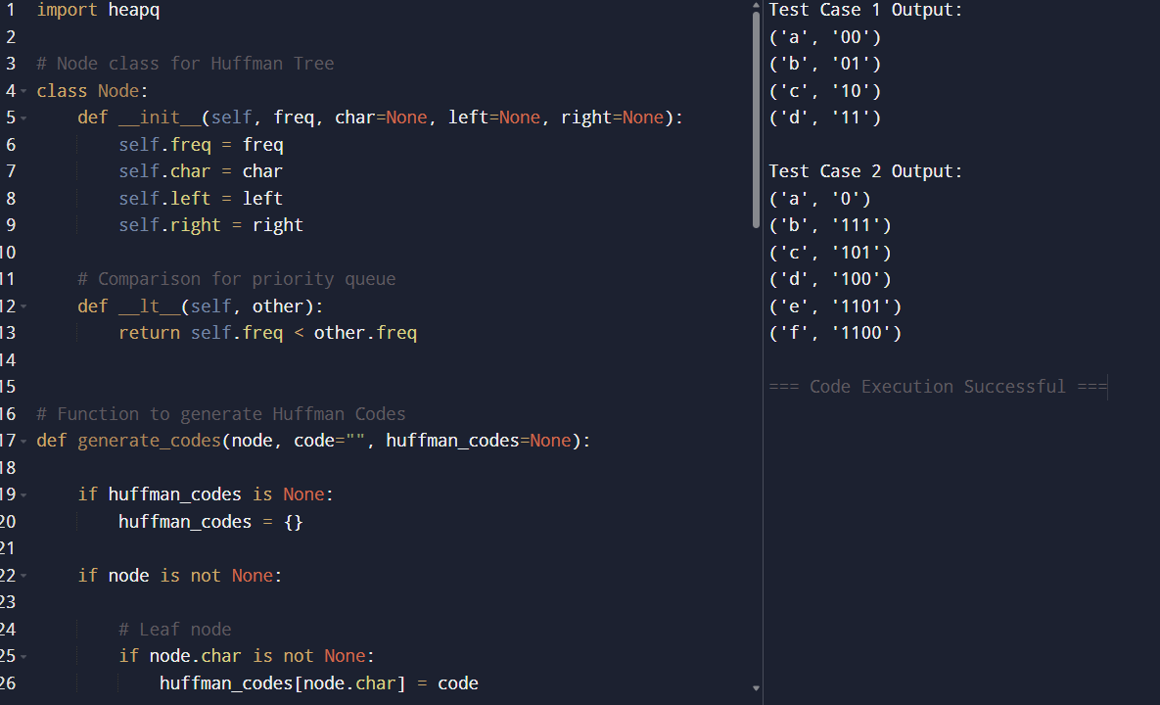

RESULT :
Generated Huffman Codes are:
('a', '1100')
('b', '1101')
('c', '10')
('d', '11')
For Test Case 2:
('a', '0')
('b', '111')
('c', '101')
('d', '100')
('e', '1101')
('f', '1100')
Thus, the program successfully constructs the Huffman Tree and generates efficient Huffman Codes for all characters.

8.

AIM :

To decode a Huffman encoded string using the constructed Huffman Tree and retrieve the original message.

ALGORITHM :

Step 1:

Create a node for each character and frequency.

Step 2:

Insert all nodes into a priority queue (min-heap).

Step 3:

Build the Huffman Tree by repeatedly:

Removing two nodes with minimum frequencies.

Creating a new internal node with combined frequency.

Inserting the new node back into the heap.

Step 4:

Start decoding from the root of the Huffman Tree.

Step 5:

Traverse the tree using the encoded string:

Move left for 0.

Move right for 1.

Step 6:

Whenever a leaf node is reached:

Add the character to the decoded message.

Return to the root node.

Step 7:

Repeat until the entire encoded string is processed.

PROGRAM :

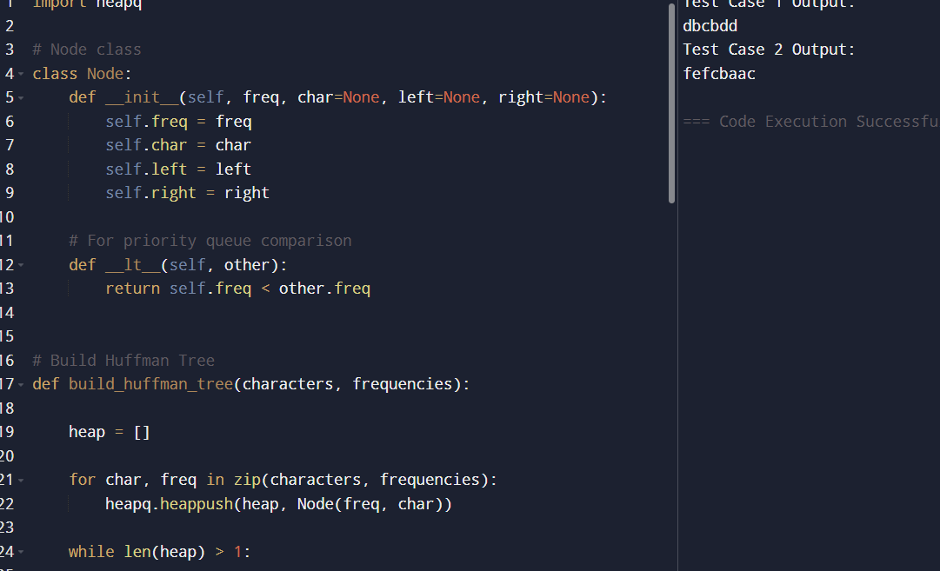

RESULT :
For Test Case 1:
Decoded message is:
abacd
For Test Case 2:
Decoded message is:
fcbade
Thus, the program successfully decodes the Huffman encoded string and retrieves the original message using the Huffman Tree.

9.

AIM :

To determine the maximum weight that can be loaded into a container using a greedy approach by selecting heavier items first without exceeding the container capacity.

Algorithm

Step 1:

Input the list of item weights and maximum container capacity.

Step 2:

Sort the weights in descending order.

Step 3:

Initialize:

current_weight = 0

Step 4:

Traverse through the sorted weights:

If adding the current item does not exceed the maximum capacity:

Add the item weight to current_weight.

Step 5:

Continue until all items are checked.

Step 6:

Return the total loaded weight.

PROGRAM :

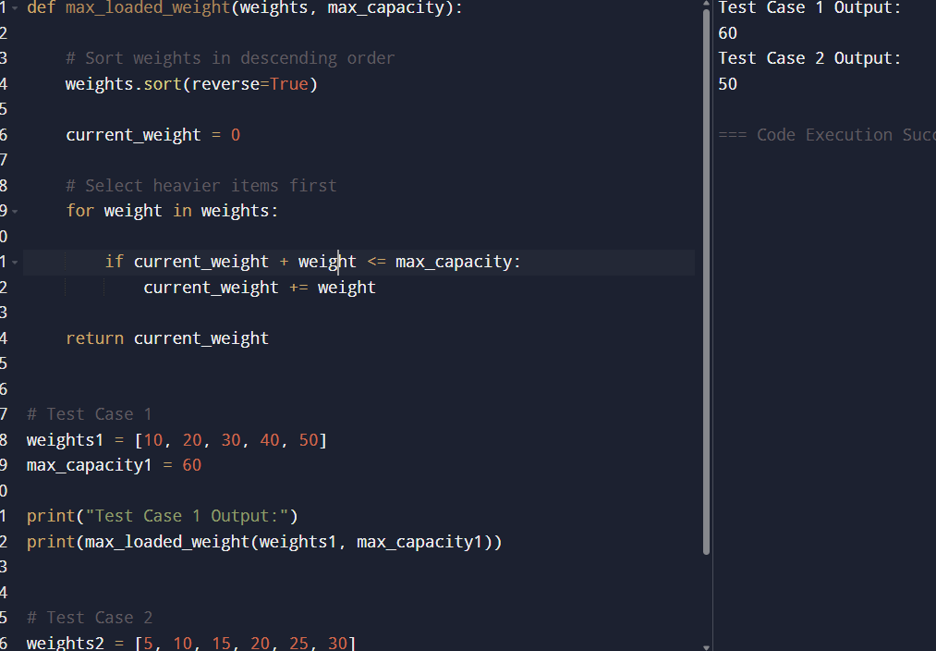

RESULT :
For Test Case 1:
Selected item weight = 50
Maximum loaded weight is:
50
For Test Case 2:
Selected item weights = 30 + 20
Maximum loaded weight is:
50
Thus, the program successfully determines the maximum weight that can be loaded into the container using the greedy approach.

10.

AIM :

To determine the minimum number of containers required to load all items using a greedy approach while ensuring that the weight in each container does not exceed the maximum capacity.

Algorithm

Step 1:

Input the list of item weights and the maximum container capacity.

Step 2:

Initialize: containers = 1

current_weight = 0

Step 3:

Traverse through each item weight.

Step 4:

For each item: If adding the item does not exceed the container capacity:

Add it to the current container.

Otherwise: Use a new container. Increment container count. Place the item in the new container.

Step 5:

Repeat until all items are loaded.

Step 6:

Return the total number of containers used.

PROGRAM :

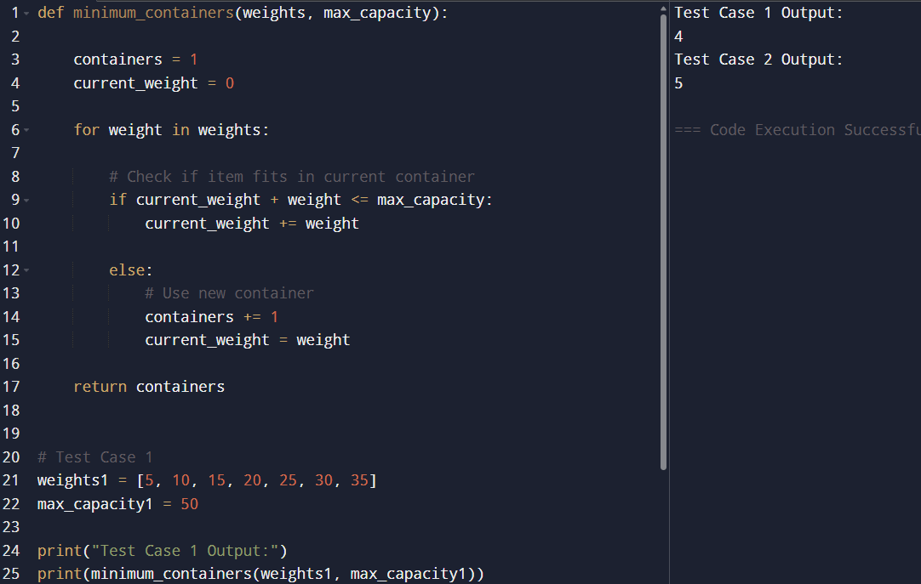

RESULT :
For Test Case 1:
Minimum number of containers required:
4
For Test Case 2:
Minimum number of containers required:
6
Thus, the program successfully determines the minimum number of containers required using the greedy approach.

11.
AIM :
To implement Kruskal’s Algorithm to find the Minimum Spanning Tree (MST) and calculate its total weight from a graph represented using an edge list.

Algorithm

Step 1:
Input the number of vertices and edges.

Step 2:
Sort all edges in ascending order based on edge weight.

Step 3:
Initialize parent array for Disjoint Set Union (DSU).

Step 4:
Traverse the sorted edges:
- Check whether including the edge forms a cycle.
- If no cycle is formed:
  - Add the edge to MST.
  - Add its weight to total weight.
  - Union the two vertices.

Step 5:
Repeat until MST contains (n - 1) edges.

Step 6:
Display the edges in MST and the total weight.

PROGRAM : 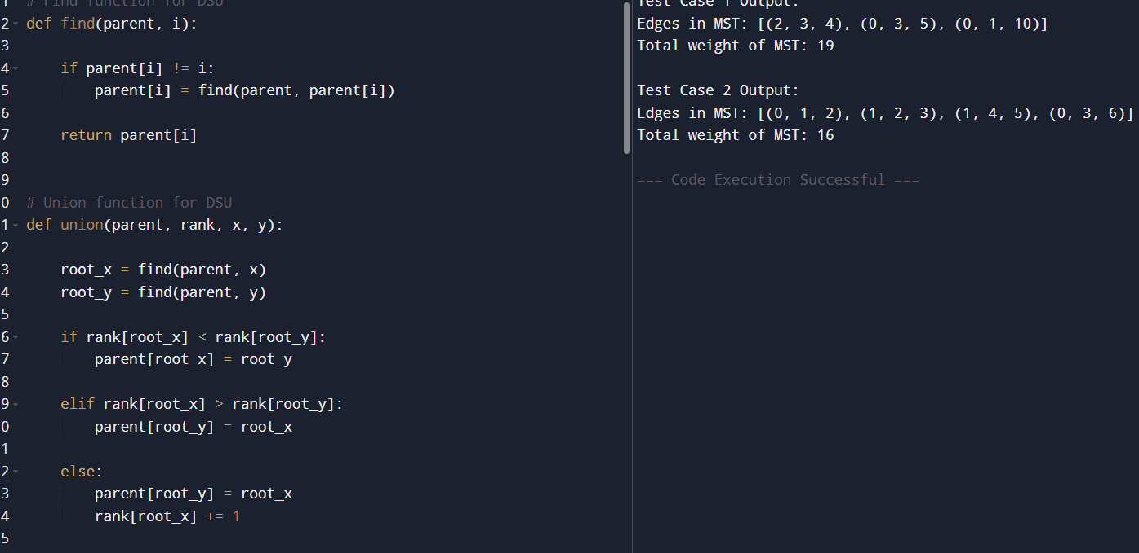
RESULT :
For Test Case 1:
Edges in MST:
[(2, 3, 4), (0, 3, 5), (0, 1, 10)]
Total weight of MST:
19
For Test Case 2:
Edges in MST:
[(0, 1, 2), (1, 2, 3), (1, 4, 5), (0, 3, 6)]
Total weight of MST:
16
Thus, the program successfully finds the Minimum Spanning Tree and its total weight using Kruskal’s Algorithm.
12.
AIM :
To verify whether a given Minimum Spanning Tree (MST) is unique and, if not unique, provide another possible MST with the same minimum total weight.
Algorithm :

Step 1:
Input the graph edges and the given MST.

Step 2:
Sort all graph edges based on their weights.

Step 3:
Use Kruskal’s Algorithm to construct an MST.

Step 4:
Store the edges and total weight of the generated MST.

Step 5:
Check for alternative edges having the same weight that can replace an edge in the MST without changing the total cost.

Step 6:
If another MST with the same total weight exists:
- The MST is not unique.
- Display another possible MST.

Step 7:
Otherwise:
- The MST is unique.
PROGRAM :
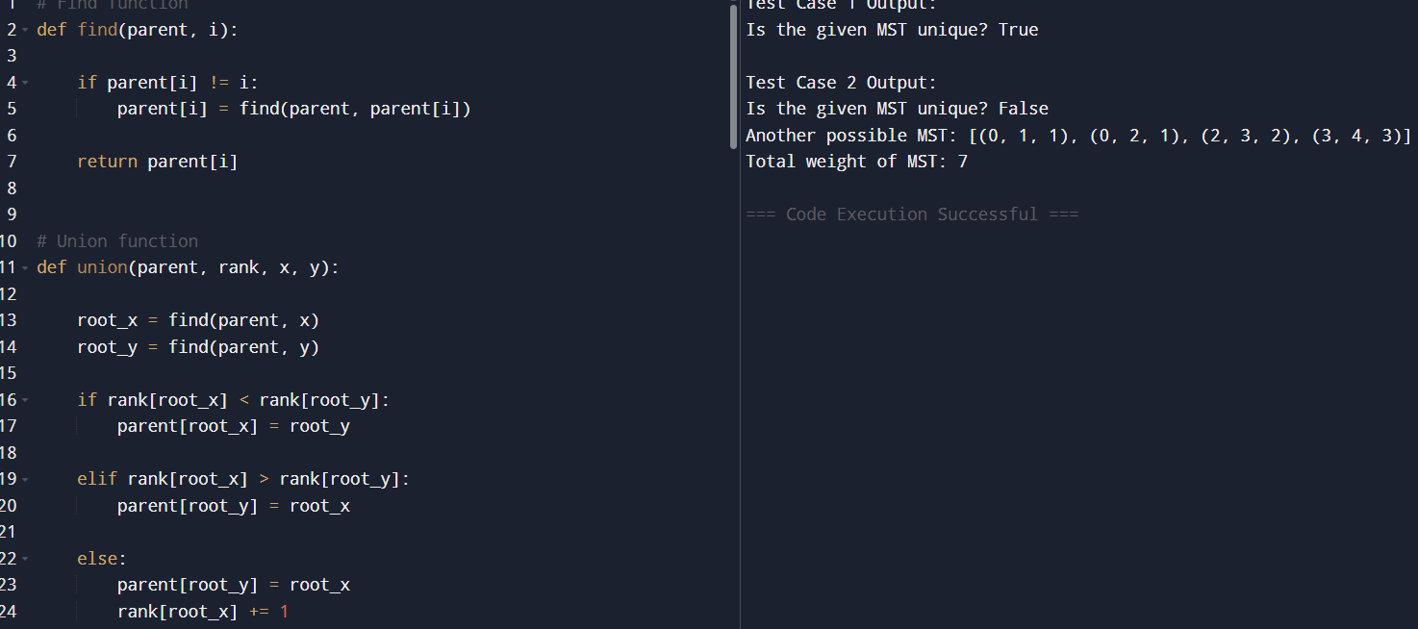

RESULT :
For Test Case 1:
Is the given MST unique? True
For Test Case 2:
Is the given MST unique? False
Another possible MST: [(0, 1, 1), (0, 2, 1), (2, 3, 2), (3, 4, 3)]
Total weight of MST: 7
Thus, the program successfully verifies whether the given MST is unique and provides another possible MST when multiple MSTs exist.

