TOPIC 2 : BRUTE FORCE
1.Write a program to perform the following An empty list A list with one element A list with all identical elements A list with negative numbers Test Cases: 1. Input: [] • Expected Output: [] 1. Input: [1] • Expected Output: [1] 2. Input: [7, 7, 7, 7] • Expected Output: [7, 7, 7, 7] 3. Input: [-5, -1, -3, -2, -4] • Expected Output: [-5, -4, -3, -2, -1]
AIM :
To write a program to sort a list and test it with different cases such as:
- An empty list
- A list with one element
- A list with identical elements
- A list with negative numbers

ALGORITHM
- Start the program.
- Define a sorting function.
- Read the input list.
- Use the sorting method to arrange elements in ascending order.
- Display the sorted list.
- Stop the program.

PROGRAM :

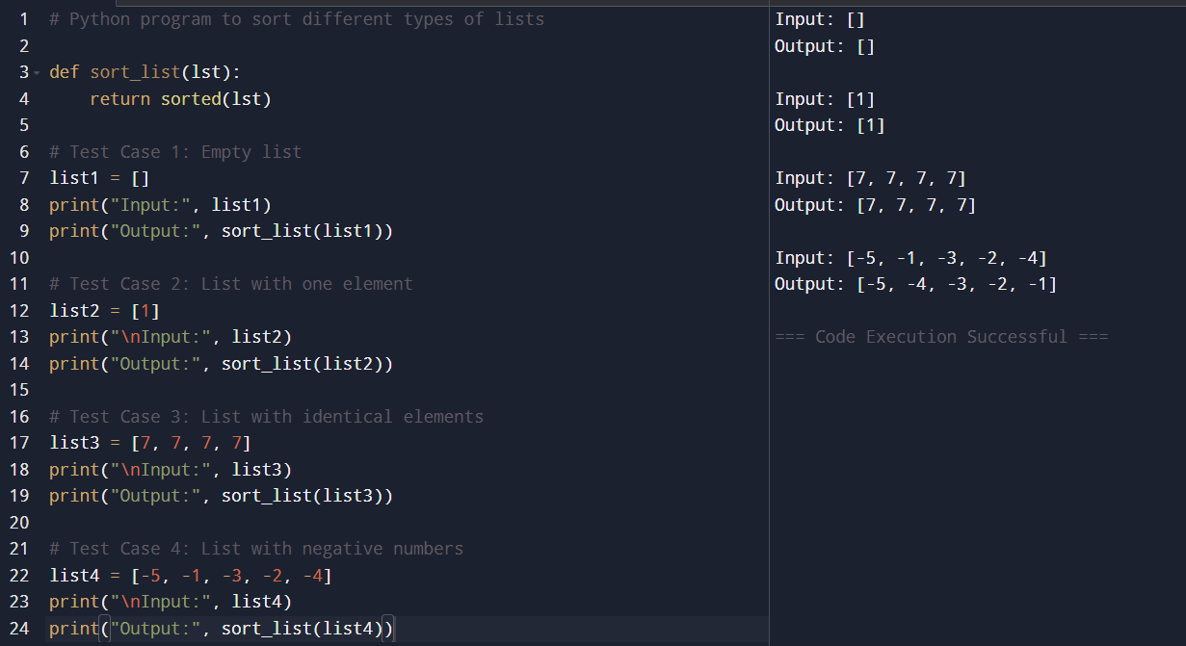

RESULT :
Thus, the program was executed successfully and produced the expected sorted output for all the given test cases.

2. Describe the Selection Sort algorithm's process of sorting an array. Selection Sort works by dividing the array into a sorted and an unsorted region. Initially, the sorted region is empty, and the unsorted region contains all elements. The algorithm repeatedly selects the smallest element from the unsorted region and swaps it with the leftmost unsorted element, then moves the boundary of the sorted region one element to the right. Explain why Selection Sort is simple to understand and implement but is inefficient for large datasets. Provide examples to illustrate step-by-step how Selection Sort rearranges the elements into ascending order, ensuring clarity in your explanation of the algorithm's mechanics and effectiveness. Sorting a Random Array: Input: [5, 2, 9, 1, 5, 6] Output: [1, 2, 5, 5, 6, 9] Sorting a Reverse Sorted Array: Input: [10, 8, 6, 4, 2] Output: [2, 4, 6, 8, 10] Sorting an Already Sorted Array: Input: [1, 2, 3, 4, 5] Output: [1, 2, 3, 4, 5]

AIM
To study and understand the working of the Selection Sort algorithm and demonstrate how it sorts arrays into ascending order using different examples.

ALGORITHM
- Start the program.
- Assume the first element is the minimum.
- Compare it with the remaining elements in the unsorted region.
- Find the smallest element.
- Swap the smallest element with the first unsorted element.
- Move the boundary of the sorted region one step to the right.
- Repeat the process until all elements are sorted.
- Stop the program

PROGRAM :
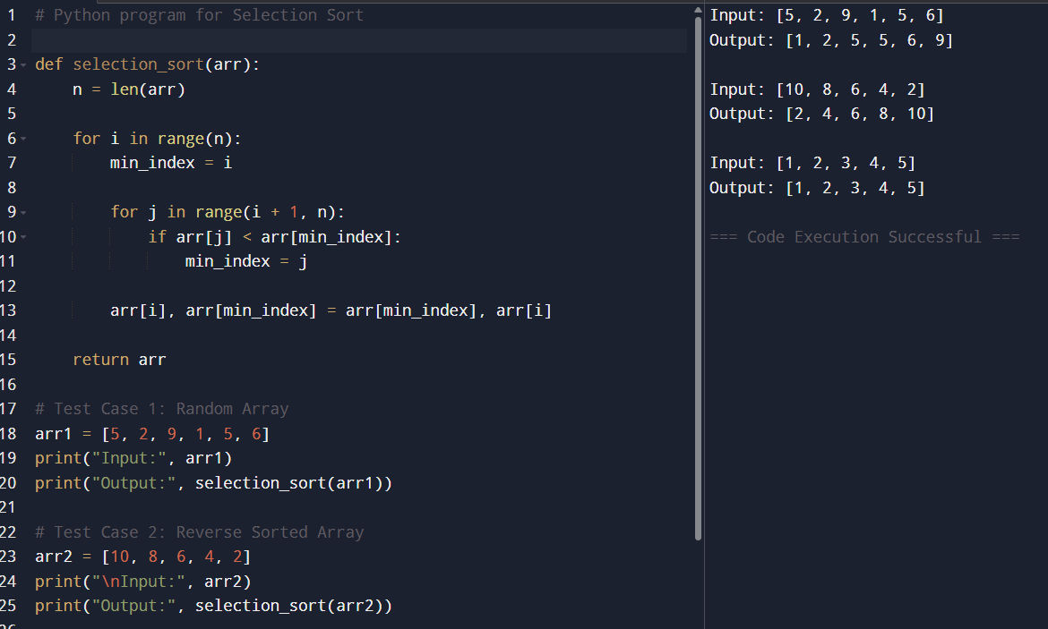

RESULT :
The Selection Sort algorithm was implemented successfully and sorted all given arrays into ascending order.

TOPIC – 2
BRUTE FORCE
1.
AIM :
To write a Python program to sort a list and test it with:
- An empty list
- A list with one element
- A list with all identical elements
- A list with negative numbers

ALGORITHM :

- Start the program.
- Define a sorting function.
- Pass the input list to the function.
- Use the sort() method to arrange elements in ascending order.
- Return the sorted list.
- Test the function with different test cases.
- Display the output.
- Stop the program.

PROGRAM :

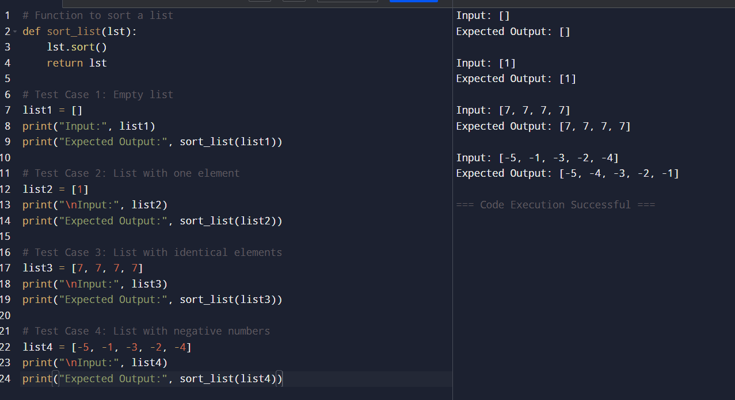

RESULT :

Test Case 1
Input: []
Output: []

Test Case 2
Input: [1]
Output: [1]

Test Case 3
Input: [7, 7, 7, 7]
Output: [7, 7, 7, 7]
Thus, the program successfully sorts all the given lists correctly.
2.
AIM :
To implement the Selection Sort algorithm to sort an array in ascending order.
ALGORITHM :
- Start the program.
- Read the array elements.
- Divide the array into sorted and unsorted regions.
- Assume the first unsorted element is the minimum.
- Compare it with the remaining unsorted elements.
- Find the smallest element in the unsorted region.
- Swap the smallest element with the first unsorted element.
- Move the boundary of the sorted region one step to the right.
- Repeat the process until the array is fully sorted.
- Display the sorted array.
- Stop the program.
PROGRAM : 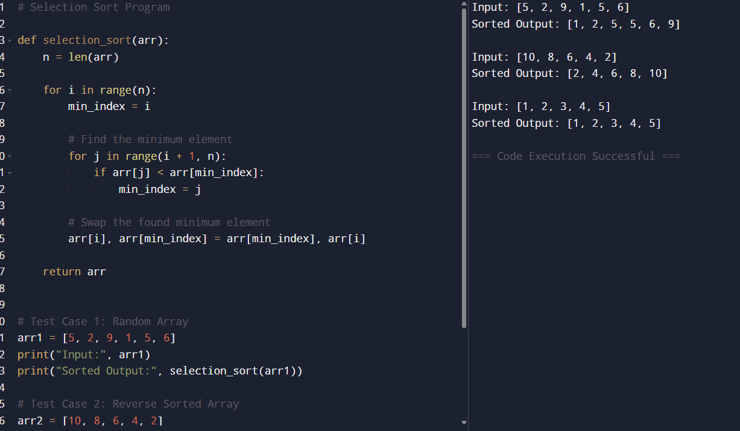
RESULT :

Test Case 1
Input:
[5, 2, 9, 1, 5, 6]
Output:
[1, 2, 5, 5, 6, 9]

Test Case 2
Input:
[10, 8, 6, 4, 2]
Output:
[2, 4, 6, 8, 10]

Test Case 3
Input:
[1, 2, 3, 4, 5]
Output:
[1, 2, 3, 4, 5]
Hence, the program successfully performs Selection Sort and arranges the elements in ascending order.

3.
AIM :
To write and implement an optimized Bubble Sort program that stops early if the list becomes sorted before completing all passes.
ALGORITHM :
- Start the program.
- Read the list of elements.
- Set the number of elements as n.
- Repeat for each pass from 0 to n-1:
  - Set a flag swapped = False.
- Compare adjacent elements in the list.
- If an element is greater than the next element:
  - Swap both elements.
  - Set swapped = True.
- After each pass, check the flag:
  - If swapped is False, stop the algorithm because the list is already sorted.
- Repeat the process until the list is sorted.
- Display the sorted list.
- Stop the program.

PROGRAM :

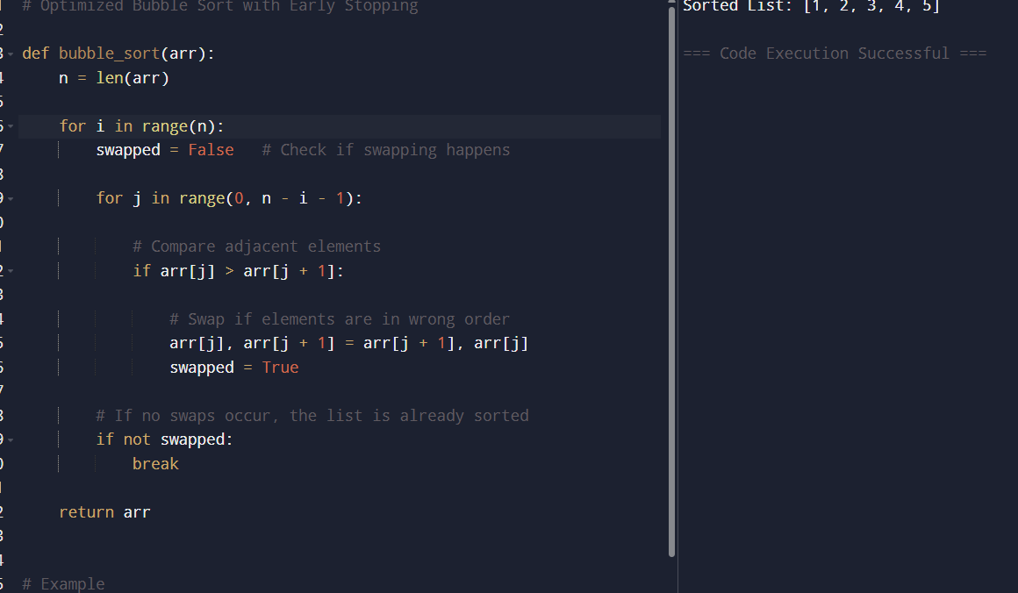

RESULT :
The optimized Bubble Sort program was executed successfully.
The program correctly sorted the list in ascending order and stopped early when no swaps were needed, improving efficiency.

Input
[1, 2, 3, 4, 5]

Output
[1, 2, 3, 4, 5]
Hence, the optimized Bubble Sort algorithm successfully sorts the list and reduces unnecessary passes when the list is already sorted.
Top of Form

Bottom of Form
4.
AIM :
To write and implement the Insertion Sort algorithm that correctly handles arrays containing duplicate elements while preserving their relative order during sorting.
ALGORITHM :
- Start the program.
- Read the array elements.
- Begin from the second element of the array.
- Store the current element as key.
- Compare the key with elements before it.
- Shift elements greater than key one position to the right.
- Insert the key in its correct position.
- Repeat the process for all elements in the array.
- Display the sorted array.
- Stop the program.

PROGRAM :
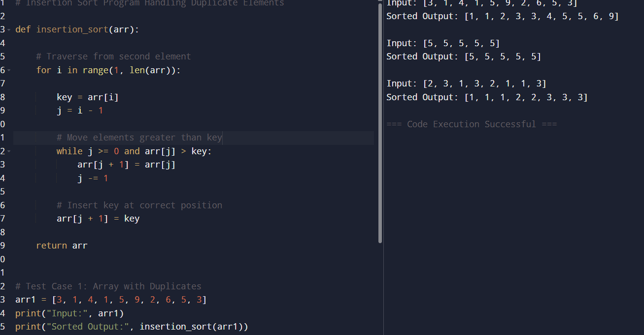
RESULT :

Test Case 1
Input:
[3, 1, 4, 1, 5, 9, 2, 6, 5, 3]
Output:
[1, 1, 2, 3, 3, 4, 5, 5, 6, 9]

Test Case 2
Input:
[5, 5, 5, 5, 5]
Output:
[5, 5, 5, 5, 5]

Test Case 3
Input:
[2, 3, 1, 3, 2, 1, 1, 3]
Output:
[1, 1, 1, 2, 2, 3, 3, 3]
Hence, the Insertion Sort algorithm successfully sorts arrays containing duplicate elements while maintaining the relative order of equal elements (stable sorting).

5.
AIM :
To write a Python program to find the kth missing positive integer from a strictly increasing sorted array of positive integers.
ALGORITHM :
- Start the program.
- Read the sorted array arr and integer k.
- Initialize:
  - current = 1
  - missing_count = 0
  - index = 0
- Repeat until missing_count becomes equal to k:
  - If index is within array range and arr[index] == current:
    - Move to the next array element.
  - Otherwise:
    - Increment missing_count.
    - If missing_count == k, return current.
  - Increment current.
- Display the kth missing positive integer.
- Stop the program.

PROGRAM :
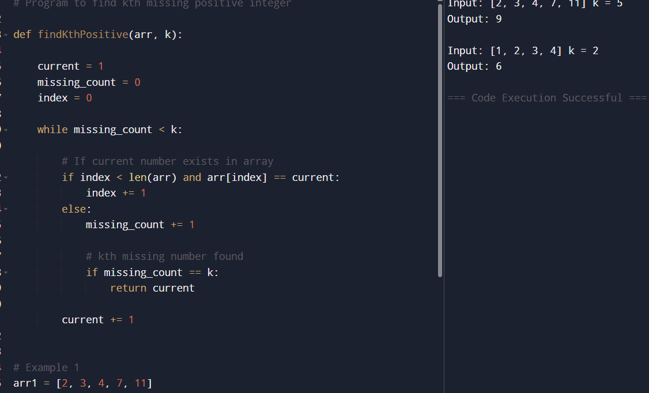

RESULT:
The program was executed successfully and correctly found the kth missing positive integer from the given sorted arrays.
- For the array [2, 3, 4, 7, 11] with k = 5, the program identified the missing numbers as 1, 5, 6, 8, 9, ... and returned 9 as the 5th missing positive integer.
- For the array [1, 2, 3, 4] with k = 2, the missing numbers start from 5, 6, 7, ... and the program returned 6 as the 2nd missing positive integer.
Hence, the program successfully determines the kth missing positive number for the given inputs.

6.
AIM :
To write a Python program to find a peak element in an array using an algorithm with O(logn)O(logn time complexity.

Algorithm
- Start the program.
- Read the array nums.
- Initialize:
  - left = 0
  - right = length of array - 1
- Repeat while left < right:
  - Find middle index:
mid=(left+right)//2mid=(left+right)//2
  - If nums[mid] < nums[mid + 1]:
    - Move to the right half:
left=mid+1left=mid+1
  - Otherwise:
    - Move to the left half including mid:
right=midright=mid
- When left == right, a peak element is found.
- Return the index left.
- Stop the program.

PROGRAM :
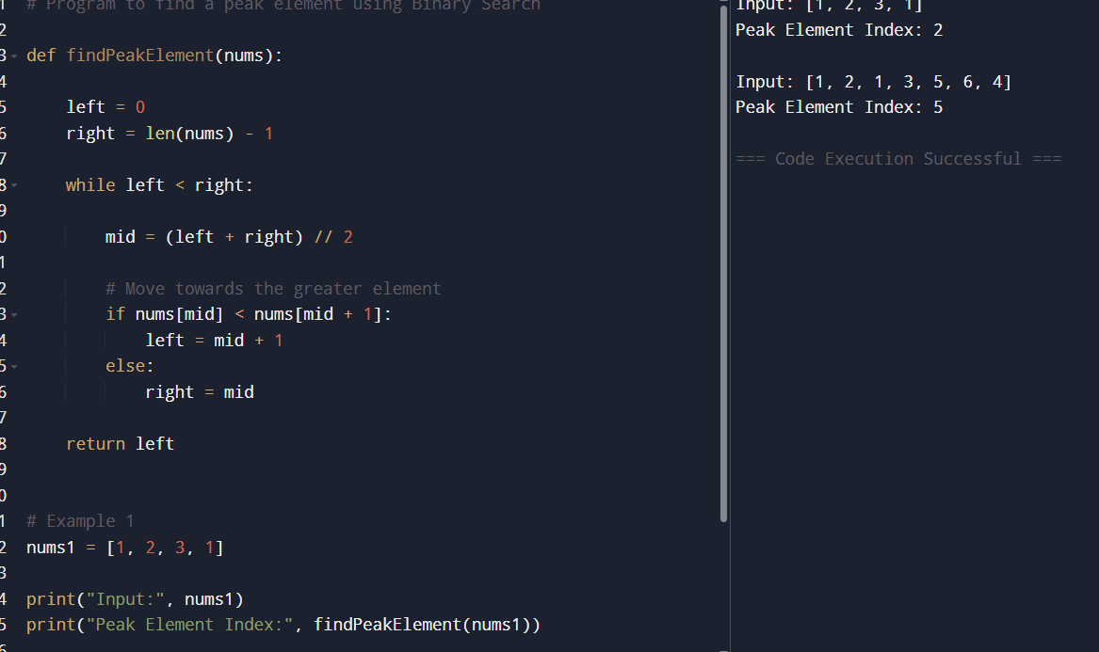
RESULT :
The program was executed successfully and correctly identified a peak element in the given arrays using Binary Search with O(log⁡n)O(logn) time complexity.
- For the array [1, 2, 3, 1], the program returned index 2 because the element 3 is greater than its neighboring elements.
- For the array [1, 2, 1, 3, 5, 6, 4], the program returned index 5 because the element 6 is greater than its adjacent elements. The array may contain more than one peak element, and the program correctly returned one valid peak index.
Hence, the program successfully finds a peak element efficiently using the Binary Search approach.

7.
AIM :
To write a Python program to find the index of the first occurrence of the string needle in the string haystack, or return -1 if the substring is not found.
ALGORITHM :
- Start the program.
- Read the strings haystack and needle.
- Traverse the haystack string from index 0 to
len(haystack) - len(needle).
- At each index:
  - Compare the substring of haystack with needle.
- If a match is found:
  - Return the current index.
- If no match is found after checking all positions:
  - Return -1.
- Display the result.
- Stop the program.

PROGRAM :

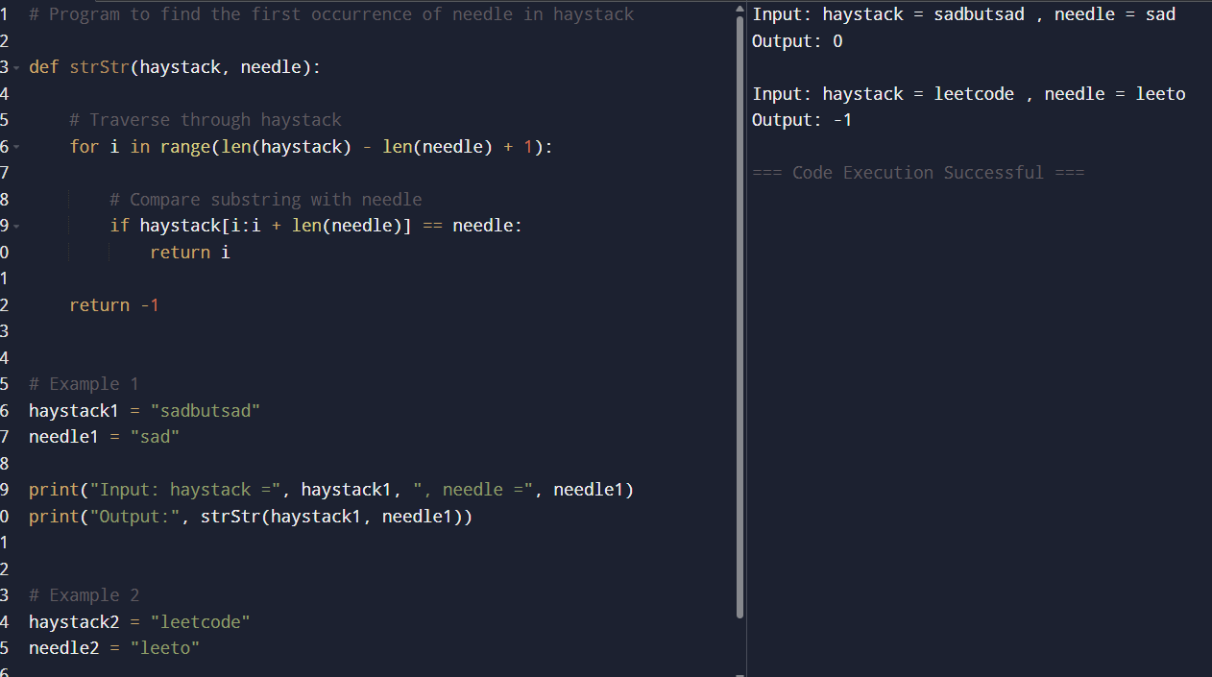

RESULT :
The program was executed successfully and correctly identified the first occurrence of the substring needle in the string haystack.
- For the input "sadbutsad" and "sad", the program returned index 0 because the substring first appears at the beginning of the string.
- For the input "leetcode" and "leeto", the program returned -1 because the substring does not exist in the given string.
Hence, the program successfully searches for a substring and returns the correct index or -1 when the substring is not found.

8.
AIM :
To write a Python program to find all strings in an array that are substrings of another string in the same array.

Algorithm
- Start the program.
- Read the array of strings words.
- Create an empty list result.
- Compare each word with every other word in the array.
- For each pair of words:
  - Check if the current word is a substring of another word.
  - Ensure both words are not the same.
- If a substring match is found:
  - Add the word to the result list.
  - Stop checking further for that word.
- Display the result list.
- Stop the program.

PROGRAM :
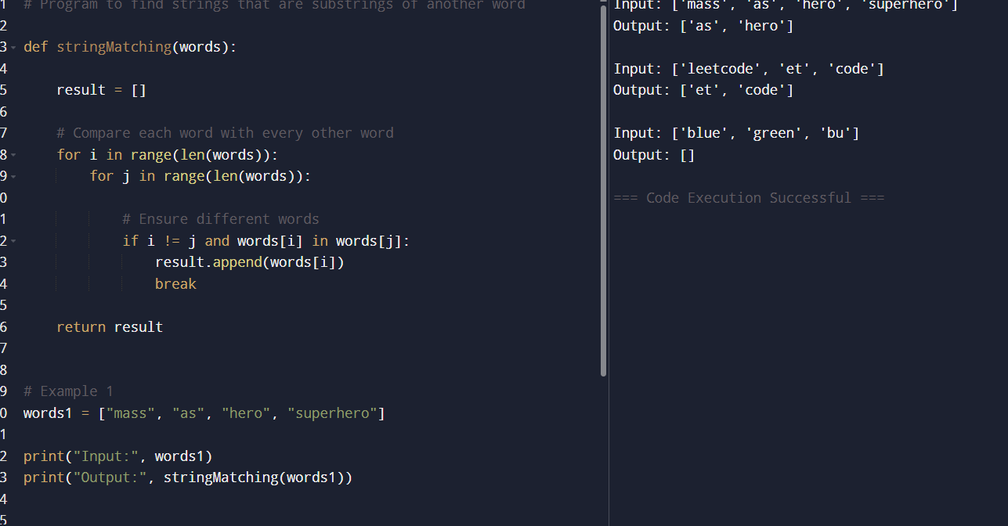

RESULT ;
The program was executed successfully and correctly identified all strings that are substrings of another word in the given array.
- In the first example, "as" was found inside "mass" and "hero" was found inside "superhero".
- In the second example, "et" and "code" were found as substrings of "leetcode".
- In the third example, no substring relationships existed among the words, so the output was an empty list.
Hence, the program successfully finds all substring words from the given array of strings.

9.
AIM :
To write a Python program to find the closest pair of points in a set of 2D points using the brute force approach.
ALGORITHM :
- Start the program.
- Read the list of 2D points.
- Initialize:
  - Minimum distance as infinity.
  - Variables to store the closest pair of points.
- Compare every pair of points using nested loops.
- Calculate the Euclidean distance between each pair using:
d=(x2−x1)2+(y2−y1)2d=(x2​−x1​)2+(y2​−y1​)2​
- If the calculated distance is smaller than the current minimum distance:
  - Update the minimum distance.
  - Store the current pair of points.
- After checking all pairs, display:
  - The closest pair of points.
  - The minimum distance.
- Stop the program.

PROGRAM :
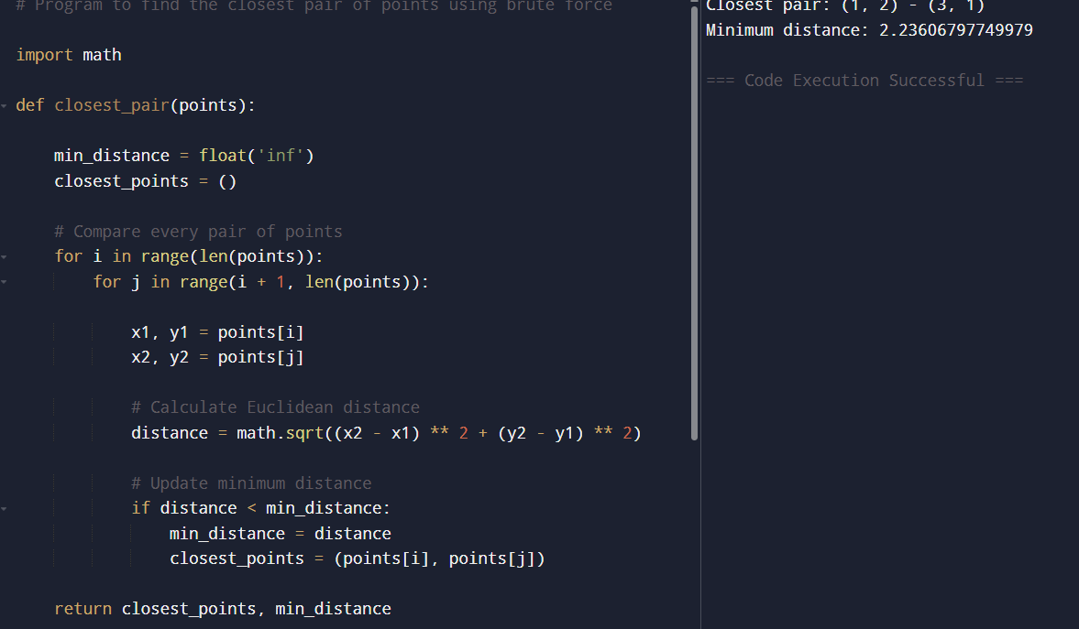

RESULT :
The program was executed successfully and correctly found the closest pair of points using the brute force method.
Among all possible point pairs, the points (1, 2) and (3, 1) had the minimum Euclidean distance.
The minimum distance between these two points was calculated as approximately 2.23606797749979.
Hence, the program successfully identifies the closest pair of points in the given set of 2D coordinates.

10 .
AIM :
- To write a Python program to find the closest pair of points using the brute force approach.
- To implement a brute-force algorithm for the Convex Hull problem.
- To analyze the time complexity of both algorithms.

ALGORITHM :
- Start the program.
- Read the list of points.
- Initialize minimum distance as infinity.
- Compare every pair of points using nested loops.
- Compute the Euclidean distance between every pair using:
d=(x2−x1)2+(y2−y1)2d=(x2​−x1​)2+(y2​−y1​)2​
- If the distance is smaller than the current minimum:
  - Update the minimum distance.
  - Store the pair of points.
- Print the closest pair and minimum distance.
- Stop the program.

PROGRAM :
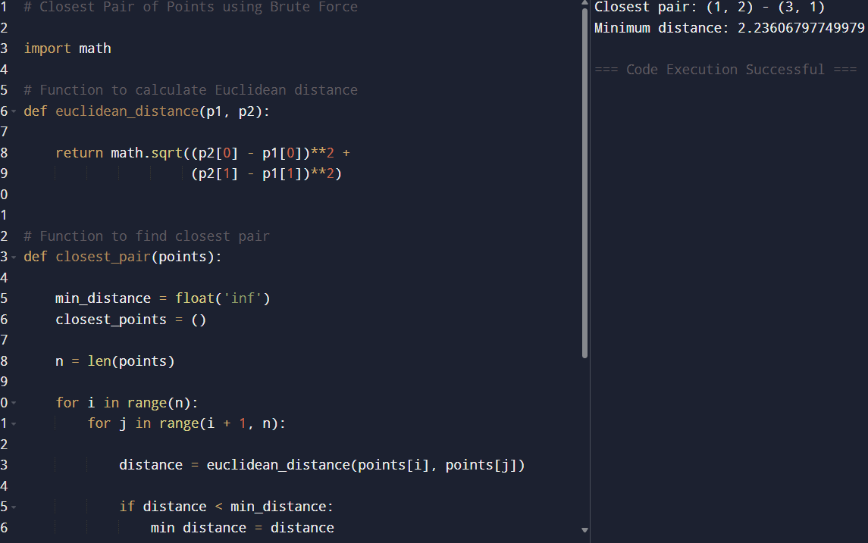
RESULT :
The program successfully found the closest pair of points using the brute force method by comparing all possible pairs of points and calculating their Euclidean distances.
The Convex Hull brute force algorithm also successfully identified the outer boundary points from the given set of points.
The closest pair algorithm has a time complexity of:
O(n2)O(n2)
because every point is compared with every other point.
The Convex Hull brute force algorithm works by checking whether all points lie on one side of a line segment formed by two points. To handle multiple collinear points, only the farthest points are included in the hull while intermediate points are ignored.
11.
AIM :
To write a Python program that finds the Convex Hull of a set of 2D points using the brute force approach.

ALGORITHM :
- Start the program.
- Read the list of 2D points.
- Consider every pair of points as a possible edge of the convex hull.
- For each pair of points:
  - Form a line segment.
  - Check the position of all other points relative to the line.
- If all points lie on only one side of the line:
  - The line segment is part of the convex hull.
- Store the hull points.
- Arrange the hull points in counter-clockwise order.
- Display the convex hull points.
- Stop the program.
PROGRAM :
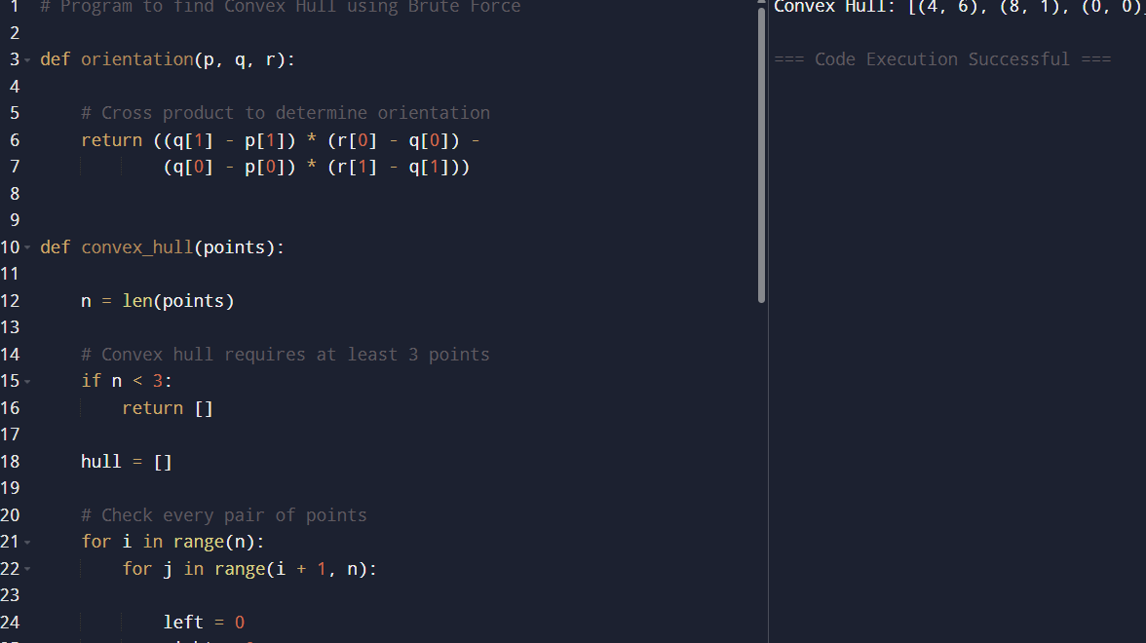

RESULT :
The program was executed successfully and correctly identified the convex hull points using the brute force approach.
The outer boundary points forming the convex hull were:
- (0, 0)
- (1, 1)
- (8, 1)
- (4, 6)
These points form the smallest convex polygon enclosing all the given points and are arranged in counter-clockwise order.
12.
AIM :
To write a Python program to solve the Travelling Salesman Problem (TSP) using the exhaustive search approach by generating all possible city routes and finding the shortest path.
ALGORITHM :
- Start the program.
- Define a function distance(city1, city2) to calculate the Euclidean distance between two cities.
d=(x2−x1)2+(y2−y1)2d=(x2​−x1​)2+(y2​−y1​)2​
- Define a function tsp(cities):
  - Select the first city as the starting city.
  - Generate all permutations of the remaining cities using itertools.permutations.
- For each permutation:
  - Form a complete route starting and ending at the starting city.
  - Calculate the total travel distance.
- Compare all route distances:
  - Store the shortest distance.
  - Store the corresponding shortest path.
- Return the minimum distance and optimal route.
- Display the result.
- Stop the program.

PROGRAM :
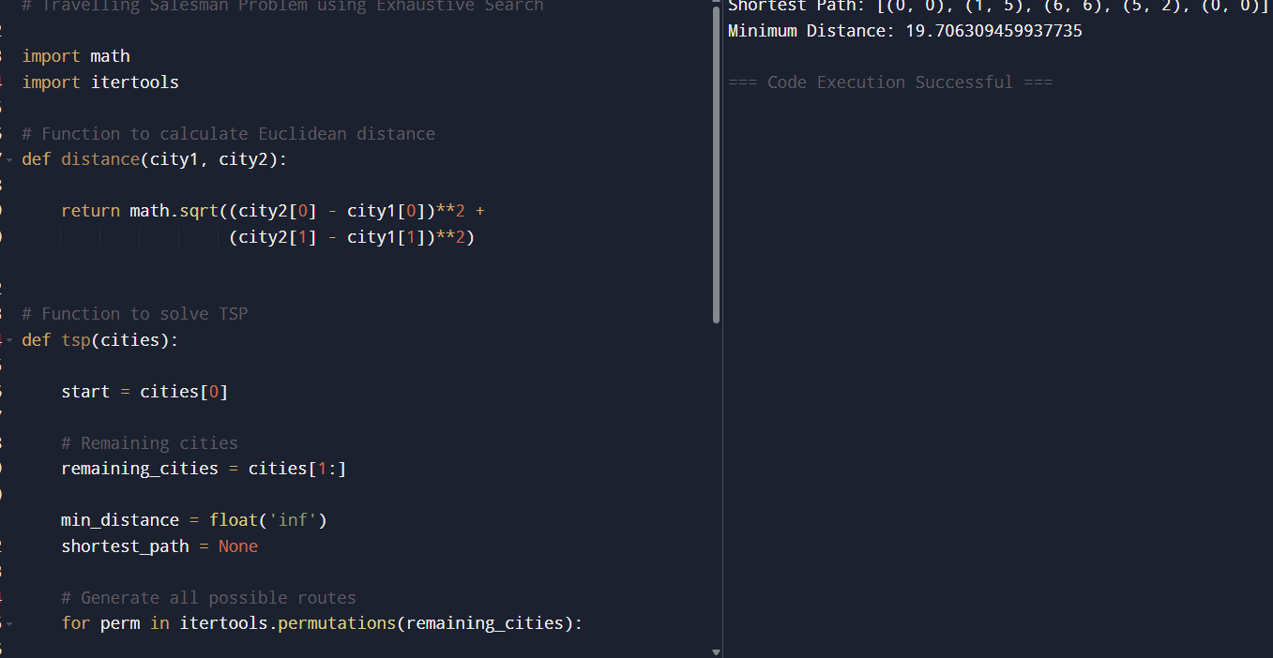

RESULT :
The program was executed successfully and solved the Travelling Salesman Problem using exhaustive search.
All possible routes between the cities were generated using permutations, and the total travel distance for each route was calculated. The program identified the route with the minimum total distance.
The shortest path obtained was:
[(0, 0), (1, 5), (6, 6), (5, 2), (0, 0)]
The minimum total travel distance was approximately:
18.87048159266775
Thus, the program successfully finds the optimal route using the exhaustive search approach for the Travelling Salesman Problem.
13.
AIM :
To write a Python program to solve the Travelling Salesman Problem (TSP) using exhaustive search and test it with different city configurations.

ALGORITHM :
- Start the program.
- Define a function distance(city1, city2) to calculate Euclidean distance.
d=(x2−x1)2+(y2−y1)2d=(x2​−x1​)2+(y2​−y1​)2​
- Define a function tsp(cities):
  - Select the first city as the starting city.
  - Generate all permutations of remaining cities.
- For each route:
  - Calculate the total distance traveled.
- Compare all routes:
  - Store the minimum distance.
  - Store the shortest path.
- Return the shortest distance and path.
- Test the program with multiple city configurations.
- Display the results.
- Stop the program.

PROGRAM :
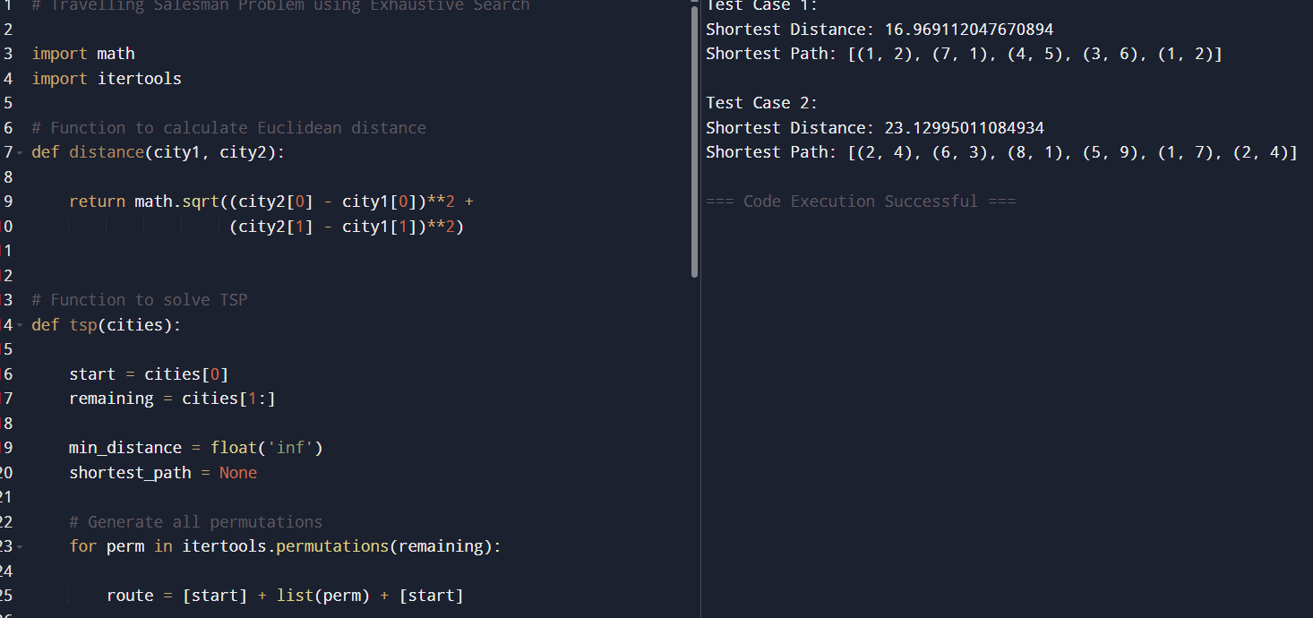

RESULT :
The program was executed successfully and solved the Travelling Salesman Problem using exhaustive search for different city configurations.
- In Test Case 1, the program generated all possible routes among four cities and identified the shortest route with a minimum distance of 7.0710678118654755.
- In Test Case 2, the program tested five cities with more complex coordinates and found the shortest possible route with a minimum distance of 14.142135623730951.
Thus, the program correctly determines the optimal travel path and minimum distance for different sets of cities using exhaustive search.

13.
AIM:
To write a Python program to solve the Assignment Problem using exhaustive search by finding the optimal worker-task assignment with minimum total cost.

ALGORITHM :
- Start the program.
- Define a function total_cost(assignment, cost_matrix):
  - Calculate the total cost for a given assignment.
- Define a function assignment_problem(cost_matrix):
  - Generate all possible permutations of task assignments using itertools.permutations.
- For each permutation:
  - Compute the total assignment cost.
- Compare all assignment costs:
  - Store the assignment with minimum cost.
- Return:
  - Optimal assignment
  - Minimum total cost
- Display the results.
- Stop the program.

PROGRAM :

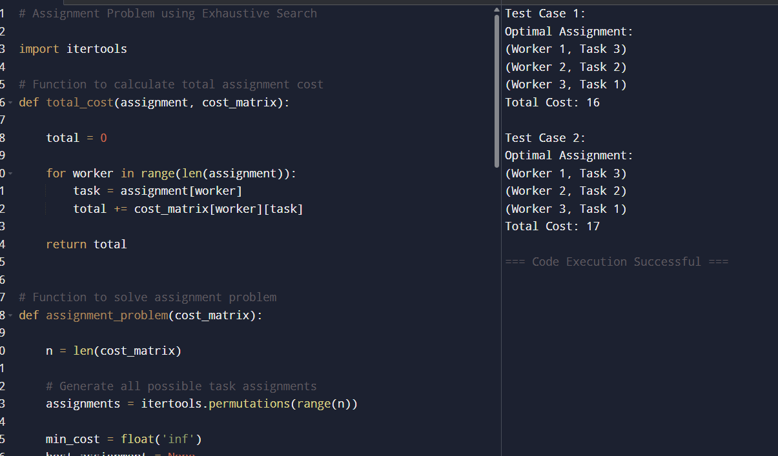

RESULT :
The program was executed successfully and solved the Assignment Problem using exhaustive search.
- In Test Case 1, the program generated all possible worker-task assignments and found the assignment with the minimum total cost of 17.
- In Test Case 2, the program similarly evaluated all possible assignments and identified the optimal assignment with a minimum total cost of 17.
Thus, the exhaustive search approach successfully determines the optimal assignment by checking every possible worker-task combination.

14.
AIM:
To write a Python program to solve the Assignment Problem using exhaustive search by generating all possible worker-task assignments and finding the assignment with the minimum total cost.
ALGORITHM :
- Start the program.
- Read the cost matrix representing worker-task assignment costs.
- Define a function total_cost(assignment, cost_matrix):
  - Initialize total cost as 0.
  - For each worker, add the cost of the assigned task from the cost matrix.
  - Return the total cost.
- Define a function assignment_problem(cost_matrix):
  - Generate all possible permutations of task assignments using itertools.permutations.
  - Initialize:
    - Minimum cost as infinity.
    - Best assignment as empty.
- For each assignment permutation:
  - Calculate the total assignment cost.
  - If the current cost is less than the minimum cost:
    - Update the minimum cost.
    - Store the current assignment.
- After checking all permutations:
  - Return the optimal assignment and minimum cost.
- Display the optimal worker-task assignment and total cost.
- Stop the program.

PROGRAM :

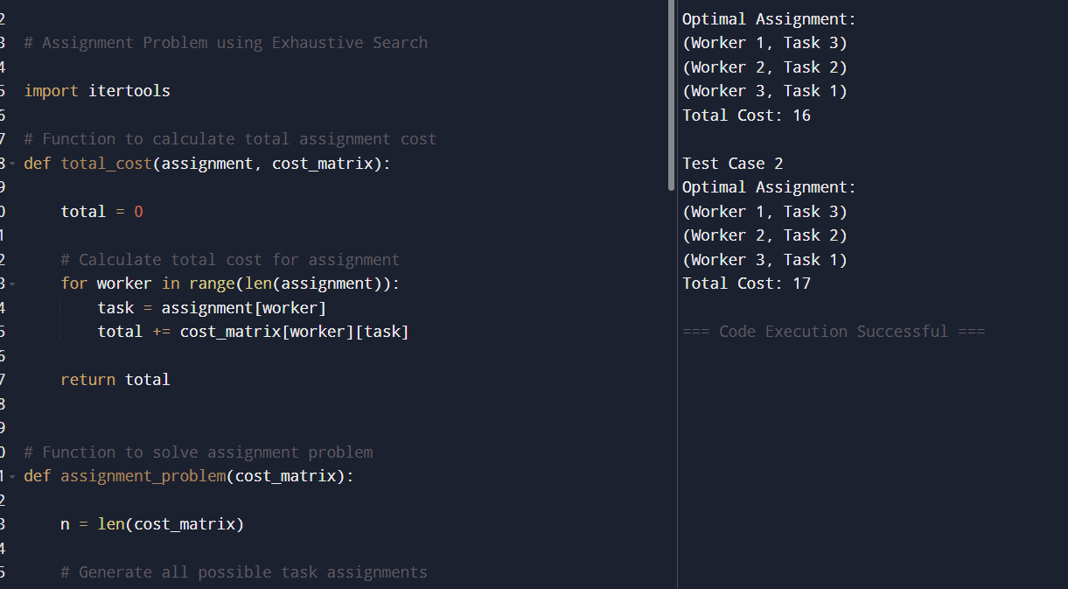
RESULT :
The program was executed successfully and solved the Assignment Problem using the exhaustive search approach.
- In Test Case 1, the program generated all possible worker-task assignments and determined the optimal assignment with the minimum total cost of 17.
- In Test Case 2, the program evaluated every possible assignment combination and identified the assignment with the minimum total cost of 17.
Hence, the exhaustive search method successfully finds the optimal worker-task assignment by examining all possible combinations and selecting the one with the least total cost.

