MATRIX CHAIN MULTIPLICATION
DP VS GREEDY
Q9 – Dynamic Programming vs Naive Greedy
Name: L. Ashraf Ali
Register No.: 192524192
Source Code, Output, Analysis and Documentation

1. Aim
To solve the Matrix Chain Multiplication problem using Dynamic Programming and compare its optimal multiplication order with a naive Greedy approach.

2. Problem Statement
Given matrices A1, A2 and A3 with dimensions (10×20), (20×30), and (30×40), determine the multiplication order that minimizes the total number of scalar multiplications. Compare Dynamic Programming with a naive greedy strategy and explain why the greedy strategy is not guaranteed to be optimal.

3. Given Matrices
A1 = 10 × 20
A2 = 20 × 30
A3 = 30 × 40
Dimension array p = [10, 20, 30, 40]

4. Dynamic Programming Approach
Dynamic Programming evaluates every possible split of the matrix chain and stores the minimum cost for each subchain. For matrices Ai…Aj, the recurrence is:
m[i][j] = min { m[i][k] + m[k+1][j] + p[i-1] × p[k] × p[j] }
The table is filled from shorter chains to longer chains. This guarantees that all possible parenthesizations are considered.

5. DP Cost Calculation
For A1A2:
Cost = 10 × 20 × 30 = 6000
For A2A3:
Cost = 20 × 30 × 40 = 24000
For the full chain there are two possible orders:
1. (A1A2)A3: 6000 + (10 × 30 × 40) = 6000 + 12000 = 18000
2. A1(A2A3): 24000 + (10 × 20 × 40) = 24000 + 8000 = 32000
Therefore, the optimal DP cost is 18,000 scalar multiplications with order (A1A2)A3.

6. Naive Greedy Approach
A simple greedy strategy may choose the cheapest immediate adjacent multiplication first. Here, A1A2 costs 6000 and A2A3 costs 24000, so greedy chooses A1A2 first. For this particular three-matrix input, the greedy choice happens to produce the optimal cost of 18,000.
However, this does NOT establish greedy correctness in general. A local cheapest multiplication can change the dimensions of the resulting matrix and make later multiplications much more expensive. With longer chains, greedy can therefore select a locally attractive operation but miss the globally optimal parenthesization.

7. Comparison
Method | Selected Order | Total Cost | Correctness
Dynamic Programming | (A1A2)A3 | 18,000 | Always optimal for the given chain
Naive Greedy | (A1A2)A3 | 18,000 | Optimal here, but not guaranteed generally

8. Why Greedy Can Fail
- Greedy considers only immediate multiplication cost.
- A multiplication changes the dimensions of the intermediate matrix.
- That changed dimension affects the cost of all subsequent multiplications.
- Therefore, a locally minimum cost does not necessarily lead to a globally minimum total cost.
- Dynamic Programming avoids this problem by evaluating all possible split positions and retaining the best subproblem solutions.

9. Correctness Analysis
Dynamic Programming is correct because every possible split point k between matrices i and j is evaluated. The algorithm combines optimal solutions of smaller subchains with the cost of multiplying the resulting matrices. By induction on chain length, the minimum stored in m[i][j] is the true minimum cost for that subchain.

10. Optimization Strategies
- Use Dynamic Programming instead of naive greedy selection for guaranteed optimal matrix ordering.
- Store previously computed subproblem costs to avoid repeated calculations.
- Store the split position separately if the actual optimal parenthesization must be reconstructed.
- For large chains, bottom-up DP provides predictable O(n^3) computation.
- Use memoization as an alternative top-down DP implementation.

11. Complexity Analysis
Approach | Complexity
Dynamic Programming | Time: O(n³), Space: O(n²)
Naive Greedy | Usually lower decision overhead, but no guarantee of optimality

12. Python Source Code
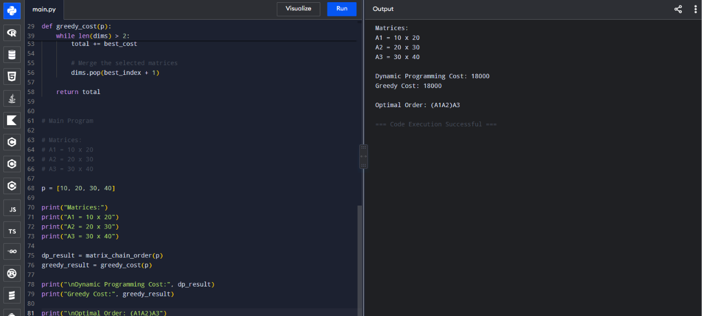

13. Analysis of Cost Difference
For the given three matrices, both methods produce the same cost: 18,000 scalar multiplications. This occurs because the greedy choice A1A2 has the smaller immediate cost (6,000 versus 24,000) and is also the globally optimal first operation. The important insight is that this is a property of this particular input, not a proof that greedy is correct for Matrix Chain Multiplication.

14. Key Insights
- Matrix Chain Multiplication has overlapping subproblems and optimal substructure, making it well suited to Dynamic Programming.
- The multiplication order can change computational cost dramatically even though the final matrix is the same.
- Greedy is attractive because it is simple, but local decisions do not generally capture future dimension changes.
- DP provides a guaranteed optimal order at O(n³) time for n matrices.
- For only three matrices, manually comparing the two parenthesizations is enough, but DP scales systematically to longer chains.

15. Conclusion
For A1 = 10×20, A2 = 20×30 and A3 = 30×40, the optimal order is (A1A2)A3 with a minimum cost of 18,000 scalar multiplications. The naive greedy approach also gives 18,000 for this specific case, but greedy is not guaranteed to be optimal for longer matrix chains. Dynamic Programming is therefore the preferred optimization strategy when correctness and guaranteed minimum cost are required.

16. Student Details
Name: L. Ashraf Ali
Register No.: 192524192

