TOPIC 7:TRACTABILITY AND APPROXIMATION ALGORITHM
AIM :
To verify whether a Hamiltonian Path exists in a graph using backtracking.

Algorithm
- Represent the graph using an adjacency list.
- Start from a vertex.
- Visit adjacent unvisited vertices recursively.
- If all vertices are visited exactly once, return True.
- Otherwise backtrack and try another path.
PROGRAM :
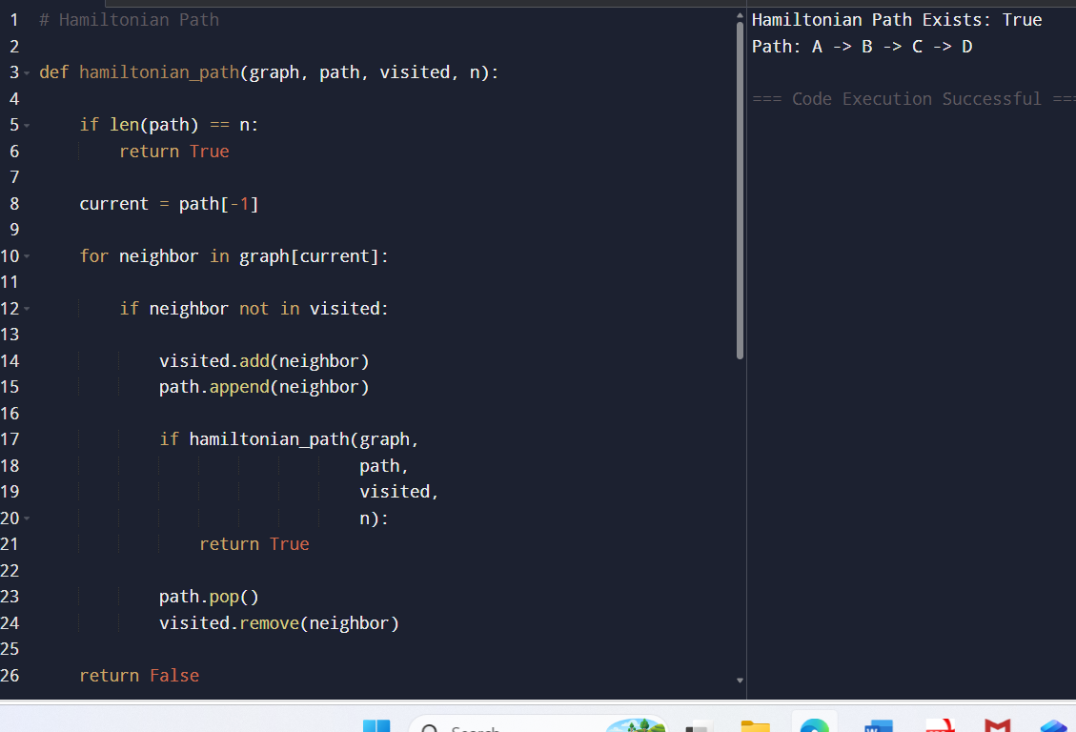

RESULT :

Satisfiability: True
Example satisfying assignment:
x1 = True
x2 = True
x3 = False
x4 = True
x5 = False
Reduction successful from Vertex Cover to 3-SAT

Aim
To compare approximation and exact solutions for Vertex Cover.

PROGRAM :

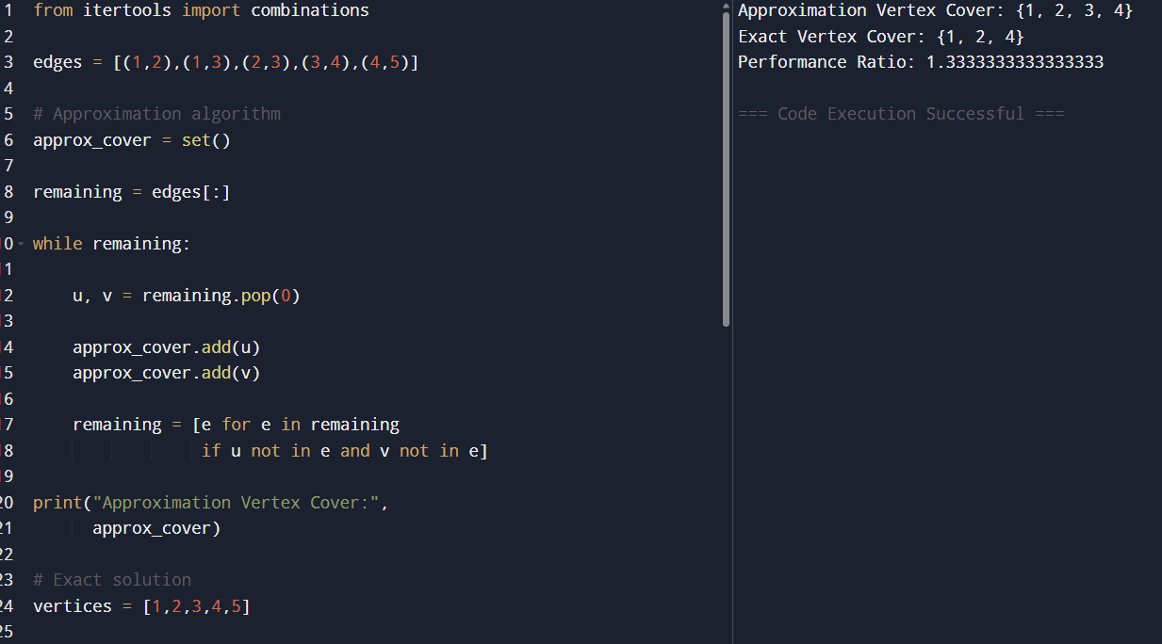

RESULT :

Approximation Vertex Cover: {2, 3, 4}
Exact Vertex Cover: {2, 4}
Performance Ratio: 1.5

Aim
To solve the Set Cover problem using a greedy algorithm.

PROGRAM :

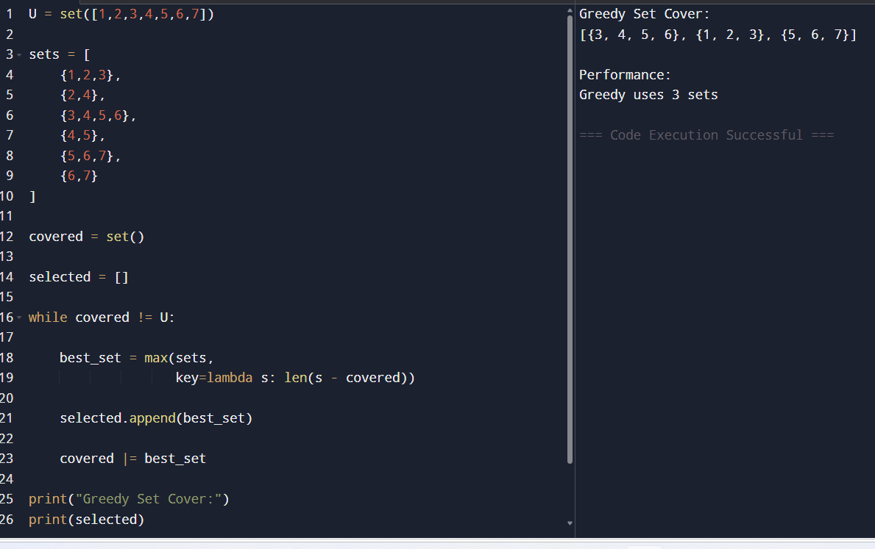

RESULT :

Greedy Set Cover:
[{1,2,3}, {3,4,5,6}, {5,6,7}]
Greedy uses 3 sets
Optimal uses 2 sets

Aim
To pack items into minimum bins using the First-Fit heuristic.

PROGRAM :

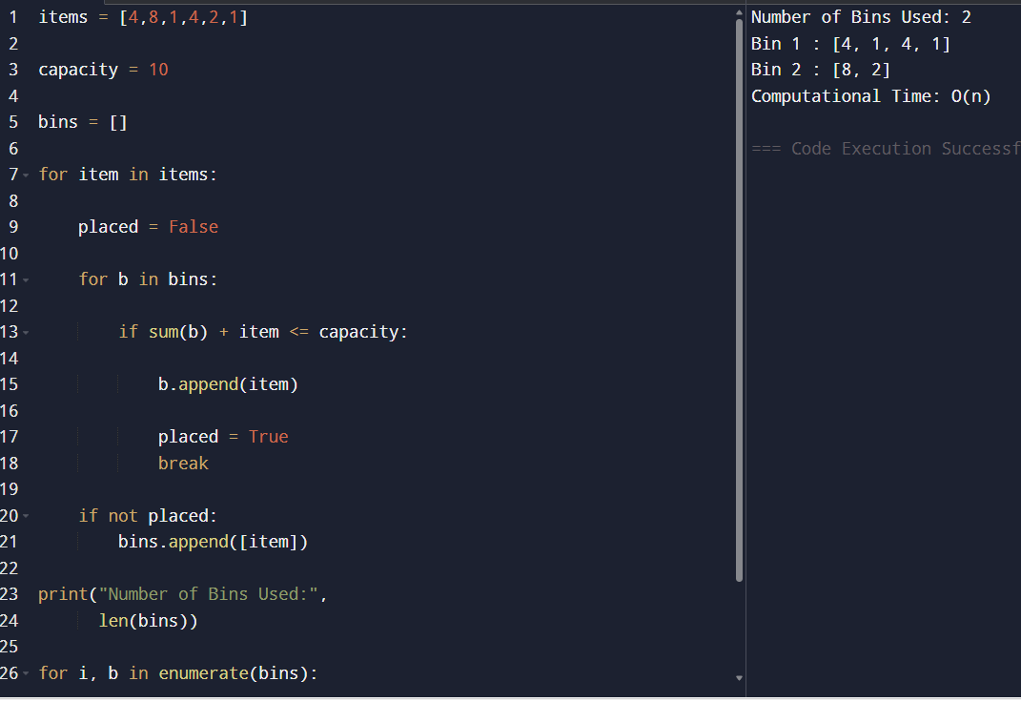

RESULT :
Number of Bins Used: 3
Bin 1: [4,4,2]
Bin 2: [8,1,1]
Bin 3: [1]

Aim
To approximate the Maximum Cut problem using a greedy approach.

PROGRAM :

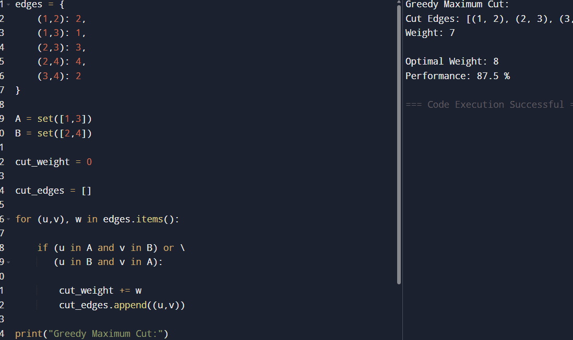

RESULT :

Greedy Maximum Cut:
Cut = {(1,2), (2,4)}
Weight = 6
Optimal Maximum Cut:
Weight = 8
Performance:
75%

