SUBSET SUM PROBLEM
USING BACKTRACKING
Name: L. Ashraf Ali
Register No.: 192524192
Q9 – Backtracking / NP-Complete Problem
Source Code, Report, Output, Analysis and Documentation
Programming Language: Python

1. Aim
To determine whether a subset of a given set of integers exists whose sum is exactly equal to a specified target value, using a backtracking approach with pruning techniques.

2. Problem Statement
Given a set (or list) of integers and a target value T, determine whether there is a subset of the given integers whose elements add up exactly to T. The algorithm must explore possible subsets systematically and avoid unnecessary computations using pruning.

3. Constraints
- Each element can be selected at most once; therefore, the same array position cannot be included twice.
- For every element there are two choices: include it in the subset or exclude it.
- The sum of selected elements must be exactly equal to the target T.
- An empty subset is allowed in the general formulation; it produces sum 0.
- For the pruning rules used in this implementation, the input elements are assumed to be non-negative integers.
- The problem is NP-complete in its general decision form, so no polynomial-time algorithm is known for arbitrary instances.

4. Effect of Constraints on Search Space
For n elements, every element has two possible states—selected or not selected. Therefore, the worst-case search space contains 2^n possible subsets. Backtracking represents this search as a binary decision tree. The constraints and pruning rules reduce the number of branches that actually need to be explored.
The implementation prunes a branch when the current sum has already exceeded the target, or when even adding all remaining elements cannot reach the target. These tests can substantially reduce the practical search space, although the worst-case complexity remains exponential.

5. Backtracking Approach
- Start from the first element with current_sum = 0.
- Choose to include the current element and recursively continue.
- If that branch does not produce a solution, remove the element and explore the exclude branch.
- If current_sum equals the target, report success.
- Stop exploring a branch if current_sum exceeds the target.
- Stop exploring a branch if current_sum plus the sum of all remaining elements is still less than the target.

6. Pruning Techniques
Pruning 1 – Sum exceeds target: If current_sum > target, no later choice can reduce the sum because all input values are non-negative. Hence the branch can be discarded.
Pruning 2 – Remaining sum is insufficient: If current_sum + suffix_sum[index] < target, even selecting every remaining element cannot reach the target. Hence the branch can be discarded.
These pruning conditions preserve correctness because a discarded branch cannot contain a valid target-sum subset under the stated non-negative-input constraint.

7. Source Code
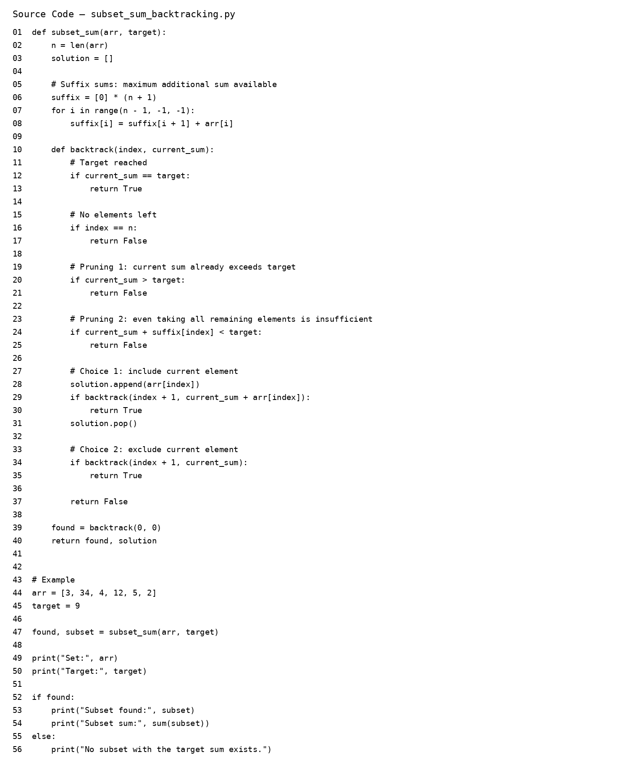
Figure 1: Source code screenshot.

8. Sample Input
Set = [3, 34, 4, 12, 5, 2]
Target = 9

9. Output
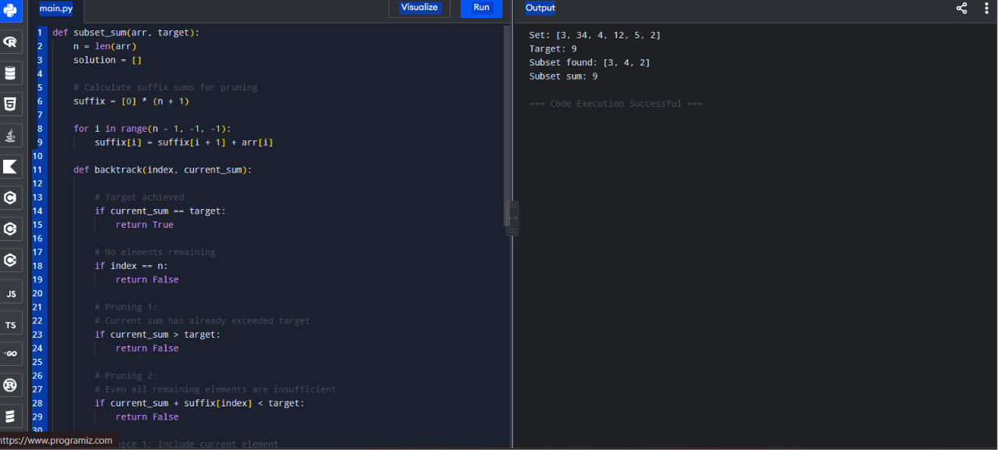
Figure 2: Program output screenshot.
The program finds the subset [3, 4, 2]. Its sum is 3 + 4 + 2 = 9, which matches the target.

10. Correctness Analysis
The algorithm considers both possibilities for every element: including it and excluding it. Thus, every subset that could satisfy the target is represented by a path in the decision tree. A solution is returned only when the accumulated sum equals the target.
The pruning is safe under the non-negative-integer assumption. If the current sum is already greater than the target, adding more non-negative values cannot return to the target. Similarly, if all remaining values together are insufficient, no subset of those remaining values can reach the target. Therefore, pruning cannot remove a valid solution.

11. Efficiency Analysis
Aspect | Analysis
Time Complexity | Worst case: O(2^n), because up to two branches are explored for each of n elements.
Space Complexity | O(n) auxiliary recursion/solution space, excluding the input and suffix-sum array. The suffix array requires O(n) additional space.
Practical Performance | Pruning can greatly reduce the number of visited nodes for many inputs, but it does not change the worst-case exponential bound.

12. Documentation
Function: subset_sum(arr, target)
Purpose: Returns whether a target-sum subset exists and returns one such subset when found.
Parameters: arr – list of non-negative integers; target – required sum.
Returns: A Boolean indicating whether a subset exists and the selected subset.
Helper function: backtrack(index, current_sum) recursively explores include/exclude decisions.
Suffix array: suffix[i] stores the sum of elements from index i to the end and supports the insufficient-remaining-sum pruning test.

13. Conclusion
The Subset Sum Problem can be solved using backtracking by exploring include and exclude choices for each element. The proposed solution is correct because it systematically covers all possible subsets while pruning only branches that cannot possibly reach the target. Although the worst-case time complexity remains O(2^n), pruning improves practical efficiency and avoids many unnecessary recursive calls.

14. Supporting Files
The supporting Python source file is provided separately as subset_sum_backtracking.py. The report also contains screenshots of the source code and output.

