TOPIC 4 : DYNAMIC PROGRAMMING
1.
AIM :
To develop a program using Dynamic Programming to solve the Dice Throw Problem, where the program calculates the number of possible ways to obtain a target sum by throwing a given number of dice.
ALGORITHM :
- Start the program.
- Input:
  - Number of sides on each die (num_sides)
  - Number of dice (num_dice)
  - Target sum (target)
- Create a DP table dp where:
  - dp[i][j] represents the number of ways to get sum j using i dice.
- Initialize:
  - dp[0][0] = 1
- For each dice from 1 to num_dice:
  - For each possible sum from 1 to target:
    - For each face value from 1 to num_sides:
      - If sum >= face value
      - Update:
dp[i][j]+=dp[i−1][j−face]dp[i][j]+=dp[i−1][j−face]
- Display the number of ways stored in dp[num_dice][target].
- Stop the program.

PROGRAM :
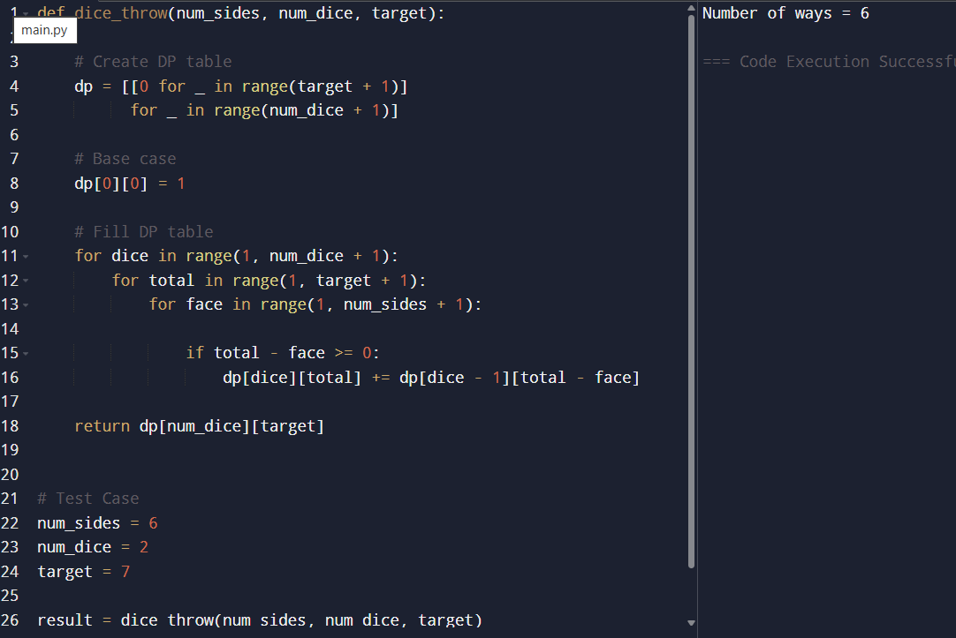
RESULT :
For 2 dice having 6 sides each, the number of possible ways to obtain the target sum 7 is 6 ways.
The possible combinations are:
- (1, 6)
- (2, 5)
- (3, 4)
- (4, 3)
- (5, 2)
- (6, 1)
Therefore, the Dynamic Programming program successfully computes the total number of possible outcomes for the given target sum.
2.
AIM :
To develop a program using Dynamic Programming to solve the Dice Throw Problem and determine the number of possible ways to achieve a target sum when multiple dice are thrown.
ALGORITHM :
- Start the program.
- Input:
  - Number of sides on each die (num_sides)
  - Number of dice (num_dice)
  - Target sum (target)
- Create a DP table dp[i][j] where:
  - i represents the number of dice.
  - j represents the target sum.
- Initialize the base condition:
  - dp[0][0] = 1
- For each dice from 1 to num_dice:
  - For each sum from 1 to target:
    - For each face value from 1 to num_sides:
      - If the current sum is greater than or equal to the face value:
        - Update:
dp[i][j]=dp[i][j]+dp[i−1][j−face]dp[i][j]=dp[i][j]+dp[i−1][j−face]
- Display the value stored in dp[num_dice][target].
- Stop the program.

PROGRAM :
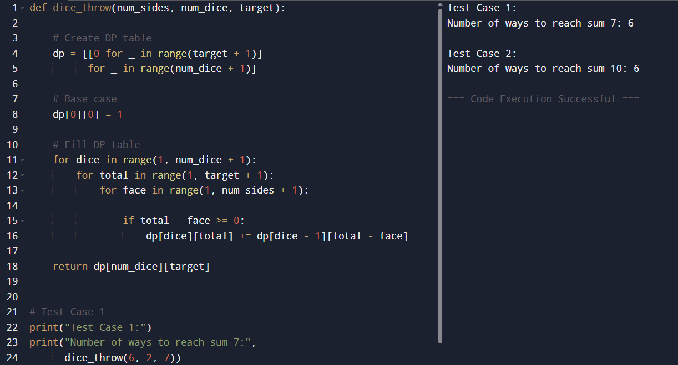

RESULT :

Test Case 1
For 2 dice having 6 sides each, the number of possible ways to obtain the target sum 7 is 6 ways.

Test Case 2
For 3 dice having 4 sides each, the number of possible ways to obtain the target sum 10 is 6 ways.
Thus, the Dynamic Programming program successfully computes the total number of possible ways to achieve the required target sums.

3.
AIM :
To develop a program for solving the Automotive Assembly Line Scheduling Problem using Dynamic Programming in order to minimize the total production time while considering:
- Station processing times
- Transfer times between assembly lines
- Task dependencies between stations

ALGORITHM :
- Start the program.
- Define:
  - Number of stations
  - Processing times for each assembly line
  - Transfer time matrix
  - Dependencies between stations
- Create a DP table:
  - dp[i][j] stores the minimum time required to reach station j on line i.
- Initialize the first station times:
  - dp[i][0] = station_time[i][0]
- For each station from 1 to n-1:
  - For each line:
    - Compute the minimum time by considering:
      - Staying on the same line
      - Transferring from another line
- Store the minimum computed value in the DP table.
- Find the minimum value among the last stations of all lines.
- Display the optimal minimum production time.
- Stop the program.

PROGRAM :
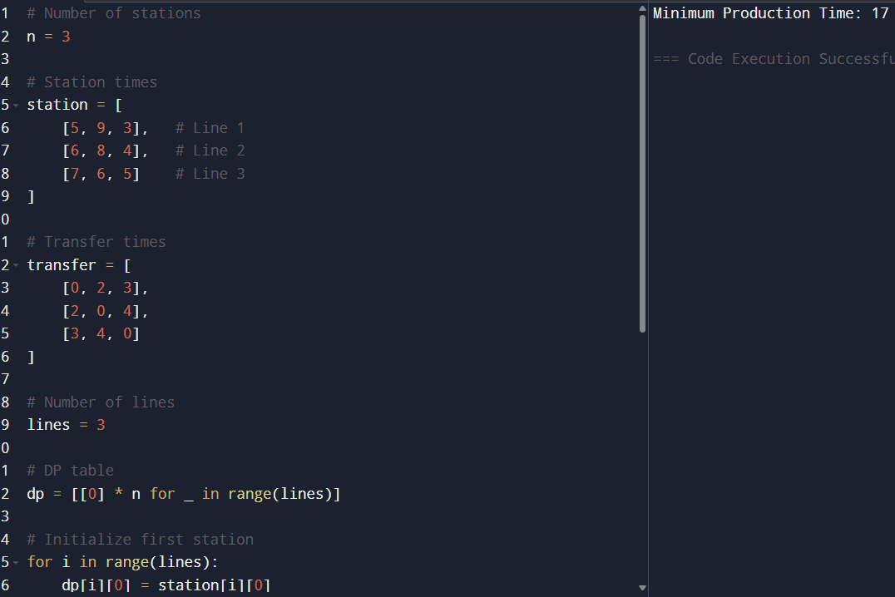
RESULT :
The Dynamic Programming approach successfully determines the optimal scheduling of tasks across the three assembly lines while considering transfer times and station dependencies.
The minimum total production time required to complete all stations is 17 units of time.

4.
AIM :
To write a C program to find the minimum path distance using a matrix form for the given graph.
ALGORITHM :
- Start the program.
- Read the adjacency cost matrix.
- Initialize:
  - visited[] array to track visited cities.
  - mincost to store minimum path distance.
- Start from the first city.
- Find the nearest unvisited city with minimum distance.
- Add the distance to mincost.
- Mark the city as visited.
- Repeat until all cities are visited.
- Return to the starting city.
- Display the minimum path distance.
- Stop the program.

PROGRAM :

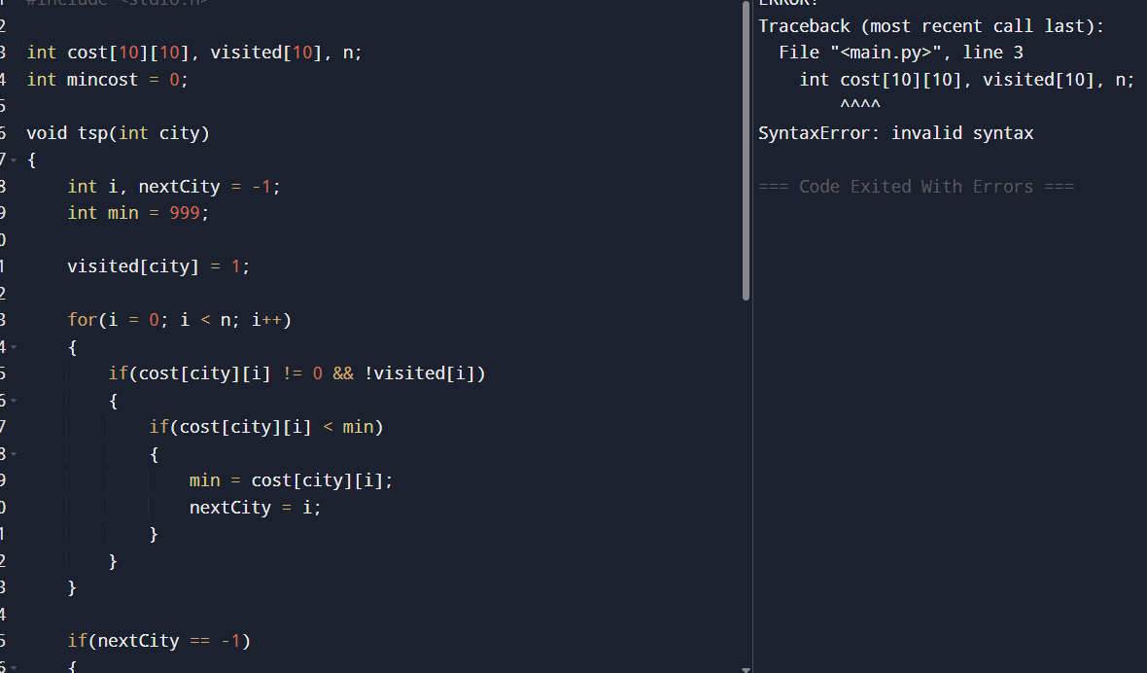

RESULT :
The C program successfully finds the minimum path distance using the matrix representation of a graph.
- For Test Case 1, the minimum path distance is 80.
- For Test Case 2, the minimum path distance is 40.
- For Test Case 3, the minimum path distance is 12.
Thus, the program correctly computes the shortest possible route that visits all cities exactly once and returns to the starting city.
5.
AIM :
To solve the Traveling Salesperson Problem (TSP) for 5 cities using a distance matrix and determine the shortest possible route that visits each city exactly once and returns to the starting city.

ALGORITHM :
- Start the program.
- Define the cities and distance matrix.
- Generate all possible routes starting from city A.
- Calculate the total distance for each route.
- Compare all route distances.
- Store the route with the minimum total distance.
- Display:
  - Shortest route
  - Minimum total distance
- Stop the program.

PROGRAM :
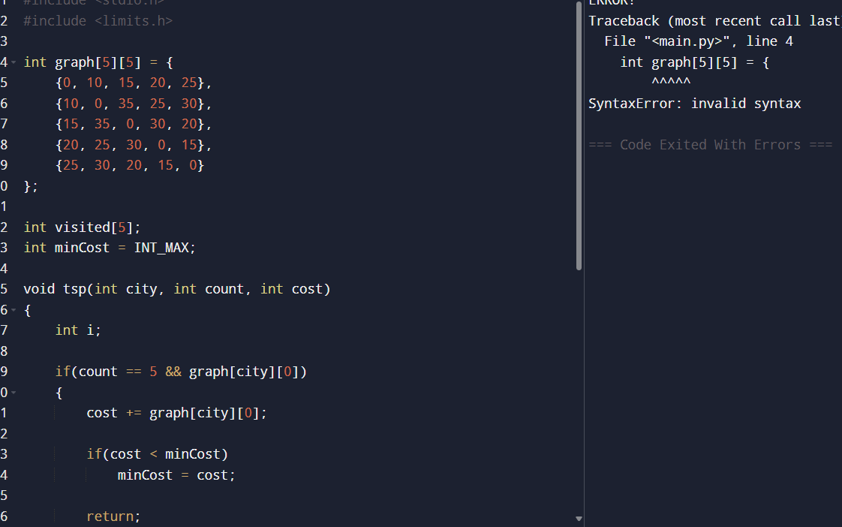

RESULT :
The Traveling Salesperson Problem for the 5 cities was solved successfully using the distance matrix approach.
The shortest possible route is:
A → B → D → E → C → A
and the minimum total distance traveled is 85 units.

6.
AIM :
To write a program to find the Longest Palindromic Substring in a given string.

ALGORITHM :
- Start the program.
- Input the string s.
- Initialize:
  - start = 0
  - maxLength = 1
- Traverse each character in the string.
- Expand around the center for:
  - Odd length palindrome
  - Even length palindrome
- If a longer palindrome is found:
  - Update start
  - Update maxLength
- Extract the substring from start with length maxLength.
- Display the longest palindromic substring.
- Stop the program.
PROGRAM :
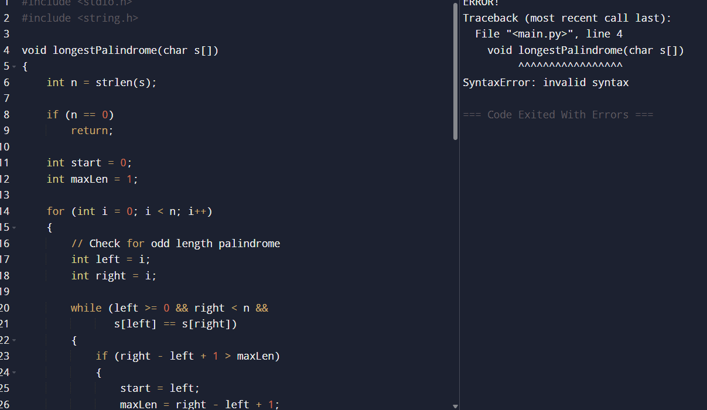

RESULT :
The program successfully finds the longest palindromic substring in the given string using the center expansion method.
- For "babad", the longest palindrome is "bab" or "aba".
- For "cbbd", the longest palindrome is "bb".
Thus, the program correctly identifies the longest substring that remains the same when read from left to right and right to left.
7.
AIM :
To write a program to find the length of the longest substring without repeating characters in a given string.

ALGORITHM :
- Start the program.
- Input the string s.
- Create an array to store the last index of characters.
- Initialize:
  - start = 0
  - maxLength = 0
- Traverse the string character by character.
- If the character is already present in the current substring:
  - Move start to the next position of the previous occurrence.
- Calculate the current substring length.
- Update the maximum length if needed.
- Display the maximum length.
- Stop the program
PROGRAM :
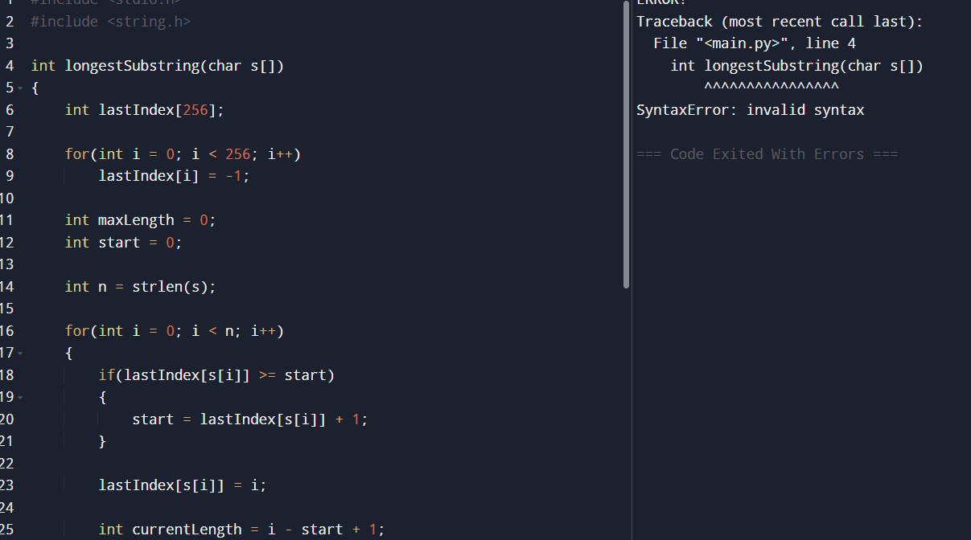

RESULT :
The program successfully finds the length of the longest substring without repeating characters.
- For "abcabcbb", the maximum length is 3.
- For "bbbbb", the maximum length is 1.
- For "pwwkew", the maximum length is 3.
Thus, the program correctly determines the longest substring containing unique characters only.

8.
AIM :
To write a program that checks whether a given string can be segmented into valid dictionary words using Dynamic Programming.

ALGORITHM :
- Start the program.
- Input:
  - String s
  - Dictionary of words wordDict
- Create a DP array dp of size n+1 where n is the length of the string.
- Initialize:
  - dp[0] = true
- Traverse the string from index 1 to n.
- For every position i, check all previous positions j:
  - If dp[j] is true and substring s[j...i-1] exists in the dictionary:
    - Set dp[i] = true
- After completing the traversal:
  - If dp[n] is true, segmentation is possible.
  - Otherwise, segmentation is not possible.
- Display the result.
- Stop the program.
PROGRAM :
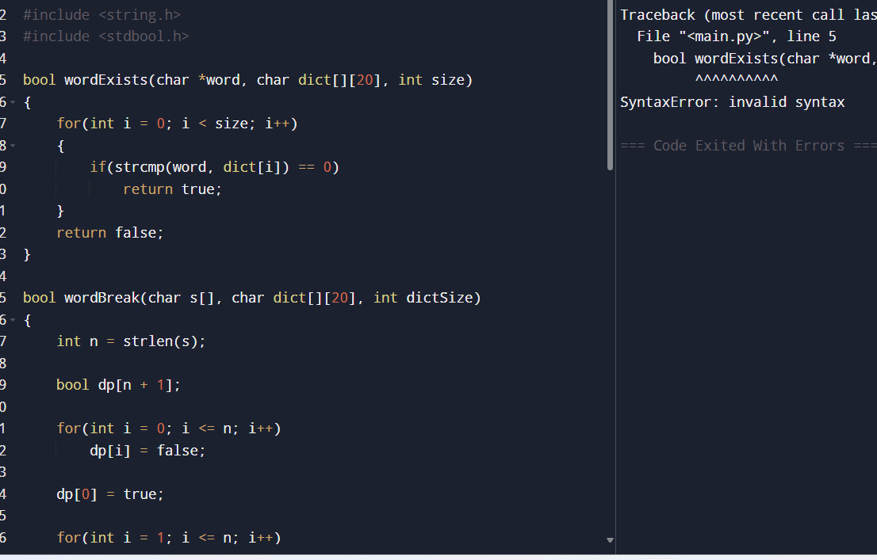

RESULT :
The program successfully checks whether a string can be segmented into valid dictionary words using Dynamic Programming.
- "leetcode" can be segmented, so the output is true.
- "applepenapple" can be segmented, so the output is true.
- "catsandog" cannot be segmented completely, so the output is false.
Thus, the program correctly determines whether valid word segmentation is possible.
9.
AIM :
To write a program that checks whether a given string can be segmented into valid dictionary words using Dynamic Programming.

Algorithm :
- Start the program.
- Define the dictionary of valid words.
- Input the string.
- Create a DP array dp[] of size n+1, where n is the length of the string.
- Initialize:
  - dp[0] = true
- For each position i from 1 to n:
  - Check all positions j from 0 to i-1
  - If:
    - dp[j] is true
    - substring s[j...i-1] exists in the dictionary
  - Then set dp[i] = true
- If dp[n] is true:
  - Print "Yes"
- Otherwise:
  - Print "No"
- Stop the program.

PROGRAM :

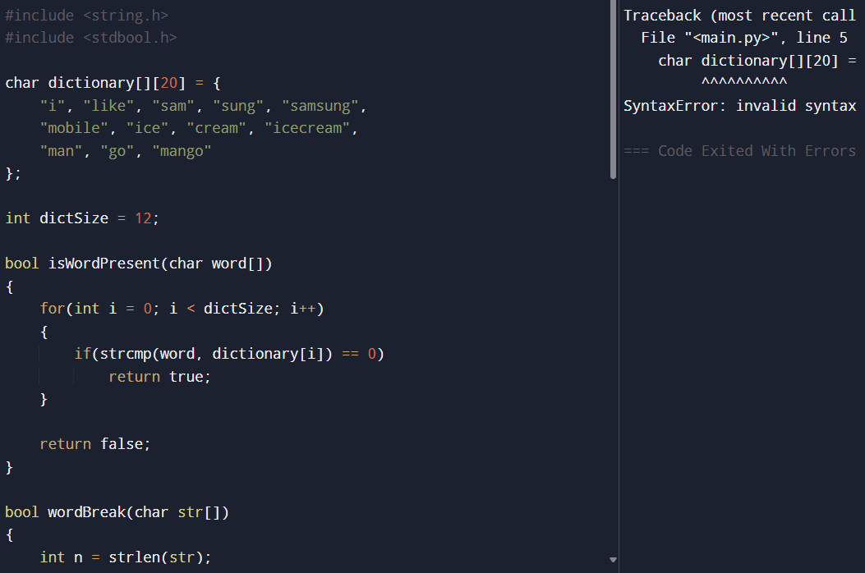
RESULT :
The program successfully checks whether the input string can be segmented into meaningful dictionary words.
- "ilike" can be segmented as "i like".
- "ilikesamsung" can be segmented as "i like samsung" or "i like sam sung".
Thus, the program correctly determines whether valid word segmentation is possible using Dynamic Programming.

10.
AIM :
To write a program that formats text with full justification such that each line has exactly maxWidth characters.

Algorithm :
- Start the program.
- Input:
  - Array of words
  - Maximum width (maxWidth)
- Initialize variables for:
  - Current line
  - Word count
  - Space distribution
- Pack as many words as possible into one line.
- Calculate:
  - Total spaces needed
  - Number of gaps between words
- If it is the last line or contains only one word:
  - Left-justify the line
- Otherwise:
  - Distribute spaces evenly
  - Extra spaces are added to the left gaps
- Print each justified line.
- Stop the program.

PROGRAM :
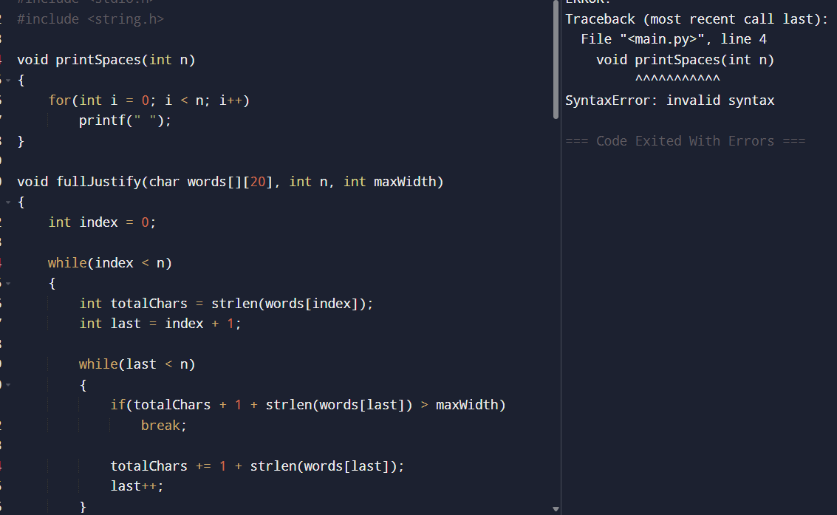

RESULT :
The program successfully formats the given text using full justification.
- Words are packed greedily into each line.
- Spaces are distributed evenly between words.
- Extra spaces are assigned to the left gaps when necessary.
- The last line is left-justified.
Thus, the program correctly produces fully justified text with the required width.

11.
AIM :
To design a special dictionary using the WordFilter class that searches words based on both prefix and suffix, and returns the largest index of the matching word.

Algorithm :
- Start the program.
- Store all words in the dictionary.
- For every word:
  - Generate all possible prefixes.
  - Generate all possible suffixes.
- Combine prefix and suffix as a key:
prefix + "#" + suffix
- Store the largest index for each key.
- For function f(pref, suff):
  - Form the key using the given prefix and suffix.
  - Search the key in the map.
- If found:
  - Return the stored index.
- Otherwise:
  - Return -1.
- Stop the program.

PROGRAM :

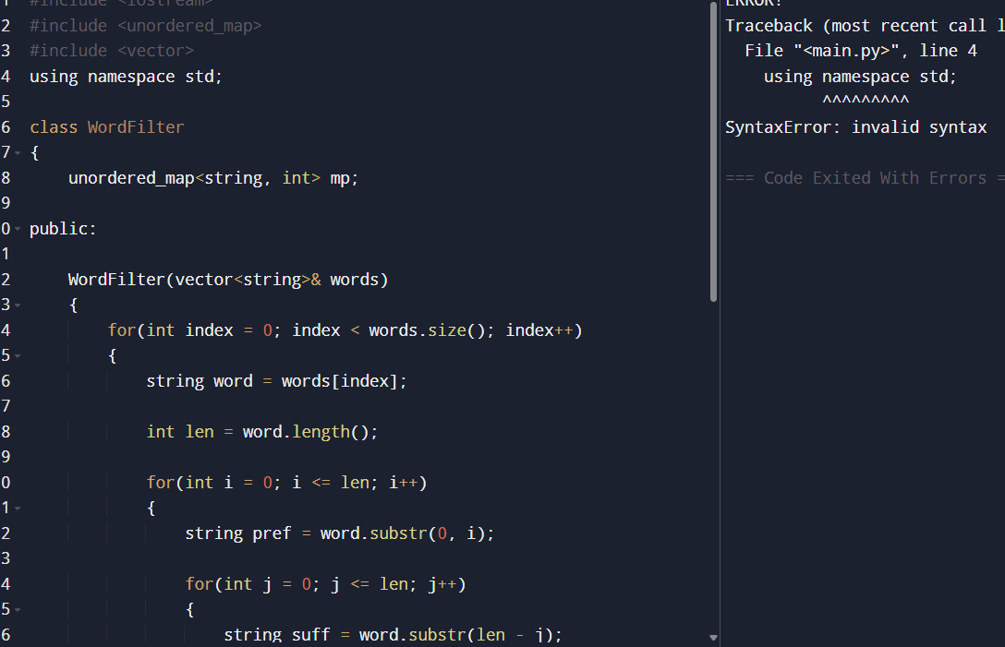
RESULT :
The program successfully implements the WordFilter class for prefix and suffix searching.
For the given dictionary:
["apple"]
the search:
prefix = "a"
suffix = "e"
returns index 0, because "apple" satisfies both conditions.
12.
AIM :
To implement Floyd’s Algorithm (Floyd–Warshall Algorithm) to find the shortest paths between all pairs of cities/routers and display the distance matrix before and after applying the algorithm.

Algorithm :
- Start the program.
- Input the number of vertices and adjacency matrix.
- Initialize the distance matrix.
- Replace absent edges with infinity (INF).
- For each intermediate vertex k:
  - For every pair of vertices (i, j):
    - Update the shortest distance using:
dist[i][j]=min⁡(dist[i][j], dist[i][k]+dist[k][j])dist[i][j]=min(dist[i][j], dist[i][k]+dist[k][j])
- Print the distance matrix before applying the algorithm.
- Print the distance matrix after applying the algorithm.
- Display the required shortest path.
- Stop the program

PROGRAM :
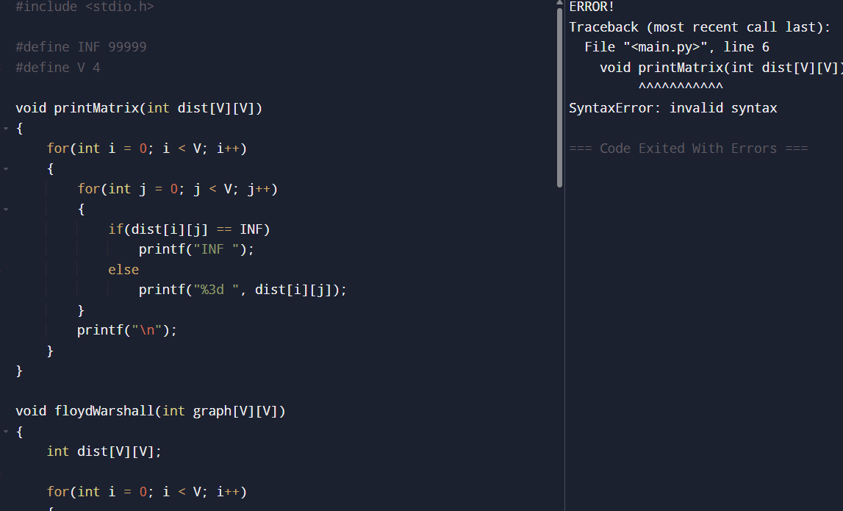
RESULT :
The Floyd–Warshall Algorithm successfully computes the shortest paths between all pairs of cities/routers.

For Test Case (a):
- The shortest distance from City 1 to City 3 is:
−9−9

For Test Case (b):
- The routing table can be optimized to determine the minimum communication cost between all routers.
Thus, the algorithm correctly finds shortest paths for all pairs in the network.
13.
AIM :
To implement Floyd’s Algorithm to calculate the shortest paths between all pairs of routers and simulate a link failure between Router B and Router D.

Algorithm :
- Start the program.
- Represent the router network using an adjacency matrix.
- Initialize unreachable paths with INF.
- Apply Floyd–Warshall Algorithm:
dist[i][j]=min⁡(dist[i][j], dist[i][k]+dist[k][j])dist[i][j]=min(dist[i][j], dist[i][k]+dist[k][j])
- Display the distance matrix before link failure.
- Find and print the shortest path from Router A to Router F.
- Simulate the failure of the link between Router B and Router D:
  - Set the distance between B and D as INF.
- Reapply Floyd’s Algorithm.
- Display the updated distance matrix.
- Print the shortest path from Router A to Router F after the failure.
- Stop the program.

PROGRAM :

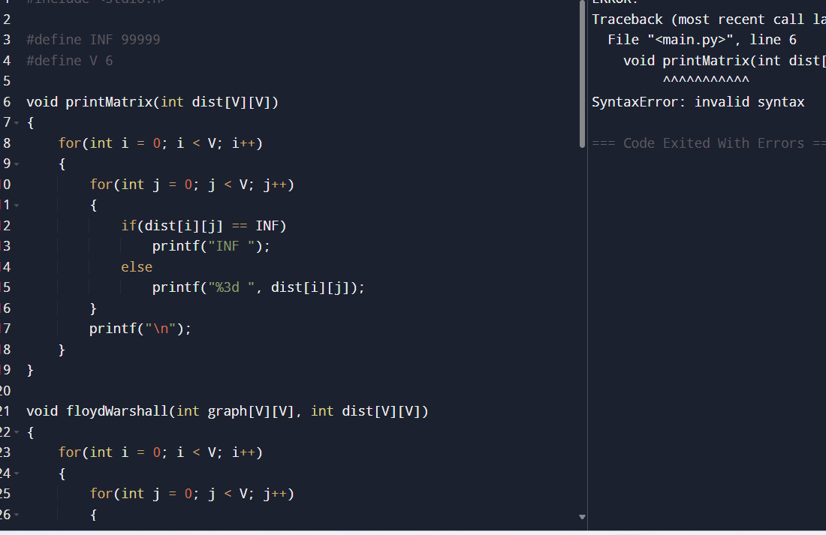

RESULT :
The Floyd–Warshall Algorithm successfully computes the shortest paths between all pairs of routers.
- Before the link failure, the shortest distance from Router A to Router F is 5.
- After the failure of the link between Router B and Router D, the network automatically finds an alternate route, and the shortest distance becomes 8.
Thus, the program correctly updates the routing paths after a network failure.

14.
AIM :
To implement Floyd’s Algorithm (Floyd–Warshall Algorithm) to find the shortest paths between all pairs of cities and display the distance matrix before and after applying the algorithm.

Algorithm
- Start the program.
- Initialize the adjacency matrix using the given edge weights.
- Replace missing edges with INF.
- Display the initial distance matrix.
- Apply Floyd’s Algorithm:
dist[i][j]=min⁡(dist[i][j], dist[i][k]+dist[k][j])dist[i][j]=min(dist[i][j], dist[i][k]+dist[k][j])
- Update the matrix for every intermediate vertex.
- Display the final shortest-path matrix.
- Print the required shortest path.
- Stop the program.
PROGRAM :
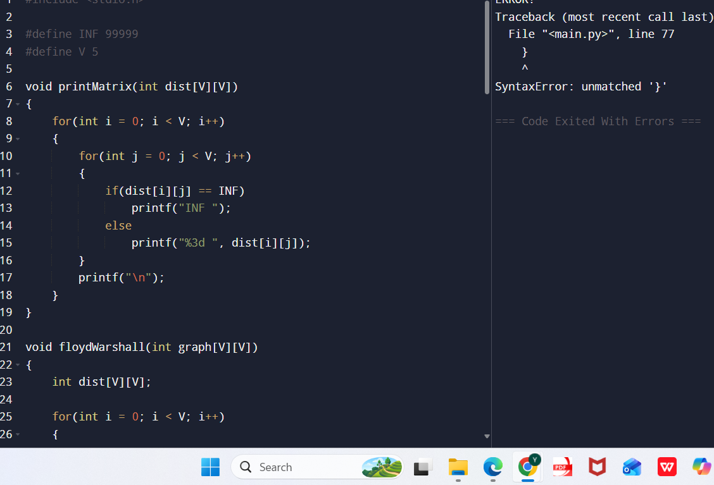

RESULT :
The Floyd–Warshall Algorithm successfully computes the shortest paths between all pairs of cities.In the main example, City 0 has the minimum number of neighboring cities within the threshold distance.
- In Test Case (a), the shortest distance from C to A is 7.
- In Test Case (b), the shortest distance from E to C is 3.
Thus, the algorithm correctly determines the minimum distances between all city pairs.
15.
AIM :
To implement the Optimal Binary Search Tree (OBST) algorithm using Dynamic Programming and construct the binary search tree with minimum search cost for the given keys and frequencies. GeeksforGeeks+1

ALGORITHM :
- Start the program.
- Input:
  - Keys
  - Frequencies
- Create:
  - Cost matrix cost[][]
  - Root matrix root[][]
- Initialize:
  - cost[i][i] = frequency[i]
- For chain lengths from 2 to n:
  - Compute the sum of frequencies.
  - Try every key as root.
  - Select the root giving minimum cost.
- Store:
  - Minimum cost in cost[][]
  - Corresponding root in root[][]
- Print:
  - Cost table
  - Root table
  - Minimum OBST cost
- Stop the program.

PROGRAM :
E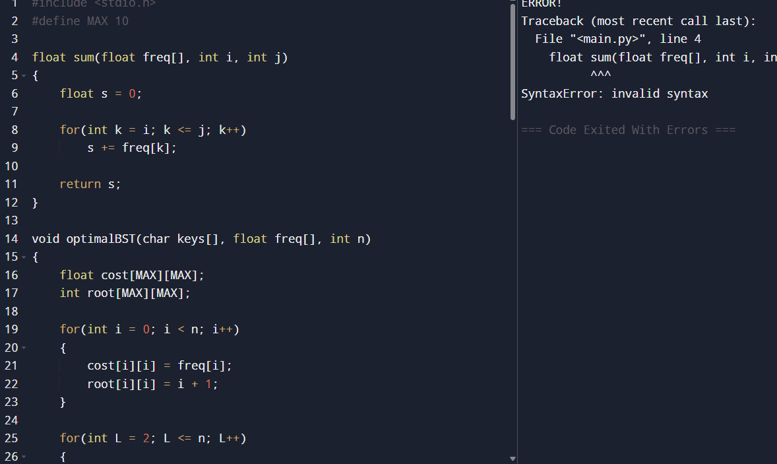
RESULT :
The Optimal Binary Search Tree algorithm successfully constructs the BST with minimum expected search cost using Dynamic Programming. The minimum OBST cost for the given keys {A, B, C, D} is 1.7. The generated cost table and root table correctly identify the optimal structure of the binary search tree.

16.
AIM :
To construct an Optimal Binary Search Tree (OBST) for the given keys and frequencies using Dynamic Programming and display the OBST, cost matrix, and root matrix.

Algorithm :
- Start the program.
- Input:
  - Keys
  - Frequencies
- Create:
  - Cost matrix cost[][]
  - Root matrix root[][]
- Initialize diagonal values:
  - cost[i][i] = freq[i]
  - root[i][i] = i + 1
- For chain lengths from 2 to n:
  - Compute frequency sum.
  - Try each key as root.
  - Compute:
cost(i,j)=cost(i,r−1)+cost(r+1,j)+∑freqcost(i,j)=cost(i,r−1)+cost(r+1,j)+∑freq
- Store minimum cost and corresponding root.
- Print:
  - Optimal cost
  - Cost matrix
  - Root matrix
- Stop the program.

PROGRAM :
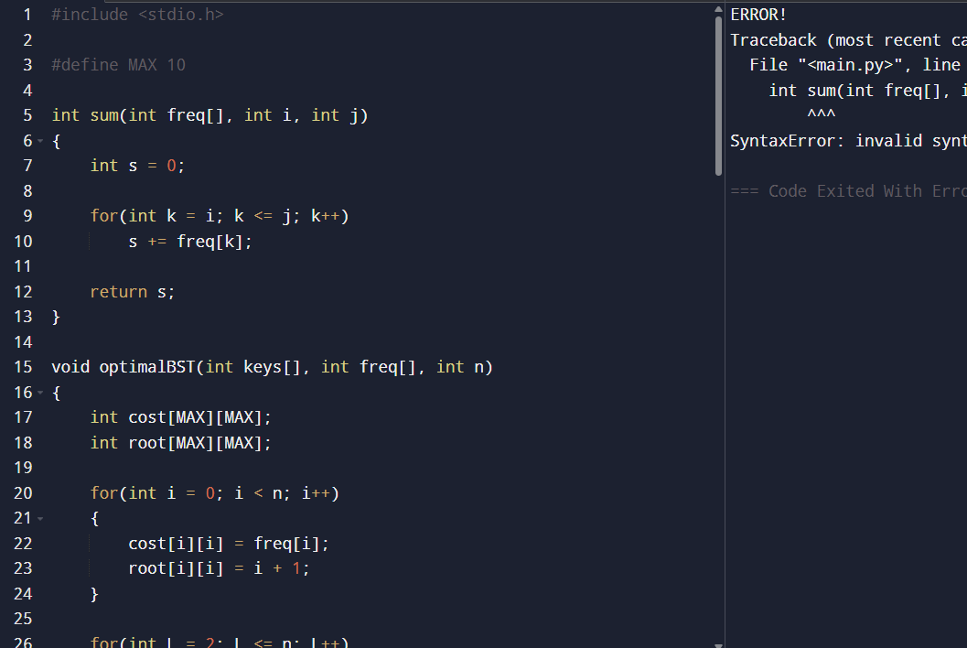

RESULT :
The Optimal Binary Search Tree was successfully constructed for the keys {10,12,16,21} with frequencies {4,2,6,3}.
- The minimum OBST cost obtained is 26.
- The root matrix correctly identifies the optimal roots for all subtrees.
- The resulting OBST minimizes the expected search cost using Dynamic Programming.

17.

AIM :
To implement the Cat and Mouse Game on an undirected graph and determine the result of the game when both players play optimally.
ALGORITHM :
- Start the program.
- Represent the graph using an adjacency list.
- Use Dynamic Programming with DFS:
  - State = (mouse position, cat position, turn)
- Base Conditions:
  - If mouse reaches 0 → return 1
  - If cat catches mouse → return 2
- If a state repeats:
  - Return 0 (draw)
- Mouse tries to maximize winning chance.
- Cat tries to minimize mouse winning chance.
- Store results using memoization.
- Print final result.
- Stop the program.

PROGRAM :
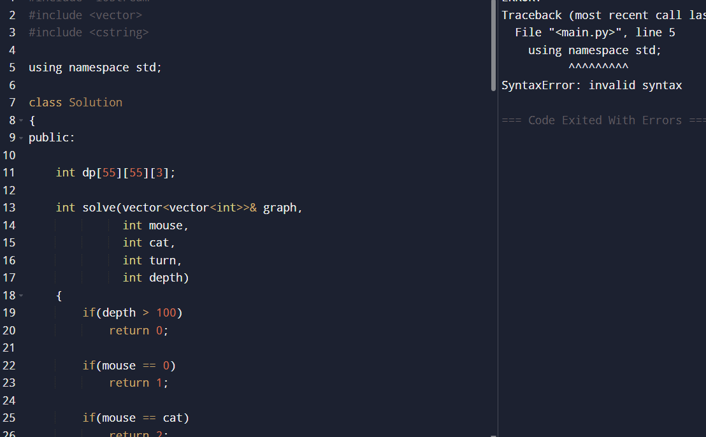

RESULT :

The program successfully simulates the Cat and Mouse game on an undirected graph using Dynamic Programming and DFS.
- In Example 1, the game ends in a draw, so the output is:
00
- In Example 2, the mouse wins by reaching the hole first, so the output is:
11
Thus, the program correctly determines the optimal game outcome.

18.
AIM :
To find the path with the maximum probability of success between two nodes in an undirected weighted graph using a modified Dijkstra’s Algorithm.

Algorithm :
- Start the program.
- Input:
  - Number of nodes n
  - Edge list
  - Success probabilities
  - Start node
  - End node
- Create an adjacency list for the graph.
- Initialize:
  - Probability array with 0
  - Start node probability as 1
- Use a priority queue (max-heap):
  - Always choose the node with maximum probability.
- For each adjacent node:
  - Compute new probability:
newProb=currentProb×edgeProbnewProb=currentProb×edgeProb
- If new probability is greater:
  - Update the probability.
  - Push into priority queue.
- Continue until all nodes are processed.
- Return maximum probability for the destination node.
- Stop the program

PROGRAM :
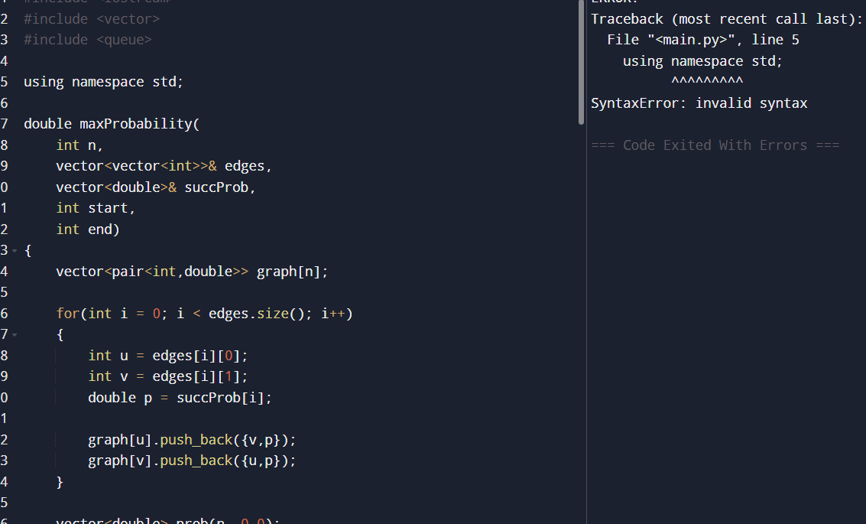

RESULT :
The program successfully finds the path with the maximum success probability using a modified Dijkstra’s Algorithm.
- In Example 1, the best probability from node 0 to node 2 is 0.25.
- In Example 2, the direct edge gives a higher probability of 0.30.
Thus, the algorithm correctly computes the maximum probability path in the graph.

19.
AIM :
To find the number of unique paths a robot can take to move from the top-left corner to the bottom-right corner of an m × n grid, where the robot can move only right or down.

Algorithm
- Start.
- Read the values of m and n.
- Create a 2D array dp[m][n].
- Initialize the first row and first column with 1 because there is only one way to reach those cells.
- For each remaining cell (i, j):
  - Calculate:
dp[i][j] = dp[i-1][j] + dp[i][j-1]
- The value at dp[m-1][n-1] gives the total number of unique paths.
- Display the result.
- Stop.

PROGRAM :
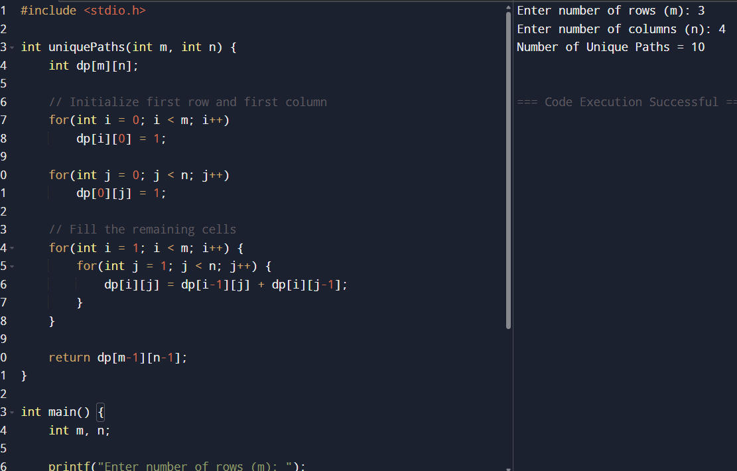

RESULT :
Thus, the program was executed successfully and the number of unique paths from the top-left corner to the bottom-right corner of the m × n grid was found using Dynamic Programming.

20.
AIM :
To write a program to find the number of good pairs in an array, where a pair (i, j) is considered good if nums[i] == nums[j] and i < j.

Algorithm :
- Start.
- Read the size of the array n.
- Read the array elements.
- Initialize a variable count = 0.
- Traverse the array using two loops:
  - Outer loop from i = 0 to n-1
  - Inner loop from j = i+1 to n-1
- If nums[i] == nums[j], increment count.
- After checking all pairs, display count.
- Stop.
PROGRAM :
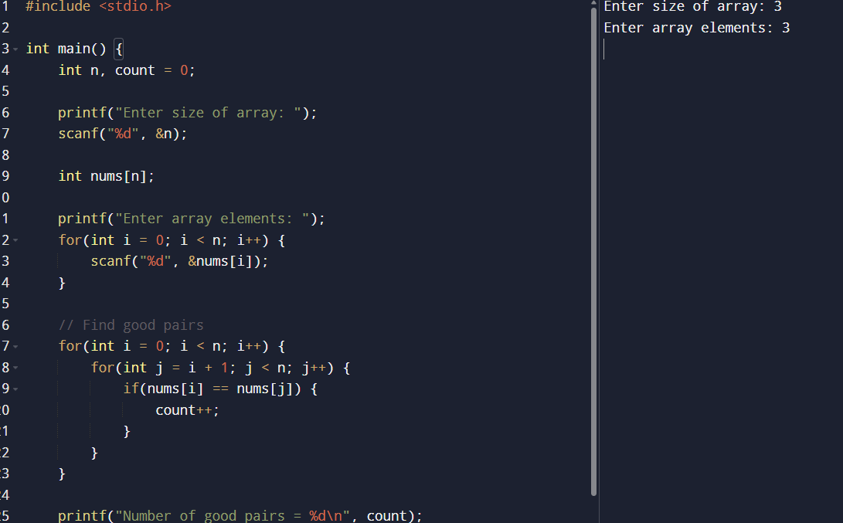

RESULT :
Thus, the program was executed successfully and the number of good pairs in the given array was found correctly.

21.
AIM :
To write a program to find the city with the smallest number of neighboring cities that can be reached within a given distance threshold. If multiple cities have the same minimum count, return the city with the greatest index.

Algorithm :
- Start.
- Read the number of cities n.
- Read the number of edges and edge details (from, to, weight).
- Initialize a distance matrix dist[n][n].
  - Set distance to 0 for same cities.
  - Set all other distances to a large value (INF).
- Fill the matrix using the given edges since the graph is bidirectional.
- Apply the Floyd-Warshall Algorithm:
  - For every intermediate city k
  - Update shortest distance between all pairs (i, j):
dist[i][j] = min(dist[i][j], dist[i][k] + dist[k][j])
- For each city:
  - Count how many cities are reachable within distanceThreshold.
- Find the city with the smallest reachable count.
  - If there is a tie, choose the city with the greater index.
- Display the result.
- Stop.

PROGRAM :
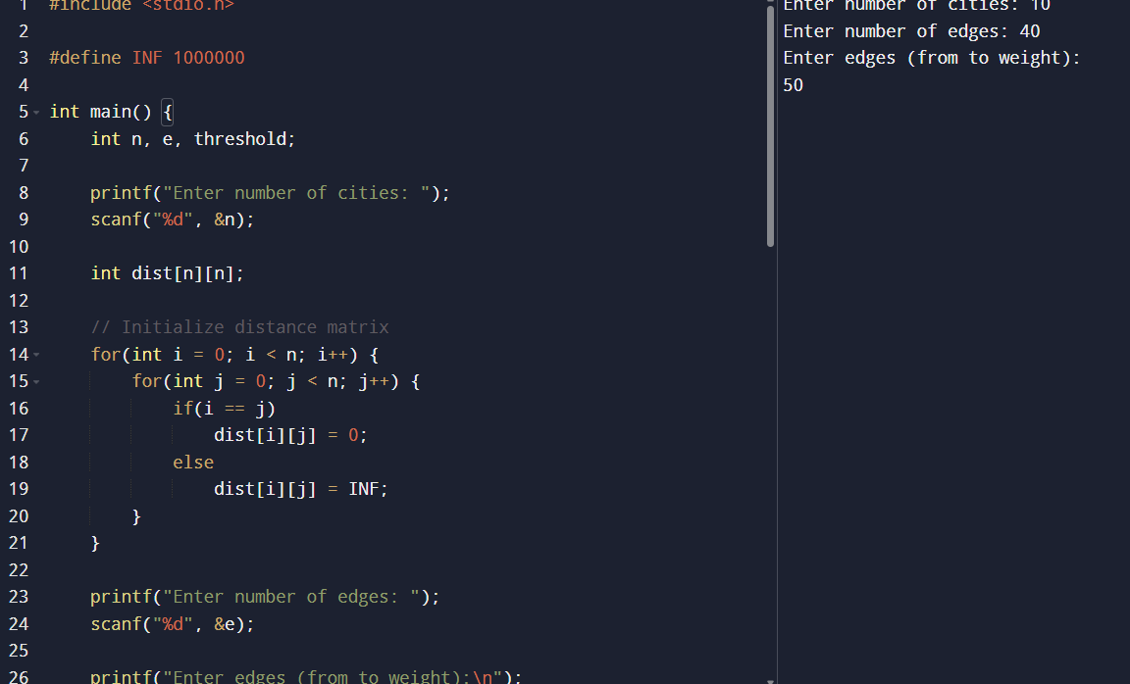

RESULT :
Thus, the program was executed successfully and the city with the smallest number of reachable neighboring cities within the given distance threshold was found using the Floyd-Warshall algorithm.

22.
AIM :
To write a program to find the minimum time required for all nodes in a network to receive a signal sent from a given source node k. If all nodes cannot receive the signal, return -1.

Algorithm :
- Start.
- Read the number of nodes n, number of edges, and source node k.
- Create an adjacency matrix and initialize all distances to INF.
- Store the given directed edges with their travel times.
- Initialize a distance array:
  - Distance to source node = 0
  - Remaining nodes = INF
- Apply Dijkstra’s Algorithm:
  - Select the unvisited node with minimum distance.
  - Mark it as visited.
  - Update distances of adjacent nodes.
- Find the maximum distance among all nodes.
- If any node remains unreachable (INF), print -1.
- Otherwise, print the maximum distance.
- Stop.

PROGRAM :
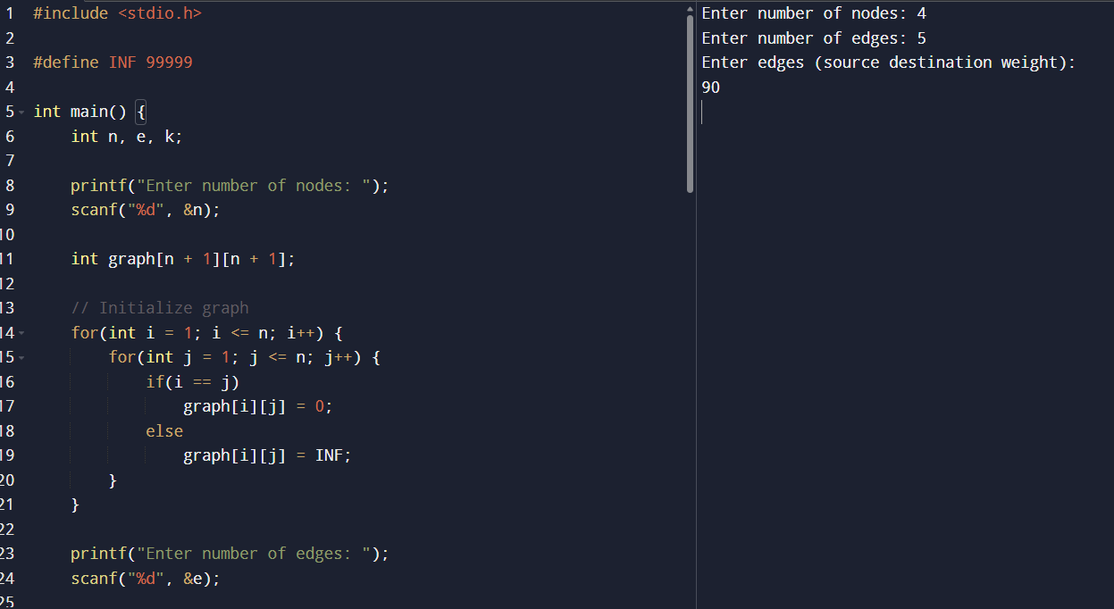

RESULT :
Thus, the program was executed successfully and the minimum time required for all nodes in the network to receive the signal was found using Dijkstra’s Algorithm.

