COIN CHANGE – PAYMENT SYSTEM
OPTIMIZATION
Q9 – Dynamic Programming vs Greedy
Name: L. Ashraf Ali
Register No.: 192524192
Source Code, Output, Analysis and Documentation

1. Aim
To find the minimum number of coins required to make a given payment amount using Dynamic Programming and compare the result with a Greedy approach.

2. Problem Statement
A digital payment system must return change to users using the minimum number of coins from a set of available denominations. The algorithm determines the minimum number of coins for a given amount and explains when Dynamic Programming or Greedy is appropriate.

3. Inputs
- coins – available positive coin denominations.
- amount – the change amount that must be formed.

4. Output
The minimum number of coins required to form the given amount. If impossible, return -1.

5. Dynamic Programming Approach
Let dp[x] be the minimum number of coins required to make amount x. The base case is dp[0] = 0. All other values start at infinity and are improved by considering each available coin.
Recurrence: dp[x] = min(dp[x], dp[x − c] + 1)
The table is constructed from amount 0 up to the target, so every smaller subproblem is solved before it is needed.

6. DP Table Example
Coins = [1, 2, 5]
Amount = 11
Amount | 0 | 1 | 2 | 3 | 4 | 5 | 6 | 7 | 8 | 9 | 10 | 11
Min Coins | 0 | 1 | 1 | 2 | 2 | 1 | 2 | 2 | 3 | 3 | 2 | 3
Therefore, dp[11] = 3. One optimal combination is 5 + 5 + 1.

7. Greedy Approach
Greedy repeatedly chooses the largest denomination that does not exceed the remaining amount. For [1, 2, 5] and amount 11, it chooses 5, 5 and 1, giving 3 coins.

8. Example Where Greedy Fails
Coins = [1, 3, 4], Amount = 6. Greedy gives 4 + 1 + 1 = 6 using 3 coins, while the optimal solution is 3 + 3 = 6 using only 2 coins. DP finds the optimal answer.

9. DP vs Greedy Comparison
Feature | Dynamic Programming | Greedy
Optimal result | Guaranteed for positive denominations | Not always guaranteed
Time complexity | O(n × A) | Usually O(n) after sorting
Space complexity | O(A) | O(1) extra space
Arbitrary denominations | Suitable | May fail
Canonical denominations | Suitable | Often suitable
Financial reliability | High when exact optimality is required | Depends on denomination system

10. Suitable Implementation Tools
- Python – simple for algorithm development and testing.
- Java – suitable for enterprise/payment applications.
- C++ – useful where high performance is required.
- Visual Studio Code / PyCharm – development environments.
- Jupyter Notebook – useful for demonstrating DP tables and results.

11. Python Source Code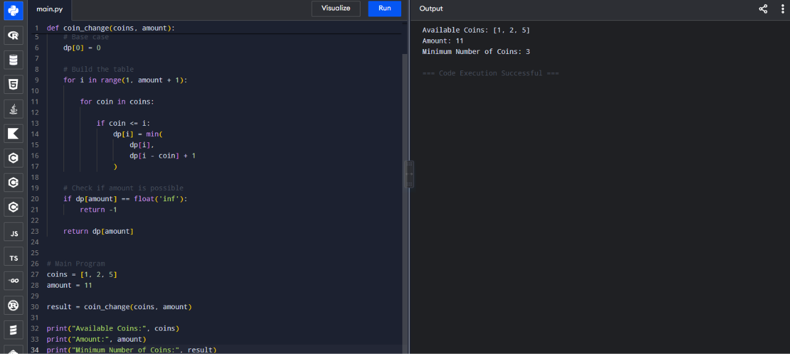

12. Time and Space Complexity
For n coin denominations and target amount A, the Dynamic Programming solution takes O(n × A) time and O(A) space.

13. Efficiency in Financial Systems
Dynamic Programming is useful when a payment system uses configurable or non-standard denominations and must guarantee minimum coin count. For small denomination sets and moderate amounts, O(n × A) is practical. High-volume systems should also consider transaction limits, latency, memory, and repeated queries.

14. Correctness Analysis
For each amount x, the algorithm considers every coin c that can be the final coin. The remaining amount x − c has already been solved optimally. Taking the minimum over all possible final coins therefore produces the optimal value for x. Building the table from smaller to larger amounts ensures the final result is correct.

15. Optimization Strategies
- Use a one-dimensional DP array to reduce memory.
- Use Greedy only when the denomination system is proven to have the greedy-choice property.
- Cache or precompute results for repeated payment queries.
- Filter invalid denominations before processing.
- Keep practical maximum-change limits so the DP table remains bounded.

16. Conclusion
For coins [1, 2, 5] and amount 11, the minimum is 3 coins: 5 + 5 + 1. Greedy produces the same result for this example, but can fail for arbitrary denominations such as [1, 3, 4]. Dynamic Programming is therefore the safer general-purpose method when a financial system must guarantee minimum coin count.

17. Student Details
Name: L. Ashraf Ali
Register No.: 192524192

