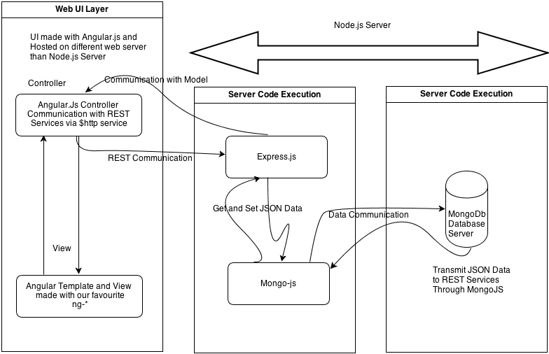

NODEJS

Node.js® is a JavaScript runtime built on [Chrome's V8 JavaScript engine](https://developers.google.com/v8/). Node.js uses an event-driven, non-blocking I/O model that makes it lightweight and efficient. Node.js' package ecosystem, [npm](https://www.npmjs.com/), is the largest ecosystem of open source libraries in the world.

HTML  
First developed by Tim Berners-Lee in 1990, HTML is short for **HyperText Markup Language**. HTML is used to create electronic documents (called pages) that are displayed on the World Wide Web.

AngularJS

AngularJS is a **JavaScript framework**. It can be added to an HTML page with a <script> tag.

AngularJS extends HTML attributes with **Directives**, and binds data to HTML with **Expressions**.

AngularJS extends HTML with **ng-directives**.

The **ng-app** directive defines an AngularJS application.

The **ng-model** directive binds the value of HTML controls (input, select, textarea) to application data.

The **ng-bind** directive binds application data to the HTML view.

Bootstrap

Advantages of **Bootstrap**: Easy to **use**: Anybody with just basic knowledge of HTML and CSS can start using **Bootstrap**. Responsive features: **Bootstrap's** responsive CSS adjusts to phones, tablets, and desktops. Mobile-first approach: In **Bootstrap**3, mobile-first styles are part of the core framework.

Mongodb

[free and open-source](https://en.wikipedia.org/wiki/Free_and_open-source_software) [cross-platform](https://en.wikipedia.org/wiki/Cross-platform) [document-oriented database](https://en.wikipedia.org/wiki/Document-oriented_database) program.

**Test Case**

|  |
| --- |
| Test Case #: 1 Test Case Name: SignUp form  System:MyShoppie Subsystem:SignUp  Designed by: Design Date:  Executed by: Execution Date:  Short Description: Test the SignUp form |

|  |
| --- |
| Pre-conditions  The user must enter the valid details in the sign up form |

|  |  |  |  |  |
| --- | --- | --- | --- | --- |
| Step | Action | Expected System Response | Pass/ Fail | Comment |
|  | Click on Signup/Login link | The Login page will be displayed | Pass |  |
|  | Click on Signup button | SignUp page will be displayed | Pass |  |
|  | Enter the mandatory fields | An alert will be displayed with the message ‘ user is successfully registered’ | Pass |  |
|  | Close the alert | The page will be redirected to login page | pass |  |

|  |
| --- |
| Post-conditions  The username and password entered in signup form can be used in the login form |