AgentFlow
A Multi-Agent AI System for Automated Customer Support Ticket Management
CA-3 | Domain-Specific Agentic AI Proof of Concept
Name: Ashrith Reddy Kota | Class: AIML A | PRN: 24070126040
Department: Artificial Intelligence and Machine Learning | Institute: Symbiosis Institute of Technology, Pune
Submission date: 19 October 2026

1. Abstract
AgentFlow is an offline, rule-based multi-agent proof of concept for customer support ticket triage. Six cooperating agents plan a task sequence, classify complaints, evaluate urgency, retrieve local knowledge, draft a response and validate the outcome. A Streamlit interface supports single tickets, batch CSV processing and an operations dashboard. Synthetic data and a mock-agent approach eliminate paid API requirements. All customer responses remain drafts pending human review.

2. Domain and Problem Statement
Domain: Customer Support and Business Process Automation. Problem: Manual support teams spend time repeatedly reading incoming tickets, deciding categories and urgency, searching for guidance, drafting responses and checking quality. Differences in judgment can delay critical escalation. The PoC tests whether an explainable multi-agent pipeline can standardize these repetitive first-response steps without automatically contacting customers.

3. Existing Workflow vs Proposed Solution
Existing manual approach | AgentFlow PoC
Read every ticket individually | Single/batch intake and structured task plan
Decide category and priority manually | Classifier + priority rules show matched evidence
Search policies across sources | Local knowledge-base lookup by category
Draft replies and review manually | Draft generator + critic review flags
Unstructured reporting | Downloadable decision traces and dashboard

4. Objectives
- Automate demonstrable ticket classification and urgency routing.
- Coordinate specialized agents using a reproducible orchestration workflow.
- Provide evidence, draft responses and human-review gates.
- Visualize synthetic-ticket outcomes and validate core behavior with unit tests.

5. Agent Roles and Orchestration
- Planner Agent: Defines task order and records intake completeness.
- Classification Agent: Scores category keywords and returns a heuristic confidence.
- Priority Agent: Uses explicit fraud/security and urgency triggers.
- Research Agent: Retrieves category-specific response guidance and the responsible team from local KB.
- Resolution Agent: Creates a safe draft and a routing recommendation.
- Critic Agent: Checks low-confidence, insufficient detail, missing fields and high-risk flags; requires human review when appropriate.
Orchestrator (agentflow/core.py): Planner → Classification → Priority → Research → Resolution → Critic. Conditional decision: any Critic flag routes to Human Review; otherwise the output is Draft Ready. Neither branch sends a message.

6. System Architecture and Data Flow
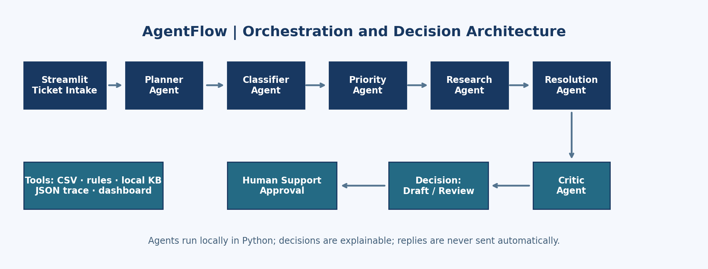
Inputs: synthetic customer, subject and complaint (form or CSV). Tools: keyword-matching rules, priority lexicon, embedded local knowledge base, Streamlit, Pandas and JSON/CSV export. Output: ticket metadata, plan, classifier evidence, priority reason, knowledge article ID, proposed draft, critic flags and final route.

7. Implementation and Technology
Python 3, Streamlit for UI, Pandas for CSV/chart summaries, pytest for unit testing. No LangChain, Ollama, external APIs or trained models are used. Separate Python classes implement the specialized mock agents; the orchestration function passes their outputs to later agents. The core pipeline is deterministic except for an informational UTC timestamp.

8. Demo Procedure
- Run: python -m pip install -r requirements.txt; python -m streamlit run app.py.
- Choose TKT-1006 to show an unauthorized-payment issue flagged Critical and Human Review.
- Choose TKT-1003 to show Delivery & Shipping with a drafted response.
- Review individual stages, the knowledge reference and the critic decision.
- Process the bundled CSV, view dashboard metrics and export the results.

9. Results and Validation
Ten fictional tickets were processed locally. Category distribution: {'Billing & Refund': 4, 'Account & Login': 1, 'Delivery & Shipping': 2, 'Product & Returns': 1, 'General Inquiry': 2}. Priority distribution: {'High': 2, 'Medium': 6, 'Critical': 1, 'Low': 1}. Routing distribution: {'Human Review': 6, 'Draft Ready': 4}. These are illustrative workflow outputs, not measured business performance gains. Six unit tests check billing classification, fraud escalation, insufficient-details escalation, a delivery draft, non-sending behavior and correct team routing; tests passed in the authoring environment.
Ticket | Predicted category | Priority | Route
TKT-1001 | Billing & Refund | High | Human Review
TKT-1002 | Account & Login | High | Human Review
TKT-1003 | Delivery & Shipping | Medium | Draft Ready
TKT-1004 | Billing & Refund | Medium | Human Review
TKT-1005 | Product & Returns | Medium | Draft Ready
TKT-1006 | Billing & Refund | Critical | Human Review
TKT-1007 | General Inquiry | Medium | Human Review
Validation controls: required form fields, short-text review, heuristic low-confidence review, automatic high-risk escalation, presence of a ticket reference in the draft, and explicit auto_send=False. Confidence is a heuristic score, not calibrated probability or evaluation accuracy.

10. Limitations and Future Scope
This is a mock-agent PoC rather than a learned or LLM-powered system. Keywords can fail on complex, multilingual, ambiguous and adversarial inputs; overlapping terms can lead to incorrect labels. No authenticated support system, live policy lookup, persistence, real deployment, email sender, or permissioned approval workflow exists. Future work: evaluate against annotated real tickets (with privacy protections); replace rules with local LLM/classifier tools; add retrieval from versioned approved policy documents, observability, authentication, bias checks and safe integration with support platforms.

11. Conclusion
AgentFlow demonstrates a coordinated multi-agent workflow rather than a simple chatbot. The PoC separates planning, triage, knowledge retrieval, drafting and validation while ensuring high-risk cases reach human reviewers. Its value is a transparent and testable prototype for future customer support automation, not a claim of production-readiness.

12. References
- Streamlit documentation — https://docs.streamlit.io/
- Python documentation — https://docs.python.org/3/
- Pandas documentation — https://pandas.pydata.org/docs/
- pytest documentation — https://docs.pytest.org/

