Code Companion
ABAP Cloud & Clean Core Assistant

Product & Technical Reference Documentation

Powered by aXet.flows

Code Companion

1. Objective
Code Companion is an AI development assistant that helps SAP developers move from a plain-language requirement to a working, Clean-Core-aligned implementation. The developer describes what they need built, and Code Companion guides them through a structured conversation — confirming the requirement, generating the implementation, validating it, and closing with a summary — producing code alongside its explanation, test strategy, deployment notes, and Clean-Core impact in one guided pass.
It supports ABAP, ABAP Cloud, CDS, RAP, OData services, Fiori/UI5 integration points, and CAP applications on SAP BTP, following SAP Clean Core design principles throughout every response.
Naming note: Code Companion is the current name for this application. Some screens, logs, and prior releases may still display its earlier name, SAP Code Agent, during the platform transition.

2. The Problem It Solves
Building a clean, well-documented SAP custom object is one of the more time-consuming and inconsistent parts of SAP development. Developers typically:
- Research which released API or extensibility pattern applies before writing a single line of code
- Write boilerplate class, CDS, or RAP structure from scratch every time
- Remember to add authorization checks, input validation, and error handling consistently
- Draft tests, deployment notes, and a Clean-Core impact assessment only after the implementation is already written
- Repeat this process for every new object, with completeness varying by developer and how much time pressure they’re under
This is slow, repetitive, and inconsistent — two developers solving the same kind of requirement can produce solutions that differ in structure, completeness, and adherence to clean-core guidance, and details like authorization or test coverage are easy to skip under deadline pressure.
Code Companion removes this bottleneck by guiding the developer through the requirement once, generating a complete, Clean-Core-aligned implementation with its supporting documentation in minutes, while keeping the developer fully in control of what’s confirmed and delivered.
3. What the Application Does
Code Companion walks the user through a guided, stage-by-stage process rather than generating a finished implementation in one uncontrolled pass. This keeps the output accurate and lets the developer confirm or correct the AI’s understanding before code is generated, and validate the result before the conversation closes.
3.1 Guided Workflow
Code Companion moves through four visible stages, shown as a progress indicator throughout the conversation:
1. Understand — the developer describes the requirement. Code Companion asks only the clarifying questions it judges essential — system landscape, package/transport target, authorization needs — and states the assumptions it will use. The developer confirms or corrects them.
2. Code — once confirmed, Code Companion generates the implementation: class definitions, CDS views, behavior definitions, service bindings, and unit test scaffolding as appropriate, each in a clearly labeled code block.
3. Validate — Code Companion reviews its own delivered solution against the requirement and any feedback given, and reports whether it’s ready or what still needs correcting.
4. Complete — the conversation closes with a summary of what was delivered, the validation outcome, a testing recommendation, deployment/transport notes, and the Clean-Core impact, with the full response available as a downloadable Word document.
3.2 Core Capabilities
- Guided, stage-gated generation: Nothing is generated until the requirement is confirmed, and nothing is finalized until it's validated — the developer stays in control at every step.
- Clean-Core aligned by default: Implementations favor released APIs, released CDS views, RAP, and side-by-side extensibility over modification of SAP standard objects, and clearly flag any exception.
- Self-review before delivery: Code Companion checks its own output against the stated requirement during the Validate stage, rather than treating first-draft code as final.
- Structured, complete output: Every response is built to include the implementation, an explanation, a test strategy, deployment notes, and a Clean-Core impact assessment — not code alone.
- Consistent, ready-to-share output: Every implementation follows the same structured format regardless of which developer runs it, so quality and completeness no longer depend on the individual author.
- Downloadable documentation: Any response can be exported as a formatted Word document for review, sign-off, or handoff.
- Transparent progress: A visible workflow indicator always shows exactly where the conversation stands — Understand, Code, Validate, or Complete.
4. What Code Companion Delivers
Every completed Code Companion response includes the same structured set of components, so the final output is consistent no matter what was built:
Component | Purpose
Assumptions | The system context, constraints, and defaults Code Companion used, stated clearly so the developer can confirm or correct them.
Code | The generated implementation — classes, CDS views, behavior definitions, service bindings, or corrected code — in clearly labeled, ready-to-use blocks.
Explanation | A concise walkthrough of the design and why it was built that way.
Test Strategy | Recommended or generated ABAP Unit tests and validation approach for the delivered solution.
Deployment / Transport Notes | What needs to happen to move the solution from development toward production — package, transport, and activation guidance.
Clean-Core Impact | An explicit statement of how the solution aligns with SAP Clean Core principles, and any exceptions made and why.

5. Accessing the Platform
Code Companion follows the shared aXet.BusinessSolutions access flow used across the suite: Agent Launcher, sign-in, project selection, model selection, then locating the application under the Realize delivery phase in the catalogue.
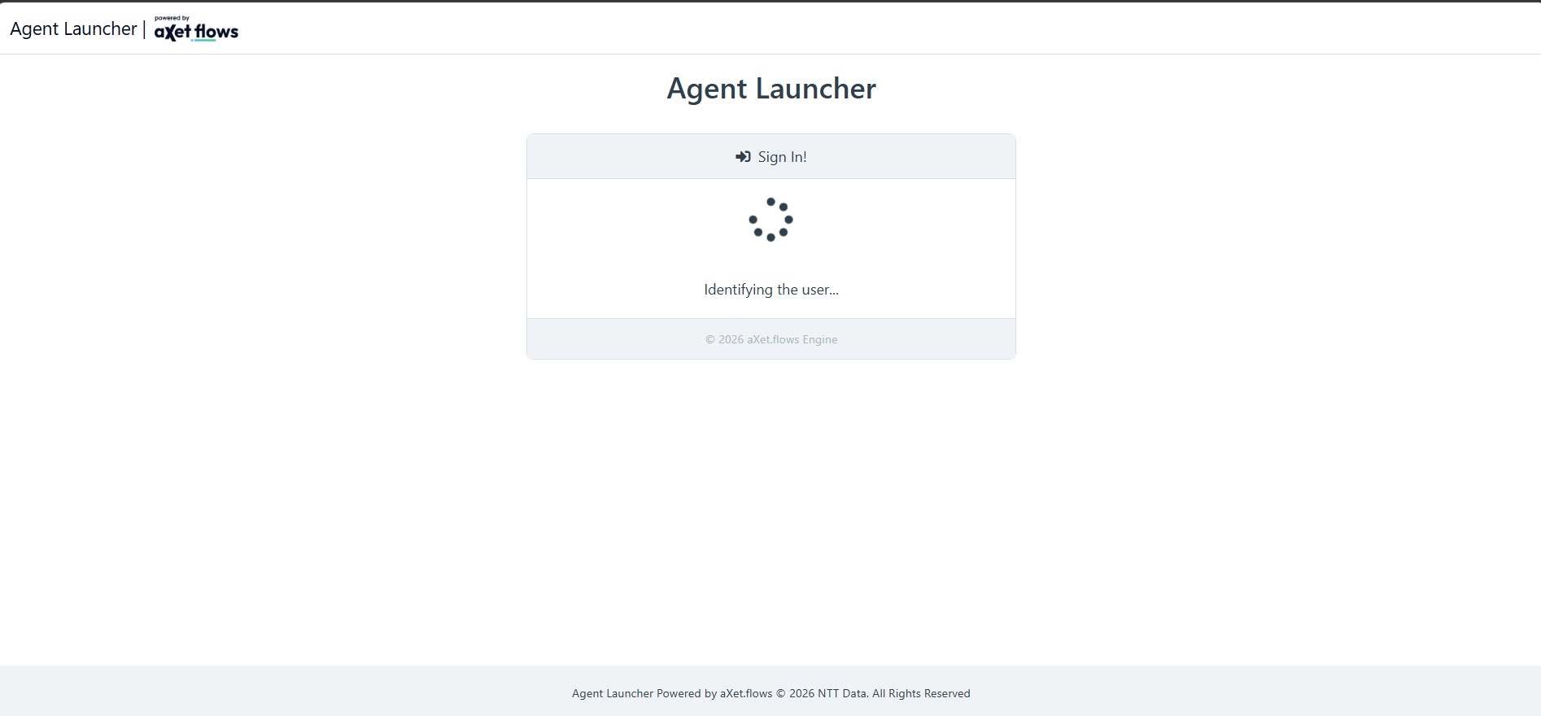
Figure 1 — Agent Launcher sign-in.
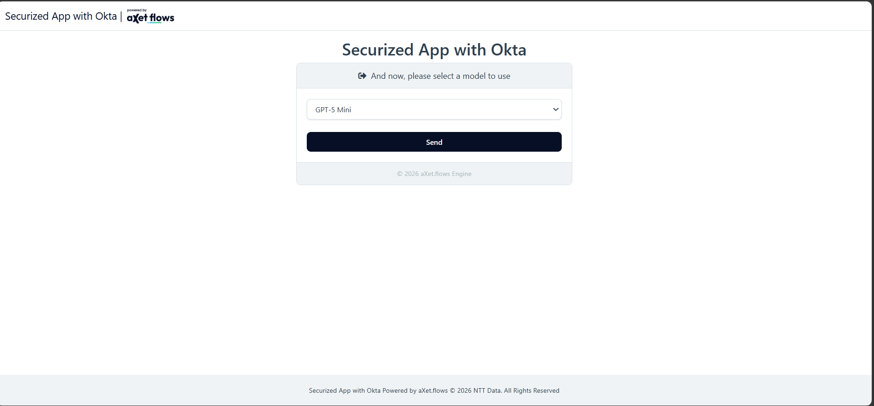
Figure 2 — Select the model available for the session and click "Send."
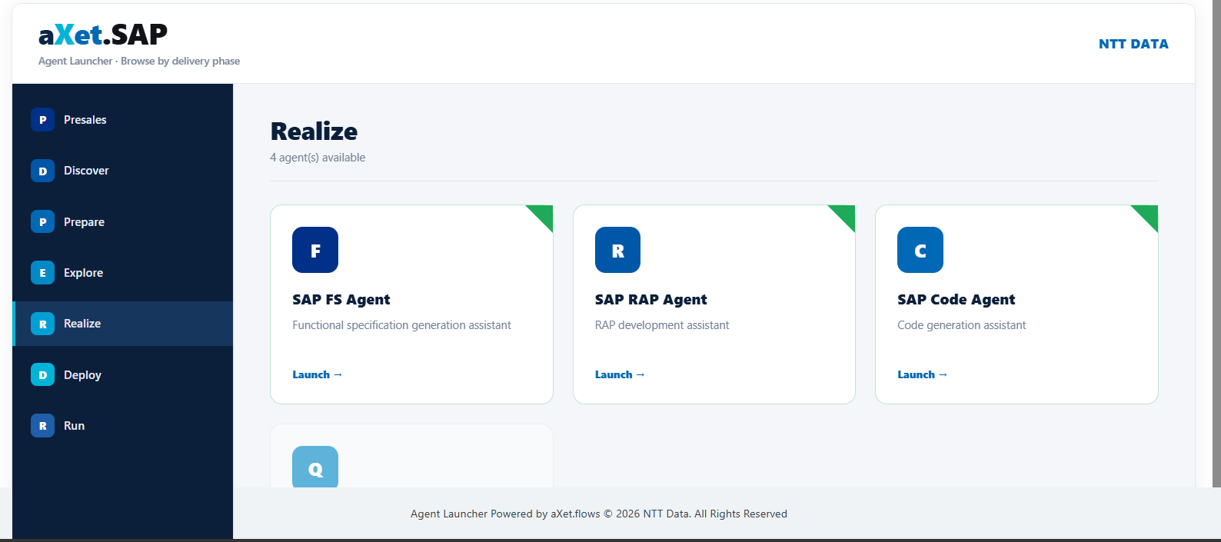
Figure 3 — aXet.BusinessSolutions catalogue, Realize phase. Code Companion is launched from here.
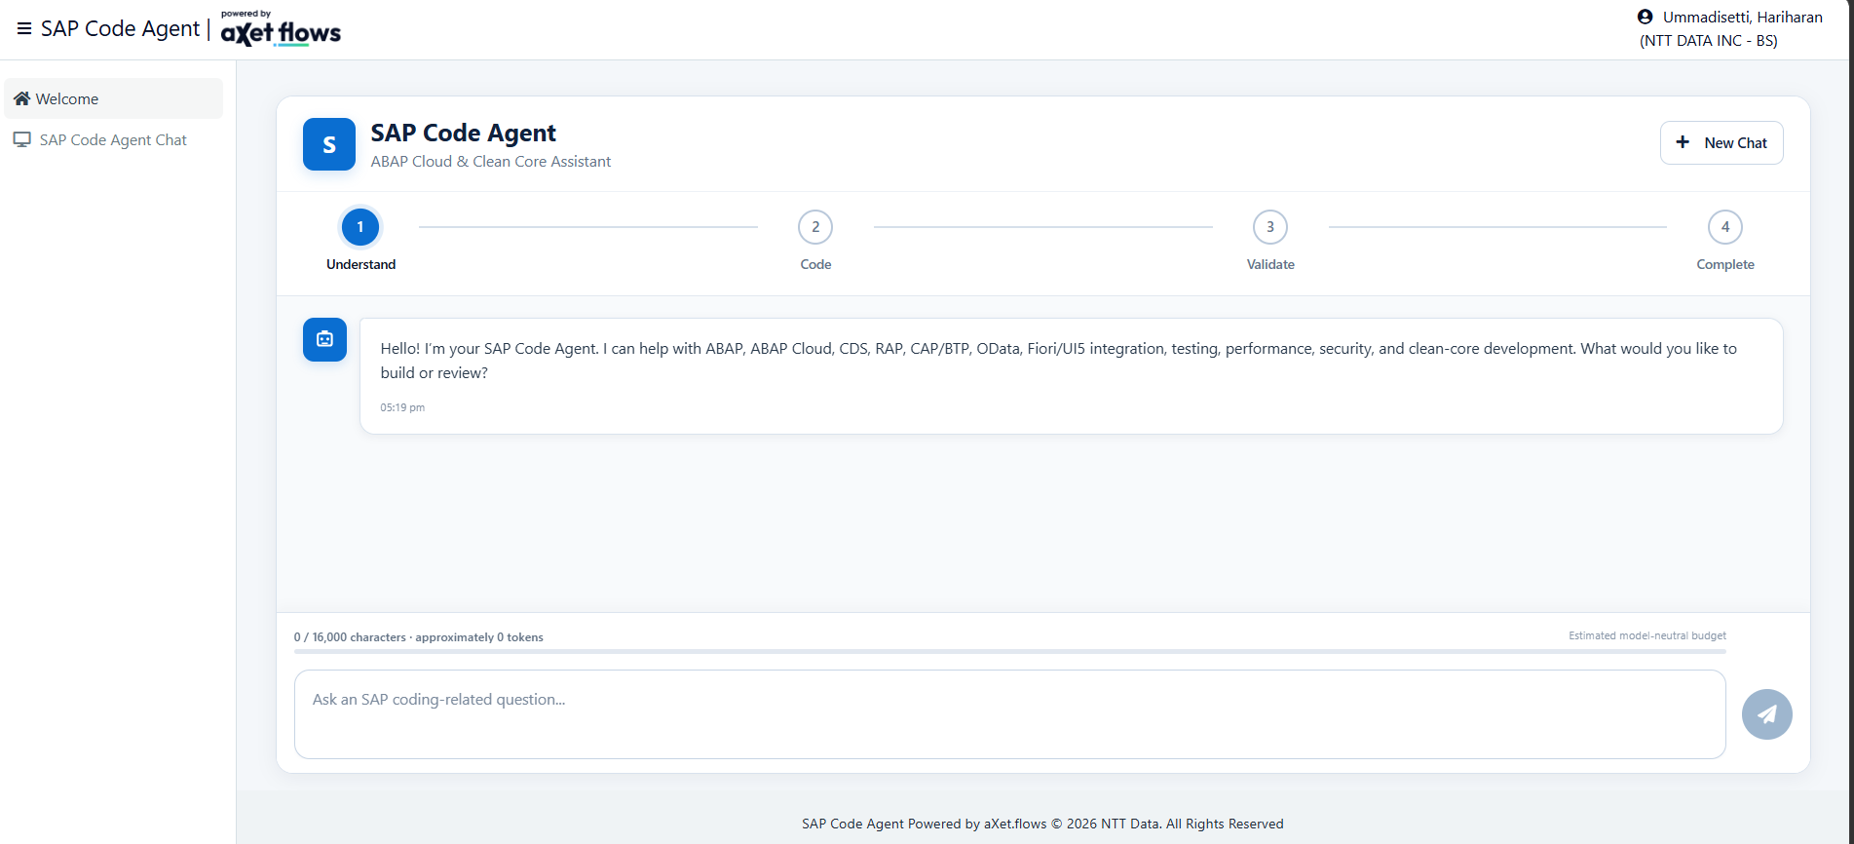
Figure 4 — Code Companion working screen, showing the four-stage progress indicator. (Shown here under its former name, SAP Code Agent, prior to the rename.)
6. Who It’s For
- SAP ABAP, ABAP Cloud, CDS, and RAP developers who want a faster, cleaner starting point for new implementations
- Development teams who want consistent, clean-core-aligned code regardless of which developer is writing it
- Delivery teams under time pressure who need boilerplate, tests, and documentation drafted quickly so they can focus on review and refinement
- Anyone responsible for SAP custom development who wants to spend more time on solution quality and less time on repetitive scaffolding
7. Why It’s Useful
Without Code Companion | With Code Companion
Manually researching the right clean-core pattern for every new object | Code Companion applies clean-core principles automatically and flags any exception
Boilerplate class, CDS, or RAP scaffolding written from scratch each time | A structured implementation is generated in minutes, ready for refinement
Authorization checks, error handling, or test coverage easy to overlook under deadline pressure | Every response is built to consider authorization, error handling, and tests by default
Explanation, test strategy, and deployment notes written up separately after the code is done | These are generated alongside the implementation as part of the same response
Quality and completeness vary by developer | Every response follows the same structured, clean-core-aligned format

8. Current Capabilities and Roadmap
8.1 Available Now
- End-to-end guided conversation across all four stages: Understand, Code, Validate, Complete
- Clean-Core-aware generation across ABAP, ABAP Cloud, CDS, RAP, OData, Fiori/UI5, and CAP/BTP
- Structured response format: implementation, explanation, test strategy, deployment notes, Clean-Core impact
- Self-review of delivered code during the Validate stage
- Export of any response as a formatted Word document
- Visible workflow progress throughout the conversation
The stage-transition logic and self-review step above reflect the application’s design and most recent development-environment testing. A final confirmation pass in the target environment is recommended before this capability list is used in a live customer-facing demonstration.

8.2 Planned Next Steps
The next phase of work is focused on three capabilities, none of which are built yet:
- Retrieval-grounded responses — restricting answers to a defined set of organizational documents, rather than general model knowledge
- Persistent, multi-conversation history with a navigable list of past conversations
- File attachment with extraction from both unstructured (e.g. PDF, Word) and structured (e.g. Excel, CSV) sources
The technical approach for each of these — including what storage is available, whether embeddings generation is supported, and what UI foundation best supports them — is still under evaluation. These are open questions, not yet decisions.
9. Known Boundaries
- Code Companion does not access, modify, or deploy anything in a live SAP system. All output is for manual review and application.
- It does not verify that a suggested object name, CDS view, or authorization object actually exists or is released in the target system — it flags assumptions and uses placeholders where it can't verify this.
- It does not currently answer from a restricted or curated knowledge base — responses draw on general model knowledge, not an organization-specific document set.
- There is no persistence across sessions today. Closing or refreshing the browser loses the active conversation, and only one conversation is active at a time.
10. Glossary
Term | Plain-Language Explanation
ABAP / ABAP Cloud | SAP’s programming language for custom development; “Cloud” refers to the restricted, upgrade-safe subset used in clean-core development
CDS (Core Data Services) | A way of defining reusable, SAP-native data views used across reporting, apps, and APIs
RAP (RESTful ABAP Programming Model) | SAP’s standard framework for building new transactional applications
Clean Core | SAP’s guidance to build extensions without modifying standard SAP objects, so the system stays upgrade-safe
OData | The standard protocol SAP uses to expose data to Fiori apps and external systems
CAP / BTP | SAP’s Cloud Application Programming model, used for side-by-side extensions on SAP’s Business Technology Platform
Stage (Understand / Code / Validate / Complete) | The four steps of a Code Companion conversation, shown as a progress indicator

11. Frequently Asked Questions
What SAP areas does it support?
ABAP, ABAP Cloud, CDS, RAP, OData services, Fiori/UI5 integration points, and CAP applications on SAP BTP.
Does it access or change my SAP system directly?
No. All output is presented for manual review and application — Code Companion never acts on a system directly.
What happens if I want to change something after the code is generated?
The Validate stage lets you give feedback before the conversation is marked complete.
Can I download the response?
Yes, as a formatted Word document.
Can it confirm that a CDS view or authorization object I’ve been given actually exists in my system?
No. It cannot verify object existence or release status in your specific system — it flags these as assumptions and uses clearly marked placeholders where it can’t confirm them.
12. Document Owners
Role | Name
Developed by | Hariharan Ummadisetti
Product Owner | Dharmat Rajnesh
Product Manager | Aparajita
Platform | aXet.BusinessSolutions (powered by aXet.flows)

