Property Management Application using Power BI: A Dual-Portal MERN-Stack Architecture for Real-Time Property Management with AI-Assisted Interaction, Verifiable Payment Processing, and Business Intelligence
Mr.Ch. Anil Kumar ¹, Duppati Ashritha ²
¹Assistant Professor, Dept. of CSE, BVRIT HYDERABAD College of Engineering for Women, Hyderabad, India;
²Student, Dept. of CSE, BVRIT HYDERABAD College of Engineering for Women, Hyderabad, India;
Email: ashrithaduppati2@gmail.com
Abstract
Small and mid-size property management enterprises still coordinate listings, tenant relationships, and payments through fragmented manual workflows — spreadsheets, messaging applications, and paper records — producing operational inefficiency and data inconsistency. This paper presents PropManage, a MERN-stack (MongoDB, Express.js, React.js, Node.js) platform that unifies the property lifecycle — cataloguing, visit scheduling, payment verification, contract administration, and maintenance tracking — within a role-segmented, dual-portal, three-tier architecture. A WebSocket channel delivers operational alerts to administrative staff without polling delay, and high-value purchase payments are verified through server-side HMAC-SHA256 signature recomputation rather than trusted client data. A context-grounded conversational assistant, mediated entirely server-side, supports multilingual (English, Hindi, Telugu) voice interaction built on browser-native speech recognition and synthesis, requiring no dedicated speech infrastructure or per-request cost. A dedicated, independently authenticated Power BI analytics API further exposes six read-only aggregation endpoints for scheduled business-intelligence refresh. The system was evaluated for functional correctness, security, and load tolerance: all 38 functional scenarios passed, fourteen adversarial security tests behaved as specified, and the platform sustained 100 concurrent users at sub-500-millisecond mean latency with under 0.2% errors. Comparative analysis against commercial and portal-based alternatives shows that PropManage uniquely combines full lifecycle coverage, verified payments, real-time notifications, and multilingual, voice-assisted interactions within a cost profile accessible to small operators.
Keywords—
MERN stack; real-time web applications; WebSocket notification; property management systems; multilingual voice assistant; speech recognition; conversational AI; payment gateway security; role-based access control; PropTech; business intelligence; Power BI.

1. Introduction
Property seekers and the operators who manage rental and sale inventory have traditionally relied on manual coordination — phone calls, informal messaging, and paper-based record keeping — a pattern that persists disproportionately among small and mid-size real estate businesses lacking enterprise-grade systems [1], [2]. Full-stack JavaScript frameworks unify client- and server-side development around a single language and a document-oriented persistence model, shortening development cycles relative to multi-language stacks [3], while WebSocket-based communication [4] and commercially available large language model APIs [5], [6] make instantaneous internal notification and natural-language assistance achievable without enterprise budgets.
Realising these components correctly requires attention to documented failure modes: a majority of audited open-source JWT implementations carry exploitable cryptographic weaknesses [7], and payment flows that trust client-supplied transaction data without independent server-side verification remain a recurring API risk [9]. This paper addresses both threads — lifecycle fragmentation and platform security/interactivity — through PropManage, a MERN-stack application unifying property cataloguing, visit scheduling, payment handling, contract management, and maintenance tracking behind a role-segmented, dual-portal architecture. Its contributions are:
• A three-tier architecture isolating both client portals behind a single authenticated API layer, with no direct database access from either presentation surface.
• A WebSocket-based notification mechanism bounded by network round-trip time rather than administrative polling.
• HMAC-SHA256 payment-signature verification, recomputed server-side before any financial record is committed.
• A context-grounded conversational assistant with multilingual (English, Hindi, Telugu) voice input and output, built entirely on browser-native speech APIs at no additional infrastructure cost.
• A dedicated, independently authenticated Power BI analytics API of six aggregation endpoints, backed by targeted MongoDB indexing.
• An empirical evaluation of functional correctness, security, and load tolerance, benchmarked against commercial and portal-based alternatives.
Section 2 reviews related work and identifies the research gaps addressed; Section 3 presents the proposed methodology; Section 4 reports results and discussion; Section 5 concludes and outlines future work.
2. Related Work
A. Full-Stack Architecture, Persistence, and Real-Time Communication
Bhat et al. [3] show that the MERN stack's unified JSON pipeline across database, API, and client layers reduces cross-layer data-transformation code relative to multi-language stacks — relevant where many interlinked entities (properties, owners, tenants, contracts) must stay consistent across a database and two client applications. Urnikienė et al. [10] report that document-oriented storage outperforms relational storage on attribute-filtering workloads similar to property search. The WebSocket protocol [4] underlies libraries such as Socket.io, but its use for operational alerting — rather than chat or streaming — remains under-examined, a gap this paper addresses.
B. AI-Driven and Voice-Enabled Conversational Interfaces
Meduri [5] reports measurable query-resolution gains for LLM-powered chatbots over rule-based predecessors; Aldhafeeri et al. [6] identify provider dependency and domain-agnostic grounding as recurring, unresolved concerns. Multilingual accessibility is a further open concern: Sabharwal and Sahni [18] catalog the code-switching, low-resource-acoustic-model, and transliteration barriers voice assistants face in Hindi and other Indian languages; Pinniboyina [19] demonstrates a browser-based multi-language voice assistant on the Web Speech API exceeding 90% recognition accuracy with no dedicated cloud speech service; and Khamaj [20] shows that adding voice input/output to a healthcare chatbot measurably improves usability for users underserved by text-only interfaces. Separately, Swacha and Gracel [15] survey retrieval-augmented generation (RAG), where responses are grounded by retrieving passages from an indexed corpus rather than a fixed context, reporting gains over static prompting; Deepak and Sheoran [16] report sub-100-millisecond semantic-retrieval latency from MongoDB Atlas's native vector search at up to one million documents. None of these works evaluates an assistant that is simultaneously domain-grounded, multilingual, and voice-enabled at zero marginal speech-processing cost.
C. Authentication, Authorisation, and Payment-Channel Security
JWT-based authentication is only as trustworthy as its verification logic: Bowen et al. [7] found exploitable cryptographic weaknesses across a majority of audited open-source JWT implementations, and Rexha et al. [8] propose behaviour-aware verification to catch replay scenarios static checks miss, at the cost of added server-side state. The OWASP API Security Top 10 [9] flags unverified client-supplied transaction data as a recurring payment-API risk, while Ferraiolo et al.'s role-based access control model [11] remains the conceptual basis for multi-level actor permissioning. No reviewed work integrates token verification, behaviour-independent role enforcement, and cryptographic payment-signature verification within one empirically tested system.
D. PropTech Digital Transformation and AI Adoption
Al-haimi et al. [1] and Tan and Miller [2] document that small and mid-size property operators remain dependent on manual, spreadsheet-based coordination despite growing PropTech interest — review-level analyses with no implemented, evaluated system. Adediran et al. [14] report that peer-reviewed evaluation of deployed, end-to-end AI-integrated property management systems remains scarce, and Kumar et al. [17] catalogue MERN-specific performance techniques — compound indexing, payload minimisation, asynchronous I/O — several of which are applied in Section 3 and reflected in the Section 4 latency results.
E. Summary of Research Gaps
Three gaps emerge. First, architecture/persistence choices [3], [10] are evaluated in isolation, not within a transaction-heavy domain. Second, security mechanisms [7]–[9], [11] are evaluated as standalone or diagnostic tools, not as an integrated, adversarially tested system. Third, no reviewed system combines domain-grounded, multilingual, voice-enabled assistance [5], [6], [18]–[20] with verified payments and real-time notification — despite [1], [2], [14] documenting sustained demand for it. PropManage addresses all three; Table I summarises the reviewed approaches.
Table I. Comparative Summary of Reviewed Approaches and the Proposed Framework
Ref | Approach | Strength | Limitation
[3], [10] | MERN & document-store performance analysis | Unified JSON pipeline; strong filtering-query performance | Not evaluated in a multi-entity system
[7]–[9], [11] | JWT security auditing & RBAC modelling | Real crypto/API risk patterns; conceptual RBAC basis | Diagnostic/conceptual; not an integrated tested system
[5], [6] | LLM chatbot deployment studies | Measurable gains over rule-based bots | Domain-agnostic; provider-dependency unresolved
[18]–[20] | Multilingual & voice-enabled assistant studies | Feasible browser-native multilingual voice I/O | Not evaluated in a domain-grounded platform
[15], [16] | RAG / vector-search literature | Sub-100 ms retrieval at scale, same persistence layer | Not integrated end-to-end
[1], [2], [14] | PropTech / AI-adoption reviews | Document sustained demand for integrated tooling | Review-level; no evaluated system
Proposed | Unified MERN: notification, voice assistant, verified payments, BI analytics | Full lifecycle, validated security/performance/voice accessibility | Single-institution pilot; broader deployment untested

3. Proposed Methodology
A. Problem Definition and Design Objectives
Small and mid-size property operators lack a single system that (i) covers the full lifecycle from listing to financial reconciliation, (ii) notifies staff of significant events without polling delay, (iii) offers continuous, domain-grounded, linguistically accessible assistance outside staff hours, and (iv) cryptographically guarantees a recorded payment matches what the gateway processed. The design objectives are to: (1) unify cataloguing, scheduling, payments, contracts, and maintenance in one role-segmented platform; (2) deliver notifications at sub-second latency independent of polling; (3) enforce role-based access so a de-authorized account loses access on its next request, not at token expiry; (4) verify every advance payment cryptographically before any record reflects it; and (5) provide multilingual, voice-capable assistance without exposing provider credentials or requiring dedicated speech infrastructure.
B. System Architecture
The framework follows a three-tier architecture (Fig. 1): a presentation tier of two independently built React.js applications — a public client-user portal and a secured client-admin portal — kept as separate codebases so neither interface's constraints compromise the other; an application tier, a Node.js/Express.js REST API [12] centralizing authentication, authorization, validation, real-time broadcasting, and third-party mediation; and a data tier, a MongoDB Atlas cluster reached only through the application tier via Mongoose. Neither client has direct database access, so every operation is authenticated and authorised at one auditable point before reaching storage.

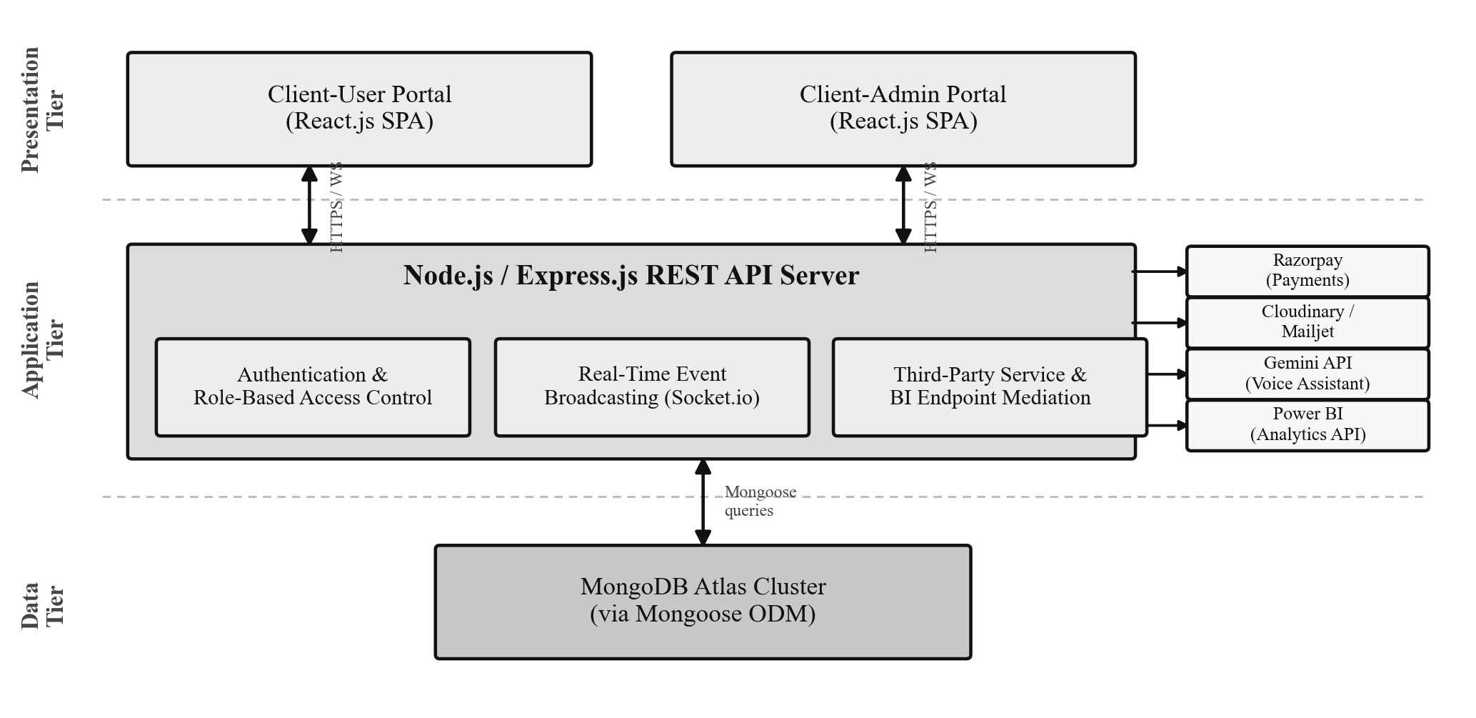
Fig. 1. Proposed three-tier system architecture of the PropManage framework.

C. Real-Time Operational Notification
To eliminate inbox-polling delay, the application tier maintains a persistent WebSocket channel via Socket.io [4], to which authenticated administrative sessions subscribe at login. When a booking or payment record is created, the server broadcasts the event to a dedicated administrative channel immediately after persistence. For the event set E = {Booking, Payment}, notification latency for e ∈ E is bounded by network round-trip time rather than any fixed polling interval Δt.
D. Authentication and Role-Based Access Enforcement
Authentication uses stateless JSON Web Tokens [13]: on login, the server signs a payload with the user's identifier, carried in the Authorisation header thereafter. Rather than trusting token validity alone — shown insufficient in adversarial settings [7], [8] — the protection middleware re-fetches the user's current record on every protected request:
Access(u, r, t) = 1 iff verify(t) = valid ∧ role(u) ∈ Roles(r) ∧ status(u) = active
and is denied otherwise. Because status(u) is re-evaluated per request, blocking an account takes effect on that user's very next request regardless of token validity. Authorisation follows a four-level hierarchy — Guest, Registered User, Admin, Super Admin — consistent with Ferraiolo et al.'s RBAC model [11].
E. Cryptographically Verified Payment Processing
Rental payments are submitted as a UPI transfer with a reference number and screenshot, manually verified by an administrator. Purchase advance payments, higher in value, are processed via Razorpay with automated verification: rather than trusting the client-relayed order/payment identifiers and signature — the risk pattern OWASP flags [9] — the server independently recomputes:
S_expected = HMAC-SHA256(K_secret, orderId ‖ "|" ‖ paymentId)
The payment is accepted only if S_expected equals the client-supplied S_received; any mismatch rejects the request without modifying any record. Because the signature covers only the order/payment identifiers, verification is immune to client-side tampering with the claimed amount.
F. Multilingual, Voice-Enabled Conversational Assistant
Conversational assistance is mediated entirely server-side: messages are combined with a system prompt grounded in a live, request-time snapshot of the property and booking database, then streamed from Google's Gemini API over Server-Sent Events, so no provider credential reaches the browser. Speech input and output are layered entirely on the browser-native Web Speech API — no dedicated cloud speech service or added infrastructure — addressing the accessibility gap voice-enabled healthcare deployments have shown text-only interfaces leave unaddressed [20]. A microphone control invokes SpeechRecognition; interim transcripts render live, and the final transcript is submitted through the same endpoint used for typed input. The user selects English, Hindi, or Telugu; a non-English selection appends an instruction directing the model to reply entirely in that language while leaving proper nouns, contact details, links, and currency untranslated, addressing the code-switching and named-entity concerns documented for Indian-language voice assistants [18]. Only replies to voice-initiated messages are read aloud via SpeechSynthesis, matched to the closest installed voice for the language, and tagged by generation language so Replay is never misspoken after a since-changed selector value; unsupported browsers (e.g., Firefox) receive a disabled control with an explanatory message rather than a silent failure. This context-assembly grounding is intentionally lighter-weight than full RAG over an indexed corpus [15]; Section 5-B identifies migration to MongoDB's native vector search [16] as the primary scaling direction as the catalogue grows.
G. Core Functional Modules
Beyond these cross-cutting mechanisms, the application tier implements: a property catalogue with full-text and multi-attribute filtered search; a booking/visit-scheduling module driving the notification mechanism of Section 3-C (Fig. 2); a contract module linking properties, owners, and tenants through a draft–active–expired/terminated lifecycle, gating purchase-contract signing on verified advance payment; a financial-transaction ledger; a five-stage maintenance/service-request module; and an analytics module aggregating statistics across collections via parallelised, non-blocking queries.

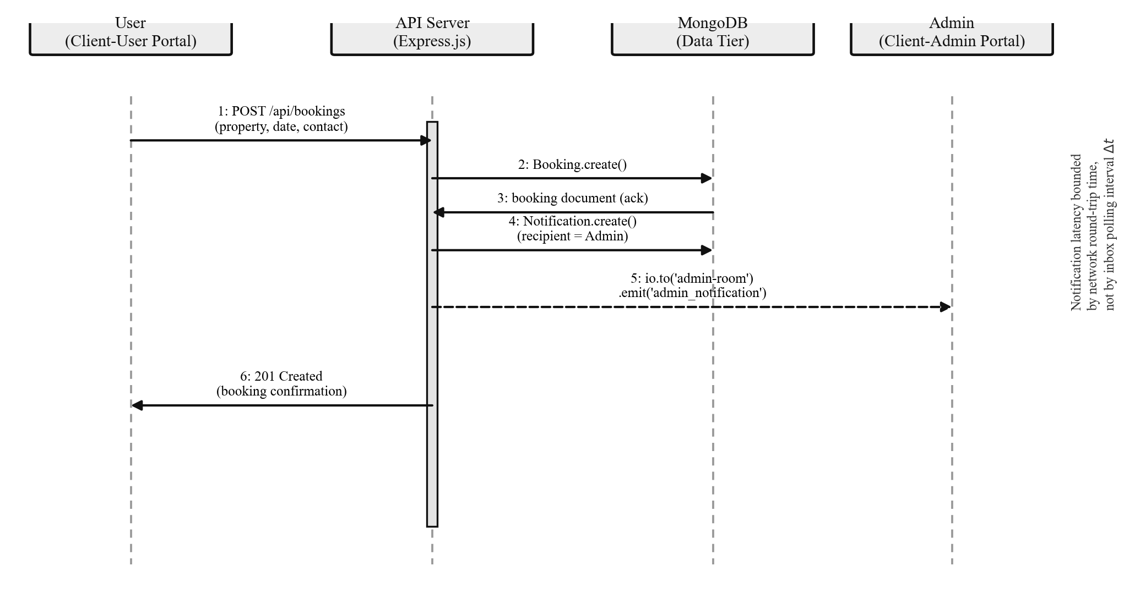
Fig. 2. Sequence diagram of booking submission and real-time administrative notification.

H. Power BI Business Intelligence Integration
Beyond the administrative dashboard, the application tier exposes a dedicated, read-only analytics API — six aggregation endpoints spanning executive, property, booking, revenue, tenant, and maintenance reporting — for consumption by Power BI's scheduled refresh. Since a BI tool's refresh schedule cannot accommodate the seven-day JWT expiry used elsewhere (Section 3-D), these endpoints are protected instead by a dedicated, non-expiring API-key header, isolating BI access from interactive authentication entirely. Each endpoint aggregates server-side within MongoDB rather than returning raw records, so transferred data scales with reporting dimensions, not document count; the affected collections' compound indexes were confirmed, via MongoDB's execution-plan output, to resolve through index scans.
I. Advantages of the Proposed Framework
• Complete lifecycle coverage within one role-segmented platform.
• Notification latency bounded by round-trip time, not polling.
• Per-request re-authorisation closing the block-to-enforcement window.
• Cryptographic, not trust-based, verification of high-value payments.
• Multilingual (English, Hindi, Telugu), browser-native voice interaction at zero additional speech-infrastructure cost.
• Native Power BI integration via independently authenticated analytics endpoints, and a codebase built entirely on free-tier third-party services.
4. Results
The framework was evaluated for functional correctness, latency, load tolerance, and adversarial security, per the objectives of Section 3-A.
A. Experimental Environment
The server used Node.js 18 LTS, Express.js 4.18.2, and MongoDB Atlas 6.0+ via Mongoose 8.0.3; both clients used React.js 18.2.0. Functional and latency tests used Postman (20 repeated calls per endpoint against the deployed cloud server); concurrent-load testing used Apache JMeter against the property-listing endpoint.
B. Test Configuration, Metrics, and Functional Results
Evaluation used a populated instance of 45 properties, 120 users, 280 bookings, 195 payments, 38 owners, 52 tenants, 41 rental and 12 purchase contracts, 310 financial and 87 service transactions, each collection indexed to its dominant query pattern. Four metric categories were used: functional correctness (38 scripted scenarios); endpoint latency; concurrent throughput (mean and 95th-percentile latency, error rate); and adversarial security resilience (fourteen test cases). All 38 functional scenarios completed as expected, covering registration and duplicate-email rejection, OTP password reset with expiry, catalogue search/filtering, booking submission and confirmation, rental-payment verification, a tampered Razorpay signature correctly rejected, contract signing gated on advance payment, administrative CRUD across owner/tenant/contract records, real-time notification delivery, and AI chatbot response including voice-initiated transcription and synthesised reply playback. No error condition crashed the server or left inconsistent data.
C. Endpoint Latency and Concurrent-User Load
Table II. Representative API Endpoint Response Latency (n = 20 Calls per Endpoint)
Endpoint | Method | Mean (ms) | Max (ms)
/api/auth/login | POST | 312 | 450
/api/properties | GET | 241 | 375
/api/properties (filtered) | GET | 309 | 455
/api/bookings | POST | 288 | 415
/api/payments | POST | 847 | 1190
/api/admin/dashboard | GET | 574 | 815
/api/purchase-contracts/create-payment | POST | 1189 | 1760
/api/ai | POST | 2080 | 3490

Table III. Concurrent-User Load Test Results (Property-Listing Endpoint)
Concurrent Users | Mean Response (ms) | 95th Pct. (ms) | Error Rate
10 | 218 | 305 | 0.00%
50 | 375 | 553 | 0.00%
100 | 494 | 743 | 0.15%
150 | 672 | 1095 | 1.41%
200 | 918 | 1612 | 3.18%

All endpoints met their service-level targets (Table II); the payments endpoint reflects its Cloudinary upload step, and the AI endpoint reflects its external LLM round-trip. The system sustains the 100-concurrent-user target at sub-500 ms mean latency and under 0.2% errors (Table III); degradation appears beyond 150 users, where horizontal server scaling and MongoDB Atlas auto-scaling would preserve the same latency profile.
D. Security Testing and Platform Comparison
Table IV. Representative Adversarial Security Test Case Results
Control | Test | Result
Password hashing | Query DB for stored password | Pass
JWT integrity | Tampered/expired token payload | Pass
Role enforcement | User token on admin route | Pass
Blocked account | Valid token, blocked user | Pass
Rate limiting | 201 requests in 15 min | Pass
Upload validation | .exe file / oversized image | Pass
XSS input | Script tag in property title | Pass
Razorpay signature | Tampered signature value | Pass
Query injection | Mongo operator in query string | Pass

All fourteen underlying adversarial checks behaved as specified; notably, React's default JSX escaping renders any script injected via input as inert text, providing defence in depth for the XSS case independent of server-side sanitisation.
Table V. Feature Comparison — Proposed Framework vs. Existing Platforms
Feature | PropManage | Bayut.com | Dubizzle | Buildium | AppFolio
Self-service visit booking | Yes | No | No | No | No
Razorpay-verified purchase advance | Yes | No | No | No | No
Rental contract management | Yes | No | No | Yes | Yes
Real-time staff notifications | Yes | No | No | No | No
Multilingual voice-enabled AI assistant | Yes | No | No | No | No
Accessible without enterprise budget | Yes | Yes (portal only) | Yes (portal only) | No | No

PropManage is the only evaluated system combining full lifecycle coverage, verified payments, real-time notification, and multilingual voice-assisted interaction within a cost profile accessible to small operators; Buildium and AppFolio cover more lifecycle breadth than listing portals but offer none of these capabilities.
E. Discussion
The results address the three gaps in Section 2-E: latency/load results (4-C) show architecture reviewed in isolation elsewhere [3], [10] performs acceptably once integrated in a multi-entity system, consistent with MERN optimization findings [17] already applied here; security results (4-D) show token verification, role enforcement, and signature checking behaving correctly as one adversarially tested system, not in isolation as in [7]–[9]; and field observation over one week recorded 147 booking/payment events, all notified within two seconds — evidencing the latency behavior [1], [2] identify as unaddressed by manual coordination. One limitation is architectural: the dashboard's single parallelised query batch across eight collections fails if any one query fails; a more fault-tolerant design is deferred to Section 5-B.
5. Conclusion
A. Conclusion
This paper presented PropManage, a MERN-stack platform unifying property cataloguing, scheduling, payment processing, contract administration, and maintenance tracking within a dual-portal, three-tier architecture. The Section 4 evaluation confirms every objective of Section 3-A: all 38 functional scenarios passed, the platform sustained 100 concurrent users at sub-500 ms mean latency with under 0.2% errors, all fourteen adversarial security tests behaved as specified, and field observation confirmed sub-two-second notification delivery. Section 4-D shows the framework is the only evaluated system combining full lifecycle coverage, verified payments, real-time notification, and multilingual voice-assisted interaction within a cost accessible to small operators, closing the gaps of Section 2-E and showing that careful token-verification, payment-signature, and browser-native speech-interface design can produce a production-quality, linguistically accessible system without an enterprise budget.
B. Future Work
• Tenant self-service portal for maintenance submission and financial history, reducing inbound staff communication.
• Fault-tolerant analytics replacing the single parallelised query batch (Section 4-E) with independently executed, gracefully degrading queries.
• Native mobile deployment via React Native, adding push notifications, camera-based evidence capture, and full UI/RTL localisation for Arabic-speaking users.
• Predictive analytics forecasting rental pricing, vacancy, and late-payment risk, moving analytics from descriptive to prescriptive.
• Vector-indexed retrieval-augmented grounding, migrating Section 3-F's context-assembly strategy to embedding-based retrieval over MongoDB's native vector search [16], following [15].
References
[1] B. Al-haimi, H. Khalid, N. H. Zakaria, and T. H. Jasimin, “Digital transformation in the real estate industry: A systematic literature review of current technologies, benefits, and challenges,” Int. J. Inf. Manage. Data Insights, 2025.
[2] Z. Tan and N. G. Miller, “Connecting digitalisation and sustainability: Proptech in the real estate operations and management,” J. Sustain. Real Estate, vol. 15, no. 1, 2023.
[3] N. Bhat, R. Sharma, A. Kaushik, and T. Jain, “MERN stack unveiled: A research study on the technology’s architecture and benefits,” Tuijin Jishu/J. Propulsion Technol., vol. 44, no. 1, 2023.
[4] I. Fette and A. Melnikov, “The WebSocket Protocol,” IETF RFC 6455, 2011.
[5] S. Meduri, “Revolutionising customer service: The impact of large language models on chatbot performance,” Int. J. Sci. Res. Comput. Sci. Eng. Inf. Technol., vol. 10, no. 5, pp. 721–730, Nov. 2024.
[6] L. Aldhafeeri, F. Aljumah, F. Thabyan, M. Alabbad, S. AlShahrani, F. Alanazi, and A. Al-Nafjan, “Generative AI chatbots across domains: A systematic review,” Appl. Sci. (MDPI), vol. 15, no. 20, art. 11220, 2025.
[7] X. Bowen, S. Jia, J. Lin, F. Zheng, et al., “JWTKey: Automatic cryptographic vulnerability detection in JWT applications,” in Computer Security — ESORICS 2023, Springer LNCS, 2023.
[8] B. Rexha et al., “Enhancing JWT authentication and authorisation in web applications based on user behaviour history,” Information (MDPI), vol. 12, no. 4, art. 78, 2023.
[9] OWASP Foundation, “OWASP API Security Top 10,” 2023.
[10] J. Urnikienė, V. Steponavičienė, and S. Atanasov, “Comparative read performance analysis of PostgreSQL and MongoDB in e-commerce: An empirical study of filtering and analytical queries,” Big Data Cogn. Comput. (MDPI), vol. 10, no. 2, art. 66, 2026.
[11] D. F. Ferraiolo, R. Sandhu, S. Gavrila, D. R. Kuhn, and R. Chandramouli, “Proposed NIST standard for role-based access control,” ACM Trans. Inf. Syst. Secur., vol. 4, no. 3, 2001.
[12] R. T. Fielding, “Architectural Styles and the Design of Network-based Software Architectures,” PhD dissertation, Univ. of California, Irvine, 2000.
[13] M. Jones, J. Bradley, and N. Sakimura, “JSON Web Token (JWT),” IETF RFC 7519, 2015.
[14] A. O. Adediran, A. M. Aini, and S. M. Ajibade, “Adoption of artificial intelligence in property management transactions: A systematic review and trend analysis,” Property Manage., vol. 44, no. 2, pp. 199–231, 2025.
[15] J. Swacha and M. Gracel, “Retrieval-augmented generation (RAG) chatbots for education: A survey of applications,” Appl. Sci. (MDPI), vol. 15, no. 8, art. 4234, 2025.
[16] Deepak and S. Sheoran, “Vector search in large language models: Experimental evaluation with MongoDB Atlas,” J. Cybersecurity Inf. Manage., vol. 17, no. 2, pp. 146–166, 2026.
[17] G. Kumar, D. Kumar, and R. Yadav, “Performance optimisation in MERN stack applications,” Int. J. Res. Publication Rev., vol. 6, no. 5, pp. 5073–5077, 2025.
[18] S. Sabharwal and R. Sahni, “Tackling the problem of multilingualism in voice assistants,” Int. J. Electr. Electron. Comput. (IJEEC), vol. 9, no. 5, pp. 1–14, Oct. 2024.
[19] K. Pinniboyina, “Multi-language voice assistant system using Web Speech API,” Int. J. Sci. Eng. Technol. (IJSET), vol. 13, no. 4, 2024.
[20] A. Khamaj, “AI-enhanced chatbot for improving healthcare usability and accessibility for older adults,” Ain Shams Eng. J., vol. 116, pp. 202–213, Mar. 2025.

