**WEEK-2**

**PL/SQL programming**

**1. Control Structures**

DECLARE

    v_marks NUMBER:=85;

    v_grade CHAR(1);

BEGIN

    -- IF-ELSIF-ELSE

    IF v_marks>=90 THEN

        v_grade:='A';

    ELSIF v_marks>=80 THEN

        v_grade:='B';

    ELSIF v_marks>=70 THEN

        v_grade:='C';

    ELSE

        v_grade:='F';

    END IF;

    DBMS_OUTPUT.PUT_LINE('Grade ' || v_grade);

    -- CASE Statement

    CASE

        WHEN v_grade='A' THEN DBMS_OUTPUT.PUT_LINE('Excellent!');

        WHEN v_grade='B' THEN DBMS_OUTPUT.PUT_LINE('Very Good!');

        WHEN v_grade='C' THEN DBMS_OUTPUT.PUT_LINE('Good!');

        ELSE DBMS_OUTPUT.PUT_LINE('Needs Improvement!');

    END CASE;

    -- FOR LOOP

    DBMS_OUTPUT.PUT_LINE('First 5 Even Numbers:');

    FOR i IN 1..5 LOOP

        DBMS_OUTPUT.PUT_LINE(i*2);

    END LOOP;

    -- WHILE LOOP

    DECLARE

        counter NUMBER:=3;

    BEGIN

        WHILE counter>0 LOOP

            DBMS_OUTPUT.PUT_LINE('Countdown: ' || counter);

            counter:=counter-1;

        END LOOP;

    END;

END;

/

**Output:**

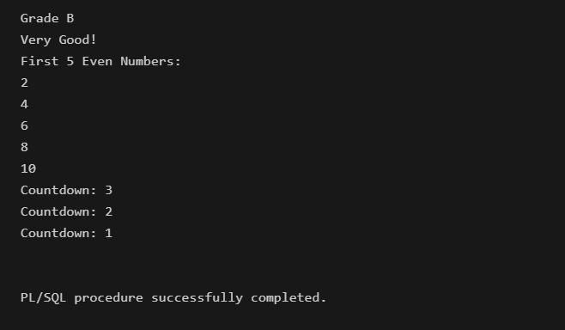

**2. Stored Procedures**

CREATE OR REPLACE PROCEDURE even_numbers(n IN NUMBER) IS

BEGIN

    FOR i IN 1..n LOOP

        DBMS_OUTPUT.PUT_LINE(i*2);

    END LOOP;

END;

/

SET SERVEROUTPUT ON;

BEGIN

    even_numbers(5);

END;

/

**Output:**

